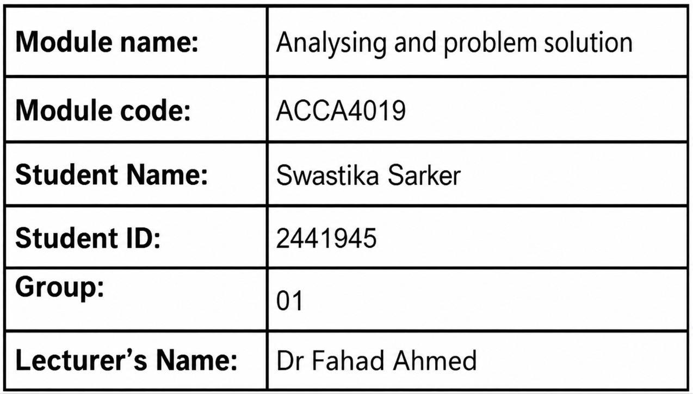


Contents
1. Introduction 3
2. Problem Deconstruction 3
2.1 Scenario Analysis 3
2.2 Requirements Analysis 3
2.3 MoSCoW Prioritisation 4
2.4 Variables 4
2.5 Constraints 6
3. Proposed Solution 6
3.1 Overview of the Proposed Solution 6
3.2 Flowchart 6
3.3 Explanation of the Algorithm 11
3.4 Decision Points 13
3.5 Benefits of the Proposed Solution 14
4. Reflection and Justification 14
4.1 Use of Abstract Thinking 14
4.2 Use of Decomposition 15
4.3 Use of Systems Thinking 15
4.4 Justification of the Proposed Solution 15
4.5 Limitation 16
4.6 Assumption 16
5: Conclusion 16
References 17
Appendices: Pseudocode 18

1. Introduction
Group projects are an important part of higher education and allow students to develop skills in teamwork, communication, and problem-solving. In computing courses, students collaborate on programming, software development, database design, networking, and systems analysis. Unfortunately, coordinating meetings is difficult due to different lecture timetables, part-time employment, and personal commitments. Lack of scheduling can lead to poor communication, uneven workload distribution, decision-making delays, and missed deadlines. Abstract thinking and structured problem-solving techniques are followed in this report to find a solution to the scheduling difficulty. It specifies the major requirements, variables, and constraints and offers practical scheduling mechanisms to improve coordination among groups, mitigate timetable conflicts, and enable successful project completion [1].

2. Problem Deconstruction

2.1 Scenario Analysis
Computing students quite often finish group projects that ask for strong communication and coordination. Still, different lecture timetables, part-time jobs, and personal commitments, can make scheduling a meeting rather tricky. In this report, we use abstract thinking, and in a way decomposition, to look at the most important scheduling factors, like availability, upcoming deadlines, and the overall meeting duration. Then we propose a structured scheduling approach to reduce clashes, strengthen collaboration, encourage fair involvement, and make sure the meetings happen before the project deadlines. With that, the hope is that the project completion will go smoother, in practice [2].

2.2 Requirements Analysis
Both functional and non-functional requirements need to be satisfied by the proposed scheduling system.
- Functional Requirements
- Collect student availability.
- Store timetables and project deadlines.
- Automatically compare available time slots.
- Identify common free periods.
- Detect timetable conflicts.
- Schedule meetings before deadlines.
- Notify group members.
- Allow availability updates.

- Non-Functional Requirements
- Easy to use.
- Fast and accurate.
- Secure and reliable.
- Consistent performance.
- User-friendly for students with different technical skills.

2.3 MoSCoW Prioritisation
The MoSCoW prioritisation technique categorises system requirements according to their importance.
Must Have | Should Have | Could Have | Won't Have
Student availability input. | Automatic notifications | Calendar integration | Voice assistant integration.
Weekly project deadlines. | Ability to update availability. | Mobile application support. | Automatic timetable generation
Conflict detection. | Reminder messages before meetings | Video meeting links. | Real time GPS location tracking.
Automatic identification of common free time. | Ranking of suitable meeting times. | Attendance statistics. | Cross university scheduling support.
Meeting confirmation before deadline. |  | AI based meeting suggestions.

The MoSCoW framework ensures that essential functions are implemented first while optional features can be added during future system development [3].

2.4 Variables
Various variables affect the scheduling algorithm.

Variables | Description
NumberOfMembers | Stores the total count of group members.
MemberAvailability | Stores members available meeting windows.
LectureTimetable | Stores members lecture timetable stuff.
WorkSchedule | Stores members part-time job schedule.
PersonalCommitments | Stores members personal obligations or other nonwork stuff.
PreferredMeetingTime | Stores their favoured meeting time.
WeeklyDeadline | Stores the weekly deadline date, for the project.
MeetingDuration | Stores the needed meeting length.
WeeklyTimeGrid | Stores the Monday through Friday time slots.
CommonTimeSlots | Stores shared open meeting slots, so everyone fits.
AttendanceCount | Stores the number of available members.
SelectedTimeSlot | Stores the chosen meeting window.
AlternativeTimeSlots | Stores extra meeting times, in case conflicts happen.
ConflictCount | Stores how many timetable conflicts show up.
MeetingConfirmed | whether the meeting is finalized or not.
AvailabilityUpdated | whether the availability has changed, recently.
Such parameters are then processed by an algorithm for the optimal meeting timetable.

2.5 Constraints
- Each group member is required to have at least one time window that is still free for scheduling, even if it feels tight.
- The meetings need to happen before the weekly project deadline, otherwise effective project coordination becomes difficult.
- Lecture hours cannot be touched, meaning they should not be interrupted or moved around later.
- Any part-time work commitments must not be disrupted by the meeting schedule; therefore, these commitments must be considered.
- The actual meeting duration must sit inside the shared free time of all chosen members, without exception.
- Every required group member should be present at the same moment, so the same time works for everyone.
- The proposed scheduling approach should reduce clashes, while also increasing attendance, as much as possible.
- If availability changes, the system must allow rescheduling without restarting the whole project again.

3. Proposed Solution

3.1 Overview of the Proposed Solution
Using the above problem analysis, a structured scheduling scheme was proposed to select the most appropriate meeting time for a student team. The algorithm uses a technique of abstraction, decomposition and optimisation to consider lecture timetable, part-time work, personal schedules, project times and meeting length. It eliminates unavailable times, searches for overlapping free time blocks and scores good options based on attendance, least conflicts and earliest available. In case of no common slot, the system selects the best one and provides support to any missing members, also to facilitate online collaboration. It enhances fairness, cuts scheduling conflicts, and promotes successful project completion [4].

3.2 Flowchart

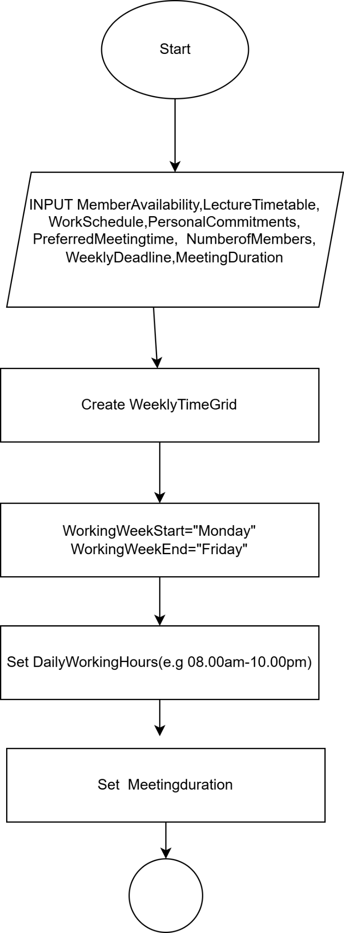

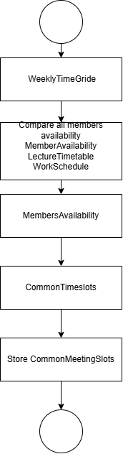

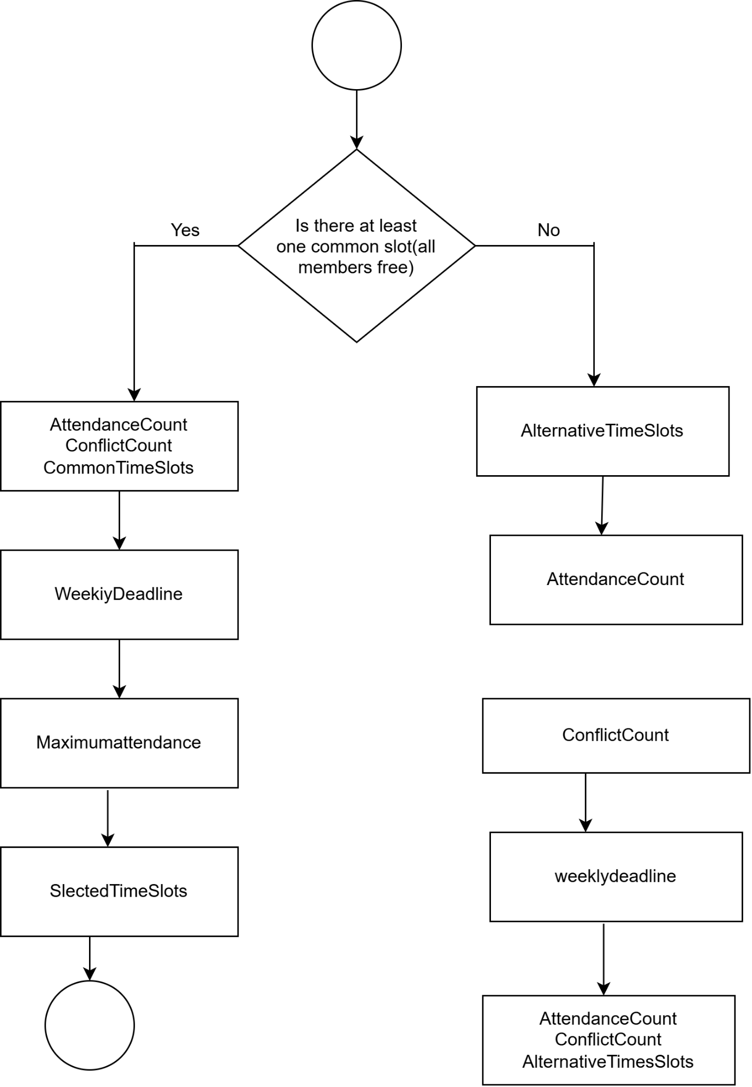

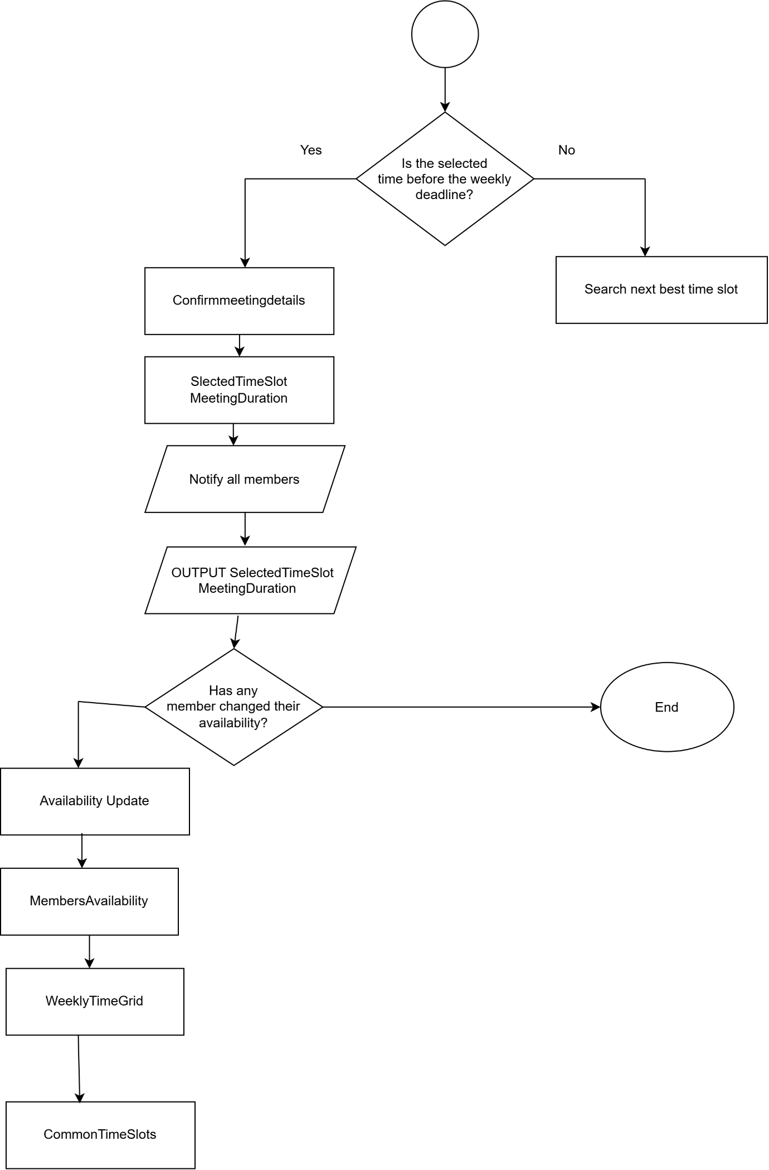

Figure 1. Proposed Meeting Scheduling Algorithm (Author's own work)

3.3 Explanation of the Algorithm
The scheduling algorithm sorts itself into a series of logical phases that work together towards finding the right time for the meeting in such a way that is not prone to overthinking [5].
Assumptions:
The solution that you propose has several assumptions
- All group members have accurate and up-to-date availability before scheduling begins.
- All members have at least one available time slot between Monday and Friday.
- The weekly project deadline and the meeting time remain fixed throughout the scheduling process.
- Lecture timetables, part-time work schedules and personal commitments are entered correctly.
- All members use the same time zone and follow the same weekly schedule.
- Members agree to attend the time of the meeting or accept the best option if necessary.
- The system retains and processes scheduling data accurately without errors or data loss.
- If there is no common time slot, the system decides on the best one with the highest attendance and fewest conflicts.
- Members can be notified of their schedules whenever the meeting is needed.
- All members can get meeting notices through email, or message apps, such as email or messaging applications.
These are some of the more realistic assumptions that would simplify the design in most college environments.

- Step 1: Collect Availability
Phase one: Obtaining data from all group members. The participants submit:
- Weekly lecture timetable
- Laboratory sessions
- Part-time working hours
- Personal commitments
- Preferred meeting periods
- Expected duration of meeting
Gathering that information guarantees you make your decisions about scheduling based on every student's commitment.

- Step 2: Store Project Deadline
The weekly submission deadline given by the lecturer is recorded in the system. So, this deadline is a very important constraint because each meeting must precede the project milestone. Doing meetings after the deadline would be of no avail regarding project completion.

- Step 3: Remove Busy Time Slots
The algorithm removes the time slots that students are not available. Unavailable periods include:
- Lectures
- Tutorials
- Laboratory sessions
- Work shifts
- Personal appointments
Only genuinely available time slots are left for comparison.

- Step 4: Compare All Schedules
We then look at the remaining free periods from all students. To do this, we attempt to find overlapping time slots in which every group member is available at the same time.

- Step 5: Assessing Meetings by Time
Sometimes there are a few workable moments to meet. Rather than just picking one at random, the algorithm sorts the available choices with several optimisation criteria, like
- Earliest free slot
- Smallest conflict risk
- Largest expected attendance
- Nearest to the project milestone without going over it
- Student preferences

- Step 6: Planning Conflicts
If no common meet time is available, the system will just handle it with conflict resolution by choosing the slot that gets the highest attendance. Meeting times are rotated, so fairness is kept in mind, while also recorded sessions and digital collaboration tools help absent members, or more precisely they help them stay in sync. With these steps, disruption is minimised and participation is maintained, so the team can keep moving with continuous progress, all the way to project completion [6].

- Step 7: Verify Deadline
The algorithm checks whether any meetings land before the weekly project deadline, before it finally confirms the meeting. It will automatically reject the proposed option if it drifts past the deadline, then search for another moment to meet. This ensures that all confirmed meetings comply with project deadlines.
- Step 8: Confirm Meeting
With every requirement, the meeting is confirmed. Each group member receives:
- Meeting date
- Start time
- Finish time
- Meeting location or online link
- Agenda
- Reminder notification
The scheduling is now complete with the final step.

3.4 Decision Points
This method uses multiple decision points that can facilitate making the algorithm more efficient.
- Decision Point: 1
Have all the students submitted their availability? If not, request missing information. If yes, continue.

- Decision Point: 2
Is there a common free time? If yes, continue to rank. If no, search for the best alternative.

- Decision Point; 3
Is the meeting before the deadline? If yes, confirm the meeting. If no, reject the meeting and continue searching.

- Decision Point :4
Has every member received notification? If yes, finish. If no, resend notifications.
These decision points involve identifying and addressing scheduling errors before meetings can be confirmed.

3.5 Benefits of the Proposed Solution
The proposed scheduling system minimises the time spent scheduling meetings by comparing students’ availability. It reduces timetable conflicts, increases attendance and ensures meetings take place before project deadlines. It is the optimisation process that selects specific times to hold meetings with objective criteria to ensure fairness between different group members. It is also very flexible and expandable with features like calendar synchronisation, artificial intelligence, reminder notifications and mobile applications. These features ensure that the solution is scalable, efficient, and well-suited for collaborative project management in higher education while allowing easier communication, equitable distribution of the workload and the successful completion of projects [7].

4. Reflection and Justification
Our scheduling system makes it easy and faster for us to compare students' availability automatically rather than having to rely on manual communication. It reduces conflicts with schedules, increases attendance, and makes sure meetings happen prior to project deadlines. It is flexible, and can be extended by calendar integration, AI and reminder notifications. The solution is grounded in abstraction, decomposition, systems thinking and optimisation. These are methods to transform a complicated scheduling problem into something simple and easy to build and assess the solutions [8].

4.1 Use of Abstract Thinking
It is about abstract thinking such that only information related to the problem is discussed, ignoring irrelevant details. Only student availability, lecture timetables, personal commitments, meeting duration, and project deadlines were included in this solution. This made scheduling a lot more efficient and made it possible for you to implement the same algorithm for several groups of students at once [9].

4.2 Use of Decomposition
Decomposition is when you break the problem into smaller, more manageable pieces. In this scheduling scheme, the process consisted of gathering student availability, recording project deadlines, identifying unavailable time slots, comparing schedules, detecting conflicts, selecting the best meeting time, confirming the meeting, and sending notifications. These systematic steps make algorithm design, testing and execution easy. It also makes it more seamless to detect and eliminate scheduling problems without having to start all over, from scratch. And, decomposition helps the future design improvements such as calendar app integration, online meeting links and scheduling reminders automatically, not breaking up the current scheduling of appointments [10].

4.3 Use of Systems Thinking
Systems thinking was applied to view the meeting scheduling problem as an interconnected system rather than a series of independent tasks. Instead of considering student availability alone, the proposed solution evaluates lecture timetables, part-time employment, personal commitments, meeting duration and project deadlines together. A change in any one variable can influence the entire scheduling process; therefore, the algorithm continuously reassesses all related factors before selecting the most suitable meeting time. This holistic approach improves decision-making, minimises timetable conflicts, supports fair participation among group members and ensures that meetings are arranged before weekly project deadlines. Applying systems thinking also makes the solution easier to maintain and extend with future features such as calendar integration, AI-assisted scheduling and real-time notifications.

4.4 Justification of the Proposed Solution
The proposed scheduling solution is suitable for all three of the project objectives
- Objective 1: Find the ideal time for the meeting:
Algorithms are employed to find times when everybody will be available; thus, the schedule need not be a manual task at all for any students in your class period.
- Objective 2: Avoid Schedule Conflicts:
Unavailable periods, whether it be lectures, work hours or private matters are excluded from the plan before it is set up so timing clashes do not occur
- Objective 3: Meet Before the Deadline for Each Week:
The scheduling system strictly enforces project deadlines, by rejecting meetings that end up scheduled after the deadline. Still, its overall effectiveness depends on the availability data being accurate, and it might need to be reworked or rescheduled when unexpected changes occur. Right now, the solution does not really take individual priorities into account, and it also skips any AI-driven prediction, so there is room for future improvements in scheduling precision and smarter decision making [11], [12].

4.5 Limitation
This scheduling approach has some limitations, it primarily depends on students giving accurate, and up-to-date availability, so if that info is wrong, the meeting times can turn out unsuitable. Also unexpected events like illness or work commitments can occur unexpectedly, and then meetings may need to be rescheduled again, even if everything looked fine before. On top of that the system only concentrates on arranging meetings, it does not really handle task assignment. In the future the system could be improved with AI based scheduling, predictive analysis, and calendar integration, so it’s more precise and more flexible [13].

4.6 Assumption
The scheduling scheme is based on these assumptions:
- Students provide accurate and up-to-date availability.
- Weekly timetables remain relatively stable.
- Project deadlines are known in advance.
- All students have internet access to receive notifications.
- Meeting duration is agreed by all group members.
- Students update their availability if their schedules change.
These assumptions simplify the scheduling process and make the solution pragmatic in a college setting.

5: Conclusion
This report analysed the problem of organising student group meetings by applying structured problem-solving techniques including abstraction, decomposition, systems thinking, optimisation and MoSCoW prioritisation. The proposed scheduling algorithm identifies suitable meeting times by comparing member availability, eliminating timetable conflicts and ensuring meetings occur before weekly project deadlines. The accompanying flowchart and pseudocode demonstrate a logical and systematic process that can be implemented in a software solution. Reflection on the proposed approach shows that breaking the problem into manageable components improves decision-making and supports fair participation among group members. Although the solution depends on accurate availability information, it provides a practical and scalable approach for higher education environments. Future enhancements such as AI-assisted scheduling, calendar integration and predictive analytics could further improve scheduling accuracy, flexibility and collaboration while maintaining an efficient and reliable meeting management process.

References
[1] S. Russell and P. Norvig, Artificial Intelligence: A Modern Approach, 4th ed. Hoboken, NJ, USA: Pearson, 2021.
[2] I. Sommerville, Software Engineering, 10th ed. Harlow, U.K.: Pearson, 2016.
[3] P. Checkland, Systems Thinking, Systems Practice. Chichester, U.K.: John Wiley & Sons, 1999.
[4] D. C. Wysocki, Effective Project Management: Traditional, Agile, Extreme, Hybrid, 8th ed. Hoboken, NJ, USA: Wiley, 2019.
[5] Project Management Institute, A Guide to the Project Management Body of Knowledge (PMBOK® Guide), 7th ed. Newtown Square, PA, USA: PMI, 2021.
[6] K. Schwaber and J. Sutherland, The Scrum Guide. Scrum.org, 2020.
[7] T. H. Cormen, C. E. Leiserson, R. L. Rivest and C. Stein, Introduction to Algorithms, 4th ed. Cambridge, MA, USA: MIT Press, 2022.
[8] R. S. Pressman and B. R. Maxim, Software Engineering: A Practitioner's Approach, 9th ed. New York, NY, USA: McGraw-Hill, 2020.
[9] M. Fowler, Patterns of Enterprise Application Architecture. Boston, MA, USA: Addison-Wesley, 2002.
[10] Agile Business Consortium, The MoSCoW Prioritisation Technique, 2023.
[11] IEEE Computer Society, Guide to the Software Engineering Body of Knowledge (SWEBOK V4.0). Los Alamitos, CA, USA: IEEE Computer Society, 2024.
[12] G. Booch, J. Rumbaugh and I. Jacobson, The Unified Modeling Language User Guide, 2nd ed. Boston, MA, USA: Addison-Wesley, 2005.
[13] R. M. Karp, "Reducibility among combinatorial problems," in Complexity of Computer Computations, New York, NY, USA: Plenum Press, 1972, pp. 85–103.

Appendices: Pseudocode
START
DISPLAY "Enter the number of group members"
INPUT NumberOfMembers
DISPLAY "Enter all members availability"
INPUT MemberAvailability
DISPLAY "Enter lecture timetables"
INPUT LectureTimetable
DISPLAY "Enter part-time work schedule"
INPUT WorkSchedule
DISPLAY "Enter personal commitment list"
INPUT PersonalCommitments
DISPLAY "Enter the weekly project deadline"
INPUT WeeklyDeadline
DISPLAY "Enter the meeting duration"
INPUT MeetingDuration
SET WorkingDays = Monday TO Friday
CREATE WeeklyTime Grid
REMOVE time slots that clash with:
LectureTimetable
WorkSchedule
PersonalCommitments
LOOK through all members time slots
FIND CommonTime Slots
IF CommonTimeSlots exist THEN
SORT CommonTimeSlots by:
highest attendance,
fewest conflicts,
earliest time
SET SelectedTimeSlot = top-ranked slot
ELSE
FIND AlternativeTimeSlots
SORT AlternativeTimeSlots by:
highest attendance,
fewest conflicts,
earliest time
SET SelectedTimeSlot = best alternative
ENDIF
WHILE SelectedTimeSlot is after WeeklyDeadline
REMOVE SelectedTimeSlot
TRY next best time slot
SET SelectedTimeSlot = next top ranked slot
ENDWHILE
DISPLAY "Meeting confirmed"
DISPLAY SelectedTimeSlot
DISPLAY MeetingDuration
DISPLAY "Notify everyone in the group"
DISPLAY "Did any member change availability?"
INPUT AvailabilityChanged
WHILE AvailabilityChanged = "YES"
DISPLAY "Enter updated availability"
INPUT UpdatedAvailability
UPDATE MemberAvailability
RECREATE WeeklyTimeGrid
DO again the time-slot selection process
DISPLAY "Has any other availability changed?"
INPUT AvailabilityChanged
ENDWHILE
END

