Module Name: Contemporary Themes In the Hotel and Hospitality Sector.
Module Code: BMIH6001
Chosen theme: Sustainability
There is a growing emphasis on sustainable and eco-friendly practices within the hotel and hospitality sector (Waste reduction strategies and recycling programs)
Assignment 2
Student Name: Sylvester Egbueri
Student ID: 1714548
Teacher Name: Ernest Balutie Wavei

Introduction
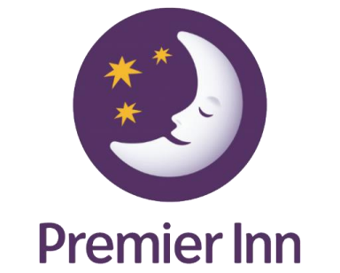
► The particular theme that will be explored in the present context is sustainability.
► The specific area in the theme that will take place is the waste reduction strategy and recycling programs.
► It has been found that sustainability is one of the most trending demands in the hospitality sector (Sharma et al., 2020).
► The effectiveness of waste reduction strategies as well as the recycling programme will be very helpful for the hospitality industry.
► It also will be helpful to have a positive impact on the enhancement of the business market along with the development of the environment.
Introduction (Contd.)
► Premier Inn is a British limited-service hotel chain as well as

regarded as the largest hotel in the UK.
► It has more than 800 hotels which have around 72,000
rooms.
► With the help of these room services, the organisation has
been able to deliver the best hospitality services to its
targeted customers around the various countries of the world.
► It was founded in 1987 and is headquartered in Dunstable,
England (Premier Inn, 2024).
► The organisation has adopted an effective sustainable
strategy to reduce carbon emissions by 50% by 2025.
Literature review
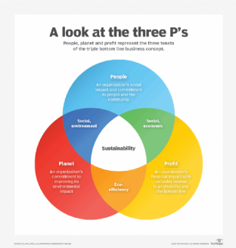
► This theory has a positive impact on three different areas such as people, the planet as well as profits.
► This particular theory was mainly developed by the British management consultant, John Elkington in 1994.
► As per the point of view of Tseng et al. (2020), this theory says the business of an organisation can be developed by improving its performance.
► In the current business market of the hospitality industry, Hilton Hotels also has adopted this particular theory.
► It has a positive impact on its business performance as well as develop the necessary initiatives to reach the commitment to sustainability.
Literature review (Contd.)
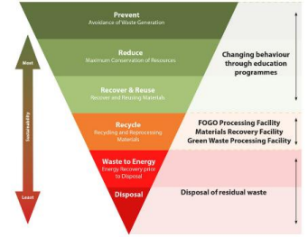
► According to Palafox-Alcantar et al. (2020), Waste Management Theory (WMT) is a notable strategy that mainly prevents waste.
► This theory therefore emphasises the design as well as development of products based on the principles of Industrial Ecology (IE).
► As suggested by Nguyen et al. (2023), the effective following of these principles mainly leads an organisation to develop effective
products.
► The effective application of this theory will have a positive impact on the business market of hotels like Hilton Hotels.
► The organisation also will effectively reduce its waste as well as recycle it properly for having a positive impact on the environment.
Literature review (Contd.)
► The waste of food is one of the major concerns in the hospitality

industry
► The effectiveness of this strategy will lead an organisation to
address this issue effectively.
► In the business market of Marriott International, the
effectiveness of this strategy has made it able to maintain the
sustainability of the environment.
► The impact of this reputation has a positive impact on their
business performance in the current market.
► As opined by Zorpas (2020), the proper waste management
strategy mainly leads an organisation to reduce its
environmental footprint.
Application to the hotel and hospitality industry
► The presence of instability of the government has created
barriers before the hospitality sector of the UK

(Papadopoulos and Ioannou, 2023).
► Organisations in the hospitality industry have been
negatively impacted due to this.
► Premier Inn also has faced issues in its business market as
the major limitation for developing business.
► The high inflation rate of the UK which is 2% has
prevented the hospitality sector from gaining financial
assistance (Statista, 2024).
► The business of Premier Inn therefore has been negatively
impacted due to this.
Application to the hotel and hospitality industry (Contd.)

► The changes in the preferences of consumers have presented as a
limitation before the success of the organisation (Conrady and Buck,
2012).
► The high employment rate of the UK around 74.5% has paved the
way for the hospitality sector to gain the best support of efficient
employees (Statista, 2024).
► Premier Inn has been able to optimise its services by using the best
technological tools.
► One of the major strengths of Premier Inn is that it has the best
customer service.
► Though the support of technology is effective the lack of proper
knowledge of employees has created barriers in the hospitality
industry (Ford and Sturman, 2020).
Application to the hotel and hospitality industry (Contd.)
► The effectiveness of the National Minimum Wage Act 1998 has
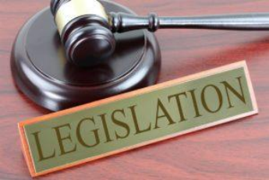
enabled the sector to deliver the proper remuneration to employees
(Legislation.UK, 2024.).
► It is one of the major strengths of the hospitality sector. On the other
hand, due to this legislation, employees are not able to demand a
high amount of salary.
► Premier Inn has experienced these things in its business market.
► The effectiveness of the Environment Act 2021 has enabled
organisations in the hospitality sector to adopt necessary strategies
for maintaining sustainability (Legislation.UK, 2024.).
► It has a positive impact on the business of Premier Inn in adopting
effective strategies.
Evaluate future policies as well as management options
► It will be effectively addressed by the policy of utilising reusable
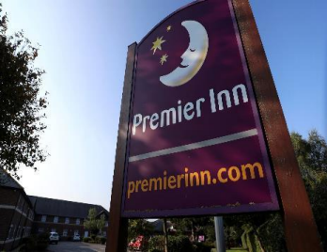
bags, bottles as well as refillable containers (Chen et al., 2021).
► The proper composting of the organic waste also will be very
helpful in order to leave a positive impact on the environment.
► The proper organisation of the awareness programs related to the
management of waste will be very useful.
► In order to adopt a collaborative approach towards meeting the
commitment to sustainability this will be a striking strategy.
► The reduction of the single use of items is one of the most
important strategies that has to be taken into account.
Conclusion
► The spreading of awareness related to waste management will lead everyone to think about it.

► The proper development of the environment therefore will be possible by the collaboration of everyone.
► Thus, a better future for the future generation as well as the business field can be imagined by using this approach.
► The effective development of the business of Premier Inn will be possible as a result of this.
► From the discussion of the study, it can be concluded that the proper adoption of the best awareness programs will be very helpful.
References
► Chen, Y., Awasthi, A.K., Wei, F., Tan, Q. and Li, J., 2021. Single-use plastics: Production, usage, disposal, and adverse impacts. Science of the total environment, 752, p.141772. ► Conrady, R. and Buck, M., 2012. Trends and Issues in Global Tourism, Springer.
► Ford, R.C. and Sturman, M.C., 2020. Managing Hospitality Organizations 2nd Edn. Sage, London.
► Ghani, B., Zada, M., Memon, K.R., Ullah, R., Khattak, A., Han, H., Ariza-Montes, A. and Araya-Castillo, L., 2022. Challenges and strategies for employee retention in the hospitality industry: A review. Sustainability, 14(5), p.2885.
► Legislation.UK, 2024. Environment Act 2021. [online] Available at: <https://www.legislation.gov.uk/ukpga/2021/30/contents/enacted> [Accessed on: 16th Oct. 2024] ► Legislation.UK, 2024. National Minimum Wage Act 1998. [online] Available at: <https://www.legislation.gov.uk/ukpga/1998/39/contents> [Accessed on: 16th Oct. 2024] ► Nguyen, A.T., Nguyen, N., Phung, P. and Yến-Khanh, N., 2023. Residents’ waste management practices in a developing country: a social practice theory analysis. Environmental Challenges, 13, p.100770.
► Palafox-Alcantar, P.G., Hunt, D.V.L. and Rogers, C.D.F., 2020. The complementary use of game theory for the circular economy: A review of waste management decision-making methods in civil engineering. Waste Management, 102, pp.598-612.
► Papadopoulos, O. and Ioannou, G., 2023. Working in hospitality and catering in Greece and the UK: Do trade union membership and collective bargaining still matter?. European Journal of Industrial Relations, 29(2), pp.105-122.
► Premier Inn, 2024. About us. [online] Available at: <https://www.premierinn.com/gb/en/why.html> [Accessed on: 16th Oct. 2024]
► Ruel, H. and Njoku, E., 2021. AI redefining the hospitality industry. Journal of Tourism Futures, 7(1), pp.53-66.
► Sharma, T., Chen, J. and Liu, W.Y., 2020. Eco-innovation in hospitality research (1998-2018): a systematic review. International Journal of Contemporary Hospitality Management, 32(2), pp.913-933. ► Srivastava, A.K., Dixit, S. and Srivastava, A.A., 2022. Criticism of triple bottom line: TBL (with special reference to sustainability). Corporate reputation review, pp.1-12.
► Statista, 2024. Employment rate in the United Kingdom from March 1971 to December 2023. [online] Available at: <https://www.statista.com/statistics/281992/employment-rate-in-the-united-kingdom/> [Accessed on: 16th Oct. 2024]
► Statista, 2024. Inflation rate for the Consumer Price Index (CPI) in the United Kingdom from January 1989 to May 2024. [online] Available at: <https://www.statista.com/statistics/306648/inflation-rate consumer-price-index-cpi-united-kingdom-uk/#:~:text=The%20UK%20inflation%20rate%20was,11.1%20percent%20in%20October%202022.> [Accessed on: 16th Oct. 2024]
► Tseng, M.L., Chang, C.H., Lin, C.W.R., Wu, K.J., Chen, Q., Xia, L. and Xue, B., 2020. Future trends and guidance for the triple bottom line and sustainability: A data driven bibliometric analysis. Environmental Science and Pollution Research, 27, pp.33543-33567.
► Zorpas, A.A., 2020. Strategy development in the framework of waste management. Science of the total environment, 716, p.137088.


