

JOB Adverts
NAME: AURITA CRISTOVAO
STUDENT NUMBER: 2430409
GROUP: 4
LECTURE: Piyumika Kithulgoda Gamage

4 Jobs Adverts in Different Company

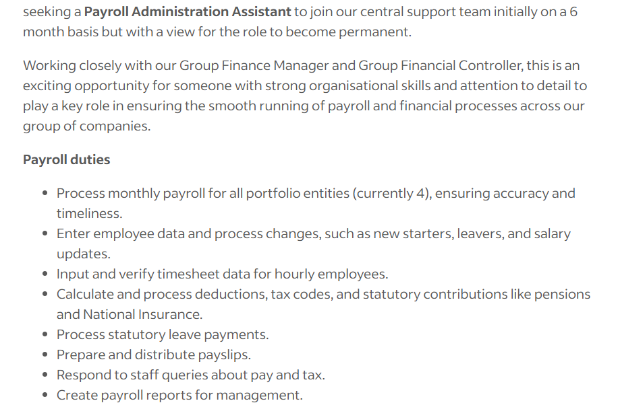
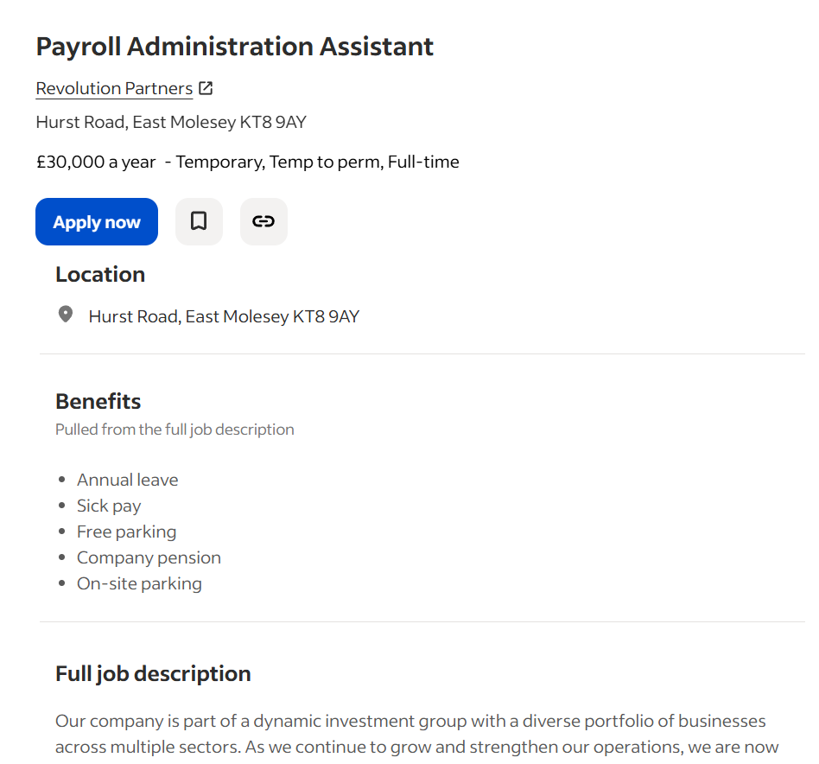

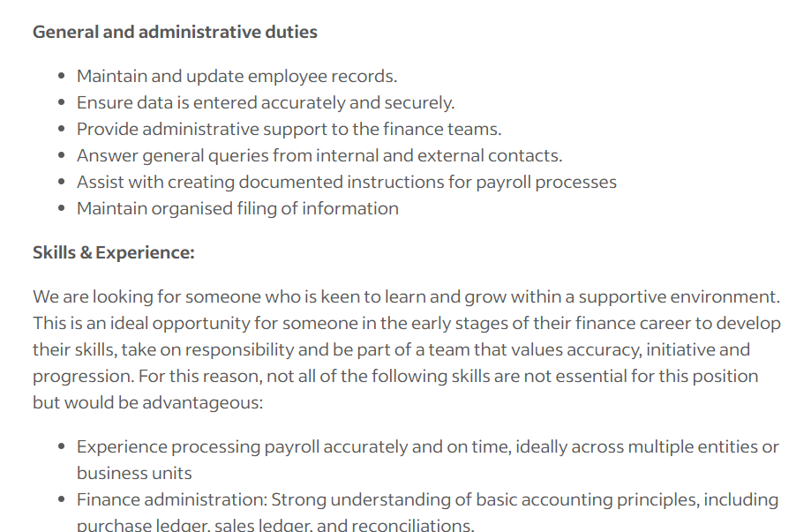
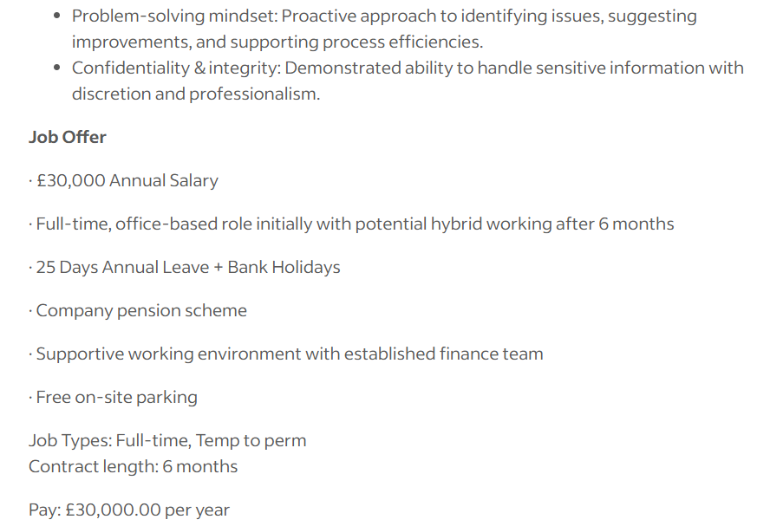

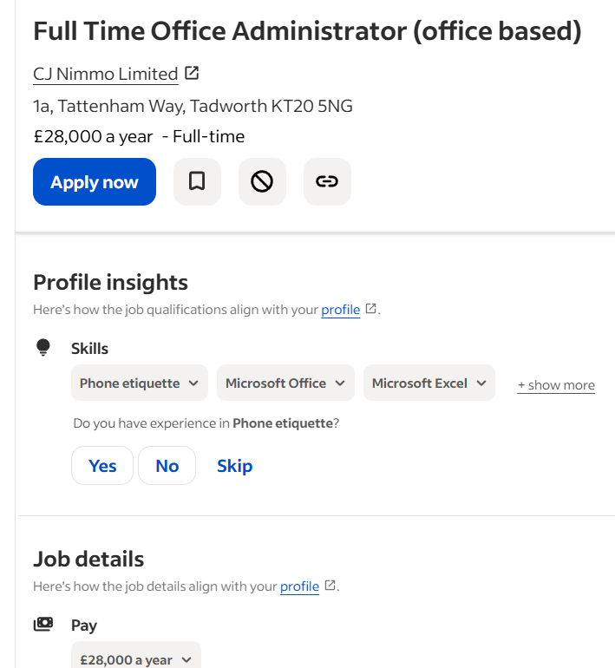
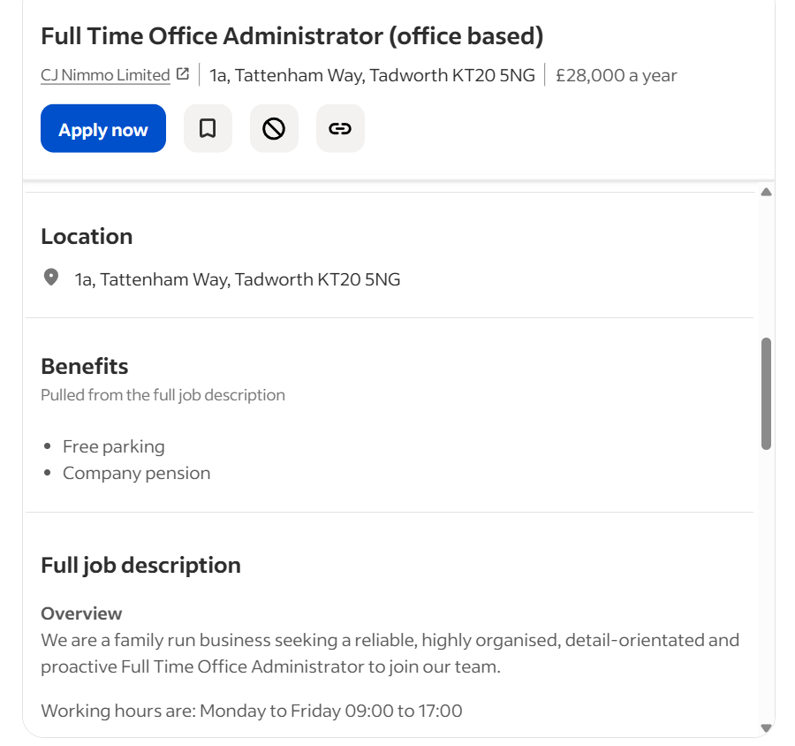
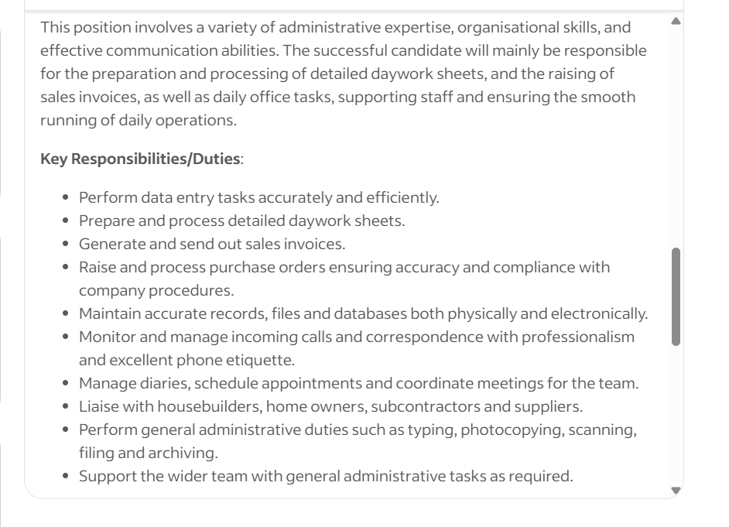
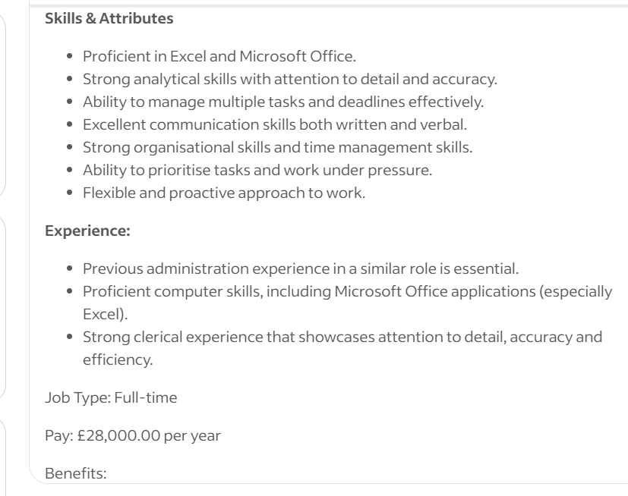
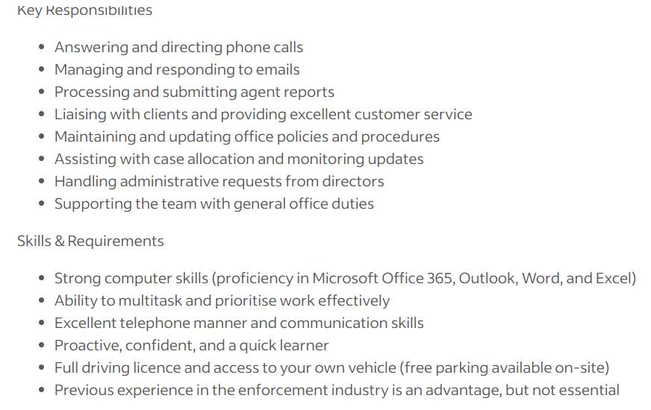
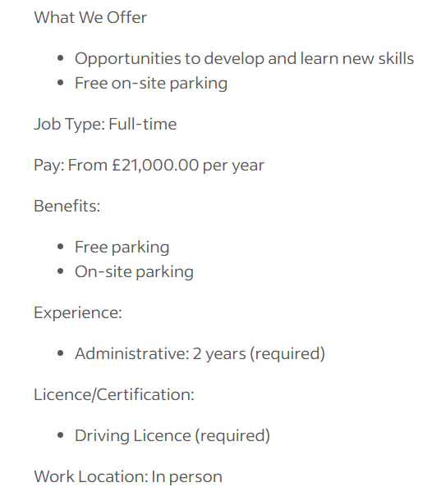
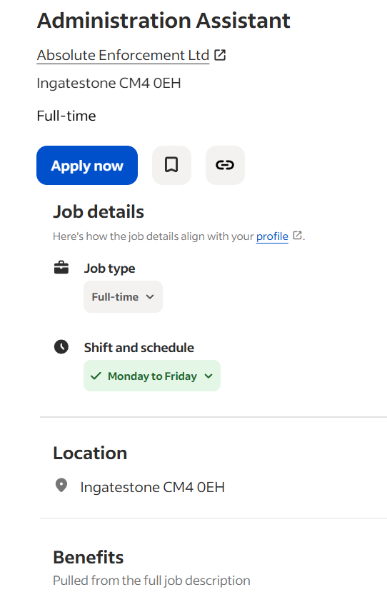
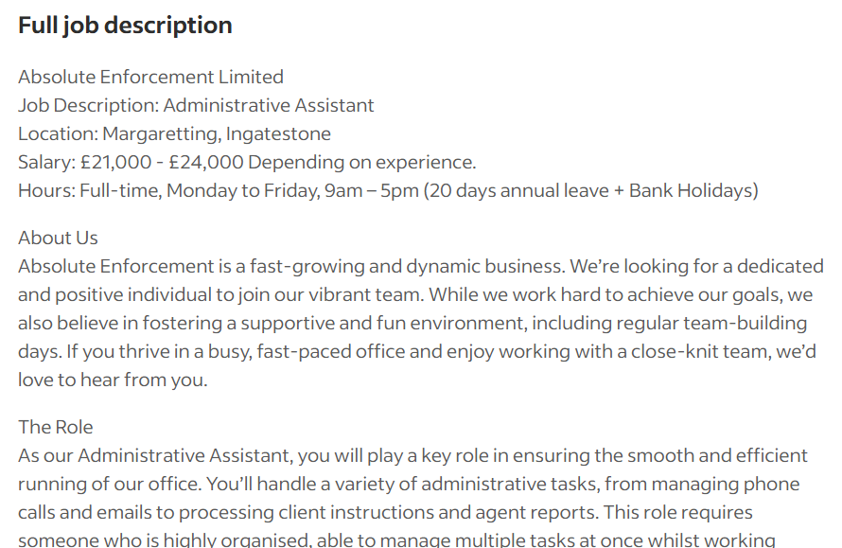
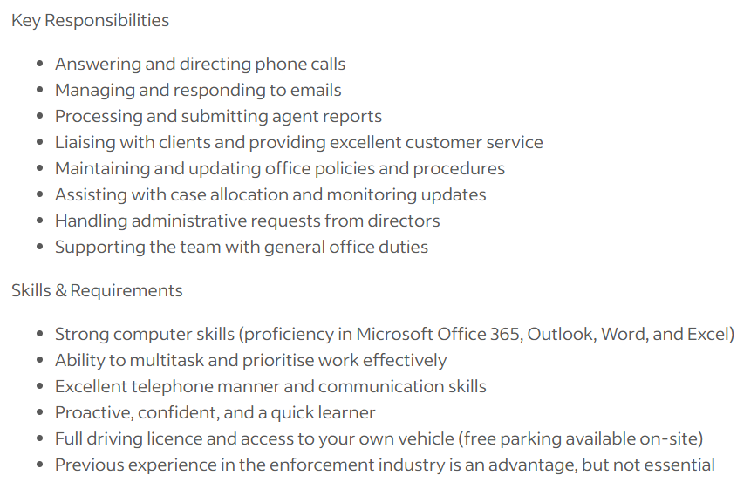
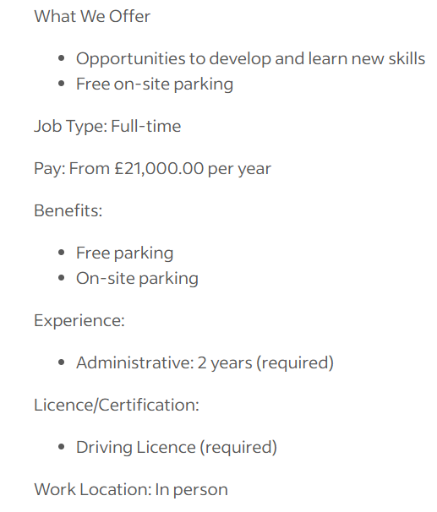

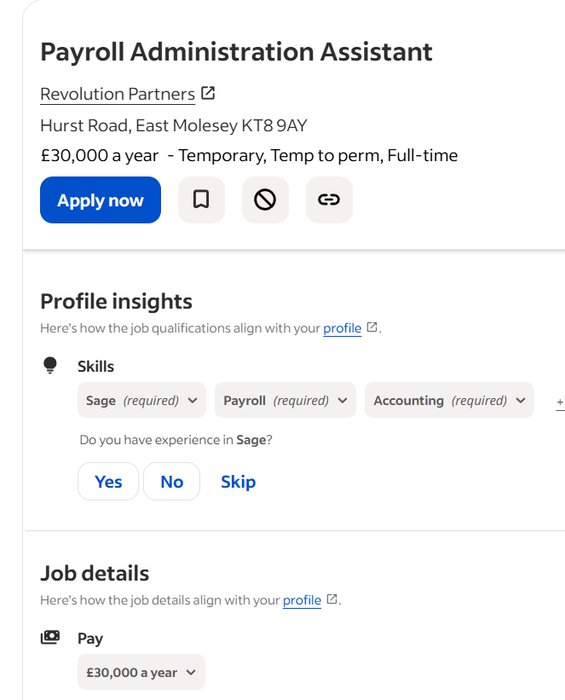
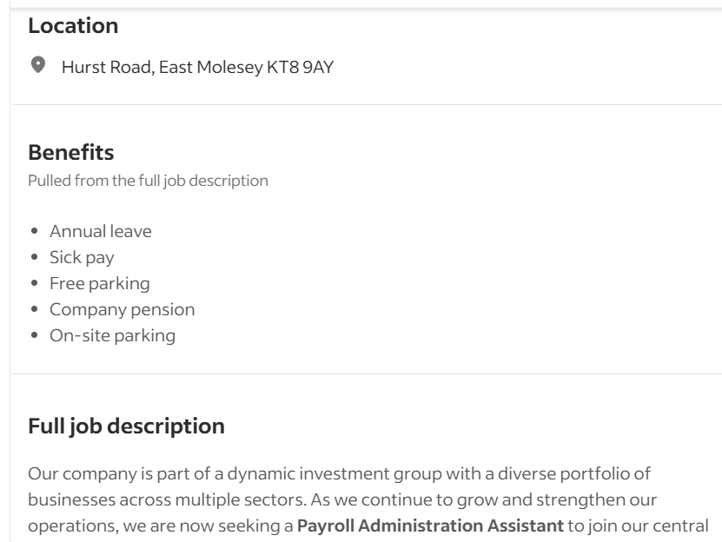
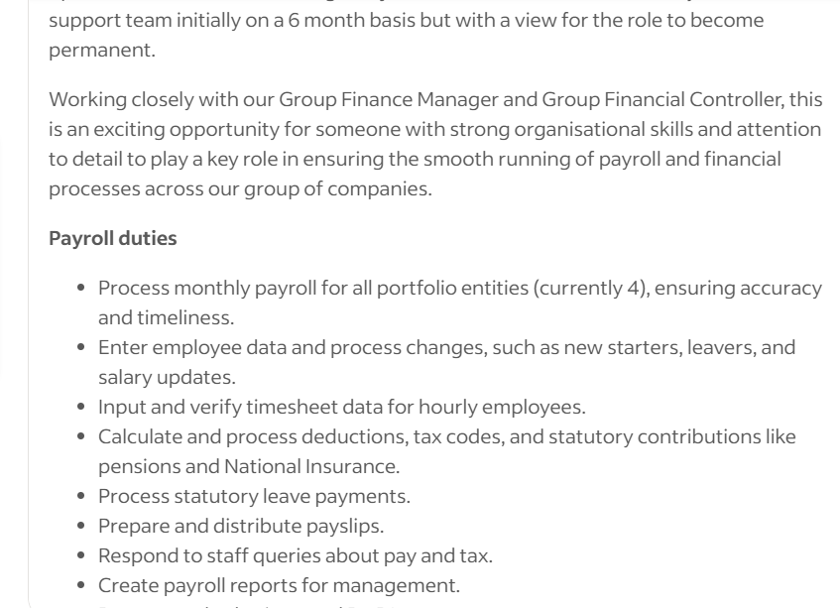

Compare Job Adverts:

The 4 Job Adverts Compared
- Payroll Assistant
- Payroll & HR Administrator
- Payroll Administrator (Payroll & Branch Support)
- Office Administrator / Administrative Assistant

- Key Skills by Job Advert
- Payroll Assistant
- UK payroll experience
- Strong Excel skills
- Accuracy with payroll data
- Experience with shift patterns / overtime (desirable)
- Attention to detail
- Meeting payroll deadlines
- Payroll & HR Administrator
- End-to-end payroll management
- Knowledge of payroll legislation
- HR administration (starters, leavers, records)
- Confidential data handling
- Payroll Administrator (Payroll & Branch Support)
- Payroll administration support
- High attention to detail & numerical accuracy
- Confident use of Outlook, Word, and Excel
- Branch and general administrative support

- Office / Administrative Assistant
- General office administration
- Handling calls, emails, and correspondence
- Document management
- Multi-tasking in a busy offices
- Microsoft Office skills
- Teamwork and communication

These are the most important and repeated skills:
- Attention to detail & accuracy
- IT skills (especially Excel & MS Office)
- Data handling
- Organisation & time management
- Ability to multi-task
- Confidentiality & professionalism
- Good communication skills
administrative payroll experience to each common skill and knowledge area identified across the job adverts.
- Attention to Detail & Accuracy
My experience:
- Accurately inputting and checking payroll data
- Verifying employee details, hours, and figures before processing
- Ensuring records are correct to avoid payroll errors

- IT & Systems Skills (Excel, Word, Outlook)
My experience:
- Using Excel to enter, manage, and check payroll data
- Using Outlook for payroll-related communication
- Using Word for documentation and records
- Working with payroll or HR systems (if applicable)

- Data Handling & Numerical Skills
My experience:
- Working daily with numerical payroll data
- Inputting, updating, and reconciling figures accurately
- Handling employees pay information with care

- Organisation & Time Management
My experience:
- Handle payroll and other work responsibilities
- Working to strict payroll deadlines

- Confidentiality & Professionalism
My experience:
- Handling sensitive payroll and employee information
- Maintaining confidentiality and data protection standards

- Self-Assessment Using SWOT Analysis

1. Strengths
Strengths are personal qualities, competencies, or traits that provide a competitive edge.
Examples:
- Abilities: Good communication, analytical thinking, and technical skills
- Personal Traits: Resilience, adaptability, creativity, leadership.

Sample self-assessment entry:
- I demonstrate effective interpersonal and communication skills, supporting successful team interactions
- I am highly organized and able to manage multiple tasks under tight deadlines.

2. Weaknesses
Weaknesses are internal areas where improvement is needed.
Examples:
- Skill Gaps: Limited technical expertise in a specific tool or area.
- Behavioural/Personal Traits: Procrastination, difficulty delegating tasks, lack of confidence in public speaking.
- Habits: Time-management challenges, difficulty saying no, overcommitment.
Sample self-assessment entry:
- I sometimes have trouble managing time when handling many tasks.
- I tend to be overly self-critical, which can slow down decision-making.

3. Opportunities
Opportunities are external factors that can help you grow personally or professionally.
Examples:
- Learning & Development: Workshops, online courses, mentorship programs.
- Career Growth: New roles, promotions, networking opportunities.
- Personal Growth: Joining clubs, volunteering, public speaking engagements.
Sample self-assessment entry:
- There are opportunities to attend professional development workshops in leadership and management.
- I can leverage online courses to strengthen my technical skills in data analytics.
- Networking with peers and industry professionals can open doors to career growth.
4. Threats
Threats are external factors that might hinder your progress.
Examples:
- Work Challenges: High competition, changing industry trends, limited resources.
- Personal Factors: Work-life balance challenges, stress, health issues.
- Skill Obsolescence: Rapid technological changes that require constant upskilling.
Sample self-assessment entry:
- Rapid technological changes in my field may make current skills less relevant if I don’t continually learn.
- Increased workload could affect work-life balance and productivity.
- Competition for promotions in my organization is high, requiring continuous performance improvement.

- Self-Assessment: Personal Strengths and Areas for Development

1. Strengths
These are my internal qualities and skills that contribute positively to my personal and professional growth:
- Strong Communication Skills: I can clearly articulate ideas, actively listen, and collaborate effectively with colleagues and team members.
- Organizational Ability: I excel at managing multiple tasks and prioritizing work to meet deadlines.

2. Weaknesses
These are areas where I recognize the need for improvement:
- Time Management Under Pressure: Occasionally, I struggle to allocate time effectively when handling multiple high-priority tasks.
- Delegation: sometimes take on too much responsibility instead of delegating tasks to others.

3. Opportunities
External factors that can support my growth and development:
- Professional Development Programs: Access to workshops, certifications, and online courses to improve both technical and soft skills.
- Mentorship and Networking: Opportunities to learn from experienced professionals and expand my professional network.
4. Threats
External factors that could hinder my progress if not addressed:
- Rapid Technological Changes: Skills may become outdated without continuous learning and upskilling.
- High Competition: Career advancement may be limited due to competition, requiring constant improvement.

- Employment Goals Based on SWOT Analysis
Short-Term Goals (6–12 months)
- Improve Time Management Skills
  - Goal: Implement strategies such as prioritization, task scheduling, and the use of productivity tools to manage multiple responsibilities more efficiently.
  - Alignment with Career Aspirations: Being organized and reliable enhances my reputation as a professional and positions me for leadership responsibilities.
- Enhance Technical Skills
- Goal: Take relevant courses or certifications to strengthen my technical abilities (e.g., data analysis, industry-specific software).
- Importance: Bridging this skills gap increases my efficiency and allows me to contribute to complex projects.
- Alignment with Career Aspirations: Technical proficiency is critical for advancing into more specialized or senior roles within my field.
- Develop Delegation Skills
- Goal: Learn to assign tasks effectively, trust team members, and monitor progress without micromanaging.
- Importance: Delegation reduces burnout and allows focus on higher-priority responsibilities.
- Alignment with Career Aspirations: Strong delegation skills are essential for managerial or leadership positions.

- Build Self-Confidence and Reduce Overcritical Tendencies
- Goal: Practice self-reflection, seek constructive feedback, and apply decision-making frameworks to increase confidence in decisions.
- Importance: Reducing self-criticism will improve efficiency and decision-making.
- Alignment with Career Aspirations: Confidence enhances leadership potential and fosters a positive professional image.

Long-Term Goals (1–5 years)

- Attain a Leadership or Managerial Role
  - Goal: Progress into a role that involves leading teams, managing projects, and mentoring colleagues.
  - Importance: Leadership positions allow me to leverage strengths while continually improving weaknesses such as delegation and time management.
  - Alignment with Career Aspirations: My long-term career vision includes leading projects and teams to achieve strategic objectives in my fie.
- Master Advanced Technical Competencies
  - Goal: Achieve advanced proficiency in key technical areas and stay current with industry innovations.
  - Importance: Ensures continued relevance and competitiveness in my profession.
  - Alignment with Career Aspirations: Deep expertise opens doors for higher-level roles, consultancy opportunities, or specialized positions.
- Establish a Personal Brand as a Reliable and Effective Professional
  - Goal: Build a reputation for efficiency, strong communication, and leadership abilities through consistent performance and professional development.
  - Importance: A strong professional brand enhances opportunities for promotion, collaboration, and networking.
  - Aligning with career aspirations: Reputation and visibility are key for career growth

Personal Development Plan (PDP)
Objective: Boost effectiveness by addressing identified weaknesses (time management, critical tendencies, technical competencies, delegation) and leveraging strengths for professional growth.

1. Improve Time Management Skills
- Action Steps:
  - Plan daily tasks using apps like Trello, Asana, or Google Calendar.
  - Use a digital planner to manage daily tasks.
- Timeline: 1–3 months for habit formation; ongoing refinement.
- Resources Needed: Use apps, tutorials, and mentoring to improve prioritization
Measure of Progress:
  - Decrease in overdue tasks and last-minute assignments.
2. Enhance Technical Skills
- Action Steps:
  - Find important technical skills for your job (like Excel, data analysis, or industry software).
  - Take online courses, attend workshops, or get certifications.
- Timeline: 3–12 months, depending on how complex the skills are.
- Resources Needed: Online courses and training, structured tutorials, company-led programs, and mentor guidance.
- Measure of Progress:
  - Successful attainment of courses or professional certifications
  - Good feedback from colleagues or supervisors on technical ability.

3. Develop Delegation Skills
- Action Steps:
  - Find tasks that can be delegated.
- Timeline: 1–6 months to practice delegating tasks consistently.
- Resources Needed: Workshops and guidance from senior leaders.
- Measure of Progress:
  - Delegated tasks successfully
  - Tasks assigned effectively

4. Build Self-Confidence and Reduce Overcritical Tendencies
- Action Steps:
  - Practice weekly self-reflection through journaling.
  - Weekly journaling to reflect on achievements and challenges
- Timeline: Ongoing, with initial noticeable improvement within 3–6 months.
- Resources Needed:
- Measure of Progress:
  - Making quicker, confident decisions when completing tasks
  - Colleagues or supervisors noticed increased confidence.

5. Leverage Strengths
- Action Steps:
- Help colleagues grow leadership skills through mentoring
- Mentor peers to improve leadership

- Timeline: Ongoing.
- Resources Needed: Opportunities to work on team projects and receive mentoring
- Measure of Progress:
  - Good feedback from supervisors or coworkers.
  - Completing complex projects successfully.

6. Review and Evaluate Progress
- Action Steps:
  - Review goals and progress every month.
  - Change strategies if actions are not working.

- Timeline: Reviewed monthly, with detailed quarterly assessments.
- Resources Needed: Self-review tools, mentor meetings, and goal sheets.
- Measure of Progress:
  - Completing short-term goals on time.
  - Recorded progress in identified development areas with ongoing enhancement of strengths.

