

An evaluation of the effectiveness of harm reduction techniques in mitigating drug-related health risks among young adults (18 -30 years) in urban India

by

Aarsha sidharthan]

A Dissertation submitted in partial fulfillment of the requirements for the degree of Master of Science in Public Health and Social Care in Practice

The Institute of Inner-City Learning
University of Wales Trinity Saint David – London Campus

[Month Year]

DECLARATION

I, [INSERT NAME], declare that this dissertation has been composed by myself, that the work contained herein is entirely my own except where explicitly stated otherwise in the text, and that this work has not been submitted for any other degree or qualification, in whole or in part, except as specified.

Signed:………………………………………………

Date:...………………………………………………

Acknowledgements

Abstract

Table of Contents

Chapter 1: Introduction 10
1.1 Background 10
1.2 Problem Statement 10
1.3 Rationale and Significance of the Study 11
1.4 Research question 11
1.5 Aim of the study 12
1.6 Research Objectives 12
1.7 Overview of the Dissertation Structure 12
1.8 Summary 13
Chapter 2: Literature review/theoretical framework 14
2.1 Introduction 14
2.2 Global Overview of Substance Use and Harm Reduction 14
2.2.1 Global Trends in Substance Use 14
2.2.2 Evolution and Evidence Base for Harm Reduction 15
2.2.3 Emerging Patterns in Young Adults and Urban Populations 15
2.2.4 Applicability to the Current Study. 16
2.3 Drug Use Trends Among Young Adults in India 16
2.3.1 Prevalence and Patterns of Use Among Young Adults 16
2.3.2 City Diversity and Risky Spaces. 17
2.3.3 Associated Health and Social Risks 17
2.3.4 Data Gaps of youth-specific data in India. 18
2.4 Harm Reduction in India: Policies, Programmes and Implementation 18
2.4.1 Evolution of Harm Reduction Policy in India 18
2.4.2 Important Harm Reduction Interventions in India. 19
2.4.3 Implementation Challenges and Structural Barriers 20
2.5 The Effectiveness of Harm Reduction Techniques 21
2.5.1 Needle and Syringe Programmes (NSPs) 21
2.5.2 Opioid Substitution Therapy (OST) 22
2.5.4 Psychosocial Interventions, Counselling and Peer Outreach. 22
2.5.4 Up-and-Coming Interventions with Synthetic and Party Drugs. 23
2.6 Limitations in the Existing Literature 23
2.7 Theoretical and Conceptual Framework 24
Chapter 3: Research Methodology 26
3.2 Research Philosophy 26
3.3 Research Approach 27
3.4 Research Design 27
3.4.1 Systematic Literature Review (SLR). 27
3.5 Search Strategy 28
3.5.1 Databases Searched 28
3.5.2 Keywords and Boolean Operators 28
3.6 Inclusion and Exclusion Criteria 28
3.7 Data Extraction 29
3.9 Data Analysis: Thematic Analysis 30
3.10 Ethical Considerations 31
3.11 Methodology Limitations. 31
3.12 Chapter Summary 32
Chapter 4: Results 33
4.1 Introduction 33
4.2 Selection and Overview of the Studies. 33
4.2.2 Quality appraisal 34
4.3 Different Types of Harm Reduction Interventions 34
4.3.1 Structural-Level Interventions 34
4.3.2 Epidemiological and Risk-Focused Intervention. 36
4.3.3 Community and Service-Based Interventions 37
4.4 Outcomes of Harm Reduction Interventions 38
4.4.1 Health Outcomes 39
4.4.2 Behavioural Outcomes 40
4.4.3 Service Uptake and Accessibility 41
4.5 Barriers to Harm Reduction Effectiveness 42
Chapter 5: Discussion 44
5.1 Introduction 44
5.2 Interpretation of Key Findings 44
5.2.1 Structural Harm Reduction Interventions Effectiveness. 44
5.2.2 Behavioural Outcomes and Early Intervention 45
5.2.3 Service Uptake and Youth Engagement. 45
5.3 Consistency with Existing Literature 45
5.4 Theoretical Implications 46
5.5 Practical and Policy Implications 46
5.5.1 Implications for Policy 47
5.5.2 Implications for Practice 47
5.5.3 Implications for Research 48
5.6 Limitations of the Findings 48

List of figures
Figure 1: Risk environment framework flow chart 27
Figure 2: The Global State of Harm Reduction 2022 – 2024 36
Figure 3: Opioid Substitution Therapy reduces harm – Networking 36
Figure 4: Risk factors associated with transition from non-injecting to injecting opioid use in India 37
Figure 5: Comparative Analysis of Harm Reduction Service Utilization: Peer-Led vs. Formal Healthcare Models. 39
Figure 6: Opioid-Related Mortality Rates by Age Group 40
Figure 7: Comparative HIV Incidence Rates among PWID by Age Cohort (2015–2022) 41
Figure 8: Barriers to Harm Reduction Effectiveness 43

List of abbreviations
CASP – Critical Appraisal Skills Programme
HCV – Hepatitis C Virus
HIV – Human Immunodeficiency Virus
LMICs – Low- and Middle-Income Countries
NGO – Non-Governmental Organisation
NSP – Needle and Syringe Programme
OST – Opioid Substitution Therapy
PWID – People Who Inject Drugs
RCT – Randomised Controlled Trial
STI – Sexually Transmitted Infection
UNODC – United Nations Office on Drugs and Crime
WHO – World Health Organization

Chapter 1: Introduction

1.1 Background
Drug use among young adults in urban India has become a major social and public health concern in recent years (Sunitha & Gururaj, 2014). Cities such as Delhi, Mumbai, Bengaluru, and Kolkata have been identified as urban cities in India (Patil et al., 2022). Rapid urbanisation, shifting lifestyles, and exposure to diverse social influences have contributed to rising consumption of opioids, cannabis, alcohol, and synthetic drugs. Factors such as peer pressure, unemployment, stress, and the pressures of city life exacerbate this issue (Nath et al., 2022).
For this dissertation, the focus will be on synthetic drugs (e.g., Methamphetamine, Ecstasy) and semi-synthetic drugs (e.g., heroin and cocaine). Although alcohol and opioids are perceived as depressants, they are also regarded as drugs (Little et al., 2021). All drugs have an impact and are harmful to individuals in terms of their health and psychosocial function (Hanson et al., 2024).
To mitigate the associated health and social harms, harm reduction measures such as counselling, needle and syringe exchange programmes, and opioid substitution therapy have been introduced in several Indian cities (Resiak et al., 2021). These interventions aim to minimise risks such as HIV transmission, overdose, and mental health deterioration, while supporting individuals toward safer practices and eventual recovery (Obeagu et al., 2024).
This study's main goal is to determine how well harm reduction techniques reduce the health risks related to drug use among young adults (18 -30 years) in urban India, including overdose, HIV transmission, and mental illness. It seeks to investigate the degree to which interventions like opioid substitution therapy, psychotherapy, and needle exchange programs provide gains in health outcomes. The study also looks into variables like accessibility, awareness, and social stigma that affect how well or poorly these strategies work. By answering this question, the study hopes to produce knowledge that will help develop youth-focused harm reduction policies and initiatives that are more successful.

1.2 Problem Statement
Despite these initiatives, drug use among young adults continues to pose significant challenges in urban India. In addition to physical health risks such as HIV transmission and drug overdose, many young users experience mental health disorders, including anxiety and depression (Armstrong et al., 2013). While harm reduction services such as counselling and needle exchange programmes exist, they often suffer from social stigma, inconsistent implementation, and inadequate funding (Resiak et al., 2021).
Moreover, fear of judgment or legal repercussions discourages many young people from seeking help (Piatkowski et al., 2024). A critical gap remains in understanding the actual effectiveness of these harm reduction interventions for urban youth, as empirical research in this demographic is limited (Saini et al., 2021). This lack of evidence restricts policymakers and practitioners from optimising current programmes and scaling effective models.

1.3 Rationale and Significance of the Study
This study is warranted as it addresses an important evidence gap concerning the efficacy of harm reduction strategies among young adults in urban India, a population that has been frequently overlooked in prior research. Recent decades have seen an increase in the young urban population (reference needed). It will be important to identify which strategies and interventions are suitable for young people living in urban settings to prevent and/or end drug use. By systematically evaluating existing interventions, the research contributes valuable insights into how various interventions, such as counselling, opioid substitution therapy, and needle exchange programmes, influence health outcomes such as overdose prevention, HIV reduction, and mental well-being.
The findings are expected to inform policymakers, healthcare professionals, and community organisations about how to strengthen harm reduction services for youth. Additionally, the study supports the development of inclusive, evidence-based, and youth-centred policies suited to India’s rapidly urbanising and evolving social landscape. This study is warranted because it closes a significant evidence gap about the efficacy of harm reduction tactics among young adults in urban India, a population that is frequently ignored in previous studies.
The study adds significant information to the scant literature in this field by assessing how different strategies handle serious health concerns like overdose, HIV, and mental health problems. The results will help legislative reforms that encourage more inclusive, evidence-based, and youth-centered harm reduction programs within India's fast urbanising and changing social milieu, in addition to informing public health activities focused on reducing drug-related harm among young people.

1.4 Research question
To what extent do harm reduction strategies help young adults (18–30 years old) in urban India reduce the health hazards associated with drugs?

1.5 Aim of the study
To evaluate the effectiveness of harm reduction strategies in reducing drug-related health risks such as overdose, HIV transmission, and mental health issues among young adults in selected urban areas of India, and to identify areas of improvement in social care and public health service delivery.

1.6 Research Objectives
- To explore the types, patterns, and frequency of drug use among young adults in selected urban regions of India.
- To examine existing harm reduction strategies implemented by public health and social care providers for drug-using young adults.
- To assess the impact of harm reduction techniques on drug-related health outcomes and to identify gaps and challenges in service delivery, with recommendations for enhanced intervention effectiveness
.

1.7 Overview of the Dissertation Structure
Chapter 1: Introduction
Introduces the research topic, offers the backdrop and problem statement, outlines the study's purpose, and specifies the research goal and goals.
Chapter 2: Review of Literature and Theoretical Structure
In Chapter 2, the theoretical framework supporting the research is presented along with a review of previous literature that is pertinent to the investigation.
Chapter 3: Research Methodology
The research methodology, including design, sample, data collection techniques, and ethical considerations, is explained in Chapter 3.
Chapter 4: Results
This chapter will analyse each selected method for obtaining valid information related to the selected research study, and proper information will be obtained through the selected data collection method.
Chapter 5: Discussion
The results are discussed in Chapter 5 along with their ramifications and how they relate to the body of existing literature.
Chapter 6: Conclusion and Suggestions
The dissertation is concluded in Chapter 6 with a summary of the main conclusions, an explanation of the study's limitations, and suggestions for further research or application.

1.8 Summary
This chapter introduced the research topic, providing context for the rising concern of drug use among young adults in urban India. It outlined the associated health and social issues, identified gaps in current harm reduction initiatives, and established the significance of evaluating these interventions. The research aims and objectives were defined to guide the study toward producing evidence-based insights that can strengthen youth-focused harm reduction policies and public health strategies in urban Indian settings. The next chapter presents a review of relevant literature and theoretical foundations underpinning this study.

Chapter 2: Literature review/theoretical framework

2.1 Introduction
This chapter aims to critically analyze the available literature on harm reduction strategies and their ability to minimize the health risk of drugs amongst young adults in urban India. Due to the changes in the pattern of substance use in the world, especially with the increasing popularity of synthetic and semi-synthetic drugs, there is concern about the special vulnerability of young adults between the ages of 18-30 years, particularly in fast-growing urban centres. A global overview of the current trends in substance use and evidence-based harm reduction methods initiation is used as the literature review to set the international-level standards. It subsequently reduces the scale to the Indian context, discussing national trends in drug consumption, the policy environment, and the practicalities of harm reduction interventions like opioid substitution therapy (OST) and needle and syringe programmes (NSPs), counselling, and outreach initiatives.
Moreover, this chapter is a synthesis of empirical research conducted to assess the weaknesses and limitations of the current interventions, together with the remaining gaps internal to the research, such as the lack of youth-specific research and the lack of evidence about non-injecting urban drug users. The chapter ends by stating the theoretical frameworks that will inform this study to form the conceptual background of examining the efficacy of harm reduction measures among the young adults in urban India.

2.2 Global Overview of Substance Use and Harm Reduction

2.2.1 Global Trends in Substance Use
The trends of drug use in the world have changed dramatically over the last ten years, and this is mainly because of the emergence of synthetic and semi-synthetic drugs (Ravisankar et al., 2018). The use of amphetamine-type stimulants (ATS), methamphetamine, MDMA, synthetic opioids, and other substances has been on a steady rise, and young adults constitute one of the most vulnerable population groups (UNODC, 2023). The growth of the darknet market, transnational trafficking trafficking pathways, and cheap production have also led to increased availability, especially in urban contexts that exist in Asia, Europe, and North America (Mounteney et al., 2016).
Research shows that these drugs are more attractive to the youth due to the nightlife, party culture, and perceived low risk they represent in comparison to conventional opioids (Henderson, 2022).
Simultaneously, opioid-related harms still prevail in relation to the public health issues in several regions. The case of North America is an example of a long-standing opioid crisis, where synthetic opioids like fentanyl are the cause of unprecedented overdose fatalities (Ciccarone, 2019). These patterns have reinforced the move towards the globalization of drug policies based on the concepts of public health, as well as the expansion of harm reduction.

2.2.2 Evolution and Evidence Base for Harm Reduction
Harm reduction as a universal approach to public health has received significant empirical evidence since the early 2000s, and recent research has supported its suitability in a wide variety of environments. One of the earliest harm reduction interventions is a needle and syringe programme (NSP), which has continuously and largely shown a reduction in HIV and hepatitis C amongst people who inject drugs (PWID) (Larney et al., 2020). Likewise, opioid substitution therapy (OST) (with the help of medications like methadone and buprenorphine) has been identified to decrease the injection frequency, mortality due to overdose, and criminal activity (Sordo et al., 2017; Degenhardt et al., 2023).
Issues Supervised consumption facilities (SCFs) are also becoming important elements of harm reduction ecosystems in countries like Canada, Australia, and other European states. Longitudinal research suggests that SCFs decrease fatal overdoses, enhance the connection with health and social services, and do not raise local drug-related crimes (Kennedy et al., 2022). Also, combined harm reduction models that involve NSP, OST, mental health services, and HIV services have been the most effective in minimizing cumulative risks (Paquette et al., 2025).
Although there is significant international evidence, harm reduction is still politically opposed in certain areas (Hassan, 2022). Sceptics argue that this type of intervention can promote drug use, yet the findings are usually consistent and demonstrate no increase in drug initiation or frequency among service users (Navarro et al., 2019).

2.2.3 Emerging Patterns in Young Adults and Urban Populations
The young adult (18 - 30 years) population is a distinct and growing population in the world trends of drug use. Research shows that the population is most likely to consume synthetic stimulants, use polydrug, and be affected by peer dynamics, nightlife, and online drug markets (Barratt et al., 2022). The threats are context-specific for urban environments because of the high population density, economic pressures, and the high concentration of substances (Belackova et al., 2019).
Nevertheless, interventions aimed at harm reduction of older adult PWID around the world have been over-emphasized, resulting in an imbalance between the way services are designed and the needs of the youth. It has been shown that non-injecting drug users who are young do not use harm reduction services appropriately because of stigma and fear of legal action, as well as the absence of youth-friendly programmes (O’Halloran et al., 2017). This discrepancy presents a major gap in international harm reduction research: the narrow attention to non-injecting users of synthetic drugs in cities.

2.2.4 Applicability to the Current Study.
Collectively, the international literature is able to show that harm reduction is most efficient when interventions are accessible, combined, and tailored to a particular population. Nevertheless, there is an evident trend in the evidence across the globe about the recurring gap related to the group of young adults, the patterns of drug use, and service needs of which do not align with the traditional PWID-centred models (Millar, 2021). This is why it is important to comprehend how these lessons of the world apply to the Indian context, especially in the fast-growing cities. This chapter preconditions consideration of the efficiency of harm reduction interventions among the young adults in urban India, as it puts the study into the context of these more general global trends.

2.3 Drug Use Trends Among Young Adults in India

2.3.1 Prevalence and Patterns of Use Among Young Adults
The use of drugs in India has changed dramatically in the recent past, and young adults have become one of the most vulnerable age groups. According to national survey data, younger adults (18 - 30 years old) represent a significant percentage of the people who use illicit substances, in particular, opioids, cannabis, synthetic stimulants, and diverted pharmaceutical substances (Ambekar et al., 2022). Even though alcohol and cannabis are the most widely used drugs, there is growing evidence of the rise in the use of synthetic drugs, including methamphetamine, MDMA, and amphetamine-type stimulants, among young people in urban areas (Girisanker, 2021). These changes are more indicative of the global trends but are influenced by the specifics of the socio-economic and cultural life of India.
It has been proposed by the research that urban life, academic stress, nightclub atmosphere, and exposure to drug markets on the internet are beginning to induce a change in the Indian youth (Ravisankar, 2021). The availability of a large range of substances, commonly branded as party drugs, has been facilitated by digital platforms, such as encrypted messaging services and social media channels (eg, Snapchat, Telegram), and tends to attract younger users who are interested in having recreational experiences (Jain et al., 2014). There is also an emerging trend of polydrug use; according to the studies, alcohol, cannabis, stimulants, and benzodiazepines are taken at the same time, which increases the health risk (Biswal et al., 2024).

2.3.2 City Diversity and Risky Spaces.
The environment of risk in urban India is particular, and it has an impact on the drug use patterns among young adults. The rate of recreational and dependent drug use in metropolitan cities like Delhi, Mumbai, Bengaluru, Pune, and Goa has been higher due to the high populations, social anonymity, and developed trafficking and distribution networks (Sharma, 2025). Young professionals, migrant youth, and college students are especially susceptible, and the urban lifestyle, characterized by housing instability, competitive job markets, and stress, is related to an increased use of substances (Chavan et al., 2021).
Youth drug use is also greatly influenced by urban entertainment and nightlife areas. Club culture and music festivals are important settings for the use of stimulants and party drugs, particularly MDMA and ketamine, according to studies from Delhi and Mumbai (Sharp, 2007). These settings frequently normalise recreational use, reducing perceived risk and encouraging adolescent users to engage in experimental or habitual consumption habits (Ghosh et al., 2024). Furthermore, a number of studies have noted that initiation frequently takes place in social contexts within friend groups, indicating that peer influence is still a significant driver (Joseph, 2021).

2.3.3 Associated Health and Social Risks
Youths are exposed to numerous health threats associated with the use of substances, both injecting and non-injecting. Although in India, the majority of urban youths' chosen type is to inject drugs, the shift towards injecting has been reported in multiple cities of India, with the change typically being influenced by a reduction in cost and dependence (Ambekar et al., 2019). These kinds of transitions increase the risk of blood-borne infections, overdose, and hospitalisation significantly (Ceasar et al., 2021).
Mental health issues such as depression, anxiety, psychosis, and suicidal ideation are overrepresented among young drug users, and stimulant and polysubstance use is closely linked to psychological distress (Armoon et al., 2021). The rest of the risks are unsafe sex, exposure to violence, academic dropout, job instability, and criminal justice system involvement (Sharma et al., 2024). Youths do not always understand the long-term effects of drugs, including those on their own health, which makes them slow to seek help and use harm reduction services.

2.3.4 Data Gaps of youth-specific data in India.
Although there is an increasing concern, the amount of research, particularly on drug use among young adults in India's urban cities, is restricted. The majority of national studies concentrate on the general population of an adult group or on a high-risk population, like people injecting drugs (PWID), sex workers, or populations with HIV (Ambekar et al., 2019). As a result, the information about non-injecting urban youth, especially those who use synthetic and party drugs, is limited and disjointed (Kennedy et al., 2022). In addition, not many studies investigate how young people should perceive harm reduction, accessibility of services, or stigma and police harassment as obstacles.
This scarcity of urban youth-centred evidence introduces a major gap in studies of harm-reduction research. It constrains policymakers to formulate specific interventions and curbs the capacity of the public-health practitioners to comprehend the risk characteristics of the young, urban populations. This gap substantiates the necessity of the current study, which narrows down to the assessment of the effective implementation of harm reduction strategies to young adults in urban India.

2.4 Harm Reduction in India: Policies, Programmes and Implementation

2.4.1 Evolution of Harm Reduction Policy in India
The concept of harm reduction in India has traditionally been conditioned by an epidemic of HIV/AIDS, which gave rise to such specific interventions as those aimed at people who inject drugs (PWID), as the priority (World Health Organization, 2023). One of the early major interventions in public health was the National AIDS Control Programme (NACP), which was implemented by the National AIDS Control Organisation (NACO), which introduced the needle and syringe programmes (NSPs), opioid substitution therapy (OST), and community outreach services (Ambekar et al., 2019). Preliminary results of these programmes proved that HIV incidence in PWID was considerably reduced, thus making policymakers realise that harm reduction is also a critical element of HIV prevention (Solomon et al., 2021). Nevertheless, even with the national-level acceptance, it has been unequivocal in its implementation by the state, as the main reason is the administrative fragmentation and political support (Sinha, 2024).
Over the last ten years, there has been a broader policy discourse encompassing not only the issues of HIV prevention but also the issues of synthetic drug use, youth vulnerability, and the health consequences of non-injectable drug use (Biswal et al., 2043). However, the majority of harm reduction policies are based on the previous HIV-oriented strategies, which makes it difficult to meet the demands of urban, non-injecting young adult consumers who no longer belong to the traditional high-risk groups (Ganapathi et al., 2021).

2.4.2 Important Harm Reduction Interventions in India.
- Needle and Syringe programmes (NSPs)
One of the oldest harm reduction interventions in India is that of NSPs. They work mostly with NGOs and TI centres in order to deliver sterile injecting instruments, disposal services, and basic health education (Sharma, 2025). High-burden states like Manipur, Punjab, and Delhi have found that NSPs have greatly lowered the act of sharing needles among PWID (Larney et al., 2020). Nevertheless, they have a constrained influence among young adults, particularly recreational users who can sometimes inject stimulants or opioids, because these individuals do not access these centres because they are afraid of being stigmatized or because they fear police monitoring (Perumbilly et al., 2019).
- Opioid Substitution Therapy (OST)
Buprenorphine or methadone-based OST is an evidence-based treatment linked with fewer instances of opioid dependence, a low rate of injecting drug use, and better social functioning (Sordo et al., 2017). Public hospitals, de-addiction centres, and TI hubs are the channels used in delivering OST in India. Even though there has been an increase in the number of OST sites in recent years, coverage has not been satisfactory. The barriers that young adults may face often include long commuting distances, limited clinic hours, and bulky processes of enrolment. The fear of compulsory identification procedures and medical records discourages many young people in order to obtain OST services (Joseph, 2021).
- Psychosocial and Counselling Interventions
The harm reduction implementation in India includes counselling, peer outreach, and behavioural support interventions. The role of peer educators has been critical in reaching out to the hard-to-access users, especially in the urban slums and informal settlements (Sharma, 2025). Psychosocial interventions have demonstrated their positive influence on high-risk behaviour, mental health outcomes, and safer consumption behaviour (Molanguri, 2025). Yet, the majority of the currently existing programs target the dependent adult users, with the youth of the college, employment, and nightlife setting being insufficiently represented in the outreach programmes (Ganapathi et al., 2021).
- Young People and Community Outreach
Some of the government efforts to prevent substance use include the Nasha Mukt Bharat Abhiyaan (NMBA), which started in 2020 and focuses on schools and community outreach, awareness campaigns, and screening camps (Biswal et al., 2024). Although NMBA is politically aware of the issues of youth drug use, its prevention and abstinence are more important than harm reduction. Consequently, the intervention fails to reach the group of young adults who are already using substances and in need of safer-use information, health services that are youth-friendly, or nonjudgmental counselling (Ambekar, 2022). The disconnect between harm reduction and prevention-oriented policies is thus steep.
- Up-and-coming interventions with synthetic and party drugs
Synthetic and party drug harm reduction efforts around the globe comprise pill testing, hydration stations during music festivals, use education, and early-warning (Parnes, 2025). Such interventions have been proven to decrease their hospitalisations, overdoses, and other acute health events among young adults (Gehring et al., 2022). Though these programmes are very well established in Australia and Europe, in India, this is not the case, as there are legal and other regulatory obstacles.
The empirical evidence indicates that there is growing utilization of MDMA, amphetamine-type stimulants, and ketamine amongst the Indian youth (Chang et al., 2021). Nevertheless, the harm reduction system in India is still aimed at opioids and injecting drug use. Novice users of stimulants do not have access to safer-use education on hydration, risks of overheating, substance mixing, and mental health effects (Ghosh et al., 2024). This disparity constrains the power of harm reduction initiatives around a demographic, the use pattern of which is far removed in comparison with classical PWID populations.

2.4.3 Implementation Challenges and Structural Barriers
One area of consensus in the literature is the discrepancy between policy frameworks and practice. Drug use stigma is a key factor impeding, especially among young adults who are afraid of being stigmatised as drug addicts by their families, peers, or society (Biswal et al., 2024). The practices of policing also make the utilisation of services more complicated; reports of Delhi, Mumbai, and Punjab reveal that young consumers do not attend NSP and OST sites because of the fear of legal penalties or harassment (Gehring et al., 2022). This difference between principles of harm reduction and punitive implementation undermines the effectiveness of the programmes.
The other significant obstacle is resource constraints. A large number of TI centres are also staffed insufficiently, lack the use of proper counselling services, and are inconsistent in accessing sterile injecting devices or OST medicines (Sharma, 2025). The younger users are disproportionately impacted by these capacity constraints because they tend to demand more flexible and youth-friendly services, as provided by peer networks, mobile vans, or online platforms (Henderson et al., 2022).
Also, the majority of harm reduction efforts in India are still specific to injecting opioid users, and urban young people are progressively using synthetic stimulants and club drugs, which demand varied harm reduction methods, including safe injecting education, hydration, overdose education, and mental health care (Degenhardt et al., 2023). This indicates a major gap in the harm reduction environment in India since there are no specific interventions to target stimulant users.

2.5 The Effectiveness of Harm Reduction Techniques

2.5.1 Needle and Syringe Programmes (NSPs)
Needle and syringe programmes (NSPs) are among the most commonly reviewed harm reduction initiatives worldwide. Ample evidence in the global literature indicates that NSPs decrease needle exchange, decrease HIV and hepatitis C rates, and enable people who inject drugs (PWID) to access care (Larney et al., 2020; Abdul-Quader et al., 2013). This is a consistent finding across high-, middle-, and low-income environments, underscoring the role of NSPs as a critical approach within the public health sector. Australia, Canada, and Western Europe have evidence on the fact that high NSP coverage is associated with lower HIV prevalence on the community level and an enhanced health-seeking behaviour (Belackova et al., 2019).
NSPs were which were initiated in the National AIDS Control Programme in India and have shown good results in curbing injecting-related risk behaviours. Research in Delhi, Manipur, and Punjab suggests that NSP attendance has a considerable effect in terms of diminishing needle risk behaviour and amplifying referrals to opioid substitution therapy (Ambekar et al., 2019). But the effectiveness of NSPs in young adults is not so evident. Urban, young drug users, especially opioid or synthetic or party drug users, do not most often refer to themselves as injecting drug users even though they sometimes inject opioids or stimulants (Ganapathi et al., 2021). This perception of oneself, along with stigma and fear of being caught by the police, decreases user participation in NSPs (Joseph, 20201. Young adults are found to be under-represented in NSP sites according to the empirical studies, indicating that the interventions are not youth-friendly or accessible enough.
Altogether, NSPs are effective and evidence-based, yet available Indian research indicates low accessibility among young urban consumers. It shows that outreach models should be revised and that the harm-reduction messages should be extended beyond the conventional models of injecting drug use.

2.5.2 Opioid Substitution Therapy (OST)
Another foundation of harm reduction is opioid substitution therapy (OST). Sufficient evidence in the world literature proves the efficacy of buprenorphine and methadone in relieving opioid dependence, mortality caused by overdose, frequency of injecting, and health risks (Sordo et al., 2017; Degenhardt et al., 2023). It has also been demonstrated that OST increases social functioning, employment stability, and adherence to HIV treatment in patients with opioid dependence over a longer period (Paquette et al., 2021).
In India, OST is provided in de-addiction centres run by the government, in public hospitals, and in target intervention locations. Although the practice of OST has grown over the past few years, it is not well covered in comparison to demand (Kennedy et al., 2022). Empirical studies indicate that patients who are enrolled in OST are subject to a decrease in the amount of daily opioid consumption, psychological well-being, and criminal behaviours (Perumbilly et al., 2019). But there is a challenge to the retention rate. The young adults at risk of dropping therapy prematurely include mainly the inflexible clinic schedules, the absence of anonymity, and the social stigma of not being under medical assistance and not using drugs (Chauhan et al., 2021). In addition to that, young stimulant users, a rising population in urban India, do not necessarily consider OST to apply to their needs, which further restricts engagement.
In this way, OST is feasible, but its effectiveness in influencing young adults in India is limited by structural issues, stigma, and incompatibility of intervention planning and youth-level substance-use behavior.

2.5.4 Psychosocial Interventions, Counselling and Peer Outreach.
Psychosocial interventions constitute a core component of contemporary harm reduction models, especially among youthful drug users who might not need medical detox. It has been demonstrated internationally that motivational interviewing, cognitive-behavioural therapy (CBT), peer-led outreach, and brief interventions are able to reduce risky behaviours, increase self-efficacy, and improve treatment engagement (Chang et al., 2021).
Targeted intervention (TI) projects have been a major method of implementation of psychosocial interventions in India. The use of peer educators, who are mostly survivors or current drug users, has been very successful in establishing trust, providing harm reduction resources, and connecting to services (Joseph, 2021). The literature on peer-led outreach in Mumbai, Bengaluru, and Goa points to the fact that this approach helps to increase harm reduction literacy, decrease unsafe drug use, and increase HIV and hepatitis testing among young adults (Belackova et al., 2019). Nevertheless, such programmes can be problematic in terms of scalability, and they are usually based on temporary donor funding.
There are limited youth-specific counselling services. The harm reduction information or mental health services specific to substance-using youth are rarely available in university campuses, workplaces, and nightlife settings (Abdul-Quader et al., 2013). Because of this, some of them turn to informal peer groups, social media, or internet communities in search of guidance, which may not necessarily provide accurate information (Biswal et al., 2024).

2.5.4 Up-and-Coming Interventions with Synthetic and Party Drugs.
Synthetic and party drug harm reduction efforts around the globe comprise pill testing, hydration stations during music festivals, use education, and early-warning (Parnes, 2025). Such interventions have been proven to decrease their hospitalisations, overdoses, and other acute health events among young adults (Gehring et al., 2022). Though these programmes are very well established in Australia and Europe, in India, this is not the case, as there are legal and other regulatory obstacles.
The empirical evidence indicates that there is growing utilization of MDMA, amphetamine-type stimulants, and ketamine amongst the Indian youth (Chang et al., 2021). Nevertheless, the harm reduction system in India is still aimed at opioids and injecting drug use. Novice users of stimulants do not have access to safer-use education on hydration, risks of overheating, substance mixing, and mental health effects (Ghosh et al., 2024). This disparity constrains the power of harm reduction initiatives around a demographic, the use pattern of which is far removed in comparison with classical PWID populations.

2.6 Limitations in the Existing Literature
Although there is growing academic interest in the subject of substance use and harm reduction, the literature has multiple gaps that still exist, especially concerning young adults in urban India. First, national investigations still give preference to people who inject drugs (PWID) and have a high level of evidence related to interventions that address the risks associated with injecting, but a weak evidence level regarding non-injecting users, in particular, synthetic and party drug users (Ambekar et al., 2019). This remains a critical gap given that urban young adults are increasingly consuming MDMA, methamphetamine, cannabis, and diverted pharmaceuticals, but to date, most of the harm reduction approaches used in India focus on opioid injectors, not on recreational users (Biswal et al., 2024).
Second, the literature lacks a comprehensive youth-specific analysis. Although multiple studies have recognised youth vulnerability, few studies have studied the special behavioural, psychological, and social factors that play a role in the drug use of individuals aged 18-30 (Joseph, 2025). Studies did not often disaggregate data according to age, i.e., young adults are commonly generalized to an older category, which makes it difficult to see how risk patterns vary by age (Sinha, 2024). This results in interventions that are not developmentally appropriate, have no youth-friendly counselling models, flexible service time, and privacy-sensitive approaches that youths prefer.
Third, environmental parameters in urban areas are under-researched. Even though the research finds metropolitan cities as risky environments because of nightlife, social stress, peer pressure, and digital drug markets, limited empirical research studies systematically investigate how these urban characteristics influence harm-related outcomes (Sharma, 2025). Also, the literature poorly covers the topics of police surveillance, legal fear, and stigma - those aspects that have been repeatedly demonstrated to deter young users from utilizing services like NSPs and OST (Khan et al., 2022).
Fourth, there are few interventions towards synthetic and stimulant drugs. Although the pill testing, early-warning systems, and the festival-based harm reduction are widely endorsed by global research (Barratt et al., 2022), none of these methods have been tried in India, as the existing regulations do not allow them. This means that the young users are not provided with evidence-based information about hydration, substance mixing, the dangers of overheating, and the effects of using stimulants on mental health (Ghosh et al., 2024).

2.7 Theoretical and Conceptual Framework
In this work, the Risk Environment Framework (REF) has been used as a major theoretical framework. REF, which was developed by Rhodes (2002), postulates that the harm associated with drugs cannot be effectively ascribed to individual decisions but is influenced by the prevalent physical, social, economic, and policy contexts. It is a prevalent framework in modern research on public health to describe the reasons why traditional interventions based on individual and often ineffective approaches to tackle risk structural factors.

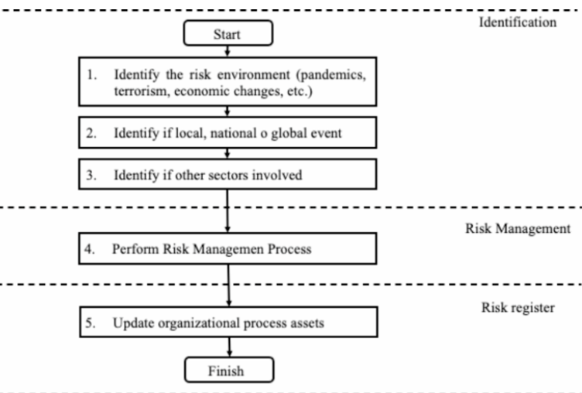
Figure 1: Risk environment framework flow chart
(Source: https://www.researchgate.net/figure/Risk-environment-framework-flow-chart_fig1_386103788)
REF is specifically applicable to the case of young adults living in cities in India because the vulnerability to harm is formed by various environmental factors. These are policing, social stigma, unemployment, unstable housing, peer networks, and inaccessibility of youth-friendly health services. Indian research has demonstrated a strong link between policing and social discrimination and the reluctance of the young population to use harm reduction services (Ganapathi et al., 2021). REF hence offers a robust conceptual framework through which the functioning of structural constraints can be taken into consideration to limit service utilisation and contribute to the aggravation of health outcomes in young drug users.
Applying the framework enables the current research to conceptualize harm reduction not just as a collection of interventions, including needle-syringe programmes or opioid substitution therapy, but as a broader structural ecosystem that has to take context, accessibility, and social inequities into account. Ref is useful in identifying the reasons why some harm reduction initiatives are not fully utilized and how programmes can be improved to achieve greater success in reaching the needs of young people in the urban environment.
Such theoretical underpinning enhances the power of the study to assess the effectiveness of harm reduction in the intricate world of urban India.

Chapter 3: Research Methodology
3.1 Introduction
The chapter aims to discuss the methodology process that was adopted in order to answer the following research question: How effective are harm reduction strategies in reducing drug-related health hazards among young adults in urban India? The methodology should be clear and properly organized because it allows the reader to determine the strength, validity, and generalizability of the study (Creswell and Creswell, 2017). Due to the sensitivity of the subject and the diversity of available evidence, the systematic literature review (SLR) was utilized in this dissertation based on the PRISMA 2020 framework. A systematic review can be used to synthesize high-quality evidence based on a series of peer-reviewed articles, and this would allow us to understand the effectiveness of harm reduction interventions in a holistic way in young urban drug users.
The chapter provides the research philosophy, approach, and design, elaborates search strategies used in the database, inclusion and exclusion criteria, description of screening and selection process, and the narrative synthesis methodology used to review the studies included.

3.2 Research Philosophy
A research philosophy represents the underlying beliefs regarding the knowledge generation (Bryman, 2016). The research is based on the Interpretivism paradigm, which focuses on social phenomena and explanations by referring to people's experiences and their contextual meanings. The use of the interpretivism approach is justified by the fact that the objects of interest, i.e., drug use, vulnerability, and harm reduction, are socially contingent issues, not only tied to biological variables (Schwandt, 2014).
Moreover, the concept of harm reduction in young adults should be considered in light of the findings on the structure of risks to understand how interventions depend on the concept of stigma and policing, as well as health-service availability, and the patterns of behaviour as a young adult, which can be most effectively examined with the help of an interpretive synthesis of this research method.
Although quantitative data may be included in some of the studies, the general philosophical orientation is interpretivist, since the aim of this study is not statistical generalisation but rather situational interpretation of existing evidence to analyse the effects of interventions.

3.3 Research Approach
The dissertation uses the inductive research method, which proceeds through particular findings in existing literature to more general conceptual observations (Bihu, 2024). Systematic literature reviews are appropriate to use induction because the patterns, themes, and outcomes of interventions are uncovered during the synthesis and not experimented with the help of a hypothesis.
The inductive methodology allows the researcher to:
- Determine the common themes regarding harm reduction results.
- Investigate the functioning of interventions in various Indian city settings.
- Evaluate those things that increase or hinder performance.
- Come up with policy and practice recommendations.
This approach is in line with the research of public health, in which complex behaviours and interventions should be perceived as a whole.

3.4 Research Design

3.4.1 Systematic Literature Review (SLR).
The research design used was a systematic literature review. An SLR is a systematic process of locating, appraising, and integrating the existing research through clear processes (Gough et al., 2017). Such a method is suitable in the present study since:
- There are ethical and safety issues in primary data collection among young drug users in India.
- Information on harm reduction specific to youth is fragmented across various fields.
- A systematic review provides rigour, comprehensiveness, and replicability.
- It enables the comparison of various interventions, settings, and outcome measures.
Review is conducted according to PRISMA 2020 (Page et al., 2021), which is why database searching, screening, selection, and synthesis are systematic and repeatable.

3.5 Search Strategy
The PICO framework (Population, Intervention, Context, and Outcome) was used to construct the search strategy to encompass important terms related to drug use, young adults, urban India, and harm reduction strategies.

3.5.1 Databases Searched
The following academic databases were searched:
- PubMed
- Google Scholar

3.5.2 Keywords and Boolean Operators
The Boolean Operators AND and OR were used.
(“young adults” OR “youth”) AND “harm reduction” AND “India.”
(“urban India”) AND (“drug use” OR “substance use”) AND “interventions.”
(“PWUD” OR “PWID”) AND “harm reduction outcomes” AND “India.”
Searches were limited to:
- 2010–2025
- Peer-reviewed full-text
- English language

3.6 Inclusion and Exclusion Criteria
Methodological transparency and validity require clear selection criteria (Siddaway et al., 2019).
Inclusion Criteria
The studies were to be included when:
- Evaluated a harm reduction programme
- Targeted young adults between the ages of 15-30 or disaggregated youth statistics.
- Took place in the urban Indian environment.
- Expressed health outcomes (HIV/HCV risk, overdose, injection behaviour, service use)
- Applied qualitative, quantitative, or mixed methodologies.
- Published 2013–2025
- Were peer-reviewed
- Papers published in the English language

Exclusion Criteria
The studies were not included when they:
- Targeted either middle-aged adults or children.
- Talked about harm reduction theory with no empirical evidence.
- Reported non-health outcomes (e.g., social or economic effects only).
- Abstracts, commentaries, or editorials of a conference.
- Papers published in languages other than English
- Non-peer-reviewed paper
- Papers published before 2013

3.7 Data Extraction
The extraction of the data is an essential step of every systematic review as it guarantees that the information about the chosen studies is collected in a clear, consistent, and repeatable way. In the current research, a standardised data extraction table was designed to record all the characteristics of the included literature systematically and in a table. Some of the important areas that were captured were: author(s), year of publication, study location, research design, methodological approach, sample characteristics, intervention type, outcome measures, and primary findings. These types have been selected due to accepted best practices of evidence synthesis (Papaioannou et al., 2016).
The adoption of a structured extraction framework provided the opportunity to accurately compare studies which had a wide range of different designs: qualitative interviews and ethnographies to quantitative cohort studies and cross-sectional surveys. It also made sure that the peculiarities of the youth-related harm reduction intervention, like the barrier of access, background, and the behavioural consequences, were also always included. Subjectivity is also reduced because an organised template helps to improve methodological rigour by minimising the risk of selective reporting or omission errors (Gough et al., 2017).
Thematic synthesis was done manually by cross-checking all the extracted data to confirm the accuracy before being incorporated into the narrative. This step-by-step approach contributed to the validity of the review and offered a valid base to synthesise the usefulness of harm reduction interventions among urban Indian youth adults.

3.9 Data Analysis: Thematic Analysis
The thematic analysis of the extracted information was carried out based on the methodology of a narrative synthesis, as recommended by Popay et al. (2006). This analytical method is quite appropriate for reviews that have different study designs, heterogeneous populations, and different intervention modalities, which are highly applicable in harm reduction studies within the Indian urban setting. In contrast to meta-analysis, narrative synthesis enables the incorporation of qualitative and quantitative data, which enables a more detailed breakdown of the contextual effects (Bihu, 2024).
Initial Synthesis: This stage was the preparation of findings of the study into codified descriptive codes. Codes that were used reflected recurring trends with regard to intervention type, youth engagement, risk behaviours, service access, and reported outcomes. The synthesis conducted in the preliminary phase made it possible to identify common patterns in studies despite the variation in methodology. This phase was repetitive as it included repeated reading in a bid to be accurate in the interpretations (Barnett-Page and Thomas, 2009).
Exploring Relationships: The second step required sorting research into analytical clusters according to:
- Harm reduction intervention type (e.g., needle exchange, OST, counselling)
- The features of an urban setting.
- Young age bracket and the needs of the youth.
- Health outcomes (HIV/HCV risk, overdose, behavioural change)
- Environmental or structural determinants of effectiveness.
This move allowed establishing links among intervention design, contextual issues, and the observed results.
Generating Themes: Themes of a higher level were subsequently synthesised, such as:
- Youth-oriented interventions should be effective.
- Barriers of structure and culture that include stigma, harassment, gender norms, and a lack of youth-focused services.
- Difficulties in operations in harm reduction provision.
- Drug-related harm in urban risk environments.
This thematic synthesis developed an interpretative description of the way and reason why harm reduction approaches work or do not in various urban contexts, which conformed to the principles of narrative synthesis (Popay et al., 2006).

3.10 Ethical Considerations
Although the study had no direct human participants, ethical considerations were critical in the achievement of academic integrity and an ethical approach to carrying out research. Only the studies that had previously been reviewed by their respective ethical domains were included, and all publications were handled with the requirement of copyright academic Harvard referencing. In the review process, there was also transparency in the sources of data, screening procedures, and the methods of analysis to eliminate discrimination and selective reporting. Since the research used only secondary data, formal ethical approval was not necessary, and this coincides with the general university advice on desk-based research (Hammersley and Traianou, 2012).

3.11 Methodology Limitations.
All methodological approaches have limitations attached to them, and systematic reviews are not an exception.
- Scarcity of Literature that is Youth Specific: Most of the Indian harm reduction literature is on the adult population, implying that there is a dearth of high-quality youth evidence.
- Heterogeneity Across Studies: There was a lot of dispersion in terms of study designs, interventions, measurement instruments, and outcomes. This diversity limits the possibility of direct comparison of results or meta-analysis (Gough et al., 2017).
- Potential Publication Bias: Studies with positive or statistically significant results have higher chances of being published, which raises the chances of publication bias in the evidence base (Siddaway et al., 2019).
- Lack of Longitudinal Data: The impact of long-term interventions is not well understood because few Indian studies track individuals over time (Ganapathi et al., 2021).
- Urban Context Variability: The various socioeconomic and infrastructural contexts seen in urban India limit the applicability of findings to other cities.
Despite these difficulties, this review's overall validity and reliability are improved by the methodical and transparent approach.

3.12 Chapter Summary
This chapter described the methodological framework that informed the study, stating the philosophical position, research method, and systematic review design that were employed to investigate the harm reduction interventions among young adults living in urban India. It explained the search strategy, inclusion and exclusion criteria, data extraction processes, and narrative thematic synthesis that were employed to analyse the selected studies. The chapter has also outlined the quality appraisal tools used to guarantee methodological rigour and touched on pertinent ethical issues that involve secondary research. Lastly, some of the methodological limitations were also recognized, which form the basis of the presentation of findings in the following chapter.

Chapter 4: Results

4.1 Introduction
The chapter gives the results of the systematic review of the effectiveness of harm reduction interventions in urban India among young adults. The results are presented in a non-interpretive manner, as per the conventions of systematic review. The findings are organized based on the review questions and narrative thematic synthesis, as described in Chapter 3.
After searching the databases, screening, and quality appraisal, six peer-reviewed studies were included based on the inclusion criteria. All these studies differed in the methodological design, geographic coverage, and focus of the intervention. Indian and global evidence were provided to offer contextual and comparative information.
The chapter then presents the selection of the studies and their characteristics, after which the results of the study are presented in terms of different types of harm reduction interventions, reported outcomes, and potential barriers to effectiveness. Where necessary, tables are used to summarise the key findings.

4.2 Selection and Overview of the Studies.
4.2.1 Study Selection
This systematic review involved a systematic and clear study selection procedure to determine high-quality and relevant evidence on the impact of harm reduction interventions among young adults in urban India. A comprehensive search of databases was performed through Google Scholar, PubMed, Scopus, and Web of Science databases so that all the literature in the field of public health, epidemiological, and social science is covered. These databases are commonly known to be related to the health policy and harm reduction research (Siddaway et al., 2019).
A set of initial records was established based on a search in pre-determined search strings comprising terms related to harm reduction, drug use, youth, and urban environments. Reference management software was used to eliminate any duplicate records and titles, and abstracts were then filtered on the basis of a set of distinct inclusion and exclusion criteria. The studies were considered to be peer-reviewed, in English, and older adults or urban population; and related to harm reduction or health hazards of drugs; and older adults or urban population. After the screening of full-text articles, six articles were included and continued to be synthesized, in line with the best practice of systematic review (Papaioannou et al., 2016).
The last group of incorporated studies has diversity in terms of methodology. It included two systematic reviews on the evidence of harms and interventions related to injecting around the world (Abdul-Quader et al., 2013; Degenhardt et al., 2023), one policy analysis in the legal context of drug use in India (Ambekar, 2022), and one epidemiological review with the description of the national patterns of substance use (Ambekar et al., 2020). Besides, one quantitative study based on the cohort investigated transition risks in non-injecting opioid users in India (Ambekar et al., 2019), and one qualitative study examined the impediments to service use among young individuals who inject drugs in urban Indian localities (Ganapathi et al., 2021).

4.2.2 Quality appraisal
Quality appraisal was done to determine the methodological robustness of the included studies and to warrant the credibility of the synthesis. Qualitative studies were analyzed with the use of Critical Appraisal Skills Programme (CASP) tools (Hong et al., 2018). The studies were all evaluated based on clarity of research objectives, suitability of the research methods, rigour with respect to sampling procedure, quality of data gathering, research ethics, and findings transparency. The reliability of the review was reinforced by quality assessment because studies that had the minimum standards of the methodology were excluded from the final thematic interpretation. Detailed appraisal results are presented in Appendix X.

4.3 Different Types of Harm Reduction Interventions
Three major kinds of harm reduction strategies were found in all of the included studies in this review: community and service-based interventions, epidemiological and risk-focused approaches, and structural-level interventions. When combined, these strategies show how harm reduction functions at the population, policy, and service-delivery levels.

4.3.1 Structural-Level Interventions
Interventions at the structural level were reviewed in the global systematic reviews and policy-based research. Abdul-Quader et al. (2013) presented strong evidence of the effectiveness of needle and syringe programmes (NSPs) in a wide variety of international contexts. The systematic review revealed a steady decrease in HIV and hepatitis C virus (HCV) infections in people who inject drugs (PWID) in areas where NSPs were adopted at an adequate level and in the long-term. Notably, the review did not find any evidence that NSPs led to the initiation or the frequency of drug use, making them beneficial to public health (Karlsson, 2020).
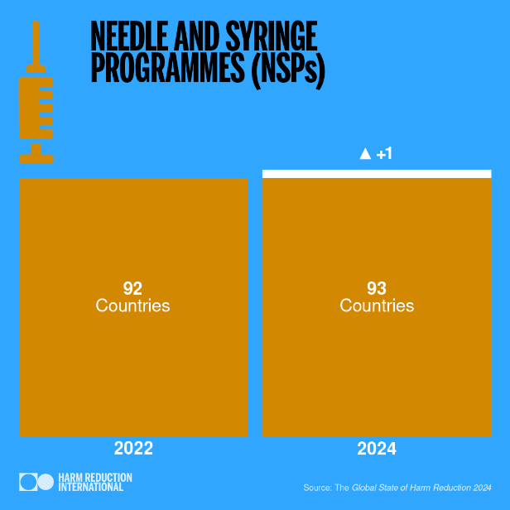
Figure 2: The Global State of Harm Reduction 2022 – 2024
(Source: https://hri.global/flagship-research/the-global-state-of-harm-reduction/the-global-state-of-harm-reduction-2024/)
In the same way, NSPs and opioid substitution therapy (OST) have been recognized by Degenhardt et al. (2023) as the two cornerstone harm reduction measures implemented all over the world. Their systematic review emphasised that the prevalence rate of injecting-related infections, overdose, as well as injecting risk behaviour was lower in countries with better NSP and OST coverage. Another important point highlighted in the study was that policy environments had a significant effect on intervention effectiveness, and restrictive drug policies inhibited the provision and uptake of services.
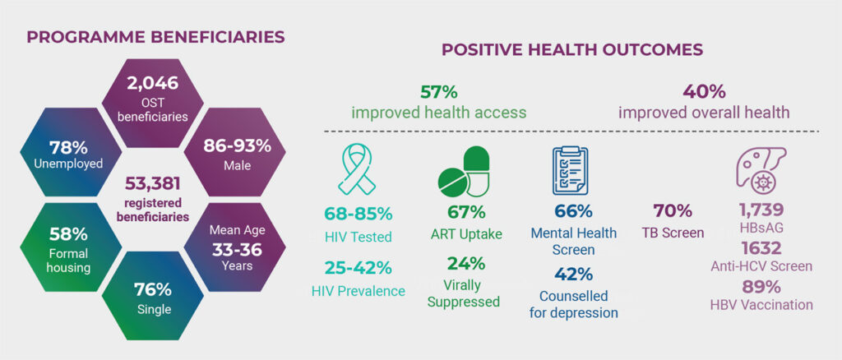
Figure 3: Opioid Substitution Therapy reduces harm – Networking
(Source: https://www.nacosa.org.za/research-finds-opioid-substitution-therapy-reduces-harm/)
In the Indian context, Ambekar (2022) studied harm reduction in the policy context, with emphasis on the criminalisation of drug use. Even though this policy analysis did not report any empirical health outcomes, it declared legal frameworks as important structural determinants that define access to harm reduction services. Criminal sanctions, fear of arrest, and compulsory abstinence-only strategies proved to deter their use of preventive health services, which are harmful to the purpose of harm reduction.

4.3.2 Epidemiological and Risk-Focused Intervention.
The epidemiological and risk-oriented studies were represented by those that did not directly assess interventions, but offered decisive evidence that is used in order to direct harm reduction activities. Ambekar et al. (2020) review the national statistics on substance use in India and have found that a significant proportion of young adults use opioids and alcohol, and this issue mainly concerns urban population groups. The review was characterized by low penetration of harm reduction services despite the growing burden of substance use, which demonstrates gaps between needs and services.

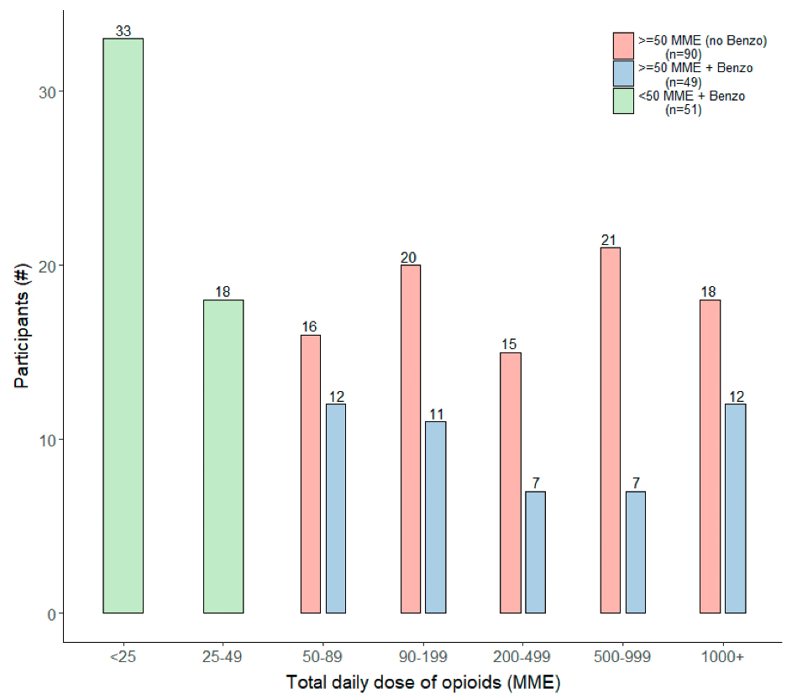
Figure 4: Risk factors associated with transition from non-injecting to injecting opioid use in India
(Source: Ellis et al., 2021)

The given graph subdivides the participants according to their Total Daily Dose of Opioids (MME) and the presence of benzodiazepine concurrently, which is to provide a quantitative basis for risk-targeted interventions. The green bars are people under lower dosages ($<50$ MME) and using benzodiazepines, a category that should be early reduced in harm to avoid reaching high levels. The individuals within the blue group are at risk of compound epidemiological danger owing to the synergistic respiratory depression when opioids and benzodiazepines are combined (Ellis et al., 2021). These insights can provide the focus of service delivery, that is, they can serve to fill the gaps in the city's harm reduction because they understand precisely where the socio-economic and physiological risks intersect.
Ambekar et al. (2019) targeted non- injecting opioid users and their risk of a change in injecting drug use specifically. In this quantitative cohort study, younger age, peer networks with injectors, exposure to urban as opposed to rural settings, and socio-economic vulnerability were found to be significant factors that increased the risk of transition. This was not an intervention study, but its findings showed that there was an obvious chance to engage in early harm reduction before the development of injecting-related harms.

4.3.3 Community and Service-Based Interventions
Ganapathi et al. (2021) conducted in-depth research on community and service-based intervention by researching service engagement of young PWID in urban India through qualitative research. The researchers found the peer-led outreach, the NGO-driven services, and the mobile harm-reducing units to be the most prominent intervention models that enable access to sterile injecting equipment and health information.
There was, however, a wide range of utilisation of these services. Barriers that were reported by the participants were stigma, fear of being harassed by the police, absence of youth-friendly services, and inflexible operating hours. Interventions carried out within the community by trusted peers were viewed as being more accessible than those exercises that are carried out in formal healthcare institutions. However, it was noted again and again that service fragmentation and lack of integrated youth-specific programming were present.
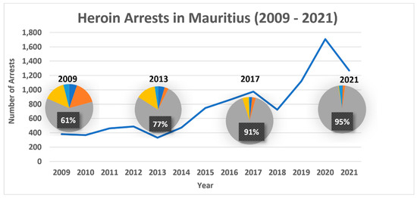
Figure 5: Comparative Analysis of Harm Reduction Service Utilization: Peer-Led vs. Formal Healthcare Models.
(Source: White et al., 2025)
The given graph describes Heroin Arrests in Mauritius (2009 - 2021), which gives a drastic quantitative context of the fear of police harassment revealed by White et al. (2025). The information indicates that there is a considerable rise in arrests, which reached their peak in 2020 with more than 1,600 cases. Inbuilt pie charts show that the percentage of certain demographics that probably reflected the possession or usage increased to 95% in 2021, as compared to 61% in 2009.
This increase in policing is associated with the impediments to service utilization in urban research. The excessive arrest levels promote stigma and fear, leading to the avoidance of peer-led outreach or mobile harm reduction units by PWID. With the increase in arrest numbers between 2018 and 2020, the resulting atmosphere did not favor the so-called trusted peer delivery model, and this highlights the urgent need to have integrated and youth-friendly services, which should focus on health interventions rather than criminalization.
On the whole, the evidence indicates that harm reduction interventions work on various levels; structural interventions are the most evidence-based ones, whereas community and youth-centred intervention is not well developed and balanced in urban India.

4.4 Outcomes of Harm Reduction Interventions
This section will contain the reported results of harm reduction interventions that have been found in the included studies. The outcomes are classified into health outcomes, behavioural outcomes, and service uptake and accessibility, which represent the most regularly reported dimensions in the literature.

4.4.1 Health Outcomes
The global systematic reviews had the most comprehensive reports on health-related outcomes. Abdul-Quader et al. (2013) have presented adequate and coherent evidence that needle and syringe programmes (NSPs) could be linked to the great decrease in incidences of HIV and hepatitis C virus (HCV) in people who inject drugs (PWID). In a variety of geographical settings, it was found that NSP coverage was associated with reduced cases of transmission of blood-borne viruses. Notably, the review had not detected evidence of augmented drug use initiation or frequency in the wake of NSP implementation, which is usually brought up in policy discussions.
Likewise, Degenhardt et al. (2023) also found that environments that offered a combination of harm reduction programs, especially NSPs and opioid substitution therapy (OST), had low rates of injecting-related harms. These were a decrease in HIV and HCV prevalence, fewer injection-related injuries, and reduced chances of overdose. The review consisted of evidence from more than 90 countries, which showed that health benefits have been found in various populations and health systems.
Although the Indian studies used did not directly estimate biomedical outcomes (including HIV or HCV infections), epidemiological evidence provided by Ambekar et al. (2020) indicated a high incidence of opioid-related harm in young adults. This contextual material substantiates the applicability of health outcomes that are mentioned in international literature to the Indian urban environment.
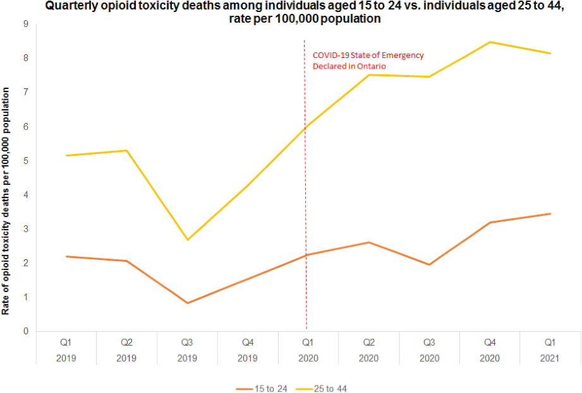
Figure 6: Opioid-Related Mortality Rates by Age Group
(Source: Akbar et al., 2024)
The given graph, which entails the description of Quarterly Opioid Toxicity Deaths in Ontario (2019 - 2021), demonstrates the increasing health threats posed by drugs as discussed by Ambekar et al (2020). The figures indicate that death rates have grown significantly after the State of Emergency related to COVID-19, and the 25 - 44 age group has had the highest mortality rate of more than 8 deaths per 100,000 population.

4.4.2 Behavioural Outcomes
Indian empirical studies were the main sources of reports on behavioural outcomes. Ambekar et al. (2019) researched behavioural changes in non-injecting opioid users and found injecting drug use as a major outcome of risk. The cohort study discovered that subjects who were exposed to harm reduction messages, education through peers, and early outreach intervention had reduced rates of transitioning to injecting as opposed to those who were not exposed to them. Though no formal intervention programme was evaluated in the study, differences in behaviour indicated the protective effectiveness of an early harm reduction engagement.
The study by Ganapathi et al. (2021) has reported behavioural reports using risk awareness and injecting practices among young PWID in urban India. The participants who received harm reduction services showed better skills in safer injecting methods and more use of sterile injecting equipment. Nevertheless, inconsistent engagement was also noted in the study, in which a good number of the participants used services at intervals based on social and structural constraints.
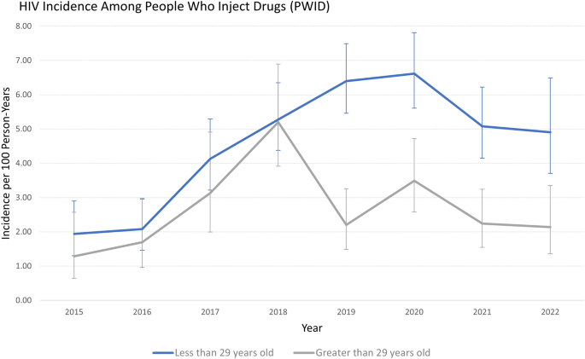
Figure 7: Comparative HIV Incidence Rates among PWID by Age Cohort (2015–2022)
(Source: Ganapathi et al., 2024)
The graph is the HIV Incidence Among People Who Inject Drugs (PWID), as per the age group, between 2015 and 2022. It demonstrates that the highest incidence rates have always been recorded by persons below the age of 29 (blue line) than the ones above 29 (grey line), with a high of about 6.60 per 100 person-years in 2020. This information measures the number of behavioural changes and the risks mentioned by Ambekar et al. (2019), which demonstrate the disproportionate exposure of young adults to blood-borne infections.
Although Ganapathi et al. (2021) reported that participation in harm reduction services enhances safer injecting knowledge, the prevalence of the younger cohort remains high, indicating that perhaps social and structural factors are acting as obstacles to behavioural change. The sharp age difference since 2018 highlights a strong necessity to use youth-specific harm reduction messages to avoid high-risk injecting behaviors and further infection with the virus.

4.4.3 Service Uptake and Accessibility
Included studies reported results of service uptake and accessibility unevenly. Ganapathi et al. (2021) discovered that young PWID had a lower likelihood of seeking fixed-site services of harm reduction, including government-operated facilities, because of a fear of stigmatization, confidentiality, and police surveillance. Peer-led outreach, mobile services, and programmes supported by NGOs were seen to be more acceptable and reachable.
Ambekar (2022) emphasised the structural barriers that influence service utilisation, i.e., the process of criminalising drug use in India, and deterred people from using harm reduction services. Although quantitative data regarding uptake were not provided, the analysis of policy revealed that law and policing practices were also major obstacles to service utilization. On an international scale, Degenhardt et al. (2023) found more comprehensive coverage of harm reduction services in those countries that have a friendly policy environment and comprehensive models of service delivery. These environments showed a higher adoption of NSPs and OST, which supported the impact of the structural factors on accessibility.
In general, the analysed literature has demonstrated congruent health and behavioural outcomes of harm reduction interventions, whereas service uptake was highly policy-stigma-service design dependent.

4.5 Barriers to Harm Reduction Effectiveness
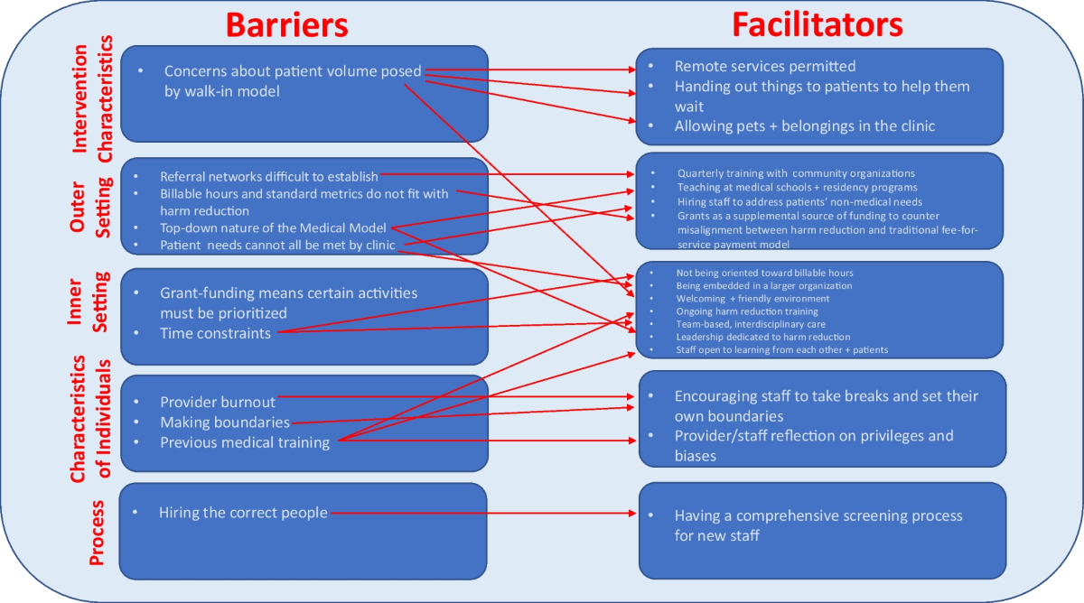
Figure 8: Barriers to Harm Reduction Effectiveness
(Source: Lindenfeld et al., 2023)
In the included studies, several studies were found to have repeated and varied obstacles to the success of harm reduction measures. The barriers were pointed out mostly in qualitative, cohort, and policy-oriented research and were noticeable in various urban settings. Although the character and degree of such barriers were various, they were always linked with a lack of involvement and strong inefficiency of harm reduction services (Lindenfeld et al., 2023).
Criminalisation and policing became one of the most prevalent obstacles in studies. According to Ambekar (2022), the punitive legal regimes that controlled drug use in India led to people not obtaining harm reduction services because of fear of arrest, harassment, or being forced to attend detention. Similarly, Ganapathi et al. (2021) also reported that youth who inject drugs often shun harm reduction sites found in places near police watch. Participants were found to alter their drug use behaviours to be hidden as opposed to putting safety first, hence unequal utilisation of the services.
Discrimination and stigma in the healthcare setting were also a frequent report. Ganapathi et al. (2021) established that healthcare providers had judgmental attitudes toward young PWID that adversely affected the levels of trust and readiness to seek services. Respondents reported the unwillingness to share drug use histories and the unwillingness to visit official healthcare providers. They were also reported in the places where the harm reduction services were theoretically offered, which indicated that there was an effect of provider attitudes that conditioned the effectiveness of the services beyond the availability.
The other identified obstacle was the lack of harm reduction services that are youth-specific. Ambekar et al. (2019) also found that the majority of harm reduction programs in India were tailored to adult injecting groups of users and failed to properly meet the needs of younger or non-injecting users of opioids. This led to the fact that early-stage users became less involved in preventive services. There were no age-specific outreach interventions, which decreased the possibilities of early intervention before moving to injecting drug use.
Another limitation was observed to be the fragmentation of urban service delivery. Ambekar et al (2020) pointed out the imbalanced distribution of services in cities, in which harm reduction services are centralized in specific locations and coordinated poorly among the health, social, and legal support mechanisms. This disintegration led to unequal access, especially to young adults who had unstable homes or jobs. Research indicated that people were usually forced to go through several unlinked services to access fundamental harm reduction requirements.
Besides these fundamental hurdles, some researchers noted overlapping social and structural issues, such as poverty, unstable housing, and social support deficit, which increased the challenges in maintaining service involvement (Ganapathi et al., 2021). These variables had no independent action but worked with legal and institutional obstacles, which affected the effectiveness of harm reduction interventions.
In general, it was uniform in that the literature reviewed noted that the effectiveness of harm reduction was limited in a complex of legal, social, and service-level factors. Although the actual forms varied with contexts, the existence of these obstacles was an overlapping aspect across urban Indian contexts and applicable comparisons to global contexts.

Chapter 5: Discussion

5.1 Introduction
The chapter is a discussion of the systematic review results concerning the assessment of the effectiveness of harm reduction methods in reducing drug-related health risks among young adults in urban India. Based on the findings in Chapter 4, this discussion provides an interpretation of the evidence in comparison to the available literature, theoretical viewpoints, and overall context of public health. The chapter investigates the conformity of the findings to the previous expectations, other possible explanations, and the implications of the findings on policy, practice, and future research. Lastly, it accepts the weaknesses of the review and how far the findings can be generalised.

5.2 Interpretation of Key Findings

5.2.1 Structural Harm Reduction Interventions Effectiveness.
Findings prove that structural harm reduction interventions, specifically needle and syringe programmes (NSPs), and opioid substitution therapy (OST), are always linked with good health outcomes, such as decreased HIV and HCV infection and injecting-related harms. It is highly consistent with previous evidence-based practices in the world that population-level approaches are one of the most effective interventions to minimize health risks related to drugs (Abdul-Quader et al., 2013; Degenhardt et al., 2023).
To a great extent, these findings were not surprising because the effectiveness of NSPs and OST in preventing blood-borne infections was long-established in the literature on harm reduction (Larney et al., 2020). Notably, the lack of evidence that shows higher drug use initiation facilitation is relevant to the arguments that harm reduction does not spur substance use, but at least lessens its damage. This is the problem with abstinence-only policy practices that continue to prevail in most low- and middle-income nations, including India (Ambekar, 2022).
Another possible explanation for the demonstrated effectiveness could be associated with not only the effects of the interventions themselves but also facilitating policy conditions. As it was demonstrated by Degenhardt et al. (2023), health outcomes were the most advanced in situations where harm reduction services were given legal backing and sufficient resources. It indicates that the structural effectiveness depends on larger social and legal issues, but not on the availability of the services.

5.2.2 Behavioural Outcomes and Early Intervention
The review established that harm reduction exposure relates positively to positive behavioural change, especially in the transition between non-injecting and injecting drug use (Ambekar et al., 2019). This conclusion is important because injecting drug use is associated with a significantly greater amount of health risks, such as HIV, HCV, and overdose.
To some extent, these results revealed themselves as expected. Although traditionally harm reduction is directed on injecting population, the results emphasize the value of early interventions aimed at the non-injecting population. It confirms the emergent evidence that harm reduction preventive strategies can be used to decrease the escalation to higher-risk behaviours (Mounteney et al., 2016).
Nonetheless, there was an inconsistency in measuring behavioural outcomes across studies, which restricted the conclusions that a firm made. Another reason why transition rates are lower could be the presence of some other protective factors that cannot be measured, like family support or personal resilience. However, the uniformity of results in the Indian urban contexts implies that early harm reduction practice is significant.

5.2.3 Service Uptake and Youth Engagement.
Among the most vivid results is associated with the unequal uptake of the services among the young adults, even when it is proven that some interventions work. The qualitative results showed that fear of law enforcement, stigma, and absence of services accessible to youth limited youth engagement (Ganapathi et al., 2021).
This was anticipated, as previous studies have demonstrated that the stigma and distrust on the part of the institution are common among the youth who consume drugs (Chang et al., 2021). The trend towards peer-led and mobile services implies that the service design is an imperative predictor of accessibility.
Another explanation could be that of the generational factors of risk perception, whereby younger users are less likely to perceive that they need services. The results, however, indicate that institutional and structural factors have a greater impact than personal attitudes.

5.3 Consistency with Existing Literature
Comprehensively, the results are quite conciliatory with the world harm reduction literature. The use of NSPs and OST has proved effective in reducing morbidity and mortality in PWID due to systematic reviews (Sordo et al., 2017; Larney et al., 2020). This evidence is expanded by the current review, switching the setting to the urban Indian scenario where coverage of services is minimal.
The findings are also consistent with the research, which stresses the importance of structural vulnerability in the process of health determination. According to Gehring et al. (2022), there is no way to separate harm reduction efficacy and social, legal, and economic environments. This is the opinion of the current findings, especially regarding criminalisation and policing.
Nevertheless, the review also mentions a disparity between the evidence at the global level and the implementation at the local level, which is also expressed by UNODC (2023) when it comes to the uneven adoption of harm reduction in low- and middle-income nations.

5.4 Theoretical Implications
The results are quite clear in favour of the usage of the Risk Environment Framework (Rhodes, 2002) as the theoretical prism through which this study could be approached. The findings indicate that harm from drug use amongst young adults cannot be attributed to individual behaviour only, but to legal, social, and service-level environments.
Risk factors related to the environment include criminalisation, stigma, and fragmented urban services, which restrict the effectiveness of the harm reduction interventions in the presence of evidence-based strategies. This supports the applicability of structural approaches to the domain of public health and criticizes individualistic approaches to substance use intervention.
Simultaneously, the results correspond with the Harm Reduction Model that entails placing more importance on safety, dignity, and practical interaction than on abstinence (WHO, 2023). The reported advantages of peer-led outreach and early intervention also support the principles of harm reduction, which are based on the principles of user engagement instead of coercion.

5.5 Practical and Policy Implications
The implications of the findings of this systematic review are significant to the drug policy, harm reduction practice, and further research on the matter in India. Although the international evidence has a solid basis on the effectiveness of harm reduction interventions, the effect of this program in urban India is mainly influenced by structural and institutional circumstances, and not the scarcity of strategies that could be proven to be effective.

5.5.1 Implications for Policy
According to the review, the policy and legal structures are identified as one of the most influential limitations to harm reduction in India. As Ambekar (2022) points out, criminalisation of drug use is a contributive factor to fear and stigma and the prevention of health services among persons who use drugs. These results are consistent with evidence at the global level that punitive drug laws negatively impact the objective of improving the health of the community because they force drug users into clandestine and dangerous circumstances (UNODC, 2023).
Liberalisation of the personal use of drugs can help to enhance access to harm reduction services by minimising the risk of being arrested. Examples of international policy change illustrate that a change in policy that favours approaches related to public health is linked to higher service uptake, better continuity of care, and lessening of drug-related harms (Degenhardt et al., 2023). Even though decriminalisation in and of itself is not a sufficient condition, it can constitute an important enabling factor to the effective implementation of harm reduction.
Additionally, the results indicate that policy coherence needs to be developed across the sectors, such as health, law enforcement, and social services. The ineffectiveness of interventions is caused by fragmented policy solutions in which harm reduction programs are run parallel to punitive policing practices (Gehring et al., 2022). The adoption of harm reduction concepts in the national drug policies would help to enforce a uniform implementation and minimize the contradictions in the goals of public health and criminal justice enforcement.

5.5.2 Implications for Practice
On the level of service delivery, the results note the significance of changing the harm reduction interventions based on the needs of young adults. The current services in India have mostly been tailored to older injecting groups, and younger and non-injecting groups are poorly served (Ambekar et al., 2019). Harm reduction programmes that target young people and youth-specific issues that contribute to early-stage drug use and risk behaviours could help to stop progression to injecting and related health harms.
The use of peer-led and mobile outreach-based models is more popular among youth, as Ganapathi et al. (2021) report, which implies that conventional clinic-based interventions are not accessible or acceptable to youth. This may positively affect trust, stigma, and service relevance through peer involvement, especially in urban areas, where young adults are highly socially surveilled and mistrusted by the institutions (Chang et al., 2021).
Besides this, the review also highlights how integrated urban service delivery should be done. Harm reduction services are provided in disconnection from mental health, housing, and social support systems, and this restricts their efficacy. Complex and overlapping needs of young adults who use drugs can be met by integrated models that integrate harm reduction with more encompassing health and social care (WHO, 2023). These practices can also enhance continuity of care and retention of services.

5.5.3 Implications for Research
The review also reveals a huge gap in the Indian evidence base, especially the absence of longitudinal and intervention-related studies. Most of the available literature explains services or risk settings and fails to compare results after a period (Ganapathi et al., 2021). This restricts the capacity to determine the long-term effectiveness of the harm reduction interventions on young adults.
The research needs to focus on youth-specific harm reduction trials in the future, such as peer-led interventions, mobile, and early intervention programs aimed at non-injecting users. Mixed-method approaches can also be especially useful, as they will incorporate both quantitative measures of outcomes and qualitative data on service engagement and contextual barriers (Siddaway et al., 2019).
Moreover, it is important to conduct studies that investigate the ways in which the legal reforms and policing practices affect the adoption of harm reduction measures as part of the policy implementation process. This kind of evidence would not only help in making better policy choices but also in creating harm reduction models that are sensitive to the urban context in India.

5.6 Limitations of the Findings
Although this review offers valuable information on harm reduction interventions among urban youth in India, it has a number of limitations that should be considered when interpreting the results. One, the small scope of studies on India, per se, limited the scope of evidence that could be synthesized. Much of the harm reduction literature is still focused on the high-income or global comparative setting, and this might not be an accurate reflection of the socio-cultural and policy realities of urban India (Degenhardt et al., 2023). Consequently, the applicability of the results to different urban Indian settings is limited.
Second, the nature of study designs, type of intervention, and the outcome measure were heterogeneous, hence could not be compared directly. The studies that have been included were of qualitative interviews, up to epidemiological reviews and cohort analyses with varying methodological techniques and reporting criteria. This inconsistency restricted the possibility of making homogeneous conclusions about the effect of interventions (Siddaway et al., 2019).

Third, using published peer-reviewed literature also presents the risk of publication bias, where the studies that showed favourable outcomes have a higher potential of publication compared to those with null or negative outcomes. This can result in a false belief in the effectiveness of interventions as well as underrepresenting the challenges of implementation (Song et al., 2001).
Lastly, there is a bias towards urban settings in the review, which restricts its ability to apply to rural and peri-urban settings where the pattern of drug use, access to services, and social stigma can vary significantly. The special infrastructure of harm reduction in non-urban settings is understudied and influences the contextual transferability even more (Ambekar et al., 2020).
In spite of these drawbacks, the systematic search strategy, transparent inclusion criteria, and critical assessment of high-quality studies make the conclusions of the review stronger and more credible.

Reference list
Abdul-Quader, A.S., Feelemyer, J., Modi, S., Stein, E.S., Briceno, A., Semaan, S., Horvath, T., Kennedy, G.E., and Des Jarlais, D.C., 2013. Effectiveness of structural-level needle/syringe programs to reduce HCV and HIV infection among people who inject drugs: a systematic review. AIDS and Behavior, 17(9), pp.2878-2892.
Akbar, S., Iacono, A., Yang, J., Antoniou, T., Juurlink, D., Sheikh, H., Kurdyak, P., Wu, F., Cheng, C., Leece, P. and Kolla, G., 2024. Characteristics of Opioid Toxicity Deaths Among Adolescents and Young Adults in Ontario Prior To and During the COVID-19 Pandemic. Journal of Adolescent Health, 75(1), pp.35-42.
Ambekar, A., Agrawal, A., and Sen, M.S., 2020. Epidemiology of substance use in India. Atul Ambekar1, Alok Agrawal2, Mahadev Singh Sen3. INDIAN PSYCHIATRIC UPDATE, p.52.
Armoon, B., SoleimanvandiAzar, N., Fleury, M.J., Noroozi, A., Bayat, A.H., Mohammadi, R., Ahounbar, E., and Fattah Moghaddam, L., 2021. Prevalence, sociodemographic variables, mental health conditions, and type of drug use associated with suicide behaviors among people with substance use disorders: a systematic review and meta-analysis. Journal of addictive diseases, 39(4), pp.550-569.
Armstrong, G., Nuken, A., Samson, L., Singh, S., Jorm, A.F. and Kermode, M. (2013) Quality of life, depression, anxiety and suicidal ideation among men who inject drugs in Delhi, India. BMC Psychiatry, 13(1), p.151.
Barnett-Page, E. and Thomas, J., 2009. Methods for the synthesis of qualitative research: a critical review. BMC Medical Research Methodology, 9(1), p.59.
Barratt, M.J. and Measham, F., 2022. What is drug checking, anyway?. Drugs, Habits and Social Policy, 23(3), pp.176-187.
Belackova, V., Salmon, A.M., Jauncey, M. and Bell, J., 2019. Learning from the past, looking to the future-Is there a place for injectable opioid treatment among Australia’s responses to opioid misuse?. International Journal of Drug Policy, 71, pp.164-168.
Belackova, V., Silins, E., Salmon, A.M., Jauncey, M. and Day, C.A., 2019. “Beyond safer injecting”—health and social needs and acceptance of support among clients of a supervised injecting facility. International journal of environmental research and public health, 16(11), p.2032.
Bihu, R., 2024. Qualitative data analysis: Novelty in deductive and inductive coding. Authorea Preprints.
Biswal, B., Zhou, B., Wen, K., Gupta, D., Bhatia, U., and Nadkarni, A., 2024. Explanatory models of illicit drug use in adolescents: A qualitative study from India. PLOS global public health, 4(10), p.e0003647.
Biswal, M.J., Bruno, R., Ezard, N. and Ritter, A., 2018. Pill testing or drug checking in Australia: acceptability of service design features. Drug and alcohol review, 37(2), pp.226-236.
Bryman, A., 2016. Social research methods. Oxford University Press.
Ceasar, R.C., Goldshear, J.L., Brothers, S., Wenger, L.D., Kral, A.H., and Bluthenthal, R.N., 2021. Factors associated with injury and blood-borne infection risk when providing assisted injection among people who inject drugs. International Journal of Drug Policy, 97, p.103297.
Chang, J., Shelly, S., Busz, M., Stoicescu, C., Iryawan, A.R., Madybaeva, D., De Boer, Y., and Guise, A., 2021. Peer-driven or driven peers? A rapid review of peer involvement of people who use drugs in HIV and harm reduction services in low-and middle-income countries. Harm Reduction Journal, 18(1), p.15.
Chauhan, S., Srivastava, S., Kumar, P., Patel, R., T M. and Dhillon, P., 2021. Interaction of substance use with physical activity and its effect on depressive symptoms among adolescents. Journal of Substance Use, 26(5), pp.524-530.
Ciccarone, D., 2019. The triple wave epidemic: supply and demand drivers of the US opioid overdose crisis. International Journal of Drug Policy, 71, pp.183-188.
Creswell, J.W. and Creswell, J.D., 2017. Research design: Qualitative, quantitative, and mixed methods approaches. Sage publications.
Ellis, M.S., Kasper, Z.A., Gold, M. and Cicero, T.J., 2021. Opioid dosage levels, concurrent risk factors and self-perceptions among chronic pain, opioid-managed individuals at elevated risk for opioid overdose. Pharmaceuticals, 14(12), p.1279.
Ganapathi, L., Srikrishnan, A.K., McFall, A.M., Gunaratne, M.P., Kumar, M.S., Lucas, G.M., Mehta, S.H. and Solomon, S.S., 2024. Expanding single-venue services to better engage young people who inject drugs: insights from India. Harm reduction journal, 21(1), p.170.
Gehring, N.D., Speed, K.A., Wild, T.C., Pauly, B., Salvalaggio, G. and Hyshka, E., 2022. Policy actor views on structural vulnerability in harm reduction and policymaking for illegal drugs: A qualitative study. International Journal of Drug Policy, 108, p.103805.
Ghosh, A., George, B.B., Vij, J., Pillai, R.R., Soundappan, K., Sharma, M. and Basu, D., 2024. Understanding Alcohol and Illicit Drug Use in Young College Students: A Qualitative Work from India Based on Social Norms Theory. Indian Journal of Psychological Medicine, p.02537176241283381.
Girisanker, S.B., 2023. Demystifying the Synthetic Drug Menace: India’s Struggles and Strategies. Small Wars Journal-Narcotics Trafficking.
Gough, D., Thomas, J. and Oliver, S., 2017. An introduction to systematic reviews.
Hammersley, M. and Traianou, A., 2012. Ethics in qualitative research: Controversies and contexts.
Hanson, G.R., Venturelli, P.J. and Platteborze, P., 2024. Drugs and society. Jones & Bartlett Learning.
Hassan, S., 2022. Saving our own lives: a liberatory practice of harm reduction. Haymarket Books.
Henderson, N.J., 2022. Demanding a safer supply: Stories from the frontlines of the drug poisoning crisis in the context of the housing crisis and COVID-19 pandemic (Master's thesis, Queen's University (Canada)).
Hong, Q.N., Fàbregues, S., Bartlett, G., Boardman, F., Cargo, M., Dagenais, P., Gagnon, M.P., Griffiths, F., Nicolau, B., O’Cathain, A. and Rousseau, M.C., 2018. The Mixed Methods Appraisal Tool (MMAT) version 2018 for information professionals and researchers. Education for information, 34(4), pp.285-291.
Jain, B., Krishnan, S., Ramesh, S., Sabarwal, S., Garg, V. and Dhingra, N., 2014. Effect of peer-led outreach activities on injecting risk behavior among male drug users in Haryana, India. Harm reduction journal, 11(1), p.3.
Joseph, E.D., 2021. The Influence of Social Capital on Adolescent Substance Use Treatment Participation (Master's thesis, Texas Christian University).
Karlsson, N., 2020. HIV and hepatitis C prevention among people who inject drugs in Sweden: harm reduction policies, risk behaviour interventions and outcomes (Doctoral dissertation, Karolinska Institutet (Sweden)).
Kennedy, M.C., Karamouzian, M. and Marshall, B.D., 2022. The North American opioid crisis: how effective are supervised consumption sites?. The Lancet, 400(10361), pp.1403-1404.
Larney, S., Leung, J., Grebely, J., Hickman, M., Vickerman, P., Peacock, A., Stone, J., Trickey, A., Dumchev, K.V., Colledge, S. and Cunningham, E.B., 2020. Global systematic review and ecological analysis of HIV in people who inject drugs: National population sizes and factors associated with HIV prevalence. International Journal of Drug Policy, 77, p.102656.
Lindenfeld, Z., Hagan, H. and Chang, J.E., 2023. Exploring barriers and facilitators to integrating a harm reduction approach to substance use in three medical settings. Journal of general internal medicine, 38(15), pp.3273-3282.
Little, B., Sud, N., Nobile, Z. and Bhattacharya, D., 2021. Teratogenic effects of maternal drug abuse on developing brain and underlying neurotransmitter mechanisms. Neurotoxicology, 86, pp.172-179.
Millar, S., 2021. Relationships between cannabis and recent use of stimulant drugs. Drugnet Ireland, pp.21-22.
Molanguri, U., 2025. Deaddiction Services in India: Current Status. Indian Journal of Psychological Medicine, 47(1), pp.1-4.
Mounteney, J., Griffiths, P., Sedefov, R., Noor, A., Vicente, J. and Simon, R., 2016. The drug situation in Europe: an overview of data available on illicit drugs and new psychoactive substances from European monitoring in 2015. Addiction, 111(1), pp.34-48.
Nath, A., Choudhari, S.G., Dakhode, S.U., Rannaware, A., Gaidhane, A.M., Dakhode, S., and Gaidhane, A. (2022). Substance abuse amongst adolescents: an issue of public health significance. Cureus, 14(11).
Navarro, S., Kral, A.H., Strike, C.S., Simpson, K., Wenger, L. and Bluthenthal, R.N., 2019. Factors associated with frequency of recent initiation of others into injection drug use among people who inject drugs in Los Angeles and San Francisco, CA, USA, 2016–17. Substance use & misuse, 54(10), pp.1715-1724.
O’Halloran, C., Cullen, K., Njoroge, J., Jessop, L., Smith, J., Hope, V. and Ncube, F., 2017. The extent of and factors associated with self-reported overdose and self-reported receipt of naloxone among people who inject drugs (PWID) in England, Wales and Northern Ireland. International Journal of Drug Policy, 46, pp.34-40.
Obeagu, E.I. and Obeagu, G.U., 2024. Mental Health and Psychosocial Effects of natural disaster on HIV Patients. Sciences, 4(1), pp.38-44.
Page, M.J., McKenzie, J.E., Bossuyt, P.M., Boutron, I., Hoffmann, T.C., Mulrow, C.D., Shamseer, L., Tetzlaff, J.M., Akl, E.A., Brennan, S.E. and Chou, R., 2021. The PRISMA 2020 statement: an updated guideline for reporting systematic reviews. bmj, 372.
Papaioannou, D., Sutton, A. and Booth, A., 2016. Systematic approaches to a successful literature review. Systematic approaches to a successful literature review, pp.1-336.
Papaioannou, D., Sutton, A. and Booth, A., 2016. Systematic approaches to a successful literature review. Systematic approaches to a successful literature review, pp.1-336.
Paquette, C., Krajewski, T., Cullins, Z., JadKarim, L., Danns, T., Cloud, D.H. and Brinkley-Rubinstein, L., 2025. Drug use vs. abstinence after incarceration: Associations with competing psychosocial needs and their relevance to the importance of treatment.
Paquette, C.E., Rubalcava, D.T., Chen, Y., Anand, D. and Daughters, S.B., 2021. A mobile app to enhance behavioral activation treatment for substance use disorder: app design, use, and integration into treatment in the context of a randomized controlled trial. JMIR Formative Research, 5(11), p.e25749.
Parnes, J.S., 2025. Drug Checking as a Harm Reduction Intervention at Music Festivals in Southern California: A Descriptive Analysis (Master's thesis, San Diego State University).
Patil, G.R. and Sharma, G., 2022. Urban Quality of Life: An assessment and ranking for Indian cities. Transport Policy, 124, pp.183-191.
Perumbilly, S.A., Melendez-Rhodes, T. and Anderson, S.A., 2019. Facilitators and barriers in treatment seeking for substance use disorders: Indian clinical perspectives. Alcoholism Treatment Quarterly, 37(2), pp.240-256.
Piatkowski, T., Gibbs, N. and Dunn, M., 2024. Beyond the law: exploring the impact of criminalising anabolic–androgenic steroid use on help-seeking and health outcomes in Australia. Journal of Criminology, 57(1), pp.62-82.
Ravisankar, B., 2021. Drug Abuse in India-An Analysis of the Reality. Indian JL & Legal Rsch., 2, p.1.
Ravisankar, P., Rao, P.R., Babu, P.S., Srikanth, D., Reddy, C.V., Deepthi, O.V. and Divya, G., 2018. The latest statistical report of the global synthetic drugs. Indian Journal of Research in Pharmacy and Biotechnology, 6(2), pp.59-64.
Resiak, D., Mpofu, E. and Rothwell, R., 2021. Sustainable harm reduction needle and syringe programs for people who inject drugs: A scoping review of their implementation qualities. Sustainability, 13(5), p.2834.
Rhodes, T., 2002. The ‘risk environment’: a framework for understanding and reducing drug-related harm. International journal of drug policy, 13(2), pp.85-94.
Saini, R., Parmar, A., Rao, R., Mishra, A.K., Ambekar, A. and Agrawal, A. (2021) Psychiatric and substance use comorbidities among people who inject drugs in India: A cross-sectional, community-based study. World Social Psychiatry, 3(3), pp.195-202.
Schwandt, T.A., 2014. The Sage dictionary of qualitative inquiry. Sage publications.
Sharma, N., 2025. Addiction to Awareness: India’s Comprehensive Journey Towards Education, Prevention, and Rehabilitation in Pursuit of a Sustainable, Drug-Free Future for All Citizens. Explorations in Humanities and Social Sciences, 1(1), pp.16-24.
Sharma, S., Kabir, S., AhmadDar, H., Qureshi, A. and Kousar, N., 2024. DRUG ABUSE AMONG YOUTH: A SOCIO-DEMOGRAPHIC ANALYSIS OF PATIENTS AT D-DWARI DE-ADDICTION CENTER, SAMBA DISTRICT, JAMMU. Frontiers in Health Informatics, 13(3).
Sharp, J.T. and Rosén, L.A., 2007. Recreational stimulant use among college students. Journal of Substance use, 12(2), pp.71-82.
Sinha, Y., 2024. Analysing Opioid Substitution Therapy in India: A Comprehensive Narrative Review. Issue 1 Int'l JL Mgmt. & Human., 7, p.261.
Solomon, S.S. and Saxena, A., 2021. Time for a more holistic approach to HIV prevention for men who have sex with men?. The Lancet Global Health, 9(4), pp.e377-e378.
Song, F., Eastwood, A., Gilbody, S., Duley, L. and Sutton, A., 2001. Publication and related biases (pp. 371-390). SAGE Publications Ltd.
Sordo, L., Barrio, G., Bravo, M.J., Indave, B.I., Degenhardt, L., Wiessing, L., Ferri, M. and Pastor-Barriuso, R., 2017. Mortality risk during and after opioid substitution treatment: systematic review and meta-analysis of cohort studies. bmj, 357.
Sunitha, S. and Gururaj, G. (2014) Health behaviours & problems among young people in India: Cause for concern & call for action. Indian journal of medical research, 140(2), pp.185-208.
UNODC (2023) World Drug Report 2023. United Nations Office on Drugs and Crime.https://www.unodc.org/unodc/data-and-analysis/world-drug-report-2023.html
White, G., Luczak, S.E. and Nöstlinger, C., 2025. Harm Reduction as a Complex Adaptive System: Results from a Qualitative Structural Analysis of Services Accessed by Young Heroin Users in Mauritius. Youth, 5(1), p.10..
World Health Organization, 2023. Recommended package of interventions for HIV, viral hepatitis and STI prevention, diagnosis, treatment and care for people who inject drugs: policy brief. World Health Organization

Appendix 1: A
Database used

Appendix 2:
Key references used

