

Software Development

Programs in C and documentation

Elliot Barnett

BSc Computer Networks and Security

Table of contents
- Part A
  - Variable
  - For-loop
  - An array
- Part b
  - Exercise 1
  - Exercise 2
  - Exercise 3
  - Exercise 4
- References

- Part A
  - Variables
A variable is one of the key features that is needed to run or develop any program that needed data values stored. It is a piece of storage equipment that is used to store small pieces of data for a program to either keep or use temporarily. There are many different types of data that can be stored within a variable. These are:
- Char – a char is known as a character and is only one letter. It can be used to create multiple characters in a row to make a string. A string is several characters combined to normally make a word. [1]
- Int – an int is known as an integer, an integer is a number that is whole and nothing else. An integer variable will only store whole numbers and not anything else. For example, it can be useful when you want someone to input time. If you use an integer variable, it will prevent the user from entering characters, floats etc.
- Float- a float is known as a decimal number. The float variable is mostly used for complicated calculations such as working out the area of a circle or even using it to create the value of shop items “£3.80”. They can be very useful when you know that the outcome of the program will give a decimal number.
When creating variables using the correct style of name is key. Using numbers at the start of variables or underscores is bad programming and can lead to many errors within the code. Keeping to conduct when creating variable names can save you a lot of time and energy. For example, using capital letters at the beginning of a variable is not recommended but is not as bad as using any special characters or numbers. Using underscores to section out the name is recommended from long variable names, making sure to only use it in the middle of the variable name, not at the beginning or the end [2]. Using camel is a very effective way of making sure that no names get duplicated with the system [3].
There are two types of variables Global and local variables. A global variable is available that will affect everything in the program. Every piece of code within the program will use the value that the global variable has. It is effective when using variables that will want to be used in different functions because it will only have to be written out once, then called for when needed by a function. A local variable is a variable which is used within a function and only within it. It can only be changed and used with the code within the functions itself [4].

  - The for-loop
The for-loop is a loop which allows a programmer to loop a certain piece of code a number of times. It’s a very useful loop to use and allows the programmer to use a piece of code over and over again. For loops are normally referred too as counting loops. These loops will allow programmers to create a count and when that count hits the end number it will finish the loop and continue with the code [5]. The count will first be initialised at the beginning and then every time the piece of code runs the count will increase. With the increase in count there can be limitations to it where if you wanted to loop the code 5 times then you would put:
#include <stdio.h>
void main()
{
int i;
for (i = 1; i <= 5; i++)
{
printf("hello world");
}

}

This will loop the ‘printf' five times and then end the program after the five loops have run. A for loop is a more efficient way of writing shortcode and saving a lot of time and memory. It will prevent you from writing ‘printf’ five times.

  - Array
An array is a piece of storage that can store a number of same data types. It will store characters, integers, and floats. They are used to create structures that data will sit in for it to be called for when needed. There are a number of types of arrays these include:
- Return array – a return array is mostly used with functions. It allows functions to return arrays back to other functions.
- Multi-dimensional array – there are multiple levels of dimensional arrays one of the most common and simple multi-dimensional arrays is two-dimensional arrays [6].
There are many different features of an array as mentioned above. One of them is an array can store multiple bits of data that have the same data type. An array is also allocated a certain size. This certain size can vary and can be beneficial with storage [7]. The most common array is the two-dimensional array. This array contains two rows for data to be stored in.
An array can be used when storing a person’s name or number. For example, each array consists of a number of memory locations. These memory locations starting at 0. Each single memory slot is used for a single piece of data such as ‘L' or ‘1'. this can be made up of {‘E’,’L’,’L’,’I’,’O’,’T}. These would be number 0,1,2,3,4,5. Making sure that the array starts with ‘0’ is crucial.

- Part B
  - Exercise 1
- Initialising the variables
- Storing 3 types of data in the variables
- Outputting data. Printf
- Inputting data. Scanf
- Display variables on the screen
Annotated code
#include <stdio.h>

void main()
{
int Wnumber = 0;// Stores the whole number 38 in the Wnumber variable. Variable type = Integer.
float Fnumber = 0;// Stores the float number 180.34 in the Fnumber variable.Variable type = Float.
char Cstring[15] = {};// Stores the 7 characters 38 in the variable Cstring.Variable type = Char.

printf("What is your name :");
scanf(" %s", &Cstring);
printf("Your name is: %s\n", Cstring); // Prints the data stored in Cstring as a string using %s.
printf("What is your age ?");
scanf("%d", &Wnumber);
printf("You am %d years old\n", Wnumber);// Prints the data stored in Wnumber using %d.
printf("How tall are you ?");
scanf("%f", &Fnumber);
printf("You are %f cm's tall\n", Fnumber);// Prints the data stored in Cstring using %f.

}
Positive Values
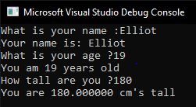

Result: The program run successfully and produceand accurate values from the variables.
Negative values
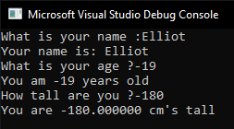
Result: Program run successfully and produced an accurate outcome showing the values that were inputted into the variables.
Incorrect values
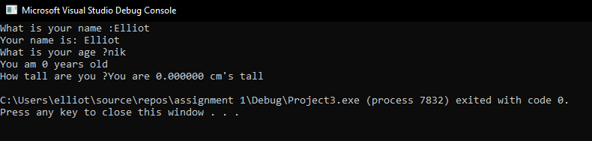
Result: Program failed as expected

  - Exercise 2
- Create variables for different data types
- Store the area of the circle and the triangle in variables
- Calculate the area of the shaded area
- Print out the questions for the user
- Input the data in the variables
Annotated code
#include <stdio.h>
#define PI 3.142;
void main()
{
float rad, height, base, Carea, Tarea, area;// Declaring the float variables for rad, height,base,Carea,Tarea and area.

printf("please enter the base dimension for the triangle: \n");// Asking the user to input the base dimension of the triangle.
scanf("%f", &base);// Placing the data into the variable 'base'.

printf("Please eneter the height dimension of the triangle: \n");// Asking the user to input the height dimension of the triangle.
scanf("%f", &height);// Placing the data into the variable 'height'.

printf("Please enter the radius of the circle: \n");// Asking the user to input the radius of the circle.
scanf("%f", &rad);// Placing the data into the variable 'rad'.

Tarea = base * height;// Calculating the area of the triangle.
Carea = (rad * rad) * PI;// Calculating the area of the Circle.

area = Carea - Tarea;// Calculating the area of the shaded area.

printf("The shaded area is: %.2f", area);// Printing the data for the shaded area.*/
}

Positive values
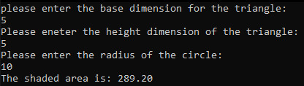
Result: Program run as expected and presented a result in a 2 decimal place form.

Negative values
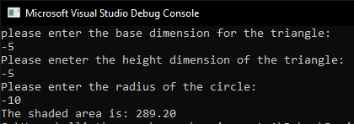
Result: Program runs, but the pre-set PI statement was not changed to a negative number resulting in the result of not being a minus.

Incorrect Values
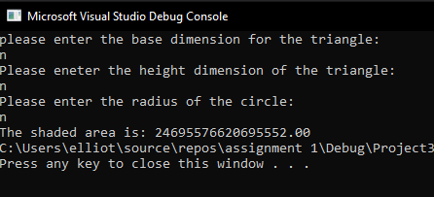
Result: The program ran but produce inaccurate data due to the inaccurate data inputted.

  - Exercise 3
- Initialise variables
- Introduce a while loop to loop ‘enter your numbers’
- Print out the numbers
- Calculate the VAT
- Print out he price plus VAT
#include <stdio.h>

void main()
{
int arr_num[5], count = 0, total, TotalplusVAT;// decalring all integer variables.

while (count < 5)// using a while loop to ask the question "Please enter your numbers:" 5 times.
{
printf("Please enter your numbers : ");// prints out a question asking the user to enter a number.
scanf("%d", &arr_num[count]);//scans the users input and stores each number into an array.
count++;
}

printf("Below are the arrays\n");
count = 0; // reseting count to perform another while loop.
while (count < 5)// loops a print function to print out all values in the array.
{
printf("%d\n", arr_num[count]); // prints all values in the array.
count++;
}

total = arr_num[0] + arr_num[1] + arr_num[2] + arr_num[3] + arr_num[4]; // adding all the numbers together in the array.

TotalplusVAT= total * 1.2; // multiplying the number by 1.2 to add the extra 20% VAT to the total price.

printf("The total price plus VAT is : %d\n", TotalplusVAT); //printing the final price.
}

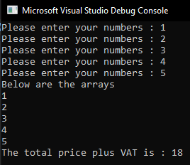
Positive Numbers

Result: The program run as expected and produced accurate values that were stored in the array. It also accurately calculated the VAT.

Negative Numbers
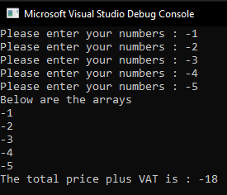
Result: The program run as expected and produced accurate data with negative values. The program also calculated the VAT outcome correctly with negative values.

Incorrect Values
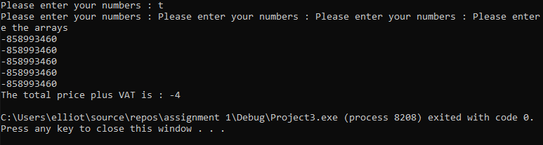
Result: Program failed as expected.

  - Exercise 4 Annotated Code
#include <stdio.h>
#include <stdlib.h>
#include <time.h>
#include <stdbool.h>
void main()
{
int myrand, myrand2, myrand3;// declaing all integer variables for the random numbers.
int low = 1;//lowest of range.
int high = 9;//highest of range.
int points = 0;
char answer = { 'n' };
int num = 1;

while (num == 1 || num == 1)// while loop to keep lopping the function if the user wants to.
{
srand(time(NULL)); //seed randomness.
myrand = rand() % (high - low + 1) + low;//generate random numbers.
myrand2 = rand() % (high - low + 1) + low;
myrand3 = rand() % (high - low + 1) + low;
printf("%d ", myrand);//outputing the random numbers.
printf("%d ", myrand2);
printf("%d\n", myrand3);

if (((myrand == 5) && (myrand2 == 5) && (myrand3 == 5)))// decalring if all numbers are the same.
{
printf("JACKPOT\n");// outputing jackpot.
points + 2000;// adding 2000 points to the vairable points
}
else if (((myrand == myrand2) && (myrand2 == myrand3) && (myrand == myrand3)))// declaring if two numbers are the same.
{
printf("20 points!\n");// outputting 20 points.
points + 20;// adding 20 points to the vairable points
}
else if (((myrand == 5 && myrand2 == 5) || (myrand2 == 5 && myrand3 == 5) || (myrand == 5 && myrand3 == 5)))// decalring if there are two 5's.
{
printf("100 points!\n");// outputting 100 points.
points + 100;// adding 100 points to the vairable points.
}

printf("points : %d\n", points);// outputing the points.
printf("Do you want to try again ? Y/N \n");// outputting the option to whether the user wants to retry.
scanf(" %c", &answer);// scans the input of the user

if (answer == 'y')// if yes then it keeps num at 1 to loop back around.
{
num == 1;
}
else// else it will end the program.
{
break;
}
}

}

- Create variables (int,char)
- Generating random numbers
- Printing out the random numbers
- If ALL ran numbers == 5 print ‘jackpot’
- If two 5 numbers print ‘100 points’
- If all same number print ’20 points’
- Store the points in a variable
- Calculate the points every turn
- Allow the user to stop or keep going

All 5’s win jackpot
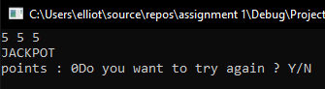
Result: The jackpot was outputted but the score was not recorded and stored in the variable.

Two 5’s win 100 points
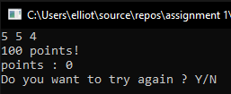
Result: The points were outputted but were not recorded and stored in the variable.

Three of the same number win 20 points
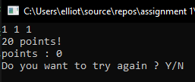
Result: The points were outputted but were not recorded and stored in the variable.

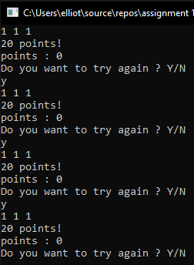
Points added and outputted

Result: Points were outputted but were not stored in the variable and outputted.

Yes and no function
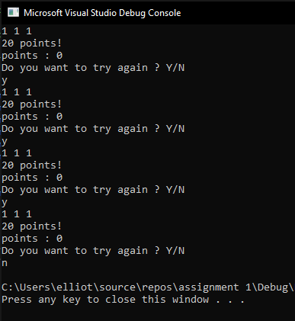
Result: The yes and no function worked as expected and looped the program if ‘y’ was inputted and exited the program if ‘n’ was inputted.

References

[1] | "Tutorialspoint," Simlyeasylearning, [Online]. Available: https://www.tutorialspoint.com/cprogramming/c_variables.htm.
[2] | A. B. Downey, Think Python, O'reilly Media, 2015.
[3] | M. Bhatt, "What is CamelCase used for ?," Quora, 2017.
[4] | A. B. Downey, Think Python, O'realiy, 2015.
[5] | A. B. Downey, Think Pyhthon, R O'reiliy, 2015.
[6] | "Tutorialspoint," SimplyEasyLearning, [Online]. Available: https://www.tutorialspoint.com/cprogramming/c_arrays.htm.
[7] | D. Thakur, "Ecomputer Notes," [Online]. Available: http://ecomputernotes.com/what-is-c/array/what-are-the-characteristics-of-arrays-in-c.

