Knowledge and Information Management Skills for the Workplace
Module Code: BMSK5006
Student Name: Anwar Miah
Student ID: 1605788
Professor Name: Anupam Mazumdar
Table of Contents
Introduction 1
Task1. Evaluation of the concept and Importance of Knowledge Management in Terms of Boots UK’s Knowledge Assets and Their Management 2
1.1. Relationship among Data, Information and Knowledge 2
1.2. Relationship between Individual Knowledge and Organizational Knowledge 3
1.3. Analysis and Modeling Techniques to Identify Knowledge Assets 5
1.4. Actual and Potential Knowledge Assets 7
Task2. Key Knowledge Management Processes Required for Organizational Development 9
2.1. Knowledge Management Process 9
2.2. Knowledge Management Techniques and Tools 10
2.3. Requirement to Create, Store, Apply and Integrate Knowledge 11
2.4. Importance of Intellectual Property Rights 13
Task3. Framework for Establishing a Knowledge Management Culture 14
3.1. Contribution of Knowledge Assets on Boots UK 14
3.2. Evaluation of Knowledge Requirements of Boots UK 15
3.3. Boots UK’s Framework for Enabling Knowledge Sharing 16
3.4. Recommended Improvements to the Current framework 17
Conclusion 18
Reference 19

Introduction
The process, by which an organization creates, shares, uses and manages knowledge and information is known as the knowledge management system. The main objective of knowledge management is to make the use of available knowledge assets in achieving organizational goals (Amine Chatti, 2012). Knowledge assets are the data, information, experience, knowledge and wisdom possessed by an organization. The modern business world has become much competitive than it was in previous years (Bones et al., 2019). To ensure competitiveness and sustainability in this competitive market, organizations need to increase their knowledge on the related field. This assignment has been made to make a clear understanding of knowledge management within business organizations. Boots UK is one of the popular health and beauty retailer and pharmacy chain in the United Kingdom (Boots.com, 2019). The company is aware of their knowledge management system and they are growing their business with the help of better knowledge management system. This organization has been selected to conduct this assignment.

Task1. Evaluation of the concept and Importance of Knowledge Management in Terms of Boots UK’s Knowledge Assets and Their Management

1.1. The relationship among Data, Information and Knowledge
When learning about knowledge management, it is necessary to have a clear idea about data, information and knowledge. A basic understanding of data, information and knowledge is a crucial thing to know before learning about knowledge management system (Fathi, 2013). Data, information, knowledge and relationship among these have been discussed in this section.
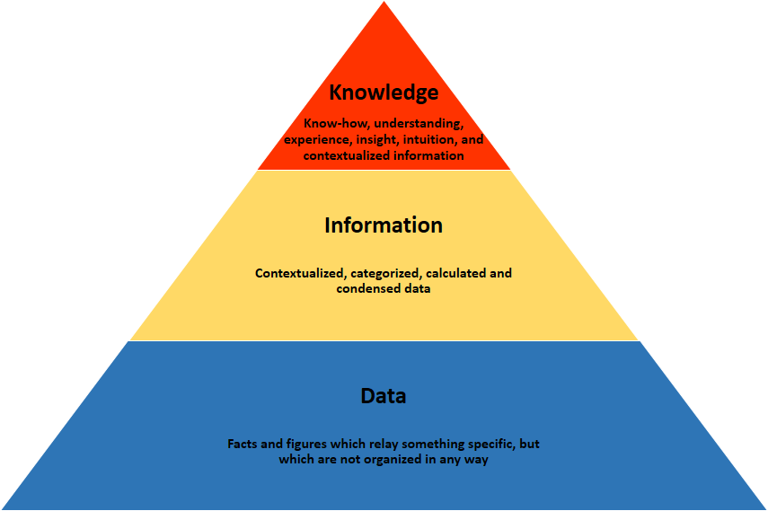
Figure 1: Relationship between Data, Information and Knowledge
Source: (Hall, 2016)
Data
Specific information and facts collected through a systematic way for a specific purpose are known as data. Many scholars have defined data as a collection of discrete objects, facts, results or events out of a context or situation is known as data (Hislop, 2010). Data is also known as unprocessed or raw information. When Boots UK shows its total amount of sales on their balance sheet, it will be called data. Data are being processed later by the parties who are interested in it and use it for any other purpose. Organizations collect information form processed data and use them in organizational decision making.
Information
When data are being processed, they are known as information. Information is driven by data. It can be called information hen a data shows meaningful results. If data does not show any meaningful result, they cannot be called information (Jashapara, 2011). Boots UK can find out information about the success of their promotional activities form the data of sales amount. Data gives a base for information that is needed for decision making for an organization. And information is considered as the base for knowledge.
Knowledge
Knowledge is the last stage of evaluation after collecting data and information. When experience, judgment and jurisdictions are applied on data and information, they are called knowledge (Lehaney, 2014). In other words, it can be said that knowledge is the internalization of collected data, information and experience. Boots UK collects information about the success of their promotional activities from the number of sales. And that experience gives the company knowledge about how to promote the organization and use it for organizational growth.

1.2. Relationship between Individual Knowledge and Organizational Knowledge
Employees are a single unit for an organization. The knowledge possessed by an individual employee is known as individual knowledge which is used in performing some tasks. And knowledge possessed by an organization is known as called as organizational knowledge which is used for ensuring compatibility and sustainability in the market (Maier, 2010). Individual knowledge and organizational knowledge are interrelated with each other. All the employees together make an organization. Thus, knowledge of all the employees working for the company makes organizational knowledge for Boots UK. Individual knowledge is considered as the starting point of organizational knowledge (Morey, 2011). It is considered as the basis of organizational knowledge. Information is the base from which individual people gather knowledge. And individual knowledge comprises the knowledge of Boots UK. Individual knowledge arises from the combination of data, information, interpretation, reflection and experience and they are considered as organizational knowledge when they are used by an individual for organizational purpose.
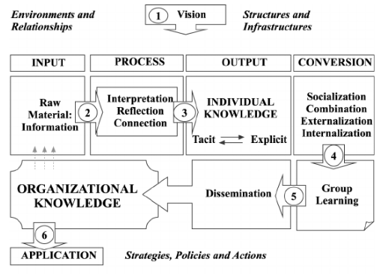
Figure 2: Relation between Individual Knowledge and Organizational Knowledge
Source: (Peel, 2012)
Figure 2 provides with a clear understanding of individual and organizational knowledge in Boots UK. According to that figure, an individual collects raw information as input. This raw information is interpreted, reflected and being connected with previous experience. This gives an individual with the knowledge on a specific aspect (Amine Chatti, 2012). This individual knowledge gets converted into organizational knowledge by socialization, combination, externalization and internalization (Beijerse, 2010). This knowledge gets shared within the organization by group learning and dissemination and finally, it becomes applied on organizational purpose as organizational knowledge. Individual knowledge gets converted into organizational knowledge when it is been shared with the other employees within the organization and when they use it for operational activities of Boots UK. Individual knowledge must have to be externalized through group learning by the individual who has that knowledge. On the other hand, knowledge needs to be internalized by the individual who lacks it.

1.3. Analysis and Modeling Techniques to Identify Knowledge Assets
Knowledge assets are needed to be identified by the organizations for ensuring better use of those assets as well as protecting them. There are several models developed by the scholars which are popularly using by the organizations in identifying their knowledge assets (Bones et al., 2019). These models provide Boots UK with the technique of identifying available knowledge assets. Some of the well-known knowledge identifying models is as followed.
Intangible Asset Monitors
Intangible asset monitors technique was developed by Karl-Erik Sveiby which measures intangible assets by classifying employees into three classifications named external structure, internal structure and competence. This model indicates the level of knowledge and expertise held by the employees (Fathi, 2013). This model can be a useful tool for Boots UK in identifying their available knowledge asset as well as providing a knowledge map which helps in ensuring better use of available knowledge assets.
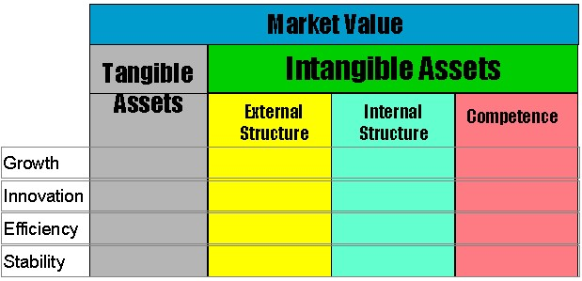
Figure 3: Intangible Asset Monitor
Source: (Hall, 2016)
Skandia Navigator
Skandia Navigator technique was developed by Leif Edvinsson in 2007 which measures knowledge assets on the basis of performance and goal achievement of the organization (Hislop, 2010). This model measures knowledge assets considering five perspectives which are, financial focus, customers focus, human focus, process focus, renewal and development focus.
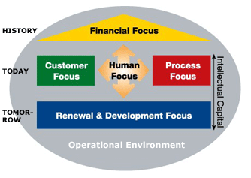
Figure 4: Skandia Navigator
Source: (Jashapara, 2011)
Meritum Guidelines
Meritum guidelines provide a framework with specific definitions of knowledge management from an organizational perspective (Lehaney, 2014). The main intention of this model is to guide organizations like Boots UK in measuring their available knowledge resources, executing them in organizational activities and re-measuring their credibility again.
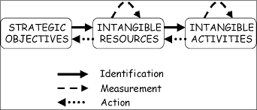
Figure 5: Meritum Guidelines
Source: (Maier, 2010)
Danish Guidelines
Danish guideline is one of the most used techniques for identifying knowledge assets. This model helps in identifying knowledge assets by constructing an intellectual capital statement (Morey, 2011). Like the balance shit statement, the intellectual capital statement focuses on Knowledge management strategy used by Boots UK. This intellectual capital statement consists of four elements, knowledge narrative, management challenges, initiatives and indicators.

1.4. Actual and Potential Knowledge Assets
Knowledge asset refers to the accumulated intellectual resources possessed by an organization. Knowledge asset may have in the form of individual knowledge or in the form of organizational knowledge (Peel, 2012). It is necessary to have a clear idea about knowledge assets to ensure better knowledge management within an organization. Scholars have defined knowledge assets into two type, actual knowledge assets and individual knowledge assets (Beijerse, 2010). Actual knowledge asset is the whole area of knowledge possessed by Boots UK and its employees.
Actual Knowledge Asset
Actual knowledge can be in the form of data, information, idea, thoughts, learning, understanding, insights, capabilities and experience of the employees. Organizational workforce, database, documents, policies, guidelines, procedures, patents, intellectual rights are also considered as the knowledge assets (Amine Chatti, 2012). Actual knowledge assets are the assets that Boots UK owns on a specific point of time. On the other hand, potential knowledge asset indicates those assets which Boots UK do not possess at a selected point of time but there are possibilities of achieving those assets in the near future. Modern organizations need to increase their organizational knowledge to face the hard competition prevailing in the market (Bones et al., 2019). An organization need to ensure continuous development of their available knowledge resources so that they can increase their compatibility and increase their sustainability.
Potential Knowledge Asset
An organization like Boots UK can convert their potential knowledge into actual knowledge by encouraging their employees for knowledge sharing, idea generating, storing knowledge and implementing them on organizational purposes. The same assets in the actual knowledge may contain in potential assets too. The difference between actual knowledge asset and potential asset lies at the point of time. Potential knowledge can be transformed into actual knowledge by the research and development process (Fathi, 2013). Boots UK as a pharmacy retailer already put emphasize on the research and development process. They can develop the process an increase their knowledge in developing their compatibility in the market. Another way to transform potential knowledge into actual knowledge is to train the employees and making encouraging them in sharing knowledge. A knowledge sharing culture needs to be promoted within the organization so that Boots UK can expand their area of knowledge.

Task2. Key Knowledge Management Processes Required for Organizational Development

2.1. Knowledge Management Process
To ensure better management of knowledge within the organization, it is necessary to follow a systematic process for creating, storing and using of knowledge. An appropriate knowledge management process helps Boots UK in protecting their knowledge and using them in achieving competitive advantage against the competitors. The success of the knowledge management process is driven by organizational policy, the way by which the organization interact with their employees and the way in which employees interact with each other (Hall, 2016). An organization need to care about the following aspects for ensuring efficient knowledge management.
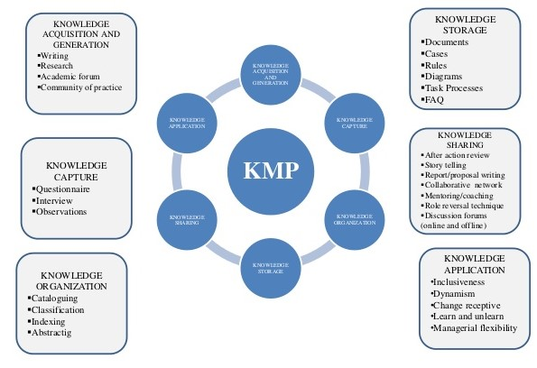
Figure 6: Knowledge Management Process
Source: (Morey, 2011)
Organizational Policy towards Knowledge Management
It is necessary to have an efficient communication process among the employees and higher authorities of the organization. Knowledge management and knowledge sharing process become fruitful when there is an efficient communication process within the organization (Hislop, 2010). Boots UK should establish such an environment within the workplace so that the employees can learn new things and share knowledge among them.
Guidelines for Knowledge Creation
When there enters any new knowledge in the organizational knowledge base, it is necessary to ensure that they are being adopted in an organized way. It is necessary to have a clear guideline about knowledge creation for employees and the way by which employees share knowledge with each other (Jashapara, 2011). It needs to be kept in mind that knowledge creation guidelines encourage employees in creating and sharing knowledge rather than it hinders in the knowledge management process.
Preserving Expertise
Organizations should encourage their employees to learn from their mistakes and preserve the knowledge that they have learnt (Lehaney, 2014). Boots UK should think about the issues they have faced before, think about the reasons behind those issues and how they solved those issues. Employees should be encouraged to preserve information about those incidents, causes behind those incidents and the ways they handled that incident.

2.2. Knowledge of Management Techniques and Tools
An ideal knowledge management process must have some features which make it effective for organizational development. Knowledge management system within an organization needs to be user-friendly and easy to use by the employees (Maier, 2010). Companies around the world generally use the following tools and techniques for ensuring better knowledge management.
Knowledge Bases
Better knowledge management comes from the base of knowledge possessed by the organization. For providing employees with a knowledge base, Boots UK can have a portal or a mini-site which will contain all the frequently asked questions asked by the employees. Description of some of the activities, technical procedures, issues that the organization faced in the past and the way they handled those situation and such other things may also contain in that site. And those knowledge bases should be updated regularly so that the employees can keep them updated with recently added knowledge.
Communication of Practice
Employees within an organization are united by a common sphere of activities, shared knowledge for a common project and by a common organizational goal. An organization can use different technical means to help employees in sharing their expertise within the workplace (Morey, 2011). Boots UK uses social media sites in helping their employees to share their expertise with the others. The organization can give the employees a common platform for sharing their ideas where they can share their ideas with much ease.
Knowledge Map
A knowledge map is a list of experts within an organization which shows the areas of their competence and expertise. Boots UK maintains a knowledge map which will help the employees in communicating with experts on specific areas of knowledge. All the employees are not expert in all the tasks (Peel, 2012). When an employee needs some advice for a specific task, knowledge map can help him/her in finding the expert who can give a competent solution for that problem.

2.3. The requirement to Create, Store, Apply and Integrate Knowledge
Creating, storing and applying and integration of knowledge are the important tasks within the whole knowledge management process. The whole process starts by identifying the location of knowledge within the organization which is known as knowledge mapping (Beijerse, 2010). The whole knowledge management process involves the documentation of workflow and the decision-making process which make it possible for the employees to identify the location of knowledge and expertise that they need. Knowledgeable employees are generally part of professional organizations (Amine Chatti, 2012). It is the most crucial thing in the knowledge management process to define enterprise level approach for knowledge management and integration of knowledge management in business workflows.
It is also necessary to engage the employees in the knowledge management process so that they can get familiar with requires k knowledge within their workplace, as well as location and application of that knowledge (Bones et al., 2019). It is the precondition of to identify the value proposition for employee participation for engaging the employees in the knowledge management process (Fathi, 2013). A growing knowledge of the employees on the related field is not only beneficial for the employees but also for Boots UK as a whole. Thus shared the interest in growing knowledge motivates employees in the knowledge management process. It is necessary to have clear requirements while designing and implementing knowledge management in Boots UK. The following requirements are needed in knowledge management.

Figure 7: Knowledge Requirements in Boots UK

2.4. Importance of Intellectual Property Rights
It is crucial to ensure proper protection of intellectual properties within an organization. Intellectual property rights put a great impact not only on the organizations but also on the national and international economy. Consumers in an economy can be assured about purchasing the safe and guaranteed product and services when there is proper enforcement of patent, trademarks and copyrights within the industry (Hall, 2016). Most of the industries across the international economy rely on proper enforcement of their patent, trademarks and copyrights. Importance of intellectual property rights is as followed.
Creating and Supporting High-Paying Jobs
It has been found in researches that employees in the intellectual property-intensive organizations are paid almost 30% higher than the non-intellectual property companies. IP-intensive companies are employing over 100 million people around the world. The growth rate of IP-intensive companies is also higher than the non-IP companies (Hislop, 2010). Employees show more interest in for working on IP organization like Boots UK comparing than the non-IP organizations. Thus, intellectual property rights are creating and supporting high paying jobs.
Driving Economic Growth and Competitiveness
Researches show that organizations driven by intellectual property rights are likely to have a 72.5% higher output per worker compared to the non-IP driven companies. It creates about £136,550 per worker yearly (Jashapara, 2011). Business organizations like Boots UK which are driven by intellectual property rights are accounted for more than 40% of the global GDP. Industries driven by intellectual property rights are accounted for more than 50% of the global economic growth.
Protecting Consumer Rights
Intellectual property rights help consumers in making choice in purchasing products and services. Boots UK ensures its customers with safety, reliability and effectiveness of products and services which they are using. Intellectual property rights accelerate confidence among the customers and ease their mind in relying on products and services available in the market.

Task3. Framework for Establishing a Knowledge Management Culture

3.1. Contribution of Knowledge Assets on Boots UK
The modern business world is much competitive than it was in previous years. Developed knowledge and expertise can ensure their compatibility and sustainability in the market (Lehaney, 2014). Boots UK is one of the popular health and beauty retailer and pharmacy chain in the United Kingdom. The company is n not confined within the United Kingdom; rather it is operating its business in Ireland, Thailand, and South Korea and in The Bahamas with success (Boots.com, 2019). The company is expanding their business day by day. All these have been possible because of their organizational knowledge assets and good management of it. Knowledge assets possessed by Boots UK are having a great contribution to the organization. Using available knowledge assets, the company is ensuring their compatibility in the market. There are a large number of health and beauty organizations operating in the United Kingdom. And Boots UK is ensuring their position in the market by using their available knowledge assets.
Knowledge assets possessed by Boots UK also help in increasing the sustainability of the organization in the industry. The company have regularly operated research and development activities which not only ensure the development of their products but also the future development of the company as well. The company is concerned about the continuous development of the company which helps in increasing their sustainability. Patent, trademark and other intellectual assets help in creating acceptability of the products of Boots UK to the customers. These knowledge assets help Boots UK in achieving the trust of the customers by protection consumer rights. It is creating to help in increasing their consumer satisfaction level. The more their consumer base increases, the more the company will be able to expand their business. Knowledge assets are contributing to increasing a better working environment within the organization. They have a knowledge sharing environment within their organization which helps employees in gathering more knowledge about their work. This knowledge sharing environment is increasing satisfaction among the employees.

3.2. Evaluation of Knowledge Requirements of Boots UK
All the business organizations require some specific individual and organizational knowledge that are needed to run the organizational activities efficiently. The knowledge may be about the understanding of the customers or maybe the skills and experience of the employees (Maier, 2010). Knowledge is not only the things that an organization needs to know to increase sales and increasing profit and expanding the business. Organizations need something more than that. It is essential to ensure continuous development, compatibility and sustainability of the business organizations. More knowledge an organization can gather, the more they can ensure their compatibility and sustainability in the industry (Morey, 2011). Boots UK is also aware of the knowledge possessed by their employees and to the organization. Knowledge requirements of Boots UK in operating their business activities are as followed.
Market Research
Organizations conduct market researches for different purposes. These market researches are important knowledge resources for an organization. Boots UK conducts market research for developing their products, market and their overall business. And these are required for organizational development (Peel, 2012). Boots UK uses these knowledge resources in developing their products and services, expanding their customer base an increasing their compatibility in the industry.
Documents
Files and documents with important data and information is another important knowledge requirement for Boot UK. These documents can help in developing product, service and customer satisfaction of Boots UK. Important documents need to be preserved for future use (Lehaney, 2014. These also help in the development of individual knowledge of the employee in future.
Experience
Experience of the employees working in Boots UK is another important knowledge required for the organization. Employees work for the organization using their skills and make it possible for the organization to achieve its organizational goals (Beijerse, 2010). Skills and experience of the employees help Boots UK in competing with the other firms in the market. Boots UK has their own knowledge base which helps the employees in sharing knowledge among them.

3.3. Boots UK’s Framework for Enabling Knowledge Sharing
Boots UK follows a knowledge sharing system within the organization so that they can ensure expanding knowledge within the employees of the organization (Amine Chatti, 2012). Figure 8 shows the knowledge sharing framework which is followed by Boots UK. The company uses its knowledge management culture, social networking system, informal technology and knowledge sharing motivation in influencing knowledge sharing environment within the organization.
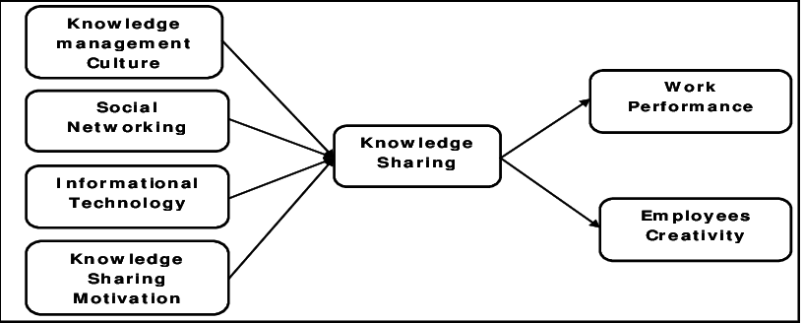
Figure 8: Knowledge Sharing Framework of Boots UK
Source: (Boots UK. 2019)
According to their knowledge sharing framework, Boots UK maintains a database related to the incidents and malfunctions within the organization. In this database, they record the adverse situations they have faced while operating business. They also record the reason for that incident and the way they have followed in handling that adverse situation. This provides a guideline to the employees when that situation shows up again. They follow transparency in performing their activities. Boots UK maintains a clear and transparent means of communication which opens the door for sharing knowledge among the employees. Employees find it easy to communicate with the experts as the company maintains a Knowledge map for their own. In the knowledge map, the list of experts is shown. As a result, employees can find an expert who can give the right solution to a particular problem. The company has its own knowledge base which helps the employees in finding and sharing knowledge. It provides employees with a knowledge sharing platform. Boots UK also maintains their own networking site where the employees can share their knowledge with others easily and quickly.

3.4. Recommended Improvements to the Current framework
An organization can ensure expanding their knowledge by creating a knowledge sharing environment within their organization. A knowledge sharing environment encourages employees to share their achieved knowledge to the other employees (Bones et al., 2019). Boots UK already has its knowledge sharing framework. Further improvements can be done for increasing its effectiveness. Boots UK can adopt the following strategies in sharing its knowledge sharing framework.
Developing Database
Boots UK has already there on database system for the employees which contain all the frequently ask problems by the employees. The employees can find solutions from the database whenever they face any problem. But that database is useful for general problems only (Fathi, 2013). They can develop the database so that the employees can get solution for more technical problems.
Developing Communication System
Boots UK can develop their communication system so that the employees can communicate with each other easily and can share their achieved knowledge with the other employees. Better communication can create a good relation among the employees (Hall, 2016). It can develop a relationship between the consumer and can make knowledge sharing process easier.
Expert-Locator System
Boots UK can maintain an expert-locator system which will show the employees who are expert in a specific area. It will help the employees in finding out the expert easily when there arises any adverse situation (Hislop, 2010). Expert locator system will help the employees in finding out the right information and knowledge that they are needed for handling a specific problem.

Conclusion
Knowledge management is the process, by which an organization creates, shares, uses and manages knowledge and information. Knowledge assets are the data, information, experience, knowledge and wisdom possessed by an organization (Jashapara, 2011). The modern business world has become much competitive than it was in previous years. To ensure competitiveness and sustainability in this competitive market, organizations need to increase their knowledge of the related field (Lehaney, 2014). Better knowledge management can help the organization in achieving its targeted success. A knowledge sharing culture needs to be established within the organization. There are some frameworks which can help in promoting knowledge sharing culture within the organization (Maier, 2010). It is necessary to ensure better management of organizational knowledge assets to ensure the competitiveness of Boots UK in the market.

Reference
Amine Chatti, M. (2012). Knowledge management: a personal knowledge network perspective. Journal of Knowledge Management, 16(5), pp.829-844.
Beijerse, R. (2010). Knowledge management in small and medium‐sized companies: knowledge management for entrepreneurs. Journal of Knowledge Management, 4(2), pp.162-179.
Bones, M., Makey, P., Duke, S. and Kiras, N. (2019). Knowledge management. Hessle (Hesslewood Hall, Hessle, East Yorkshire HU13 0JF): Butler Consulting Group.
Boots.com. (2019). [online] Available at: https://www.boots.com/webapp/wcs/stores/servlet/TopCategoriesDisplay?catalogId=28501&langId=-1&storeId=11352&webrewrite=Y&geoOpts=Y [Accessed 1 May 2019].
Fathi, M. (2013). Integration of practice-oriented knowledge technology. Berlin: Springer.
Hall, M. (2016). Knowledge management and the limits of knowledge codification. Journal of Knowledge Management, 10(3), pp.117-126.
Hislop, D. (2010). Knowledge management as an ephemeral management fashion?. Journal of Knowledge Management, 14(6), pp.779-790.
Jashapara, A. (2011). Knowledge management. Harlow, Essex: Pearson/Financial Times/Prentice Hall.
Lehaney, B. (2014). Beyond knowledge management. Hershey, Pa.: Idea Group.
Maier, R. (2010). Knowledge management systems. Berlin: Springer.
Morey, D. (2011). High‐speed knowledge management: integrating operations theory and knowledge management for rapid results. Journal of Knowledge Management, 5(4), pp.322-328.
Peel, J. (2012). Knowledge Management. Delhi: Orange Apple.

