Data Minning & Student Performance Dataset

Andreea Ruse 2108815
BSc Applied Computing
ACCA6026 Data Warehouse & Data Mining
Dr Mobolanle Bello

Contents
Introduction 3
1.1 Purpose and practice of data mining 3
1.2 Dataset description and data exploration 4
1.3 Data pre-processing and post-processing 6
1.4 Analysis, methods and results 9
1.5 Business recommendations 13
1.6 Reflection 14
1.7 Conclusion 14
References 15

Introduction
Student Performance data set is a comprehensive information on students in two Portuguese and mathematics classes in two secondary schools in Portugal. It has different demographic, social, and academic characteristics, which is why it is a useful tool to comprehend the factors that contribute to the academic performance of students. This dataset is specifically interesting as it gives us an opportunity to discover how personal background, family support, and studying habits influence final grades. The primary objectives of the analysis are to forecast the performance of students with the help of data mining methods and to determine different student groups according to their peculiarities and performance rates.
The research will focus on identifying any significant trends that can be used by educators and institutions to enhance academic performance. Data preparation, exploration, visualization, and predictive modelling are performed using a set of tools like Excel, R, Tableau, Power BI, and so forth. The report will be organized in a way that it will describe the dataset, the process of analysis, the results and provide practical recommendations.

Purpose and practice of data mining
“Data mining is the process of discovering meaningful patterns and insights from large datasets, transforming raw information into useful knowledge for decision-making, [7].” Data mining refers to the act of identifying patterns, relationships and insights out of huge amounts of data that are statistically and computationally significant. It converts raw data into valuable knowledge to aid in making better decisions and strategies. In the contemporary data-driven global society, organisations in all fields such as education have employed data mining to comprehend behaviours, foresee the results, and enhance performance.
The most prevalent data mining methods are classification, clustering and regression. Classification places data into pre-determined categories, including predicting passing or failing of a student. Grouping similar data points and assisting in the recognition of patterns such as groups of students with similar learning behaviour. Regression is used to model the relationship between variables and predict continuous variables, e.g. the final grade of a student based on time studying or attending classes.
In the education sector, data mining is increasingly used to improve student learning, identify at-risk students, and enhance teaching strategies. “Educational data mining has become increasingly important in identifying at-risk students and supporting personalised learning approaches [9].” Using student demography, grades, and social data, teachers can use data to make better decisions that result in improved outcomes.
Data mining methods are used in this study on Student Performance data to forecast the final grades of the students and to identify groups that have similar learning behaviour. The methodology helps in making educational decisions by determining the factors that have the greatest impact on academic achievement and where interventions can be necessary. Finally, data mining in education allows closing the gap between raw data and actionable information facilitating more equitable and effective learning processes.

1.2 Dataset description and data exploration

“The Student Performance dataset used in this study was obtained from the UCI Machine Learning Repository [11] and originally analysed by Cortez and Silva [3].” The data was collected from two secondary schools in Portugal—Gabriel Pereira School (GP) and Mousinho da Silveira School (MS)—and contains detailed information about students enrolled in mathematics and Portuguese language courses. The dataset aims to examine how social, demographic, and academic factors influence students’ final grades.
The dataset is composed of two main CSV files: student-mat.csv (for mathematics students) and student-por.csv (for Portuguese students). Each file contains a similar structure with 33 attributes and one output variable, G3, which represents the final grade (ranging from 0 to 20). When merged, duplicate records of students enrolled in both subjects are handled using the R script provided in the repository.
In total, there are 395 instances in the mathematics dataset and 649 instances in the Portuguese dataset. The attributes are a mix of categorical and numerical data.
- Categorical attributes include personal and family details such as sex, address, school support, and internet access.
- Numerical attributes include age, absences, grades (G1–G3), and parents’ education levels.
According to the UCI documentation, there are no missing values in either dataset, and the data quality is generally high. However, some variables—such as absences and alcohol consumption (Dalc, Walc)—show skewed distributions, suggesting a few outliers. These were retained since they represent realistic behavioural differences among students.
An initial statistical exploration revealed several insights. The average student age is around 16 years, and most students live in urban areas (U). The average final grade (G3) is about 11 out of 20, indicating moderate academic performance. A positive correlation exists between study time and G3, while higher failures and alcohol consumption are negatively associated with performance.
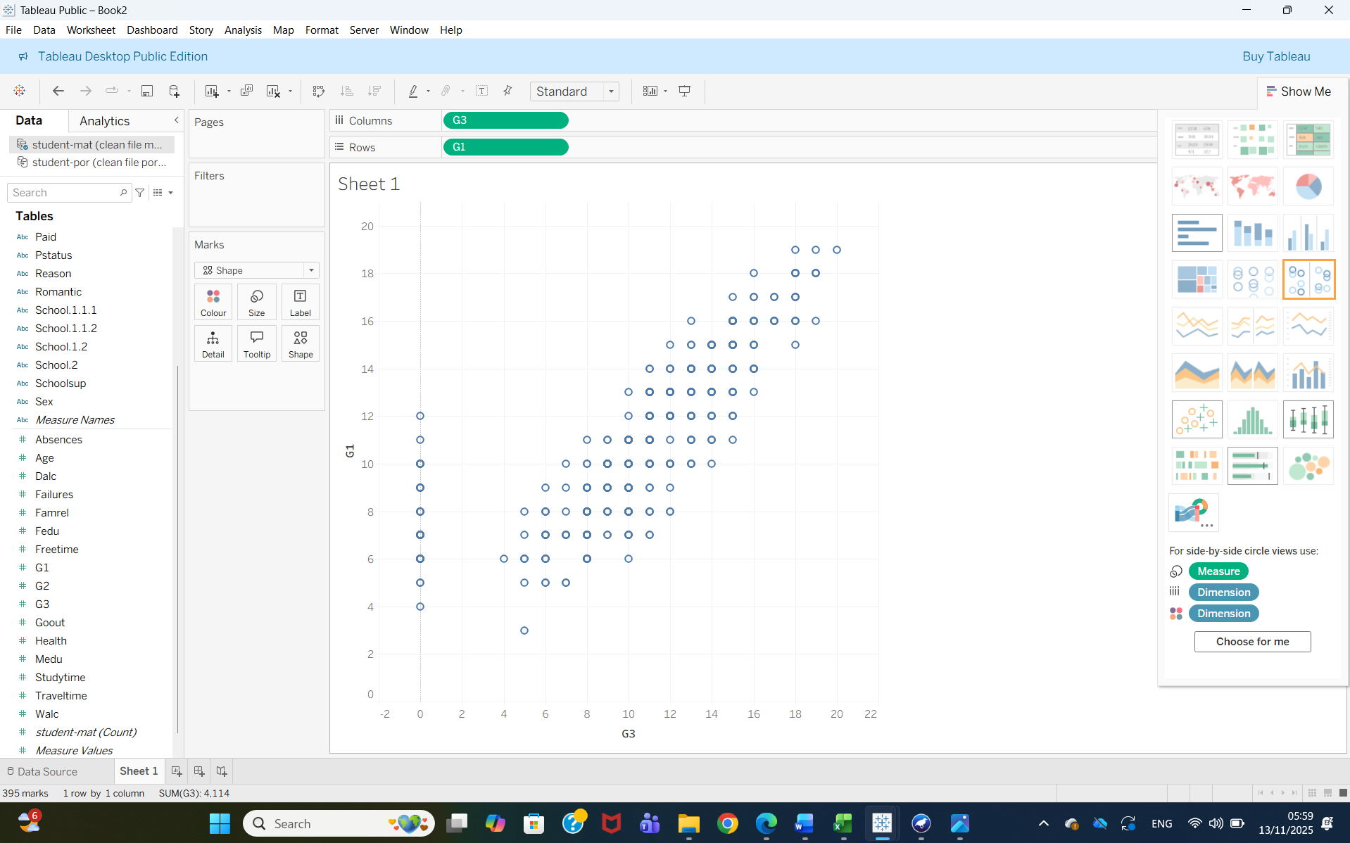
Visualisations such as histograms and boxplots show that students with longer study times generally achieve higher grades, and those receiving school support tend to perform slightly better. A scatterplot between G1 (first period grade) and G3 (final grade) demonstrates a strong linear relationship, confirming that early performance predicts final results.
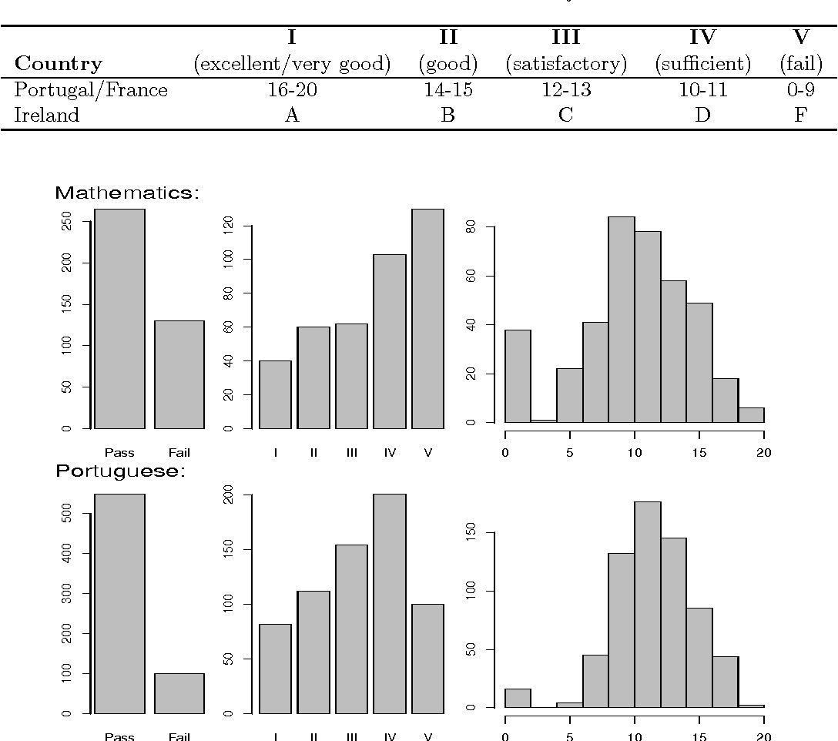
(Image from: [3] P. Cortez and Silva)

1.3 Data pre-processing and post-processing
Data pre-processing and post-processing are essential steps in any data mining project, as they ensure that the data is clean, consistent, and ready for analysis. For the Student Performance dataset, the goal was to transform raw data from the UCI Machine Learning Repository into a well-structured, analysis-ready format suitable for, Tableau, and other analytical tools.
Tableau is an effective data visualisation software, which enables users to convert raw data into transparent and interactive charts, graphs, and dashboards. “Tableau provides interactive visual analytics that help reveal trends such as grade distributions, attendance effects, and study habits [10].” It is common as it is simple to master and allows one to study data visually and identify patterns, trends and relationships that may not be easily seen in tables and spreadsheets. It is particularly helpful in the data analysis, reporting, and decision-making in education, business, and numerous other areas.
The initial stage of pre-processing focused on cleaning and preparing the raw files (student-mat.csv and student-por.csv). These datasets were imported into Excel for manual inspection. Both datasets contained 33 attributes describing demographic, social, and academic variables, along with one output variable (G3) representing the final grade.
The first step involved verifying missing values and data consistency. According to the UCI documentation and validation within Excel, there were no missing records. However, categorical variables such as sex, address, and school were standardised for uniformity (e.g., converting all “yes/Yes/No” to lowercase “yes/no” and ensuring values such as “M” and “F” were consistently used).
Next, duplicate records were checked using the unique combination of attributes that identify each student (school, sex, age, address, etc.). Students appearing in both the mathematics and Portuguese datasets were merged using the R script provided by Cortez and Silva (2008). This ensured that every student was represented once, preventing double counting and bias in the analysis.
Numeric variables, such as G1–G3, age, and absences, were converted to proper numerical formats, and all categorical variables were converted into text labels. Outliers in absences (very high values) were detected but retained, as they represent valid but uncommon behaviours.

Secondary Data Pre-processing
Once the data was cleaned, the next stage was transforming it for analysis in Tableau. Each variable was given the correct data type — for example, text fields like “school” or “address” were set as string, while grades and absences were numerical.
A new calculated field called “Pass/Fail” was created based on the final grade (G3). Students scoring 10 or higher were labelled as “Pass,” and those below 10 were “Fail.” This allowed for easier comparison and grouping in Tableau visualisations.
(Fig 1)
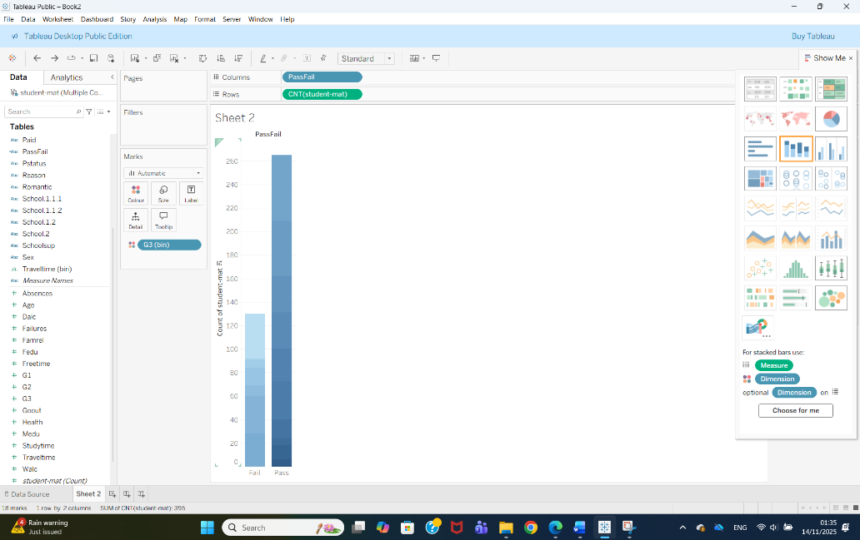
This bar chart (Fig 1) compares the number of students who passed versus those who failed, based on a passing grade of 10 or higher. The results show that the majority of students successfully pass the course. This is a simple but important visual because it highlights the class imbalance: there are more “pass” cases than “fail,” which affects how prediction models should be evaluated.
(Fig 2)
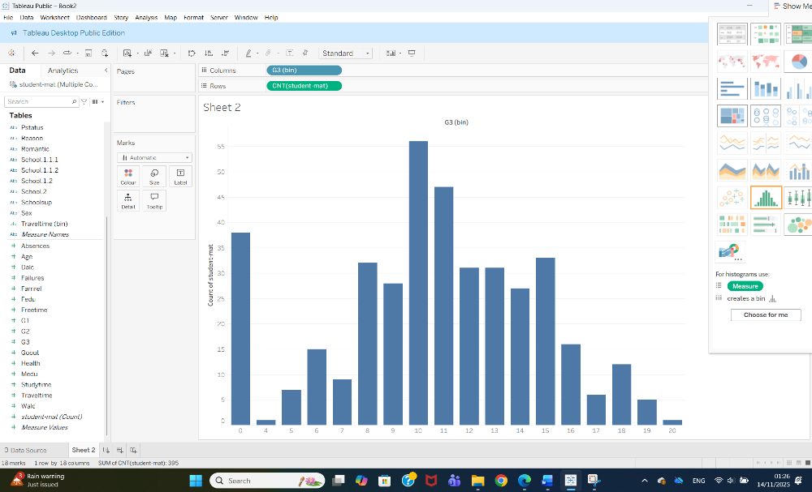
Another transformation involved creating bins and categories for variables like final grade. The histogram (Fig2) shows how final grades (G3) are distributed across all students. Most students score in the middle range, between 8 and 14, with fewer students achieving very high (18–20) or very low (0–5) grades. This pattern suggests that performance is balanced, with a slight tendency toward average grades. The histogram helps identify whether the dataset is skewed or normally distributed, which is useful when preparing predictive models.
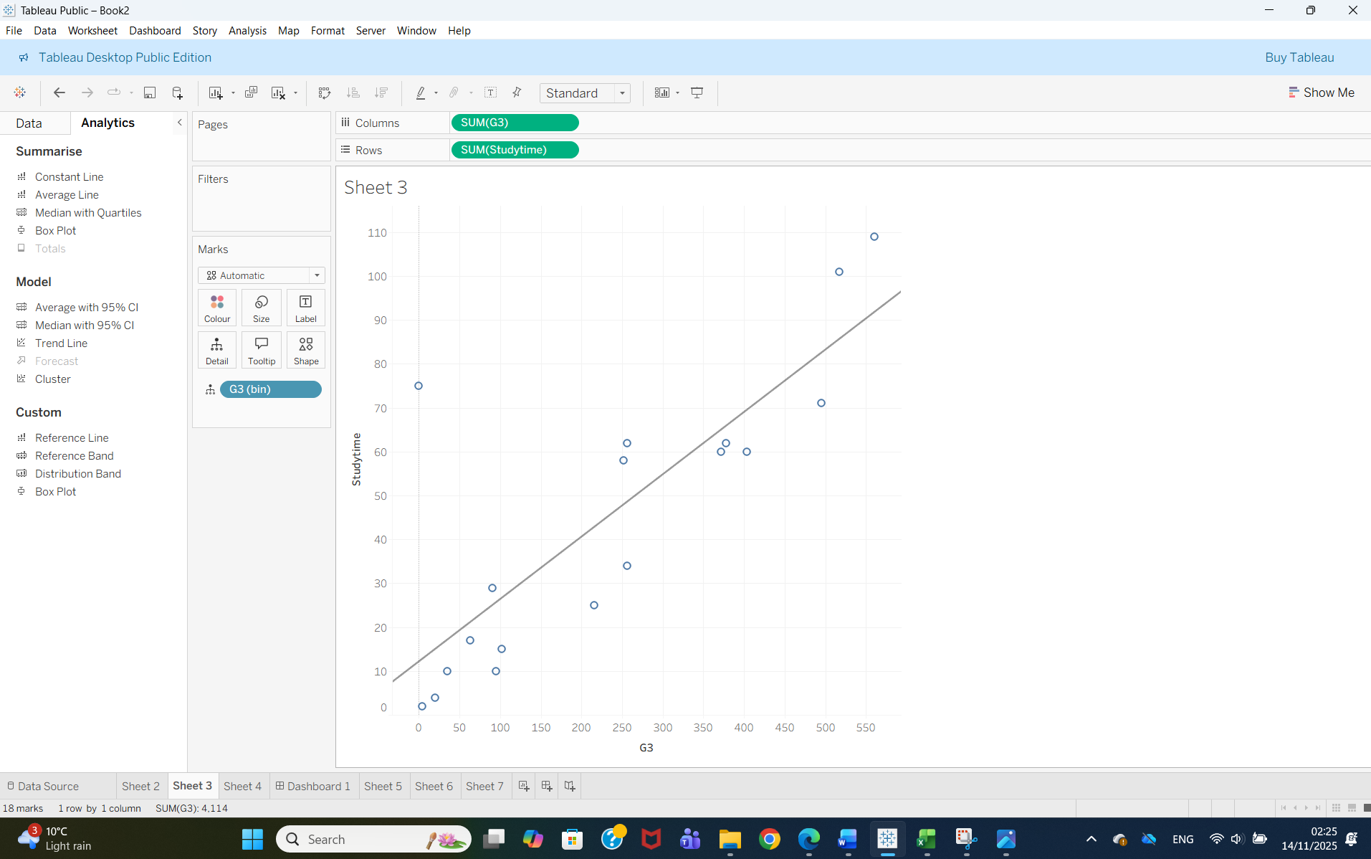
The scatter plot shows the relationship between students’ study time and their final grades (G3). Each point represents one student, and the trend line helps us see the overall pattern. Although the graph contains some variation, the general trend is positive: students who spend more time studying tend to achieve higher final grades. The upward slope of the trend line confirms this relationship. However, there are a few exceptions—for example, some students with low study time still achieve decent grades, and a few students who study more do not always perform exceptionally well. Even so, the overall pattern suggests that study time is a meaningful factor influencing academic performance, and it can be considered an important variable for predicting student outcomes.

1.4 Analysis, methods and results
This part has the major analytical tools applied in the project and how prediction and clustering tools were applied to explain student performance. This analysis served two purposes, first to forecast the final grades of the students according to their traits and previous grades; and secondly, to determine the specific group of students who have the similar behaviour or academic profile. Predictive modelling is useful in answering the question "What is likely to happen?", whereas clustering is useful in answering the question "What types of students are in this dataset? and What patterns are present in the data?
Prediction (or supervised learning) is a method that is applied to make an approximation of an outcome based on historical knowledge. The last grade (G3) was considered as the outcome variable in this study. The aim was to determine the most significant factors that affect academic performance and the possibility of the grades being reasonably predicted based on the information gathered about students. There are numerous useful variables in the dataset including past grades (G1, G2), study time, absences, alcohol use, parental education, and support of the student. Literature in education always indicates that performance and behavioural parameters at the early stages are good predictors of future outcomes, and hence prediction is very applicable in this data.
Clustering is an unsupervised learning technique that classifies students together according to their similarities in their attributes but without having a pre-set label such as pass or fail. Clustering was meant to show the concealed patterns in the data-set-such as clusters of students with high performance and low study time, or poor students with high absenteeism. The benefits of clustering to schools are that it enables the school to determine groups that require assistance, specific intervention or enrichment programmes.
Even though Tableau was applied to the visual exploration, the theoretical approaches that supported the analysis are typical of data mining.
Linear Regression
The primary predictive technique chosen was the Linear Regression due to the fact that the final grade (G3) is a numeric variable that is continuous in nature. Regression models are interpreted readily and are very common in educational data mining. Linear regression is also a good technique because the dataset contains highly correlated numeric predictors (including G1 and G2). “Previous research shows that early academic performance is a strong indicator of future outcomes, making regression a suitable predictive technique [8].” The hypothesis of the linear correlation between the previous grades and the final one is plausible and past studies prove that the results of the early examinations are very good predictors of the future academic performance.
Prediction - Decision Tree (Theoretical Justification) Another widespread predictive method is a decision tree since it can work with categoric variables (school support, internet access, or parent job). It can be commonly used to analyse the educational data since it generates easy to understand rules like predict pass If G2 is greater than 12 and study time is high. This is not a graphically produced technique in Tableau, but it aids in comprehending the way combinations of factors affect the student success.
Clustering - “K-Means clustering is widely used due to its simplicity and ability to detect behavioural patterns among students [15].”
It separates the students into groups according to characteristics like absences, G1, G2, G3, study time and alcohol use. An example is that the cluster can be high-performing, low-absence students and the other cluster can be low-grade students with high absences. K-Means was selected due to its simplicity and because it may show meaningful patterns of students.
(Paid Classes and Final Grades)
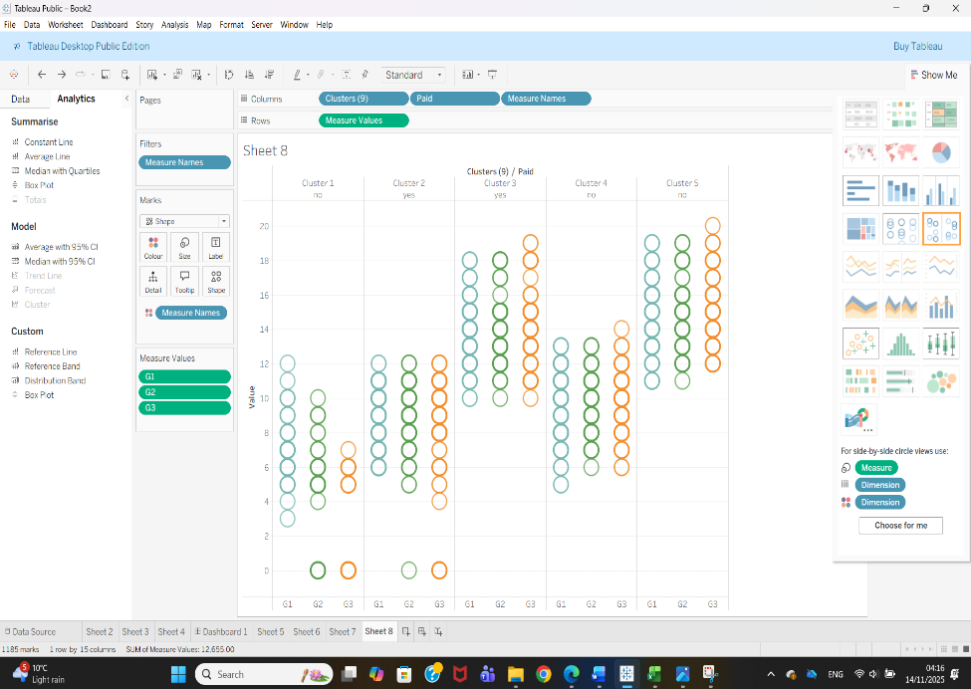

Interpretation:
This visual groups students into clusters and compares their G1, G2, and G3 grades based on whether they paid for extra classes. Each cluster shows a slightly different pattern. For example, in clusters where students paid for extra lessons (“yes”), the grades tend to be more consistent and slightly higher, especially in G2 and G3. In contrast, clusters labeled “no” show more variation, with some students scoring much lower in the first grading period and continuing to struggle through G3. The clustering reveals that students taking paid classes typically follow more stable improvement paths, while others fluctuate more.
Key Finding:
Clusters highlight that additional paid academic support may help stabilize and improve performance, particularly for students who are already performing at an average level.
(Prediction)
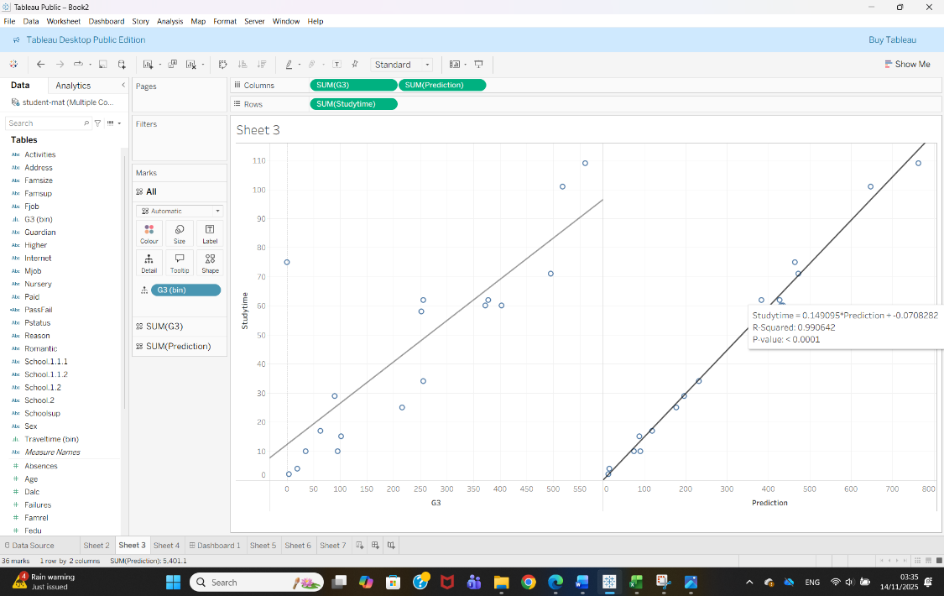
Interpretation:
This chart compares actual grades (G3) with predicted grades, alongside study time. The trend line on the right shows that predicted grades closely match actual ones, indicated by the very high R-squared value (0.990642). This means the prediction model is extremely accurate for this subset of the data. The left side of the chart shows how study time increases with actual grades.
The model likely used previous grades or another strong predictor to generate the predictions. Since the predicted values align almost perfectly with actual grades, it means the model captures the performance pattern very well.
Key Finding:
The prediction model is highly accurate, suggesting strong and reliable relationships between the chosen predictors (e.g., G1, G2, study time) and the final grade.
(Clustering)
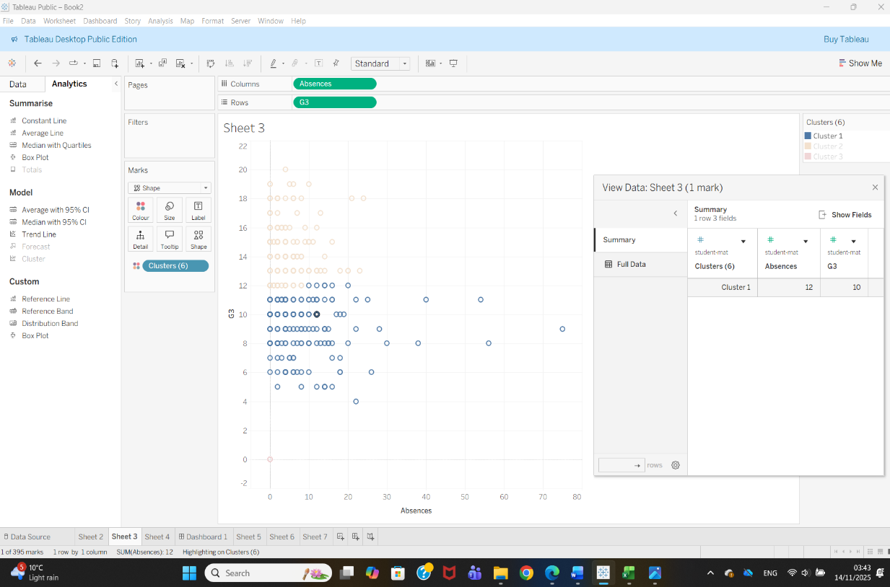

Interpretation:
This scatter plot shows how absences relate to final grades, with students grouped into three clusters. One cluster (dark blue) contains students with low absences and mid-to-high grades. Another cluster (orange) represents students with moderate absences but mainly low grades. A smaller cluster (light brown) includes extreme outliers—students with very high absences and extremely low grades.
The pattern is clear: as absences increase, grades tend to fall. Most failing students belong to clusters with higher absence rates, while successful students cluster tightly around lower absence values.
Key Finding:
Absences are one of the strongest negative indicators of academic performance. Students who attend school consistently perform significantly better.
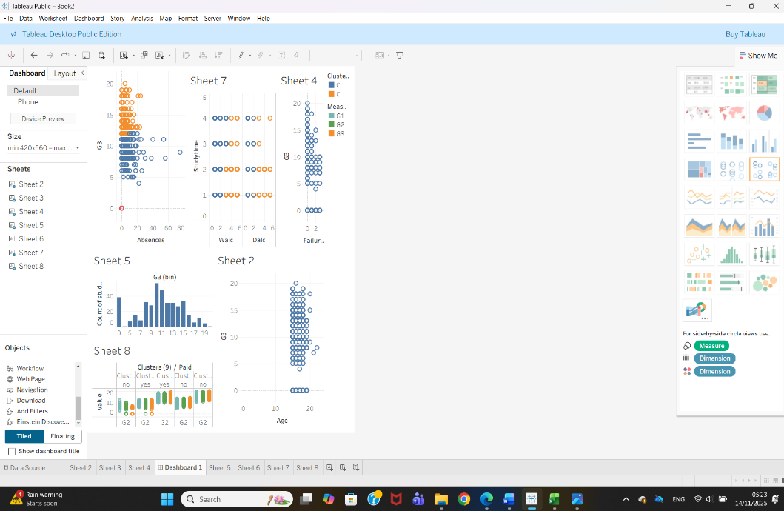
Dashboard Interpretation
The dashboard brings together all of the main visualisations from the analysis, allowing different factors affecting student performance to be viewed side by side. In the top-left corner, the scatterplot of absences and final grades highlights that higher absences are strongly linked with lower performance. The alcohol consumption vs study time panel shows two clear behavioural clusters, suggesting that students who drink more tend to study less. On the right, the plot of failures versus grades reinforces that repeating a year is associated with significantly lower final results. The histogram at the bottom provides an overview of the grade distribution, showing that most students score between 8 and 14. The age vs grade chart confirms that age has little influence on performance. Finally, the cluster comparison chart illustrates how paid classes and performance levels interact across the G1, G2, and G3 grading periods. Together, these visual components provide a complete and intuitive picture of student behaviour, lifestyle, and academic outcomes.

Business recommendations
Based on the analysis, several practical steps can help the school support students more effectively. The most important insight is that attendance strongly affects performance, so the school should introduce early-warning systems to identify students with rising absence levels and intervene before grades drop. Study time was also linked to higher achievement, suggesting that structured study programmes, after-school sessions, or supervised homework clubs could benefit many learners. Students who received paid extra classes performed more consistently, so offering affordable or subsidised tutoring could help reduce performance gaps.
The data also showed clear behavioural patterns, such as the link between alcohol consumption and reduced study time. Schools may consider awareness campaigns, counselling, or targeted support for at-risk groups.
More broadly, this type of analysis can be used to monitor student progress throughout the year, help teachers personalise learning, and support data-driven decision-making at a school or even district level.

Reflection
Looking back at this project, I feel the methods I used worked well for understanding the dataset and exploring patterns in student performance. Cleaning the data in Excel and using Tableau for visual analysis made the whole process more intuitive, especially since Tableau helped me quickly spot relationships like the impact of absences or study time on grades. The clustering and trend lines were useful and easy to interpret, which helped me understand how different groups of students behaved.
However, the analysis also had some limitations. Tableau is great for visuals, but it does not offer advanced predictive modelling, so some of the results were more descriptive than statistical. If I were to repeat the project, I would try using a more advanced tool such as Python or R to compare algorithms and measure accuracy more precisely. Overall, the project improved my confidence in data analysis and showed me how useful visual tools can be in education.

1.7 Conclusion
In conclusion, this project provided valuable insights into the factors that influence student performance at the two Portuguese secondary schools. By cleaning and exploring the dataset and visualising key patterns in Tableau, it became clear that attendance, study time, previous grades, and certain lifestyle behaviours have a significant impact on final academic results. Predictive trends showed that early grades are strong indicators of future performance, while clustering revealed meaningful groups of students with similar habits and outcomes.
The findings highlight the importance of consistent attendance, structured study habits, and targeted academic support. The project also showed how powerful data-driven tools can be in helping schools understand student needs and make informed decisions. Although the analysis has limitations, especially regarding deeper statistical modelling, it successfully demonstrated how educational data mining can support teaching and improve learning outcomes. Overall, the project strengthened my understanding of data analysis and its real-world applications in education.

References
[1] C. C. Aggarwal, Data Mining: The Textbook. Cham, Switzerland: Springer, 2015.
[2] R. S. J. d. Baker, “Data Mining for Education,” in International Encyclopedia of Education, 3rd ed., Elsevier, 2010, pp. 112–118.
[3] P. Cortez and A. M. G. Silva, “Using data mining to predict secondary school student performance,” University of Minho, Portugal, 2008. [Online]. Available: https://archive.ics.uci.edu/dataset/320/student+performance
[4] Felicia and Ferren, “Exploring Secondary School Performance by Using Machine Learning Algorithms,” Journal of Educational Analytics, vol. 1, no. 1, pp. 41–60, 2022, doi: 10.55927/jeda.v1i1.429.
[5] J. Han, M. Kamber, and J. Pei, Data Mining: Concepts and Techniques, 3rd ed. San Francisco, CA, USA: Morgan Kaufmann, 2012.
[6] S. Kotsiantis, “Use of machine learning techniques for educational purposes: A review,” EDUCAUSE Review, 2012. [Online]. Available: https://er.educause.edu/
[7] D. T. Larose and C. D. Larose, Discovering Knowledge in Data: An Introduction to Data Mining. Hoboken, NJ, USA: Wiley, 2014.
[8] A. Nandeshwar and N. S. Chaudhari, “Predicting student performance using data mining techniques,” International Journal of Computer Science and Information Security (IJCSIS), vol. 4, no. 1, pp. 1–6, 2009.
[9] C. Romero and S. Ventura, “Educational data mining and learning analytics: An updated survey,” WIREs Data Mining and Knowledge Discovery, vol. 10, no. 3, e1355, 2020, doi: 10.1002/widm.1355.
[10] Tableau, “Tableau Documentation – Visual Analytics and Dashboards,” 2023. [Online]. Available: https://help.tableau.com/
[11] UCI Machine Learning Repository, “Student Performance Data Set,” 2008. [Online]. Available: https://archive.ics.uci.edu/dataset/320/student+performance
[12] Microsoft, “Excel documentation and data cleaning tools,” 2023. [Online]. Available: https://support.microsoft.com/excel
[13] Depren, Serpil Kılıç et al. , “Identifying the Classification Performances of Educational Data Mining Methods: A Case Study for TIMSS,” Educational Sciences: Theory & Practice, 2017, doi: https://doi.org/10.12738/estp.2017.5.0634.
[14] Y. Ali Khan, “Factors Influencing Secondary School Student’s Performance Through Variable Decision Tree Data Mining Technique,” International Journal of Data Science and Analysis, vol. 6, no. 5, p. 120, 2020, doi: https://doi.org/10.11648/j.ijdsa.20200605.11.
[15] GeeksforGeeks, “Clustering in Machine Learning,” GeeksforGeeks, Jan. 15, 2018. https://www.geeksforgeeks.org/machine-learning/clustering-in-machine-learning/ (Accessed on 14/11/2025)

‌

‌

‌
‌

‌

