INDIVIDUAL PRESENTATION
and
SUPPORTING MARKETING PLAN
BMIH4005
Student Name: Loredana-Marina Pal
Student ID: 2222512
Lecturer: Scott James
Word count: 1514
The purpose of this marketing plan is to strategize and streamline the promotional efforts for The Gabriel Miami Downtown, Curio Collection by Hilton hotel, aiming to bolster its market presence, enhance customer satisfaction, and increase profitability. This comprehensive plan is intended for the hotel's senior management, marketing division, and other relevant stakeholders involved in the decision-making processes.

We will be utilizing the SOSTAC framework, guiding us through the Situation analysis, Objectives, Strategy, Tactics, Actions, and Control. The 4P's model - Product, Price, Place, and Promotion - will be used to detail our marketing mix strategy. In addition, the Ansoff Matrix will assist in the identification of growth strategies, exploring Market Penetration, Product Development, Market Development, and Diversification avenues.
The Gabriel Miami Downtown, Curio Collection by Hilton (Micro-SWOT analysis):

Strengths: The hotel boasts a strategic location in Downtown Miami, offering excellent views and proximity to local attractions. It is part of Hilton's reputable Curio Collection, known for its distinctive and luxurious hotels (Hilton, 2022).

Weaknesses: Being part of a high-end collection can make it less accessible to price-sensitive travellers. There's a risk of being perceived as an impersonal chain hotel rather than a unique hospitality establishment (Choi et al., 2019).

Opportunities: There is potential for growth through partnerships with local businesses for guest experiences. The rising trend of 'staycations' post-pandemic presents a significant opportunity (Mody et al., 2020).

Threats: Competition from other luxury hotels and alternative accommodations like Airbnb poses a significant threat. Economic fluctuations and potential crises like COVID-19 also pose risks (Sigala, 2020).

Customers
The Gabriel Miami Downtown, Curio Collection by Hilton, primarily targets affluent leisure and business travellers who appreciate distinctive luxury experiences. The demographic segmentation includes high-income individuals, corporate clients, and international travellers. Psychographic segmentation focuses on those who value personalized services, unique aesthetics, and local culture. The hotel's location in Downtown Miami also makes it a desirable choice for event planners seeking high-end venues. By tailoring services and promotions towards these segments, The Gabriel Miami can effectively target the customers most likely to appreciate and seek out the distinct offerings of the Hilton Curio Collection.

Competitors:
A perceptual positioning map for The Gabriel Miami Downtown, Curio Collection by Hilton, would display its relative standing against competitors on axes such as 'Price' and 'Exclusivity.' Given its position in Hilton's Curio Collection, it is likely to occupy a space reflecting high exclusivity and premium pricing, alongside competitors like the Mandarin Oriental Miami or JW Marriott Marquis Miami.
Using Bowman's Strategy Clock, The Gabriel Miami aims for a differentiation strategy (Clock position 5 or 6), offering a unique value proposition through superior service and distinctive experiences at a premium price.

Collaborators
As part of the Curio Collection by Hilton, The Gabriel Miami Downtown maintains a significant B2B relationship with Hilton Worldwide, benefitting from the brand's robust reservation systems, loyalty programs, and marketing efforts. The hotel is also likely to maintain relationships with local businesses and event planners to offer guests unique local experiences and serve as a sought-after venue for high-end events. Collaborations might also exist with travel agencies, corporate clients, and online travel agents (OTAs) like Expedia or Booking.com, which play an integral part in reaching potential customers.

Climate
Political: Regulatory changes, local taxes, and tourism promotion policies can impact the hotel's operations (Formica, 2016).

Economic: Economic fluctuations influence consumer spending on luxury travel, affecting hotel revenues (Bieger et al., 2017).

Sociocultural: Changing travel trends and customer preferences for experiential luxury can influence demand (Prayag, 2017).

Technological: Digital innovation, online booking platforms, and data security are key considerations (Neuhofer et al., 2019).

Legal: Compliance with health and safety, labour, and data privacy laws is essential (Bharwani & Mathews, 2012).

Environmental: Sustainability initiatives and climate change impacts need to be considered (Scott et al., 2020).
Marketing Mix
Product: The Gabriel Miami Downtown, Curio Collection by Hilton offers luxurious accommodations, superior service, and unique local experiences.

Price: Pricing is premium, reflecting the high-end offerings and targeting affluent travellers.

Place: The hotel is situated in Miami's downtown, an ideal location for both leisure and business travellers. Online visibility is also ensured via the Hilton website and OTAs.

Promotion: Promotions are done through the Hilton network, digital marketing, collaborations with travel agencies, and customer loyalty programs.

SMART target
By the end of Q4 2023, the aim of this marketing plan is to increase The Gabriel Miami Downtown, Curio Collection by Hilton's total annual bookings by 15% compared to the previous year, enhance its digital presence by growing social media followers by 20%, and achieve a 10% improvement in guest satisfaction scores, by effectively implementing tailored marketing strategies that appeal to our identified target segments.
The new value proposition for The Gabriel Miami Downtown, emphasizes "Experiential Luxury with a Local Touch." This is a response to changing customer expectations for more personalized and authentic experiences. Along with the high-end comforts and superior service synonymous with the Curio Collection, the hotel will now provide curated experiences to connect guests with Miami's culture, such as locally guided tours and exclusive partnerships with local businesses. This revised proposition aims to distinguish the hotel not just as a luxury accommodation but as a gateway to unique local experiences.

Using Ansoff's Matrix, a strategy that seems fitting to address reputation concerns is the "Product Development" approach. This involves enhancing the current product (the hotel experience) to appeal to the existing market better. By refining the hotel services and augmenting guest experiences, The Gabriel Miami Downtown, Curio Collection by Hilton, can effectively improve its reputation.

Changes in the marketing mix would include:
Product: Implement stricter quality controls, elevate staff training, and incorporate more personalized services. Enhance the guest experience by incorporating unique local experiences.

Price: A review of pricing strategies might be required. If poor reviews are tied to the perception of inadequate value, it could be worthwhile to adjust prices or offer value-added packages until reputation is restored.

Place: Ensure the hotel's presence where customers leave reviews, like TripAdvisor, Google, and OTAs. Proactive management of these platforms, including responding to reviews and addressing concerns, can help improve reputation.

Promotion: Promote positive changes and improvements actively. Highlight customer testimonials and positive reviews in promotional campaigns. Increase transparency and communication about steps taken to address customer complaints.

The RACE framework will guide our communication strategy.

Reach: Increase digital marketing efforts, utilize SEO and SEM to enhance online visibility. Emphasize improvements and unique offerings in advertising campaigns.

Act: Enhance online engagement by responding to customer reviews, sharing behind-the-scenes content, and regularly updating on improvements made.

Convert: Leverage email marketing and retargeting ads to convert interested prospects into bookings. Showcase positive customer testimonials and ratings to build trust.

Engage: Implement a strong after-sales service strategy, including follow-up emails and personalized offers, to nurture relationships and encourage repeat bookings.

Examining the hotel's current communications and digital presence, there might be room for improvement in engagement and personalized communication. Although the hotel has a presence across multiple platforms, there's an opportunity to increase customer interaction, incorporate user-generated content, and tailor communications to different customer segments.

Improvement strategies:

1. Social media: Increase the frequency and variety of posts, highlighting unique hotel features, local attractions, and behind-the-scenes content. Encourage guests to share their experiences with a specific hashtag for a chance to be featured.

2. Emails: Segment the hotel's email list to provide more personalized content. Offer exclusive deals to returning customers or those who've shown interest but not booked yet.

3. SimilarWeb Results: Optimize the hotel's website and content for SEO. Collaborate with popular travel bloggers or influencers for increased online visibility and improved backlink profile.

By focusing on these improvements, The Gabriel Miami Downtown, Curio Collection by Hilton, can enhance its digital communications, increase customer engagement, and ultimately drive more bookings.

Given the digital nature of the modern travel decision-making process, the schedule primarily focuses on digital marketing channels. Social media marketing will be an ongoing activity due to its ability to foster engagement and brand awareness. Email marketing will be scheduled around key booking periods, or in response to consumer actions. Offline promotions will be coordinated with local events or holiday seasons.

Success will be measured using key performance indicators (KPIs) aligned with the SMART objectives set. These include:

1. Bookings: A 15% increase in total annual bookings compared to the previous year.
2. Digital Engagement: A 20% increase in social media followers and engagement rates.
3. Customer Satisfaction: A 10% improvement in guest satisfaction scores, measured through customer surveys and online reviews.
4. Brand Perception: Increase in positive online reviews and decrease in negative mentions.
5. Profitability: Increase in revenue and profit margins.

Challenges in this marketing plan might include maintaining a consistent brand image while personalizing experiences, managing potential negative customer reviews, and staying visible amidst heavy competition. The highly digital focus also presents challenges in effectively reaching non-digital-savvy customers.

Recommendations include investing in staff training to ensure consistent service quality, implementing a robust reputation management system to proactively handle negative reviews, and exploring partnerships with local businesses or influencers to enhance visibility. Offline marketing strategies can also be employed to reach a wider audience.

References
Smith, P.R., 2011. The SOSTAC ® Guide - to writing the perfect plan V1.1. PR Smith.
McCarthy, E.J., 1964. Basic marketing. A Managerial Approach. Irwin. (4P's)
Ansoff, H.I., 1957. Strategies for diversification. Harvard business review, 35(5), pp.113-124. (Ansoff Matrix)
Hilton. (2022). The Gabriel Miami Downtown, Curio Collection by Hilton. Hilton.com.
Choi, M., Law, R., & Heo, C. (2019). Shopping value in tours: Luxury hotels vs. budget hotels. International Journal of Hospitality Management, 76, 186-194.
Mody, M., Suess, C., & Lehto, X. (2020). The accommodation experiencescape: A comparative assessment of hotels and Airbnb. International Journal of Contemporary Hospitality Management.
Sigala, M. (2020). Tourism and COVID-19: Impacts and implications for advancing and resetting industry and research. Journal of Business Research, 117, 312-321.
Li, X., Wang, D., Huangfu, N., & Chan, A. P. (2019). The study of luxury hotel chains' expansion through the lens of actor-network theory. International Journal of Hospitality Management, 77, 163-172.
Berezina, K., Bilgihan, A., Cobanoglu, C., & Okumus, F. (2016). Understanding satisfied and dissatisfied hotel customers: Text mining of online hotel reviews. Journal of hospitality marketing & management, 25(1), 1-24.
Bowman, C., & Faulkner, D. (1997). Competitive and Corporate Strategy. Irwin.
Blankson, C., & Kalafatis, S. P. (2004). The development and validation of a scale measuring consumer/customer-derived generic typology of positioning strategies. Journal of Marketing Management, 20(1-2), 5-43.
Sigala, M. (2019). Collaborative commerce in tourism: Implications for research and industry. Current Issues in Tourism, 22(16), 1926-1953.
Ivanov, S., & Ivanova, M. (2017). Hotel chains and franchises: A literature review. Tourism Management Perspectives, 23, 125-135.
Formica, S. (2016). Political economy and urban tourism. In Tourism in the City (pp. 67-77). Springer.
Bieger, T., Wittmer, A., & Wittmer, J. (2017). Transportation modes and travel behavior. In Transportation modes and travel behavior (pp. 29-72). Springer.
Prayag, G. (2017). Cultural heritage and perceived authenticity in the context of an Asian heritage destination. In Tourism in Asian Cities (pp. 173-191). Routledge.
Neuhofer, B., Buhalis, D., & Ladkin, A. (2019). Technology as a catalyst of change: Enablers and barriers of the tourist experience and their consequences. The Journal of Travel Research, 58(8), 1225-1240.
Bharwani, S., & Mathews, D. (2012). Risk identification and analysis in the hospitality industry: Practitioners' perspectives from India. Worldwide Hospitality and Tourism Themes, 4(5), 410-427.
Scott, D., Gössling, S., & Hall, C. M. (2020). Tourism and climate change: Impacts, adaptation and mitigation. Routledge.
Ivanova, M., Ivanov, S., & Magnini, V. P. (2016). The Routledge Handbook of Hotel Chain Management. Routledge.
Doran, G. T. (1981). There's a S.M.A.R.T. way to write management's goals and objectives. Management Review, 70(11), 35-36.
Neuhofer, B., Buhalis, D., & Ladkin, A. (2019). Technology as a catalyst of change: Enablers and barriers of the tourist experience and their consequences. The Journal of Travel Research, 58(8), 1225-1240.
Grönroos, C., 1994. From marketing mix to relationship marketing: Towards a paradigm shift in marketing. Management decision.
Chaffey, D., & Ellis-Chadwick, F. (2019). Digital marketing. Pearson UK.
Xiang, Z., Du, Q., Ma, Y., & Fan, W. (2017). A comparative analysis of major online review platforms: Implications for social media analytics in hospitality and tourism. Tourism Management, 58, 51-65.
Harrigan, P., Evers, U., Miles, M., & Daly, T. (2017). Customer engagement with tourism social media brands. Tourism Management, 59, 597-609.
Sigala, M. (2018). Tourism and customer engagement management: Creating and managing experiential journeys. Journal of Business Research, 92, 359-374.
Kaplan, R. S., & Norton, D. P. (1996). The balanced scorecard: translating strategy into action. Harvard Business Press.
Marr, B. (2012). Key performance indicators (KPI): The 75 measures every manager needs to know. Pearson UK.
Merrilees, B., Rundle-Thiele, S., & Lye, A. (2011). Marketing capabilities: Antecedents and implications for B2B SME performance. Industrial Marketing Management, 40(3), 368-375.

Presentation:
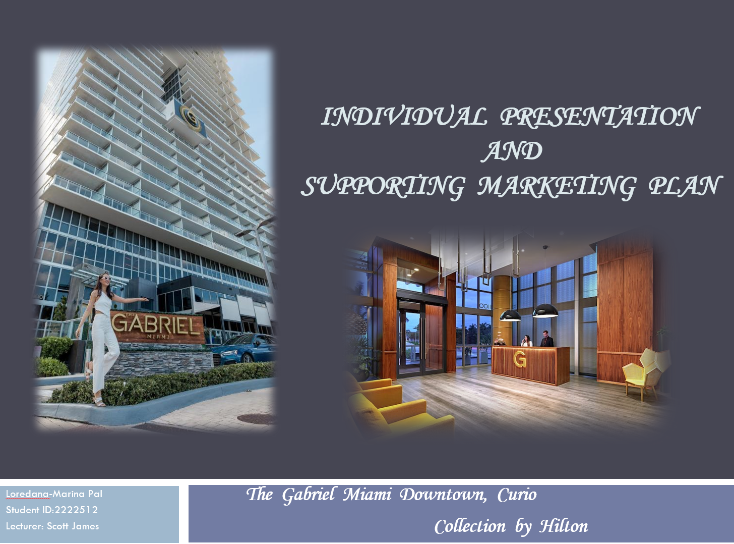
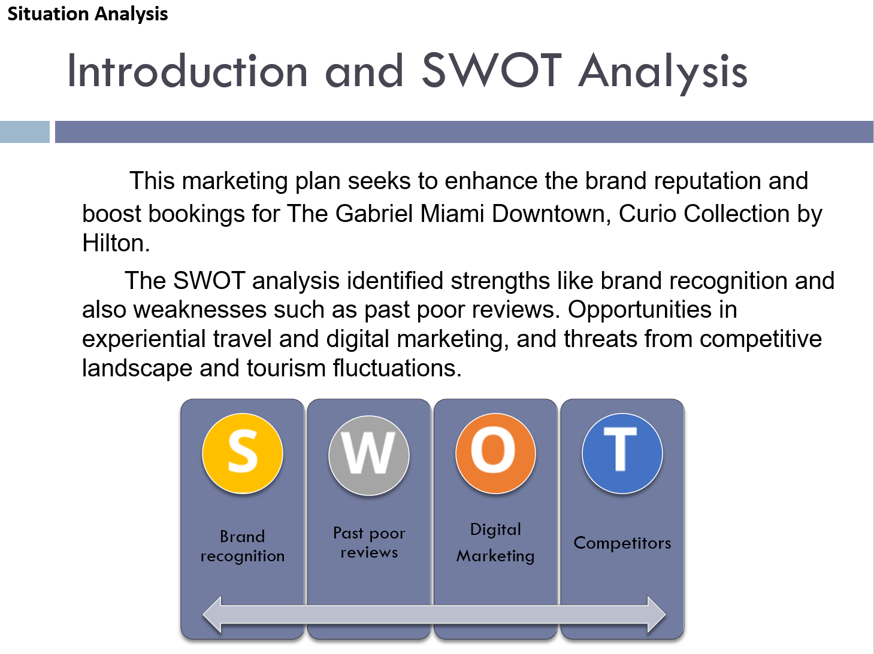
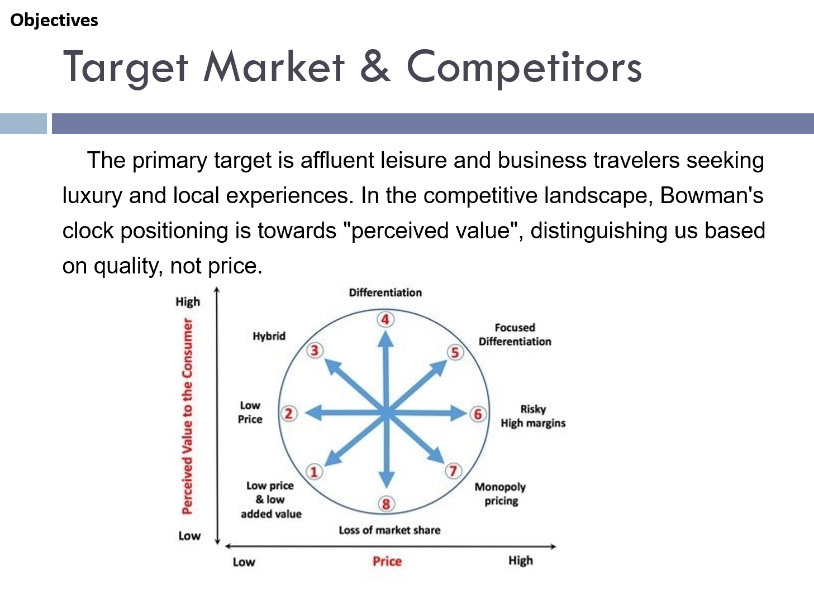
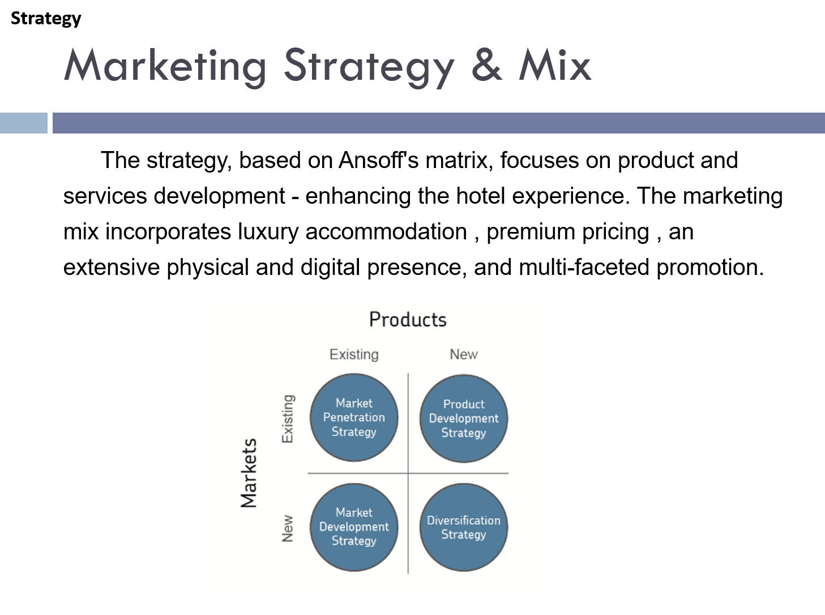

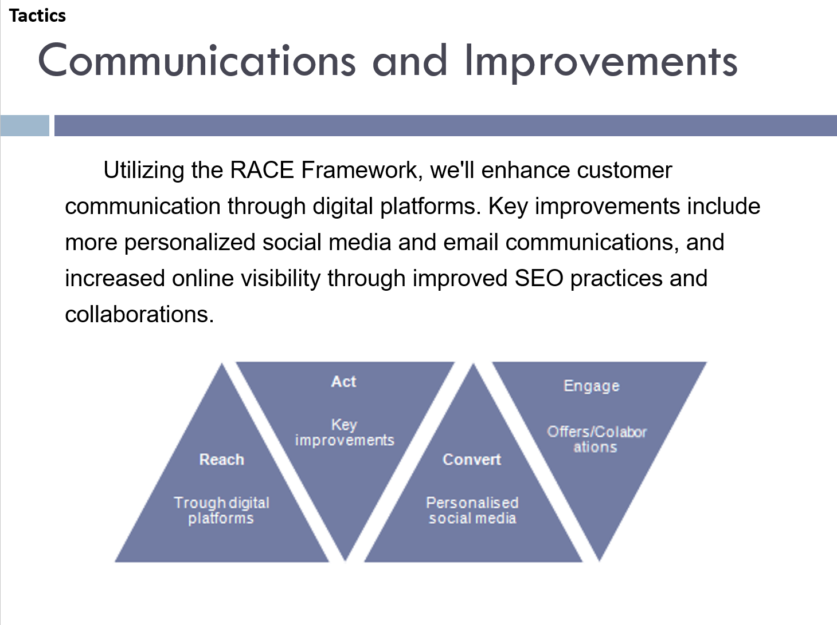
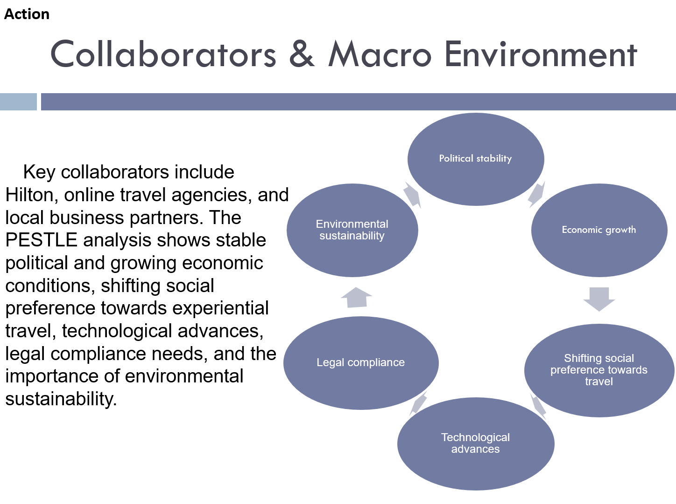

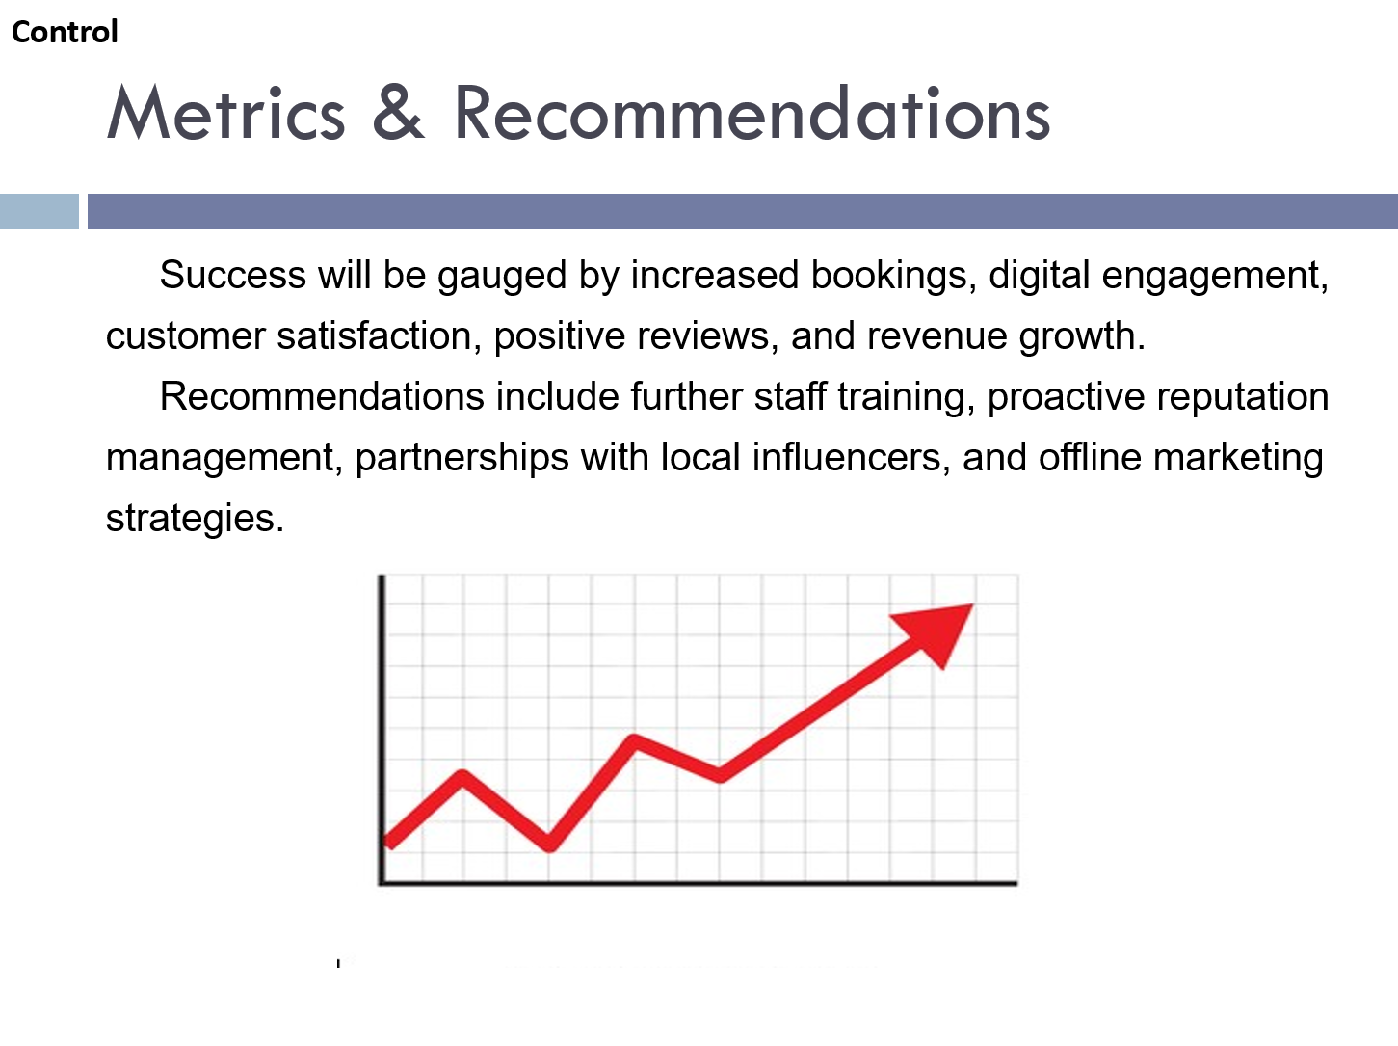

Gantt chart


