Problem
Analysis and Solution
Development

Module Name: Analysing and Solving Problems
Module Code: ACCA 4019
Student Name: Liliana Stryzhakovska
Student ID: 2518099
Group:1
Lecturer’s Name: Dr. Fahad Ahmed

Table of Contents
Table of Contents 1
1. Introduction 2
2. Deconstruct the Problem 2
2.1 MoSCoW Technique Requirement 2
2.2 Variables Identification 2
3. Proposed Solution 2
3.1 Flowchart 2
3.2 Flowchart Explanation 2
4. Reflection and Justification 2
4.1 Abstract thinking 2
4.2 Sub-dividing 2
4.3 Justification of solution 2
4.4 Limitation 2
4.5 Assumption 2
5. Conclusion 2
References 2

Introduction
Group work is a central part of every college computing course. It gives students valuable practice in teamwork, communication, and sharing tasks, skills that are essential for future jobs in technology. However, arranging regular meetings is one of the most common problems students face today. Most computing students have different timetables, part-time jobs, family duties, and personal plans that rarely match up perfectly. When meetings cannot be arranged easily, groups often run late with their work, some members end up doing far more than others, and the quality of the final project suffers.
This issue is not just about inconvenience, and it directly affects how well students learn and how they are graded. Tutors often assess group work on how well the team collaborates and communicates, not just the final code or report. When meetings are missed or rushed, it becomes much harder to discuss ideas, test code together, or fix mistakes before the deadline. This report will break down the problem clearly, design a simple step-by-step solution that anyone can use, and explain why this approach works well for students. It uses well-known planning methods and follows all the requirements given in the assignment.
For computing projects, meetings are extra important because you often need to code together, share screens, test programs, and agree on how to build your work. If you cannot meet, it is much harder to spot mistakes, split tasks fairly, or make sure everyone’s code works together. This leads to last-minute panic, rushed work, and lower marks.

Deconstruct the Problem

MoSCoW Technique Requirement

The MoSCoW method helps us focus on what will actually make the solution work, instead of getting distracted by extra features that do not help the main goal [1].

Category | Requirements
Must have | • Find times that work for all group members  • All meetings must happen before deadlines  • Avoid clashes with classes, work, or important commitments  • Simple enough for anyone to use with no special skills
Should have | • Pick times that people prefer where possible  • Let people update their plans if things change  • Suggest backup times if needed
Could have | • Send automatic reminders  • Keep a record of what was agreed in meetings  • Work with the college’s online timetable
Won’t have | • Force people to attend  • Replace face-to-face talks fully  • Cost money or need paid accounts

Variables Identification
Variables: | Description:
Individual availability | Times when each student is free from classes, work, or personal duties (this is the most important input, if we do not have this information, we cannot find a suitable time).
Fixed deadlines | The set dates when parts of the project or the final work must be handed in ( deadlines cannot be changed and all meetings must be scheduled before these dates).
Required meeting length | Minimum time needed to get work done (usually 1–2 hours). If a slot is only 20 minutes long, it is not long enough to discuss tasks properly.
Group size | Number of people working together (normally 3 to 6). The more people there are, the harder it is to find a time that suits everyone.
Priority level | How easy it is to move a commitment. For example, an exam cannot change, but a hobby can (things like exams or work shifts cannot be moved, but free time or hobbies usually can).
Preferred times | When people like to work best (e.g. not early mornings or late nights). Choosing preferred times helps people pay attention and take part fully.
For example: as group size gets bigger, the chance of finding a common time gets smaller. If deadlines are very close together, you have much less room to move or reschedule meetings. Understanding these links helps us build a solution that works in real life, not just on paper [2].

- Proposed Solution

Flowchart
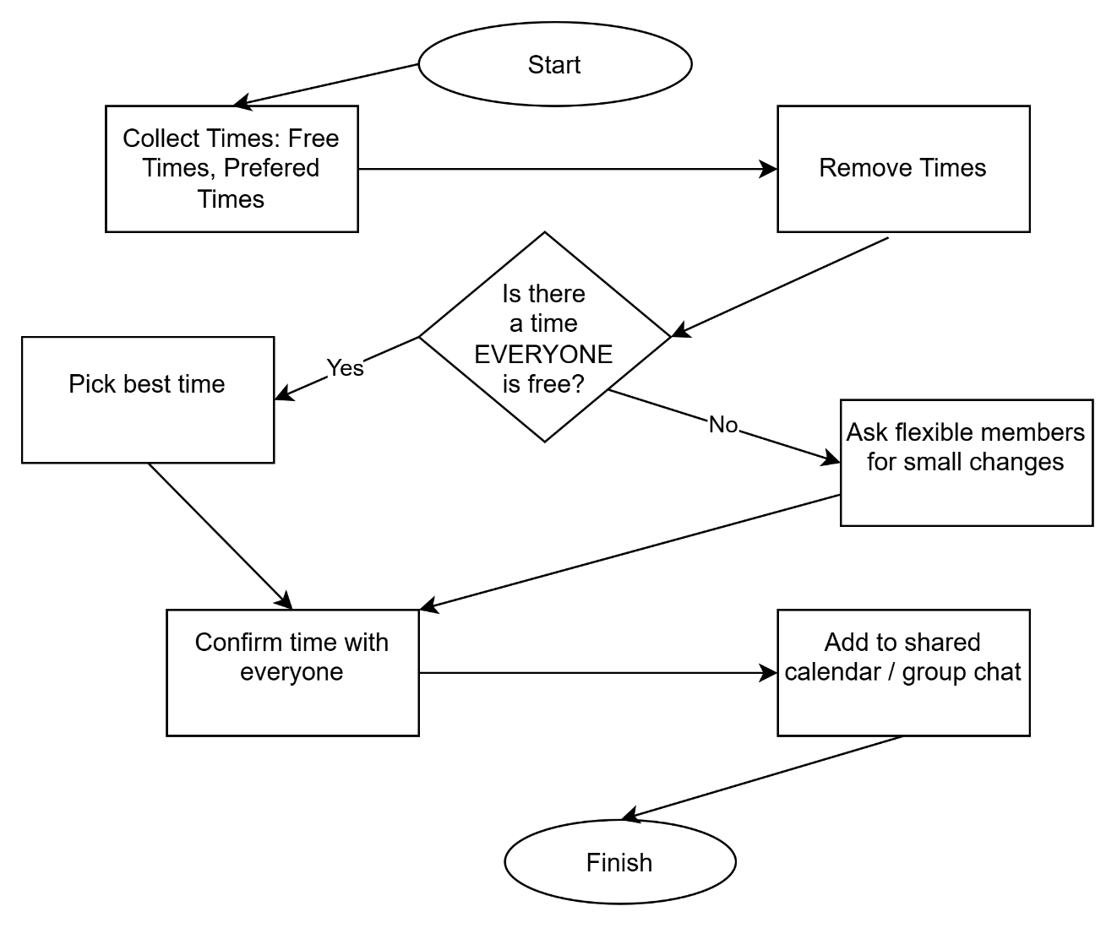

Flowchart Explanation
Step 1: Agree the basics first.
Before asking anyone’s schedule, the group agrees: when work must be handed in, how long each meeting needs to be, and how often you will meet. This stops you picking times that are too late or too short.
Step 2: Collect clear information.
Instead of vague messages like “when are you free?,” ask everyone to list exact times they are free, mark what cannot be changed, and say when they prefer to meet. This makes it easy to compare everyone’s schedule.
Step 3: Remove impossible times.
Cross out any slots that are after deadlines, too short, or clash with things that cannot be moved like classes or shifts. This leaves only realistic options.
Step 4: Find common free times.
Check what is left and find times that work for every single person. This is the most important part to make sure no one misses out.
Step 5: If no common time exists.
If no slot works for everyone, ask people who can move things easily to make a small change (like swapping a 30-minute break). Never ask the same person every time.
Step 6: Lock in the time.
Write the agreed time in one shared place like a pinned message. Everyone can see it, so you do not need to ask again.

Reflection and Justification

Abstract thinking
I looked past messy details like exact class subjects or different jobs, and saw the problem simply as matching free time against fixed rules. This makes the solution work for any group, not just this course. It follows the idea that complex problems can be understood better when you focus on the main parts [4].

Sub-dividing
I split one big hard problem into six simple, easy steps. Instead of trying to fix meeting times all at once, you finish one small task before moving to the next. This is a standard way to make hard work much easier to manage [2].

Justification of solution
This approach is perfect for students because:
- It needs no paid tools or advanced IT skills (you can use free websites or even pen and paper)
- It puts fairness first: no one is forced to miss important things
- It stops messy group chat messages and repeated arguments
- It makes sure deadlines are always the first thing you check
- It follows proven methods like MoSCoW and time optimisation used in project management [1][3]

Limitation
No solution is perfect, and this one has some limits:
- It works best for groups of 3–6 people; larger groups will find it much harder to find matching times
- It cannot fix situations where one person is only free on weekdays and another only on weekends
- It does not link automatically to the college’s official timetable system
- It relies on people being honest about their availability
To work around these limits, groups can use video calls if they cannot meet in person, or split tasks into smaller parts that can be done at different times.
If you cannot find a time that suits everyone, you can use video calls, split tasks so some people work asynchronously, or ask your tutor for help, these are simple workarounds that keep the project moving.

Assumption
- Everyone will share their true and full availability
- People will agree to small reasonable changes if needed
- No one will have last-minute emergencies that no one can plan for

How the Solution Meets the Requirements.
The process always prioritises finding time slots that work for every group member first, only asking for small adjustments if no common time exists, so no one is forced to miss important commitments unless absolutely necessary.
All slots that clash with fixed duties such as classes or work are filtered out before any decisions are made, so you only ever consider realistic options and avoid creating new timetable conflicts.
Deadlines are set clearly at the very beginning, and any time falling after these dates is removed straight away. This ensures every meeting is planned early enough to allow time for completing work, checking details, and submitting everything on schedule.

Conclusion
Arranging group meetings does not need to be stressful or confusing. By breaking the problem down, setting clear rules at the start, and following this simple step-by-step process, student groups can find fair times that work for everyone. This will help teams meet their deadlines, share work more evenly, and get better results in their projects.
This method is not just for this one assignment and it can be used for any group work, any course, and any situation where people need to coordinate around busy schedules. It is simple, fair, and built around the real needs of students balancing study, work, and personal life. Following this process will help groups work better together and get the most out of their time at college.

References:
1. D. Clegg, Project Management for Dummies, 3rd ed. Chichester: John Wiley & Sons, 2017.
2. D. Meadows, Thinking in Systems: A Primer. London: Earthscan, 2008.
3. M. S. Bazaraa, J. J. Jarvis, and H. D. Sherali, Linear Programming and Network Flows, 4th ed. Hoboken: John Wiley & Sons, 2010.
4. J. W. Paul, “The role of abstraction in problem solving,” Journal of Mathematical Education, vol. 12, no. 2, pp. 89–104, 2019.
5. K. A. Smith and D. W. MacGregor, “Collaborative learning: Enhancing group work in higher education,” Journal of Excellence in College Teaching, vol. 26, no. 3, pp. 47–68, 2015.

