Referencing practice activity
In the following Activity you will find 9 different credible sources, comprising of books, journal articles and websites.

The actual websites and journal articles are connected to the website image with a link, so you can access the original source to look around for information if needs be. To access this please right click on the image and open the link.

For each source, please provide the citation (both variations) and the full reference.

Once complete, make sure you are happy and confident with your answers before submitting to the Turn-It-In link.
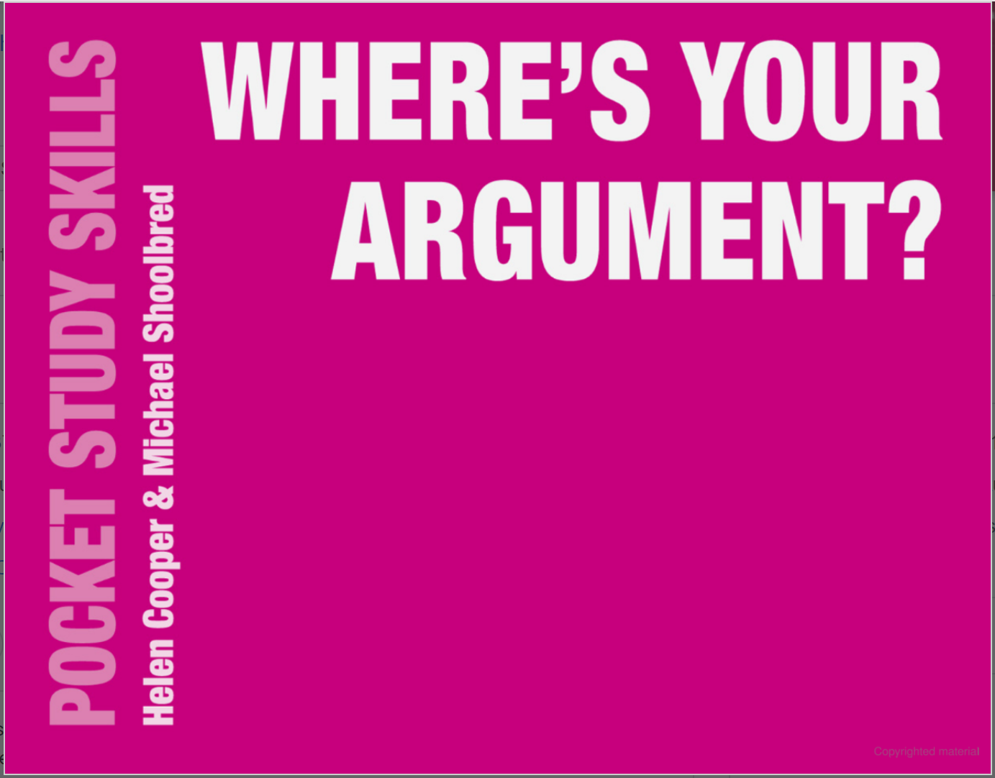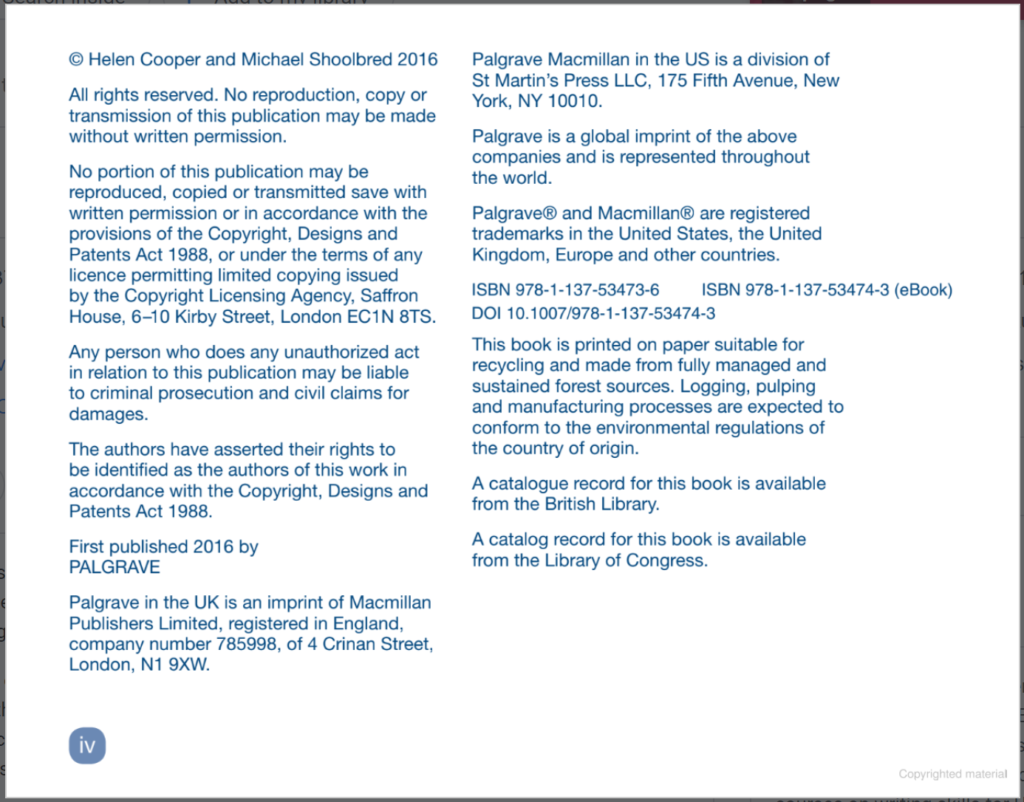

Citation: (Cooper and Shoolbred, 2016) or Copper and Shoolbred, (2016)
Reference: Cooper, H and Shoolbred, M.
2016
Where’s Your Argument? Pocket Study Skills
London. Palgrave.

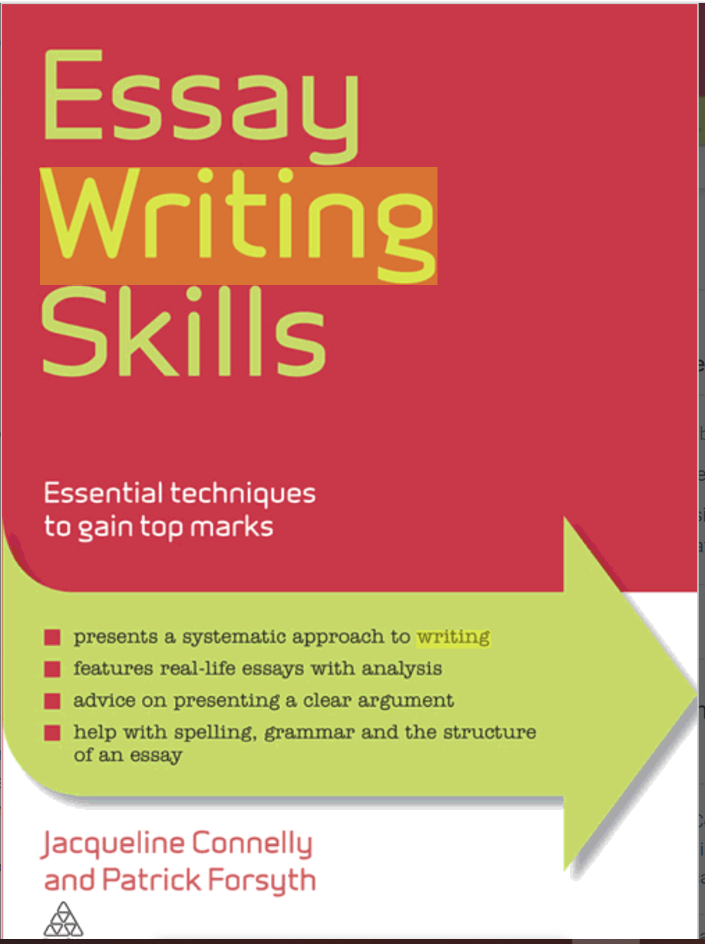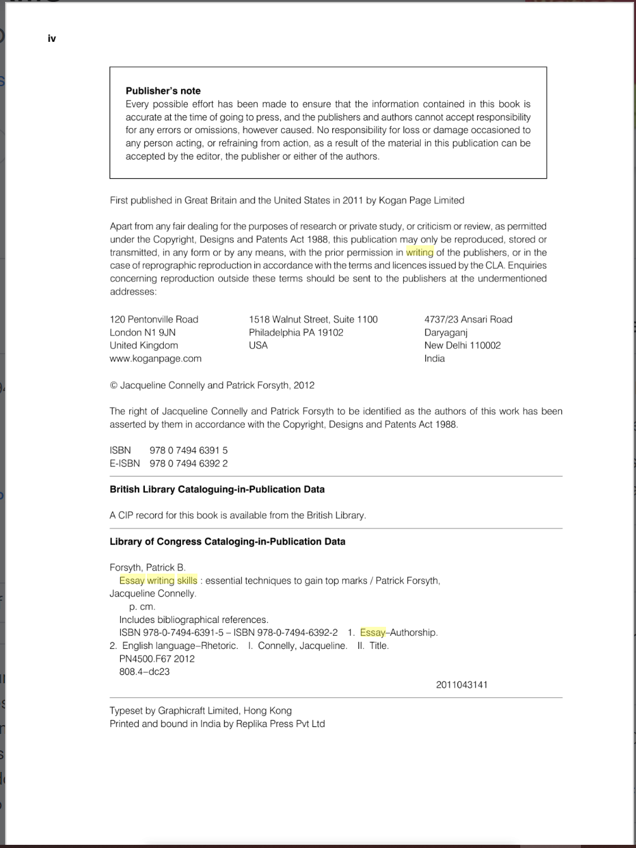
Citation: (Connelly and Forsyth 2012) or Connelly and Forsyth (2012)

Reference: Connelly, J and Forsyth, P
(2012)
Essay Writing Skills. Essential Techniques to Gain Top Marks
London
Kogan Page

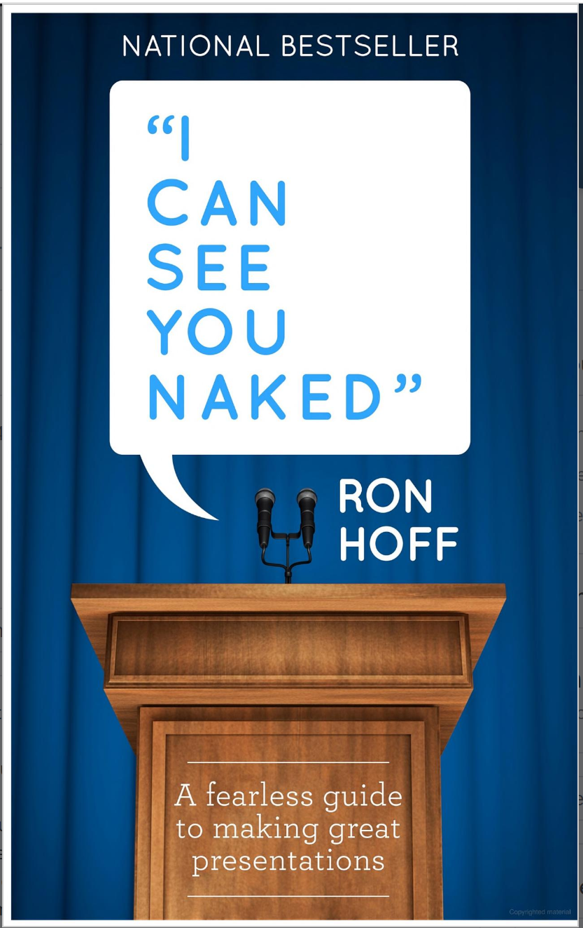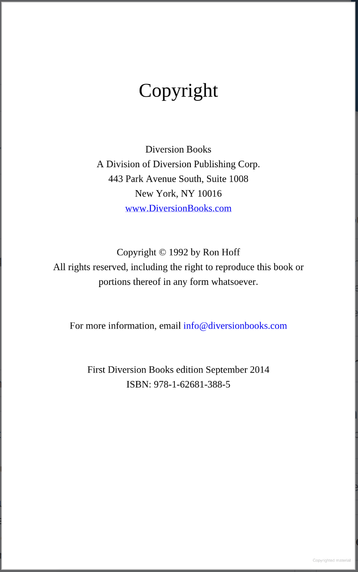
Citation: (Hoff, 2014) or Hoff (2014)

Reference: Hoff, R
(2014)
“I Can See You Naked” A Fearless Guide to Making Great Presentations
New York
Diversion Books
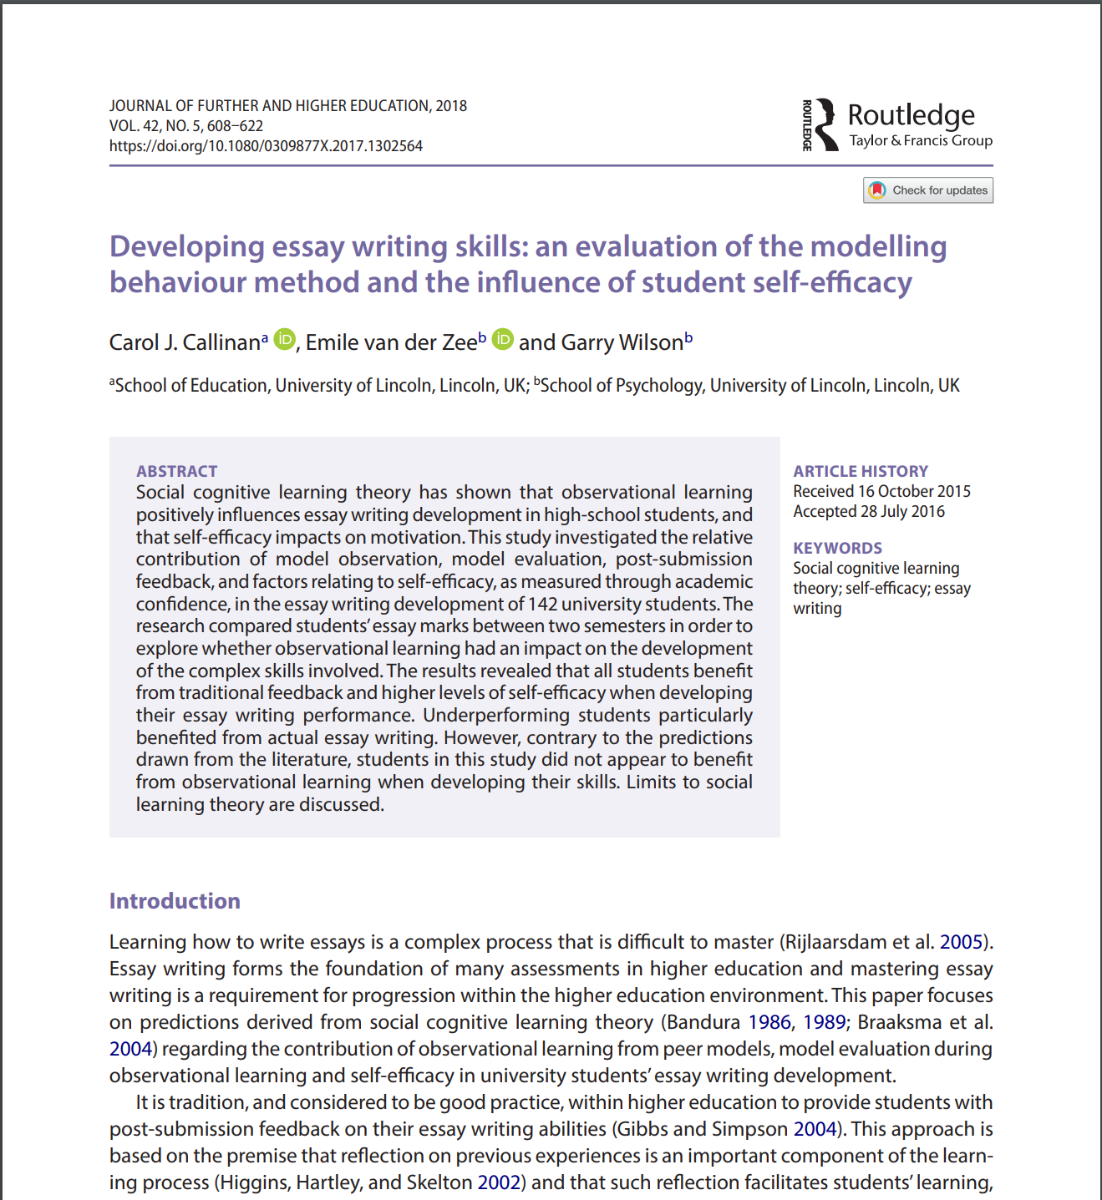
/10
Citation: (Callian, van der Zee and Wilson 2018) or Callian, van der Zee and Wilson (2018)

Reference: Callian, C.J, van der Zee, E and Wilson, G.
(2018)
Developing essay writing skills: an evaluation of the modelling behaviour method and the influence of student self-efficacy
Journal of Further and Higher Education
42 (5)
pp. 608-622
Available at: http://doi.org/10.1080/0309877x.2017.130.2564

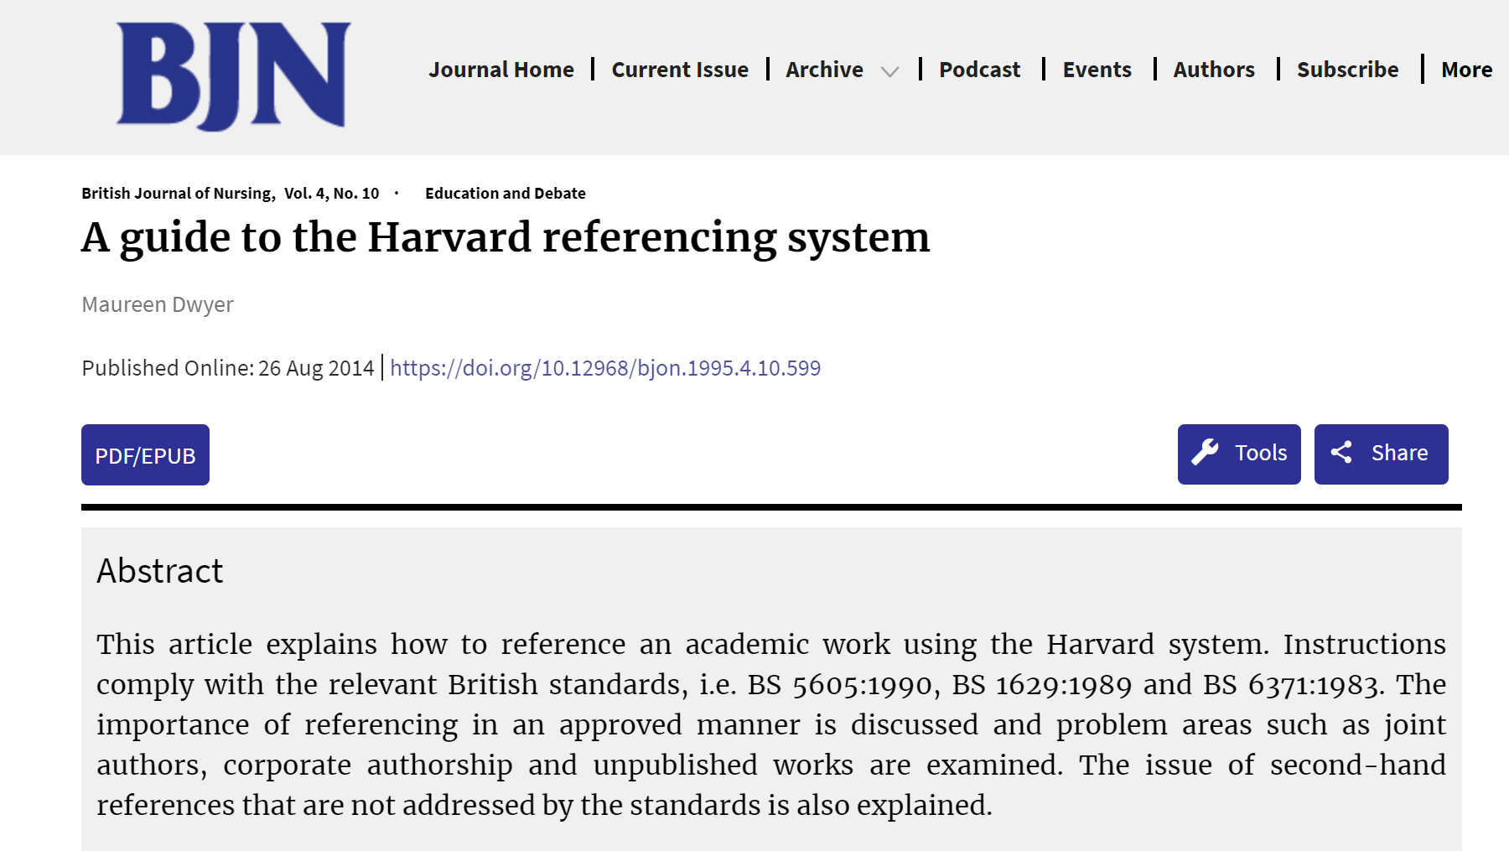
Citation: (Dwyer 2014) or Dwyer (2014)

Reference: Dwyer, M.
(2014)
A Guide to the Harvard referencing system
British Journal of Nursing
Vol. 4 No .10
Available at: http://doi.org/10.12968/bjon.1995.4.10.599

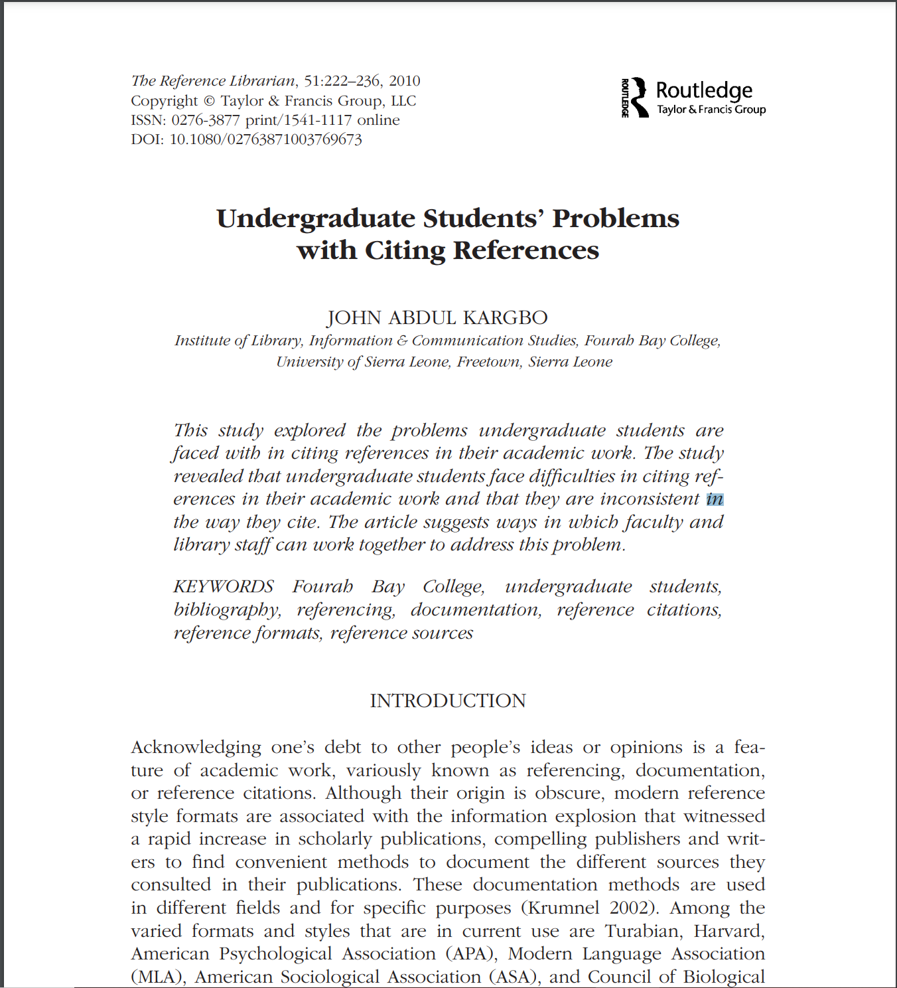
Citation: (Kargbo 2010) or Kargbo (2010)

Reference: Kargbo, J.A
(2010)
Undergraduate Students’ Problems with Citing References
The Reference Librarian
Vol. 51
pp. 222-236
Available at: http://doi.org/10.1080/02763871003769673

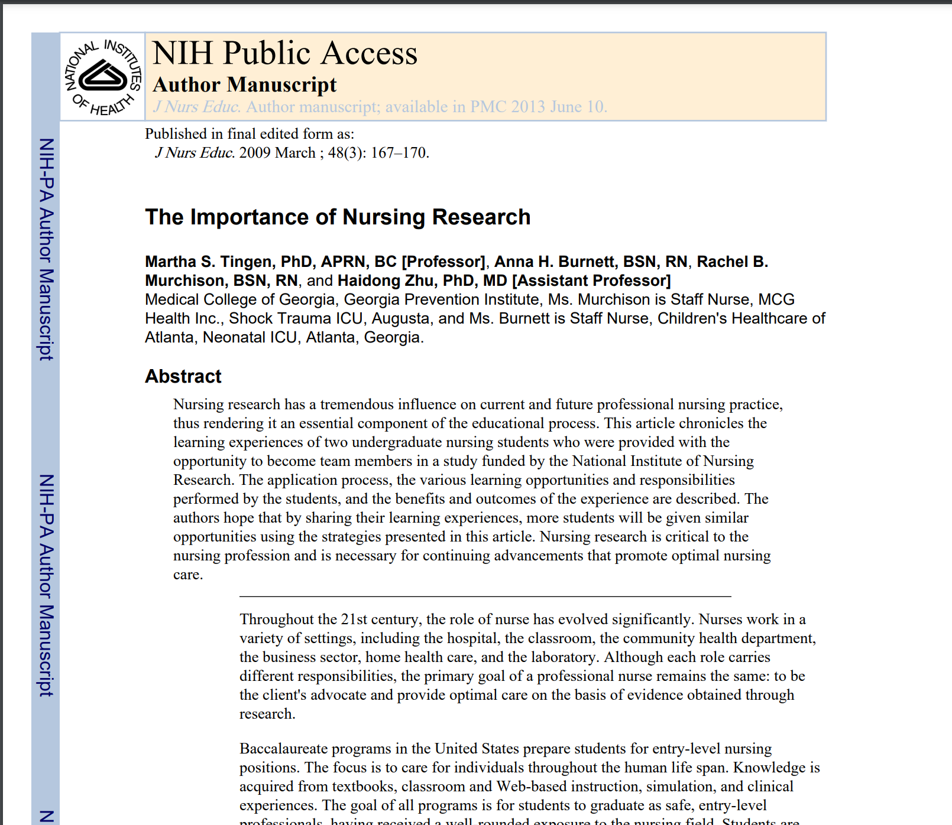
Citation: (Tingen et al. 2009) or Tingen et al. (2009)

Reference: Tingen, M.S., Burnett, A.H., Murchison, R.B. and Zhu, H.
(2009)
‘The importance of nursing research’, Journal of Nursing Education
Vol. 48(3)
pp. 167–170
Available at: https://doi.org/10.3928/01484834-20090301-10

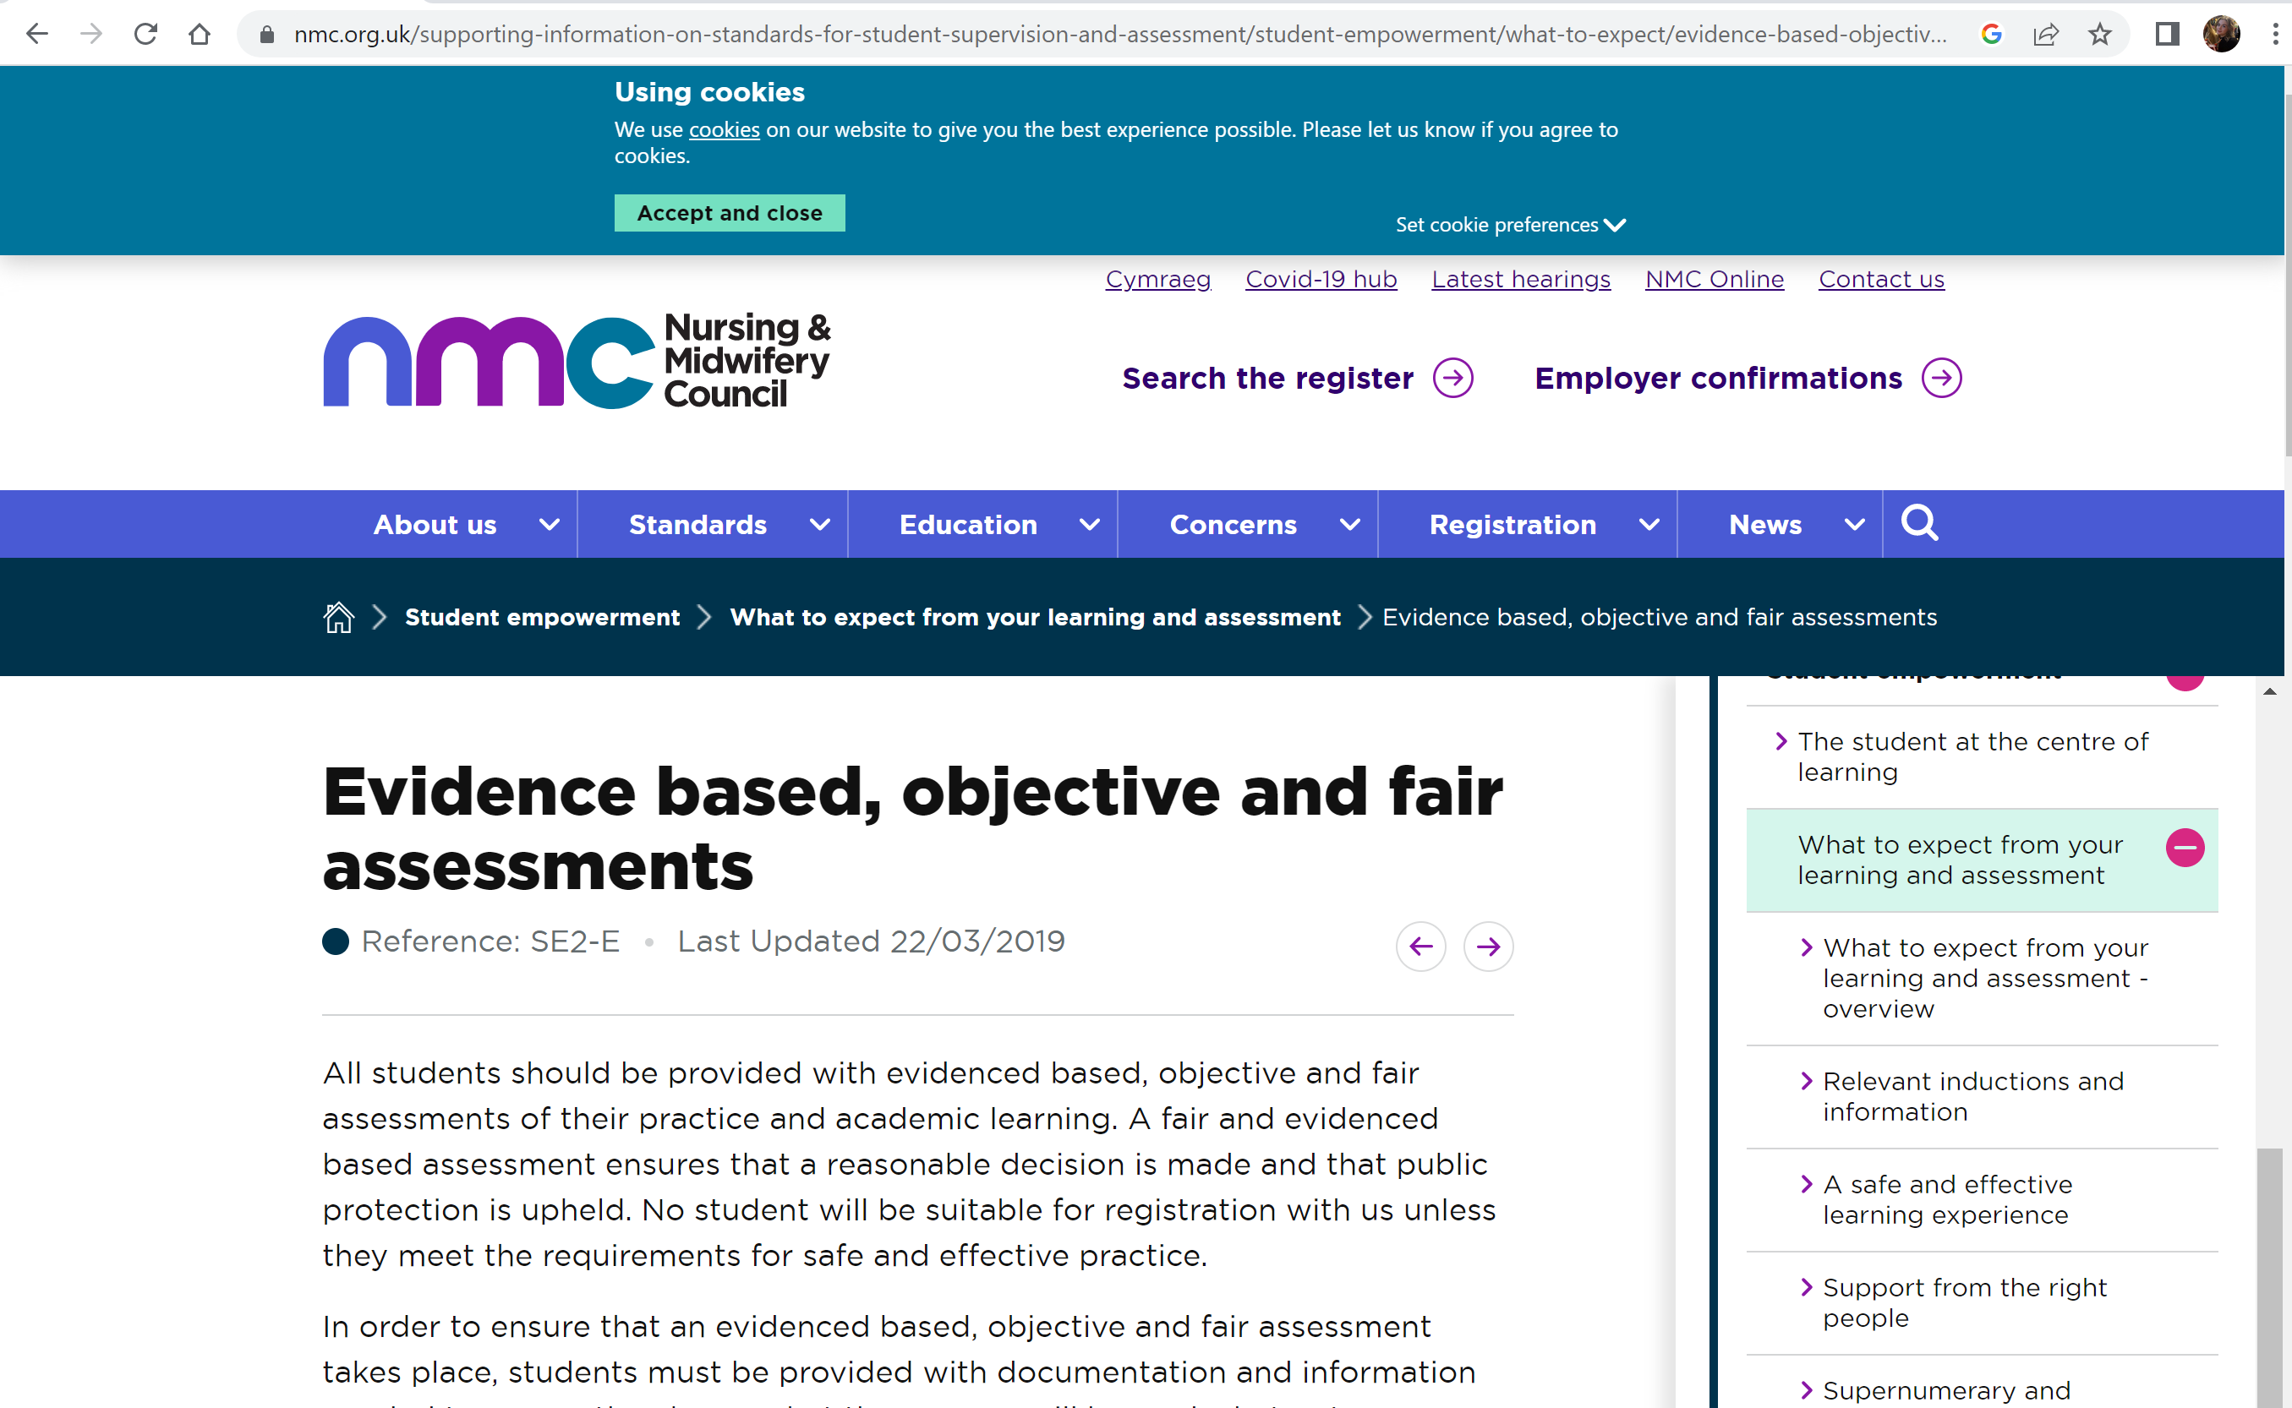
Citation: (Nursing & Midwifery Council 2019) or Nursing & Midwifery Council (2019)

Reference: Nursing & Midwifery Council (NMC)
(2019)
Evidence based, objective and fair assessments
Available at: https://www.nmc.org.uk/supporting-information-on-standards-for-student-supervision-and-assessment/student- empowerment/what-to-expect/evidence-based-objective-and-fair-assessments/
(September 2026)

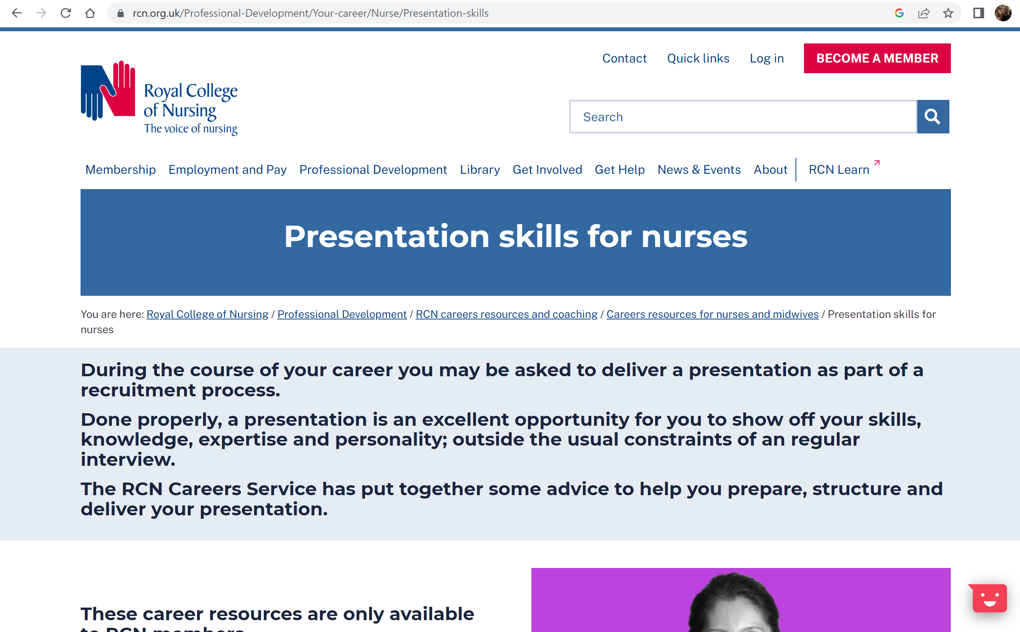
Citation: (Royal College of Nursing 2026) or Royal College of Nursing (2026)

Reference: Royal College of Nursing
(2026)
Presentation skills for nurses
Available at: https://www.rcn.org.uk/Professional-Development/Your-career/Nurse/Presentation-skills
(September 2026)

