
Unit name: Financial Management
Module code: BMBM6007

From Transaction to Transformation: Evaluating M&S's Acquisition of Gist

Student ID:2500387
Written by：Junwei Wang
Instructor：Badir Miftah
Date：27 March 2026

1. Executive Summary
The acquisition of Gist Limited by Marks and Spencer was in my opinion a rather successful is a vertical acquisition, nevertheless the success can be well seen in the operations rather than on the pure deal economics. It was announced by M&S in July 2022 and completed on 30 September 2022, as one of the means to gain control over its food supply chain, eliminate an expensive legacy contract, and enhance resilience following the Brexit, Covid-19 disruption and labour shortages (M&S, 2022). This argument applies to the traditional efficiency perspective of mergers, with value being created by coordination and rationalisation, as well as in terms of combining resources and not just by size (Trautwein, 1990; Bradley, Desai and Kim, 1988; Healy, Palepu and Ruback, 1992).
The evidence that could be obtained post-transaction indicates that those working objectives were largely realized. M&S claimed the integration created greater logistics savings than anticipated and a payback on invested capital was realized in a very short span however it also added that the inherited network was still old and costly to serve. This is why the acquisition is a good case study of a deal that is strategically correct but leaves significant execution tasks after the deal and this is in line with research findings that M&A value is less on announcement logic and more on the ability to integrate into the deal (Cartwright and Schoenberg, 2006; Haleblian et al., 2009; Meglio and Risberg, 2011). In general, this deal appears to have achieved much of its original goals, although the greatest conclusion is that it did not generate automatic value to shareholders but conditional value.

Table of Contents
1. Executive Summary 2
2. Introduction 4
3. Analysis 5
4. Conclusion 10
5. References 12

2. Introduction
M&S purchased one hundred percent of the share capital of Gist with an initial cash sum of £145 million, with additional sums of money dependent on the results of the freehold property purchase, and it was financed through existing cash reserves. Gist was not a new target: they had been the major logistics and supply partner of M&S Food since 1967 and have a network of 8 main and 10 minor distribution centres in the UK and the Republic of Ireland with approximately 5,800 employees. This was not a diversification play in the more conventional conglomerate sense due to that long-standing relationship. It was a vertical acquisition aimed at internalising a strategic value.
That distinction matters. According to the lecture notes on Financial Market Efficiency, acquisitions in an efficient market can only be made when the acquirer can generate real gains due to economies, rationalisation or enhanced control, but not through paying a premium to the already-priced assets (Week topic: Financial Market Efficiency). The same is generally supported by M&A theory. Trautwein (1990) demonstrates that motives of mergers vary with efficiency motives as well as empire-building motives, whereas Roll (1986) and Jensen (1986) caution that the motives of mergers may include managerial hubris, and free cash flow may push the firms to poor dealings. It is against this reason that it is not whether Gist was strategically relevant, as this was pure, but whether its in-house acquisition generated scale, efficiency, cash consumption, profitability and shareholder wealth, which are measurable.
Table 1 provides the basic transaction context that frames the analysis (Financial Times, 2022).
Item | Evidence
Deal announcement | July 2022
Completion date | 30 September 2022
Initial consideration | £145 million cash
Funding source | Existing cash reserves
Gist network | 8 primary and 10 secondary distribution centres
Gist workforce | Approximately 5,800 employees ​
Stated aim | Bring food logistics in-house, remove higher-cost legacy contracts, and modernise the network.

3. Analysis
The greatest support of success is the economies of scale, which eradicate inefficiencies and complementary resources. Gist was already dealing with most of the logistics of M&S Food, and therefore ownership enabled M&S to internalise all the planning, eliminate multiple contractual levels and coordinate incentives in the retail, warehousing and transport services. Chatterjee (1986) writes that synergy is best when the target possesses capabilities closely related to core activities of the acquirer, and Barney (1988) also argues that the relatedness gives a greater likelihood that returns of the bidders will be facilitated by real operating fit. The fit in this case was an unusual one M&S provided brand, stores and customer demand, and Gist provided logistics assets, depot knowledge and execution capability. Such is precisely the type of complementary resources match-up talked of by Capron and Hulland (1999), who reveal that the acquisition worth tends to be contingent upon the capacity to reallocate and arrange the different resources into more efficient operation with common ownership.
This is also the reason why the speed of growth was a valid motive. Developing a dedicated internal logistics network in terms of chilled-food would have taken a long time, been risky and costly, but the purchase of Gist provided M&S with direct access to infrastructure, management capacity and route density. Resource-based viewpoint can be used to say that acquisitions can hasten the process of capabilities acquisition when the organic market of acquiring capabilities is too sluggish or unstable (Seth, Song and Pettit, 2000; Haleblian et al., 2009). In that regard, Gist was a mechanism of faster growth not in terms of creating a new revenue stream, but a cork in the neck of the expansion of the M&S Food. This interpretation is evidenced by the fact that M&S termed the old agreement a growth constraint.
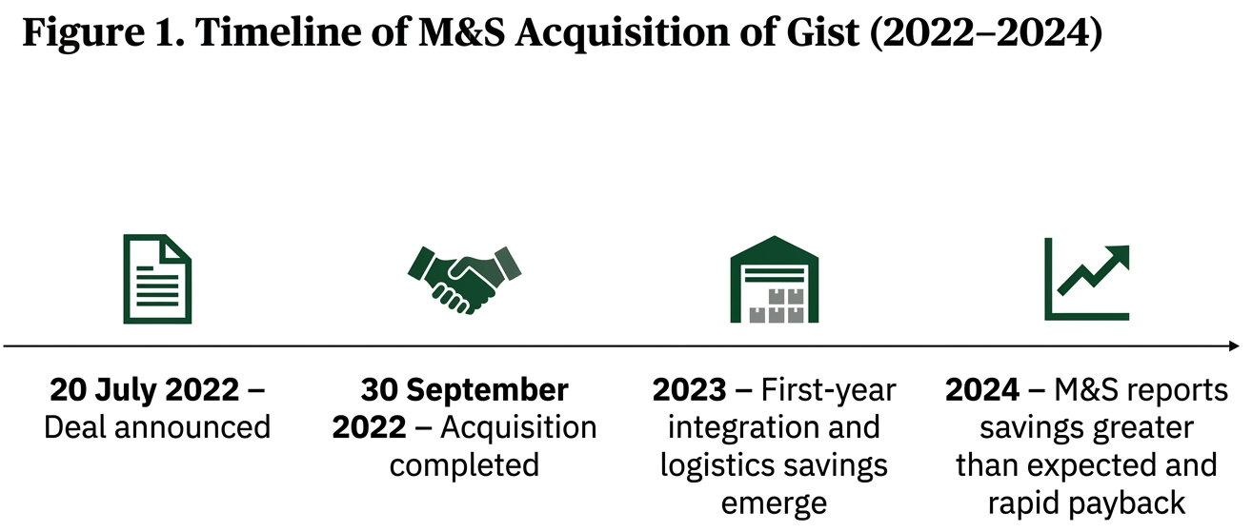
(Source: Self-made)
As Figure 1 indicates, acquisition was not a one-time affair but a gradual process where strategic intent, transaction completion, operational integration and reported results were realised in the course of time, and it can be summarised as the reason why the success of the Gist deal is best evaluated based upon post-acquisition execution rather than the original logic behind the announcement.
The argument against inefficiencies is higher than the argument of scale. M&S stated clearly that the deal would create immediate returns by removing contractual fees and expenditures as well as instituting congruent operational procedures. This is important since the announcement also added that most of the pro forma EBITDA of approximately 55 million of Gist was management fees charged to M&S under the current agreements that would be eliminated on consolidation. More importantly, this implies that the deal cannot be as though M&S had merely acquired an external stream of profits. The gain had to be through cost elimination, process redesign and network optimisation; much of the supposed target profit was already in economic substance part of the M&S system. It is much more in line with Devos, Kadapakkam and Krishnamurthy (2009), who see efficiency gains as a more convincing account of the merger gains than bare market power.
Table 2 can summarise this strategic logic.
Objective | Evidence after acquisition | Critical judgement
Economies of scale | Network control across the existing food logistics footprint | Achieved mainly through coordination, not pure size
Elimination of inefficiencies | Contract fees and duplicated processes targeted for removal investigation. | Strongest source of value
Complementary resources | Retail demand plus logistics capability combined | High strategic fit
Speed of growth | Immediate access to depots, staff and systems | Faster than organic build
Financial benefits | Savings reported greater than expected; rapid payback claimed | Positive, but attribution must be cautious
The original investment case had an element of financial benefits, and the available evidence is in the positive direction, albeit with caveats. On the announcement, M&S added that the deal would be earnings-enhancing within its first full year. Subsequently, it had indicated that the integration was generating good returns, logistics savings beyond expectation and quick payback of invested capital. On the surface, which appears to be an apparent success. Healy, Palepu and Ruback (1992) concluded that improvements in operating post-merger could be used to support the case of synergy, and Gugler et al. (2003) also indicate that not all mergers are inefficient and unprofitable. Nonetheless, Ghosh (2001) is also less optimistic, stating that the post-acquisition performance gains are widely exaggerated when benchmarking issues are taken into consideration. That warning is relevant in this case since M&S was experiencing a wider commercial recovery during the same period. The improved product performance, pricing, store implementation and brand recovery could have contributed to the profits together with the Gist integration.
The lecture notes on Cash Flows and Cash Management come in handy here since it emphasizes that profit is not cash and that managers should not assume that accounting improvement and real liquidity implications of cash management are the same (Week topic: Cash Flows and Cash Management). M and S used acquired cash as a result of the existing cash reserves hence the surplus cash motive can be interpreted in either way. On the bright side, Jensen (1986) would say that an earnings-accretive deal formed by cash would be preferred instead of sitting idle cash. Poorly, free cash flow may promote acquisitions that the managers are interested in, and the shareholders do not require. The following report that logistics savings are coming faster than expected in this instance undermines the overinvestment objection, but it does not eradicate it completely.
The impact of the acquisition on the enhancement of market power and diversification is less overall. Within a very literal sense, the acquisition of Gist can enhance the bargaining power of M&S to the suppliers and enhance service reliability, since logistics is no longer a contract division, but a division of a synchronized internal value chain. However, this does not mean the same as raising the degree of concentration in the food retail in the UK materially. Eckbo (1983) and Andrade, Mitchell and Stafford (2001) indicate that certain mergers are subject to concern in raising competition when they make changes in the market structure, but this was primarily a vertical and operational merger. It is supported by the fact that all the needed merger control approvals were obtained prior to it being completed; this supports the perception that the regulators did not regard it as a significant competitive threat. Moreover, Gist was slightly continuing with the third-party logistics business, yet the description given by M&S itself makes it clear that this is not the main objective of the acquisition. Thus, the advantages of diversification were low. The deal was also strategically narrow, which is believed to be a strength and not a weakness since it minimised the integration complexity.
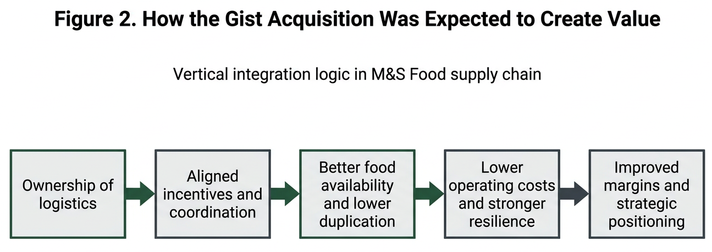
(Source: Self-made)
Figure 2 illustrates the vertical integration logic behind the acquisition by showing how ownership of logistics was expected to improve coordination, reduce duplication, strengthen food availability and ultimately support margins and long-term positioning, which reinforces the argument that value creation depended mainly on operational control rather than diversification or market concentration. (see the generated image above).
The hardest aspect to make a judgment about is shareholder wealth. The case to the affirmative is that the acquisition was anticipated to be accretive in terms of earnings per share, financed without apparent financing stress, and subsequently linked with higher-than-anticipated savings and payback speed. Bradley, Desai, and Kim's (1988) study indicates that there may be total gains that can be created in the case of real synergies in the case of acquisitions, and King et al. (2004) and Schoenberg (2006) urge us to remember that the measurement of value is complex and largely dependent on which metric is used. The cleanest wealth argument in the case of M&S is not that the acquisition changed revenue due to the statement of M&S that like-for-like sales remained unchanged by acquisition in the six-month results, with statutory revenue standing at £6,134.0 million, 10.8 per cent higher (M&S, 2023, p. 8). Instead, it is more convincing to say that a shareholder would have been advantaged when a strategically weak outsourced functionality was more credible and cost-effective without the need to erode operational discipline.
Meanwhile, the transaction is not entirely free of the traditional M&A criticisms. As demonstrated by Larsson and Finkelstein (1999), the success of integration is attributed to how well they cooperate and implement, and according to Cartwright and Schoenberg (2006), integration failures happen so often because the promised synergies turn out to be more difficult to reap than the managers had anticipated. The fact that the network was later on admitted by M&S to still be old and costly to serve, demonstrates that the ownership and incentive deficiencies were resolved, but not the entire structural issue. This is the reason why it would not declare the acquisition as an unqualified success. Apparently, it is an effective measure in a longer supply-chain change.
Table 3 captures that balanced judgement.
Area | Assessment
Economies of scale | Moderately strong
Elimination of inefficiencies | Very strong
Surplus cash use | Justified, but worth scrutinising
Increased market power | Limited externally, stronger internally
Complementary resources | Very strong
Speed of growth | Strong
Financial benefits | Positive but partly intertwined with wider turnaround
Diversification | Weak motive, limited outcome
Regulatory framework | Managed successfully (Financial Times, 2022)
Shareholder wealth | Probably positive, but only conditionally proven
Figure 3 below offers a brief analysis of the results of the acquisition by separating the aspects that were greatly supported by the advantages and the more ambiguous arguments. The visual is that efficiency-related gains are the most plausible achievements; other generalisations involving diversification, market power and total shareholder wealth need to be approached more carefully since the results are less transparent and more diverse.
Figure 3: Expected value drivers vs realised evidence.
Assessment matrix for M&S acquisition of Gist
Value driver | Evidence strength
Cost savings | Strong
Rapid payback | Strong
Supply-chain control | Strong
Market power | Limited
Diversification | Weak
Shareholder wealth impact | Mixed
(Source: Self-made)

4. Conclusion
Marking the conclusion, Marks and Spencer's acquisition of Gist succeeded in reaching the most significant strategic goals, namely, superior control of the supply chain, elimination of the inefficiency of the old contracts, accelerated ability of acquisition and immediate logistical benefits. The fact that savings were higher than anticipated and that payback was quick is a strong indication that the deal had generated operational value. Nevertheless, the new deal was not an expansive diversification triumph, and any post-deal advancement cannot be blamed entirely on Gist since M&S was transforming in multiple directions simultaneously.
I would say that the overall result of the transaction is successful in a balance, although primarily due to a focused vertical integration action, with a clear operational rationale behind it, and not a speculative growth acquisition. It is more believable than most of the M&A cases scrutinised in the literature as a result of hubris, poor fit or overpayment (Roll, 1986; King et al., 2004; Meglio and Risberg, 2011). It is, therefore, the most reasonable conclusion that M&S made significant strategic and financial gains in the Gist deal, and the full shareholder value issue remains to rely upon the effectiveness with which the company can further modernise the inherited system of logistics in the course of time.

5. References
Andrade, G., Mitchell, M. and Stafford, E. (2001) ‘New Evidence and Perspectives on Mergers’, Journal of Economic Perspectives, 15(2), pp. 103–120. Available at: https://doi.org/10.1257/jep.15.2.103.
Barney, J.B. (1988) ‘Returns to bidding firms in mergers and acquisitions: Reconsidering the relatedness hypothesis’, Strategic Management Journal, 9(S1), pp. 71–78. Available at: https://doi.org/10.1002/smj.4250090708.
Bradley, M., Desai, A. and Kim, E.Han. (1988) ‘Synergistic gains from corporate acquisitions and their division between the stockholders of target and acquiring firms’, Journal of Financial Economics, 21(1), pp. 3–40. Available at: https://doi.org/10.1016/0304-405X(88)90030-X.
Capron, L. and Hulland, J. (1999) ‘Redeployment of Brands, Sales Forces, and General Marketing Management Expertise following Horizontal Acquisitions: A Resource-Based View’, Journal of Marketing, 63(2), pp. 41–54. Available at: https://doi.org/10.1177/002224299906300203.
Cartwright, S. and Schoenberg, R. (2006) ‘Thirty Years of Mergers and Acquisitions Research: Recent Advances and Future Opportunities’, British Journal of Management, 17(S1), pp. S1–S5. Available at: https://doi.org/10.1111/j.1467-8551.2006.00475.x.
Chatterjee, S. (1986) ‘Types of synergy and economic value: The impact of acquisitions on merging and rival firms’, Strategic Management Journal, 7(2), pp. 119–139. Available at: https://doi.org/10.1002/smj.4250070203.
Devos, E., Kadapakkam, P.-R. and Krishnamurthy, S. (2009) ‘How Do Mergers Create Value? A Comparison of Taxes, Market Power, and Efficiency Improvements as Explanations for Synergies’, The Review of Financial Studies, 22(3), pp. 1179–1211.
Eckbo, B.Espen. (1983) ‘Horizontal mergers, collusion, and stockholder wealth’, Journal of Financial Economics, 11(1-4), pp. 241–273. Available at: https://doi.org/10.1016/0304-405x(83)90013-2.
Financial Times (2022) Marks & Spencer completes acquisition of Gist – Company Announcement - FT.com, markets.ft.com. Available at: https://markets.ft.com/data/announce/full?dockey=1323-15652707-2LKNLGKK9CI0QQSO3MA00EPL4S (Accessed: 8 March 2026).
Ghosh, A. (2001) ‘Does operating performance really improve following corporate acquisitions?’, Journal of Corporate Finance, 7(2), pp. 151–178. Available at: https://doi.org/10.1016/s0929-1199(01)00018-9.
Gugler, K., Mueller, D.C., Yurtoglu, B.Burcin. and Zulehner, C. (2003) ‘The effects of mergers: an international comparison’, International Journal of Industrial Organization, 21(5), pp. 625–653. Available at: https://doi.org/10.1016/s0167-7187(02)00107-8.
Haleblian, J., Devers, C.E., McNamara, G., Carpenter, M.A. and Davison, R.B. (2009) ‘Taking Stock of What We Know About Mergers and Acquisitions: A Review and Research Agenda’, Journal of Management, 35(3), pp. 469–502.
Healy, P.M., Palepu, K.G. and Ruback, R.S. (1992) ‘Does Corporate Performance Improve after mergers?’, Journal of Financial Economics, 31(2), pp. 135–175. Available at: https://doi.org/10.1016/0304-405X(92)90002-F.
Jensen, M.C. (1986) ‘Agency Costs of Free Cash Flow, Corporate Finance, and Takeovers’, The American Economic Review, 76(2), pp. 323–329. Available at: https://www.jstor.org/stable/1818789.
King, D.R., Dalton, D.R., Daily, C.M. and Covin, J.G. (2004) ‘Meta-analyses of post-acquisition performance: indications of unidentified moderators’, Strategic Management Journal, 25(2), pp. 187–200.
Larsson, R. and Finkelstein, S. (1999) ‘Integrating Strategic, Organizational, and Human Resource Perspectives on Mergers and Acquisitions: A Case Survey of Synergy Realization’, Organization Science, 10(1), pp. 1–26.
M&S (2022) MARKS AND SPENCER TO ACQUIRE GIST AS PART OF ACCELERATING ITS FOOD SUPPLY CHAIN TRANSFORMATION, Marks & Spencer. Available at: https://corporate.marksandspencer.com/newsroom/press-releases/marks-and-spencer-acquire-gist-part-accelerating-its-food-supply-chain (Accessed: 8 March 2026).
M&S (2023) Marks and Spencer Group Plc Half Year Results for 26 Weeks Ended 30 September 2023 ‘RESHAPING M&S’ STRATEGY DELIVERS STRONG RESULTS. Available at: https://corporate.marksandspencer.com/sites/marksandspencer/files/2023-11/Marks-and-Spencer-Group-Plc-Half-Year-Results-for-26-Weeks-Ended-30-September-2023.pdf (Accessed: 9 March 2026).
Meglio, O. and Risberg, A. (2011) ‘The (mis)measurement of M&A performance—A systematic narrative literature review’, Scandinavian Journal of Management, 27(4), pp. 418–433. Available at: https://doi.org/10.1016/j.scaman.2011.09.002.
Roll, R. (1986) ‘The Hubris Hypothesis of Corporate Takeovers’, The Journal of Business, 59(2), pp. 197–216.
Schoenberg, R. (2006) ‘Measuring the Performance of Corporate Acquisitions: An Empirical Comparison of Alternative Metrics’, British Journal of Management, 17(4), pp. 361–370. Available at: https://doi.org/10.1111/j.1467-8551.2006.00488.x.
Seth, A., Song, K.P. and Pettit, R. (2000) ‘Synergy, Managerialism or Hubris? An Empirical Examination of Motives for Foreign Acquisitions of U.S. Firms’, Journal of International Business Studies, 31(3), pp. 387–405. Available at: https://doi.org/10.1057/palgrave.jibs.8490913.
Trautwein, F. (1990) ‘Merger motives and merger prescriptions’, Strategic Management Journal, 11(4), pp. 283–295.
University of Wales Trinity Saint David (n.d.) Financial Management BMBM6007: [module lecture notes]. Topics used: ‘Fin

