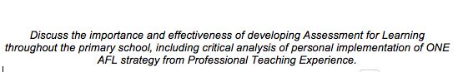

Assessment in education must serve the purpose of supporting learning. The Assessment Reform Group (2002) defined Assessment for Learning (AFL) as “the process of seeking and interpreting evidence for use by learners and their teachers to decide where the learners are in their learning, where they need to go next, and how best to get them there.” Assessment for learning can be described as a type of formative assessment, which can be an effective tool in closing the attainment gap between the higher and lower attaining pupils. This focusses on the use of informal assessment in the classroom to allow the teacher and the pupil to gain an understanding of where one is at with their learning and identifying areas where there are gaps in their knowledge and understanding. This allows the relationship between the pupil and the teacher to become more of a partnership, with both pupil and teacher playing a role. AFL is also recognised as a significant strategy in raising pupil achievement not just closing the attainment gap. Raising attainment in education is a continual quest for educators as it is seen that raising attainment is linked with individual quality of life and economic growth (Clarke, 2008). Dylan William (2006), argues that the higher the education level, the higher the income received resulting in a longer lifespan and a better quality of life. This will then have a positive effect on the economy, by increasing the level of education then it can reduce the money spent on healthcare as individuals have a better understanding on how to look after themselves effectively. For AFL to be successful it is most likely informal, embedded in all aspects of the school and carried out by teachers depending on their teaching styles (Black et al, 2006). The start of the focus and importance on formative assessment was the review by Black and William (1998a). This included 250 case studies and found the effective formative assessment allowed improvement in student achievement and was likely to lead to lifelong learning. This followed by the booklet ‘Inside the Black Box’ which had four aims;

- “Brief review of research evidence
- Make a case for more attention to be paid to helping practice inside the classroom
- Draw out implications for practical action
- Discuss policy and practice”
(Black and William, 1998b)

In their 9 years of international research Black and William found that AFL can be see as one of the most powerful ways to improve learning and raise standards. However, it is highlighted that this is only the case if it is carried out correctly (Black and William, 1998b). To maximise the success of AFL it is important that there is a consistency with the strategies throughout the school so pupils are learning and developing their skills. AFL should be carried out in a sensitive but constructive manner as assessment has an emotional impact on pupils. Educators need to be aware and careful of the way that their feedback can effect learners’ confidence and motivation towards learning. Successful AFL ensures that feedback is as constructive as possible and any comments are work focused and are more constructive for learning and motivation (Assessment Reform group, 2002).

There are four elements of ALF;

- Sharing criteria with learners;
- Quality of questions / Quality of talk;
- Use and quality of the feedback given;
- Peer and self-assessment

The AFL strategy implemented was comment only marking. This strategy comes under the use and quality of feedback element of AFL. An essential part of AFL is feedback, this is not only to identify their current achievements but to identify what the next steps are for individuals (Black et al, 2006). This strategy provides feedback that is based on the individuals work, giving advice on ways to improve. This strategy links to Black et al (2006) as the teacher will give advice and methods for improvement without comparing to other pupils or giving it a mark. Research carried out by Butler (1988) who was interested in the feedback pupils received for their written work showed that learning gains were higher with the group of children who received comment only feedback. It was also highlighted by teachers from Butlers research that children would rarely engage with the comments but would prefer to compare marks with peers. The use of comment only marking can help eliminate the negative way in which pupils look at themselves and education, feedback given as rewards or marks can enhance ego rather than task engagement (Black et al, 2006). Pupils will then not have a mark to compare themselves with others. This AFL strategy can also raise the self-esteem of our learners, giving students a grade or a mark focuses their attention on their ‘ability’ while taking away the importance of effort and improvement (Black et al 2006). A humanist approach would support this strategy, Holt (1990), believed that success and failure are adults ideas that we impose on children and it is only when pleasing adults (in this case the teacher) is important to children then there is distinct line between success and failure. By using comment only marking the children are not straight away looking for if they have succeeded or failed by the mark they would have received. Estyn recommends and highlights that marking and feedback to pupils should be meaningful and motivating for the children while having an impact on pupil progress (Estyn, 2016). This strategy can also be used with the peer and self-assessment element of AFL as the pupils can engage with their feedback and comments from either themselves, other pupils or teachers to then improve further learning. The starting point of peer and self-assessment was based on the work of Sadler (1989) who split formative assessment into two core areas. One being how learners see themselves, they need to identify where they are currently and where they would like to be. The second being the route taken by the learner to achieve their desired goal. It is very challenging for pupils to achieve the learning objective unless they have a clear understanding of the objective and can assess how they can achieve it. Therefore, self-assessment is vital for learning. Peer assessment has been seen to be a compliment to self-assessment and the idea of peer assessment has been argued to improve the motivation of students to work carefully. Students learning can be enriched by self and peer assessment (Black et al, 2006). However, humanist would argue that peer assessment can lead to the discomfort of children. They may suffer with anxiety at the thought of another pupil in their class looking and ‘judging’ their work. John Holt (1990) expressed how children are afraid of the mockery from their peer groups and are made fun of if they cannot do things or do things wrong.

The comment only marking strategy would need to be implemented throughout the whole school for it to be effective in progressing the learning. It is important that this strategy is implemented early in Foundation Phase to ensure the children start to have a growth mindset that will then motivate and improve their learning throughout their education. Comment only marking will be used in both peer and self-assessment in Foundation Phase but in a child friendly,verbal way. Teachers would ask prompt questions to allow the children to assess their own work such as “What do you like about your work?” “What did you enjoy?” “What could you do differently?” This will allow for feedback and eventually help the children to set targets informally to promote understanding. In Year Two children will be introduced to two stars and a wish during some lessons using a work sheet to support them (see appendix 1). This will help the children to understand the idea of two stars and a wish for self and peer assessment. In lower KS2, year 3 and 4 comment only marking will be used frequently and the children will be encouraged to analyse their work to self-assess by giving themselves two stars and a wish linking to the success criteria. This will also be encouraged for peer assessment by analysing a friend’s piece of work and giving two stars and wish. This strategy will help the children to develop their understanding of the success criteria and what is needed to produce a high-quality level of work. Throughout KS2 all children will have time allocated in the day to read and answer any comments or feed forward questions in their books from the teacher. This will show acknowledgement and understanding of the feedback from the teacher. Upper KS2 years 5 and 6 will also follow the comment only marking strategy but will be encouraged to mark each other’s work as if they were the teacher.

This strategy meets many of the characteristics from the habits of mind. There are 16 habits of mind that can develop children’s critical thinking skills and support the chosen AFL strategy.

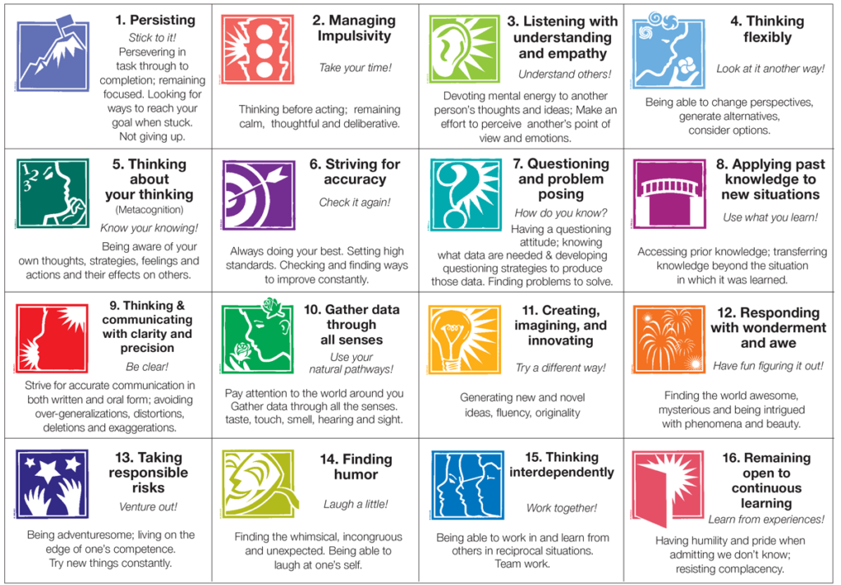

(Learning Personalized, 2018)

The habits of mind were a development by Costa and Kallick. The aim of developing the habits of mind was to help educators develop pupils who are thoughtful, compassionate and cooperative human beings who can thrive in an information rich world (Costa and Kallick, 2000). This idea links to Donaldson’s Successful Futures with an aim to allow students to have the knowledge and understanding alongside a range of first hand experiences to help them be equipped to live in a forever developing society (Donaldson, 2015). Some of the dispositions that could be met from the habits of mind through this strategy include is striving for accuracy, remaining open to continuous learning and persisting. The correct habits of mind vocabulary will need to be used throughout the school to develop children’s understanding of what habit of mind they are developing. By setting and working towards their target(s) (wish), then the children are developing the striving for accuracy in their work and being open to continuous learning.

In conclusion, there is a clear focus throughout education on the importance and effectiveness of Assessment for Learning throughout the primary school. AFL is most successful and effective when there is a consistency throughout the school, this enables children to develop their own understanding of where they are currently at while identifying the next steps to get them to where they need to be. It needs to be embedded throughout the school. AFL is also effective for teachers to help close the attainment gap between the higher and lower attaining pupils. However, it is important that schools create a positive learning environment where students feel safe and ready to learn. This will help to ensure that children can do their best and feel comfortable when self and peer assessing. By having consistency across the school children will have a better understanding of how to self and peer assess effectively and will begin to grow in confidence. Comment only marking can be a great way to improve task engagement and takes away the idea of only success or failure, it develops a continuum of learning. The use of this strategy also develops a range of the habits of mind which will help prepare individuals to survive in a fast pace, information rich, developing world we live in.

Bibliography

Assessment Reform Group (2002). [online] Available at: https://www.aaia.org.uk/content/uploads/2010/06/Assessment-for-Learning-10-principles.pdf [Accessed 5 Dec. 2018].

Black, P. and William, D. (1998a) Assessment and Classroom Learning, Assessment in Education.

Black, P. and William, D. (1998b) Inside the Black Box: Raising standards through classroom assessment. London: School of Education, King’s College.

Black, P. et al. (2006) Assessment for Learning: Putting it into Practice, Berkshire: Open University Press.

Butler, R. (1988). Enhancing and undermining intrinsic motivation: the effects of task-involving and ego-involving evaluation on interest and performance. British Journal of Educational Psychology.

Clarke, S. (2008). Active learning through formative assessment. London: Hodder Murray.

Claxton, G. (2002) Building Learning Power, Bristol: TLO Ltd.

Costa, A. and Kallick, B. (2000). Assessing & Reporting on Habits of Mind. a Developmental Series, Book 3. Association for Supervision and Curriculum Development.

Donaldson, G. (2015) Successful Futures – Independent Review of Curriculum and Assessment Arrangements in Wales. Cardiff: Welsh Government. Available at:
http://gov.wales/docs/dcells/publications/150225-successful-futures-en.pdf

Grigg, R. (2010) Becoming an Outstanding Primary School Teacher, Harlow: Pearson, 2010.

Holt, J. (1990). How Children Fail. London: Penguin.

Learning Personalized. (2018). Terry Heick: Integrating the 16 Habits of Mind - Learning Personalized. [online] Available at: http://www.learningpersonalized.com/integrating-16-habits-mind/ [Accessed 11 Dec. 2018].

Sadler, R. (1989) Formative assessment and the design of instructional systems, Instructional Science, 18:119-44.

William, D. (2006). Assessment for learning: why, what and how, edited transcript of a talk given at the Cambridge Assessment Network Conference on 15th September 2006 at the Faculty of Education, University of Cambridge.

Appendix One.


