ANALYSIS OF CASE STUDY ON MARRIOTT INTERNATIONAL

Table of Contents
Introduction 3
Task 1: Critical Analysis of Marketing Strategies and Their Effectiveness as Taken by Marriott International 3
1.1 Conceptualisation and Relevance Marketing during the Covid Crisis 3
1.2 SWOT Analysis of Marriott International 4
1.3 Analysis of the Marketing Strategies 5
1.4 Competitive Analysis of the strategies used by Marriott International 6
1.5 Identifying the Impact of Technology 7
1.6 Critical Evaluation of the Success of Strategies 7
Task 2: Managerial Implication on Marketing Strategies 9
2.1 Managerial Implication of the Strategies 9
2.2 Alignment with the Theories 10
Task 3: Recommendations to improve marketing strategies 11
Conclusion 13
References 14

Introduction
The present assignment helps in identifying the effectiveness of the strategies taken by Marriott International for responding to the global pandemic situation. At present time there is an importance of marketing strategies in the tourism and hospitality industry as the outbreak of the pandemic has changed the overall operation of this sector. A thorough evaluation of the strategies has been done in this assignment and a recommendation for further improvements of the strategies has been made to cope in the post-pandemic era.

Task 1: Critical Analysis of Marketing Strategies and Their Effectiveness as Taken by Marriott International

1.1 Conceptualisation and Relevance of Marketing during the Covid Crisis
The concept of marketing refers to an emphasis on the need of buyers and converting the products into cash. There is several importance of marketing for business owners irrespective of the size or nature of the business. Different firms have taken different innovative strategies for marketing and attracting more customers towards the business (Sadiku-Dushi et al. 2019). During the outbreak of the global pandemic COVID-19, the significance and need of marketing has been gaining importance. As mentioned by Nikbin et al. (2022), the pandemic has influenced the global economy dramatically; hence firms need to undertake strategies for survival. The total number of Marriott hotels worldwide is 8000 and 145.56 U.S. dollars ADR (statista.com, 2022). These statistics provide the insight into the importance of marketing strategies that the hotel has been taking during the pandemic. The strategies help the company to maintain these large hotel chains and striving in the tourism industry.
Due to the global crisis at the time of the pandemic, firms tend to move from Defence to Offense for building the value of the brand. It has become important for marketers to optimise research and take initiatives accordingly to cope with the situation. The famous Hotel chain Marriott International changed marketing resources and distribution at the time of COVID for the purpose of survival. Marriott focuses on reducing the investment in marketing-related programs to deal with the loss of revenue due to the lockdown (MarketLine case studies, 2020). The hotel chain emphasises marketing to the loyalty scheme customers for enhancing the business.
Different marketing channels have been used by this hotel to gain more recognition and attract customers towards the hotel. Moreover, customer engagement was the main focus of Marriott hence the customer base during the global crisis. Several financial markets tend to react towards the outbreak of the global pandemic as the pandemic worsened the levels of uncertainty (Huynh et al. 2021). The social media approaches considered by Marriott to target guests in the hotels and enhance customer engagement. The resources allocation has been taken strictly by the hotel chain to respond to the crisis appropriately focusing on the longevity of the hotel at the forefront.

1.2 SWOT Analysis of Marriott International
Strength  - Strong recognition of the brand all over the world.  - A good cash reserve for future use and use in the time of crisis.  - Strong market image across 30 brands in 130 countries | Weakness  - The increasing level of debts such as was $65 million (spglobal.com, 2020).  - unionised staff in the US  - The strength of the Union can be a threat in the time of crisis.
Opportunity  - Presence of long investment pipelines.  - Strong Operational Network  - Joint ventures | Threats  - Operating in a highly competitive industry.  - Presence of similar large chains in the market.  - The potential threat of insolvency during the pandemic.
Table 1: SWOT Analysis
(Source: Created with the information from MarketLine case studies, 2020, “Marriott International: Marriott's response to the COVID crisis as the travel and tourism industry struggles”)
Marriott International has a vast presence in the international market with good brand recognition. The presence of a brand and its recognition helps businesses to create a good image of a large proportion of the customers to understand their perception of the customers (Sandes, 2023). It is evident that the cash of the company in 2019 was $225 and this can be a strong point (Macrotrends.net, 2023). This is the main strength of the hotel that helps it during the outbreak of COVID-19. Nonetheless, there is a strong market image of the hotel as it has the presence of 30 brands in 130 different countries of the world (MarketLine case studies, 2020). However, the strong presence of e Marriott in one of the strongest economic zones of North America possesses strength of this hotel.
Marriott can use these strengths to enhance the opportunities for business and thrive in the time of crisis in the market. It has long investment pipelines that help in gaining a competitive advantage despite the pandemic condition all over the world. Additionally, a strong operational network and participation in joint ventures are other opportunities that the hotel has possessed to overcome the crisis (MarketLine case studies, 2020). The presence of joint ventures for the hotel has become beneficial for allowing innovative ideas to flourish and mitigate the spread of the virus.
Despite of strengths and opportunities, there are several weaknesses of Marriott that the company needs to take into consideration for better operation. The presence of “Unite Here” in the labour sector can impose challenges for Marriott. Besides this, existing debts can be harmful to the hotel chain. Bad debts can be responsible for the failure of the business in many ways and can have a negative impact on the business environment (Martin, 2019). The Bad debt amount of this hotel was $65 million during COVID (spglobal.com, 2020). Hence, it is important for the company to focus on the union and debt to overcome challenges.
The main threat to the company is its presence in a highly competitive industry. As mentioned by Zhang et al. (2020), the traditional hotel business has been facing increasing challenges due to rising industry efficiency. There are competitors such as the Hilton and Accor who are also doing well in business. Additionally, the threat of insolvency is also there for Marriott as the crisis of the pandemic creates a loss of a huge amount for the hotel across its different businesses around the globe.

1.3 Analysis of the Marketing Strategies
The outbreak of the global pandemic has impacted the business of the tourism industry in a negative way. In these circumstances, several companies focus on adopting digital marketing strategies for the betterment of the business (Ketter and Avraham, 2021). However, in order to cope up with the situation, Marriott International also took marketing strategies considering the crisis and impact of corona virus on business. This hotel lessens its investment liabilities to deal with the challenge of the global pandemic (MarketLine case studies, 2020). Additionally, delaying the process of renovation by one year and following strict brand guidelines in every region. Hence, this can help the company to relieve the pressure of extra expenditure for the business.
Marketing Mix for Marriott International
Product
Core products or services of Marriott International are the hotels that generate more revenue for the business. The company tends to focus on the development of “smart rooms” that helps in improving the experiences of external stakeholders such as the customers (MarketLine case studies, 2020).This connected solution and equipment are accommodating for receiving the loss during a pandemic.
Pricing Strategy
Pricing strategy has its importance in order to attract customers and enhance brand loyalty (Rangaswamy et al. 2020). Marriott tends to focus on this strategy to strengthen its relationship with external stakeholders. This hotel chain focuses on offering the customers the right product at the right price by using the demand and supply pricing strategy. The dynmic pricing strategy has been adopted by Marriott for setting flexible prices based on market demand (travelweekly.com, 2021). This process helps both the external and internal stakeholders to understand the demands and act accordingly.
Place
The Hotel chain tends to look for expansion during the COVID time. Despite the crisis of the pandemic, Marriott International launched a brand-new hotel in Puerto Rico (forbes.com, 2020). Moreover, the main aim of the company is to choose the location based on the natural beauty that attracts customers.
Promotion
At the time of the global pandemic, Marriott International used mobile platforms for promoting the brand and offered customers a range of customised services (MarketLine case studies, 2020). The digital marketing strategy of the brand has positively impacted the business and sales of the franchisee.
However, the overall strategy of the company has helped the customers to have unique experiences and the internal stakeholders to gain profit from the market. The management initiated a campaign in 2021 in order to inspire visitors around the world to plan trips (hospitalitynet.org, 2021). Additionally, a closer look has been given by the management at the marketing channels following the rules of different countries at different times and making the strategies accordingly for those Pacific regions. The company takes steps for preparing the hotels for the end of the crisis and gives a solid start.

1.4 Competitive Analysis of the strategies used by Marriott International
Strategy of Marriott | Strategy by competitors
Use of “Electrostatic sprayers with hospital-grade” (Kim and Han, 2022). | No other competitors such as Hilton or Accor have used this strategy.
Total shutdown of food and beverage outlets. | Hilton did not completely close its operations in the US (MarketLine case studies, 2020).
Reduce marketing investments | Other hotels focus on doing extensive market during COVID.
Table 2: Competitive strategy analysis
(Source: Self-developed)
The pandemic has impacted the business of different industries and companies need to take strict actions to sustain in the market. In accordance with Bakar and Rosbi (2020), the outbreak of the global pandemic has impacted the economic development of the tourism industry due to the restrictions on travel and social distancing. Marriott also took initiatives to sustain in the industry at the time of COVID-19. The company has used “Electrostatic sprayers with hospital-grade” for the purpose of disinfection which give it a competitive advantage over other hotels such as “Hyatt Hotels Corporation” and Hilton (Kim and Han, 2022). Additionally, the vast presence and good brand recognition of Marriott International give it a competitive advantage during the time of crisis as people tend to focus on the safety measures for ensuring the prevention of the spread of the virus.
The hotel chain totally closed the outlets for food and beverage for reducing the spread of the virus, whereas, hotels such as Hilton did not completely close their operations in the US (MarketLine case studies, 2020). In these circumstances, the Marriott gained a competitive advantage for not deploying the sanitisers throughout the property and maintaining the protocol at the time of crisis. The company also reduced its marketing investments at the time of COVID to minimise the loss and cope with the crisis. Due to the global presence of the brand, this strategy can not impact in a negative way. Hence, the strategies of Marriott help the brand to hold a strong position in the market despite the crisis and gain a competitive advantage.

1.5 Identifying the Impact of Technology
Technology has become an integral part of the business at the present time due to its utmost importance in generating sales and giving a competitive advantage. Digital transformation or implication of digital strategies plays a pivotal role in enhancing the resilience of business at the time of COVID (Elgazzar et al.2022). A number of new digital technologies have been taken into consideration by Marriott to target new customers and gain business recognition. The digital transformation regarding the process of communication has helped the company to maintain the COVID protocols and safety measures. The personalised mobile application enables visitors to check in and check out with the app.
Additionally, the guests can use the smart-phones as room keys and access digital services such as entertainment apps and others (MarketLine case studies, 2020). The promotion of business on social media helps Marriott to target new guests and engage in interaction with the travellers. Moreover, the use of Analytics and AI for the enhancement of services during the pandemic gives them a competitive advantage.

1.6 Critical Evaluation of the Success of Strategies
The success of the implemented strategy by a company can be measured through the increasing brand awareness, customer engagement towards the brand, increasing revenue and ROI. Being one of the global giants in the hotel business, the revenue of Marriott International is increased continually from 2020 to 2022 despite the effect of COVID. As per the data for 2021, the company is positioned ahead of some of the large hotel chains such as Caesars Entertainment, and “MGM Resorts International” in terms of revenue (statista.com, 2023). This can help in underlining the effectiveness of marketing strategies for the company.
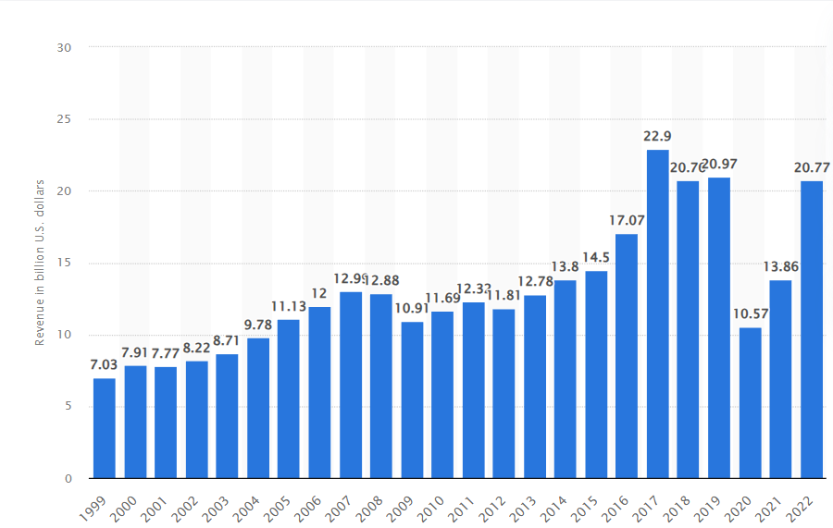
Figure 1: Growth of Revenue of Marriott International
(Source: statista.com, 2023)
The ROI (Return on Investment) of the company has seemed to be increasing after the implementation of the marketing strategies. At present, the ROI is 38.25% which was 34.29% in 2022 and 7.06% in 2021 (macrotrends.net, 2023). Hence, it can be implied that the strategy of Marriott helps this hotel to gain a strong position in the market focusing on the teen and statistics. The marketing strategies are effective in enhancing the functionalities of the hotel chain.

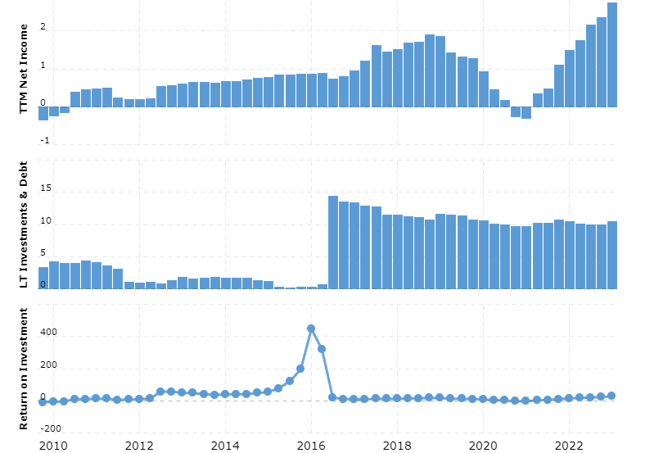
Figure 2: ROI of Marriott International
(Source: macrotrends.net, 2023)

Task 2: Managerial Implication on Marketing Strategies

2.1 Managerial Implication of the Strategies
Managerial implications of a strategy deal with the overall consequences that have been taken into consideration by the management of the company. In the present scenario, it is important to identify the strategies that Marriott International has taken during COVID to sustain growth and hold a strong position in the competitive industry. An unexpected and exceptional situation had been raised at the time of the outbreak of the pandemic and several industries were facing challenges to cope with the situation (Al-Mansour and Al-Ajmi, 2020). In the strategy of digital transformation, Marriott has included Analytics and the use of Artificial Intelligence to provide customised suggestions to guests. It helps in improving the relationship with the stakeholders and benefits the internal stakeholders as well.
Government support is an important factor for different industries based on their operations. However, there is a significant importance for government support at the time of crisis in the travel industry (MarketLine case studies, 2020). The strategies have placed Marriott in a better position to survive the crisis and make it through the tough situation. Some of the small hotels may not survive the economic crisis that emerged due to COVID and this can help Marriott in gaining a good position in the competitive market. Hotels have changed their behaviour regarding social responsibilities and booking for sustaining with the restrictions of the pandemic and doing business simultaneously (Shin et al. 2021). Brand culture and safety are the two of the most important parts that need to be taken into consideration while focusing on strategy implementation.
Focusing on the demand of the customers and giving “discounted room vouchers” through the online platform during the epidemic has helped the company to retain its position (Li and Wang, 2022). On the other hand, there are issues with the hotel's integrity that can negatively impact the brand image and recognition of the brand. Marriott still uses the rate of occupancy as the marketing strategy to target potential visitors. Postponing all construction projects was another decision that the management of Marriott took during the pandemic. This section may significantly damage the reliant economy of tourism and slow down the process of recovery.
The digital marketing strategy that the hotel has taken for tracking the pulse of guests on social media has proved to be beneficial for attracting customers. It enables the company to check on the feedback and enhance the services as necessary (MarketLine case studies, 2020). Hence, most of the strategies that the company and the managers have taken prove to be significant for the growth of the company in several regions.

2.2 Alignment with the Theories
The “technology acceptance model” (TAM) is a digital transformation theory, which is followed by Marriott for digital transformation in Covid. There is wide acceptance of TAM theory describing the user's acceptance and use of new technology (Granić and Marangunić, 2019). The theory contends that users’ propensity to adopt technology is significant and simple practices considered by them.
The management implications of Marriott’s focus on digital transformation to give their consumers seamless and frictionless experiences are consistent with TAM. Marriott intended to increase the perceived ease of use of their digital products by making investments in user friendly mobile apps, online check-ins and contactless payment alternatives (Aburbeian et al. 2022). TAM focuses on different users’ perceived usefulness and consistency while adopting new technologies. Users are more likely to adopt and continually utilise a technology for helpful and simple to use digital technology. Marriott boosted the perceived usefulness of their technology such as AI, smart rooms and analytics for encouraging better consumer uptake and acceptance, by highlighting safety precautions and displaying the value of their digital solutions during a period of elevated health concerns. Marriott International aimed to create a positive customer experience that satisfies needs and encourages greater adoption of digital services.
The “enterprise risk management” (ERM) paradigm is one risk management theory that Marriott International aligned with managerial implications during the Covid incident. ERM is a thorough method of detecting, evaluating and reducing risks in all facets of an organisation (Saeidi et al. 2019). The managerial implications for Marriott are consistent with the ERM methodology as they were proactive in their risk management during the crisis. The members were able to spot possible hazards including declining customer’s demand with safety measurements. It helps in altering pricing tactics, improving cleaning procedures and providing flexible cancellation policies. Additionally, Marriott’s emphasis on social responsibility and community involvement was consistent with the ERM notion of taking a larger stakeholder perspective (Malik et al. 2020). Marriott showed a dedication to managing risks beyond financial concerns by providing housing for frontline workers and assisting communities, further boosting their resilience throughout the crisis.

Task 3: Recommendations to improve marketing strategies
There can be some following of certain recommendations for Marriott to integrate better managerial implications.
- Enhanced digital transformation
Marriott can integrate with a customer-centric approach for better understanding of consumer demands. It can also conduct in-depth consumer research and feedback analysis. The utilising of this knowledge can guide the creation of digital solutions to satisfy customers during COVID, which can ultimately improve the user experience as a whole. Besides, there can also be use of data analytics and personalization, where Marriot can invest in cutting edge data analytics tools (Chen et al. 2021). There can also be investing in thorough training programmes to make sure that staff members are adept at utilising digital tools and technology. Encouraging the hotel staff to adopt digital solutions in turn help in enhancing their customer services and operational effectiveness. Moreover, there can also be encouraging a culture of ongoing exploration and innovation. In order to maintain Marriott at the forefront of technical innovation, promote cross functional cooperation and get staff members to come up with ideas for new safety measures for Marriott.
- Risk management
The staff members can evaluate potential hazards affecting the operations. It includes conducting scenario planning with creating backup plans for various eventualities. Adhering to local laws and implementation of strict health or safety procedures can be more effective. For instance, visitors can be informed about safety precautions on a regular basis to foster trust and confidence. Moreover, the hotel can also provide consumers with peace of mind and this can provide flexible cancellation and refund policies to accommodate shifting travel limitations and uncertainty. In order to help staff through difficult times, they can have training for new positions (Rehman and Anwar, 2019). It can keep an eye on key performance indicators and update stakeholders on risks and mitigation plans. Assessing and enhancing supply chain resilience will mainly guarantee a steady supply of necessary products and services. During COVID, there can be development of better management by offering effective services.
- Developing innovations plans
There needs to place a higher priority on health and safety with refocusing over innovation efforts for upgrading safety procedures at all properties. In order to manage the security of both guests and employees, the hotel can make investments in innovative cleaning technologies, contactless check in procedures and social distancing solutions (Castro-Arce and Vanclay, 2020). It can be important to focus on enhancing channels of connections with customers to deliver real time updates, responding over the issues and gathering feedback. The support will help in establishing trust and maintaining client loyalty. The employee training and development can be funded with employee development initiatives. As per the beginning of operations, workers can handle the situations by their skills and can also be better equipped to handle changing tasks and responsibilities. It can involve long term cost savings by achieving through programmes with responsible sourcing.
- Meeting brand standards
The suspending of brand standards can be met by focusing over critical areas and allocating resources. Resources can be temporarily redirected for improving health and safety procedures on all sites. It can help to ensure updated hygiene guidelines and legal requirements with better conducting thorough inspections (Ansari et al. 2019). Communication with guests is also a top priority when it comes to service adjustments, health precautions and security measures. There can be implementing feedback mechanisms and security measures. The brand standards audit mainly put emphasis on sustainable practices. It can determine possible ways to lessen the impact of Covid on the environment.
- Promotion and marketing
The hotel can use customer information to give content and can also offer people’s needs. There can be use of omni-channel strategy to provide consistent message and brand experiences across digital channels (Tong et al. 2020). It can also help to provide insightful and compelling material those appeals to the target market and positions Marriott as a thought leader in the sector. The staff members can work together with relevant influencers to increase brand’s trust and reach with their audiences. The visitors can be encouraged to share their experiences through user generated content to foster trust and authenticity. Besides, there can also be utilisation of data analytics to evaluate the effectiveness of campaigns for COVID. It can ultimately refine their approach and pinpoint problem areas. The hotel can target social media advertising to reach more people and increase conversions. There can be implementing automated campaigns to nurture leads and encourage repeat reservations. It also includes offering virtual events and experiences to interact with customers remotely and encourage brand loyalty.

Conclusion
Marketing can help companies to build and maintain the reputation of the brand and strong relationships with the customers. The digital marketing and promotion ideas into practices, Marriott can be able to position itself for success in the always changing digital environment. Marriott can effectively engage customers, improving brand loyalty and spur business growth by putting a priority on personalisation.

References
Aburbeian, A.M., Owda, A.Y. and Owda, M., (2022). A technology acceptance model survey of the metaverse prospects. Ai, 3(2), pp.285-302.
Al-Mansour, J.F. and Al-Ajmi, S.A., (2020). Coronavirus ‘COVID-19’–supply chain disruption and implications for strategy, economy, and management. The Journal of Asian Finance, Economics and Business (JAFEB), 7(9), pp.659-672.
Ansari, S., Ansari, G., Ghori, M.U. and Kazi, A.G., (2019). Impact of brand awareness and social media content marketing on consumer purchase decision. Journal of Public Value and Administrative Insight, 2(2), pp.5-10.
Bakar, N.A. and Rosbi, S., (2020). Effect of Coronavirus disease (COVID-19) to tourism industry. International Journal of Advanced Engineering Research and Science, 7(4).
Castro-Arce, K. and Vanclay, F., (2020). Transformative social innovation for sustainable rural development: An analytical framework to assist community-based initiatives. Journal of Rural Studies, 74, pp.45-54.
Chen, C.L., Lin, Y.C., Chen, W.H., Chao, C.F. and Pandia, H., (2021). Role of government to enhance digital transformation in small service business. Sustainability, 13(3), p.1028.
Elgazzar, Y., El-Shahawy, R. and Senousy, Y., (2022). The role of digital transformation in enhancing business resilience with pandemic of COVID-19. In Digital transformation technology: Proceedings of ITAF 2020 (pp. 323-333). Springer Singapore.
forbes.com, (2020). Marriott Sees Growth In Caribbean And Latin America, Despite Covid-19. Available at: https://www.forbes.com/sites/ramseyqubein/2020/09/24/marriott-sees-growth-in-caribbean-and-latin-america-despite-covid-19/.[Accessed on: 15th July, 2023].
Granić, A. and Marangunić, N., (2019). Technology acceptance model in educational context: A systematic literature review. British Journal of Educational Technology, 50(5), pp.2572-2593.
hospitalitynet.org, (2021). Marriott's Mandy Gill on how marketing strategies shifted during the pandemic. Available at: https://www.hospitalitynet.org/external/4109896.html. [Accessed on: 15th July, 2023].
Huynh, N., Dao, A. and Nguyen, D., (2021). Openness, economic uncertainty, government responses, and international financial market performance during the coronavirus pandemic. Journal of Behavioral and Experimental Finance, 31, p.100536.
Ketter, E. and Avraham, E., (2021). # StayHome today so we can# TravelTomorrow: tourism destinations’ digital marketing strategies during the Covid-19 pandemic. Journal of Travel & Tourism Marketing, 38(8), pp.819-832.
Kim, J.J. and Han, H., (2022). Saving the hotel industry: Strategic response to the COVID-19 pandemic, hotel selection analysis, and customer retention. International Journal of Hospitality Management, 102, p.103163.
Li, Yuchuan and Wang, Gefei. (2022). Research on the Organizational Management Problems and Development Suggestions of Marriott Hotels in the Context of COVID-19. BCP Business & Management. 34.
macrotrends.net, (2023). Marriott Cash on Hand 2010-2023 | MAR. Available at:https://www.macrotrends.net/stocks/charts/MAR/marriott/cash-on-hand.[Accessed on: 15th July, 2023]
macrotrends.net, (2023). Marriott Return on Investment 2010-2023 | MAR. Available at: https://www.macrotrends.net/stocks/charts/MAR/marriott/roi. [Accessed on: 15th July, 2023].
Malik, M.F., Zaman, M. and Buckby, S., (2020). Enterprise risk management and firm performance: Role of the risk committee. Journal of Contemporary Accounting & Economics, 16(1), p.100178.
MarketLine case studies, (2020). Marriott International: Marriott's response to the COVID crisis as the travel and tourism industry struggles.
Martin, A., (2019). The practical guide to understanding and raising hotel profitability. Routledge.
Nikbin, D., Iranmanesh, M., Ghobakhloo, M. and Foroughi, B., (2022). Marketing mix strategies during and after COVID-19 pandemic and recession: a systematic review. Asia-Pacific Journal of Business Administration, 14(4), pp.405-420.
Rangaswamy, A., Moch, N., Felten, C., Van Bruggen, G., Wieringa, J.E. and Wirtz, J., (2020). The role of marketing in digital business platforms. Journal of Interactive Marketing, 51(1), pp.72-90.
Rehman, A.U. and Anwar, M., (2019). Mediating role of enterprise risk management practices between business strategy and SME performance. Small Enterprise Research, 26(2), pp.207-227.
Sadiku-Dushi, N., Dana, L.P. and Ramadani, V., (2019). Entrepreneurial marketing dimensions and SMEs performance. Journal of Business Research, 100, pp.86-99.
Saeidi, P., Saeidi, S.P., Sofian, S., Saeidi, S.P., Nilashi, M. and Mardani, A., (2019). The impact of enterprise risk management on competitive advantage by moderating role of information technology. Computer standards & interfaces, 63, pp.67-82.
Sandes, F.S., (2023). The Impact of Brand Presence on Consumer Perceptions of Controversial and Noncontroversial Topics. ICIEMC Proceedings, (4).
Shin, H., Sharma, A., Nicolau, J.L. and Kang, J., (2021). The impact of hotel CSR for strategic philanthropy on booking behavior and hotel performance during the COVID-19 pandemic. Tourism Management, 85, p.104322.
spglobal.com,(2020). COVID-19, CECL contributed to Marriott's $65M bad debt expense in Q1. Available at:https://www.spglobal.com/marketintelligence/en/news-insights/latest-news-headlines/covid-19-cecl-contributed-to-marriott-s-65m-bad-debt-expense-in-q1-58567932.[Accessed on: 15thJuly, 2023].
Statista.com, (2022). Marriott International - statistics & facts. Available at: https://www.statista.com/topics/1872/marriott-international/#topicOverview. [Accessed on: 15th July, 2023].
Statista.com, (2023). Revenue of Marriott International worldwide from 1999 to 2022. Available at: https://www.statista.com/statistics/266279/revenue-of-the-marriott-international-inc-hotel-chain/. [Accessed on: 15th July, 2023].
Tong, S., Luo, X. and Xu, B., (2020). Personalized mobile marketing strategies. Journal of the Academy of Marketing Science, 48, pp.64-78.
travelweekly.com, (2021). Marriott to adopt a dynamic pricing system for Bonvoy loyalty program. Available at: https://www.travelweekly.com/Travel-News/Hotel-News/Marriott-adopting-dynamic-pricing-loyalty-program. [Accessed on: 15th July, 2023].
Zhang, D., Tu, J., Zhou, L. and Yu, Z., (2020). Higher tourism specialization, better hotel industry efficiency?. International journal of hospitality management, 87, p.102509.

