Cultivated Land as Space and Place:
A Cross-Cultural Study of Agrarian Imaginaries in Visual and Artistic Practices

1. Introduction: Cultivated Land as a Cultural Space
In an era marked by accelerating globalisation, environmental crisis, and large-scale displacement, questions of space and place have become increasingly central to contemporary cultural and artistic inquiry. Rapid urbanisation, ecological degradation, and the circulation of global capital have fundamentally altered how humans inhabit, perceive, and imagine space. These processes have not only transformed physical environments but have also reshaped cultural meanings attached to everyday landscapes. Space is no longer understood as a neutral backdrop for human activity; rather, it is recognised as socially produced, politically charged, and culturally imagined. Artistic and visual practices play a crucial role in revealing these spatial dynamics, making visible the power relations, historical sedimentations, and affective attachments embedded in seemingly ordinary environments.
Within this expanded spatial discourse, agricultural land—one of the most fundamental spatial forms in human history—offers a particularly productive lens through which to examine how different cultures construct meaning, identity, and belonging. Long before the emergence of modern cities, cultivated land organised social life, economic exchange, and cosmological belief. Agricultural cycles structured time, while land ownership and cultivation practices shaped social hierarchies and collective responsibility. Even in contemporary societies where farming is no longer a dominant occupation, agricultural landscapes continue to shape cultural memory, moral imagination, and symbolic narratives of origin, stability, and loss.
Although agricultural practices exist across the globe, the ways in which cultivated land is represented in visual and creative culture vary significantly across regions and historical moments. These differences reflect distinct relationships between humans and nature, labour and land, memory and power. In some contexts, farmland is depicted as harmonious and abundant; in others, it appears as a site of struggle, alienation, or ecological vulnerability. Farmland thus functions not merely as an economic resource or environmental condition, but as a culturally mediated place shaped by geography, ideology, and collective imagination. Visual representations of farmland often condense complex social histories into seemingly simple scenes, making them particularly revealing sites for spatial analysis.
This essay addresses Question 3: Space and Place, asking how contemporary and historical creative practices participate in the politics and poetics of space by examining representations of agricultural land across different cultural contexts. It argues that cultivated land operates simultaneously as a material space, a symbolic surface, and an affective place, through which social values, historical experiences, and spatial imaginaries are articulated. By comparing artistic and cultural works related to agrarian life from Northern China, Southern China, and selected regions in Europe, Africa, and the Americas, the essay investigates how the same elemental spatial form—farmland—is repeatedly reconfigured through diverse visual languages and symbolic systems.
The central research question guiding this study is:
How do people in different cultural and geographical contexts creatively represent agricultural land, and how do these representations construct distinct senses of place shaped by local environments, social structures, and historical conditions?
In response, the essay proposes that agricultural imagery constitutes a critical site where spatial politics and spatial poetics intersect. On one hand, representations of cultivated land encode power relations, including land ownership, colonial histories, and systems of labour. On the other, they express emotional attachment, collective memory, and cosmological understandings of human–nature relationships. This dual function positions agrarian space as both politically contested and poetically charged, capable of revealing tensions between exploitation and care, control and coexistence.
The essay draws on humanistic geography, particularly Yi-Fu Tuan’s concept of sense of place, alongside Henri Lefebvre’s theory of the production of space, which frames land as a socially constructed spatial form shaped by ideological and economic forces. These perspectives are complemented by symbolic interpretation and visual culture theory, as well as posthumanist and feminist thought, including the work of Donna Haraway and Rosi Braidotti. Methodologically, the essay adopts a comparative and interdisciplinary approach, moving from theoretical framing to regional case studies and cross-cultural comparison.
By situating agricultural land within broader debates on space and place, this research demonstrates how creative practices transform a shared material necessity into culturally specific spatial imaginaries. In doing so, it contributes to a deeper understanding of how space is continually reimagined through art, design, and visual culture in a globalised yet uneven world, where environmental crisis and spatial injustice increasingly demand critical attention.
Building on these perspectives, this research advances the following proposition:
that cultivated land functions as a culturally differentiated spatial interface where environmental conditions, historical power relations, and affective attachments are negotiated simultaneously through visual form.
Rather than treating agrarian imagery as either symbolic representation or social documentation, the essay argues that creative practices actively produce cultivated land as place—transforming material environments into culturally specific spatial imaginaries. This proposition provides a critical lens through which the comparative case studies are analysed.

2. Theoretical Framework: Space, Place, and the Cultural Imagination of Agricultural Land

2.1 From Space to Place: Agricultural Land as Lived Experience
A foundational distinction within geographical and cultural theory is that between space and place. Space is often conceptualised as abstract, open, and undifferentiated, whereas place emerges through lived experience, emotional attachment, and cultural meaning. Yi-Fu Tuan famously defines place as “space made meaningful,” shaped by memory, perception, and embodied practice (Tuan, 1977). This distinction is particularly relevant to agricultural land, which exists not only as physical terrain but also as a site of repetitive labour, seasonal rhythm, and intergenerational continuity.
Through everyday practices such as ploughing, planting, harvesting, and resting, cultivated land becomes inscribed with memory and identity. These embodied actions transform soil into a lived environment rather than a neutral surface. In many agrarian societies, farmland is inseparable from notions of home, ancestry, and moral order, functioning as both an economic foundation and an ethical landscape. Representations of agricultural land therefore cannot be understood as neutral depictions of nature; rather, they articulate how communities experience, value, and imagine their environments over time.
This transformation from space to place provides a critical foundation for analysing agrarian imagery across cultures. While farming is a globally shared activity, the meanings attached to cultivated land vary according to geography, climate, and historical context. Agricultural land thus offers a productive site for examining how place is culturally constructed rather than geographically given. Artistic representations play a crucial role in this process by selectively emphasising certain spatial experiences—labour, abundance, hardship, or loss—while marginalising others.

2.2 The Production of Space and the Politics of Land
While humanistic geography foregrounds experience and affect, critical spatial theory emphasises the political dimensions of space. Henri Lefebvre’s theory of the production of space argues that space is not a passive container but an active social product shaped by economic systems, power relations, and ideological structures (Lefebvre, 1991). Space is produced through the interaction of spatial practices (everyday activities), representations of space (plans, maps, ideologies), and representational spaces (lived and imagined spaces).
Agricultural land exemplifies this process with particular clarity. Systems of ownership, labour organisation, and governance—from feudal tenure and colonial plantations to collectivised farming and industrial agribusiness—shape not only how land is used, but how it is imagined and represented. Visual depictions of farmland often naturalise particular social orders, presenting agricultural labour as timeless, harmonious, or inevitable, while obscuring relations of exploitation, displacement, or control embedded in land use.
Understanding agricultural land as a produced space enables this essay to analyse how creative practices participate in the politics of space, either by reinforcing dominant spatial ideologies or by exposing their contradictions. In some contexts, agrarian imagery legitimises state authority or capitalist productivity; in others, it becomes a means of resistance, revealing the violence and exclusions that underpin seemingly pastoral landscapes.
Beyond Lefebvre’s triadic model, agricultural land can also be understood through the lens of spatial temporality. Farmland is not only produced socially in space, but also structured through time—seasonal cycles, generational inheritance, and historical rupture. As geographer Tim Ingold argues, landscapes are “taskscapes,” shaped by accumulated activities rather than static forms (Ingold, 1993). Cultivated land thus embodies layered temporalities: past labour embedded in soil, present routines of cultivation, and anticipated futures of harvest or loss.
This temporal dimension is crucial for understanding how agrarian space becomes politically charged. Moments of land reform, enclosure, collectivisation, or forced displacement interrupt these temporal continuities, producing what Avery Gordon describes as “haunted landscapes,” where absence and violence remain materially present (Gordon, 2008). Artistic representations of farmland frequently register these temporal disruptions through ruins, abandoned fields, or idealised retrospection, revealing how time itself is unevenly distributed across space.

2.3 Symbolic Interpretation: Agricultural Motifs as Cultural Signs
To analyse representations of cultivated land, it is necessary to consider symbolic meaning alongside material conditions. Symbolic interpretation and visual culture theory provide tools for understanding how images function as culturally encoded systems of signs rather than transparent reflections of reality (Barthes, 1977).
Agricultural motifs—soil, crops, tools, seasonal cycles—operate as symbols that convey culturally specific values. Soil may signify fertility, ancestry, or national belonging; crops may represent abundance, vulnerability, or sacrifice; tools may embody labour, technological progress, or human agency. These meanings are never fixed or universal but are shaped by cultural narratives, historical experience, and ideological framing.
By approaching agricultural imagery as a symbolic system, this essay foregrounds cultural specificity and avoids universalising interpretations of agrarian space. Visual representations of farmland thus become sites where material conditions and symbolic meaning intersect, allowing artists to communicate complex ideas about identity, power, and belonging through seemingly familiar rural scenes.

2.4 Posthuman and Feminist Perspectives: Land as a Relational Space
Posthumanist and feminist theory challenge human-centred narratives of land as an object of mastery or domination. Donna Haraway’s emphasis on multispecies entanglement and Rosi Braidotti’s relational conception of subjectivity offer alternative ways of understanding agricultural land as a space of co-becoming rather than control (Haraway, 2016; Braidotti, 2013).
Applied to agrarian imagery, these perspectives shift attention toward interdependence between humans, non-human agents, and environments. Farming emerges not as unilateral human action but as a negotiated relationship involving soil, plants, animals, climate, and tools. This framework is particularly relevant to contemporary practices responding to ecological crisis, where cultivated land is increasingly represented as fragile, exhausted, or endangered.
By decentring the human subject, posthuman perspectives allow agrarian space to be understood as an active participant in cultural production. Cultivated land is no longer a passive backdrop but a relational field where multiple agencies interact, challenging modernist narratives of progress and control.

2.5 Analytical Framework
Bringing together these perspectives, the essay analyses agricultural land through four interrelated dimensions: environmental conditions, social production of space, symbolic encoding, and relational coexistence. This framework enables a comparative reading of agrarian representations across China and global contexts, ensuring that both material specificity and cultural imagination are taken seriously.
Recent spatial scholarship has further extended these debates by addressing agrarian space under conditions of ecological crisis and global extraction. For instance, Tsing’s concept of “disturbed landscapes” reframes cultivated land as a site shaped by ongoing human–nonhuman entanglements rather than stable productivity (Tsing, 2021). Similarly, Nixon’s notion of “slow violence” has been increasingly applied to agricultural environments, highlighting how soil depletion, pesticide exposure, and land dispossession operate as spatially uneven and temporally delayed forms of harm (Nixon, 2011; Davies, 2022).
These contemporary perspectives complicate earlier humanistic and Marxist spatial theories by foregrounding vulnerability, precarity, and more-than-human agency within cultivated landscapes. Integrating these insights allows agricultural land to be understood not only as socially produced or symbolically encoded, but as an unstable and contested ecological space under late capitalism.

3. Agricultural Land and Cultural Place-Making in China: Northern and Southern Perspectives

3.1 Northern China: Monumentality, Soil, and Agrarian Order
In northern China, dryland farming, loess soil, and a continental climate have profoundly shaped both agricultural practice and cultural representation. Agrarian imagery from this region frequently emphasises solidity, endurance, and moral order, reflecting a spatial imagination rooted in permanence and collective survival.
Traditional Northern Chinese folk woodblock prints (nianhua) from regions such as Shaanxi and Hebei in the late Qing dynasty offer a clear example. Works such as Harvest Celebration (anonymous, c.1890, Shaanxi) depict expansive wheat fields rendered through bold outlines and dense compositions. Figures appear sturdy and monumental, visually integrated into the land itself. The heavy visual treatment of soil mirrors the physical labour required to cultivate loess earth (Wu, 2010).
Similar spatial logic appears in modern Chinese painting. Li Keran’s Harvesting in the North (1958, Beijing) presents broad horizontal planes and compressed depth, framing cultivated land as a moral and national foundation during the early socialist period (Andrews, 1994). In both cases, farmland is transformed into a moralised place embodying endurance and collective order.

3.2 Southern China: Water, Cyclical Time, and Agrarian Fluidity
In contrast, southern China’s wet-rice agriculture and water-based ecologies produce a spatial imagination centred on fluidity, rhythm, and cyclical time. This is evident in Shen Zhou’s Peasants Working in the Fields (c.1480, Suzhou), where rice paddies unfold gradually through a handscroll format, inviting experiential engagement with agricultural space (Clunas, 1996).
Southern woodblock prints from Qing-dynasty Suzhou workshops, such as Rice Transplanting in Spring (anonymous, c.1760), further emphasise fine lines, layered space, and tonal softness, reflecting both humid climate and cultural associations of water with fertility (Hay, 2001).
Contemporary artist Chen Qi’s Field No.3 (1999, Hangzhou) continues this tradition through dense repetitive carving, evoking both rice paddies and flowing water. His work foregrounds duration and material intimacy rather than heroic labour (Sullivan, 2012), aligning with posthuman perspectives on relational space.

3.3 Comparative Reflection
Together, northern and southern Chinese representations demonstrate how geography structures cultural imagination. The same agrarian activity produces radically different spatial meanings, confirming that cultivated land is a culturally produced place shaped by environmental conditions and embodied practice.
It is also important to recognise that these regional differences within China are not fixed or isolated. Migration, state policy, and modernisation have increasingly blurred traditional agrarian distinctions. Contemporary artists working with agricultural themes often operate across these regional imaginaries, negotiating between inherited visual traditions and present-day spatial transformations.
For example, rural-to-urban migration has profoundly altered the lived experience of farmland, particularly for younger generations. Cultivated land increasingly appears in contemporary Chinese art as a site of absence or nostalgia rather than everyday labour. This shift reflects what Marc Augé describes as the emergence of “non-places,” where traditional spaces of identity are destabilised by mobility and abstraction (Augé, 1995). In response, agrarian imagery can function as a counter-space, reclaiming local memory against homogenising development.
Thus, northern solidity and southern fluidity should not be understood as essentialised regional traits, but as historically situated spatial imaginaries continually renegotiated through social change. Chinese agrarian art demonstrates how cultivated land remains a dynamic cultural space, capable of absorbing new meanings while retaining traces of embodied agricultural knowledge.

4. Global Perspectives on Cultivated Land: Europe, Africa, and the Americas

4.1 Europe: Agricultural Land, Modernity, and Alienation
Within European art history, cultivated land has frequently been represented as a site of productivity, order, and, increasingly, alienation under modernity. Unlike the cosmological or cyclical associations that characterise many Asian agrarian traditions, European representations tend to frame farmland as a rationalised and commodified space shaped by industrialisation, private ownership, and capitalist modes of production.
A canonical example is Jean-François Millet’s The Gleaners (1857, Barbizon, France). The painting depicts three peasant women collecting leftover grain after the harvest, their bent postures emphasising physical exhaustion and social marginality. While the field stretches expansively behind them, it is clearly owned and regulated, with distant haystacks symbolising agricultural surplus. The contrast between abundance and deprivation exposes cultivated land as a politically stratified space structured by class relations. In Lefebvre’s terms, the field operates as a socially produced space, organised through systems of labour and ownership rather than communal belonging (Lefebvre, 1991; Nochlin, 1971).
Later European modernist practices further complicate agrarian space by internalising it as a psychological landscape. Vincent van Gogh’s The Harvest (1888, Arles, France) presents cultivated land through turbulent brushwork and heightened colour. Linear perspective is destabilised, transforming farmland into an emotionally charged and affective environment. Rather than celebrating agricultural productivity, Van Gogh’s fields register a sense of existential tension and displacement, reflecting what Yi-Fu Tuan describes as the emotional inscription of space through lived experience (Tuan, 1977). European agrarian imagery thus increasingly reflects the erosion of traditional rural life under modernity, producing alienation rather than rootedness.
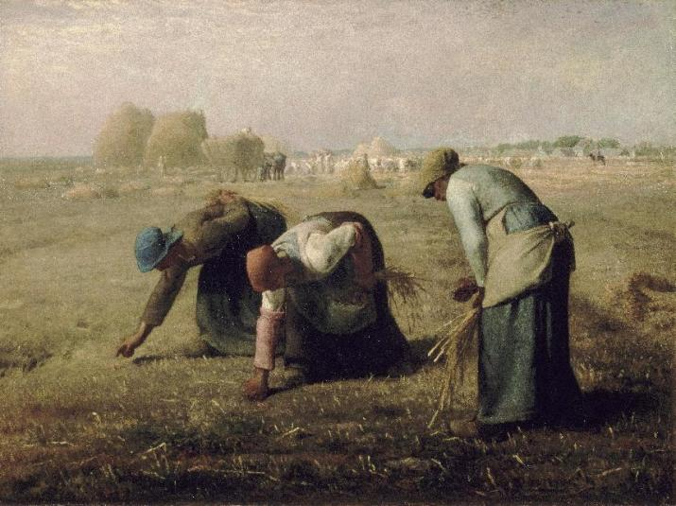
Figure 1. Jean-François Millet, The Gleaners (1857, Barbizon, France)
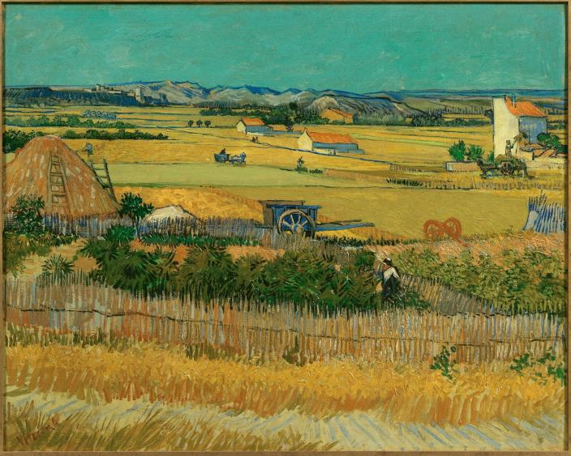
Figure 2.Vincent van Gogh， The Harvest (1888, Arles, France)

4.2 Africa: Cultivated Land, Colonial Disruption, and Indigenous Knowledge
In many African contexts, cultivated land cannot be separated from colonial histories and Indigenous systems of spatial knowledge. Artistic representations of agrarian space frequently respond to imposed colonial geographies that disrupted long-standing relationships between land, community, and cosmology.
This tension is evident in the work of El Anatsui (b. 1944, Ghana/Nigeria), particularly Earth’s Skin (2007, Nsukka). Although not a literal depiction of farmland, the installation—constructed from discarded bottle caps—evokes cultivated surfaces through its modular repetition and tactile materiality. The work references both subsistence farming and extractive economies, transforming industrial waste into a metaphorical land surface scarred by colonial trade and global capitalism. Cultivated land is thus abstracted into a space of memory, circulation, and historical trauma rather than a stable territory (Enwezor, 2007).
More direct representations of agrarian life appear in Malick Sidibé’s photographs of rural Mali (1960s–70s), such as Farmers Returning from the Fields (1968). These images depict agricultural labour as a communal and rhythmic practice embedded in everyday life. Rather than emphasising ownership or productivity, Sidibé foregrounds movement, collective presence, and continuity. Farmland functions here as a lived place shaped by social relations and embodied practice, aligning with Indigenous African spatial frameworks that prioritise relationality over fixed territorial boundaries (Mbembe, 2001).
From a postcolonial perspective, these works challenge Western capitalist and cartographic conceptions of land. They resonate with Doreen Massey’s argument that space should be understood as relational, open, and continuously produced through interaction rather than as a closed or static container (Massey, 2005).
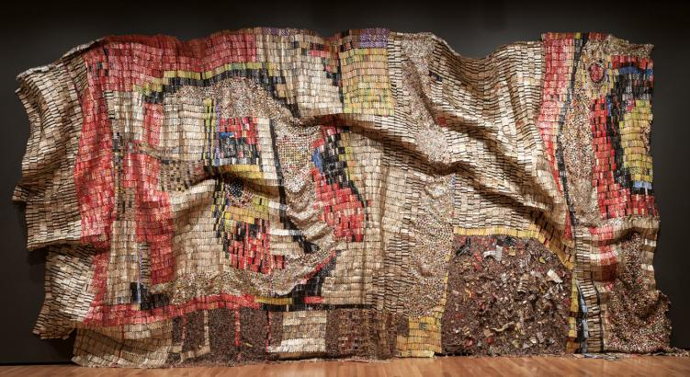
Figure 3.El Anatsui，Earth’s Skin (b. 1944, Ghana/Nigeria)

4.3 The Americas: Cultivated Land, Displacement, and Environmental Politics
In the Americas, representations of cultivated land are deeply entangled with histories of settler colonialism, Indigenous displacement, and environmental exploitation. Artistic practices often address farmland as a contested space shaped by violence, erasure, and resistance.
A key example is Diego Rivera’s mural The History of Mexico (1929–1935, Mexico City), in which agricultural scenes occupy a central position. Rivera depicts Indigenous farmers cultivating maize using traditional techniques, presenting cultivated land as a site of continuity and resistance. In contrast to capitalist extraction, the land is framed as a collective Indigenous space grounded in communal labour and historical memory (Craven, 1997). Agrarian imagery thus functions as an explicitly political tool within Rivera’s anti-colonial visual narrative.
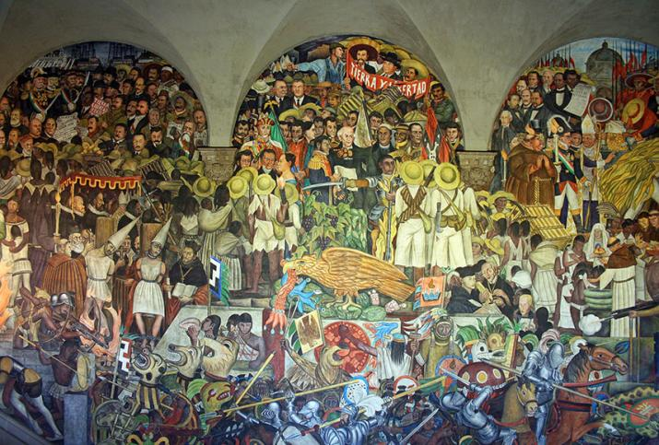
Figure 4.Diego Rivera’s mural，The History of Mexico (1929–1935, Mexico City)
In North America, Grant Wood’s American Gothic (1930, Iowa, USA) indirectly reflects agrarian spatial politics. Although the painting foregrounds human figures rather than farmland itself, the implied agricultural setting situates the subjects within an idealised vision of rural stability and moral order. Produced during the Great Depression, when many farming communities faced displacement and economic collapse, the image constructs cultivated land as a nostalgic symbol rather than a lived reality. In this sense, the farmland operates as what Jean Baudrillard would describe as a simulacrum of rural authenticity—an image that masks social instability through idealisation (Baudrillard, 1994).
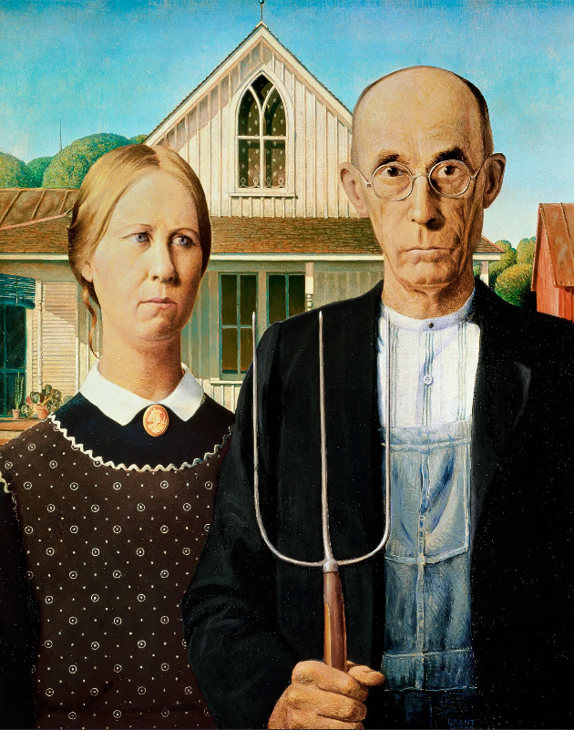
Figure 5.Grant Wood，American Gothic (1930, Iowa, USA)
Contemporary Indigenous and activist artists further complicate agrarian narratives by foregrounding environmental politics. Rebecca Belmore’s Fountain (2005, Venice Biennale), while centred on water, implicitly addresses land dispossession and ecological degradation. By positioning natural elements as active agents rather than passive resources, Belmore reframes cultivated land within a broader ecological system, aligning with posthuman critiques of human domination over land and nature (Braidotti, 2013).

4.4 Comparative Analysis: Global Difference, Shared Materiality
Across Europe, Africa, and the Americas, cultivated land emerges as a shared material condition but a radically differentiated cultural space. European representations frequently frame farmland through lenses of productivity, alienation, or nostalgia; African practices foreground relationality and colonial rupture; American examples emphasise displacement, resistance, and environmental politics.
These differences confirm that cultivated land cannot be understood as a universal or purely functional space. Instead, it is a culturally imagined place shaped by historical power relations, environmental conditions, and symbolic systems. Creative practices play a crucial role in revealing these spatial differences, transforming agricultural land into a site where the politics and poetics of space are continually negotiated (Harvey, 2000; Massey, 2005).
Across global contexts, one recurring tension in representations of cultivated land lies between use value and symbolic value. While farmland is materially tied to survival and subsistence, its artistic representation often exceeds utility, transforming land into a metaphorical surface for broader social concerns. This tension is particularly evident in contexts of ecological crisis, where agricultural land becomes a site of anxiety rather than abundance.
Contemporary eco-art and land-based practices increasingly depict cultivated land as vulnerable, degraded, or exhausted. These representations challenge earlier narratives of mastery and progress, aligning instead with what Jason Moore terms the “Capitalocene,” in which capitalist agriculture is understood as a central driver of ecological breakdown (Moore, 2015). Artistic engagements with farmland thus expose the entanglement of environmental degradation with historical systems of extraction and inequality.
At the same time, Indigenous and decolonial practices reclaim agrarian space as a site of alternative knowledge production. Rather than separating culture from nature, these works emphasise reciprocity, stewardship, and long-term ecological responsibility. Cultivated land becomes a pedagogical space, teaching ways of inhabiting the world that resist both commodification and abstraction.
This global comparison reinforces the argument that cultivated land functions as a critical spatial interface between local experience and planetary crisis. Creative practices do not merely represent farmland; they actively participate in reimagining how humans might coexist with land in more ethical and sustainable ways.
(Moore, 2015; Haraway, 2016)
4.5 Cultivated Land, Uncanny Space, and Affective Geography
In addition to political and symbolic dimensions, cultivated land can also generate affective responses associated with familiarity, loss, and the uncanny. Freud’s concept of the uncanny describes the unsettling return of what is both familiar and estranged. In many contemporary representations, farmland appears as a space that once sustained life but now bears traces of abandonment, mechanisation, or ecological damage.
This uncanny quality is particularly evident in post-industrial and post-agricultural landscapes, where cultivated fields are no longer worked by human hands but by machines or left fallow altogether. Artistic depictions of such spaces evoke emotional ambiguity—simultaneously nostalgic and unsettling. Farmland becomes a ghostly reminder of displaced labour, vanished communities, and disrupted human–land relations.
Affective geography helps explain why cultivated land continues to exert such symbolic power even as fewer people directly engage in farming. It is not simply remembered as a workplace, but as a space of moral imagination and existential grounding. Through creative practice, these affective dimensions are made visible, allowing audiences to confront the emotional consequences of spatial transformation.
Importantly, this research also informs practice-led and visual modes of inquiry. By conceptualising cultivated land as a spatial interface rather than a fixed site, the analysis provides a framework for translating theoretical concerns—such as relational space, environmental precarity, and affective memory—into visual form.
In this sense, the research does not conclude with representation alone, but opens toward design and artistic strategies that foreground layering, material trace, and spatial tension. Cultivated land becomes not only an object of analysis, but a methodological tool for visual thinking across media.

5. Conclusion: Cultivated Land as a Spatial Imagination Across Cultures
This research has examined how cultivated land functions as a shared yet culturally differentiated spatial element within creative practices across diverse regions and historical contexts. By focusing on agrarian imagery from China (North and South), Europe, Africa, and the Americas, the study has demonstrated that farmland is not a neutral or purely functional environment, but a complex spatial construct shaped by geography, ideology, memory, and power. In doing so, it has directly engaged with Question 3: Space and Place, revealing how creative practices participate in both the politics and poetics of space.
Drawing on humanistic geography, critical spatial theory, semiotics, postcolonial studies, and posthumanist thought, the theoretical framework established that space becomes place through lived experience, symbolic encoding, and cultural practice (Tuan, 1977; Massey, 2005). Cultivated land, as one of the most fundamental human-modified environments, emerges as a particularly revealing site for this transformation, functioning simultaneously as material ground, symbolic surface, and ideological terrain.
The Chinese case studies demonstrated how environmental conditions shape spatial imagination. Northern representations emphasise solidity, monumentality, and collective endurance, reflecting dryland agriculture and loess landscapes, while southern practices foreground fluidity, rhythm, and cyclical time shaped by wet-rice cultivation. These differences confirm that spatial imagination is deeply rooted in embodied agricultural practice, producing distinct visual languages and cultural meanings.
European representations revealed a historical shift from communal labour toward alienation and nostalgia under modernity. Works by artists such as Millet and Van Gogh frame farmland as socially stratified or psychologically charged space, exposing tensions between productivity, ownership, and loss. African and American examples further complicated this narrative by foregrounding colonial disruption, Indigenous knowledge systems, and environmental politics. In these contexts, cultivated land emerges as a contested space marked by displacement, resistance, and ecological precarity.
Taken together, these comparative analyses demonstrate that while cultivated land is a globally shared human condition, its artistic representation is never universal. Instead, it is shaped by local histories, power relations, and cultural epistemologies. Creative practices thus play a crucial role in revealing how space is imagined differently across cultures, and how these imaginaries both reflect and challenge dominant spatial orders.
Finally, this research suggests that cultivated land offers a productive lens for understanding contemporary spatial concerns, including ecological crisis, postcolonial reparation, and the rethinking of human–nonhuman relations. By engaging with agrarian space as an affective, political, and symbolic site, artists and designers contribute to alternative spatial narratives that resist abstraction and homogenisation in an increasingly globalised world.
In conclusion, cultivated land should be understood not as a passive backdrop for human activity, but as an active cultural agent within spatial imagination. Through creative practice, it becomes a site where memory, labour, identity, and power intersect—making it central to any critical inquiry into space, place, and contemporary visual culture.

Harvard Reference List
Books & Journal Articles
Andrews, J. (1994) Painters and Politics in the People’s Republic of China. Berkeley: University of California Press.
Augé, M. (1995) Non-Places: Introduction to an Anthropology of Supermodernity. London: Verso.
Barthes, R. (1977) Image–Music–Text. London: Fontana Press.
Baudrillard, J. (1994) Simulacra and Simulation. Ann Arbor: University of Michigan Press.
Braidotti, R. (2013) The Posthuman. Cambridge: Polity Press.
Clunas, C. (1996) Pictures and Visuality in Early Modern China. Princeton: Princeton University Press.
Craven, D. (1997) Diego Rivera: As Epic Modernist. New York: G. K. Hall.
Davies, T. (2022) Slow Violence and Environmental Inequality. Cambridge: Polity Press.
Enwezor, O. (2007) Archive Fever: Uses of the Document in Contemporary Art. Göttingen: Steidl.
Freud, S. (2003) The Uncanny. London: Penguin. (Original work published 1919)
Gordon, A. (2008) Ghostly Matters: Haunting and the Sociological Imagination. Minneapolis: University of Minnesota Press.
Haraway, D. (2016) Staying with the Trouble: Making Kin in the Chthulucene. Durham: Duke University Press.
Harvey, D. (2000) Spaces of Hope. Edinburgh: Edinburgh University Press.
Hay, J. (2001) Shitao: Painting and Modernity in Early Qing China. Cambridge: Cambridge University Press.
Ingold, T. (1993) ‘The Temporality of the Landscape’, World Archaeology, 25(2), pp. 152–174.
Lefebvre, H. (1991) The Production of Space. Oxford: Blackwell.
Massey, D. (2005) For Space. London: Sage.
Mbembe, A. (2001) On the Postcolony. Berkeley: University of California Press.
Moore, J. W. (2015) Capitalism in the Web of Life. London: Verso.
Nochlin, L. (1971) Realism. London: Penguin.
Nixon, R. (2011) Slow Violence and the Environmentalism of the Poor. Cambridge, MA: Harvard University Press.
Sullivan, M. (2012) Modern Chinese Artists. Berkeley: University of California Press.
Tsing, A. L. (2021) The Mushroom at the End of the World. Princeton: Princeton University Press.
Tuan, Y.-F. (1977) Space and Place: The Perspective of Experience. Minneapolis: University of Minnesota Press.
Wu, H. (2010) A Story of Ruins: Presence and Absence in Chinese Art and Visual Culture. London: Reaktion Books.

