Data Analysis
The previous chapter successfully achieved its first, second, and third objectives by explaining the theoretical frameworks employed by serial killers in the United Kingdom, evaluating the influence of advancements in policing on the prevalence of serial killers, and reviewing evidence that indicates a potential correlation between serial killers and the escalation of animal cruelty. The objective of this study is to investigate the contemporary occurrence of serial killers in the United Kingdom and to determine if the British public perceives an enhanced sense of safety in light of the diminishing prevalence of serial killers. In order to facilitate the achievement of the objectives, primary research will be undertaken by administering questionnaires to both the general public and experts employed in the domain of animal cruelty. This approach collects qualitative and quantitative data to address the study objectives.

- Establish theoretical approaches of serial killers in the UK.
- Evaluation of how police development has impacted the number of serial killers in the UK.
- Evaluation of modern phenomena of Serial Killers UK

The decision-making process will be guided by the research onion framework developed by Saunders et al. (2019) in order to achieve these objectives. This study will take into account the concepts of reliability, validity, limitations, and ethical issues.
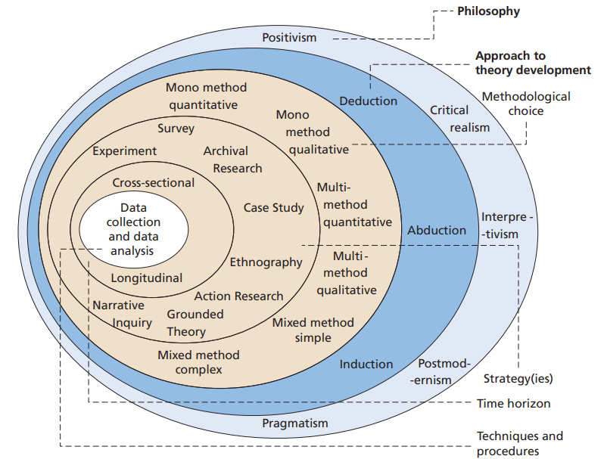
Saunders et al. (2007, p.102) claim that the research onion encompasses three fundamental philosophies, epistemology, ontology, and axiology. Each viewpoint on research philosophy is also linked to a unique philosophical framework. Positivism, realism, interpretivism, and pragmatism are regarded as the most prominent theoretical perspectives that significantly shape the research methodology used by researchers. This research utilises an interpretivist approach since it acknowledges the subjectivity of several potential replies and relies on the analysis of participants' viewpoints via the administration of a questionnaire in order to gain understanding. According to Bhattacherjee (2012), although interpretivism research often involves the collection of qualitative data, the inclusion of quantitative data has the potential to enhance accuracy and aid in understanding. Every philosophical perspective has many benefits, and the most suitable choice is chosen by its suitability. Moreover, the field of philosophy serves to clarify the conceptual framework of research and emphasises its fundamental boundaries (Easterby-Smith et al., 2018). Consequently, having an understanding of the research theory might aid in providing clarity. This inquiry examines the underlying assumptions that underpin the research process and their interrelation with the chosen approach. Data collection will be conducted via the administration of questionnaires to both the general public and professionals employed in the area of animal cruelty.

Approach
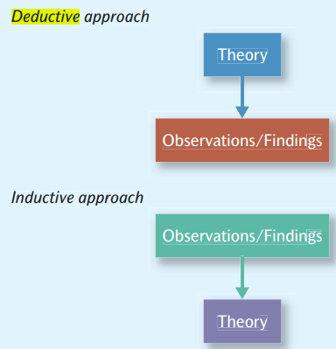
Figure 3.2 illustrates two distinct research procedures within academic writing, namely deductive and inductive methodologies. Bryman (2012) clarifies that the fundamental difference between the two methodologies lies in the fact that an inductive technique starts with pre-existing research and, after that, attempts to gather data and ascertain the underlying causes of a phenomenon. In contrast, a deductive approach involves formulating a theory as the basis for investigation, whereby the researcher aims to validate or invalidate their initial hypothesis. Hence, this study will use an inductive methodology to analyse data to appreciate the emergent patterns and ideas (Bhattacherjee, 2012). The distribution of these questionnaires includes the general public and specialists within the domain of animal cruelty. The intended demographic comprises individuals who are 18 years of age or older. Professionals specialising in the domain of animal cruelty are specifically focused on ensuring precise data collection to assess the causes contributing to the increase in incidents of animal cruelty. Additionally, these professionals are tasked with investigating if contemporary serial killers are directing their aggression towards animals rather than people. The general public is also being specifically focused on in order to ensure a precise comprehension of the public's opinion of UK serial murderers and if the decrease in their prevalence has engendered a heightened sense of security within their communities.

Strategy
Goundar (2012) defines methods as the procedures and approaches for gathering and examining data. Cleave (2021) demonstrates the efficacy of questionnaires for swiftly and cost-effectively collecting research data from large sample sizes. These measures have been shown to be advantageous in assessing subject behaviour, preferences, intentions, attitudes, and perspectives. In addition, using open and closed questions enables researchers to gather qualitative and quantitative data, leading to more comprehensive and insightful conclusions (Cleave, 2021).

This study aims to gather data from specialists in the area of animal cruelty as well as the general public, using both digital and paper-based questionnaires. The collected material will be analysed to provide insights to address the research goals. Using both digital and paper-based questions would facilitate universal accessibility to the questionnaire among experts and the general public. Furthermore, it has been acknowledged as a viable approach for studying and gathering fresh data to complement previous investigations (Villers, 2012). The survey will consist of inquiries associated with the research objectives, which will be distributed via email to professionals actively engaged in animal cruelty, such as veterinarians and animal rescue centres.

Additionally, professionals working in this industry will be granted access to the questionnaire through social media platforms like LinkedIn (LinkedIn, 2022). Furthermore, the questions targeting the general public will be disseminated throughout several social media pathways, including Facebook, LinkedIn, and Instagram, using the Google Forms platform. According to Melo (2018), Google Forms is a cost-free online tool that facilitates streamlined and compelling data collection. Surveys may be efficiently generated over a short period, providing immediate results as they are received. Additionally, Google Forms can provide a concise overview of findings via the use of charts and graphs, therefore facilitating a more efficient and effortless evaluation of the data. According to Asiedu (2019), using email and social media platforms facilitates faster engagement, cost-effectiveness, ease of use for participants, and simplified data analysis for researchers.

Furthermore, in order to capture correct data effectively, printed copies of the questionnaire will be made available to those who have little experience in the use of social media. This approach aims to engage the target audience directly and facilitate the collection of reliable information (Smart Survey, 2022a). The questionnaires begin by introducing the study to the participants, followed by a short debriefing and an explanation of the questionnaire's aim. Furthermore, the researcher's contact information is included in the brief for participants who want to discuss any aspect of the study.

Choice
The study will use a mixed-methods approach, using both qualitative and quantitative data collection methods. Creswell (2014) asserts that integrating qualitative results with quantitative approaches facilitates the interpretation and enhanced comprehension of research. The analysis of participants' perspectives will be conducted by using both qualitative and quantitative data, which will then be triangulated as a component of a mixed-methodological approach. According to Bhandari (2022), the concept of triangulation in research relates to the practice of tackling a research problem via the utilisation of several datasets, methodologies, theoretical frameworks, or researchers. This research approach can potentially enhance the validity and reliability of the study findings.

Time Horizon
The time horizons layer is responsible for determining the duration of the research and the collection of data within a specific timeframe (Melnikovas, 2018). Given the brevity of this investigation, the most appropriate temporal framework would be cross-sectional. Due to the temporal constraint imposed by the timeframe, researchers will use online questionnaires as a means of data collection. This method is preferred due to its expediency in engaging with the intended demographic and its efficiency compared to traditional paper-based surveys (Asiedu, 2019). Furthermore, the use of Google Forms may enhance the efficiency and ease of data assessment by providing prompt results and presenting a clear overview of findings via the incorporation of charts and graphs (Melo, 2018).

Data Collection and Data Analysis
According to Smart Survey (2022b), primary research involves directly accessing the original source of information rather than relying on pre-existing data samples. This particular kind of study is particularly suitable when the acquired data has to be contextually relevant. This research aims to acquire data via the distribution of questionnaires to specialists in the area of animal cruelty, including veterinarians and animal rescue centres, as well as to the general public. The objective is to get insights into the public's impressions of serial murderers. Ghauri et al. (2020) suggest that surveys are subject to several restrictions, such as temporal constraints and restricted availability of crucial resources.

Nevertheless, this research has the advantage of having direct communication channels, including email and social media platforms, with professionals actively engaged in animal welfare. These channels provide sufficient time to carry out a cross-sectional survey. Furthermore, Ghauri et al. (2020) show that surveys emphasise various occurrences, facilitating the ability to make comparisons.

The analysis will include both qualitative and quantitative data obtained from the questionnaires. McLeod (2019) claims that qualitative research involves the systematic collection, analysis, and interpretation of data that is not numerical. Furthermore, qualitative research may be used to enhance comprehension of the study by collecting subjective insights and perspectives on the topic. According to McLeod (2019), quantitative research involves the systematic collection and analysis of numerical data in an objective manner in order to characterise, forecast, or control elements of interest. Quantitative research tries to demonstrate causal relationships among variables, generate predictions, and extend the applicability of results to broader populations. The analysis of quantitative data would include the use of a Likert scale, as suggested by Bhandari (2020).

On the other hand, the analysis of qualitative data will be conducted thematically to identify repeating themes or patterns. All inquiries posed within the questionnaire refer to the study goals. The breakdown analysis will conduct a separate examination and evaluation of data for each question after the data has been assessed. The data gathered will be systematically displayed and evaluated with spreadsheet software, such as Microsoft Excel, focusing on maintaining a high level of organisation. This approach aims to facilitate the generation of reliable and precise conclusions (Natter, 2019). It is essential that all questions in the questionnaire effectively include the three goals outlined in the subsequent chapter. The inclusion of Appendix 2 in the present study encompasses a questionnaire and a literature review matrix, which clarifies the interconnection between the survey and the literature review.

Limitations and Potential Problems
One notable limitation of this study is the time demands associated with accessing essential resources, conducting primary investigations, and analysing the resultant data. In order to address this challenge, a Gantt chart has been devised, which will further facilitate effective time management. According to Ramos (2021), a Gantt chart is a graphical depiction of the progress of individual tasks within a project, organised by specific time intervals. The provided timelines visually depict the interconnections and dependencies among the various activities. Gantt charts provide a comprehensive representation of project activities and their respective progress, hence offering distinct advantages.
Furthermore, the researcher may face a potential barrier in the form of non-participation by the intended participants, particularly specialists employed in the domain of animal welfare, when it comes to engaging in an online questionnaire. Nevertheless, by using direct email communication with industry experts and utilising a specialised social media site like LinkedIn, this constraint may be effectively managed (LinkedIn, 2022).

