Module Code-BMSW5103
Module Name : Understanding and engaging in the customer experience
Lecturer Name ; Nishi Ramsurrun

Word Count- 5443

Student Name-Bogdan Andrei Stefaniga
Student ID-1917193

Organisation’s quality systems and customer relationship management
Executive Summary:
Covid-19 has influenced a long-term effect over everyday life. The unavailability of proper medication and contagious nature of the virus compelled the governments to introduce social distancing and restriction on free travel. The advance technologies were present in front of the customers long before the outbreak of pandemic. However, the lockdown restrictions and health hazards has removed the mental restrains among the people. The report is going to discuss about an online retail giant Amazon and how they have survived from the changes imposed by the pandemic.

Table of Contents
Introduction: 3
Company context: 4
Models review: 8
Model selection: 17
Recommendations: 30
Conclusion: 32
References: 33

Introduction:
The companies have employed technological skills to improve sales, maintain a better relation with the customers and limited human involvement in the business operations. In this ‘New Normal’ life style, creation of better relation with the customer is the only way to attain a business growth. Popularity is the key business ingredient for a seller to secure a better profit margin. A better Customer Relationship Management (CRM) strategy can help a company to attain competitive advantage and negate the macro-environmental threats. This report is going to discuss about Amazon and its business policies which enabled them through the economic turmoil. In addition, the report is also going to recommend practical strategies to improve the CRM value chain of the company.

Company context:
In 1994, Amazon.com was established by Jeff Bezos as an US based online book selling platform. In 2018, the same company reached $1 trillion mark just few months after Apple achieved that milestone. In present days, the company is operating internationally over 100 countries and offering online retail, consumable electronic items, digital contents, cloud computing services along with local services such as grocery supply and daily deals. As a leading e-retail service provider in US, the revenue of Amazon was reached nearly $386 billion in 2020 in spite of the Covid-19 restrictions (Garcia, 2021). The company is generating most of its revenue though online product sales, digital subscriptions and AWS cloud computing services. The worldwide B2C market is growth, customer centric brand image and excellent geographical reach of Amazon, positioned the company among most valuable brands all over the world.
Factors effecting Amazon’s quality system:
PESTEL analysis:
The PESTEL analysis is consist of external environmental factors which have a considerable impact over organisational stability and business policies. The macro or external environmental factors influencing the organisational and customer requirements of Amazon are discussed with the help of PESTEL analysis.
Political factors:
- The trade protectionism regulations implemented by president Donald Trump in US has a dual effect over Amazon. On the positive side, a ban on trading of foreign companies increased the retail sale of Amazon. On the negative side, the scarcity of imported items created an inconvenient situation for the consumers as well as for Amazon.
- During covid-19 the government has exempted online services from restrictions. It turned as a huge opportunity for Amazon. In third quarter of 2020, Amazon secured a profit of $96.15 billion (Alimahomed-Wilson and Reese, 2021).
- Government’s increasing effort to improve cyber security profited the company.
- The Brexit deal imposed a negative effect over Amazon UK businesses. The product values for the geographic area increased due to excess import export cost which affected the interest of consumers.
Economic factor:
- As an international service provider, the stable economy of developed EU countries has helped Amazon to attain a sustainable growth.
- The number of online transactions was increased after the outbreak of pandemic. The growth in virtual transactions has benefited the company similarly it benefits the bank.
- The decrement in disposable income due to Covid-19, had affected Amazon’s profit margin.
Social factor:
- Since the beginning, Amazon follows an anarcho-capitalist business structure. It created a negative brand image and increased the competitive rivalry.
- The tax evading strategies of Amazon benefited the company greatly. However, the US population did not welcome those policies.
- The exploitation charges of company workers against Amazon created a negative popularity (Aćimović, 2020).
Technological factors:
- The implementation of machine learning technologies and artificial intelligence helped Amazon to attain meteoric growth. With perfect assumptions of customer requirements Amazon became much more customer friendly, customer specific and interactive.
- A Strong technological R&D department is improving the customer services with innovative solutions.
- The involvement of the company in cloud computing (Amazon Web Services) is promising even more future growth.
- The utilisation of robotics has offered better mobility and accuracy in business operations during the outbreak of pandemic. On the ither hand, Amazon was criticised by the US population due to job downsizing.
Environmental factors:
- The world-wide retail services of Amazon and excellent geographical reach is benefitting the customers. However, the company is also facing criticisms due to the massive carbon footprint it is leaving behind during shipping process.
- Poor environmental initiatives and unclear environmental goals are hampering the brand image of Amazon (Aćimović, 2020).
Legal factors:
- Inappropriate product specifications and claims had attracted federal convictions against the company.
- The company is facing legal obligations due to Brexit deal and trade protectionism rules.
SWOT analysis:
The SWOT analysis evaluates the micro environmental or internal factors such as strengths, weaknesses, opportunities and threats those influences organisational efficiencies and customer relations.
Strengths:
- The technological improvements are providing Amazon access to the personal choices, shopping behaviour and preferences of the customer. With technological superiority, Amazon is adding valuable attributes to the online retail platform to improve customer experience.
- Popular brands and sellers from all over the world are selling their product through the online platform of Amazon which is positioning the company as a one-stop shopping solution for the customers.
- Diversified business segments are appealing customers from different levels of the society and attracting them to involve with Amazon.
Weaknesses:
- The employee responses are not supporting the brand image.
- Reports about bad delivery experiences are increasing since the beginning of pandemic.
- Poor effort of Amazon towards environmental concerns is degrading the brand image and serving as a weakness for the company (Agnihotri, 2022).
Opportunities:
- The healthy growth of worldwide B2C market is providing opportunity to the company to increase business.
- The growth in logistic services has improved the position of the Amazon Logistics. In 2021 Amazon Logistics has experienced best growth in market share among its competitors in UK.
- The worldwide popularity of Amazon is providing opportunity to earn more revenue from paid advertising through its online retail platform.
Threats:
- The charges of exploitation, intense work schedules, work injuries and poor wages are weakening the workforce of Amazon.
- The close competitors of Amazon such as eBay, Walmart and JD are also employing technologies to improve customer experience and improve brand loyalty.
- Market surveys are indicating that around 36% of customers are preferring to change the retailer after having bad delivery experiences (Alimahomed-Wilson, 2021).
- Outside US Amazon is struggling with the grocery supply services.

Models review:
The Customer Relationship Management (CRM) models are based on company-wide plans to grow profit and revenues, reduce operational costs and enhance relationship with customers. Prioritising customer preferences and increase sales and brand loyalty simultaneously is the underpinning principal CRM models.
Payne’s five process model:
The priority of Payne’s five process model is improvement of customer relations and retention of existing customers. In 2006, Payne and Frow introduced five processes to build and maintain a better relationship with the customers (Tahir et al, 2017). The processes are interlinked with each other and support process-oriented approaches.
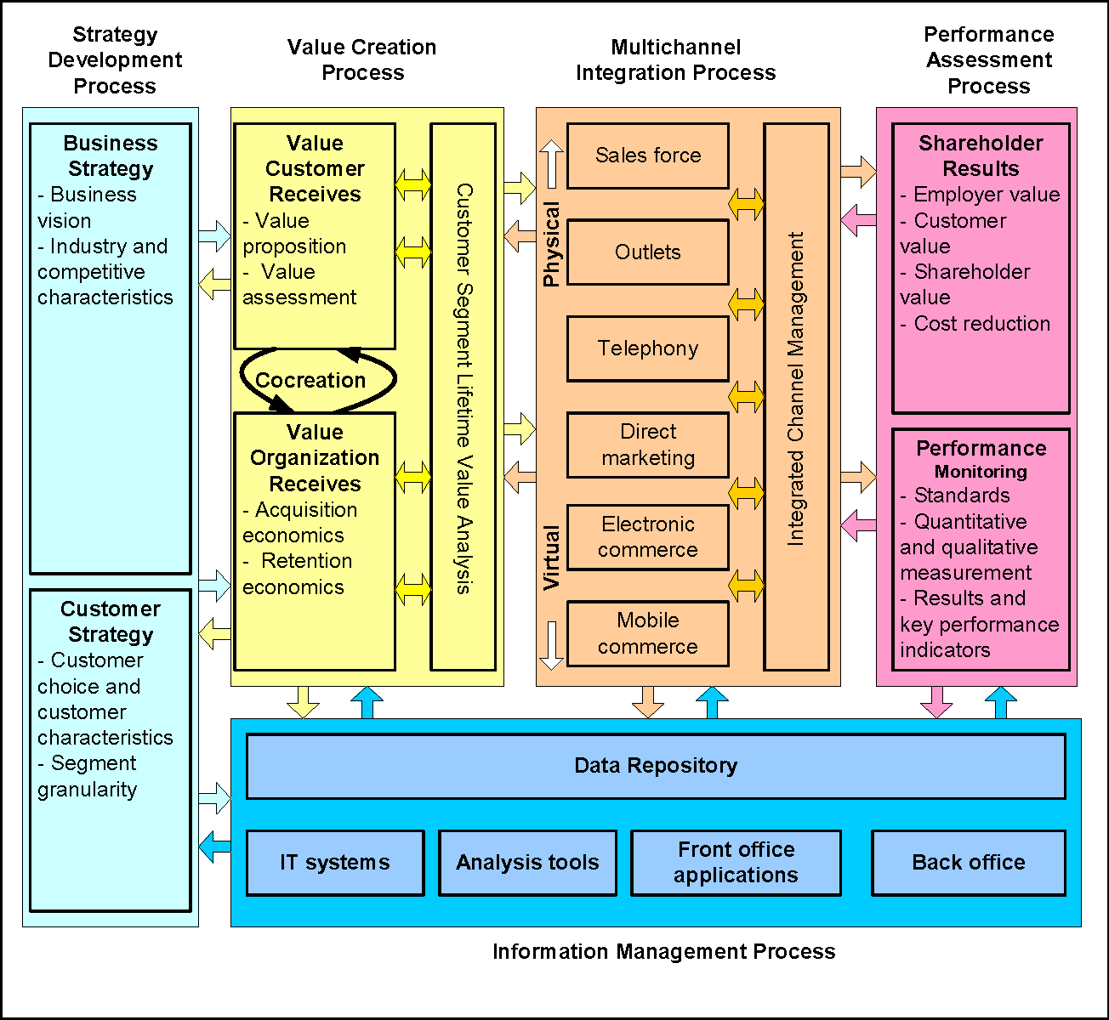
(Tahir et al, 2017)
A brief discussion of the process is given below:
Strategy development:
The process of strategy development is divided into two subcategories: strategy for business operations and strategies with customers. The business operations are strategies with a vision to create a better relationship with the customers through business offerings. On the other hand, the customer requirements, preferences are the underpinning concept to build the strategies for business operations (Anh, 2019).
Value creation:
The creation of values in business offerings considers the important attributes customer values most. The process involves three aspects in order to create effective value attributes in business:
- Identification of the processes which are valuable for the customers.
- Identification of the customer group can create value to the business.
- Identification of the characteristics of value development process to initiate a successful value exchange.
Multichannel integration:
The insight from business operations and value adding services are integrated with the multichannel integration process. The concept developed from business operations acts as inputs for value creation process. The process integrates all channels of business with a common focus of positive customer experience (Baboolal-Frank, 2021).
Performance assessment:
The assessment of KPIs (Key Performance Indicators) and satisfaction of the customers provides the idea about how successfully CRM processes were implemented. The benefits of company from the customer interests are informs about the appropriateness of the value propositions.
Information management:
The information about customer preference, behaviours and competitive measurement of market, helps the marketing team to find the appropriate approach to build up value propositions, marketing strategies and increase the business performance (Dadhich, 2022).
CRM value chain:
The goal of the CRM value chain model is to understand the requirements in order to build a better relationship with the customers and improve business process to obtain competitive advantages (Thakur, 2019). The CRM value chain can be developed in two stages: Primary stage and support stage.
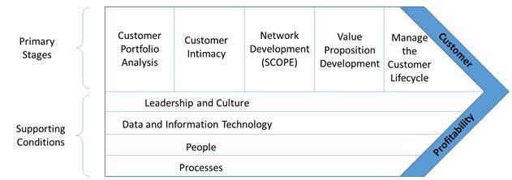
(Thakur, 2019)
Primary stage: The primary stages are used to develop an effective CRM strategy:
- Customer data analysis:
The first stage involves collection of customer data and analyse those data to identify the needs, preference, purchase behaviour and habits of the valuable customers in order to develop CRM value chain (Escursell, 2021).
- Customer interaction:
The next stage is interaction with the valued customer through electronically or personally and approach them with rewards or additional benefits in order to improve the customer retention and motivate them for future purchases.
- Creation of value propositions:
The insight from the customer interaction helps an organisation to develop offers which are customised to serve the customers on a personal level (Fuchs, 2021).
- Network development:
The acquired information is used to obtain a network of required peoples from every stage of business. Within this network, all the business entities and supportive peoples such as suppliers, investors, customer service providers and other stakeholders works together to improve the customer experience.
- Customer lifecycle management:
In conclusion, the developed network and business processes are integrated to ensure the customer loyalty, retention of the customers and conversion of the targeted customer into potential customers without harming the company interest.
Supporting stage: The supporting stage provides the necessary infrastructure to perform the committed strategies in primary stage.
- Culture and leadership:
The culture and efficiency of leadership works as an integrating and motivating force behind the business processes (Garcia, 2021).
- Information technology and data acquisition process:
The infrastructure such as big data storage and analysis, AI technologies, machine learning algorithms helps an organisation to identify risks and make informed decisions.
- People and employee:
In the face of technological development, it is the people who adds value to the organisation and regulates the business process. The efficiency of the employees and their devotion to the organisational values and ethics works as a brains and binding force behind the organisational success (Genchev, 2017).
- Business processes:
An organisation creates its brand image through its business operations and processes. The legal and ethical business processes, respect to the social and moral values of the customers and environment friendly services improves the popularity of accompany, attracts customers and increase brand loyalty. Besides it is the business processes which improves brand image on the way of making profit for the company.
Marketing theories:
Marketing mix:
The next step after development of a strategy is the implementation. The marketing mix helps an organisation in strategic implementation and maximises the outcome.
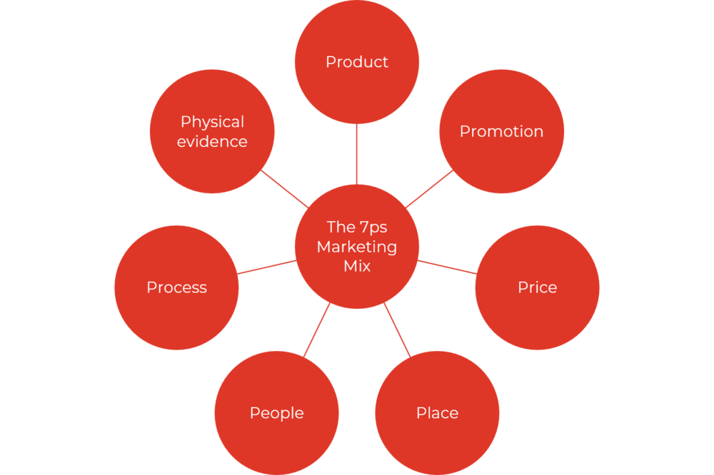
(Khorsheed et al, 2020)
The seven Ps of marketing mix are discussed below:
Product:
The product quality, specific features, packaging or improved offers which attracts and satisfies the customer are the centre of every marketing strategy and influences every composition of marketing mix (Gupta, 2021).
Place:
The ingredient ‘place’, doesn’t refer to the physical location of a store. It is the way to sale products convenient for the customers where exchange of values can be possible. In this age of technological development and health consciousness among customers due to the outbreak of pandemic, the e-commerce platforms are more successful than physical place.
Price:
The pricing structure of a product or service has a huge impact over the business success. The appropriateness of the pricing strategy depends on the market condition, availability of substitute products and value adding attributes of the products (Hwang, 2021).
Promotion:
The strategies of brand promotion increase brand awareness among the customers. Content marketing, social campaigning, PR marketing or on-store pitching, the promotional strategies attract the customers towards the brand.
Physical evidence:
The physical evidence is what the customers experience during and after dealing with the company. The way of providing services, post sales experiences, packaging of the product, brand visibility of the company or in other words, the presentation and appearance of the company towards the customers which influences viability, reliability and legitimacy are counted as physical evidence.
Peoples:
The peoples are representing the company to the real world. The employees are adding values to the company. Employee satisfaction and suitable working condition influences devotion and innovation in business processes (Ignat, 2020).
Process:
The business processes ensure the growth and sustainability of a company. The customer centric product or services designing, legal and ethical business moves, social understandings and environment friendly business decisions encourages sustainability and popularity of a brand.
Communication mix:
The communicating tools which improve the communication of a company with the customers are included in the communication mix (Genchev and Todorova, 2017). The elements of communication mix are discussed below:
Advertising:
Promotional strategies via television, print media, radio or social media campaigning or anything which promotes the brand image, USP of a company and attracts customers are counted as advertising (Janger 2019).
Digital marketing:
The digital marketing strategies comes under direct marketing strategies. The communication with the customer via email, SMS and mobile applications brand loyalty and enables the marketing team to strategies a more accurate, targeted and cheap business policy.
Public relations:
The PR strategies promotes the brand messages into appealing stories which attracts the media and target customers. An effective PR strategy revolves around current trends, events or interests and connects them to the product, service or brand.
Personal selling:
The company use the specialist knowledge, experience and communication skills of the employees to communicate with the customers and encourage the customers to avail the product or service of the company.
Promotional sales:
The limited time deals or improved offers, sales coupons, prizes, reduced pricing, loyalty cards, offer on repeat purchases and personalised discounts attract customers to buy products or services. The promotional sales also help an organisation to gather information about customer choices and behaviours (Jeong, 2020).
Stakeholder mapping:
The stakeholders have a direct influence over the business performance. The stakeholders play a crucial role during new product development, penetrating new business territory or initiating a new project. There are two types of stakeholders: internal and external. The internal stakeholders are shareholders, managing executives, project designers, developer and ground level workers. The external stakeholders are outside investors, partners, customers, governing bodies and local associates (Styk and Bogacz, 2022).
The importance of a stakeholder can be determined by their influence and involvement with the business process. To improve the efficiency of the business processes, proper prioritization and communication with the important stakeholders are necessary.
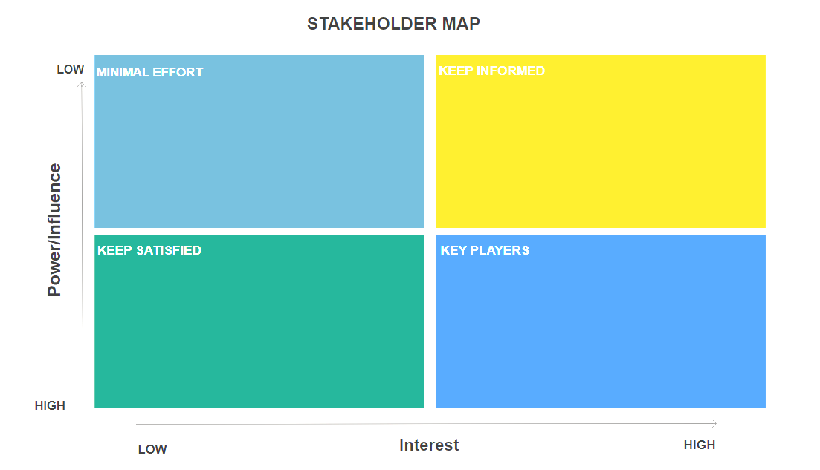
(Raum, 2018)
The shareholders can be prioritised in four categories:
- Highly influential and high interest (require to manage closely)
- Highly influential and less interest (require to keep satisfied)
- High interest and less influential (require to keep informed)
- Less interest and less influential (require to keep monitoring)

Model selection:
Data Analysis:
A secondary market research was conducted to gather quantitative data to derive the strengths and weaknesses of amazon.
Published article: Vollero, A., Sardanelli, D. and Siano, A has discussed on the article “Exploring the role of the Amazon effect on customer expectations: An analysis of user-generated content in consumer electronics retailing” (2021) about how amazon has changed the customer experiences. The researchers have found that not only the price, shopping convenience is also a motivating factor for the customers. The competitors of Amazon are also offering price discounts but the customers are returning to Amazon due to shopping convenience (Jindal, 2021).
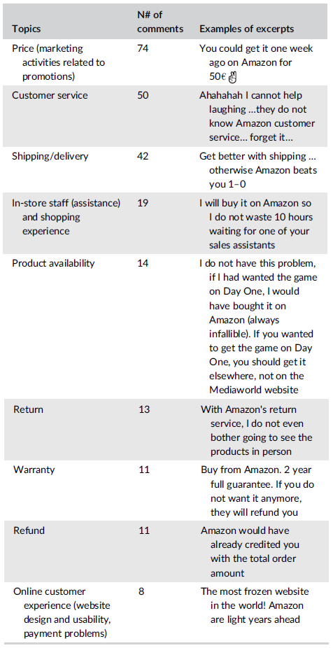
(Vollero et al, 2021)
Consumer survey: Amazon is known as the most customer centric company in world. A massive customer base is the strength of the company. Amazon has employed drone-based delivery system during the pandemic and received a good customer response from the consumers. The technological superiority also helped the company to understand the customer preferences and necessities (Khorsheed, 2020). Amazon employed cloud computing technologies to analyse the big data related to customer and employ innovative solutions to solve the customer problems. The company has also designed AI frameworks and machine learning algorithms to provide customer assistance. The language-based AI algorithms were designed to answer the customer enquiries 24×7.
- Amazon is remaining as the most preferred product search platform to the customers. 75% of the customers regularly check product price and range on Amazon app.
- 92% customers choose amazon for regular shopping which positioned the company as the driving force of the e-commerce market (Lai, 2022).
- The covid-19 restrictions have pushed a major number of customers towards online shopping. During the pandemic the profit percentage of Amazon has increased nearly 63.3%. The number of Prime memberships were increased with a 50% yearly growth after the outbreak of pandemic. In 2018 the number of Prime members were 100 million. In 2020 it became 150 million and in 2021 it became 200 million.

(Warrier et al, 2021)
Besides, the Prime members are becoming more valuable to Amazon due to their spending nature. 64% prime members are preferring to shop more often than the pre-pandemic time. 53% members buy at least on product per weak. 9% members buy products on daily basis or almost daily basis (Luo, 2020).
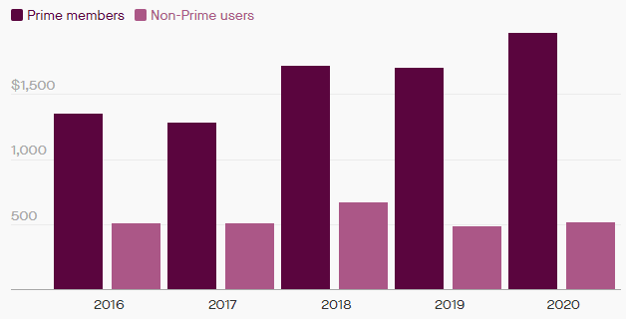
Average spending of the Prime members (Jeong et al, 2020)
- The attributes of retail delivery services most preferable for the consumers:

(Anh, 2019)
Amazon has improved their retail delivery services in terms of speed and cost. However, the bad delivery experiences are increasing among the customers.
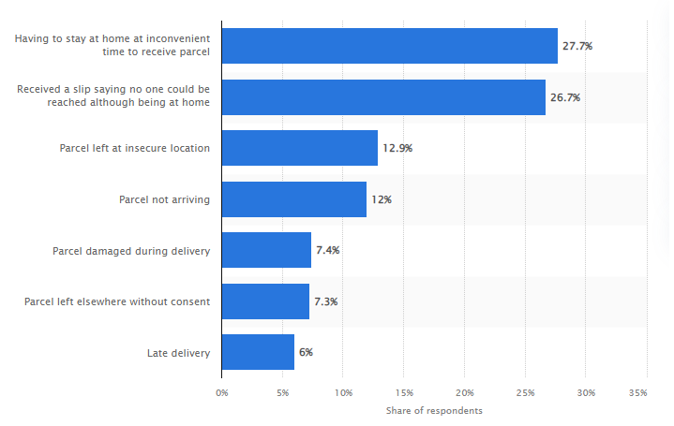
(Aćimović et al, 2020)
Roughly 81% of the consumers has reported that they had bad delivery experience at least once.

(Rodrigue, 2020)
At least 36% of the customers are preferring to change their retailer after getting bad delivery experiences.

(Hwang et al, 2021)
- During the post pandemic time the meteoric growth of online retail business and home delivery services has provoked an environmental concern among the consumers. The consumers are preferring the retailers adopting environmentally sustainable delivery system.

(Ignat and Chankov, 2020)
The environmental stand of Amazon is not clear among the customer. The surveys are revealing that the in 2019, the global carbon emission of amazon was equal to the total emission of Denmark and in 2020 it has increased by 19% (Qin, 2022).
- Amazon has evaded 11billion tax in 2018 by reinvesting the profit again into business. this incident created a lot negative impact over the US based customers.
- Due to bad delivery experiences, environmental concerns and tax evading techniques the popularity index of Amazon is going down.

(Qin, and Liu, 2022)
- The brand loyalty among the consumers is also decreasing. Roughly 66% of the customers are intending to try new brands.
Employee satisfaction:
- Amazon has received multiple offences about exploitation of employees. The company opposes unionism inside the company (Agnihotri and Bhattacharya, 2022).
- Injuries during work is increasing among the workers of facility centres. In 2020 almost 24,000 injuries were reported by the workers.
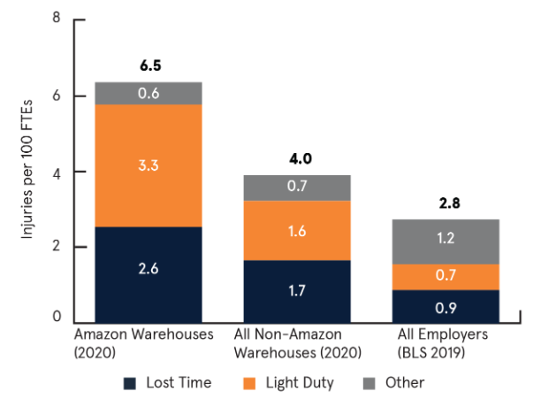
Injury rate in Amazon and other employers, 2020 (Fuchs et al, 2021)
- 89% of reported injuries were caused due to tight work schedule and pressure of faster delivery.
- During pandemic the situation of the delivery workers become worse. The pressure of maintaining the delivery schedule and covid-19 restrictions created an unsustainable work environment for the delivery workers.
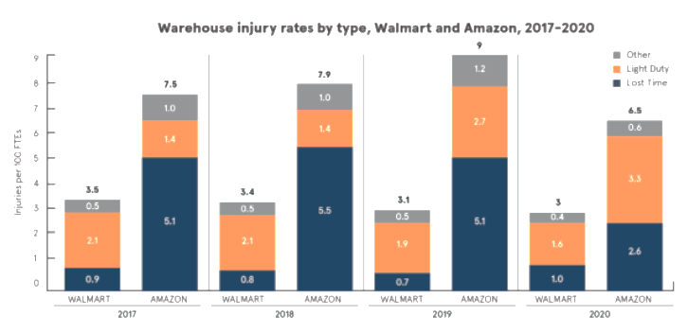
(Jindal et al, 2021)
Seller survey:
Selling on Amazon provides a huge opportunity to the sellers. The sellers avail a ready to go service just after registering on Amazon. The excellent geographical reach, established delivery network and trust of the customer on Amazon provides millions of potential buyers to a selling brand (Rodrigue, 2020).
- In spite of the covid-19 restrictions, 75% of the sellers were profitable in 2021.
- 58% sellers are adopting ambitious growth plan in 2022.
- 25 % entrepreneurs are making profit by selling their product on Amazon.
- On the down side, the e-commerce platform is limiting the scope of brand recognition. The product presentation of Amazon is not suitable for the customers to remember the brand name.

(Janger and Twerski, 2019)
- The crucial customer data are inaccessible for the sellers. It is hard to personalise the business without any customer data.
- Availing FBA (Fulfilled by Amazon) facility provides great benefit to the sellers by automating the pick up, packaging and delivery process. However, 58% of the sellers complained that FBA facility is limiting the scope of selling products (Lai et al, 2022). The products are remaining unsellable even when the company is relocating the products between warehouses (Styk, 2022).
Business positioning of Amazon:
The customer centric business approaches, diversity in business practices such as digital content creation, audiobook selling, video streaming, and cloud platforms has provided a competitive advantage to the company. A perceptual map of business positioning of Amazon is given below:
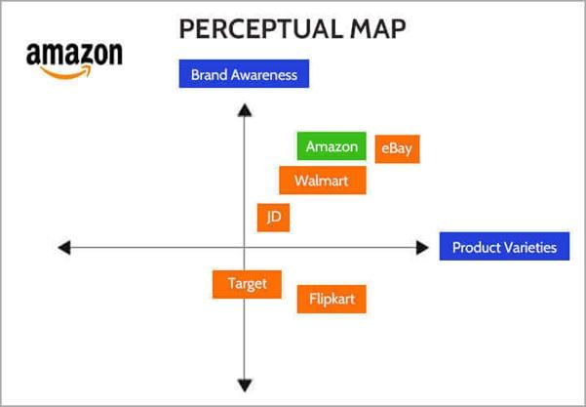
(Baboolal-Frank, 2021)
The map is signifying that among the close competitors of the company only eBay has managed to attain a similar brand image as Amazon.
More to it, diversified business policies are the main reason the company is managing a spectacular growth in spite of situations like outbreak of Covid-19, implementation of Brexit and trade protection rules imposed by former US president. The implementation of Brexit in UK and Trade Protection Act in US limited the market scope in these geographical regions and created a highly competitive environment. Excellent brand popularity and access to the global supply chin helped the brand to survive this competition (Tahir, 2018).
During the outbreak of Covid-19 the diverse business practices became the driving force of the company. It is true, that government has supported the home delivery services and e-commerce platforms to continue business during lockdowns and helped Amazon with substantial growth in revenues however, the Amazon Prime membership and AWS services attained a healthy growth during the pandemic. The prime membership has reached 200 million during 2020 and the AWS services was exceeded by 40 million USD.

(Dadhich and Thankachan, 2022)
Amazon has outsmarted their competitors such as Flipkart and Walmart by introducing the Prime facility. On the other hand, the competitors of Amazon like Walmart, JD, Flipkart and Target are also started to implement the technology to improve their brand satisfaction, customer retainment and customer acquisition. The anarcho-capitalist model of Amazon has increased the competitive rivalry. In this time, when amazon is obsessed with customer centric business approaches and speed in delivery process, increasing customer loyalty is becoming more demanding task (Baboolal-Frank, 2021). Besides, the unsatisfied sellers are turning to the competitor platforms to sale their products. this is also a matter which is not suitable for a healthy growth.
Identification of the model:
The above study is indicating that the popularity and profit margin of Amazon is increasing with a healthy growth. New customers are connecting with amazon regularly and the existing customers are spending more through the e-retail platform. However, in spite of being a customer centric company, the loyalty of the customer is decreasing. The internal and external matters responsible for the situation are discussed below:
- Bad delivery experiences
- Improper environmental initiatives
- Tax evading techniques
- Unethical business processes such as exploitation of workers
To improve this situation, Amazon should adopt CRM value chain model. The 7P’s of marketing mix will help the company to implement the model. The CRM value chain considers not only the value addition to the product or services, it also considers the processes and people is also responsible to create better relationship with the customers. The theory of marketing mix also agrees about the value of people and processes (Thakur, 2019).
The business structure of Amazon has increased the competitive rivalry. The close competitors of Amazon are also implementing advance technologies to increase the customer base and brand loyalty.
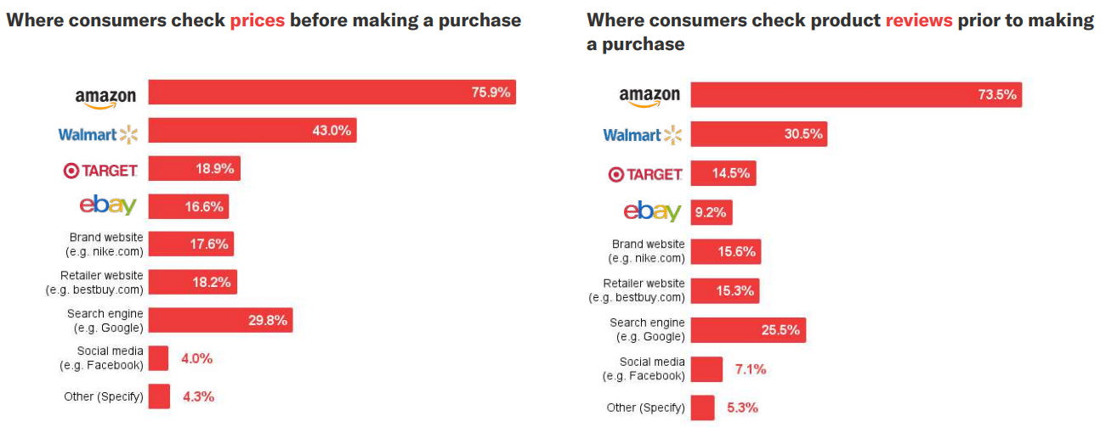
(Luo, 2020)
Establishing a better relationship with the customer with right people and right process is the only way for the company to negate the competitive threats and improve the brand image.

Recommendations:
Improvement of the list mile of the delivery services: In present situation, the delivery service is one of the techniques to retain customers. Around 36% of the customers are intending to change the retailer after bad delivery experiences. A company such as Amazon, 36% is a huge number. In order to do so:
- Amazon have to bring flexibility to their delivery network. The delivery should reach the customer when it is convenient for the customer.
- Implementation of a sustainable delivery service will be tough for the company at the urban areas. The electric vans don’t have the capability to travel a long distance. The company can increase the number of fulfilment centres. It will help the company to implement sustainable, environment friendly delivery system and improve the flexibility in delivery network (Escursell et al, 2021).
- The tax evading tactics are profitable for company. However, the company is not respecting the social interests. It is harming their key strength: the support from the customers.
Better working condition for the employees: The peoples of accompany provides structural support to the business processes. It is impossible to gain the committed goals without the efficiency and loyalty of its people. More to it, a satisfied employee promotes a better brand image in his/her surrounding environment (Vollero, 2021). To improve the working environment:
- Amazon can employ technology. Automation in warehouses will help the company to reduce cost and increase accuracy in work. It will push the company to downsize the warehouse employees but the automatic set up will open the opportunity of a new set of technical jobs. Amazon can use the warehouse employees to improve the delivery fleet.
- Amazon have to abide by the laws of minimum wages and working hours. The company should also employ assistive machinery to help the workers. Besides, the health and wellbeing of the workers should be taken seriously.
Business focus: The focus on a particular market where Amazon is successfully serving the requirements of customers will help the company to grow quickly. Undeniably, the diverse business model of amazon has helped them to overcome tight economic and competitive situation, however, the entry of Amazon in grocery business was not a focused decision. The decision caused loses and reduced the market share value of the company (White, 2020). Amazon has started the grocery business in 2007, since then Amazon is still struggling inside and outside of US to get a better hold of the market.
Instead of focusing on grocery business, the company should concentrate on the Amazon Web Services. During covid-19 the AWS service was unaffected from the economic turmoil and secured $40 million growth (Gupta et al, 2021). Companies like Barclays, Pinterest, are using the cloud computing service of Amazon. The technology has huge prospect in future and will help Amazon to position above the competitive rivalry.
Effective CSR (Corporate Social Responsibility) strategy: An effective CSR strategy helps a company to improve the brand image. With an efficient CSR strategy, Amazon will be able to maintain the social, ethical, legal and environmental responsibilities of the company on the way of making profit. The carbon footprint of Amazon is actually a concerning matter. The company have to implement environment friendly delivery system to win back the customer loyalty.

Conclusion:
The restriction due to the outbreak of pandemic has chained the shopping habits of the consumers. The popularity of the online platforms has increased manyfold. The enormous growth of e-retail platforms is increasing the competitiveness of the market. The key ingredient of every business is the product and its appeal to the customers. However, in present days, the process and people involved with the business have substantial influence over business success. The business process and its people together create a system which increase the customer loyalty without harming the organisational interest. The study has analysed the market research data of Amazon and made recommendations which can be practically implemented to improve the brand image, business sustainability and customer loyalty without harming the organisational interest.

References:
Aćimović, S., Mijušković, V. and Milošević, N., 2020. Logistics aspects of goods home delivery: the case of Amazon company. Marketing, 51(1), pp.3-11.
Agnihotri, A. and Bhattacharya, S., 2022. Addressing Poor Working Conditions at Amazon, Inc.: Challenges Before, During, and After COVID-19. SAGE Publications: SAGE Business Cases Originals.
Alimahomed-Wilson, J. and Reese, E., 2021. The cost of free shipping: Amazon in the global economy. Pluto Press.
Anh, K.Q., Nagai, Y. and Nguyen, L.M., 2019. Extracting customer reviews from online shopping and its perspective on product design. Vietnam Journal of Computer Science, 6(01), pp.43-56.
Baboolal-Frank, R., 2021. Analysis of amazon: Customer centric approach. Academy of Strategic Management Journal, 20, pp.1-16.
Baboolal-Frank, R., 2021. Analysis of amazon: Customer centric approach. Academy of Strategic Management Journal, 20, pp.1-16.
Dadhich, A. and Thankachan, B., 2022. Sentiment Analysis of Amazon Product Reviews Using Hybrid Rule-based Approach. In Smart Systems: Innovations in Computing (pp. 173-193). Springer, Singapore.
Escursell, S., Llorach-Massana, P. and Roncero, M.B., 2021. Sustainability in e-commerce packaging: A review. Journal of cleaner production, 280, p.124314.
Fuchs, M., Dannenberg, P. and Wiedemann, C., 2021. Big Tech and Labour Resistance at Amazon. Science as Culture, pp.1-15.
Garcia, V., 2021. Examining the Impact of Selling on Amazon on the Revenue growth of MSEs in the US. International Journal of Contemporary Financial Issues, 1(1), pp.28-38.
Genchev, E. and Todorova, G., 2017. Sales promotion activities–effective tool of marketing communication mix. Available at SSRN 3089894.
Gupta, B., Mittal, P. and Mufti, T., 2021. A review on Amazon web service (AWS), Microsoft azure & Google cloud platform (GCP) services.
Hwang, J., Kim, J.J. and Lee, K.W., 2021. Investigating consumer innovativeness in the context of drone food delivery services: Its impact on attitude and behavioral intentions. Technological Forecasting and Social Change, 163, p.120433.
Ignat, B. and Chankov, S., 2020. Do e-commerce customers change their preferred last-mile delivery based on its sustainability impact?. The International Journal of Logistics Management.
Janger, E.J. and Twerski, A.D., 2019. The Heavy Hand of Amazon: A Seller Not a Neutral Platform. Brook. J. Corp. Fin. & Com. L., 14, p.259.
Jeong, H.Y., Song, B.D. and Lee, S., 2020. The flying warehouse delivery system: A quantitative approach for the optimal operation policy of airborne fulfillment center. IEEE Transactions on Intelligent Transportation Systems, 22(12), pp.7521-7530.
Jindal, R.P., Gauri, D.K., Li, W. and Ma, Y., 2021. Omnichannel battle between Amazon and Walmart: Is the focus on delivery the best strategy?. Journal of business research, 122, pp.270-280.
Khorsheed, R.K., Abdulla, D.F., Othman, B.A., Mohammed, H.O. and Sadq, Z.M., 2020. The Role of Services Marketing Mix 7P's on Achieving Competitive Advantages (The Case of Paitaxt Technical Institute in Kurdistan Region of Iraq). TEST Engineering and Management, 83, pp.15947-15971.
Lai, G., Liu, H., Xiao, W. and Zhao, X., 2022. “Fulfilled by Amazon”: A Strategic Perspective of Competition at the e-Commerce Platform. Manufacturing & Service Operations Management.
Luo, N., 2020. Amazon. com, Inc Strategic Audit.
Qin, Y. and Liu, H., 2022. Application of Value Stream Mapping in E-Commerce: A Case Study on an Amazon Retailer. Sustainability, 14(2), p.713.
Raum, S., 2018. A framework for integrating systematic stakeholder analysis in ecosystem services research: Stakeholder mapping for forest ecosystem services in the UK. Ecosystem Services, 29, pp.170-184.
Rodrigue, J.P., 2020. The distribution network of Amazon and the footprint of freight digitalization. Journal of transport geography, 88, p.102825.
Styk, K. and Bogacz, P., 2022. A Method for Stakeholder Mapping in Connection with the Implementation of a Development Project. Energies, 15(4), p.1592.
Tahir, D., Arshad, M. and Khan, M.M., 2018. Customer Relationship Management Model From Strategic Approach: A knowledge Management Perspective.
Thakur, S., 2019. Understanding the importance of Buttle’s CRM value chain model.
Vollero, A., Sardanelli, D. and Siano, A., 2021. Exploring the role of the Amazon effect on customer expectations: An analysis of user‐generated content in consumer electronics retailing. Journal of Consumer Behaviour.
Warrier, U., Singh, P., Jien, C.W., Kee, D.M.H., Yi, G.Z., Jiann, T.W., Liang, T.Y., Gopika, S.B., Nair, S., Nair, R.K. and Lokhande, S.D., 2021. Factors that lead Amazon. com to a successful online shopping platform. International journal of Tourism and hospitality in Asia Pasific (IJTHAP), 4(1), pp.7-17.
White, S., 2020. Amazon and Whole Foods: adventures in grocery shopping. The CASE Journal.

