Hyatt Grand Central New York REPORT
Department of Customer Service

Student name: Alina Elena Craciun
Student number: 2212851
Module title: Organisational Consultancy
Module code: BMIH6005
Lecturer name: Jaliya De-Silva

Company Name : Prestige Hospitality Solutions
Delivery date for this report : 12 / 11 / 2024

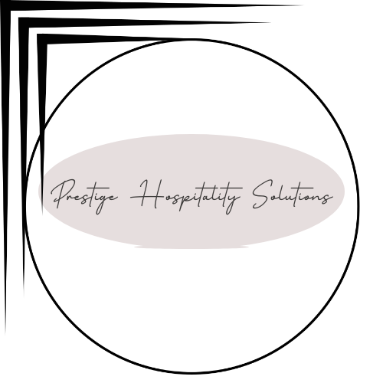

I acknowledge the use of Grammarly App and Microsoft Word Editor on 12th November to check my grammar,syntax and misspellings.
I confirm that I have not presented any AI generated text as my own work. I confirm I have copies of my drafts, notes, and other resources I used before,and after the use of AI tools which I may be asked to provide in evidence.

Table of contents

1.Executive Summary…………………………………………..………..5
2.Introduction………………………………...…………………...……….8
3.Analysis………………………………………..……….…………....…10
3.1 PESTEL Analysis………………………………………………….12
3.2 SWOT Analysis…………………………………...……………….15
3.3 TOWS Analysis…………………………………………………….17
3.4 Porter's Five Forces Analysis…………………………………….19
3.5 Detailed Impact Analysis………………………………………….22
4.Recommendation………………………………………...…………….25
4.A Customer service training…………………………………………26
4.B Facilties Modernization and Maintenance……………………….27
4.C Technological Improvements……………………...………………27
4.D Sustainability Initiatives…………………………………………….27
4.E Strategic Marketing and Loyalty Program Upgrade……………..28
4.F Better Feedback Mechanism and Continous Improvement…….28
5.Change Management Strategies……………………………………….29
6.Success Measurement…………………………………………………..30
7.Cost Analysis…………………………………….………………………..31
8.Conclusion……………………………………….………………………..34
9.References……………………………………….………………………..36

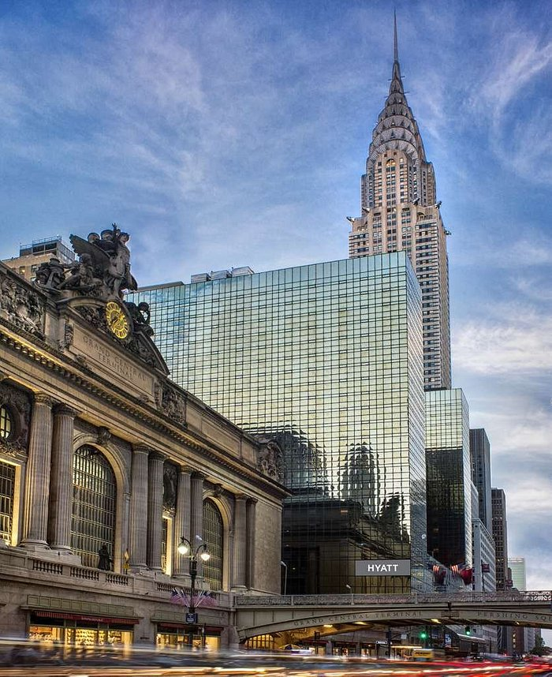  Hyatt Grand Central New York REPORT | Hyatt Grand Central New York  Department of Customer Service

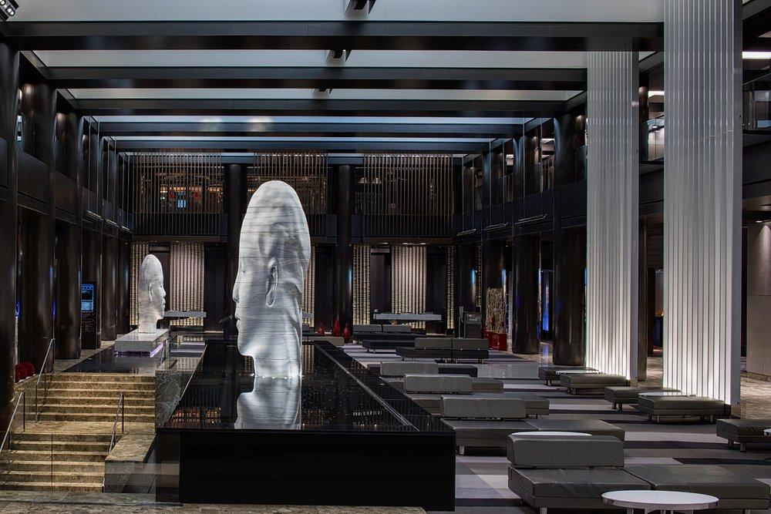
Executive Summary

The Issue
Hyatt Grand Central New York is a famous hotel in the heart of Manhattan, serving travellers on business and pleasure trips. Recent guest feedback reveals significant challenges affecting the hotel's reputation and performance. Principal issues include disrespectful and unresponsive service, absence of in-room amenities, insufficient facility maintenance, and varying cleanliness standards. These issues weaken the guest experience, affecting customer loyalty, repeat reservations, and overall brand reputation. This situation is especially troubling considering the competitive dynamics of New York's hospitality sector, where travellers expect superior service and facilities.
The challenges confronting Hyatt Grand Central have broader implications for hotel performance, covering revenue, occupancy rates, and staff satisfaction. Effectively addressing these issues is crucial for maintaining the hotel’s market relevance, customer satisfaction, and profitability. This report offers an in-depth examination of the fundamental factors and strategic suggestions to address these issues.
The examination of Hyatt Grand Central's operational difficulties produced substantial insights from various data sources and guest evaluations. The hotel has experienced service quality problems, evidenced by recurrent guest complaints regarding unprofessional conduct and unresponsive employees. The deficiencies in service directly impact guest satisfaction, as evidenced by unfavourable reviews on TripAdvisor and Booking.com, where descriptors such as "rude" and "unhelpful" are commonly noted in feedback. Research indicates that these service deficiencies result in lower customer loyalty and retention (Cheng et al., 2020).
Moreover, facility-related issues contribute to guest dissatisfaction, including malfunctioning in-room amenities, outdated decor, and insufficient cleanliness. Research indicates that the quality and accessibility of amenities are vital to guest loyalty, as travellers increasingly prioritise comfort, cleanliness, and functionality during their accommodations (Hu et al., 2019). These deficiencies signify an immediate necessity for improved maintenance protocols and facility improvements.
The service and facility issues are impacting Hyatt Grand Central's revenue generation. The absence of repeat reservations and reduced occupancy rates resulting from customer dissatisfaction negatively impact the hotel's revenue streams. The inability to impose premium rates due to decreased service quality constrains financial flexibility, which is essential for covering operational expenses and maintenance (Subramaniam et al., 2011).
The report employs the PESTEL, SWOT, TOWS and Porter 5 frameworks to assess Hyatt Grand Central New York’s strategic environment, revealing internal and external factors influencing the hotel's performance. The PESTEL analysis identified external challenges, including regulatory modifications influencing labour expenses, economic variations affecting tourism demand, and shifting customer expectations regarding safety, cleanliness, and sustainability (Kara, 2018; Nair & Choudhary, 2019). These factors highlight Hyatt's need to modify its operations by regulatory and market trends.
The SWOT analysis examined Hyatt Grand Central's strengths, weaknesses, opportunities, and threats. Although the hotel enjoys a prime location and robust brand affiliation, these advantages are eclipsed by persistent service and facility problems. The hotel's deficiencies, especially in service quality and facility maintenance, threaten its competitive standing in a market rich with luxury alternatives (Tripadvisor, 2024; Birru et al., 2022).
The TOWS analysis offered practical ways to mitigate internal weaknesses and leverage external opportunities. Essential strategies include utilising the Hyatt brand to implement sustainable practices, upgrading technology and amenities, and prioritising staff training for better service interactions. These strategies correspond with contemporary industry trends and guest expectations, allowing Hyatt Grand Central to improve guest satisfaction, increase loyalty, and maintain competitiveness in New York's hospitality sector.
Recommendations
This report provides multiple strategic recommendations for Hyatt Grand Central New York based on the analysis mentioned.
- Reinforce Customer Service Training: Create a complete training program prioritising empathy, responsiveness, and problem-solving competencies. Better service quality will directly reduce guest complaints and cultivate loyalty.
- Facility Modernization and Maintenance: Allocate resources for extensive improvements to guarantee that accommodations and common areas fulfil guest standards for comfort, hygiene, and utility.
- Technological Enhancements: Upgrade in-room technology by incorporating high-speed Wi-Fi and digital amenities to meet the demands of modern travellers.
- Sustainability Initiatives: Implement green practices, including energy-efficient lighting and waste minimisation programs, to align the hotel with current sustainability trends in the industry.
Based on industry research and best practices, these recommendations are expected to positively impact Hyatt Grand Central's service quality, guest satisfaction, and brand perception.
This report's strategic recommendations aim to guide Hyatt Grand Central New York in resolving fundamental service and facility challenges, positioning the hotel for sustained success. By investing in customer service training, facility improvements, and sustainability initiatives, Hyatt can realign with guest expectations and regain its competitive advantage in New York's challenging hospitality market. These modifications will improve guest satisfaction and enhance revenue generation through heightened loyalty and favourable brand perception. The proposed strategies facilitate a sustainable future for Hyatt Grand Central, guaranteeing its continued standing as a preferred option for travellers.
Introduction
Hyatt Grand Central New York is a distinguished hotel located in the heart of Midtown Manhattan, directly connected to Grand Central Terminal. With its strategic location, the hotel is an ideal destination for business and leisure travellers seeking easy access to New York’s landmarks and commercial hubs. Established in 1980, Hyatt Grand Central has nearly 1,300 guest rooms, making it one of the more significant properties in the Hyatt portfolio. The hotel is known for its modern yet classic architecture, expansive event spaces, and comprehensive amenities to accommodate diverse travel needs. However, recent feedback from guests suggests that some facilities and services may be falling short of contemporary expectations, particularly in terms of customer service quality and in-room amenities. This report aims to address these areas of concern, proposing strategies that will enable Hyatt Grand Central to reinforce its brand reputation and elevate guest satisfaction in a competitive market.
Prestige Hospitality Solutions specialises in providing strategic and operational consulting services tailored to the hospitality industry. With a team of experts in customer experience, facility management, and sustainable hospitality practices, we assist hotels in enhancing their operational efficiency and market competitiveness. Our proven track record includes transforming service delivery standards and optimizing facility usage for hotels around the globe. At Prestige Hospitality Solutions, we employ data-driven methodologies and industry best practices to identify core issues and deliver actionable recommendations. We are committed to supporting Hyatt Grand Central New York in its goal to achieve improved guest satisfaction, loyalty, and profitability.
Hyatt Grand Central New York is currently facing significant challenges in service quality and facility standards, as evidenced by guest feedback on multiple review platforms. Common complaints highlight impolite and unresponsive staff, inconsistent cleanliness, malfunctioning room amenities, and a general need for facility upgrades. These issues have led to dissatisfaction among guests, adversely affecting the hotel’s reputation and competitiveness in the demanding New York hospitality market.
The impact of these challenges extends beyond customer satisfaction; they influence operational efficiency, employee morale, and, ultimately, revenue. Poor service experiences and inadequate facilities discourage repeat visits and reduce the likelihood of positive reviews, which are critical elements in maintaining a high occupancy rate and premium pricing structure. In a competitive environment where guests increasingly prioritize both service quality and modern amenities, these shortcomings represent a risk to the hotel’s market position. Addressing these challenges is essential for Hyatt Grand Central to fulfil its brand promise, enhance guest loyalty, and sustain profitability.

This report utilises PESTEL, SWOT, TOWS, and Porter’s Five Forces analyses to identify challenges faced by Hyatt Grand Central New York and influence strategic planning. The PESTEL framework examines external Political, Economic, Social, Technological, Environmental, and Legal factors affecting the hotel's operations. The SWOT analysis outlines internal strengths and weaknesses when combined with external opportunities and threats, forming a foundation for improvement and development. The TOWS matrix converts SWOT factors into achievable strategies utilising these insights. Porter’s Five Forces analysis ultimately evaluates competitive dynamics within New York’s luxury hotel sector. Collectively, these frameworks offer the complete basis for achievable, market-oriented strategies.
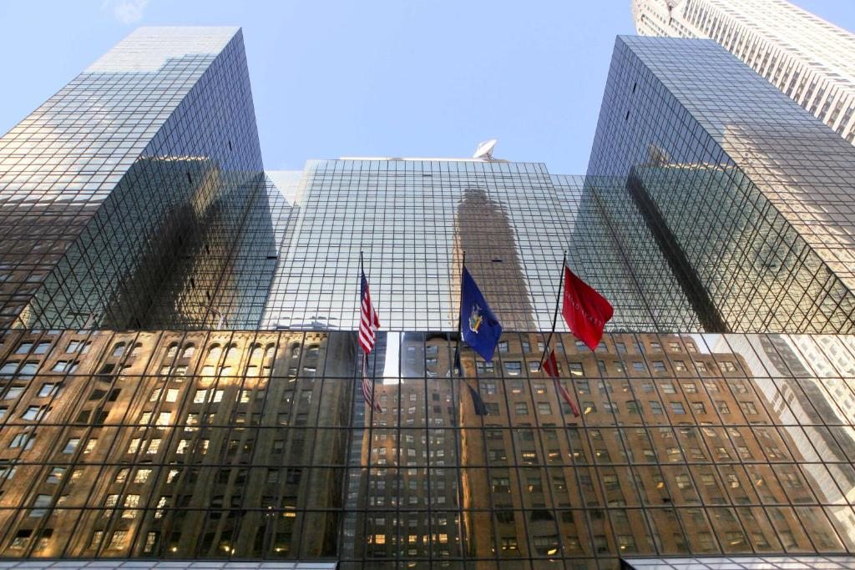

Analysis
Issue Description
The Hyatt Grand Central New York is experiencing significant difficulties in service quality and customer satisfaction, as evidenced by persistent complaints from clients on various platforms, including TripAdvisor and Booking.com. Critical concerns highlighted in guest reviews include disrespectful and unresponsive staff members, limited in-room amenities, insufficient upkeep of facilities, and inconsistency in meeting customer standards for cleanliness and room preparedness. Reviews often describe staff interactions as "rude" and "unhelpful," validating research that suggests customer disrespect can result in service sabotage when employees perceive a lack of support or motivation (Cheng et al., 2020; Booking.com, 2024).
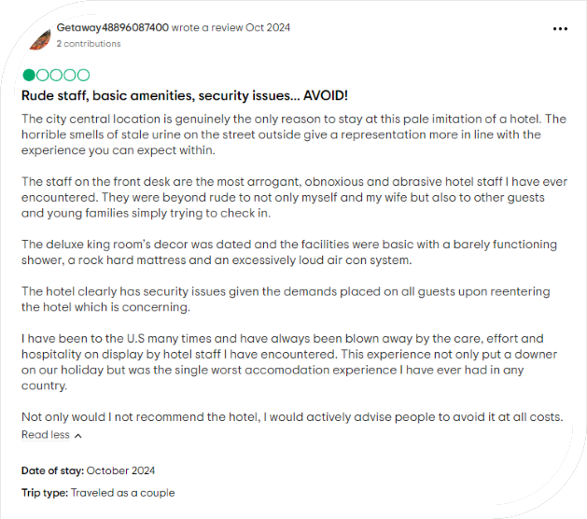
A persistent complaint relates to facility problems, including defective room features and insufficient access to essential amenities, which impact customer satisfaction (TripAdvisor.com, 2024). Studies indicate that the quality and accessibility of these amenities directly affect customer loyalty and return visits (Hu et al., 2019). The inconsistency in housekeeping standards and room preparedness at arrival indicates that better operational protocols are necessary (Hyatt.com, 2024). The discrepancy between anticipated and provided service, frequently measured using the SERVQUAL model, is essential for understanding customer dissatisfaction in the hospitality sector (Sharma & Srivastava, 2018).
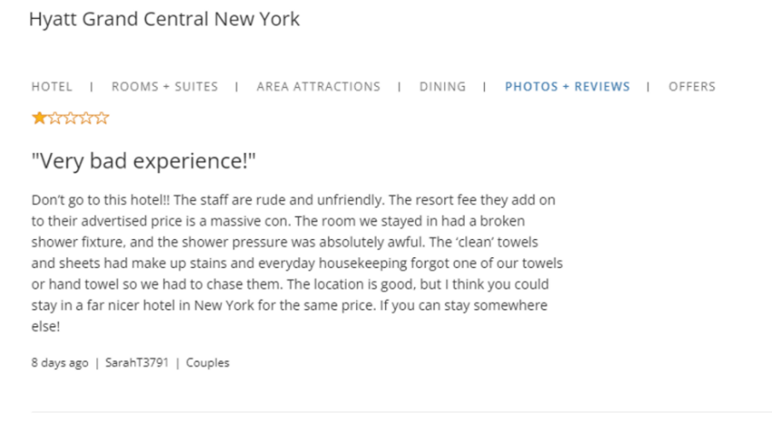
The challenges at the Hyatt Grand Central New York are related to deficiencies in service quality, covering customer interactions and the physical state of rooms, which negatively influence the hotel's credibility and long-term customer loyalty (Marco, 2013).

PESTEL Analysis

A PESTEL analysis of the Hyatt Grand Central New York offers an organised investigation of external influences impacting the hotel's operations and strategic trajectory.
Political | Local and national regulatory frameworks impact the hospitality sector in New York City. Political changes, including reforms in labour legislation and minimum wage policies, significantly affect operational expenses (Farelly et al., 2005). Implementing pro-labour policies may require increased staffing budgets, which will affect the financial stability of hotels (Kara, 2018).
Economic | Economic factors, especially in the context of post-pandemic recovery, are vital for the success of Hyatt Grand Central. Inflation rates and the prices of raw materials are increasing, thereby growing operational costs (Marinov and Marinova, 2021). Moreover, variations in the tourism market, shaped by the overall economic climate, impact occupancy rates and revenue, requiring financial adaptability (Birru et al., 2022).
Social | The evolving demographics and preferences of travellers following COVID-19 have transformed expectations in the hotel industry. Guests increasingly prioritise cleanliness, safety, and convenience, forcing hotels to maintain elevated service standards and conform to these growing expectations. Social factors are influenced by the increasing awareness of sustainability across younger generations (Nair & Choudhary, 2019).
Technological | Technological advancements provide hotels with opportunities that would improve customer experience; however, Hyatt Grand Central has faced difficulties in this area. Problems with room amenities such as Wi-Fi and digital services affect guest satisfaction, showing a pressing need for improvements in technology that will build customer satisfaction and operational efficiency (Seyitoğlu & Ivanov, 2020).
Environmental | Environmental sustainability has become increasingly important in the hospitality sector, as travellers are demanding eco-friendly practices. This combines energy-efficient installations and waste management. The hotel must deal with sustainability issues to meet changing customer expectations and regulatory standards (Khatter, 2023).
Legal | The hotel sector in New York faces rigorous legal obligations, especially concerning health and safety regulations, data privacy, and labour legislation. Compliance to these regulations is crucial to prevent legal consequences and maintain customer trust, particularly as data privacy becomes a very important concern for travellers (Thakur, 2020).

This PESTEL analysis breaks down the necessary external factors that Hyatt Grand Central New York must address to maintain competitiveness and meet customer expectations in a quickly evolving hospitality environment.

SWOT Analysis
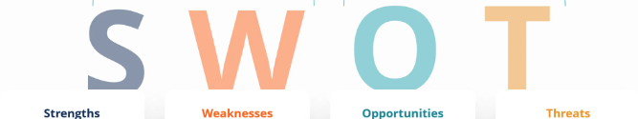
The SWOT analysis of the Hyatt Grand Central New York explores essential internal and external factors influencing its competitive stance and operational efficacy, that is grounded in customer feedback and industry literature.
Strengths | Prime Location: Situated in vicinity to Grand Central Terminal, the hotel enjoys excellent accessibility and attracts both business and leisure travellers, a significant advantage for guests who value accessibility.  Brand Recognition: The hotel, as a component of the Hyatt brand, possesses a solid global reputation that draws a loyal customer base (Israeli, 2002; Sheinberg, 2021).
Weaknesses | Service Quality Issues: Multiple reviews reveal persistent problems regarding unhelpful and occasionally disrespectful customer service, adversely impacting the hotel's reputation and guest satisfaction (Lydia987, 2024).  Facility Maintenance and Cleanliness: Customers often mention broken amenities, old decor, and sanitation concerns, indicating insufficient maintenance of the facilities (Sarah T, 2024).
Opportunities | Sustainability Initiatives: The movement towards sustainable travel offers Hyatt the chance to adopt eco-friendly practices, likely to appeal to environmentally conscious travellers.  Technological Upgrades: Upgrading in-room technology, such as Wi-Fi and digital services, may improve guest experience, as contemporary travellers increasingly prioritise technology (Nair & Choudhary, 2019).
Threats | Competitive Pressure: The luxury hotel market in New York is intensely competitive, with numerous options providing premium services and exceptional amenities, challenging the Hyatt Grand Central's efforts to attract and retain guests.  Economic Instability: Economic variables, including variable tourism demand and inflation, could worsen revenue constraints, especially as global events influence travel habits (Birru et al., 2022).

In conclusion, although the Hyatt Grand Central New York benefits from an excellent location and strong brand association, persistent flaws in service and facilities limit its potential. Adopting sustainability and modernising technological facilities might reduce certain issues while improving guest perceptions. However, competitive and economic pressures require strategic responses to sustain market relevance and resilience.
TOWS Analysis

The TOWS analysis utilises insights from the SWOT framework to develop practical strategies that reduce Hyatt Grand Central New York's internal weaknesses and external threats while maximising its strengths and opportunities.
Strength-Opportunity (SO) | Make use of its excellent location and brand for sustainable practices, Hyatt can capitalise on its position near Grand Central Terminal and strong brand identity by implementing eco-friendly initiatives, including energy-efficient lighting, water conservation programs, and waste reduction strategies. These practices correspond with sustainability trends and attract environmentally conscious customers (Nair & Choudhary, 2019).
Strength-Threat (ST) | In an extremely competitive market, Hyatt's renowned brand reputation can be exploited to provide exclusive loyalty benefits or partnership promotions. By accentuating brand-specific advantages, the hotel may draw in loyal customers and differentiate itself from surrounding luxury rivals, leading to reduced turnover in a competitive landscape (Ghodeswar, 2008).
Weakness-Opportunity (WO) | Hyatt should invest in employee training and customer service protocols which will reduce negative feedback regarding unhelpful staff. Technological upgrades, including improved Wi-Fi and in-room digital services, would correspond with modern customer demands and raise satisfaction ratings (Sarah T, 2024).
Weakness-Threat (WT) | To protect against competitor risks and fulfil guest expectations, the hotel should execute a strategic renovation plan focused on upgrading room amenities and guaranteeing all facilities are operational. Also, prioritising staff training in hospitality and customer relations is essential to improve service quality and limit negative reviews (Burnes, 2014).

The TOWS strategies supply Hyatt Grand Central with a framework to fix operational deficiencies, raise guest satisfaction, and strengthen its competitive position by aligning with market demands and sustainability standards.

Porter's Five Forces Analysis
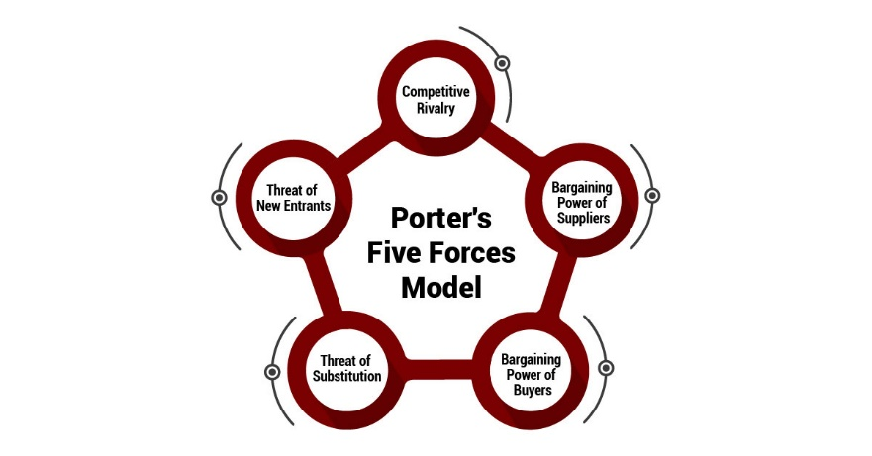
The Porter's Five Forces model offers an in-depth structure to review the competitive landscape of Hyatt Grand Central New York, an iconic hotel in Manhattan's vibrant hospitality sector. This model, created by Michael Porter in 1979, evaluates five critical forces that affect industry profitability and strategic decision-making (Tavitiyaman et al., 2011). In the context of New York's luxury hotel sector, knowing these dynamics is crucial for Hyatt to further develop its strategy and sustain its market position (Porter, 2008).
A. Threat of New Entrants
The risk posed by new entrants in New York's luxury hotel market is moderate. Despite substantial capital requirements, high central real estate costs, and rooted brand loyalty towards existing hotels, new boutique and luxury hotels continue to appear in Manhattan, frequently supported by international hospitality chains or investment groups. Research indicates that substantial entry barriers restrict new entrants in competitive urban regions; even so, the appealing nature of the New York market for tourists and business travellers makes it attractive to new brands with sufficient resources (Göral, 2015).

B. Bargaining Power of Buyers
The negotiating power that customers have in New York's hotel sector is substantial. The large number of luxury hotels, such as Marriott and Four Seasons, provides customers with numerous choices. Moreover, digital platforms like Booking.com and Expedia facilitate price comparisons, amplifying price sensitivity and allowing customers to choose accommodations based on service quality, amenities, and online reviews. The simplicity of transferring between hotels pushes businesses such as Hyatt to continually uphold higher service standards and competitive pricing to retain and attract customers (Fernández, Cala & Domecq, 2011).
C. Bargaining Power of Suppliers
In the hospitality sector, the bargaining power of providers, including food vendors, cleaning services, and utility providers, is generally moderate. Large hotel brands such as Hyatt benefit from long-term contracts and economies of scale, which usually result in advantageous pricing and reduce supplier power. However, specialised luxury suppliers (e.g., high-end furnishing or gourmet food providers) may possess greater influence, as their replacement could adversely affect service quality and brand image. Research indicates that supplier power in urban hotels can fluctuate significantly depending on the specific demands of the luxury sector (Porter, 2008).
D. Threat of Substitutes
The threat of substitutes growing due to the rise of peer-to-peer rental platforms like Airbnb, which provide distinctive lodging alternatives appealing to both cost-sensitive and experience-oriented travellers. Although conventional hotels offer amenities and services often unavailable for short-term rentals, certain guests may still prefer these alternatives due to their competitive pricing and varied locations throughout the city. This trend reinforces the necessity for luxury hotels to prioritise differentiation through exceptional guest experiences (Türker & Özdemir, 2022).

E. Competitive Rivalry
The competitive rivalry in New York's hotel market is fierce, pushed by higher customer expectations, the existence of prominent international brands, and constant advancement in amenities and services. Hotels compete across various dimensions, including room quality, customer service, pricing, and brand reputation. The rivalry is further fuelled by the transparency of online reviews, where even minor service deficiencies can result in negative feedback, affecting prospective bookings. The intensely competitive environment necessitates that hotels such as Hyatt consistently improve service quality and allocate resources for facility maintenance in order to maintain their favourable image (Progress, Whilhemia & Tarisai, 2013).
Taking all of this into account, to sustain its market position, Hyatt must persist in meeting customer expectations, innovating amenities, and benefiting from its brand loyalty. By understanding these forces, Hyatt can formulate a strategic approach that eases competitive pressures and improves customer satisfaction.

Detailed Impact Analysis

The challenges at Hyatt Grand Central New York, such as customer service quality, facility maintenance, and old amenities—substantially impact multiple facets of the hotel's performance. The discussion in this section analyses the effects of these issues on the hotel's reputation, revenue, and guest satisfaction, which constitute important metrics of success in the hospitality sector.
Impact on Reputation
The hotel's reputation continues to decline mainly due to ongoing complaints regarding unprofessional and negligent employees. Customer reviews on platforms like TripAdvisor and Booking.com indicate occurrences of impolite and unhelpful service, negatively impacting the Hyatt brand's reputation. In the hospitality sector, service quality is an important factor influencing brand reputation, with research highlighting that favourable guest interactions are essential for establishing trust and loyalty (Whittington et al., 2020). The evident deficiency in facility maintenance, exemplified by malfunctioning amenities and outdated decor, creates a perception of neglect, ultimately adding to a negative view to the hotel's reputation. Burnes (2014) indicates that ignoring guest comfort and contemporary standards in a service setting can severely harm brand reputation and drive customers to seek alternatives.
The detrimental impact on reputation is intensified by the online prominence of unfavourable reviews, which potential guests significantly consider when making reservation choices. O’Mahoney (2021) says that in a fiercely competitive market like New York's hotel industry, a damaged reputation from poor service may discourage valuable customers seeking a dependable and pleasant experience, ultimately weakening the competitive edge of a globally esteemed brand such as Hyatt.
Impact on Revenue
The revenue is seriously impacted by these reputational problems. A decrease in guest loyalty resulting from bad service and insufficient facilities leads to a reduction in repeat visitors, which is especially harmful in an industry dependent on customer retention (Subramaniam et al., 2011). Repeat business is an essential revenue generator for hotels; as guests opt for alternative lodgings with superior reviews and perceived value, Hyatt Grand Central loses essential sources of consistent income. Studies demonstrate that customer loyalty is directly linked to stable revenue, as devoted customers ensure a consistent occupancy rate and are more inclined to recommend the hotel to others (Mavridopoulou&O’Mahoney,2020).
Moreover, Hyatt's pricing strategy is adversely impacted by these service and maintenance challenges. The customer's readiness to pay higher prices depends on perceived value, which reduces when guests experience bad service. Negative reviews compel the hotel to decrease its rates in order to attract reservations, leading to a diminished Average Daily Rate (ADR) and adversely affecting profitability (Buttrick, 2009). In a competitive market like New York, the failure to substantiate premium pricing limits Hyatt's financial flexibility, crucial for managing operational and maintenance expenses.
Impact on Guest Satisfaction
Guest satisfaction at Hyatt Grand Central is considerably lowered due to persistent complaints regarding poor customer service, old facilities, and absence of modern amenities. Kipping and Clark (2012) assert that guest satisfaction is most important in the hospitality industry, where expectations for comfort and convenience are raised. Malfunctioning air conditioning, outdated decor, and inadequate room amenities (e.g., absence of complimentary water or coffee makers) generate frustration and disappointment among guests, resulting in negative feedback and lower satisfaction ratings.
Patron anticipations in luxury hotels involve a flawless experience, ranging from check-in to room amenities. Studies indicate that unfulfilled expectations lead to adverse emotional reactions from guests, limiting their tendency to provide favourable reviews or return in the future (Burnes, 2014). Furthermore, in-room technology and modern facilities are becoming progressively essential for contemporary travellers, especially in urban luxury accommodations. The lack of these amenities at Hyatt Grand Central fosters a perception of insufficient value for money, leading to lower satisfaction ratings (Whittington et al., 2020).
Quantitative Effects on Performance Metrics
Quantitative measurements, such as Net Promoter Score (NPS), occupancy rates, and Average Daily Rate (ADR), show the real-world impact of these issues on the hotel's performance. Poor guest satisfaction resulting from service quality problems is associated with a decrease in NPS, a critical measure of brand loyalty and guest advocacy (Newton, 2010). A lower NPS influences future occupancy rates, as unfavourable reviews discourage potential guests, while a decreased ADR arises from competitive pricing strategies intended to counteract negative reviews and appeal to cost-sensitive travellers. Collectively, these factors exert pressure on the hotel’s financial stability and limit its capacity to sustain long-term profitability.
The operational deficiencies at Hyatt Grand Central New York are interrelated with the hotel's reputation, revenue generation, and guest satisfaction levels. Addressing these areas is crucial to reinstating the hotel’s competitive standing while improving overall performance in New York’s demanding hospitality market.

Recommendations
This section offers strategic recommendations that focus on improving customer service by updating facilities and adapting changing guest expectations while addressing the performance challenges at Hyatt Grand Central New York. These recommendations seek to address concerns affecting the hotel's reputation, revenue, and guest satisfaction.
- Customer Service Training: Create an elaborate customer service training program with the goal of improving staff empathy, responsiveness, and conflict resolution abilities. Studies indicate that competent and dedicated customer service is crucial to improving guest satisfaction and loyalty (Kalnaovakul and Promsivapallop, 2023). By prioritising interpersonal skills, Hyatt could reduce common guest complaints related to unprofessional staff behaviour.
- Facility Modernization and Maintenance: Allocate resources for facility improvements, including the renovation of guest accommodations and the modernisation of common areas. This strategy guarantees a superior level of cleanliness and functionality, essential for sustaining guest satisfaction (Jin et al., 2019). Regular maintenance will prevent facility-related problems that adversely affect guest experiences.
- Technological Improvements: Integrate modern in-room technology, including superior Wi-Fi and digital services, to increase accessibility for technically savvy guests. The implementation of artificial intelligence technologies in hotels has shown a beneficial impact on guest satisfaction by optimising services (Wang, 2023).
- Sustainability Initiatives: Adopt environmentally friendly policies, including energy-efficient illumination and waste reduction initiatives. Sustainability initiatives correspond with consumer demands for eco-friendly travel, strengthening brand value and customer loyalty (Yu & Liu, 2023).
- Strategic Marketing and Loyalty Program Upgrade: Rethinking the loyalty program by offering exclusive, high-value advantages may draw in repeat customers, cultivating lasting customer commitment and differentiating the brand in a competitive landscape (Yilmaz et al., 2019).
- Better Feedback Mechanism and Continuous Improvement: Having a systematic, real-time feedback mechanism facilitates proactive problem-solving and ongoing changes, aligning services with guest anticipations and increasing satisfaction (Díaz & Duque, 2021).

  - Customer Service Training
The improvement of service quality serves as essential for increasing guest satisfaction and loyalty. Research indicates that properly trained staff can significantly improve service quality and customer loyalty. Research indicates that cross-functional training in hospitality can improve employees' understanding of interdepartmental processes, resulting in better guest interactions and heightened satisfaction (Sumaneeva et al., 2019). Implementing customer service training that addresses communication and responsiveness is essential, particularly since negative reviews frequently identify inadequate service as a primary concern.
Equipping employees with interpersonal skills helps the hotel to reduce service-related complaints. A separate study indicated that training for hospitality employees improves customer satisfaction by fostering a more engaged and responsive service atmosphere (Johnson et al., 2018). This training can include simulations, role-playing, and workshops that boost engagement and preparedness for addressing varied customer requirements.

B. Facility Modernization and Maintenance
The quality of facilities is an important aspect influencing customer satisfaction in hotels. Studies indicate that facilities strongly impact guest satisfaction and loyalty, as customers prioritise clean, functional, and visually appealing environments (Baquero, 2023). Updating outdated facilities and maintaining cleanliness standards is necessary to fulfil guest expectations.
Improvements to the quality of ffacilities can also improve financial performance. A study on renovation capital expenditure indicates that facility upgrades raise revenue and customer satisfaction in the short term, as guests are inclined to pay premium rates for updated and well-maintained rooms (Turner & Hesford, 2018). Through consistent maintenance and modernisation of rooms and common areas, Hyatt Grand Central may positively impact guest perceptions and reduce long-term maintenance operating costs, which frequently grow due to delayed upkeep.
C. Technological Improvements
As guest preferences move towards simplicity, technological innovations in hospitality are essential to bettering the customer experience. A study indicates that in-room technology, including digital room controls and high-speed internet, significantly improves guest satisfaction, particularly for business and younger travellers who value comfort and connectivity (Waqanimaravu & Arasanmi, 2020).
Technological advancements are doable for Hyatt, particularly in light of the lasting advantages of increased guest satisfaction and repeat business. Digital check-in and mobile room key alternatives could reduce check-in delays, boost the guest experience, and improve operational efficiency. A study on customer satisfaction indicates that innovative services fulfil the requirements of modern travellers and reduce friction during their stay, resulting in favourable reviews and loyalty (Baquero, 2023).
D. Sustainability Initiatives
Sustainability initiatives have gained popularity in the hospitality sector, as an increasing number of travellers pursue eco-friendly accommodations. Research indicates that sustainable interior design, including the use of energy-efficient materials and environmentally conscious elements, improves guest satisfaction by matching with guests' environmental values (Abdullah et al., 2023).
Implementing sustainable practices improves the hotel's reputation and can simultaneously decrease operational expenses. Research indicates that hotels implementing sustainable practices incur lower energy and water costs, boosting profitability while maintaining service quality (Abrudan et al., 2020). By promoting sustainability, Hyatt Grand Central can attract the increasing demographic of environmentally conscious travellers, which results in increasing the hotel's market appeal.
E. Strategic Marketing and Loyalty Program Upgrade
In a competitive market, customer loyalty programs are able to differentiate a hotel by offering exclusive benefits that promote repeat customer loyalty. Research indicates that loyalty programs strengthen customer retention by providing distinctive, personalised rewards, including room upgrades, free services, and exclusive event access (Yilmaz et al., 2019).
Modifying Hyatt's loyalty program to incorporate tiered benefits and targeted rewards may encourage a sense of exclusivity and value for regular customers. Offering loyalty members exclusive incentives, including early check-in, reduced rates, and event invitations, can improve customer engagement and build lasting brand loyalty (Dat & Hang, 2023).
F. Better Feedback Mechanism and Continuous Improvement
Gathering as well as responding to guest feedback is crucial for maintaining superior service standards. Studies demonstrate that hotels employing efficient feedback systems can quickly change to meet guest expectations, which improves satisfaction and loyalty (Díaz & Duque, 2021).
An anticipatory strategy for guest feedback facilitates immediate problem-solving and constant improvements derived from recognised trends. Implementing feedback stands, digital surveys, and direct post-stay follow-ups guarantees the timely resolution of guest concerns, which results in avoiding the recurrence of issues that might damage the hotel’s reputation. Ongoing development initiatives informed by feedback might improve internal accountability and raise team motivation (Castro-Casal et al., 2019).

Change Management Strategies
A structured change management strategy is essential for the successful implementation of changes at Hyatt Grand Central New York. This strategy must prioritise clear communication, employee involvement, and ongoing assistance during the transition process. The following methods identify effective methods for managing change, overcoming resistance, and improving morale:

- Clear and Consistent Communication: Open communication is essential in change management, as it reduces uncertainty and fosters trust among employees (Lines et al., 2005). Consistent updates regarding the progress and reasoning of changes, along with anticipated benefits, facilitate staff understanding of their role in the process. Research demonstrates that effective communication, particularly when facilitated by genuine leaders, improves employee engagement and diminishes resistance to change (Shulga, 2020). Regular meetings and Q&A sessions afford employees the opportunity to express concerns and obtain feedback.
- Training and Support Programs:Setting up training and support programmes for staff during the transition reduces resistance and adjusts them to new expectations. Training empowers staff to feel competent and assured in adjusting to changes, especially in customer service, technology, and sustainability efforts. Research indicates that customised training programs raise employee adaptability, boost job satisfaction, and build a proactive attitude towards new responsibilities (Ali & Anwar, 2021).
- Employee Involvement and Empowerment: Engaging personnel in the change process cultivates a sense of ownership and lowers resistance. Creating a task force containing employee representatives allows frontline feedback in the decision-making process and fosters a culture of inclusivity. Research in hospitality indicates that empowering employees to propose ideas strengthens their commitment to organisational changes and overall morale (Reilly, 2018).
- Recognition and Incentive Programs: Recognising employee contributions during the transition creates motivation and maintains morale. Incentive structures, including performance-based rewards or recognition initiatives, recognise adaptability and engagement. Positive reinforcement has demonstrated a rise in staff capacity to accept change and sustain productivity (Ghani et al., 2022).
Together, these change management strategies offer a complete structure for executing essential changes at Hyatt Grand Central New York, guaranteeing that employees are supported, engaged, and motivated during the process.

Success Measurement
To evaluate the efficacy of the recommendations, Hyatt Grand Central New York should monitor the following Key Performance Indicators (KPIs) for an in-depth viewpoint on customer experience, operational efficiency, and sustainability results:
- Guest Satisfaction Scores: Assessing guest satisfaction ratings on platforms such as TripAdvisor and Booking.com is essential. An increase in these scores would signify effective upgrades in service quality and facility upkeep, directly influencing guest perceptions (Lu et al., 2015).
- Net Promoter Score (NPS): The Net Promoter Score (NPS) is a standardised metric utilised to assess customer loyalty and brand reputation by measuring guests' tendency to recommend the hotel. An increase in NPS after implementation suggests that modifications have positively influenced guest experiences and brand perception (Sven et al., 2022).
- Repeat Guest Rate: Monitoring the frequency of returning customers offers insights into how satisfied customers are with the improved services. Increased repeat visit rates signify the successful outcome of these efforts to improve guest satisfaction and brand loyalty (Montgomery, 2018).
- Operational Efficiency Metrics: Metrics such as average complaint resolution time and check-in/check-out processing time indicate improvements in operational efficiency resulting from training and technological advancements. Decreased resolution times indicate better efficiency and improved service delivery (Panno, 2020).
- Energy and Water Consumption: KPIs centred on sustainability monitor decreases in resource consumption, illustrating the efficacy of environmental initiatives. Reduced energy and water consumption strengthens environmental sustainability and decreases operational expenses, therefore aligning with brand reputation and profitability objectives (Zhang et al., 2021).
These KPIs provide a comprehensive framework for assessing the efficacy of Hyatt Grand Central's strategic changes, strengthening both guest satisfaction and operational efficiency.

Cost Analysis
Implementing the suggested upgrades at Hyatt Grand Central New York necessitates meticulous budget alignment, with anticipated expenses substantiated by industry standards:
- Customer Service Training Program: Projected at £50,000–£70,000 per year, this covers trainer fees and materials. Research demonstrates that these investments are important in increasing employee responsiveness and guest satisfaction, generating a substantial return on investment in customer retention (Arkansyah et al., 2021).
- Facility Upgrades and Maintenance: Estimated at £200,000–£300,000, covering renovations and maintenance. Research indicates that properly maintained facilities significantly improve guest loyalty and occupancy rates (Turner & Hesford, 2018).
- Technological Enhancements: Estimated at £100,000, prioritising Wi-Fi and smart controls, essential for modern guest expectations (Dogra, 2023).
- Sustainability Initiatives: £30,000–£50,000 for energy-efficient solutions, with research indicating this decreases operational expenses and appeals to environmentally conscious travellers (Sheykin, 2024).
These investments conform to standards set by the industry, improving long-term guest satisfaction and operational efficiency.
Problem | Proposed Solution | Desired Outcome | Time Frame | Estimated Cost
Poor Customer Service | Implement a comprehensive customer service training program focusing on communication, empathy, and problem-solving skills. (Arkansyah et al., 2021; CBRE, 2024) | Better guest satisfaction and reduced complaints. | 6 months | £50,000–£70,000 annually
Outdated Facilities | Invest in renovations and regular facility upgrades, including room decor and common areas (Turner & Hesford, 2018). | Improved guest experience and satisfaction ratings. | 12 months | £200,000–£300,000
Limited Technological Amenities | Upgrade in-room technology (Wi-Fi, smart controls) and add digital check-in options (Dogra, 2023). | Modernised guest experience and efficient operations. | 6-9 months | £100,000
No Sustainability Practices | Implement energy-efficient lighting, water-saving solutions, and recycling programs (Sheykin, 2024). | Reduced operational costs and greater brand image. | 6 months | £30,000–£50,000
Low Customer Retention | Rethink loyalty program with tiered benefits and exclusive rewards for frequent guests (Yilmaz et al., 2019). | Increased guest loyalty and repeat bookings. | 6 months | £20,000–£40,000

This action plan provides a systematic strategy for addressing major operational challenges, including defined timelines, budget projections, and specific objectives for Hyatt Grand Central New York. Every solution conforms to industry standards to facilitate lasting improvements in service quality, guest satisfaction, and operational efficiency.

Conclusion
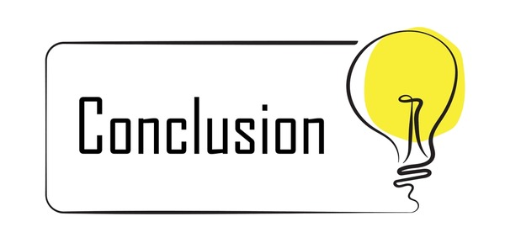
An examination of Hyatt Grand Central New York's performance reveals significant factors where service quality and facility standards affect customer satisfaction and brand reputation. Major obstacles include frequent complaints of unprofessional and unresponsive service, insufficient in-room amenities, and inconsistent cleanliness, all of which impact the guest experience. The hotel's outdated facilities aggravate these issues, often identified by guests as a source of discontent.
The application of the SWOT and PESTEL frameworks reveals that Hyatt Grand Central possesses significant strengths, including its advantageous location and strong brand recognition; however, these benefits are negatively impacted by weaknesses in service and operations. The TOWS analysis underlined strategic initiatives for addressing these challenges by utilising strengths (e.g., brand reputation) and seizing external opportunities, such as the increasing demand for sustainability in the hospitality sector. Essential recommendations cover customer service training, facility improvements, technological advancements, and the implementation of sustainable practices.
Implementing these strategies promises an improvement in guest satisfaction and loyalty, as research links improvements in service quality and technology with increased customer retention and competitive advantage. By implementing improved training, maintenance, and customer-centric strategies, Hyatt Grand Central can improve its operational performance to meet contemporary guest expectations in the hospitality industry.
The suggested recommendations are crucial for positioning Hyatt Grand Central New York in order to improve its market standing and ensure sustained long-term growth. Strengthening customer service and modernising facilities will directly handle the fundamental causes of guest dissatisfaction, while technological advancements and sustainability efforts will align the hotel with evolving industry standards and guest preferences. Collectively, these strategies facilitate a comprehensive approach that blends operational development with brand strengthening, addressing traditional and modern hospitality requirements.
By concentrating on internal upgrades and external prospects, Hyatt Grand Central can re-establish guest confidence, boost repeat reservations, and attract prospective customers who value quality, sustainability, and convenience. Ultimately, these modifications will not only address current challenges but also strengthen the hotel’s competitive stance in New York’s vibrant hospitality sector, ensuring a sustainable and profitable future.
Analysing the hotel’s operations and formulating specific recommendations to better its performance has been a privilege.
Prestige Hospitality Solutions values the chance to improve Hyatt’s legacy of excellence and are assured that the proposed strategies will result in significant benefits.

Prestige Hospitality Solutions anticipate future collaboration opportunities and would like to support Hyatt Grand Central in achieving greater guest satisfaction and operational success.

References
- Abdullah, S., Khalil, N., Haron, S., Hamid, M., & Yan, Y., 2023. Unveiling the Impact of Sustainable Interior Design Criteria on Hotel’s Operational Performance Effectiveness and User’s Hedonic Consumption. International Journal of Sustainable Construction Engineering and Technology. https://doi.org/10.30880/ijscet.2023.14.03.013.
- Ali, B., & Anwar, G., 2021. The mediation role of change management in employee development. 6, pp. 361-374. https://doi.org/10.22161/IJELS.62.52.
- Arkansyah, M., Hamzah, M. and Ibad, M.N., 2021. DALWA SYARI'AH HOTEL COMMUNICATION STRATEGY IN IMPROVING THE QUALITY OF SERVICE TO GUESTS. Wasilatuna: Jurnal Komunikasi dan Penyiaran Islam, 4(1), pp.14-27. https://scholar.archive.org/work/zr77aae3ubd2di22t7ogpti2zq/access/wayback/https://ejournal.iaidalwa.ac.id/index.php/wasilatuna/article/download/554/228
- Baquero, A., 2023. Is Customer Satisfaction Achieved Only with Good Hotel Facilities? A Moderated Mediation Model. Administrative Sciences. https://doi.org/10.3390/admsci13040108.
- Birru, A.C., Sudarmiatin, S. and Hermawan, A., 2022. Competitive strategies in the lodging service sector: Five porter analyses and case study SWOT analysis. Journal of Business and Management Review, 3(1), pp.001-017. https://profesionalmudacendekia.com/index.php/jbmr/article/download/273/147

- Booking.com, 2024. Hyatt Grand Central New York. https://www.booking.com/hotel/us/grand-hyatt-new-york.ro.html?aid=356980&label=gog235jc-1FCAso7AFCFGdyYW5kLWh5YXR0LW5ldy15b3JrSDNYA2jAAYgBAZgBILgBF8gBDNgBAegBAfgBDIgCAagCA7gC8dC9uQbAAgHSAiRiM2QyYzE4ZC1kMGJlLTQ3NTItYjNkMS03MGNmOGJjNmM1ZDnYAgbgAgE&sid=1496687c729948b22b31584cb60306e2&dest_id=20088325;dest_type=city;dist=0;group_adults=2;group_children=0;hapos=1;hpos=1;no_rooms=1;req_adults=2;req_children=0;room1=A%2CA;sb_price_type=total;sr_order=popularity;srepoch=1731160186;srpvid=fc0e613993821730;type=total;ucfs=1&#tab-main
- TripAdvidor.com, 2024. Hyatt Grand Central New York. https://www.tripadvisor.com/Hotel_Review-g60763-d93450-Reviews-Hyatt_Grand_Central_New_York-New_York_City_New_York.html
- Hyatt.com, 2024. Hyatt Grand Central New York. https://www.hyatt.com/en-US/hotel/new-york/hyatt-grand-central-new-york/nycgh?src=adm_sem_crp_chico_crp_ppc_NAM-UnitedStates-NY-NewYork-HY-NYCGH_google_Evergreen2022_e_hyatt%20grand%20central%20new%20york&gad_source=1&gclid=Cj0KCQiArby5BhCDARIsAIJvjIRYbUf42tC3_i3Jb1ybSDuWO_qKouluAREAUuBvthubX-Owqiq_-vUaAl_IEALw_wcB
- Burnes, B. (2014) Managing change. Sixth edition. Harlow, England: Pearson. https://librarysearch.uwtsd.ac.uk/permalink/44WHELF_UWTSD/1pbrh66/alma9929876802421
- Castro-Casal, C., Vila-Vázquez, G., & Pardo-Gayoso, Á., 2019. Sustaining Affective Commitment and Extra-Role Service among Hospitality Employees: Interactive Effect of Empowerment and Service Training. Sustainability. https://doi.org/10.3390/SU11154092.
- CHENG, B., GUO, G., TIAN, J. and SHAALAN, A., 2020. Customer incivility and service sabotage in the hotel industry. International Journal of Contemporary Hospitality Management, 32(5), pp. 1737-1754. https://www.proquest.com/scholarly-journals/customer-incivility-service-sabotage-hotel/docview/2405833887/se-2?accountid=130472
- Dat, N. and Hang, N., 2023. Service Quality and Performance Results through Customer Satisfaction at Small-Scale Hotels in Hanoi Area. International Journal of Scientific Research and Management (IJSRM). https://doi.org/10.18535/ijsrm/v11i11.em07.
- Díaz, M. and Duque, C., 2021. Open Innovation through Customer Satisfaction: A Logit Model to Explain Customer Recommendations in the Hotel Sector. Journal of Open Innovation: Technology, Market, and Complexity. https://doi.org/10.3390/joitmc7030180.
- Dogra, T., 2023. A comparative analysis of service quality in public and private sector hotels. Journal of Tourism Management Research. https://doi.org/10.18488/31.v10i1.3369.
- Farrelly, M.C., Nonnemaker, J.M., Chou, R., Hyland, A., Peterson, K.K. and Bauer, U.E., 2005. Changes in hospitality workers’ exposure to secondhand smoke following the implementation of New York’s smoke-free law. Tobacco Control, 14(4), pp.236-241. https://www.ncbi.nlm.nih.gov/pmc/articles/PMC1748080/pdf/v014p00236.pdf
- Fernández, J.I.P., Cala, A.S. and Domecq, C.F., 2011. Critical external factors behind hotels' investments in innovation and technology in emerging urban destinations. Tourism Economics, 17(2), pp.339-357. https://doi.org/10.5367/te.2011.0033

- Ghani, B., Zada, M., Memon, K., Ullah, R., Khattak, A., Han, H., Ariza-Montes, A., & Araya-Castillo, L., 2022. Challenges and Strategies for Employee Retention in the Hospitality Industry: A Review. Sustainability. https://doi.org/10.3390/su14052885.
- Ghodeswar, B.M., 2008. Building brand identity in competitive markets: a conceptual model. Journal of product & brand management, 17(1), pp.4-12. https://edisciplinas.usp.br/pluginfile.php/2492230/mod_resource/content/3/Building%20brand%20identity%20in%20competitive%20markets.pdf
- Göral, R., 2021. Competitive Analysis of the Hotel Industry in Konya by Using Porter’s Five Forces Model. https://revistia.com/index.php/ejes/article/view/5248/5101
- HBRE, 2024. Investing in Training Hotel Employees. https://www.cbre.com/insights/briefs/investing-in-training-hotel-employees
- Hu, N., Zhang, T., Gao, B., & Bose, I., 2019. What do hotel customers complain about? Text analysis using structural topic model. Tourism Management. https://doi.org/10.1016/J.TOURMAN.2019.01.002.
- Hyatt Grand Central New York Reviews, 2024. https://www.hyatt.com/en-US/hotel/new-york/hyatt-grand-central-new-york/nycgh/photos-reviews#reviews
- Israeli, A.A., 2002. Star rating and corporate affiliation: their influence on room price and performance of hotels in Israel. International Journal of Hospitality Management, 21(4), pp.405-424. https://doi.org/10.1016/S0278-4319(02)00037-3
- Jin, D., Nicely, A., Fan, A., & Adler, H., 2019. Joint effect of service recovery types and times on customer satisfaction in lodging. Journal of Hospitality and Tourism Management. https://doi.org/10.1016/J.JHTM.2019.01.005.

- JOHNSON, K.R., PARK, S. and BARTLETT, K.R., 2018. Perceptions of customer service orientation, training, and employee engagement in Jamaica’s hospitality sector. European Journal of Training and Development, 42(3), pp. 191-209. https://www.proquest.com/scholarly-journals/perceptions-customer-service-orientation-training/docview/2083792774/se-2?accountid=130472
- Kalnaovakul, K. and Promsivapallop, P., 2023. Hotel service quality dimensions and attributes: an analysis of online hotel customer reviews. Tourism and Hospitality Research, 23(3), pp.420-440. https://doi-org.ezproxy.uwtsd.ac.uk/10.1177/14673584221145819
- Kara, E., 2018. A Contemporary Approach For Strategic Management in Tourism Sector: PESTEL Analysis on The City Muğla, Turkey. Journal of Business Research - Turk. https://doi.org/10.20491/ISARDER.2018.446.
- Khatter, A., 2023. Challenges and solutions for environmental sustainability in the hospitality sector. Sustainability, 15(15), p.11491. https://doi.org/10.3390/su151511491
- Kipping, M. and Clark, T., 2012. The Oxford handbook of management consulting. Oxford: Oxford University Press. https://librarysearch.uwtsd.ac.uk/permalink/44WHELF_UWTSD/11c0l68/alma99100108242602421
- Lines, R., Selart, M., Espedal, B. and Johansen, S.T., 2005. The production of trust during organizational change. Journal of Change Management, 5(2), pp.221-245. https://doi.org/10.1080/14697010500143555
- LU, C., BERCHOUX, C., MAREK, M.W. and CHEN, B., 2015. Service quality and customer satisfaction: qualitative research implications for luxury hotels. International Journal of Culture, Tourism and Hospitality Research, 9(2), pp. 168-182. https://www.proquest.com/scholarly-journals/service-quality-customer-satisfaction-qualitative/docview/2105050026/se-2?accountid=130472

- Marinov, M.A. and Marinova, S.T., 2021. COVID-19 and International Business. Change of era. https://www.researchgate.net/profile/Marin-Marinov-5/publication/342986791_International_Business_in_the_COVID-19_Pandemic/links/605229dda6fdccbfeae91dee/International-Business-in-the-COVID-19-Pandemic.pdf
- Maroco, A.L. and Maroco, J., 2013. Service quality, customer satisfaction and loyalty. European Journal of Tourism, Hospitality and Recreation, 4(3), pp.118-145. https://www.academia.edu/download/70984701/Service_quality_Customer_Satisfaction_an20211002-27270-1ptqf6h.pdf
- Montgomery, D., 2018. Measuring performance. Quality and Reliability Engineering International, 34, pp. 967. https://doi.org/10.1002/qre.2371.
- Nair, G., & Choudhary, N., 2019. Sustainability in the Hospitality Industry: A Social Factor Dimension. EMAJ: Emerging Markets Journal. https://doi.org/10.5195/EMAJ.2018.154.
- Nair, G., & Choudhary, N., 2019. Sustainability in the Hospitality Industry: A Social Factor Dimension. EMAJ: Emerging Markets Journal. https://doi.org/10.5195/EMAJ.2018.154.
- Newton, R., 2010. The Management Consultant: Mastering the Art of Consultancy. Financial Times. https://librarysearch.uwtsd.ac.uk/permalink/44WHELF_UWTSD/11c0l68/alma9929876902421
- Özdemir, G. and Türker, D., 2023. A competitive analysis of e-distribution systems in the hospitality industry. Afyon Kocatepe Üniversitesi Sosyal Bilimler Dergisi, 25(1), pp.387-402. https://dergipark.org.tr/en/download/article-file/2178614

- PANNO, A., 2020. Performance measurement and management in small companies of the service sector; evidence from a sample of Italian hotels. Measuring Business Excellence, 24(2), pp. 133-160. https://www.proquest.com/scholarly-journals/performance-measurement-management-small/docview/2533296178/se-2?accountid=130472
- Porter, M.E., 2008. The five competitive forces that shape strategy, Harvard business review. United States: Harvard Business Review, pp. 78–137. https://librarysearch.uwtsd.ac.uk/permalink/44WHELF_UWTSD/1ir6fgh/cdi_proquest_miscellaneous_70293081

- Progress, H., Whilhemia, S. and Tarisai, C., 2013. The Delineation of Porter’s Five Competitive Forces Model from a Technological Marketing Perspective: A Case Study of Buffalo City Metropolitan Municipality. Journal of Economics, 4(2), pp.169-182. https://www.researchgate.net/profile/Progress-Hove-Sibanda/publication/321216732_The_Delineation_of_Porter%27s_Five_Competitive_Forces_Model_from_a_Technological_Marketing_Perspective_A_Case_Study_of_Buffalo_City_Metropolitan_Municipality/links/5b50870b0f7e9b240fede011/The-Delineation-of-Porters-Five-Competitive-Forces-Model-from-a-Technological-Marketing-Perspective-A-Case-Study-of-Buffalo-City-Metropolitan-Municipality.pdf
- REILLY, P., 2018. Building customer centricity in the hospitality sector: the role of talent management. Worldwide Hospitality and Tourism Themes, 10(1), pp. 42-56. https://www.proquest.com/scholarly-journals/building-customer-centricity-hospitality-sector/docview/2025799023/se-2?accountid=130472
- Seyitoğlu, F. and Ivanov, S., 2020. A conceptual framework of the service delivery system design for hospitality firms in the (post-) viral world: The role of service robots. International Journal of Hospitality Management, 91, p.102661. https://doi.org/10.1016/j.ijhm.2020.102661
- Sharma, S. and Srivastava, S., 2018. Relationship between service quality and customer satisfaction in hotel industry. TRJ Tourism Research Journal, 2(1), pp.42-49. https://doi.org/10.30647/trj.v2i1.20
- Sheinberg, J., 2021. To Brand or Not to Brand? An Empirical Analysis of the Advantages and Disadvantages of Hotel Branding. https://ecommons.cornell.edu/bitstream/handle/1813/109684/Sheinberg_cornell_0058O_11176.pdf?sequence=1
- Sheykin, H., 2024. How Eco-Friendly Measures Affect Hotel Operational Costs. https://finmodelslab.com/blogs/operating-costs/eco-friendly-hotel-operating-costs?srsltid=AfmBOop7y2UwoZ2MUPVXSHLAPKHxTCAT6NNQn2HBJ6CJsg5yH4mYCkPG
- Shulga, L., 2020. Change Management Communication: The Role of Meaningfulness, Leadership Brand Authenticity, and Gender. Cornell Hospitality Quarterly, 62, pp. 498 - 515. https://doi.org/10.1177/1938965520929022.
- SUBRAMANIAM, N., COLLIER, P., PHANG, M. and BURKE, G., 2011. The effects of perceived business uncertainty, external consultants and risk management on organisational outcomes. Journal of Accounting & Organizational Change, 7(2), pp. 132-157. https://www.proquest.com/scholarly-journals/effects-perceived-business-uncertainty-external/docview/2439154596/se-2?accountid=130472

- SUMANEEVA, K.A., ELUWOLE, K.K. and AVCI, T., 2018. Cross-Functional Training of Front-Line Hotel Employees, In-Role and Extra-Role Job Performance, Customer Satisfaction, and Customer Loyalty: A conceptual Model Proposal. Journal of Environmental Management & Tourism, 9(6), pp. 1183-1189. https://www.proquest.com/scholarly-journals/cross-functional-training-front-line-hotel/docview/2432816456/se-2?accountid=130472

- SVEN, B., O’DWYER MICHELE, O’MALLEY LISA and LEE, N., 2022. The use of Net Promoter Score (NPS) to predict sales growth: insights from an empirical investigation. Journal of the Academy of Marketing Science, 50(1), pp. 67-84. https://www.proquest.com/scholarly-journals/use-net-promoter-score-nps-predict-sales-growth/docview/2619341974/se-2?accountid=130472
- Tavitiyaman, P., Qu, H. and Zhang, H.Q., 2011. The impact of industry force factors on resource competitive strategies and hotel performance. International journal of hospitality management, 30(3), pp.648-657. https://doi.org/10.1016/j.ijhm.2010.11.010
- Thakur, V., 2020. Framework for PESTEL dimensions of sustainable healthcare waste management: Learnings from COVID-19 outbreak. Journal of Cleaner Production, 287, pp. 125562 - 125562. https://doi.org/10.1016/j.jclepro.2020.125562.
- Tripadvisor, 2024. Review of Hyatt Grand Central New York. https://www.tripadvisor.com/Hotel_Review-g60763-d93450-Reviews-Hyatt_Grand_Central_New_York-New_York_City_New_York.html
- Turner, M., & Hesford, J., 2018. The Impact of Renovation Capital Expenditure on Hotel Property Performance. Cornell Hospitality Quarterly, 60, pp. 25 - 39. https://doi.org/10.1177/1938965518779538.
- Turner, M., & Hesford, J., 2018. The Impact of Renovation Capital Expenditure on Hotel Property Performance. Cornell Hospitality Quarterly, 60, pp. 25 - 39. https://doi.org/10.1177/1938965518779538.
- Wang, T., 2023. Exploration on User Acceptance Behavior of Hotel Artificial Intelligence Technology Based on Experience Quality. Journal of Artificial Intelligence Practice. https://doi.org/10.23977/jaip.2023.060505.
- Waqanimaravu, M., & Arasanmi, C., 2020. Employee training and service quality in the hospitality industry. Journal of Foodservice Business Research, 23, pp. 216 - 227. https://doi.org/10.1080/15378020.2020.1724850.

- Whittington, R, Regnér, P, Angwin, D, Johnson, G, Scholes, K, Whittington, R, Regnér, P, Angwin, D, Johnson, G, & Scholes, K 2019, Exploring Strategy, Text and Cases, Pearson Higher Education & Professional Group, Upper Saddle River. Available from: ProQuest Ebook Central. https://ebookcentral.proquest.com/lib/trinity/detail.action?docID=5987036
- Yılmaz, Ö., Ferguson, M., Pekgün, P. and Shang, G., 2022. Strategic behavior for hotel standby upgrade programs: Empirical evidence and pricing implications. Journal of Operations Management, 68(6-7), pp.675-701. https://doi.org/10.1002/joom.1177
- Yılmaz, Ö., Ferguson, M., Pekgün, P., & Shang, G., 2019. Strategic Behavior for Hotel Standby Upgrade Programs: Empirical Evidence and Pricing Implications. Manufacturing. https://doi.org/10.2139/ssrn.3411087.

- Yu, C., & Liu, C., 2023. Research on the Improvement of Service Quality in the Service Industry-Perspectives of Customer Relationship Management. International Journal of Membrane Science and Technology. https://doi.org/10.15379/ijmst.v10i3.1901.
- Zhang, C., Xu, Z., Gou, X., & Chen, S., 2021. An online reviews-driven method for the prioritization of improvements in hotel services. Tourism Management, 87, pp. 104382. https://doi.org/10.1016/J.TOURMAN.2021.104382.

