
Programme | BSc Health and Social Care
Module Title | Changemakers: Building your Personal Brand for Sustainable Employment
Module Code | BMHP5015
Assessment Title | Component 1: Online Portfolio of Set Exercises
Assessment Type | Portfolio
Student Name | Zaiba Tabassum
Student ID | 2407213
Lecturer Name | Olufemi Oluranti

Task 1 – Personal Brand (Reliable and Growth-Oriented Professional)
Introduction
A personal brand is the way I present myself to employers and professional contacts. It is a representation of my abilities, values and professional identity. Peters (1997) states that using personal branding, people stand out in the competitive job market. So, it's vital to have a strong personal brand to reach my career objectives.
Main Body – Discussion
My current personal brand is based on being reliable, hardworking, and willing to learn. I am committed to completing tasks in a timely fashion and show professionalism. I am also well organized and can work independently as well as in a team. These attributes help me to achieve a profitable career. I think my employers would consider me to be a responsible person who is motivated to grow in both my personal and professional life. But I have some things that need to improve. I want to develop my communication and leadership ability. In addition, I will be expanding my professional network on LinkedIn and at industry events. These skills will make it easier for me to communicate confidently with my colleagues and employers. According to Montoya and Vandehey (2008), personal branding is a process that needs ongoing development and consistent promotion of strengths. To enhance my brand, I will take advantage of training opportunities, get hands-on experience, and develop my professional online image.
Conclusion
In conclusion, the personal brand I have built is one of reliability, commitment and learning. Attending conferences will help me build my professional image by enhancing my communication, leadership and networking abilities. This will enhance my employability and contribute to my career aspirations.

Task 2: Network Map (Hybrid) and Rationale
My network can be described as a hybrid network, as it consists of both friendships and connections on a professional level (shown in figure 1). I have good relationships with my family, friends, lecturers and classmates. These links offer various forms of assistance and opportunities. Putnam (2000) states that the social networks provide individuals with support, information and resources.
The strongest part about my network is the support factor. Emotional support and practical assistance from family and close friends when necessary. I also have helpful contacts at the university from lectures and in class, and through working with people. These relationships enable me to acquire new skills and gain career advice.
But there are some weaknesses in my network. The people I know the most are those that have similar educational and social levels. That basically means that I have limited bridging social capital. Bridging connections are key as they enable access to new ideas and opportunities (Woolcock, 2001). In addition, I have limited networking opportunities with people who are senior professionals, managers, or industry professionals who could offer guidance and employment opportunities.
To grow my network, I will attend networking events, build my LinkedIn connections and engage in community projects. These actions will enable me to develop my bridging and linking social capital. As a result, I will gain access to more career opportunities and realize my career goals.
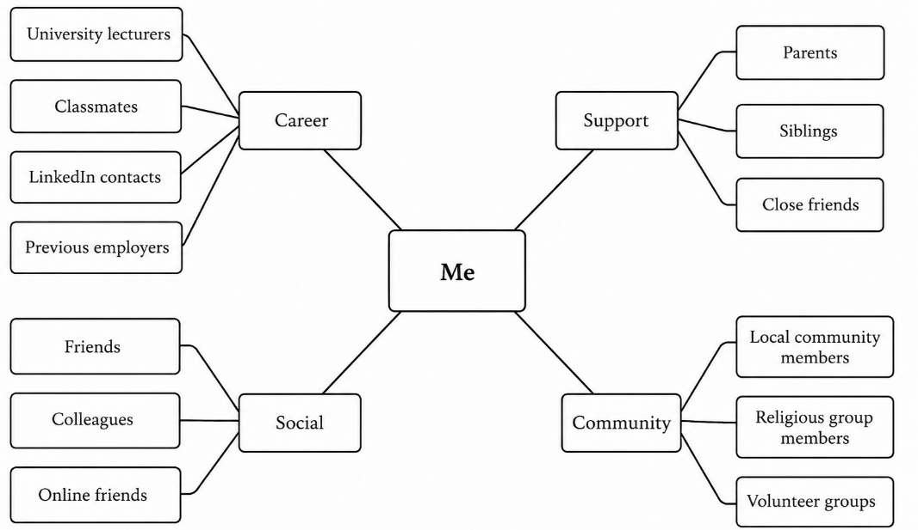
Figure 1: Network map illustrates the key relationships that support my personal and professional development (Drawn by using Visual Paradigm Online Tool).

Task 3: Blog Mental Health Services
Title: Mental Health Services for Young Adults in the UK
Introduction
Target Audience: Young adults and their families
Mental health is a key component of well-being. But for many young adults in the UK, there are obstacles to the way of accessing mental health support. Anxiety, depression and stress are on the rise. This is especially crucial when it comes to mental health services (NHS England, 2024).
Main Body
Mental health problems are common in young people between the ages of 11 and 14 when they are in education, employed or going through a significant life change. NHS England (2023) reported that there is a higher number of young people seeking mental health support than ever before. This has led to a greatly increased demand for services.
Long waiting times constitute one of the challenges. There are some young adults who delay treatment for weeks or even months. Mental health issues may be exacerbated by delays, and delays can have an impact on educational, occupational and social functioning. Early support is essential as it can help to avert issues becoming more severe (Mind, 2024).
The UK health sector has developed several measures to increase access to health services. These include mental health apps, community support programmes and online counselling. Digital services enable young people to find support in their own homes and can lessen any barriers to seeking support. But for those with more complex needs, face-to-face support is important.
Conclusion
In conclusion, there is a crucial role for mental health services in supporting young adults in the UK. Though advances have been accomplished with digital services and awareness, issues like long waiting times persist. There is a need for ongoing investment in mental health services to ensure that young people are supported at the earliest opportunity and effectively.
Image
Figure 2 illustrates the typical pathway through mental health services for young adults in the UK, from recognising mental health needs to accessing support and achieving recovery. It also highlights key challenges, such as long waiting times and limited resources, which can affect access to timely care.
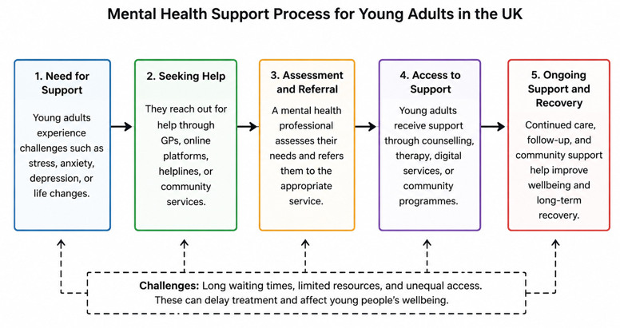
Figure 2: Mental Health Support Process for Young Adults in the UK (Drawn by using Visual Paradigm Online Tool)

Task 4: Quiz Answers – NHS Equality, Diversity and Inclusion
- Answer 1
The main goal is to reduce prejudice and discrimination in the NHS workforce and improve equality, diversity, inclusion, and belonging so staff can work well and give better care.
- Answer 2
The plan says the NHS should analyse pay gap data, make improvement plans, and use flexible work for all staff to help reduce the gender pay gap.
- Answer 3
Intersectionality means people can face more than one form of disadvantage at the same time, because they have multiple identities, so one protected characteristic should not be looked at alone.
- Answer 4
A psychologically safe work environment is important because staff feel comfortable speaking up, asking questions and admitting mistakes. This improves teamwork, staff morale and patient safety.
- Answer 5
The plan suggests improving the experience of internationally recruited staff by giving clear pre-joining information, strong onboarding, cultural awareness in teams, and equal access to training and career development.
- Answer 6
Leadership is key because chairs, chief executives, and board members must set the tone, have clear EDI objectives, and use data and lived experience to improve culture.
- Answer 7
One way it aims to reduce health inequalities is by reducing bullying and harassment and improving staff health and wellbeing through regular well-being conversations with line managers.
- Answer 8
The NHS emphasises data on protected characteristics so it can track progress, spot inequality, and target action where it is needed most.
- Answer9
Flexible working helps staff balance work and personal life, improving fairness in recruitment, retention and career progression.
- Answer 10
Review bullying data by protected characteristics, set reduction targets, and use early informal intervention where possible.
Source to all 10 answers: NHS England (2023)

Task 5 – A Letter to Myself
Dear Younger Myself,
I remember a time when I felt stressed and uncertain about my future. I was facing academic stress and personal issues at the same time. Sometimes I had to fear making errors and felt overwhelmed in my duties. During that period, my confidence was low, and I found it difficult to stay positive.
Looking back, I now know how crucial emotional intelligence and resilience are. I would have realised and controlled my emotions better as I had emotional intelligence. My feelings oversaw my thoughts and I could have responded in a different way, more calmly, without stress and frustration. It would have been helpful for me to be able to communicate better with my family, friends and teachers when they needed me.
Resilience would have been equally important. Sometimes I saw failures as setbacks at that time. I now understand that challenges are part of life and can help me to grow. I would have bounced back from failures more quickly and stayed on track with my objectives if I had been more resilient.
My suggestion for you is to be patient with yourself. Don't feel bad about asking for assistance when needed. Don't get demoralized by mistakes; learn from them. Try to concentrate on the things you can do and take small steps. Keep in mind that tough times don't last forever.
Emotional intelligence and being resilient are important qualities to develop both in personal and professional life today. These skills would have been beneficial in my earlier life to deal with stress, gain confidence and approach challenges in a positive way.
Kind Regards,
Your Future Self

Task 6: Gantt Chart – From 7 July 2026 to 31 March 2027 (9 Months Plan)
The Gantt chart in Table 1 shows the activities that I will undertake to meet my employment targets in the Health and Social Care sector in the future. The timeline begins on 7 July 2026 and ends on 31 March 2027.
I have a few tasks I need to get done before the University work, and I've got to get my CV and LinkedIn profile updated. These activities will enhance my professional presentation of my skills, qualifications and experience to prospective employers. Additionally, I will explore employers and job opportunities to gain insight into the criteria for various positions and career paths.
I am going to seek work experience or volunteering from August to November 2026. This will enable me to build up skills of practice, confidence and an understanding of the Health and Social Care sector. Experience matters because employers will appreciate candidates who have experience and skills in the workplace.
I will seek employment with organisations that align with my interests and skills in my career, and will submit job applications from September to December 2026. Lastly, between November 2026-March 2027, I will be preparing for interviews and focusing my energy on finding a job.
The overall Gantt chart gives me a clear plan of how to achieve my goals in career. It assists me to plan my time efficiently, track progress and maintain focus on the required actions to gain employment in my desired career.

Table 1: Gantt chart illustrating the tasks and timeline planned from 7 July 2026 to 31 March 2027 to support the achievement of my future employment goals in the Health and Social Care sector.
Task | 07 Jul–31 Jul 2026 | 01 Aug–31 Aug 2026 | 01 Sep–30 Sep 2026 | 01 Oct–31 Oct 2026 | 01 Nov–30 Nov 2026 | 01 Dec–31 Dec 2026 | 01 Jan–31 Jan 2027 | 01 Feb–28 Feb 2027 | 01 Mar–31 Mar 2027
Complete university assignments
Update CV and LinkedIn profile
Research employers and job opportunities
Gain volunteering or work experience
Submit job applications
Attend interviews and secure employment

Task 7: Flexible Staff Rota System – Making Changes Report
Introduction
As a manager of a care home, I would like to implement a flexible staff Rota system. This change is designed to enhance residents' care, boost staff satisfaction and well-being, as well as better staff well-being. There are also benefits of flexible working hours that can help minimise staff turnover and absenteeism.
Planning the Change
This change will be affected using Lewin's Change Model (Lewin, 1951). In the unfreezing phase, staff will be kept updated on the rationale for the new Rota system and opportunities will be provided for staff to express their thoughts. A trial flexible Rota will be in place for three months during the change stage. Where possible, staff preferences will be considered whilst ensuring staffing is adequate. Feedback will be given in the refreezing stage and the new Rota system will be implemented as a part of the regular work practice, if successful. The process will engage managers, care staff and residents (Burnes, 2020).
Skills Required
There are several skills that are needed to effectively manage this change. The ability to communicate is required to tell people the advantages of the new system. Leadership will be needed to support the change process for staff. Creating fair and effective rotas is important to consider aspects of time management and organisational skills. Problem solving skills will also be able to solve any problems that may be there (Burnes, 2020).
Barriers and Solutions
Staff resistance may be one barrier, where some staff may prefer the existing Rota system. This can be mitigated with participation by staff in planning and taking account of their concerns. The other obstacle is having sufficient personnel on duty for every shift. Careful scheduling and regular monitoring can help maintain safe staffing levels. There may also be conflicts between staff preferences and service needs. Open communication and fair decision-making can help resolve these issues. Engaging employees in change can increase commitment and help minimise resistance, as stated by Kotter (1996).
Conclusion
To conclude, a flexible staff Rota system can help to increase employee satisfaction and promote a good work-life balance. This transformation can be achieved with good planning, communication and leadership and can benefit staff and care for home residents.
Diagram
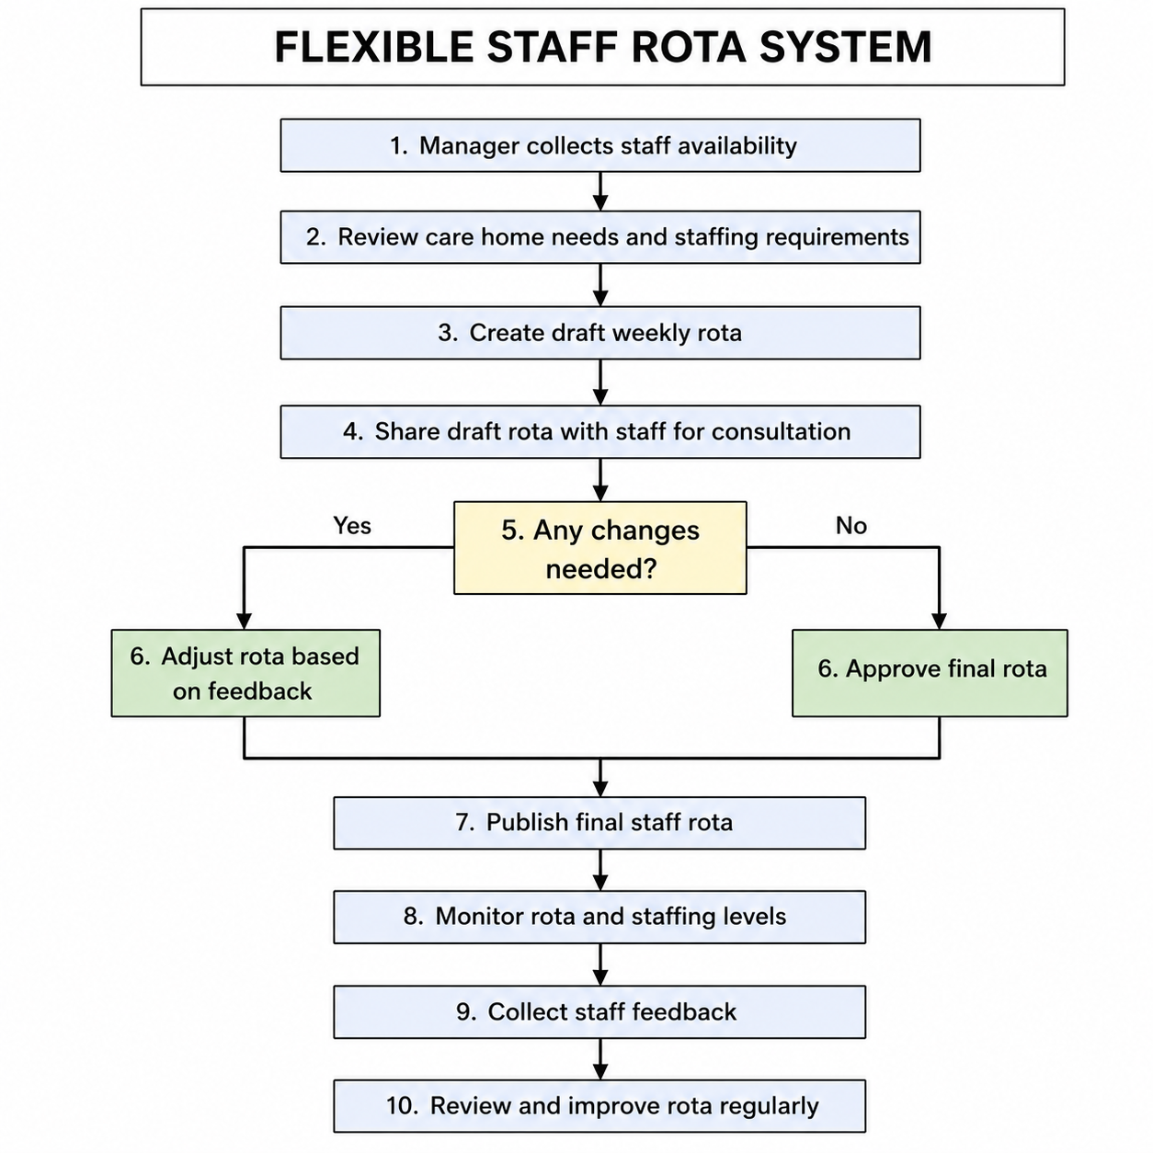
Figure 3: Flexible Staff Rota System Process

Reference List
Burnes, B. (2020) Managing Change. 8th edn. Harlow: Pearson. https://api.pageplace.de/preview/DT0400.9781292156071_A30401762/preview-9781292156071_A30401762.pdf (Accessed: 22 June 2026).
Kotter, J.P. (1996) Leading Change. Boston: Harvard Business School Press. https://irp-cdn.multiscreensite.com/6e5efd05/files/uploaded/Leading%20Change.pdf (Accessed: 22 June 2026).
Lewin, K. (1951) Field Theory in Social Science. New York: Harper & Row. https://doi.org/10.1177/000271625127600135
Mind (2024) Mental Health Facts and Statistics. London: Mind. Available at: https://www.mind.org.uk/information-support/types-of-mental-health-problems/mental-health-facts-and-statistics/ (Accessed: 22 June 2026).
Montoya, P. and Vandehey, T. (2008) The Brand Called You: Make Your Business Stand Out in a Crowded Marketplace. New York: McGraw-Hill. https://www.scirp.org/reference/referencespapers?referenceid=1936001 (Accessed: 22 June 2026).
NHS England (2023) NHS Equality, Diversity and Inclusion Improvement Plan. London: NHS England. Available at: https://www.england.nhs.uk/wp-content/uploads/2023/06/edi-improvement-plan-plain-english.pdf (Accessed: 22 June 2026).
NHS England (2024) Mental Health Services. Available at: https://www.england.nhs.uk/mental-health/taskforce/imp/mh-dashboard/ (Accessed: 22 June 2026).
Peters, T. (1997) ‘The Brand Called You’, Fast Company, 10, pp. 83–90. https://personalimpact.ca/wp-content/uploads/2015/08/thebrandcalledyou.pdf (Accessed: 22 June 2026).
Putnam, R.D. (2000) Bowling Alone: The Collapse and Revival of American Community. New York: Simon & Schuster. http://www.csun.edu/~rdavids/350fall08/350readings/Putnam_Bowling_Alone.pdf (Accessed: 22 June 2026).
Woolcock, M. (2001) ‘The place of social capital in understanding social and economic outcomes’, Canadian Journal of Policy Research, 2(1), pp. 11–17. https://faculty.washington.edu/matsueda/courses/590/Readings/Woolcock%20Soc%20Cap%20Development.pdf (Accessed: 22 June 2026).

