Ryan Jones (2009252)
2009252@student.uwstd.ac.uk
Submission: Friday 7th April

Cyber security and networking
Operating systems ACCA4022

Table of Contents
Introduction: 4
1. Key functions of general Operating Systems: 4
1.1. Operating System (OS) 4
1.2. Kernel: 5
1.3. Process Management: 5
1.4. Memory Management 5
1.5. Device Management: 6
1.6. File Management: 6
1.7. Security Management: 7
1.8. User Interface: 7
1.9. Networking: 7
1.10. Error handling and recovery: 7
1.11. Multi-tasking: 7
2. Use of Windows OS CLI commands: 8
3. Use of Linux OS CLI commands: 12
4. Use of Windows OS scripts: 15
5. Use of Linux OS scripts: 19
Conclusion: 21
Reference: 22
Appendices: 24
A- Types of operating systems: 24
Batch OS: 24
Distributed OS: 24
Multitasking OS: 24
Network OS: 24
Mobile OS: 24
B- Evidence of engagement Cisco course: 25

Tables of figures
Figure 1: Operating system [2] 4
Figure 2: Operating system Kernal [4] 4
Figure 3: Process Management [6] 5
Figure 4: Computer Memory Pyramid [8] 5
Figure 5: Device Management [10] 6
Figure 6: User Interface [14] 6
Figure 7: Multi-tasking [18] 7
Figure 8: DIR Dos CLI Command 8
Figure 9: CD Dos CLI Command 8
Figure 10: CD.. Dos CLI Command 8
Figure 11: IP Config Dos CLI Command 9
Figure 12: MD Dos CLI Command 9
Figure 13: RD Dos CLI Command 10
Figure 14: Help Dos CLI Command 10
Figure 15: CHKDSK Dos CLI Command 11
Figure 16: VER Dos CLI Command 11
Figure 17: Hostname Dos CLI Command 11
Figure 18: pwd Linux CLI Command 12
Figure 19: cd Linux CLI Command 12
Figure 20: ls Linux CLI Command 12
Figure 21: rm Linux CLI Command 13
Figure 22: history Linux CLI Command 13
Figure 23: cd- Linux CLI Command 14
Figure 24: mkdir Linux CLI Command 14
Figure 25: sudo apt upgrade Linux CLI Command 14
Figure 26: echo Linux CLI Command 15
Figure 27: ps Linux CLI Command 15
Figure 28: Loop Command PowerShell 15
Figure 29: Variables PowerShell 16
Figure 30: if Else PowerShell 16
Figure 31: Switch Statement PowerShell 16
Figure 32: Array PowerShell 17
Figure 33: Function PowerShell 17
Figure 34: For Loop PowerShell 17
Figure 35: Arithmetic PowerShell 17
Figure 36: User Input PowerShell 18
Figure 37: Echo PowerShell 18
Figure 38: Until Loop Linux Bash 18
Figure 39: Variables Linux Bash 19
Figure 40: If Statement Linux Bash 19
Figure 41: Case Statement Linux Bash 19
Figure 42: Array Linux Bash 19
Figure 43: Function Linux Bash 20
Figure 44: For Loop Linux Bash 20
Figure 45: Arithmetic Linux Bash 20
Figure 46: User Input Linux Bash 20
Figure 47: Echo Linux Bash 20

Introduction:

This report will outline key general and common functions of a general Operating System (OS). To analyse these, it is important to understand what is meant by this term. “An operating system is an intermediary program between computer user and the computer hardware” [1]. Whilst OS can differ (see Appendix A) this report outlines key features which are deemed essential to manage the resources within any of the chosen general OS. This report has focused upon Microsoft and Linux within the OS and explains the program Kernel which acts as an interface between the hardware and software.
The different types of Windows and Linux Command Line Interface (CLI) will also be detailed. These are used to manage computer files and interact with the OS. PowerShell script and Bash script will also be explored which refer to a computer language with several commands or a set of instructions within a file. Throughout this report, the strengths and limitation of these will be noted to inform the conclusion.

Key functions of general Operating Systems:

  - Operating System (OS)

“An operating system is an intermediary program between computer user and the computer hardware” [1]. Essentially a software program that manages computer hardware and software resources and provides common services for computer programs to operate. It is an essential component of any computing device, from smartphones to supercomputers. Performing all basic tasks such as file management, memory management, memory management, process management, input/output handling, and controlling peripherals such as drives and printers.

The OS acts as the backbone for all computer activities as several applications and programmes run simultaneously enabling users to access and interact with the computer system seamlessly. Like any technology OS have developed over time to serve emerging trends in business and society. The fundamentals within an OS remain the same, the type will however vary dependant on the need.

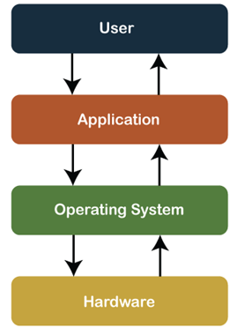
Figure 1: Operating system [2]

  - Kernel:

Kernel is the core component of an OS that provides basic services and controls access to the computer's hardware resources. “A computer program that is a core or heart of an operating system.” [3]. Below shows how the Kernel interacts and provides a secure environment for running applications.
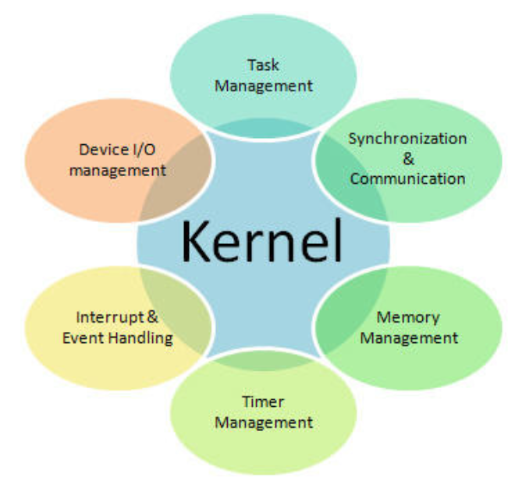
Figure 2: Operating system Kernal [4]

Functions within the OS are detailed below.
  - Process Management:

“A process is an instance of a program running in a computer” [5]. The OS manages the execution of multiple processes simultaneously, ensuring that they do not interfere with each other. It manages the resources, including the CPU, memory, and input/output devices, ensuring that each process gets the resources it needs to run.

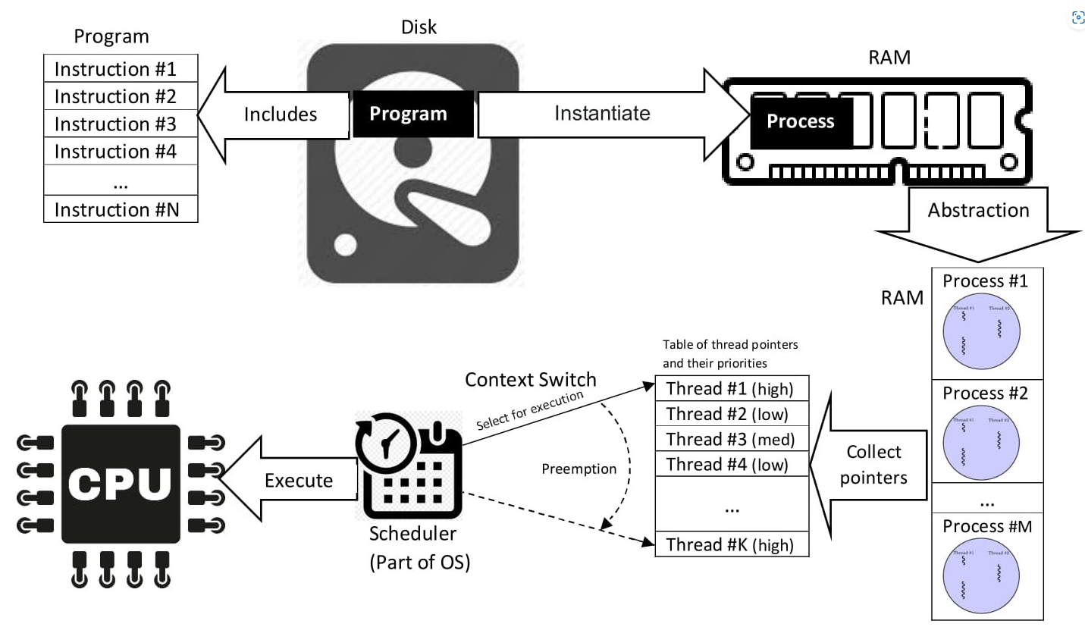
Figure 3: Process Management [6]

  - Memory Management:

The OS manages the allocation and deallocation of memory resources. Enabling processes to share memory it provides protection mechanisms whilst tracking what is in use. “Memory Management continuously moves processes between memory and storage devices (hard disk or SSD), while tracking each memory location and its allocation status” [7].

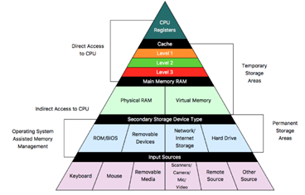
Figure 4: Computer Memory Pyramid [8]

  - Device Management:

The OS manages the allocation of input/output devices such as printers, keyboards, and network interfaces. “Device management is the process of managing the implementation, operation and maintenance of a physical and/or virtual device” [9]. This is highlighted below.

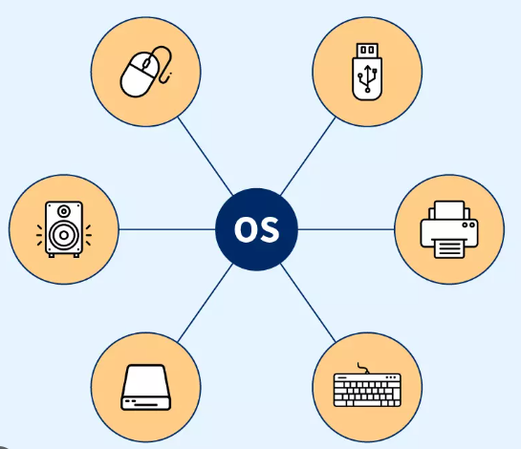
Figure 5: Device Management [10]

  - File Management:

The OS provides a file system that manages the storage, organization, and retrieval of data files. “The file management in operating system allows users to create a new file and modify and delete the old files present at different locations of the computer system.” [11]. It controls access, ensures data integrity, and provides protection against data loss.

  - Security Management:

The OS provides security mechanisms protecting from unauthorized access. “This specified steps or measures used to protect the OS from threats, viruses, worms, malware or remote hacker intrusions.” [12]. To do this, it authenticates users, controls access to system resources, enforces security policies, and detects and responds to security breaches.

  - User Interface:

The OS provides a user interface enabling users to interact with the computer system. Essentially, “a program, or device that allows a user to enter and receive information.” [13] as shown below. It includes a graphical user interface, command-line interface, and other input/output interfaces.

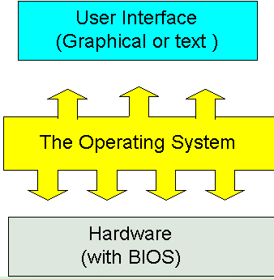
Figure 6: User Interface [14]

  - Networking:

The OS provides networking capabilities that allow computers to communicate with each other. “Built-in software designed to simplify networking. Typical OS software includes an implementation of TCP/IP and related utility programs such as ping and traceroute” [15]. To achieve this, it includes protocols for connecting to the internet, managing network resources, and secure communication.

  - Error handling and recovery:

The OS provides methods for detecting errors and recovering from them. It does this at various stages, “It detects errors when a file is opened, when a program device is acquired or released, during I/O operations to a file, and when the file is closed” [16].

  - Multi-tasking:

The OS enables users to run multiple programs simultaneously. “Allowing a user to perform more than one computer task (such as the operation of an application program) at a time.” [17]. To achieve this, it manages memory resources and assigns processing time to each program as illustrated below.

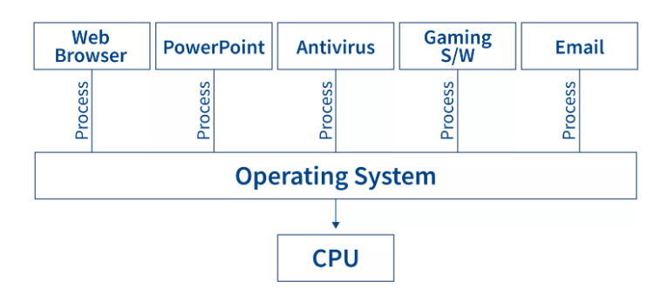
Figure 7: Multi-tasking [18]

Use of Windows OS CLI commands:

Command Line Interface (CLI) are used within system management. The Windows (CLI) is a text-based interface used to interact with the Windows operating system through a command prompt. “Text-based user interface (UI) used to run programs, manage computer files and interact with the computer” [19]. By doing so it provides a way to execute commands and scripts using a keyboard instead of a graphical user interface.
Below I have demonstrated the 10 Windows CLI Commands I utilise and that can be found from the following source [20].

DIR – This command is a command prompt used to display a list of files and subdirectories contained in a directory. For each file or directory listed, the command by default displays the date and time the item was last modified, whether the item is a directory (tagged with DIR) or a file, the size of the item. file if present, and finally the name of the file or directory, including its extensions as seen below:
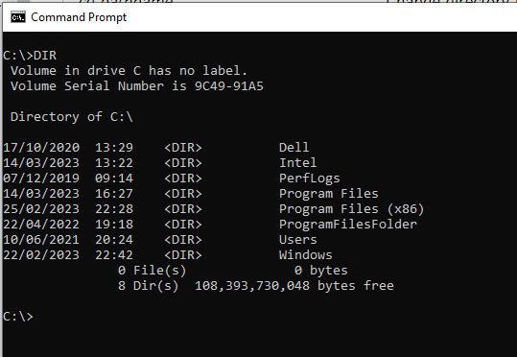
Figure 8: DIR Dos CLI Command

CD – This command is short for “change directory” (folder) in the file system. This command allows you to navigate to a directory as seen below:
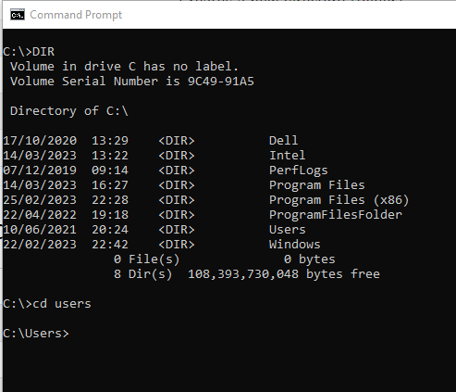
Figure 9: CD Dos CLI Command
CD .. – This command will move one level up (one folder), as see below:

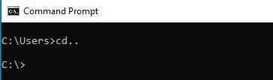
Figure 10: CD.. Dos CLI Command
IP Config– This command is used to display information about your network configuration and refresh DHCP and DNS Settings. By default, the ipconfig command displays your IP Address, Subnet Mask, and default gateway, as seen below:
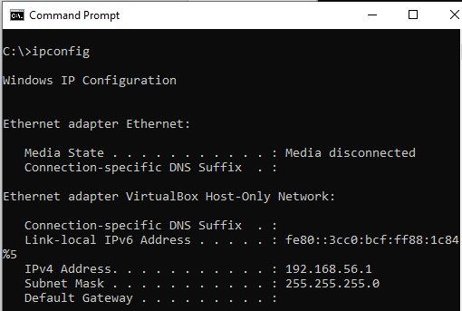
Figure 11: IP Config Dos CLI Command

MD – This command is short for “make directory” (folder) this creates a new directory (folder) on the indicated directory level, as seen below:
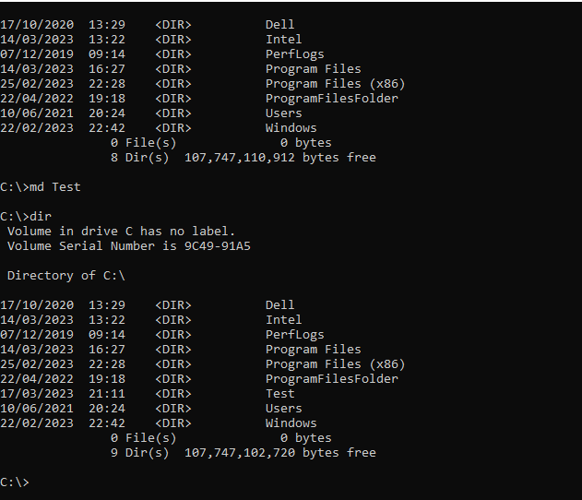
Figure 12: MD Dos CLI Command
RD – This command is short for ”remove directory” (Folder) The directory needs to be empty before you can use this command, as seen below:
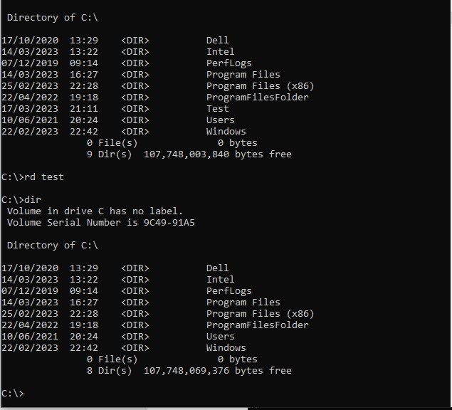
Figure 13: RD Dos CLI Command

Help – This command list commands that you can use within DOSS, as seen below:
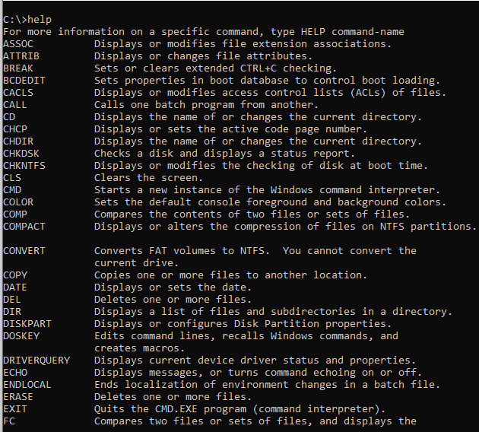
Figure 14: Help Dos CLI Command
CHKDSK –This command is short for “Check Disk”, is a utility that checks the integrity of the files and file structure of your hard disk, as seen below:
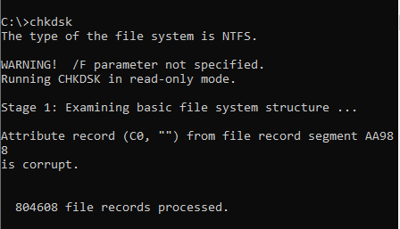

Figure 15: CHKDSK Dos CLI Command

Ver – This command is used to display the current MS-DOS version number, as seen below:
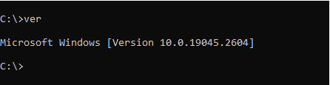
Figure 16: VER Dos CLI Command

Hostname –This command displays the hostname label that is assigned to a device, as seen below:
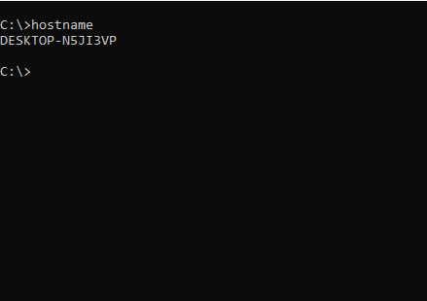

Figure 17: Hostname Dos CLI Command

Use of Linux OS CLI commands:

In addition to Microsoft commands described above, there are also Linux command-line interface (CLI). Also, a text-based interface used to interact with the Linux operating system through a terminal which executes commands and scripts in that same way that Microsoft uses a command prompt. Linux, unlike Microsoft operates an Open-source OS. The benefits of which attract large companies such as goggle and eBay. One of the main benefits is that modification can be made and distributed by anyone unlike others which can only be modified by the owner.
Below demonstrates the 10 Linux CLI Commands I utilise which can be found from source [21].

pwd – This command prints working directory. It is one of the most basic and frequently used commands in Linux. When invoked the command prints the complete path of the current working directory, as seen below:
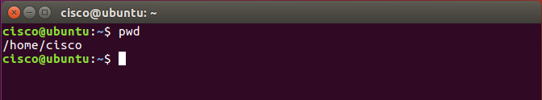
Figure 18: pwd Linux CLI Command
cd –This command is short for “change directory” (folder), this command is used to navigate the directory tree structure, as seen below:
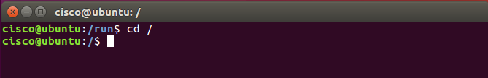
Figure 19: cd Linux CLI Command

ls -This command Is short for “list”, this command lists information about directories and any type of files in the working directory, as seen below:
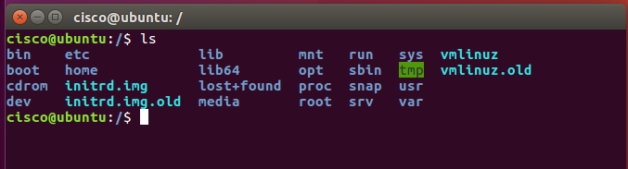
Figure 20: ls Linux CLI Command
rm – This command is used to remove objects such as files, directories, symbolic links and so on from the file system, as seen below:
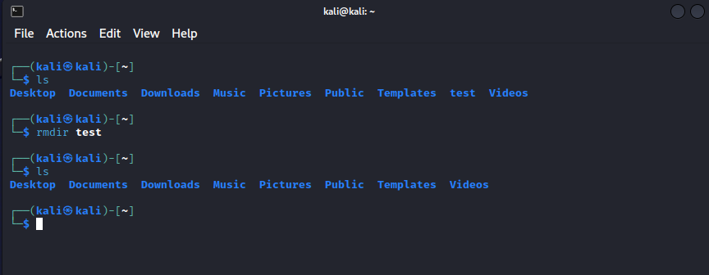
Figure 21: rm Linux CLI Command
history – This Command displays the history of the commands that you’ve recently run, the commands are numbered, with the most recently used, as seen below:

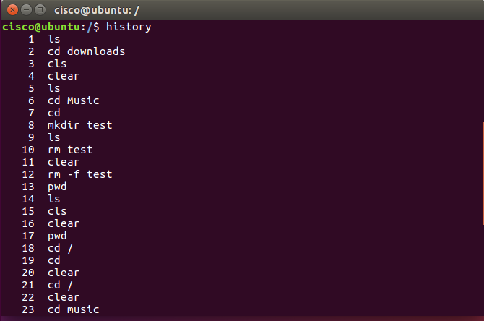
Figure 22: history Linux CLI Command
Cd - – This command returns to the previous directory, change directory command. It is used to change current working directory, as seen below:

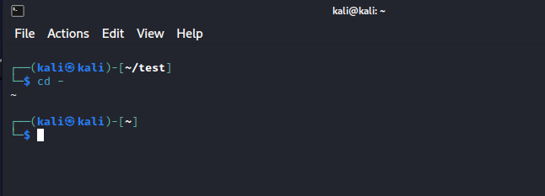
Figure 23: cd- Linux CLI Command
mkdir -This command allows you to create new directory (folder) in the file system, as seen below:
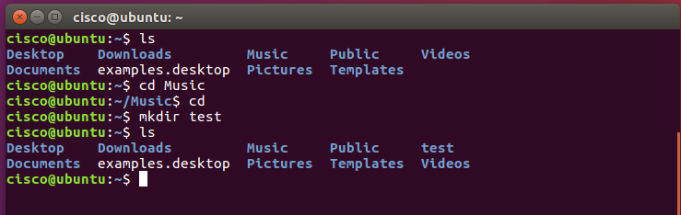
Figure 24: mkdir Linux CLI Command
sudo apt upgrade – This command “sudo apt upgrade” is the command used to download any available updates and apply them to the out-dated packages installed in a Linux system, as seen below:
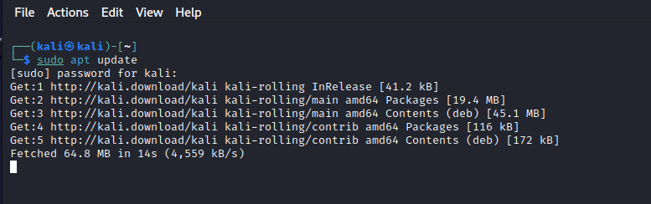
Figure 25: sudo apt upgrade Linux CLI Command

echo – This command is used to display a sting provided user, as seen below:
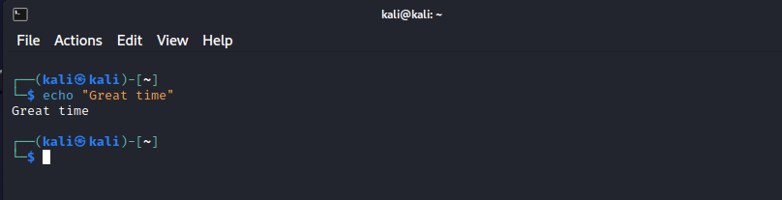
Figure 26: echo Linux CLI Command
ps - This command looks at the processes your current shell session is running and one of the most commonly used commands when troubleshooting issues on Linux systems, as seen below:
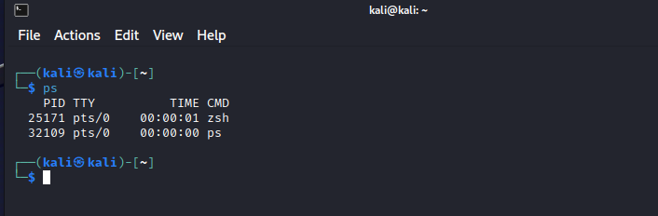
Figure 27: ps Linux CLI Command

Use of Windows OS scripts:

Windows script refers to a set of instructions written in a scripting language that can be interpreted and executed by the Windows Script Host (WSH) or Windows PowerShell. It “provides an environment in which users can execute scripts in various languages that use various object models to perform tasks” [22].
Below I have demonstrated 10 PowerShell scripts, some of the commands I have used were taken from [23].

Until Loop – Do Until loop is used when we want to repeatedly execute statements as long as the condition is false Count loops until it reaches 5 then stops, as seen below:

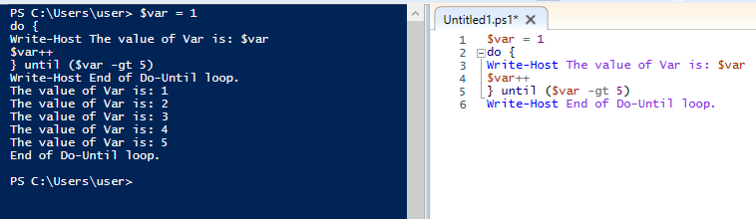

Figure 28: Loop Command PowerShell

Variables – Is a string of characters with an assigned value. The assigned value can be a number, text, filename, device, or any other type of data. A variable is nothing more than a pointer to actual data. The shell allows you to create, assign, and remove variables, variables are represented by text strings that begin with a dollar sign ($), as seen below:
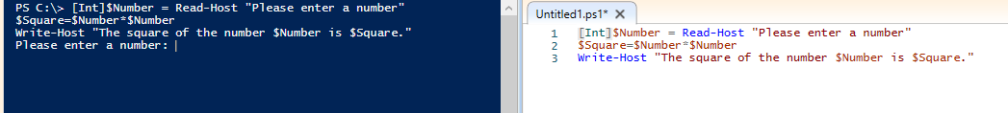

Figure 29: Variables PowerShell

If Else statement - Statements that help execute different branches of code based on certain conditions are called conditional statements. if...else is one of the most used conditional statements. allows you to make logical comparisons between a value and what you expect.
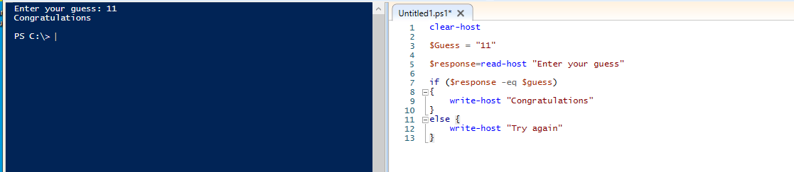
Figure 30: if Else PowerShell

Switch Statement – Allows you to provide a variable and a list of possible values. If the value matches the variable, as seen below:
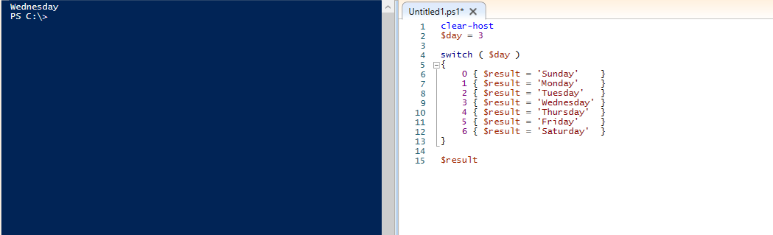
Figure 31: Switch Statement PowerShell
Array – Is a data structure, which stores a fixed-size sequential collection of items of any type. Arrays are used to store a set of data, but it is more useful to think of an array as a collection of variables or objects, it can hold multiple values at the same time, as seen below:

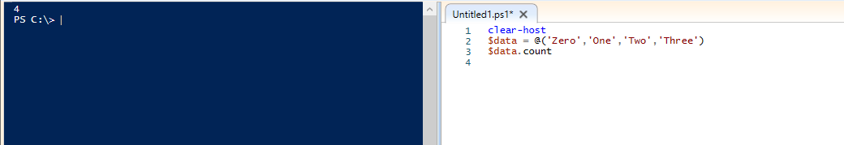

Figure 32: Array PowerShell

Function – allows us to create self-contained blocks of code, as seen below:
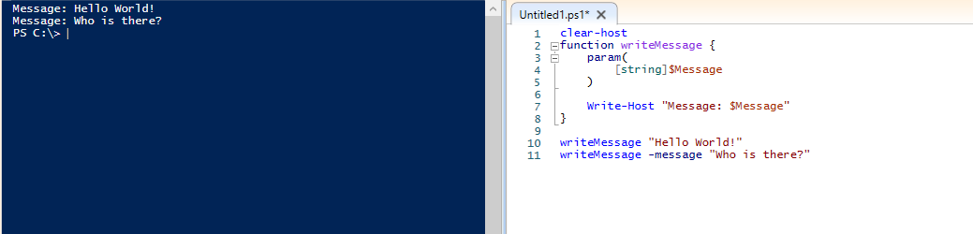

Figure 33: Function PowerShell

For Loop This loop executes the statements in a code of block when a specific condition evaluates to True, as seen below:
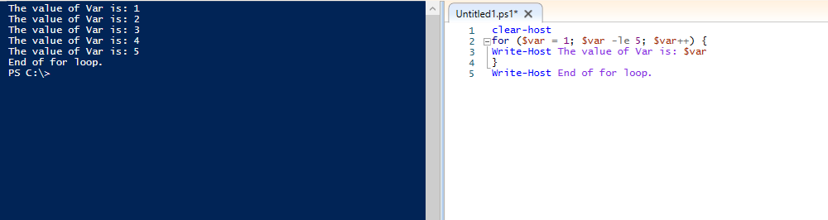
Figure 34: For Loop PowerShell
Arithmetic – adding two numbers together, as seen below :
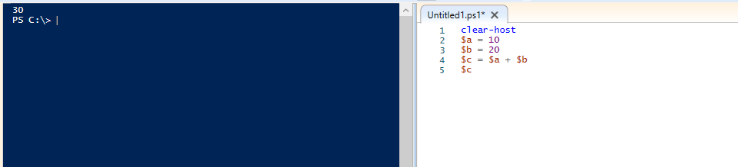
Figure 35: Arithmetic PowerShell
User Input – allows you to enter a value, as seen below:
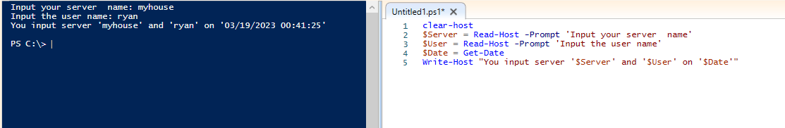
Figure 36: User Input PowerShell

Echo - The echo command is used to display a sting provided by the user, as seen below:
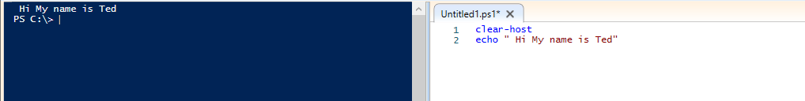
Figure 37: Echo PowerShell

Use of Linux OS scripts:

A Linux script is a set of instructions written in a scripting language that can be interpreted and executed by the Linux OS. Linux scripts can automate tasks, configure system settings, and perform system administration tasks. Essentially, “A text file that contains a sequence of commands for a UNIX-based operating system” [24].
Below I have demonstrated 10 Bash scripts, some of the commands I have used were taken from [25].

Until Loop – Do Until loop is used when we want to repeatedly execute statements as long as the condition is false Count loops until it reaches 5 then stops, as seen below:
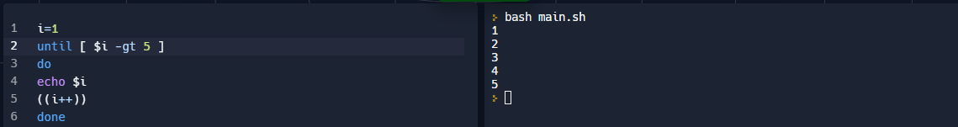
Figure 38: Until Loop Linux Bash
Variables – a string of characters with an assigned value which can be a number, text, filename, device, or any other type of data. A variable is nothing more than a pointer to actual data. The shell allows you to create, assign, and remove variables, to define a variable you type the name you want and set its value using the equals sign ( = ), as below
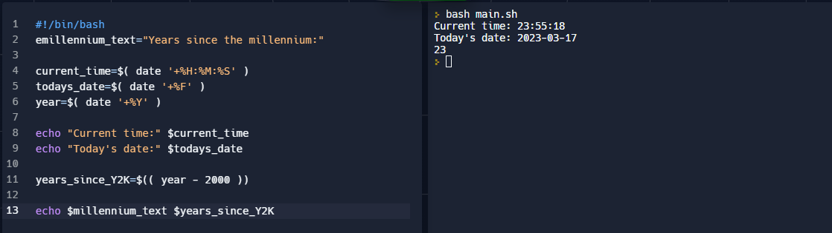
Figure 39: Variables Linux Bash
If statement - Statements that help execute different branches of code based on certain conditions are called conditional statements. if...else is one of the most used conditional statements. allows you to make logical comparisons between a value and what you expect, See Below

Figure 40: If Statement Linux Bash

Case statement – is used when you want to connect to multiple program segments based on the value of a variable Takes a value then test that value against multiple conditions, seen below:
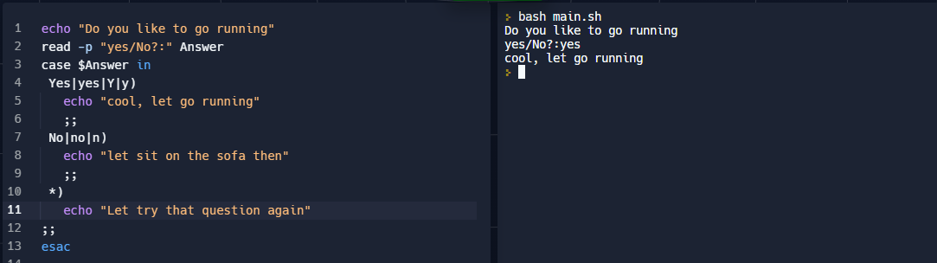
Figure 41: Case Statement Linux Bash
Array – a data structure, which stores a fixed-size sequential collection of items of any type. Arrays are used to store a set of data, but it is more useful to think of an array as a collection of variables or objects, it can hold multiple values at the same time, as below:
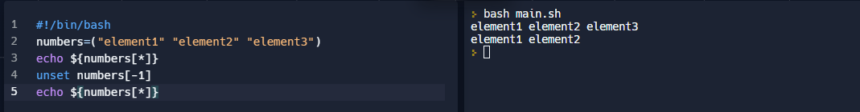
Figure 42: Array Linux Bash
Function – allows us to create self-contained blocks of code, see below:
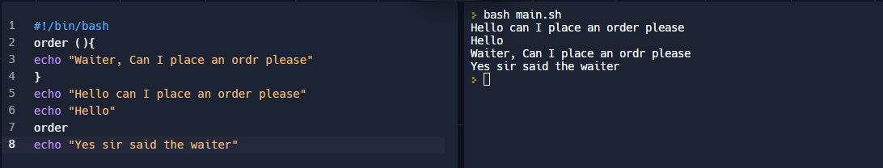
Figure 43: Function Linux Bash
For Loop - This loop executes statements in a code of block when a specific condition evaluates to True, as below:

Figure 44: For Loop Linux Bash
Arithmetic - This allows application of mathematics, as below:
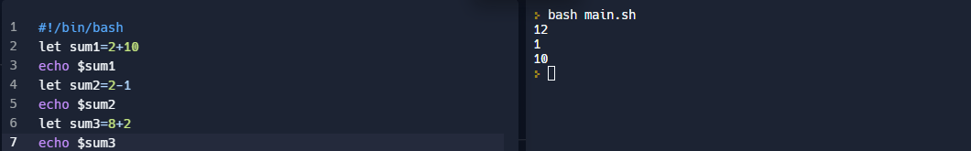
Figure 45: Arithmetic Linux Bash
User Input – Allows you to enter a value, shown below:
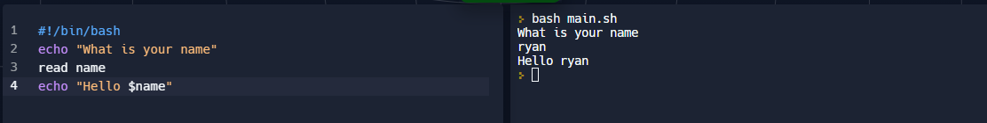
Figure 46: User Input Linux Bash
Echo – The echo command is used to display a sting provided by the user, as below:
Figure 47: Echo Linux Bash

Conclusion:

This report has examined the key and common functions of general Operating Systems, demonstrating how they play a critical role in making computers and other electronic devices work effectively and efficiently. They allow users to interact with software applications, manage hardware resources, and perform a wide range of tasks. As technology continues to evolve, Operating Systems will continue to adapt and improve as they have to date.
Both Windows and Linux have command-line interfaces (CLI) provide a powerful and efficient way to interact with the operating system.
Windows CLI, also known as the Command Prompt, allows users to execute commands and perform administrative tasks on the system. Using a set of commands and utilities that are specific to Windows, it can be accessed through the Start menu or by typing "cmd" into the Run dialog box.
On the other hand, Linux CLI is known as the terminal or shell, and it provides a vast range of commands and utilities that can be used to manage the OS and applications. As shown throughout this report Linux has several terminal emulators, such as Bash.
From the functions outlined of both Windows and Linux CLI they both have their own strengths and weaknesses. Windows CLI is more user-friendly and intuitive for beginners, while Linux CLI is more powerful and customizable, allowing advanced users to automate complex tasks and workflows. This is evidenced by the size of usage of the companies we know to use the Linux CLI within the OS.
Overall, understanding how to use the CLI in either operating system can greatly enhance a user's productivity and efficiency.

Reference:
[1] T. Chakrabarty, "What is operating system? What are the purposes, goals and roles of operating system. « Online Class Notes," 2016. Available: https://onlineclassnotes.com/what-is-operating-system-describe/.
[2] Anonymous (). History of the Operating System - javatpoint. Available: https://www.javatpoint.com/history-of-operating-system [Accessed Mar 28, 2023].
[3] Anonymous (). What is Kernel in Operating System (OS)? - Javatpoint. Available: https://www.javatpoint.com/what-is-kernel [Accessed Mar 31, 2023].
[4] “What is Operating System, Kernel and Types of kernels,” www.linkedin.com. https://www.linkedin.com/pulse/what-operating-system-kernel-types-kernels-aajitha-rathnayaka (accessed Mar. 31, 2023).

[5] Anonymous (). What is process? | Definition from TechTarget. Available: https://www.techtarget.com/whatis/definition/process [Accessed Mar 28, 2023].

[6] Anonymous "Process (computing)," 2023. Available: https://en.wikipedia.org/w/index.php?title=Process_(computing)&oldid=1146659510.
[7] Anonymous "Process (computing)," 2023. Available: https://en.wikipedia.org/w/index.php?title=Process_(computing)&oldid=1146659510.

[8] Anonymous "Computers: Memory," Available: https://www.shmoop.com/computer-science/how-computers-work/memory.html[AccessedMar 28, 20232023 ].
[9] Anonymous "Device Management," Available: https://www.techopedia.com/definition/30187/device-management.
[10] P. Singh. (-10-13T00:00:00.000Z). Device Management In Operating System. Available: https://www.scaler.com/topics/device-management-in-operating-system/ [Accessed Mar 31, 2023].
[11] S. Gaurav. (-10-11T00:00:00.000Z). https://www.scaler.com/topics/file-management-in-operating-system/. Available: https://www.scaler.com/topics/file-management-in-operating-system/ [Accessed Mar 31, 2023].
[12] Anonymous "Operating System Security," Available: https://www.techopedia.com/definition/24774/operating-system-security-os-security. (
[13] Anonymous "Operating system and user interface | Student's digital skills," Available: https://blogs.helsinki.fi/students-digital-skills/1-introduction-to-the-use-of-computers/1-1-computer-functionality/operating-system-and-user-interface/[AccessedMar 31, 20232023 ].
[14] Anonymous "Operating Systems," Available: https://homepage.cs.uri.edu/faculty/wolfe/book/Readings/Reading07.htm[AccessedMar 31, 20232023 ].
[15] Anonymous (). Operating Systems and Their Built-In Computer Networking Capabilities. Available: https://www.lifewire.com/operating-systems-and-computer-networks-817375 [Accessed Mar 31, 2023].
[16] Anonymous (-04-14). IBM Documentation. Available: https://www.ibm.com/docs/en/i/7.2?topic=management-file-error-detection-handling-by-system [Accessed Mar 31, 2023].
[17] Anonymous (). What is multitasking? | Definition from TechTarget. Available: https://www.techtarget.com/whatis/definition/multitasking [Accessed Mar 31, 2023].
[18] B. Kumari. (-11-18T00:00:00.000Z). Multitasking Operating System. Available: https://www.scaler.com/topics/multitasking-operating-system/ [Accessed Mar 31, 2023].
[19] Anonymous (). What is a command-line interface (CLI)?. Available: https://www.techtarget.com/searchwindowsserver/definition/command-line-interface-CLI [Accessed Mar 31, 2023].
[20] Anonymous (). The Ultimate, Complete List of MS-DOS Commands. Available: https://www.lifewire.com/dos-commands-4070427 [Accessed Mar 31, 2023].
[21] A. B, "40 Essential Linux Commands That Every User Should Know," 2019. Available: https://www.hostinger.com/tutorials/linux-commands.
[22] Anonymous (). wscript. Available: https://learn.microsoft.com/en-us/windows-server/administration/windows-commands/wscript [Accessed Mar 31, 2023].
[23] D. Scripto. (-06-11T00:01:00+00:00). Table of Basic PowerShell Commands. Available: https://devblogs.microsoft.com/scripting/table-of-basic-powershell-commands/ [Accessed Mar 31, 2023].
[24] Anonymous (). What is a Shell Script and How Does it Work?. Available: https://www.techtarget.com/searchdatacenter/definition/shell-script [Accessed Mar 31, 2023].
[25] Anonymous (-03-20T17:35:58.000Z). Bash Scripting Tutorial – Linux Shell Script and Command Line for Beginners. Available: https://www.freecodecamp.org/news/bash-scripting-tutorial-linux-shell-script-and-command-line-for-beginners/ [Accessed Mar 31, 2023].
[26] Anonymous (). Operating System - Properties. Available: https://www.tutorialspoint.com/operating_system/os_properties.htm [Accessed Mar 31, 2023].
[27] Anonymous (). What is a Network Operating System? | Definition from TechTarget. Available: https://www.techtarget.com/searchnetworking/definition/network-operating-system [Accessed Mar 31, 2023].
[28] Anonymous (). What is a Mobile Operating System (Mobile OS)? | Definition from TechTarget. Available: https://www.techtarget.com/searchmobilecomputing/definition/mobile-operating-system [Accessed Mar 31, 2023].

Appendices:

Types of operating systems:

Batch OS:
A batch operating system is a type of operating system that processes many similar jobs in batches, without any user interaction during the processing. “Operating System collects the programs and data together in a batch before processing starts.” [26]. In a batch operating system, users submit jobs to the system, which are then collected and processed in batches. Each job is executed without any user interaction, and the output is stored for later retrieval.

Distributed OS:
A distributed operating system (DOS) is an operating system that manages a group of independent computers and makes them appear to be a single computer. “A distributed environment refers to multiple independent CPUs or processors in a computer system.” [26]. In other words, it enables multiple computers to work together as a single, unified computing system. In a distributed operating system, resources such as CPU, memory, storage, and input/output devices are shared among the connected computers.

Multitasking OS:
A multitasking operating system (MTOS) is an operating system that allows multiple tasks to run concurrently on a single computer. “Multitasking is when multiple jobs are executed by the CPU simultaneously by switching between them.” [26]. This means that the computer can execute multiple processes or programs at the same time, allowing users to work on multiple tasks simultaneously. In a multitasking operating system, the operating system kernel allocates CPU time to each task based on its priority and the CPU's availability.

Network OS:
A networking operating system (NOS) is an operating system that provides the necessary software to enable a computer to become a network node and participate in a network. “operating system (OS) that's designed primarily to support workstations, PCs and, in some instances, older terminals that are connected on a local area network (LAN).” [27]. It is designed to support the networking protocols and services necessary to facilitate communication between networked devices.

Mobile OS:
A mobile operating system (Mobile OS) is an operating system designed to run on mobile devices such as smartphones, tablets, and wearables. “Software that allows smartphones, tablets and other devices to run applications and programs”. [28]. It provides a framework that allows mobile applications to run on the device and communicate with the hardware. They are designed to be lightweight, efficient, and optimized for low-power consumption, as mobile devices.

Evidence of engagement Cisco course:



