A Guidance Handbook for Early Years Practitioners during childhood transitions.

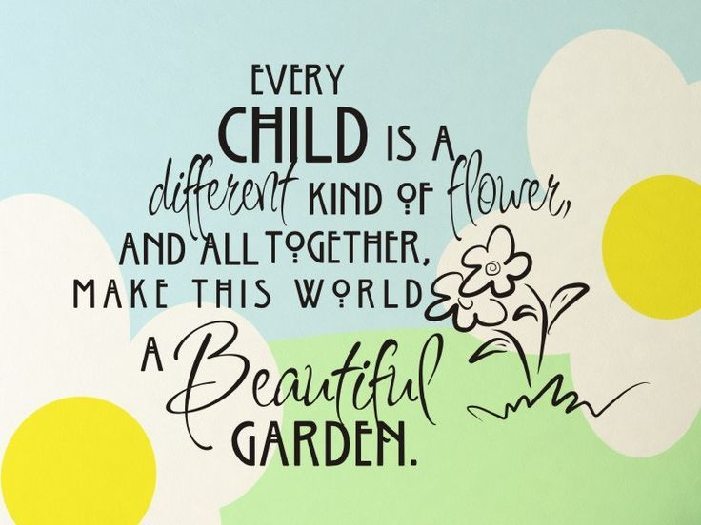

(Source: Pinterest, 2020).

Contents Page

Introduction 3

What is transition? 4

Positive relationships 6

The role of the adult 9

Partnerships 12

Interventions 14

Proposed outcomes 17

References 18

Introduction

This handbook has been made and designed for you as a key worker and early

years practitioner to give you an understanding of the transition process in an early

years setting.

This will help you as professional practitioners to gain insight and understanding on

the importance of the transition in the early years and the steps which should be

taken.

What is transition?

BTEC Childcare Unit (2019) states that transition is a change experienced by

all children as they progress through various stages of their lives. Some of which are

natural stages that each child will face.

Common transitions include children moving from Nursery to Reception or Primary to

Secondary school. Children may experience transition which is personal to them,

such as a parental break-up or a serious illness or disability.

It is very important that as early years practitioners, you have an understanding of

the transition process of a child who is starting in a nursery or going through a

change. Pacey (2014) notes that children need to feel welcomed when going through

the transition process as it can be a scary experience for them. Transitions are a

huge part of a child’s childhood journey. Every child will go through transition

processes within the first years of their lives.

A child’s start in school has varying emotions, such as excitement, tension and

nerves. It is very important to ensure that the transition process is as smooth as

possible. This is to ensure that children feel safe, relaxed and comfortable in their

new environment.

Bronfenbrenner (1979) goes on to say that children which have experienced a

smooth and positive transition process from the home to the learning environment,

were more likely to make successful transitions in the future. He recognised that

depending on the environment which the child would transition into and develop, also

depended on the outcome of the child and their ability to become successful

learners.

The environment should be an encouraging and nurturing place to be for the child,

as well as positive relationships to help the child to grow, learn and develop

themselves.

When changes are supported by knowledgeable and responsible adults, children are

able to discover that the world is a safe place to explore.

It is important to remember that every child is different and unique. Some children

will need more support than others through the transition process. Some children will

start the transition process confidently and will need minimal support.

Children are not expected to “fit in”, but children are to have their needs met within

the school.

It is in the child’s best interests that the transition is a smooth experience as it can

be, as a poor transition could traumatise the child and have a negative impact on

future transitions.

Parents/carers are to be fully involved with the transition process at all times so that

they feel involved and included with the process. This will also help the parent/carer

to pass on any key information which they may feel is necessary to the school, and

vice versa.

“Children who smoothly transition through the stages grow to be calm, well centred

adults.” (Freud, 2018).

Positive Relationships

Bronfenbrenner (1979) states that children’s microsystems are made up of the

immediate environment surrounding the child. This will include any immediate

relationship that they interact with including their family, carer or school.

How these groups choose to interact with the child will have an effect on how the

child develops and grow. These relationships should be nurturing and positive for the

child.

Bronfenbrenner (1979) says that there are four layers to which a child will interact

and connect with.

These include:

- Microsystem – the first and closest layer of the child’s individual relationships

and their immediate surroundings. This meaning the child’s relationship

between parents, siblings and teachers.

- Mesosystem – this includes relationships between a child’s family and school

teachers.

- Exosystem – this is an effect on the family, such as the loss of a parents’ job

or reduced hours which may cause parental stress which the child could pick

up on.

- Macrosystem – this could include religious or cultural beliefs which may

affect a child’s development.

Bronfenbrenner’s approach helps practitioners to consider any influences that may

affect a child’s development.

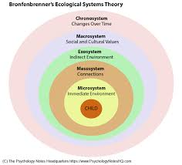

(Source: Psychology Note HQ, 2020).

Having positive relationships between parents/carers and the key workers will

also have a positive impact on the child, as well as having effective and appropriate

communication. Bronfenbrenner (1979) mentions that children pick up on negative

relationships between peers and adults and this can cause them to perceive

negative expectations.

Parents/carers having a positive and active role with the child’s school can contribute

towards a child’s overall growth and development.

Bowlby (1969) suggests that children have an attachment towards those that they

feel safe and close with. The child will feel more secure with that person, and seek

them for comfort in new and scary situations. He mentions that children need to

attach to one main attachment figure, and that it is needed for survival.

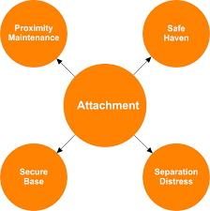

(Source: Family Matters, 2020)

Children need to have a consistent and sensitive relationship to secure a positive

attachment and bond with their caregivers. A child who feels secure with their

caregiver, will learn that when they are distressed, they will develop a sense of being

consoled and loved. It is important for children to form positive relationships with

their teachers so that they feel safe in their new environment.

Children who have formed positive attachment relationships are able to manage their

own feelings and behaviour. This will help the child to form positive relationships with

peers and teachers too.

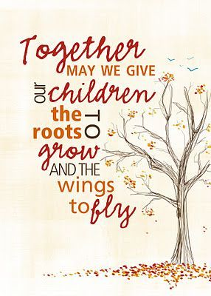
(Source: Pinterest, 2020)

The role of the adult

It is very important that as early years practitioners, you must ensure that the child is

fully supported during the transition process.

Practitioners have the responsibility to ensure that the transition process goes as

smoothly as it possibly can, and that the environment is a safe and nurturing space

for the child to learn and develop.

Staff and parents/carers need to work together and have appropriate and effective

communication during the transition process.

If the child has any needs, these need to be identified and catered for, in order to

encourage and promote a positive learning experience.

When children start Nursery, it is the beginning of a whole new chapter in their lives.

As early years practitioners, it is your role to make sure that it is a safe and

welcoming environment for them to start their schooling journey.

Families are invited to have a look around the Nursery classroom if they would like

to, to familiarise themselves with the setting. They are informed of the timings and

the structure of the school day. They are welcome to ask any questions at this point

regarding Nursery, or school in general. It is important at this point, to familiarise

yourself with the child by asking the parents if the child has any allergies or what

their likes and dislikes are.

It is important to try to put the parent/carer and the child’s mind at ease as Nursery is

a fun and welcoming environment for the child to be in.

Pacey (2014) states that it is important to get to know the child, and that during the

settling in period, you should find out the child’s likes and dislikes, their favourite toy

and activity. It is very important also for the child to get to know you as their

teacher/key worker.

It is essential that effective communication is taking place between families and

practitioners to ensure that all of the needs of the child are met.

For example, if a child is starting in the setting with a diagnosis of Autism, it is

essential to ensure that all staff in the Nursery class are made aware of this, whilst

also making sure that you are keeping in line with GDPR.

It is very important to ensure that parent/carer’s opinions and contributions are

valued and respected. It is important to ensure that the parent is included at all times

and that they are aware that their children’s needs are at the forefront of the process.

Make sure that you have answers for any queries which the parents may have, and

that they are answered promptly.

John Bowlby’s attachment theory (1969,1988) suggests that children are born into

this world biologically programmed to form attachments with others, in order to

survive.

This is why it is essential for children to form positive relationships with their peers

and teachers to support a smooth transition process.

It is vital that the child knows that you are listening to them when they are speaking.

This helps the child to feel valued and respected.

You should kneel down to their level and make eye contact with them. This will help

to gain their trust and they will begin to start to confide and talk to you. They need to

know that you are listening and that they are being listened to.

It is important to be a good role model to the child and their families. You can do this

by:

- Being supportive to the child and their family.

- Be a good listener.

- Ensuring the child’s needs are met.

- Be positive and encouraging to the child.

- Support the child and family.

Being a good role model can have a lasting impression on a child, so it is absolutely

vital that you show the child good behaviour, respect and how to treat others. They

will watch how you as professional practitioners speak and behave, and will often

copy these actions.

This supports Albert Bandura’s theory (1977) that children learn through observation

and that they model behaviour which they see. They will imitate this behaviour,

whether it is positive or negative.

It is important to reinforce positive behaviour. For example, if you see a child

promoting positive behaviour such as sharing toys with their friends, make sure that

you tell them how good they are or give them a sticker. This will ensure that they

repeat this behaviour as they will feel rewarded.



(Source: Learn events, 2020)

Partnerships

National Minimum Standards for Childcare in Wales (2016) states that good

partnerships between parents/carers and early years practitioners is essential for

effective transition and communication.

It is important that you give the parent/carer regular updates on their child’s

progress. You should share with them any targets which their child is working

towards and that you tell the parent/carer how they can help the child to achieve

these at home.

For example, the child may be struggling to hold a pencil correctly, so you would

suggest that the parent/carer practices with them.

Make sure that you tell the parent/carer anything positive which the child may have

done at the setting at that time. If the child has been settled within the Nursery,

make sure that you make the parent aware, as this shows that progress is being

made and that the child is beginning to settle into the Nursery.

This will help the parent/carer to feel more at ease and less anxious for their child to

attend the Nursery. It is also appropriate to share any negative behaviour which the

child may be displaying as this could be the effect of a new situation at home for

example, which the parent is yet to discuss with you, such as a new partner or

sibling.

Ensuring that parents/carers are involved in the child’s transition and learning

process, has a positive impact on the child as children will be supported throughout

school and at home. It is essential that as early years practitioners, you give

parents/carers appropriate guidance and support of how best they can support their

child. Parents are to be consulted on any changes which may be made which might

have an effect on the child. This might include, moving classrooms.

It is important to remember that:

- Parents/carers are treated with respect and consideration.

- Appropriate and relevant information is being shared between the setting and

home.

- Parents/carers and early years practitioners have an equal partnership.

- You listen and respect each other’s comments and queries.

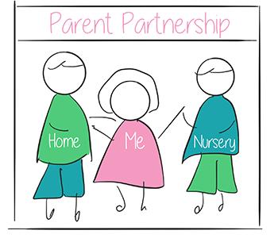

(Source: DanDans, 2020)

Interventions

It is very important for children to receive high quality and suitable childcare. This will

ensure that they feel supported and comfortable in their new routine. It is also

important for children to feel secure and happy in their new environment.

It is important to carry out regular assessments and observations of the child to

ensure that they are making sufficient progress for their age. This way, you will

notice anything regarding them or their learning which may stand out.

Resources for Early Learning (2014) suggests that assessments will provide a

common ground between practitioners and parents/carers on how best to support

the child, if required.

Early years practitioners as well as parents/carers should all be showing

commitment to the child’s learning and future progress. It is important to share a

holistic approach to ensure the very best is gained for the child.

In Reggio Emilia, Italy, Loris Malaguzzi (1963) believed that children can construct

their own learning, and that children learn through interaction. Children develop

knowledge and understanding through communication and working with others.

The Reggio Emilia approach also states that children learn from their environment

alongside parents and teachers.

It is important as early years practitioners that children have access to a nurturing

and stimulating environment. Children must be able to play with others

independently and comfortably. They must have access to appropriate toys and

resources to stimulate their learning.

The Reggio Emilia approach has been proven very successful over the years with

people from all over the world travelling to Italy to see the approach in action.

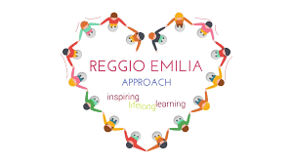

(Source: Immaculate Tots Childcare, 2020)

Maslow (1943) introduced the hierarchy of needs, which suggests that people are

motivated to fulfil their basic human needs before going on to fulfil more advanced

needs.

These include:

- Physiological – sleep, food and water.

- Safety – a secure home, health and wellness and financial security.

- Social – family, friendships and social groups.

- Esteem – feeling valued.

- Self-actualization – concerned about personal growth and interested in

fulfilling their own full potential.

This shows that children need their basic needs to be met, in order to achieve their

full potential. If children don’t have access to basic human needs such as food, water

and a secure home, they will struggle to reach personal growth and have a fulfilling

life.

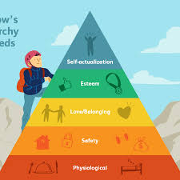

(Source: Very Well Mind, 2020)

Proposed outcomes

Every child is unique and individual. Some children may find the transition process

very easy, whilst others might struggle with the process and need a little bit of extra

support. This is very normal and can depend entirely on the child.

As Early Years Practitioners, it is your role to ensure that the transition process goes

as smoothly as it can for the benefit of the child and their parent/carer.

Unicef (1992) states in article 12 of children’s rights that a child has the right to

express their own views, feelings and wishes in any matters which may affect them.

These views should be taken seriously and considered at all times.

This is why it is so important that you listen to the child so that they feel valued and

respected in the new environment.

The main outcome is to ensure that the transition process is a positive experience for

the child and the child’s parent/carer. This can only be achieved if effective

communication is carried out as well as a suitable and nurturing environment in

place. It is important to ensure that children, parents and carers have appropriate

support and guidance during this process.

National Minimum Standards for Childcare in Wales (2016) says that partnerships

are essential to effective and successful transition and communication.

Bowlby (1969) mentions that It is important for you as the practitioner, to build a

positive attachment with the child so that they feel happy and safe in the

setting and to ensure that it is consistent for the child.

A strong key worker system should be in place to support the child and their families,

and children’s needs must be met through effective practice.

Bandura (1977) states that you should be a good role model for the child as this will

have a lasting impression on their behaviour. They will watch how you as

practitioners talk and behave and will often copy these actions. Make sure that you

are professional at all times, especially when talking to parents and carers.

The new curriculum for Wales has four main purposes. These include:

- Ambitious, capable learners ready to learn throughout their lives.

- Enterprising, creative contribution ready to play a full part in life and work.

- Ethical, informed citizens of Wales and the World.

- Healthy and confident individuals ready to lead fulfilling lives as valued

members of society.

Our job as early years practitioners is to ensure that effective transition is made to

ensure that children go on to become happy and successful learners in the future as

all children deserve.

References

Bartram Academy (2020). Fundamental Principles of Reggio Emilia. Available at: https://bartramacademy.com/fundamental-principles-of-reggio-emilia/ (Accessed: 14th November 2020).

Belfast Education and Library Board. (2011) Early Years Learner Support Handbook. BELB reprographics. Available at: https://moodle.uwtsd.ac.uk/pluginfile.php/86467/mod_resource/content/1/Transitions%20handbook.pdf (Accessed on: 8th November 2020).

Bronfenbrenner, U. (1979) The Ecology of Human Development 1st Ed. United States of America: Harvard University Press.

Byers, E. Daly, M and Taylor, W. (2009) Early Years Management in Practice. China: Pearson Education Limited.

Cherry, K. (2020) The 5 levels of Maslow’s hierarchy of needs. Available at: https://www.verywellmind.com/what-is-maslows-hierarchy-of-needs-4136760 (Accessed: 21st November 2020).

DanDans (2020) How we work in partnership with parents. [Online]. Available at: https://dandans.co.uk/nursery/nursery-parent-partnership/

Family Matters (2020). Attachment theory: Main characteristics of attachment. Available at: https://www.ronitbaras.com/family-matters/parenting-family/attachment-theory-main-characteristics/ (Accessed: 21st November 2020).

First Discoveries (2020) Child Development theories: Urie Bronfenbrenner. Available at: https://www.firstdiscoverers.co.uk/child-development-theories-urie-bronfenbrenner/ (Accessed: 21st November 2020).

Grace, E. (2018) Freud’s Theory of Developmental Stages. Available at: http://www.kidsdevelopment.co.uk/freudsdevelopmentaltheory.html (Accessed: 7th November 2020).

Immaculate Tots Childcare (no date) Reggio inspired approach. [Online] Available at: https://immaculatetots.co.uk/reggio-inspired-approach/ (Accessed: 14th November 2020).

Lavis, P. (2016) Why relationships are so important for children and young people. Availble at: https://www.mentalhealth.org.uk/blog/why-relationships-are-so-important-children-and-young-people (Accessed: 8th November 2020).

Learn events (2020) World of learning summit. [Online] Available at: https://www.learnevents.com/blog/2015/05/05/five-tips-for-building-positive-relationships/ (Accessed: 8th November 2020).

McLeod, S. (2016) Albert Bandura – Social learning theory. Available at: https://www.simplypsychology.org/bandura.html (Accessed: 14th November 2020).
McLeod, S. (2017). Attachment theory. Available at: https://www.simplypsychology.org/attachment.html (Accessed: 14th November 2020).

McLeod, S. (2017) Bowlby’s Attachment Theory. Available at: https://www.simplypsychology.org/bowlby.html (Accessed: 14th November 2020).

Oswalt, A. (2020) Child & Adolescent Development Overview: Urie Bronfenbrenner and Child Development. Available at: https://www.gulfbend.org/poc/view_doc.php?type=doc&id=7930 (Accessed on: 8th November 2020).

Pacey (2014) Transitions and settling in. Available at: https://www.pacey.org.uk/Pacey/media/Website-files/school%20ready/PG10-transitions-and-settling-in.pdf (Accessed: 8th November 2020).

Pearson Schools and Colleges (2009) Supporting Children in Transition. Available at: https://www.pearsonschoolsandfecolleges.co.uk/feandvocational/childcare/btec/bteclevel2firstchildrencarelearninganddevelopment/samples/bteclevel2firstccldstudentbookunit1samplematerial/bteclevel2firstccldstudentbookunit01.pdf (Accessed: 7th November 2020).

Pinterest (2020) Together may we give our children the roots to grow and the wings to fly. [Online]. Available at: https://www.pinterest.co.uk/pin/82120393182210365/

Psychology Notes HQ (2020) What is Bronfenbrenner’s Ecological System’s Theory? [Online] Available at: https://www.psychologynoteshq.com/bronfenbrenner-ecological-theory/ (Accessed: 21st November 2020).

Resources for Early Learning (2014) Early Childhood Assessments. Available at: http://resourcesforearlylearning.org/fm/early-childhood-assessment/ (Accessed: 23rd November 2020).

The Centre for Parenting Education (2020) Being a role model – The promise and the peril. Available at: https://centerforparentingeducation.org/library-of-articles/focus-parents/role-model-promise-peril/ (Accessed: 14th November 2020).

Welsh Government (2016) National Minimum Standards for Regulated Childcare for children up to the age of 12 years. Available at: https://careinspectorate.wales/sites/default/files/2018-01/160411regchildcareen.pdf (Accessed: 14th November 2020).

Unicef (1992) A summary of the UN Convention of the rights of the child. Available at: https://www.unicef.org.uk/wp-content/uploads/2019/10/UNCRC_summary-1_1.pdf (Accessed: 21st November 2020).

Very Well Mind (2020) The 5 levels of Maslow’s hierarchy of needs. [Online]. Available at: https://www.verywellmind.com/what-is-maslows-hierarchy-of-needs-4136760

Welsh Government (2020) Curriculum for Wales: Summary of proposed legislation. Available at: https://hwb.gov.wales/curriculum-for-wales/summary-of-proposed-legislation/ (Accessed: 23rd November 2020).

