PROFESSIONAL CAREER DEVELOPMENT

REFLECTIVE JOURNEY

[21.06.2019]
UNIVERSITY OF WALES TRINITY SAINT DAVID

EXECUTIVE SUMMARY
The purpose of this study is to analyse the distinct ways in which skills are learned and developed to achieve certain professional goals.
Benefits will be more significant and will render us viable in the market for longer periods of time.
The desire for improvement will motivate us constantly, and we will be able to allocate sufficient amount of time to achieve our objective.
Failures are part of every person's life, but we need to discover motivation for ourselves even when it feels like we're stuck.
By implementing methods such as SWOT and SMART, lifelong learning will also improve.
This study analyses and assesses our shortcomings and improvements and the techniques used to do so. It will also assist us to enhance our strengths in achieving market chances and in developing lengthy and short time plans

Contents
CAREER DEVELOPMENT PLAN 1
REFLECTIVE JOURNEY 1
EXECUTIVE SUMMARY 2
INTRODUCTION 4
FINDINGS 6
PERSONAL DEVELOPMENT PLAN 11
CONCLUSION 13
APPENDICES 14
REFERENCES 18

INTRODUCTION
At the very beginning of our life we start a process of discovering, learning, and building practices and thoughts that define who we are as a human beings.
This report is about my career development and my journey in learning and Improving personality and lifestyle.
The word “career” comes from the latin word for cart or chariot (charrus), which means to carry somebody from one point to another and is about involving decision among possible and preferred futures.
According to Oxford dictionary career means a job or a series of jobs that you do during your working life especially if you continue to get better jobs and earn better money.
Career development occurs as people adapt to change to react to duties of vocational growth, handle career transition throughout their lives and react to changing worlds of job argues Dr. Catherine Huges (2018) in her article “Why is career development important for young people”
“Career means dealing with more complexity in career choises and developing the skills to manage career transition, but also leaving a clear understanding of the role of learning and development activities argues Tricia J., (2000) in her book “Career development”

FINDINGS

There is one point in our lives when we decide we want to improve ourselves and procrastination is not accepted anymore.
This journey started with the desire to improve myself and lead me to enroll at “University of Wales Trinity Saint David” in 29th of April 2019 which will help me to reach my goal-become an transport manager and work for the largest transport company in UK.
Self-awareness can be described as good knowledge and judgment about yourself if we check the Oxford dictionary, but the theory was developed by Psychologists Shelley D., and Robert W., in 1972 and they proposed that: “when we focus our attention on ourselves, we evaluate and compare our current behaviour to our internal standards and values. We become self-conscious as objective evaluators of ourselves”. In essence, they consider self-consciousness a significant self-control mechanism”.
Self-awareness is one of the first elements to arise from the self-concept.
As a part of my journey we learn that, in order to improve our professional and personal development we need to analyse constantly our threats, weaknesses, strengths and opportunities which is known as a SWOT analysis or by doing constantly self-reflective learning. A way of implementing this in our lives in to ask for regular feedback from people with experience such as our supervisors or close friends which might have experienced the same problems we face.

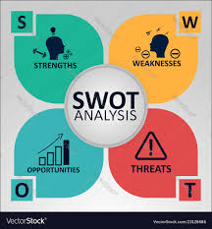

Self-reflection is characteristic to human condition to be introspective and to want to understand ourselves and the rest of humanity better (Mark B., 2017).
The learning quantification method has proved very hard, but being in the situation where you have to be model and educator for others VARK test is a big help in order to understand different types of learning, also will help students having a greater success rate, and to be more concentrated.
VARK tells you something about yourself that you might or might not know. It can be used to understand your boss, your colleagues, your parents, your workmates, your partner, your customers, your teacher, your relatives, your clients and yourself.
It is a brief, straightforward stock that has been well received due to accurate understanding of its dimensions and practical applications.
This test informs you something you may or may not know about yourself. It can be used to understand your boss, your colleagues, your parents, your partner, your customers, your teacher, your relatives, and even yourself.
It is generally free to be used for student or faculty development by individual educators and students in colleges, high schools and universities. Business but other customers (trainers, coaches, tutors ...) have always been charged a fee.
Doing the VARK questionnaire showed me that my learning preference style is Kinestetic/Tactile
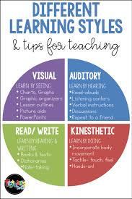

This report will help me set my goal, which is to become a transport manager and work for one of the largest transport company from UK, OWENS. In order to accomplish my goal, and to be capable to lead other people it would be expected from me to have the skills to do so.
There are a number of abilities that are essential in achieving the company's objectives. In one of the motivational videos of Danlok from YouTube, he is talking about seven abilities in order to become a successful entrepreneur:
- The ability to talk to customers persuasively (closing skill)
- Public speaking skill
- The ability to communicate with words in print(copywriting skill)
- The ability to communicate clearly and effectively with your team (leadership skill-business is a team sport)
- The ability to manage and organise your time for maximum results (time management)
- The ability to read financial statements (financial literacy skill)- you need to understand the language of money
- The ability to manage your mind (mind set skill)-if you do not have your mind set right, it’s not going to work.
By setting up self-management teaching, the content, methods and pace of growth can be fully controlled.
Some results can be achieved and started with techniques and methods, but creativity does not include genuine self-management (Ronald E. Purser, Steven C. 1998)
The teaching method is more than a job or activity; it also calls for reflection and learning from it. It must be meaningful to each individual for learning to take place, with students reflecting critically on the information presented; they must be able to ' experience ' the data, and the way this can be facilitated is by drawing on previous experiences (John D. 1983). He also dismissed traditional types of education based on data strengthening where the student has a passive position, indicating this form of teaching was superficial.
Some individuals are more creative than others and can readily find a solution to any issue, but one of the hardest choices is to cope with instinct and choose the best alternative even if your intuition tells something else.
Compromising, assessing and mentoring a problem, can be the best option to fix an issue. Compromises can be said to be the key to develop problem solving abilities.
Personal Development Planning is a structured method of developing an action plan to plan for personal, professional and educational development based on the teaching, results and accomplishments of the individual.
Learning never stops, is continuous, supportive (we don’t do it alone) stimulating and empowering-it is self-directed and is active not passive (Duyff Roberta L., 1999)
In order to set up a development plan there are a number of operations, such as reading books, newspapers, articles, setting targets and constantly reflecting on every step you take to achieve your objective.
To achieve my objective, I will do all of this and much more, and also create a bridge between my existing abilities and the abilities I need to enhance by attending different courses (CPC manager, digital marketing social media training, public speaking meditation classes) but also attending conference seminars, leadership skills enhancement training sessions. Stephen R. Covey, in his book “The 7 habits of highly effective people” was talking about 4 independent factors in the centre of our lives which are:
- Security
- Guidance
- Wisdom
- Power
According to Stephen R. Covey security and clear guidance bring true wisdom, and wisdom becomes the spark that release the power.
Improvement is not only about learning something is about give up on different ” guilty pleasures” such us going out, planning holidays, time spent with family, colleagues, friends or even neighbours. This development plan will help me to prioritise my priorities and I will engage myself in keeping an agenda where I will organise my duties in urgent or important in order to become better on time keeping and get things done in efficient time.
My development plan is achievable in 3 year time. In this 3 years I will be very strict into improving all the necessary skills but also analysing myself, reflecting, turning my weaknesses into strengths.
In order to achieve my goal I will look myself in the mirror every morning and I will sick for opportunities and solutions to overcome my obstacles. This summer on 20th of July I will start the CPC manager course, I will finish with the higher mark and after first year of university I will start my voluntary job on OWENS Transport.
Inside the company I will learn practically how to be a successful transport manager from experienced people.
Doing the Johari and SWOT analysis and based on my goal I realise that:
My weaknesses are:
- No self confidence
- Procrastination
My strengths are:
- Charismatic
- Calm
- Leader behaviour
- Time kipping
- Hard worker
- Take initiative
My opportunities:
- Linked in
- Skills for workplace course
- Digital marketing social media training course
My threats:
- digital skills
- public speaking skills
As public speaking is one of my threats I will attend group meetings seminars and courses in order to make it become one of my strengths. Watching motivational videos (Tim Urban, Elle Degeneres, Jay Shetty et. al.) and reading (Steve Jobs, Jack Ma,Himeesh Madaan et. al.)

Methods of learning can be categorized as interference, but they are essential in helping the learning process, building coaching skills, mixing, learning and growth through exercise (Sangster, 2019)
The questionnaire of Honey and Mumford (Honey and Mumford, 1992) showed my learning style as “reflector” ones of the characteristics of my learning style are the ability to observe details and think before taking action
It's essential to have policies that assist us handle time and balance requirements, it can readily seem like time runs out and adjusting our daily routine and habits can decrease stress in our life.
Learning and development should be organised and fallow some principles such as having developing activities, but also having a purpose, order of priority and sense of direction (Tricia J. ,1996)

PERSONAL DEVELOPMENT PLAN

DEVELOPMENT OBJECTIVE | SPECIFIC ACTION | BLOCKERS AND HOW THEY WILL BE REMOVED | SUPPORT REQUIRED | WHOW I WILL KNOW WHEN I ACHIVED THE OBJECTIVE
- Improve myself | Start skills for workplace 3 year course | Nobody to stay with my son-I involved my sister in law | My sister in law to stay with my son while I am on university | When I will take my degree in “Skills for workplace” and also CPC manager and digital skills course
- Financial freedom | Attend CPC manager course | Not enough time to attend the classes-involve my manager and ask for holidays | Ask for more information from somebody with experience | When I will have the monthly income of £4000
- Better life for me and my family | Attend a digital marketing social media training course | Spend most of my time, trying to improve my digital skill in order to achieve my goal | Practice at home daily | Afford to go holidays, to have the car of my dreams (Porche Panamera), help other people.

CONCLUSION
In conclusion this report shows that are many different skills needed in order to progress and to have a successful development plan such as efficient communication with customers but also in writing, leadership skills, time management skills and also managerial skills.
All these abilities come in distinct proportions for each individual, but each person's creativity and desire for improvement will lead to achievement.
A swot analysis allows an individual to know what their strengths and weaknesses are, but also the possibilities and threats.
Knowing all these things each individual will understand what needs to be improved and find a way to do it.
For some sectors, the primary issue is to replace ancient individuals with young and enthusiastic individuals who can add value to the business, so we need to sick for regular improvements in order to get the best jobs from the market and keep updated with everything’s new on market.

APPENDICES
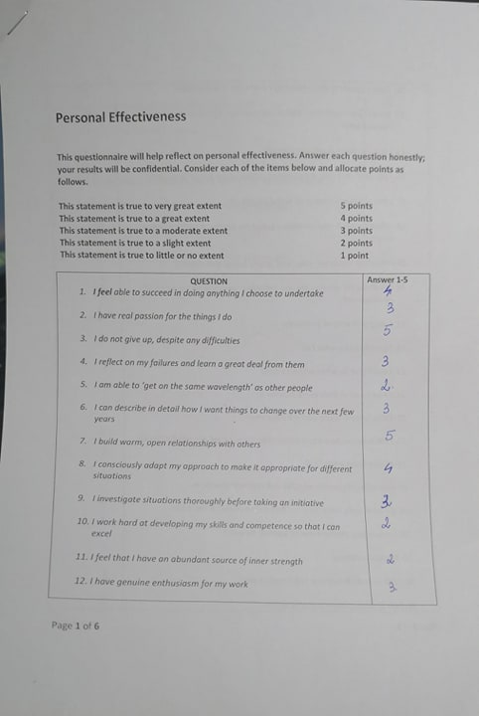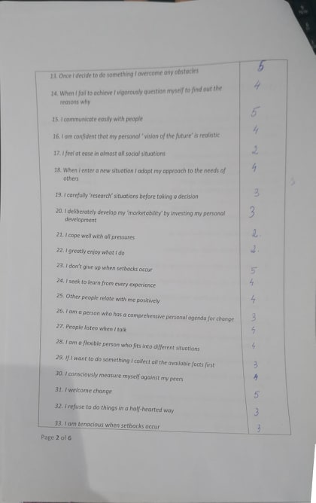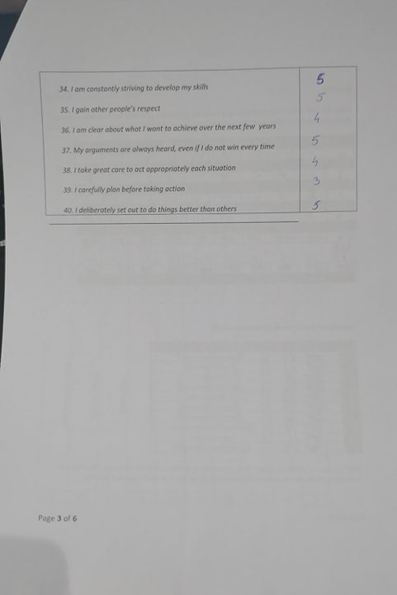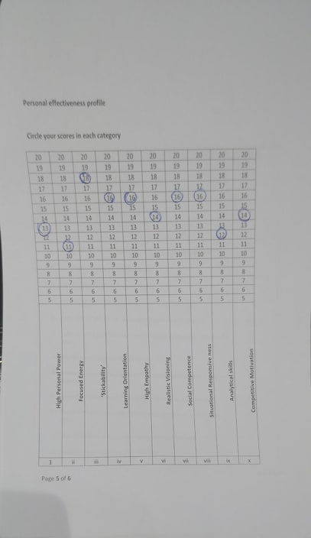

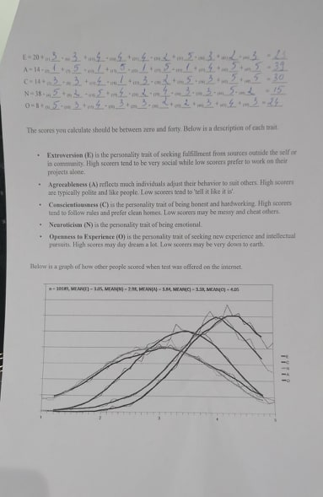
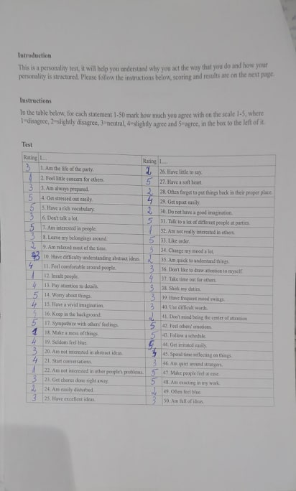

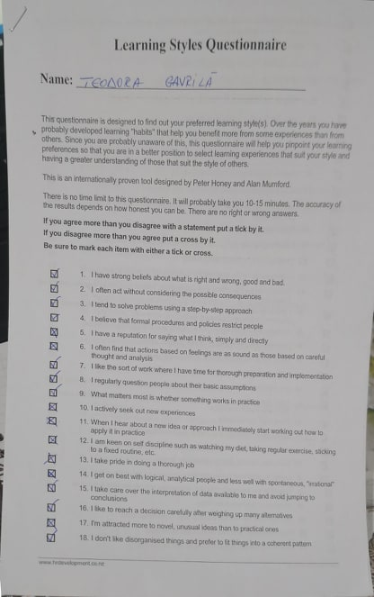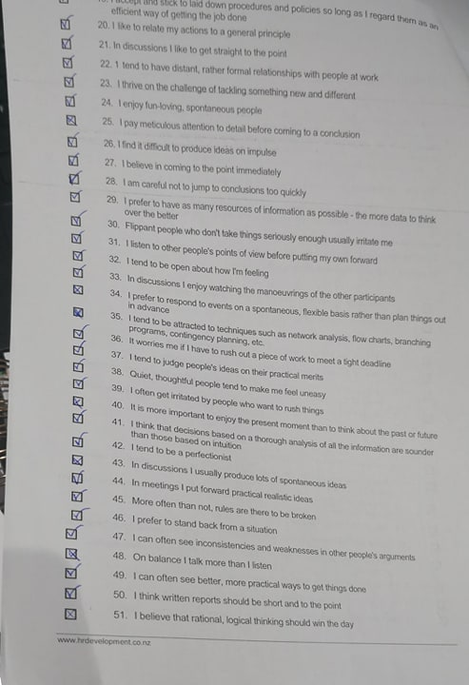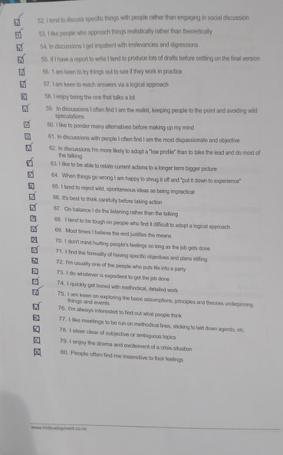

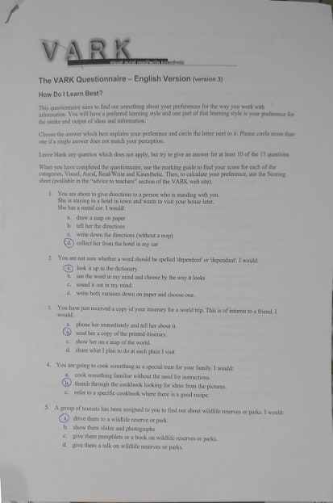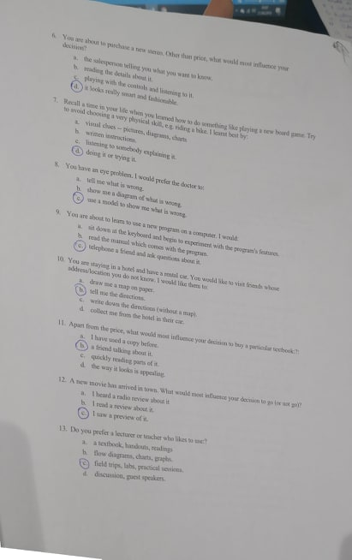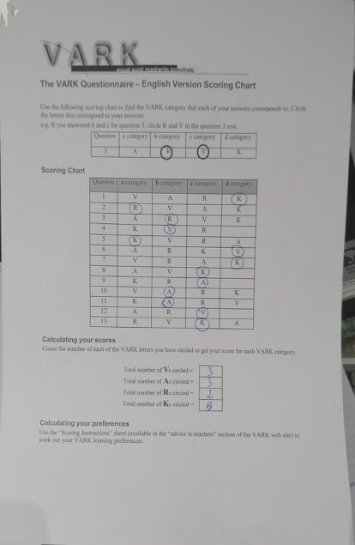

REFERENCES
- About self-awareness
Available at :
https://l.facebook.com/l.php?u=https%3A%2F%2Fwhat-when-how.com%2Fsocial-sciences%2Fself-awareness-theory-social-science%2F%3Ffbclid%3DIwAR0BYLgpvOXDKlih5L_S7Qpm7QtHvdMoOkZEJ_7nFhYFx8eFCfzUnDZvoL4&h=AT16ytjWhhscSnRFj1ujpO9vABVqN82_0OvBgj917VBRqGxIYjv1EbHiWBlsyBUWRnYxUla3W45cE3TGll28DTHmaOJBSEXASHFMlKGoqdV8Amm9fMG7A6Jm2wpyUsreYhs
(accessed: 17.06.2019 )

- Briller, Sherlyn, H., & Goldmacher, A., (2009) Designing an Antroplology Career: Profesional development Exercises. Altamira Press, Available at Lampeter Library Main Collection (301.2023BRI)

- Duyff, Roberta L. (May 1999). The value of lifelong learning: Key element in professional career development .American Dietetic Association. Journal of the American Dietetic Association; Chicago Vol. 99,Iss 5: 5384

- Frances T., (2012). Briliant Employability Skills. Great Britain. Pearson Education Limited. P. 90
- Frances T., (2017). Briliant Employability Skills. Second Edition. Great Britain. Pearson Education Limited. P. 90
- Honey, P., & Mumford, A., (1992). The manual of learning style. Berkshire: Peter Honey Publications
- Kroth, M. S., (2009). Career development. Place of publication not identified
- Learning approaches
Available at:
https://l.facebook.com/l.php?u=https%3A%2F%2Fwww.skillsyouneed.com%2Flearn%2Flearning-approaches.html%3Ffbclid%3DIwAR1E2vqGkfGXm7Zh41qqI--t185lpDVLJb8WSmG8nuV5yhYfvmdIbS_FbfQ&h=AT16ytjWhhscSnRFj1ujpO9vABVqN82_0OvBgj917VBRqGxIYjv1EbHiWBlsyBUWRnYxUla3W45cE3TGll28DTHmaOJBSEXASHFMlKGoqdV8Amm9fMG7A6Jm2wpyUsreYhs
(accessed: 18th June 2019)
- Stephen, R. Covey, (1989,2004). The 7 habits of highly effective people. Great Britain by Simon &Schuster UK LTD p.110
- Tricia, J., (1996) Career development London: Institute of Personnel and Development. Available at Swansea Business Campus Library Main Collection (658.3124.JAC)
- VARK learning style-introduction to VARK
Available at:
https://l.facebook.com/l.php?u=http%3A%2F%2Fvark-learn.com%2Fintroduction-to-vark%2F%3Ffbclid%3DIwAR3WyHm35RokS5h_wnKH5hn3OkcpGFKGDIUCgiX2-cONKdzUircZvHt3zsk&h=AT16ytjWhhscSnRFj1ujpO9vABVqN82_0OvBgj917VBRqGxIYjv1EbHiWBlsyBUWRnYxUla3W45cE3TGll28DTHmaOJBSEXASHFMlKGoqdV8Amm9fMG7A6Jm2wpyUsreYhss
(accessed: 15th June 2019)
- Weeks, J., (2008). Current issues in Professional Development in Developing Countries: A personal view. Journal of Education Administration. 26(3). Pp.382-392

- What is personal development
Available at: https://l.facebook.com/l.php?u=https%3A%2F%2Fwww.mbaskool.com%2Fbusiness-concepts%2Fhuman-resources-hr-terms%2F6780-personal-development-plan.html%3Ffbclid%3DIwAR0sW0zw18fH2_WM3cEanR675w2ZP_JTKnTT50AuHJpyuS5oYwgtUHPr1-U&h=AT16ytjWhhscSnRFj1ujpO9vABVqN82_0OvBgj917VBRqGxIYjv1EbHiWBlsyBUWRnYxUla3W45cE3TGll28DTHmaOJBSEXASHFMlKGoqdV8Amm9fMG7A6Jm2wpyUsreYhs
(accessed: 16th June 2019)

- What is self-awareness
Available at: https://l.facebook.com/l.php?u=https%3A%2F%2Fwww.verywellmind.com%2Fwhat-is-self-awareness-2795023%3Ffbclid%3DIwAR3N7O9prWC_fe915ceHpd5mwM8yXNqQakBzw3HAydX--CCGiV_xYCTnUAw&h=AT16ytjWhhscSnRFj1ujpO9vABVqN82_0OvBgj917VBRqGxIYjv1EbHiWBlsyBUWRnYxUla3W45cE3TGll28DTHmaOJBSEXASHFMlKGoqdV8Amm9fMG7A6Jm2wpyUsreYhs
(accessed: 18th June 2019)

