University of Wales Trinity Saint David
Wales Institute of Science



Electronic circuits testing and applications
Electrical Control Systems
ACHA4010

Isaac Jones
2403961
06/04/2025
Contents
1 Task 3 1
1.1 Scope Time Division Calculations (3) 1
1.2 Function Generator output square wave (3) 1
1.3 Capacitor charge and discharge wave marked at correct points. (3) 1
1.4 Basic Capacitor Calculations (3) 1
1.5 Capacitor discharge table (2) 1
1.6 Plot log(V) Gradient (2) 1
1.7 Gradient Calculations and Compare(4) 1
1.7.1 Gradient Calculations 1
1.7.2 Comparison table 1
1.8 Capacitor Uses (5) 1
1.9 Inaccuracies Question (4) 1
2 References 2

Task 3

Scope Time Division Calculations (3)

Time/div = Period(T)/10
(In the case of 40 periods)
Time/div = 40ms/10 = 4ms/div

Function Generator output square wave (3)
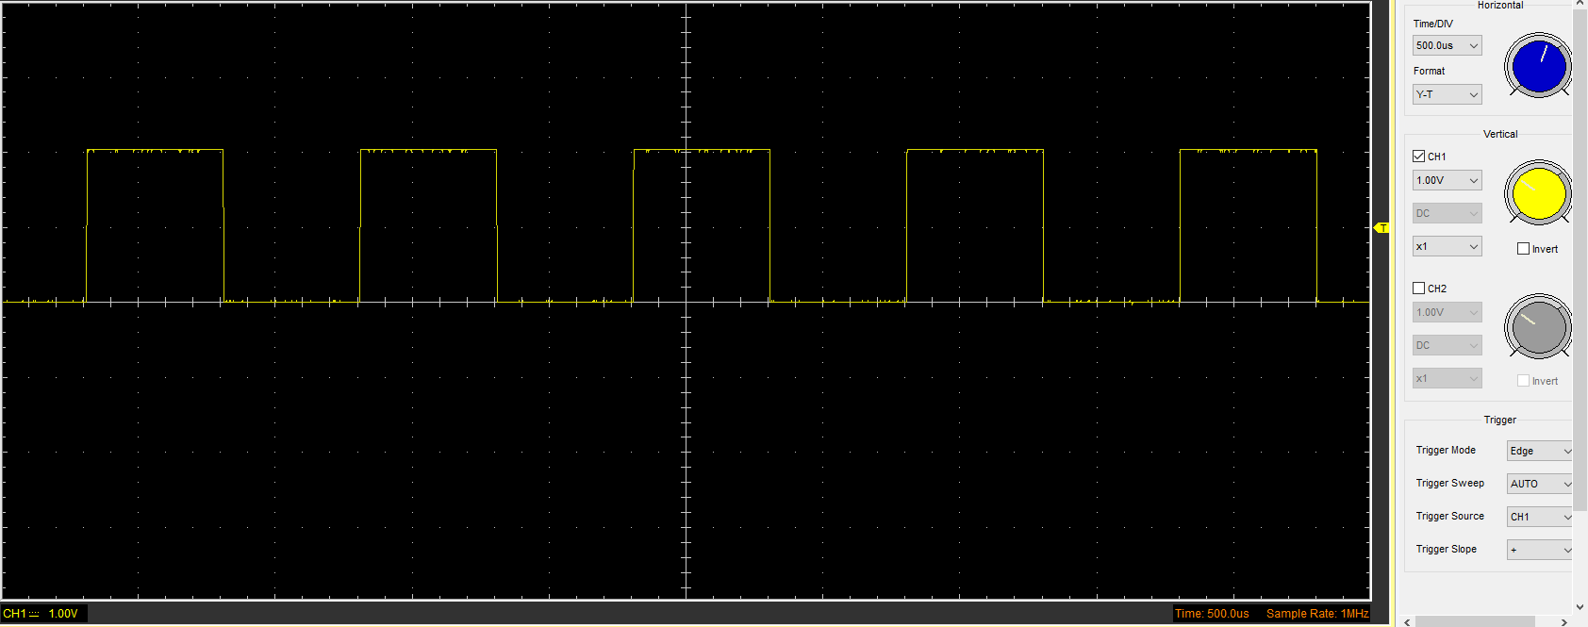

Capacitor charge and discharge wave marked at correct points. (3)
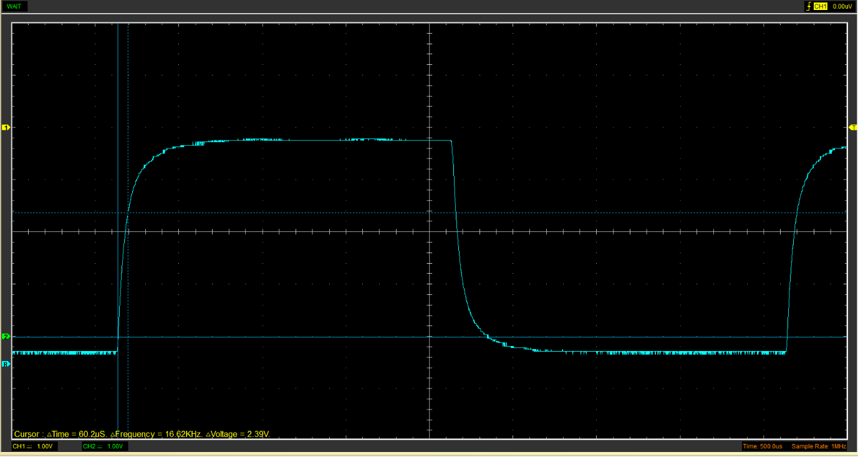

Basic Capacitor Calculations (3)
Maximum voltage difference is = 3.79v, therefore at 63.2% the voltage difference would be 2.39v. Using the charge and discharge wave, 2.39v difference gives a time constant of 60.2us. T=RC, therefore C=T/R and 60.2us/100ohms = 6.02x10^-7 F

Capacitor discharge table (2)

Time (s) | Voltage (V) | ln (V) | dy = y2 – y1 | dx = x2- x1 | dy/dx
Time (s) | Voltage (V) | ln (V) | dy = ln(V)2-ln(V)1 | dx = Time2 – Time1 | dy/dx
0.0048 | 0.8345 | -0.1809 | x | x | x
0.0049 | 0.5584 | -0.5827 | -0.4018 | 0.000026 | -15452.20
0.0049 | 0.3765 | -0.9768 | -0.3942 | 0.000026 | -15159.90
0.0049 | 0.2698 | -1.3101 | -0.3332 | 0.000027 | -12342.11
0.0049 | 0.2071 | -1.5746 | -0.2645 | 0.000026 | -10172.28
0.0050 | 0.1569 | -1.8521 | -0.2776 | 0.000027 | -10281.23
0.0050 | 0.1380 | -1.9805 | -0.1284 | 0.000026 | -4936.73
0.0050 | 0.1255 | -2.0754 | -0.0949 | 0.000027 | -3516.59
0.0050 | 0.1004 | -2.2986 | -0.2231 | 0.000026 | -8582.44
0.0051 | 0.0941 | -2.3634 | -0.0648 | 0.000027 | -2400.15

Plot log(V) Gradient (2)
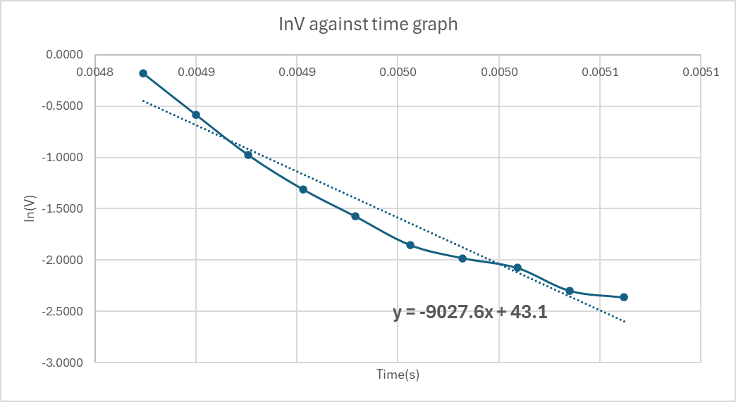

Gradient Calculations and Compare(4)

Gradient Calculations
Gradient of the graph = -9027.6
T=R.C
Time constant = -1/-9027.6 = 1.108x10^-4s
C= T/R.
Capacitance = 1.108x10^-4s / 100ohms = 1.108x10^-6F or 1.108µF

Comparison table
 | Capacitance | Delta | Percentage difference
Actual | 1µF | x | x
Marker calculation | 0.62µF | -0.38µF | -38%
Gradient calculation | 1.108µF | 0.108µF | 10.8%

Capacitor Uses (5)

Capacitors are widely used across various fields, including electrical systems, automotive, and motorcycles. In electrical applications, they serve multiple purposes such as snubbing voltage spikes, coupling signals, stabilizing voltage levels, filtering electrical noise, and functioning as sensors. In snubber circuits, capacitors help protect electronic components from voltage surges by offering an alternate path for excess energy when a switch opens or closes. This absorption of energy enhances the overall efficiency and reliability of the system (Jordan Yates, 2023).
Capacitors are used in coupling applications to allow AC voltage to pass through a circuit while blocking DC voltage. This is typically achieved using a capacitor that blocks the constant component (DC) but permits the alternating component (AC) to continue flowing. Coupling is especially useful when connecting two circuits, one operating on AC and the other on DC, ensuring signal transmission without unwanted DC interference. In this way, coupling acts as a form of filtering (Tycorun, 2023).
Capacitors are commonly used to stabilize voltage, particularly in power supplies and voltage converters, where maintaining a consistent voltage flow is essential. They achieve this by absorbing excess voltage during surges and helping to suppress arcing at contact points, therefore, enhancing the reliability and safety of the system (Simon Mao, 2023).
Capacitors are also used to filter out electrical noise, which is important because such interference can cause voltage fluctuations and reduce a circuit's effectiveness. By blocking DC voltage while allowing high-frequency noise to pass through, capacitors help prevent the noise from impacting the main circuit operation (Tech-mag, no date).
Capacitors can also function as sensors by detecting changes in capacitance. They are capable of sensing various factors such as humidity, mechanical strain, and proximity. These sensing capabilities make them ideal for a wide range of applications, including motion detectors (Easby Electronics, 2020).
In automotive applications, capacitors are used in a variety of systems, including radio interference suppression, regenerative braking, CDI units, alarm systems, and airbag occupant detection. For radio interference suppression, capacitors filter out high-frequency disruptions and are often combined with other filtering methods to reduce electromagnetic interference. This helps maintain clear and uninterrupted radio signals within the vehicle (Alfatec, no date).
Supercapacitors are used in regenerative braking systems, particularly in electric and hybrid vehicles. These systems capture kinetic energy during braking and convert it into electrical energy, which can be stored and reused to extend the vehicle's driving range. This process improves the efficiency of the vehicle (EE power, no date).
Capacitor Discharge Ignition (CDI) units use capacitors to store and rapidly release the high voltage needed to generate a spark in the spark plug. A circuit within the vehicle charges the capacitor, which then discharges the voltage through the ignition coil to the spark plugs. The use of capacitors allows for fast charging and discharging, making CDI systems well-suited for high RPM operation (RP Deshpande, 2024).
Capacitors are also used in vehicle alarm systems to stabilize voltage and filter out electrical noise, helping prevent false alarms triggered by sudden voltage spikes. They protect the alarm circuitry from malfunctions, furthermore, they provide backup power to keep the alarm functioning even when the main battery is off (Kohler-UPS, 2020).
Capacitors can also be used to detect whether a person is seated in a car by sensing changes in electrical capacitance. This works by monitoring the electric field around the seat. Knowing if the seat is occupied can be used to determine if an air bag should be deployed in the event of a crash (Marj Hajim, 2024).

Inaccuracies Question (4)

Although a capacitor has a specified value, this value is often not accurate to the actual capacitance being used. This is due to a variety of factors such as the tolerance of the capacitor, leaking current, temperature, and wear and tear. All capacitors are given a tolerance when constructed, as they can’t be made precisely to their capacitance values. The tolerance varies from capacitor to capacitor but can range from -20% to +80%. Leaking current also affects the overall capacitance, as the loss of current slowly discharges the capacitor. This is caused by the capacitor not having a perfectly insulated dielectric. The amount of current leaking can vary, but some may leak a significant amount. Temperature has a large impact on a capacitor's effectiveness, as high heat can deform the components and, in some cases, evaporate the electrolyte's liquid. The temperatures that affect capacitors vary, but it's said that working temperatures should not exceed 70 degrees Celsius to ensure proper functioning(Electronic tutuorials, no date). Finally, if the capacitor is overused, it can break down the dielectric, reducing performance (Electrocube, no date).

References
Alfatec (no date) Radio Interference Suppression Capacitors: alfatec GmbH & Co. KG, Alfatec. Available at: https://www.alfatec.de/en/products/passive-components/film-capacitors/radio-interference-suppression-capacitors (Accessed: 6 April 2025).
Easby Electronics (2020) A Guide to the Applications of Capacitors %. Available at: https://easby.com/a-guide-to-the-applications-of-capacitors-easby-electronics/ (Accessed: 6 April 2025).
EE power (no date) Energy Storage | Applications | Capacitor Guide, EE power. Available at: https://eepower.com/capacitor-guide/applications/energy-storage/ (Accessed: 6 April 2025).
Electrocube (no date) Why Do Capacitors Fail? Capacitor failure modes and common causes. Available at: https://www.electrocube.com/pages/why-capacitors-fail-technical-bulletin (Accessed: 6 April 2025).
Electronic tutuorials (no date) Capacitor Characteristics and Capacitor Specifications. Available at: https://www.electronics-tutorials.ws/capacitor/cap_3.html (Accessed: 6 April 2025).
Jordan Yates (2023) Understanding the Crucial Role of Snubber Capacitors in Power Electronics. Available at: https://blog.knowlescapacitors.com/blog/understanding-the-crucial-role-of-snubber-capacitors-in-power-electronics (Accessed: 6 April 2025).
Kohler-UPS (2020) Critical Power and your Business: Why capacitors are fundamental to the health of your UPS - KOHLER Uninterruptible Power. Available at: https://www.kohler-ups.co.uk/critical-power-and-your-business-why-capacitors-are-fundamental-to-the-health-of-your-ups/?srsltid=AfmBOopLfjrQeuY1IfygQ0eY_jJECZuMHQ3Ks2cy5PEKrLBIR-I6SWuz (Accessed: 6 April 2025).
Marj Hajim (2024) Occupant Detection Sensors: A Guide to Enhanced Safety, Alpha car hire. Available at: https://alphacarhire.com.au/blog/glossary/occupant-detection-sensors/ (Accessed: 6 April 2025).
RP Deshpande (2024) Auto Ignition and CDI Capacitors | Capacitor Connect, Capacitor connect. Available at: https://www.capacitorconnect.com/auto-ignition-and-cdi-capacitors/ (Accessed: 6 April 2025).
Simon Mao (2023) Capacitor Fundamentals: Part 2 – How are Capacitors Used?, Knowlescapacitors.com. Available at: https://blog.knowlescapacitors.com/blog/capacitor-fundamentals-part-2-how-are-capacitors-used (Accessed: 6 April 2025).
Tech-mag (no date) Components—Part 1: The Capacitor is the Simplest Noise Filter｜Intro to EMC Topics｜Learn about Technology with TDK, TDK.com. Available at: https://www.tdk.com/en/tech-mag/noise/04 (Accessed: 6 April 2025).
Tycorun (2023) Coupling capacitor - what it is and how it works-Tycorun Batteries. Available at: https://www.tycorun.com/blogs/news/coupling-capacitor?srsltid=AfmBOope6FONvUInwd9aw5x-doyWIW2G26aGcbnmUq8UC-wIdnC17Uw2 (Accessed: 6 April 2025).

