

CertHE Computing Skills for Workplace

Module Name : Software Solution for Business
Module Code : ACCA4026

Student Name : Surendheran Sugumaran
Student ID :2533422
Group :1
Lecture Name : Rajeev Nath

11 August 2026
Contents
CertHE Computing Skills for Workplace 1
Introduction 1
Task 1. e-Commerce Website builders/software solutions 2
1.1 Wix 2
1.2 Shopify 3
Task 2. Mind-map of contemporary software applications 4
2.1 Mind mapping and its benefits 4
2.2 Mind map of contemporary software applications 5
Task 3. Office Applications 6
3.1 Four office software solutions for business operations 6
Ms Word 7
Ms Excel 9
Ms PowerPoint 11
Ms Access 13
3.2 Test any two features 14
VLOOKUP 14
IF Statement 18
Task 4. Communication and Collaboration applications 21
4.1 One contemporary Communication and one Online Collaboration 21
Gmail 21
Zoom 23
4.2 Test one feature of a freely available Communication (1) and one feature of a Collaboration (1) application 24
Gmail 24
GMAIL INTERFACE (2026) Mac 24
Zoom 26
Conclusion 27
References 28

Introduction

This assignment explores how digital skills and software applications support academic learning and modern business operations. It covers key areas including mind mapping, office applications, communication and collaboration tools, e-commerce website builders, and professional development. Applications such as Microsoft Word, Excel, PowerPoint, Access, Gmail, Zoom, Wix and Shopify are discussed to understand their features, benefits and limitations. The assignment also demonstrates practical use of these technologies through step-by-step activities and screenshots. Overall, these tasks help develop practical digital, communication, teamwork and organisational skills that are valuable for future employment.



Task 1. e-Commerce Website builders/software solutions

1.1 Wix
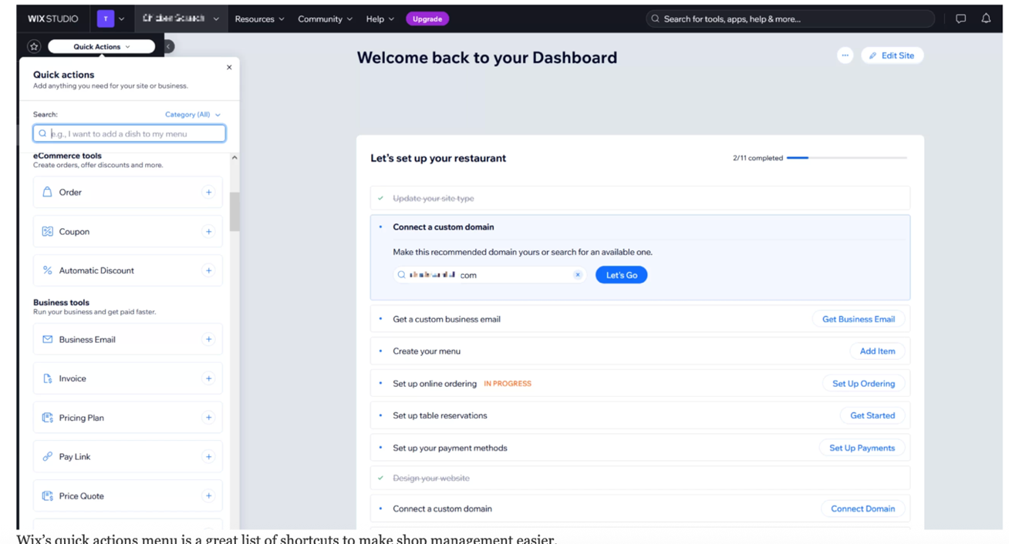

Figure 1: Show the Wix Dashboard [1]
Wix is a website builder that is based on the cloud. This means that users can make their professional websites. They can do this by using a tool that lets them drag and drop things into place. Wix is good for businesses and startups. It is also good for individuals who want to make a store. The best part is that they do not need to know how to code.
Wix has a lot of templates that users can choose from. These templates can be changed to match the style and brand of a business. This way the website will look like it was made for that business [1]
One of the main features of Wix is its drag-and-drop website editor, which allows users to add text, images, videos and other content easily. It also includes built-in e-commerce features such as product management, secure online payments, inventory tracking and order management. Businesses can also connect their website to social media platforms and use marketing tools to reach more customers [2].
The main benefits of Wix are its ease of use, affordable pricing and flexible website design options. It is ideal for beginners because users can quickly create a professional online store without technical experience. However, Wix may have fewer advanced e-commerce features than platforms designed specifically for large online businesses [2].

1.2 Shopify
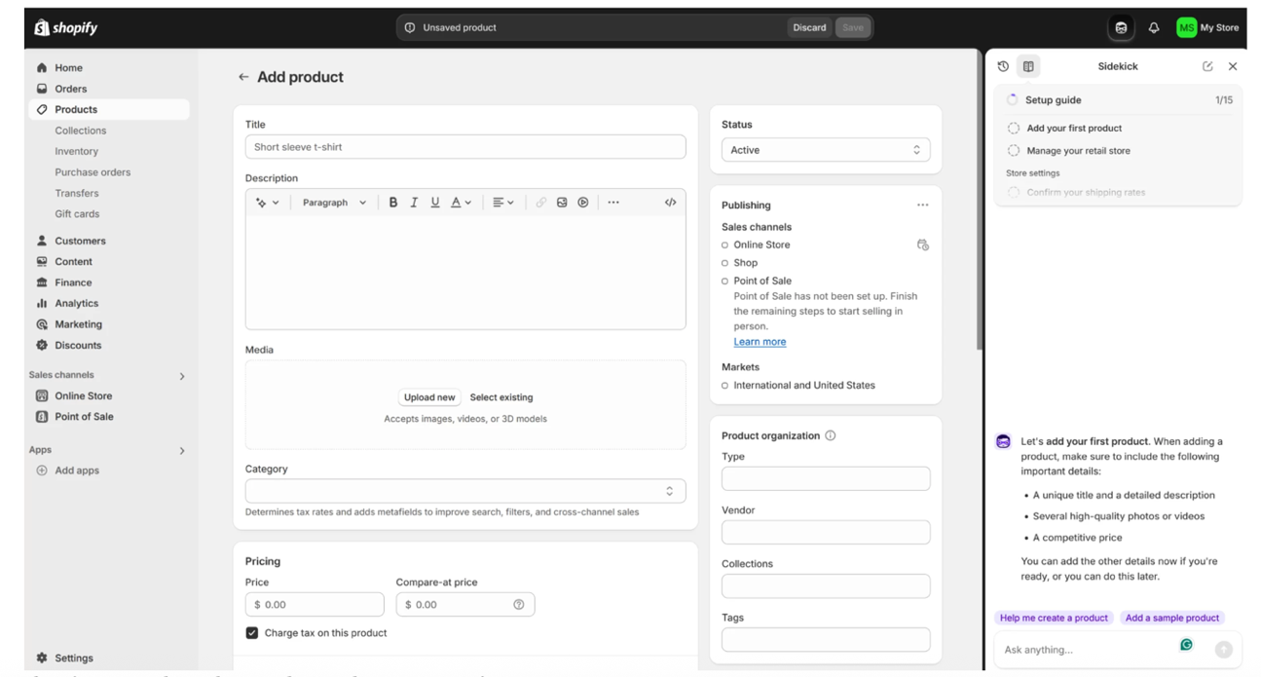

Figure :2 Show the Shopify interface [1]
Shopify is a platform that helps people sell things on the internet. It makes it easy for businesses to make a website and manage their store. Shopify gives businesses everything they need to sell products. This includes a place to host their website, a way to take payments a system to keep track of what they have in stock and a way to follow orders. Shopify is useful for all kinds of businesses no matter how big or small they are from startups to really big companies that sell things all around the world like Shopify does for large international retailers and small startups. [3].
One of Shopify's key features is its complete e-commerce management system. Users can add products, manage stock levels, process customer orders and accept payments through multiple payment methods. Shopify also offers marketing tools, customer management features and detailed sales reports to help businesses improve their performance. In addition, it supports thousands of third-party applications through the Shopify App Store, allowing businesses to add extra functionality as they grow [3].
The main advantages of Shopify include its powerful selling features, high security and scalability. It is suitable for businesses that expect to grow because it can handle large product catalogues and high sales volumes. However, Shopify can be more expensive than other website builders, especially when additional apps and premium features are required [3].

Comparison of Wix and Shopify
Both Wix and Shopify enable businesses to create professional online stores, but they are designed for different purposes. Wix focuses on website design It is very flexible which makes it a great choice for people who are just starting out and for small businesses. Shopify focuses on advanced e-commerce features, making it more suitable for businesses that plan to expand their online sales. According to Forbes Advisor, Wix offers greater design flexibility, while Shopify provides stronger e-commerce tools, inventory management and scalability for growing businesses [1].

Task 2. Mind-map of contemporary software applications

2.1 Mind mapping and its benefits
Mind mapping is a way to see information. It helps you put your ideas and thoughts in order around one thing. You do not have to write things down in a line like you normally do. A mind map starts with the idea, in the middle. Then it uses lines to connect ideas and words that are related to the main idea. This makes it easy to see how things are connected to mind mapping. You can use mind mapping to keep track of your thoughts and ideas. Images, symbols and colours can also be used to make information easier to understand and remember. In business, mind mapping can be used for brainstorming, planning, problem-solving and organising complex information. It helps individuals and teams see the bigger picture while also understanding how different ideas are connected [4].
One important benefit of mind mapping is that it can improve creativity and idea generation. During business meetings or brainstorming sessions, employees can quickly add new ideas and connect them to existing ones. This flexible approach encourages people to think beyond traditional methods and explore different possibilities. Mind maps can also help businesses with strategic planning by placing a main business goal at the centre and creating branches for objectives, actions and possible strategies. This makes it easier to understand how different activities contribute towards achieving the overall business goal [4].
Mind mapping can also improve organisation and productivity in business operations. Complex projects can be divided into smaller tasks and arranged visually, making responsibilities and priorities easier to understand. For example, a project manager could create a mind map showing the main project, team members, deadlines, tasks and resources. This gives employees a clear overview of the work and helps them focus on what needs to be completed. By presenting information in a structured visual format, mind mapping can also help professionals understand complex subjects, remember important information and manage their workload more effectively [5].
Another major advantage is better teamwork and communication. A shared mind map provides employees with a common visual reference, allowing everyone to understand the same goals, responsibilities and project requirements. It can be particularly useful when different departments need to work together, as the map can show how their individual tasks are connected. Mind mapping can also support problem-solving and
Decision-making because teams can identify different options, examine possible outcomes and discuss ideas in one place. This can reduce confusion and help employees reach decisions more confidently [6].
Mind mapping is also useful for business growth and innovation. Businesses can use mind maps to identify new opportunities, develop strategies and explore ways to improve products or services. The visual structure allows managers and employees to connect different ideas and recognise relationships that may not be obvious when information is presented only as text. Digital mind-mapping tools can make this process even more effective by allowing teams to edit, share and collaborate on maps. Therefore, mind mapping can support business planning, creativity, communication, productivity and innovation, making it a useful technique for modern business operations [6].

2.2 Mind map of contemporary software applications
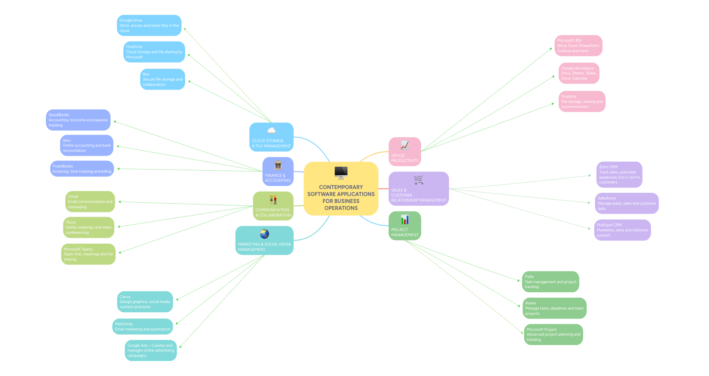

Figure 3: shows the mind map I created, highlighting contemporary software applications.
Click the link below to view my mind map on contemporary business software applications. https://mm.tt/map/4030977586?t=LTqV8PdBbi

Task 3. Office Applications

3.1 Four office software solutions for business operations
Office software is widely used in modern organisations to create, store, present and analyse information. Microsoft Office applications provide different tools for completing everyday business activities, including writing documents, creating presentations, analysing data and managing databases. Four important applications are Microsoft Word, Microsoft PowerPoint, Microsoft Excel and Microsoft Access. Each application has different features, benefits and limitations, but together they can support many business operations.

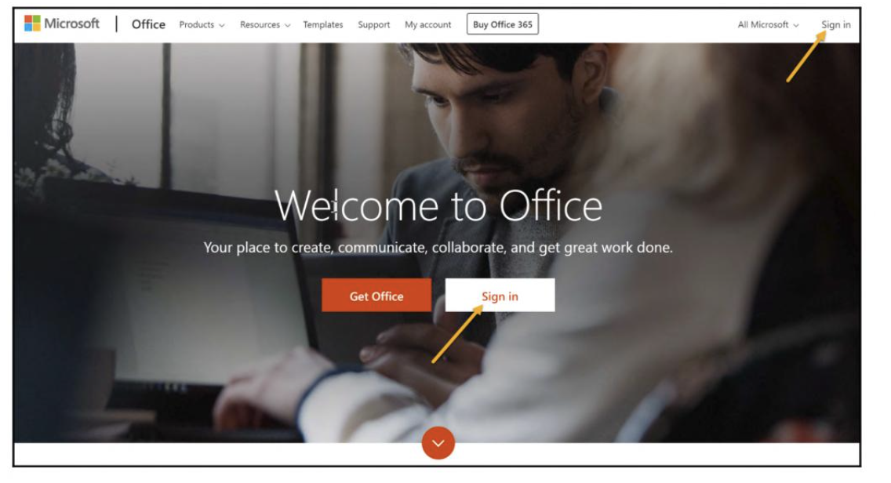
To access and use all the features of Microsoft 365, users need to log in to their Microsoft 365 account [7]

Figure 4: shows the Microsoft Login
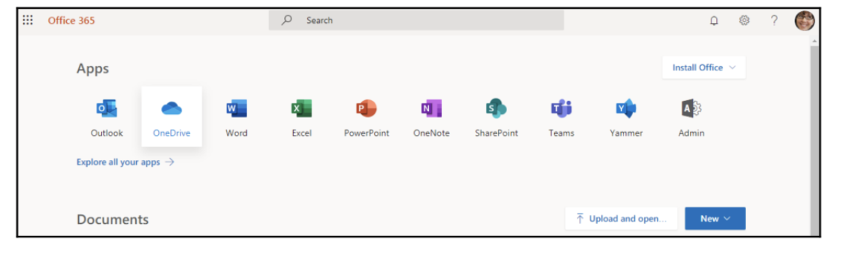

Figure 5: shows the Home Page [7]

Ms Word
 Microsoft Word is a word-processing application used to create, edit, format and store documents. Businesses commonly use Word to produce letters, reports, meeting minutes, CVs, business plans and other professional documents. It provides tools for changing fonts, headings, paragraphs, page layouts and document styles, helping users create professional-looking documents [8].
Major Features
One important feature of Microsoft Word is its text formatting tools. Users can change font type, size and style and use options such as bold, italic and underline. These features help businesses create professional-looking documents. Word also provides tools for inserting tables, pictures, hyperlinks, headers, footers and page numbers.
Another useful feature is spell checking and grammar support, which can help users identify mistakes before a document is shared. Word also provides templates that allow users to create documents using pre-designed layouts. The Microsoft Office environment also includes file-management functions for opening, saving and printing documents [8].
Benefits
Microsoft Word can improve business productivity because employees can create and edit documents quickly. It is particularly useful for producing professional reports and written communication. Documents can also be edited without having to recreate the entire document, which saves time and reduces paper usage.
Word is also useful for collaboration because documents can be shared with colleagues for review and editing. Businesses can therefore use Word for both individual and team-based work [8].
Limitations
One limitation of Word is that it is primarily designed for text-based documents, so it is not the best application for analysing large amounts of numerical data. Complex spreadsheets and databases are better managed using Excel or Access. Another limitation is that documents can become difficult to manage when many versions are created by different users [8].

Menu Bar
Title Bar
Quick Access Tool Bar
Style Gallery
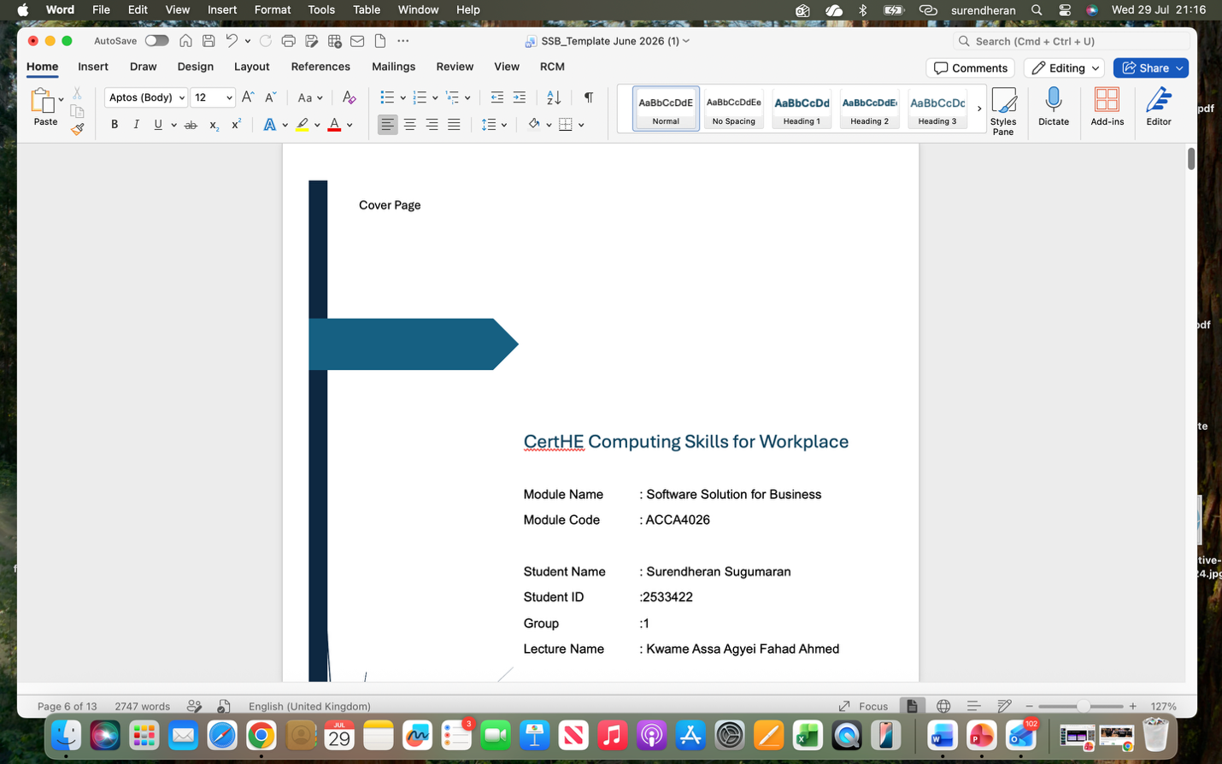

Ribbon Bar

Scroll Bar
Home Tab

Menu Bar
Zoom control

Figure 6: Show the Microsoft Word Interface on a Mac 2026 (Personal collection)
Menu Bar –It contains options such as Word, File, Edit, View, Insert, Format, Tools, Table, these menus provide access to different commands and Word functions.
Quick Access Toolbar – It provides quick access to commonly used commands such as Save, Undo, Redo, and Print.
Title Bar – Displays the name of the current document
Ribbon Tabs – The tabs such as Home, Insert, Draw, Design, Layout, References, Mailings, Review, View, and RCM organise Word's tools into different categories.
Home Tab – This contains tools for basic document editing and formatting, including font style, font size, underline, text colour, bullets, numbering, and paragraph settings.
Styles Gallery – These styles help users format headings and paragraphs consistently throughout a document
Status Bar –This displays information such as the page number, total number of pages, word count, language, and other document information.

Ms Excel
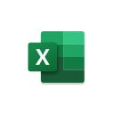Microsoft Excel is a spreadsheet application used to enter, organise, calculate and analyse data. It is widely used in businesses for budgets, financial calculations, sales records, employee information, stock management and data analysis. Excel organises information into rows and columns, making large amounts of data easier to manage [8].
Major Features
Excel organises information using rows, columns and cells. Users can enter text, numbers and dates into cells and perform calculations using formulas and functions. Common functions include SUM, AVERAGE, IF and VLOOKUP.
For example, the IF function can be used to check whether a condition is true or false, while VLOOKUP can be used to find related information from a table. Excel also provides sorting and filtering tools that help users find and organise information.
Another major feature is charts and graphs. Businesses can use charts to present numerical information visually. Excel also provides formatting tools, tables and conditional formatting to make important information easier to identify [8].
Benefits
Excel can save businesses considerable time by performing calculations automatically. Instead of calculating information manually, employees can enter a formula and allow Excel to produce the result. This can reduce calculation errors and improve productivity.
Excel is also useful for business decision-making because data can be analysed and presented using tables, charts and graphs. For example, a business manager could analyse monthly sales data to identify increases or decreases in performance.
Basic ICT training resources also identify creating, saving and working with spreadsheets, entering information into cells and using rows and columns as important computer skills [9].
Limitations
Excel can become difficult to manage when a spreadsheet contains a very large amount of information. Incorrect formulas or data entry can produce incorrect results. It is also possible for users to accidentally overwrite important information. For large-scale data storage and complex relationships between records, a database application such as Microsoft Access is more suitable [9].
Menu Bar
Home Tab
Title Bar
Ribbon Tab
Quick Access Tool Bar
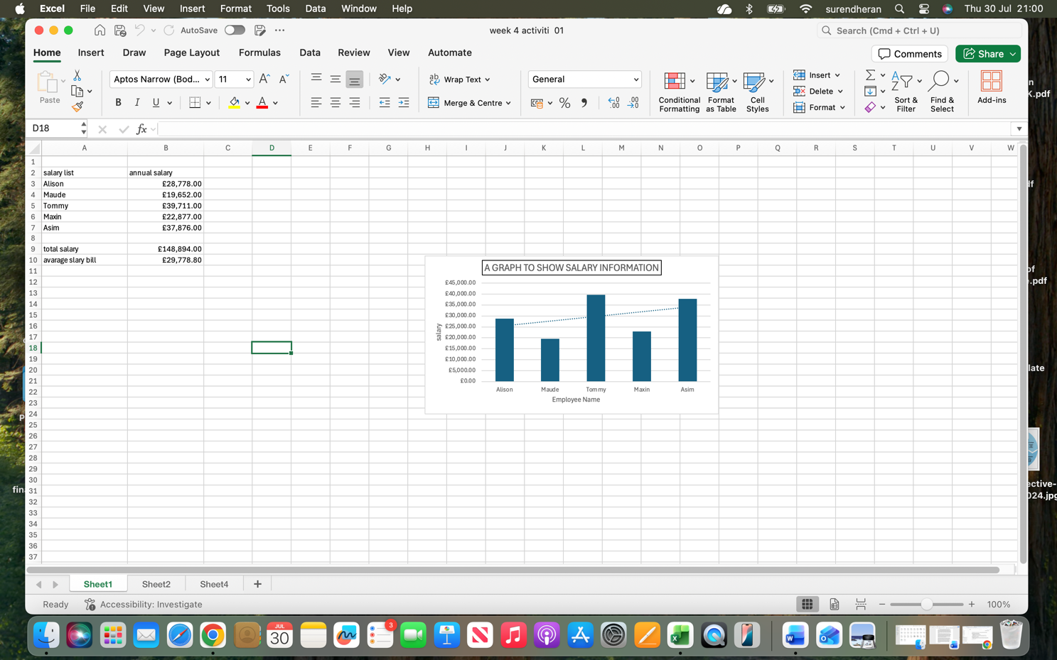

Name Box
Formula Bar
Column Headings

Row Headings
Sheet Tables

Figure 7: Show the Microsoft Excel interface on a Mac 2026, Source: Personal Collection.
Menu Bar – This menus provide access to different Excel commands and functions.
Quick Access Toolbar – It provides quick access to common commands such as Save, Undo, Redo, and AutoSave.
Ribbon Tabs – The Ribbon contains tabs such as Home, Insert, Draw, Page Layout, Formulas, Data, Review, each tab provides tools for performing different tasks in Excel.
Name Box – which indicates that cell D18 is currently selected. Users can also type a cell reference into the Name Box to move directly to that cell.
Formula Bar – fx symbol It is used to enter, view and edit data or formulas contained in the selected cell. This is particularly useful when working with calculations.
Column Headings – The letters A, B, C, D, E, F and so on at the top of the worksheet represent columns. Each column contains cells arranged vertically.
Row Headings – The numbers 1, 2, 3, 4, 5 and so on the left side represent rows. Rows run horizontally across the worksheet.

Ms PowerPoint
 Microsoft PowerPoint is a presentation application used to create slides for presenting information to an audience. Businesses can use PowerPoint for meetings, training sessions, sales presentations, project updates and business proposals. Presentations can contain text, images, charts, tables, videos and other multimedia elements.
Major Features
PowerPoint provides a range of slide layouts and templates, allowing users to create presentations quickly. Users can add text, pictures, shapes, charts, tables and videos to slides. It also provides transitions and animations, which can be used to make presentations more engaging.
Another important feature is Presenter View, which helps the presenter manage a presentation while delivering it to an audience. Speaker notes can also be added to slides to provide additional information for the presenter.
PowerPoint can be particularly useful when information needs to be communicated visually. For example, a business could use charts and graphs to present sales performance rather than explaining all the figures using text [7].
Benefits
The main benefit of PowerPoint is that it allows businesses to communicate information in a clear and visual format. Images, charts and diagrams can make complex information easier to understand. It can also support training by combining written information with visual examples.
PowerPoint can save time because employees can use existing templates and duplicate slides when preparing similar presentations. Presentations can also be shared digitally or delivered through online meetings [9].
Limitations
PowerPoint presentations can become ineffective if too much text, animation or unnecessary information is included. A presentation containing many slides may also take a long time to prepare. In addition, PowerPoint is mainly designed for presenting information rather than storing or analysing large datasets [9].
Quick access Tool Bar
Ribbon Tabs
Home Tab
Menu Bar

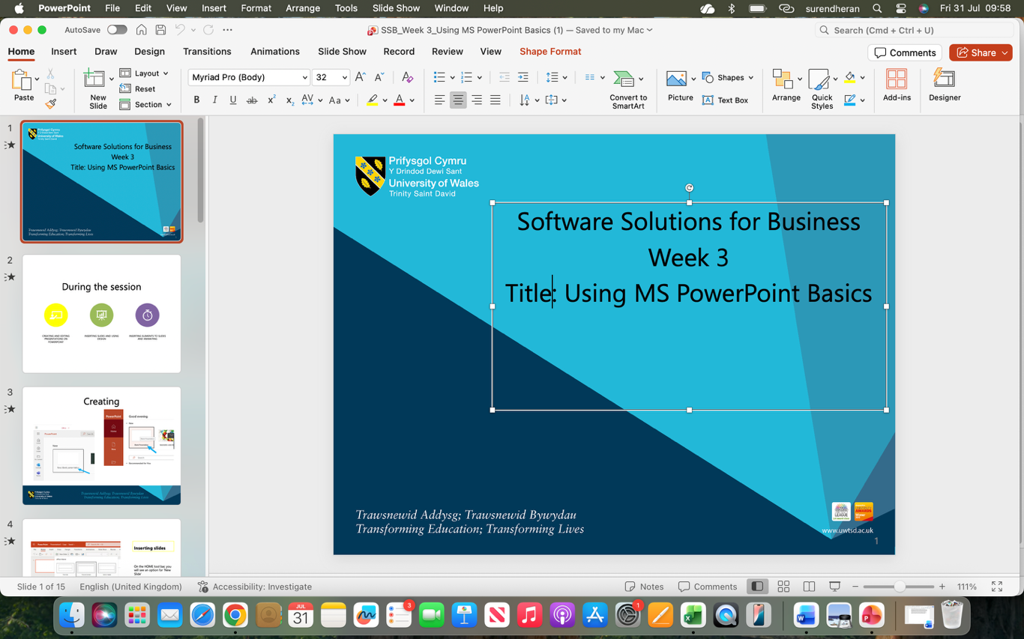
View Control
Comments and Notes Section
Slide thumbnail pane
Figure 8: Show the Microsoft PowerPoint interface on a Mac 2026, Source: Personal Collection.
Menu Bar – PowerPoint, File, Edit, View, Insert, Format, Arrange, Tools, Slide Show, these menus provide access to different PowerPoint commands and functions.
Quick Access Toolbar – Located near the top-left of the PowerPoint window. It provides quick access to common commands such as Save, Undo, Redo, and AutoSave.
Ribbon Tabs – The Ribbon contains tabs such as Home, Insert, Draw, Design, Transitions, each tab provides different tools for creating and editing presentations.
Home Tab – It provides tools for creating new slides, changing slide layouts, formatting fonts, adjusting paragraph alignment, inserting shapes and pictures, arranging objects.
Slide Thumbnail Pane: Shows slide previews and allows users to select and rearrange slides.
Comments and Notes: The Comments feature allows users to add feedback, while the Notes section helps presenters add speaker notes to explain the slide.
View Controls – Near the bottom-right corner, PowerPoint provides different viewing options, allowing users to change how the presentation is displayed while editing.

Ms Access
 Microsoft Access is a database management application used to store, organise and retrieve structured information. Businesses can use Access to manage information such as customer records, employee details, products, suppliers and orders.
Major Features
Access uses tables to store information in an organised structure. A table can contain fields such as Customer ID, Customer Name, Email Address and Telephone Number. Each record represents an individual item, such as one customer.
Access also provides queries, which allow users to search for specific information from a database. For example, a business could create a query to find all customers located in a particular area.
Another important feature is forms. Forms provide an easier interface for entering and viewing database information. Reports can also be created to present information in a professional format. Access can therefore support the complete process of storing, retrieving and presenting structured business data [10].
Benefits
One major benefit of Access is that it can organise large amounts of structured information more effectively than a simple spreadsheet. Businesses can use relationships between tables to reduce repeated information and improve data organisation.
Access can also improve efficiency because queries can quickly retrieve specific information. For example, a company could search its customer database to find contact details without manually checking every record [8].
Limitations
Access can be more complicated to learn than Word or PowerPoint, particularly for beginners who have never worked with databases. It may also be less suitable for very large organisations that require enterprise-level database systems. In addition, users need to design tables, relationships and queries correctly; poor database design can result in inaccurate or duplicated information [9].

3.2 Test any two features

VLOOKUP
VLOOKUP is an Excel function used to quickly find specific information from a table. For example, Enter an Employee ID, and VLOOKUP will search the table and automatically show the matching Last Name. This is useful for finding information quickly without manually searching through a large amount of data
Step 1: Select Blank Workbook to open a new Excel spreadsheet.
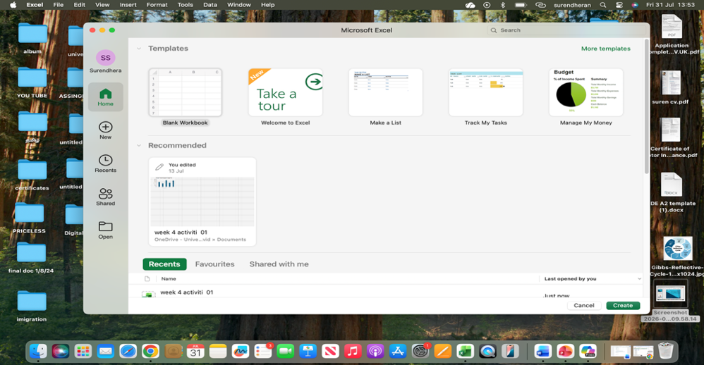
Figure 9: Show the Microsoft Excel New Sheet, Source: Personal Collection.
Step 2: Enter your data by typing the headings, such as Employee ID, Last Name, and First Name, into any three columns of your choice. Then, enter the relevant employee information below each heading.
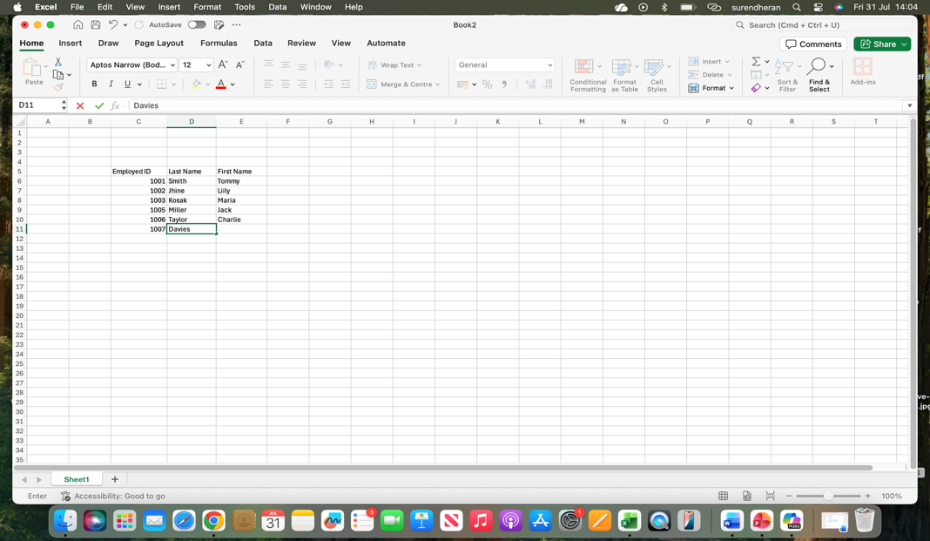
Figure 10: Show the Entering Data
Step 3: Create a separate area next to your main data table, then enter the headings Employee ID and Last Name in two separate cells. These cells will be used to enter an Employee ID and display the matching Last Name using the VLOOKUP function.
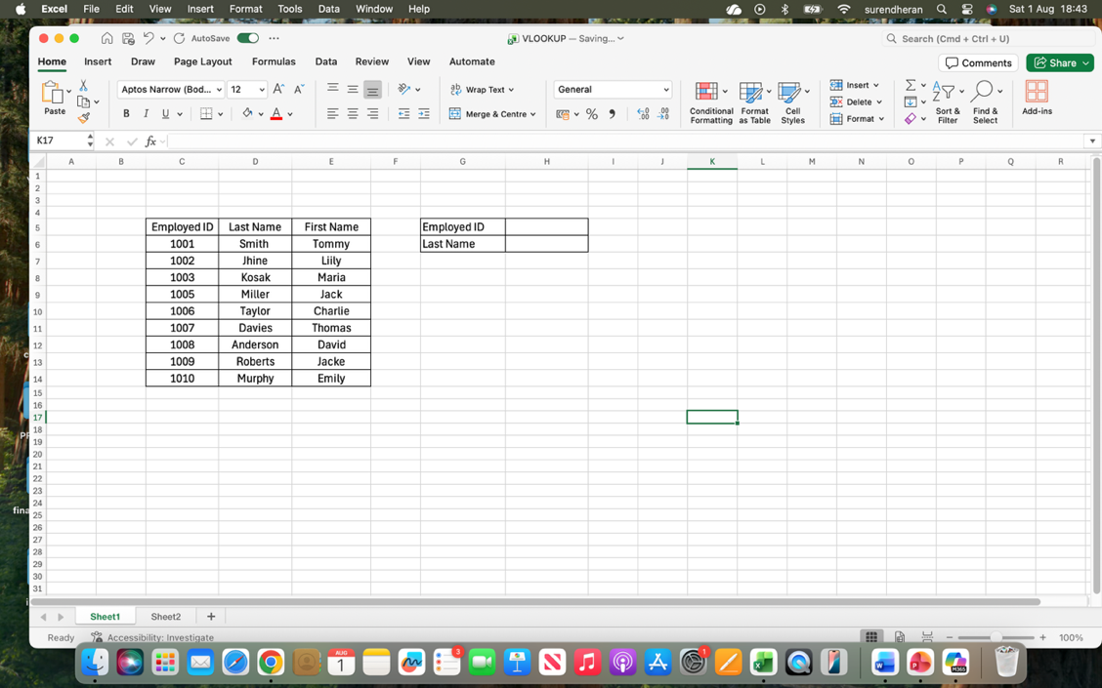
Figure 11: Show the Create a separate area next to your main data table
Step 4: Select all the data you have entered, then go to the Home tab and click the Borders icon. Select More Borders and customise the border style according to your preference. Finally, click OK to apply the borders to your data
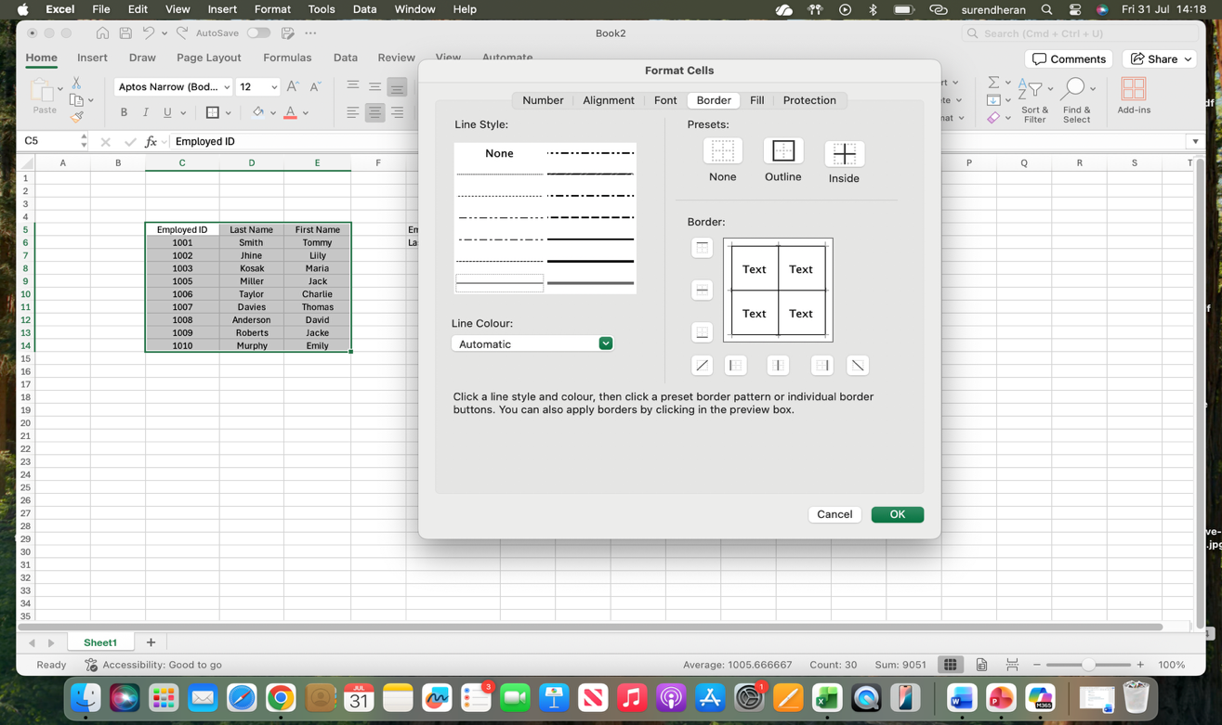
Figure 12: Show the customise the border style
Step 5: Select the heading cells you want to format, then go to the Home tab and choose a suitable heading style. Next, click the Fill Colour icon, select your preferred colour, and apply it to the selected cells.
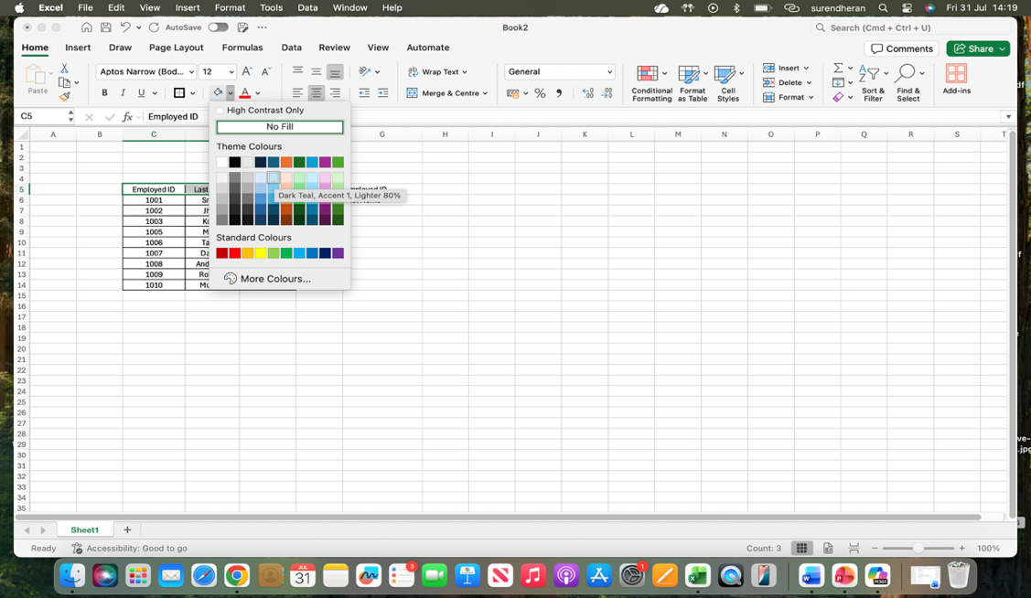
Figure 13: Show the customise the Heading and background colour

Step 6: Select the cell where you want the Last Name to appear and type =VLOOKUP (. Next, select the cell containing the Employee ID you want to search for, type a comma, and select the entire data table. Then, type 2 because the Last Name is in the second column of the selected table
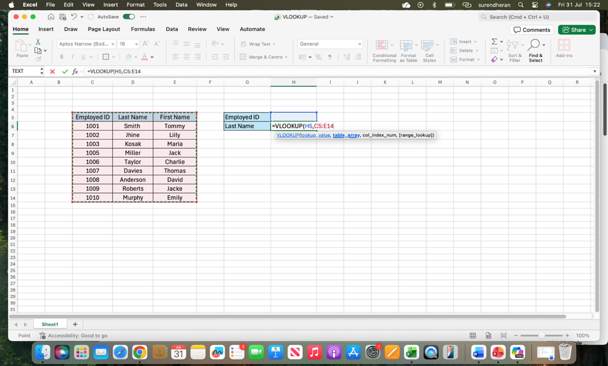
Figure 14: Show the Apply the VLOOKUP Formula
Step 7: Followed by, FALSE) to find an exact match. Finally, press Enter to display the matching Last Name.
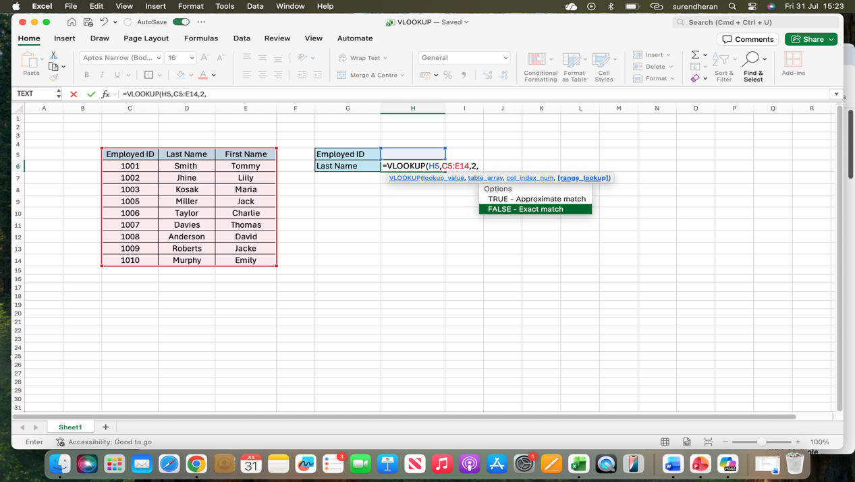
Figure 15: Show the Display the Matching Last Name
Step 8: Finally, enter an Employee ID into the designated Employee ID cell, and the VLOOKUP function will automatically search the data table and display the matching Last Name in the Last Name cell. You can change the Employee ID to find the Last Name of a different employee.
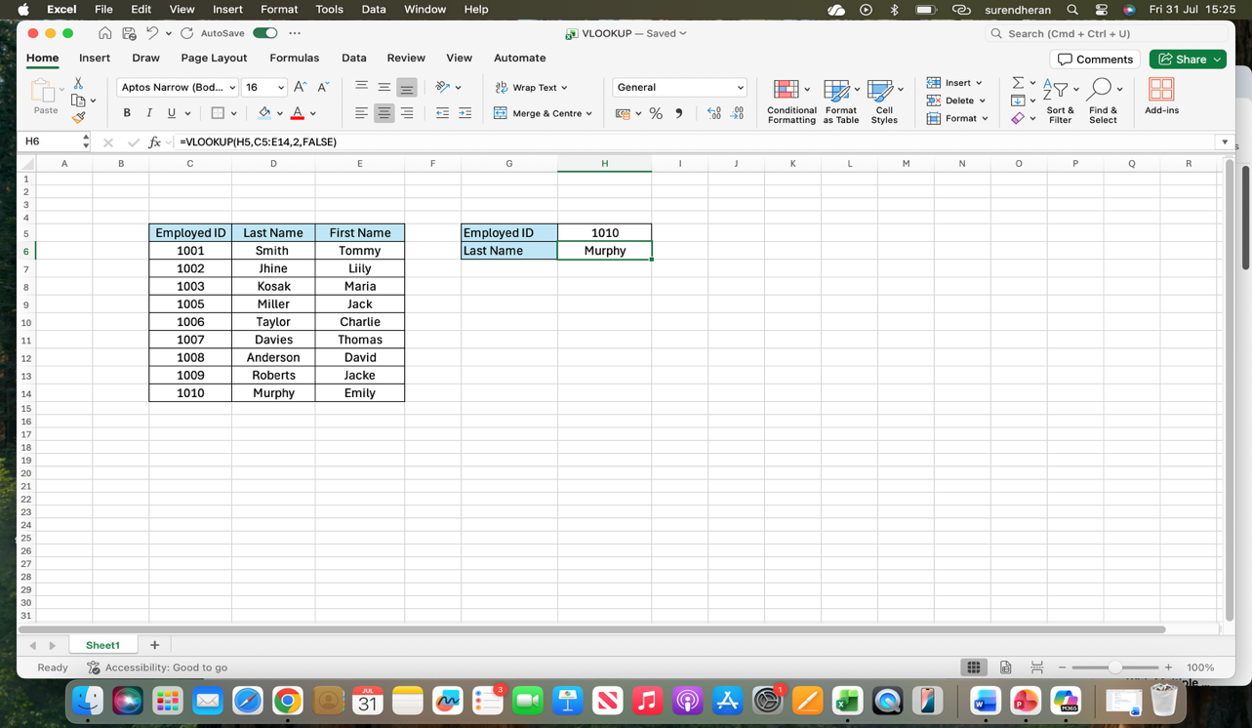
Figure 16: Show the Using Employee ID to Find a Last Name Automatically.

IF Statement
I will explain how to use the IF function in Microsoft Excel step by step. The IF function is used to check a condition and automatically display different results depending on whether the condition is true or false. In this example, I created a student marks table and used the IF function to show "Pass" for marks of 60 or above and "Fail" for marks below 60
Step 1: Open Microsoft Excel, select Blank Workbook to create a new spreadsheet, then click File and choose Save As to save the file with a suitable name, such as "IF Function Practice”
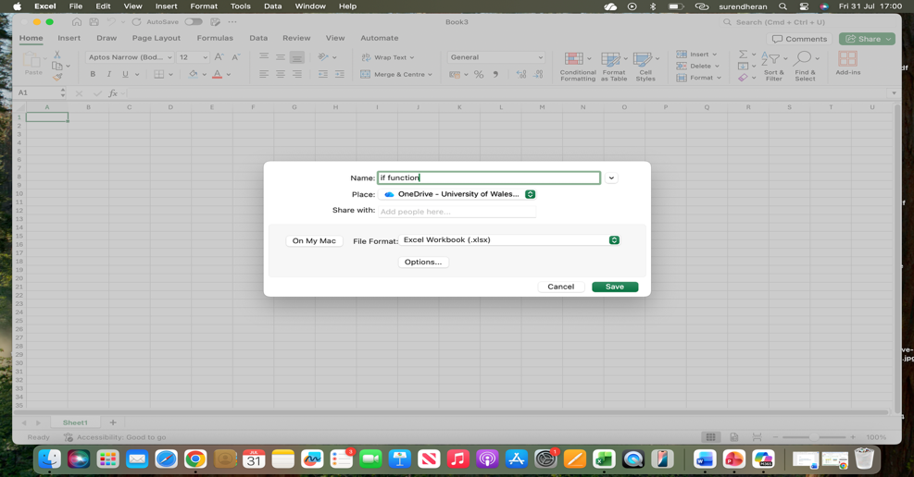
Figure 17: Show the Create and Save a New Workbook, Source: Personal Collection

Step 2: Enter the headings "Name", "Marks", and "Results" in three separate columns, then enter the relevant student information and marks below the headings. Select the entire data range, go to the Home tab, click the Borders icon, and apply a suitable border
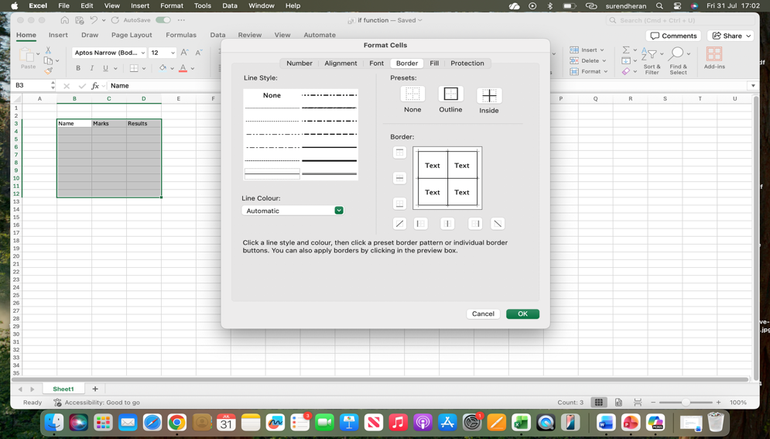
Figure 18: Show the Entering Student Data and Applying Borders.
Step 3: Create a separate criteria table next to your main data and add two headings, "Marks" and "Grade". Under the Marks heading, enter the criteria as 0–59 and 60–100, and under the Grade heading, enter "Fail" for marks between 0 and 59 and "Pass" for marks between 60 and 100.
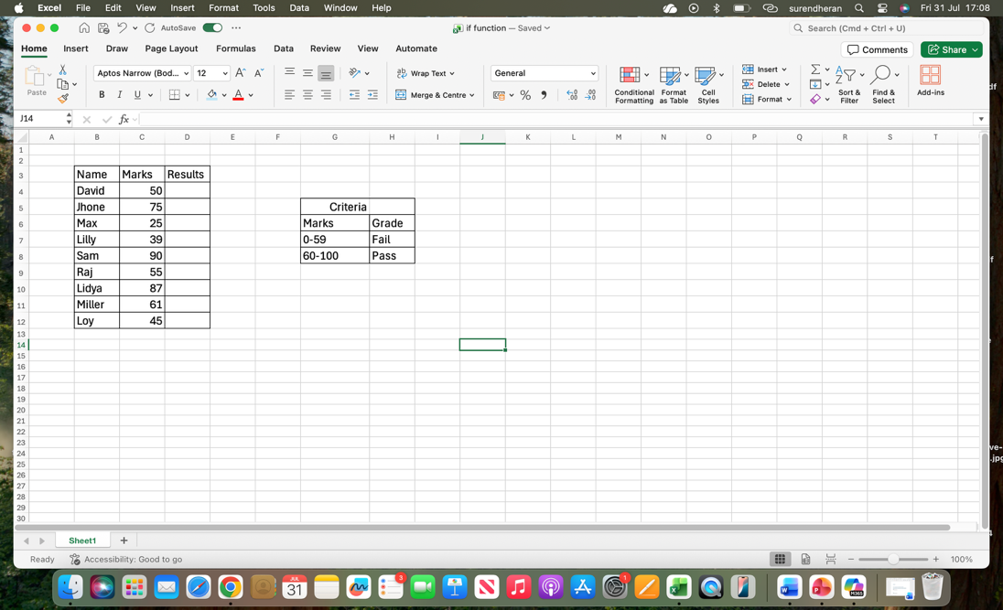
Figure 19: Show the Creating a Criteria Table for Grades.

Step 4: Select both heading cells in the table, go to the Home tab, click the Fill Colour icon, choose your preferred colour, and apply it to the selected cells.
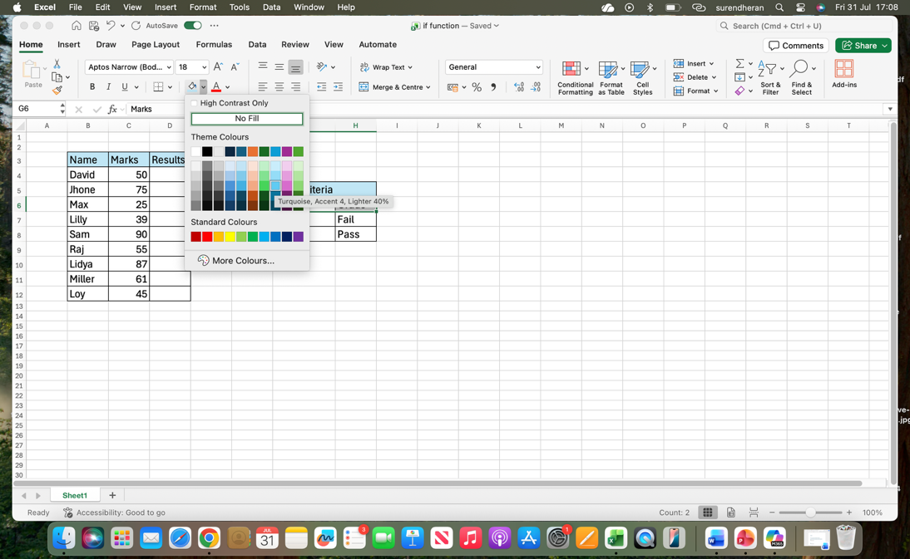
Figure 20: Show the Applying Fill Colour to Heading Cells.

Step 5: Select the first cell under the Results heading and type the IF formula to check the student's marks.
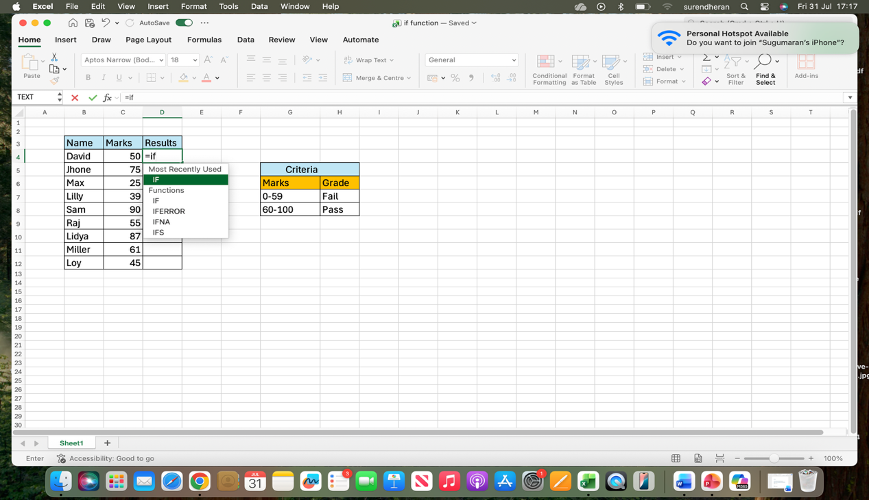
. Figure 21: Show the Entering the IF Formula for Results
Step 6: Select the Results cell, type =IF(C4>=60,"Pass","Fail"), and press Enter. Excel will check the mark in cell C4 and automatically display "Pass" if the mark is 60 or above, or "Fail" if the mark is below 60.

Figure 22: Show the Entering the IF Formula and Displaying Results.

Task 4. Communication and Collaboration applications

4.1 One contemporary Communication and one Online Collaboration

Gmail
Gmail is an email communication application that allows users to send, receive and organise electronic messages. In a business environment, Gmail can be used to communicate with colleagues, customers, suppliers and other stakeholders. Users can compose an email by entering the recipient's email address, adding a subject and writing the message. Gmail also allows users to attach files, such as documents, images and spreadsheets, making it useful for sharing business information digitally [11].
One of the main features of Gmail is its ability to send and receive emails quickly. Users can organise messages using folders, labels and search functions, which makes it easier to find important information. Gmail also supports email attachments, allowing users to send files with their messages. This is particularly useful in business because employees can share reports, invoices, presentations and other documents without needing to send physical copies [11].
Another important benefit of Gmail is that it supports professional communication between individuals and organisations. Businesses can use email to communicate with customers and provide information about products or services. Gmail also allows users to forward messages and reply to previous conversations, helping maintain a record of business communication. This makes email useful for keeping track of discussions and sharing information with multiple people [11].
However, Gmail also has some limitations. Employees may receive many emails, which can make it difficult to identify important messages. Email communication can also be slower than real-time communication when an immediate response is required. In addition, users need to be careful when opening attachments or clicking links in emails because of the risk of phishing and other security threats.

Enter your first name, last name, username, and a secure password. Your username will become your new email address.
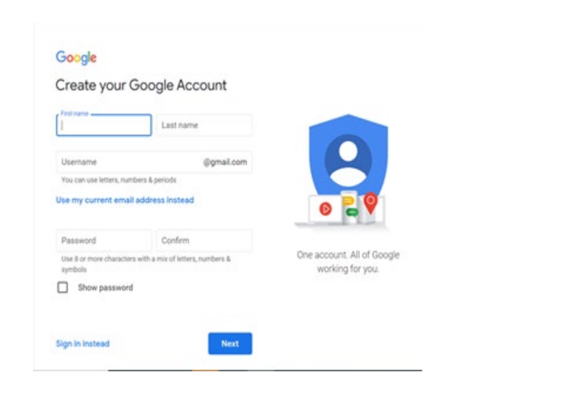

Figure 23: Show the Create google account [11].

To create a new email, click “Compose” in the top-left corner. The New Message window will then appear.
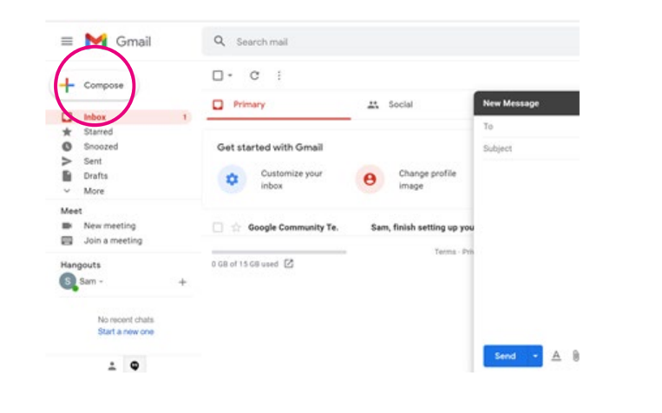

Figure 24: Show the Create a new email [11].

Zoom

Zoom is an online communication and collaboration application that allows people to communicate through video meetings and online conferences. It is widely useful for businesses with employees working remotely or from different locations. Users can join meetings through an invitation or meeting link, allowing teams to communicate without being physically present in the same office [12]
A key feature of Zoom is video conferencing, which allows participants to communicate using video and audio. Users can also turn their cameras or microphones on and off during meetings. This provides a more interactive communication experience compared with traditional email. Businesses can use Zoom for team meetings, interviews, presentations, training sessions and discussions with customers or clients [12].
Zoom also provides features that support online collaboration. Participants can share their screens, allowing them to show presentations, documents, websites or software to other meeting participants. This is particularly useful when employees need to explain a project or demonstrate how to complete a task. Zoom also provides features such as chat, which allows participants to send written messages during a meeting [12].
Another advantage of Zoom is that it supports remote working and flexible collaboration. Employees can participate in meetings from different locations, which can reduce the need for travel and allow organisations to work with people in different cities or countries. This can save time and support teamwork between geographically distributed employees [12].
However, Zoom also has some limitations. The quality of a meeting can be affected by a poor internet connection, resulting in audio or video problems. Large meetings may also become difficult to manage if too many participants speak at the same time. Furthermore, businesses need to consider privacy and security when using online meeting platforms and should ensure that appropriate meeting security settings are used [12]

4.2 Test one feature of a freely available Communication (1) and one feature of a Collaboration (1) application

Gmail

GMAIL INTERFACE (2026) Mac
Compose button
Search mails
Google Apps
Setting
Main Menu

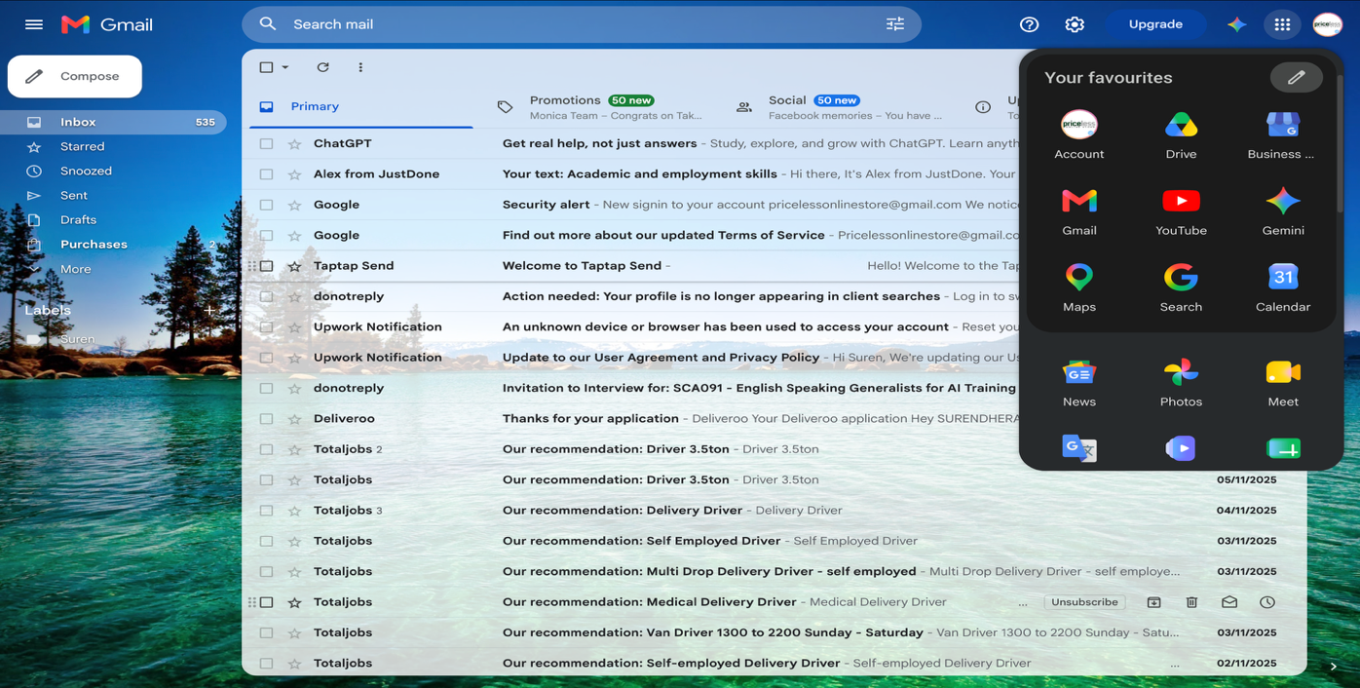
Navigation Menu
Figure 25: Show the Gmail interface (2026) mac, Source: Personal Collection.

Menu Button: The three-line menu button allows you to expand or minimise the left-hand navigation panel.
Search Mail: Helps you find specific emails quickly.
Compose Button: Click the Compose button to create and send a new email.
Inbox: Displays received emails and shows the number of unread messages.
Starred: Stores important emails marked with a star.
Snoozed: The Snoozed section contains emails that you have temporarily removed from your inbox and scheduled to appear again later.
Sent: The Sent section stores emails that you have successfully sent to other people.
Drafts: Stores emails that you have started writing but have not yet sent.
Email List: Shows the sender, subject, and date of received emails
Email Categories: Gmail organises emails into categories such as Primary, Promotions and Social, helping users manage different types of messages.
Google Apps: The Google Apps icon in the top-right corner provides quick access to other Google services, such as Google Drive, Gmail, YouTube, Maps, Calendar and Google Meet.
Settings: The gear icon opens Gmail's settings, where users can customise their inbox and email preferences
Google Account: The profile icon in the top-right corner provides access to your Google Account settings and account options.

Gmail is an easy way to send and receive emails quickly and securely. Users can enter an email address, add a subject, write a message, and attach files if needed. It makes it simple to communicate and share information with other people.
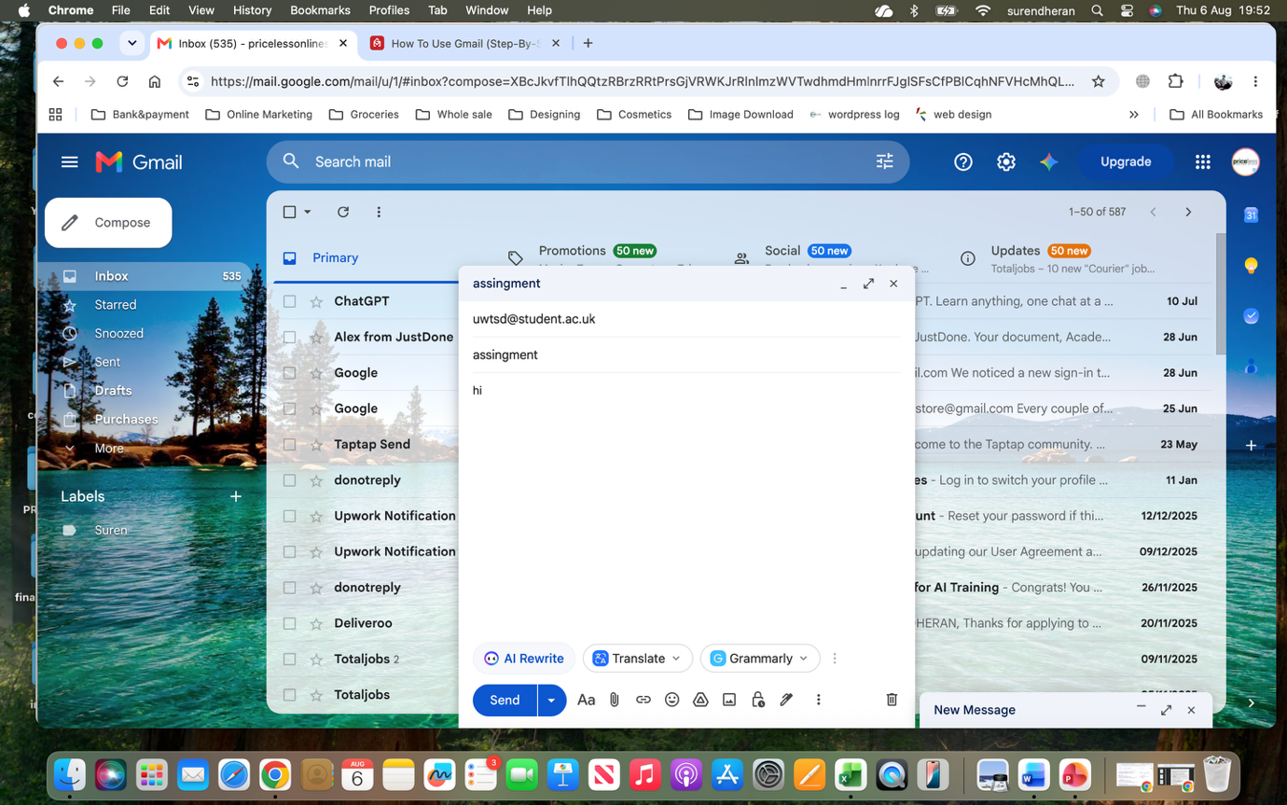
Figure 26: Show the Gmail send an email (2026) mac, Source: Personal Collection.

Zoom

Left navigation Menu
Meeting Panel
Compose button
Top Menu

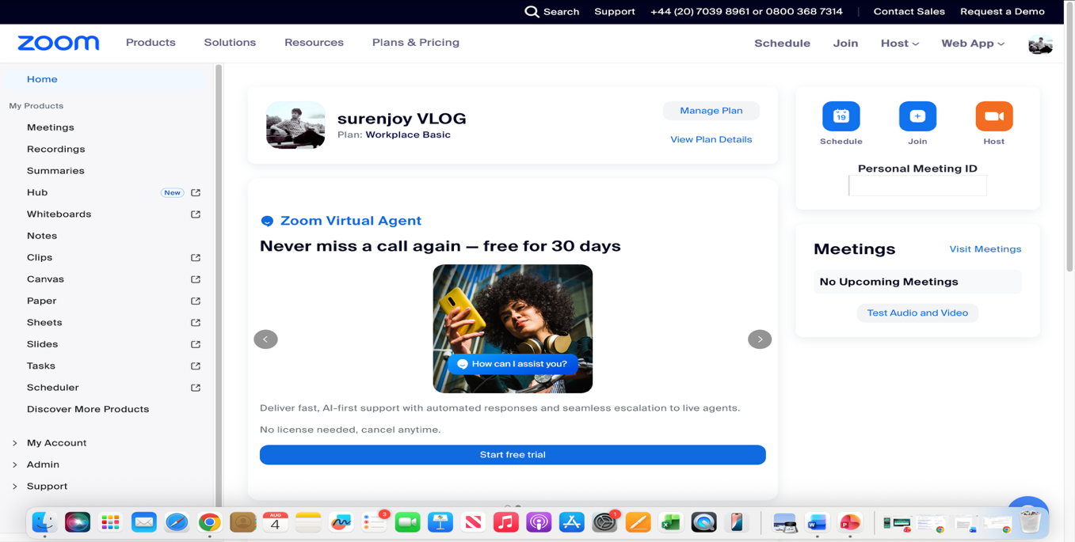
Figure 27: Show the Zoom Interface, Source: Personal collection.

Top Menu: Provides options such as Products, Solutions, Resources, and Plans & Pricing
Meetings: Allows you to view and manage your meetings
Left Navigation Menu: Provides access to Zoom features such as Meetings, Recordings, Whiteboards, Notes, and other tools.
Test Audio and Video: Allows you to check your microphone, speaker, and camera before a meeting.
Recordings: Stores your recorded meetings.
Schedule: Allows you to schedule a new meeting.
Join: Allows you to join a meeting using a meeting ID or link.
Host: Allows you to start or host a meeting.
Personal Meeting ID: Shows your personal meeting ID for joining meetings.
Meetings Panel: Displays your upcoming meetings.

Conclusion
this assignment has demonstrated the importance of contemporary software applications in supporting modern business operations. Wix and Shopify provide useful solutions for creating and managing e-commerce websites, while mind mapping helps organise ideas and support planning. Microsoft Word, PowerPoint, Excel and Access provide different tools for creating documents, presenting information, analysing data and managing databases. The practical use of VLOOKUP and IF functions showed how Excel can help users process information and make simple decisions efficiently. Furthermore, Gmail and Zoom demonstrated how digital communication and collaboration tools can support teamwork and remote working. Overall, developing practical skills with these applications can improve digital competence, productivity and effectiveness in the workplace and support future professional development in computing.

References
[1] liz masonar, rachel wlliams, “Wix vs. Shopify (2023 Comparison),” 30 october 2025.
[Online]. Available: https://www.forbes.com/advisor/business/software/wix-vs-shopify/.
[Accessed 05 august 2026].
[2] wix, “wix e commerce,” [Online]. Available
: https://www.wix.com/ecommerce/website.
[Accessed 7 august 2026].
[3] Shopify, “What Is Shopify and How Does It Work?” [Online]. Available
: https://www.shopify.com/uk/blog/what-is-shopify.
[Accessed 5 august 2026].
[4] Micromentor, “Micromentor,” [Online]. Available
: https://micromentor.org/blog/how-can-mind-mapping-enhance-small-business-growth-1.
[Accessed 27 july 2026].
[5] Sean Peek, Gretchen grunburg, “Business.com,” 12 january 2026. [Online]. Available
: https://www.business.com/articles/benefits-of-mind-mapping-for-professionals/.
[Accessed 27 july 2026].
[6] Tony Buzan, C.Griffith, “google books,” 2013. [Online]. Available
: https://surl.li/jnpzea.
[Accessed 27 july 2026].
[7] Carter, Nikkia, “Office 365 User Guide:
A Comprehensive Guide to Increase Collaboration and Productivity with Microsoft Office 365,” 2019.
[Online]. Available
: https://books.google.co.uk/books?hl=en&lr=&id=-y6WDwAAQBAJ&oi=fnd&pg=
PP1&dq=microsoft+applications+365+about#v=onepage&q
=microsoft%20applications%20365%20about&f=false.
[Accessed 09 august 2026].
[8] Meridian Outpost, “Microsoft 365 Office Apps Explained,”
[Online]. Available
: https://www.meridianoutpost.com/resources/articles/microsoft-365-office-apps-explained.php.
[Accessed 09 august 2026].
[9] Northwood Technical Community College, “ICT Learning Tools,” [Online]. Available
: https://greece.iom.int/ict-learning-tools.
[Accessed 09 august 2026].
[10] Northwood Technical Community College, “Microsoft Office Resources,” [Online]. Available
: https://itlc.northwoodtech.edu/office.
[Accessed 09 august 2026].
[11] age UK, “A Beginner's Guide to Email,” [Online]. Available
: https://www.ageuk.org.uk/bp-assets/globalassets/redbridge-barking-
-havering/digital-champions/5.-a-beginners-guide-to-email.pdf. [Accessed 3 august 2026].
[12] Salters, Madison, “Introduction to teaching with Zoom,” 2020.
[Online]. Available:https://books.google.co.uk/books?hl=en&lr=&id=Ksr2DwAAQBAJ&oi
=fnd&pg=PA8&dq=zoom+step+by+step+beginners+book&ots=ZnE0pVwwP6&sig=
_LDA1LerKbc0RGHYM2mxIbRvi2w&redir_esc=y#v=onepage&q&f=false.
[Accessed 3 August 2026].
[13] Bottorff, Broverman, Rob Watts, “Adviser,” [Online]. Available
: https://www.forbes.com/advisor/uk/business/software/wix-vs-shopify/.
[Accessed 31 10 2023].
[14] Ritoban mukherjee, owain Williams, “Techradar shopify review,” [Online]. Available
: https://www.techradar.com/reviews/shopify. [Accessed 13 02 2026].
[15] James capell, Owain Williams, Ritoban Mukherjee, “Techradar,” [Online]. Available
: https://www.techradar.com/news/the-best-website-builder?.
[Accessed 10 06 2026]

