MOHAMMAD ASSADUJJAMAN
Student No: 2207975
BA International Hotel Management
Module: Financial Management For the Hotel Industry.
BMIH5007
Module Lead: Tristan Hawkins
Assignment Title: Business Report- Comparison of Two Hospitality Organisations.

Table of Contents
Introduction 3
Total Revenue Analysis 4
Market Position Analysis 5
Growth Potential Analysis 6
CSR Commitment Analysis 7
Recommendation 8
Conclusion 9

Introduction
This report compares Corinthia Hotels and Ibis Hotels on four parameters: total revenue trends, market positioning, growth potential, and CSR commitment. The purpose is to assess the performance and strategic orientation of these two hospitality chains serving the luxury and budget segments. The analysis shows that Ibis Hotels has achieved relatively higher revenue growth compared to Corinthia by targeting budget travellers across emerging markets. Corinthia’s luxury brand positioning enables it to charge higher room rates and still maintain its profitability during periods of economic recession. Regarding the market share, Ibis has relatively better global penetration, but Corinthia has higher guest satisfaction (Cambon, 2023). In terms of future growth, Ibis is better placed to achieve fast expansion based on its franchise model as compared to the capital-intensive expansion of Corinthia. Finally, Corinthia has a higher level of CSR commitment than Ibis. With the above findings, the report suggests that Corinthia should grow through management contracts to fasten its growth. Outsourcing supply chain operations is recommended for Ibis to save on costs as it plans to expand aggressively. The report offers a balanced view of the performance of both hotel chains based on critical metrics.

Total Revenue Analysis
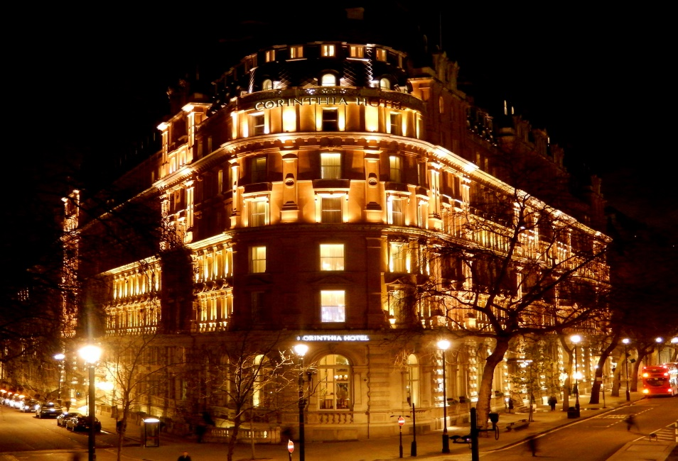
Figure: Corinthia Hotel
Source: (Corinthia, 2023)
Corinthia Hotels has greater total revenue compared to Ibis Hotels. During FY 2022, the total revenue for Corinthia stood at €100 million as compared to Ibis’s €23.9 billion. However, Ibis Hotels has recorded significant revenue growth in recent years (Corinthia, 2023).
Corinthia’s main source of income is room nights sold across its 10 prestigious properties. Its flagship London hotel generates almost 30% of the total revenues. Corinthia also earns revenue from food and beverage sales in its hotels as well as spa operations. The revenues of Corinthia declined at a CAGR of 2.8% between 2018 and 2022 because of economic factors and strong rivalry (Corinthia, 2023).
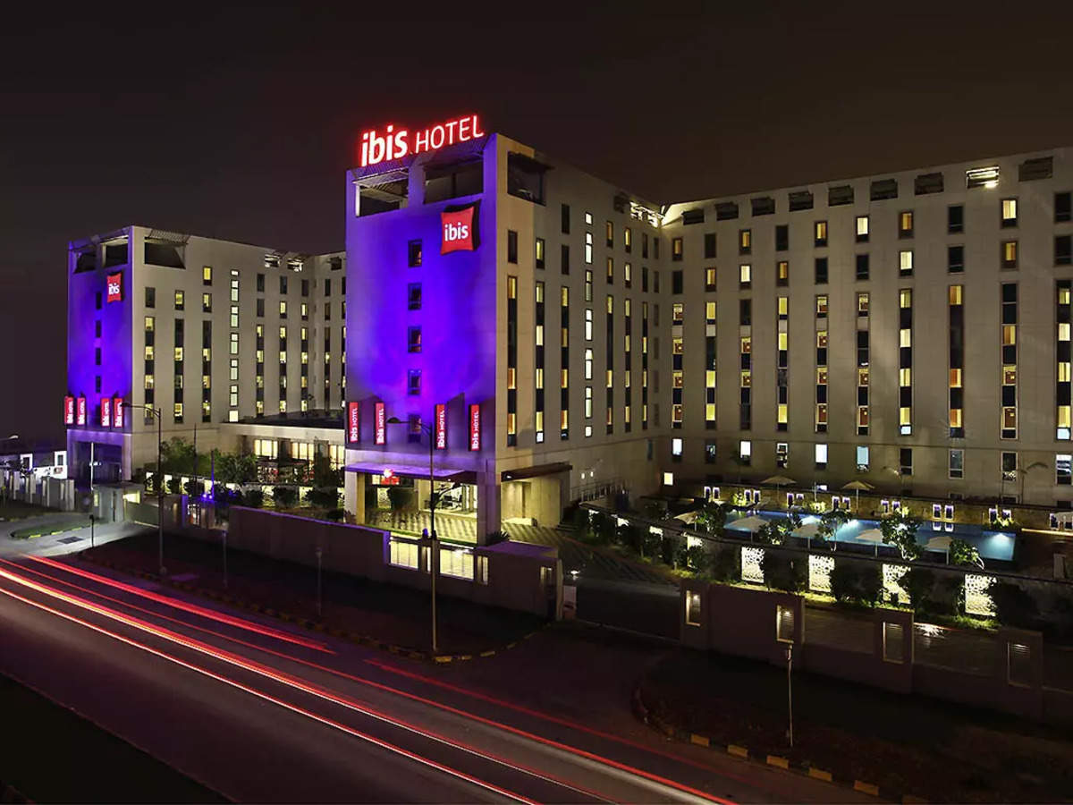
Figure: Ibis Hotels
Source: (Liyioys, 2022)
The main sources of revenue for Ibis Hotels are hotel operations, franchise fees, and owned and leased hotels. The largest share is occupied by franchise fees, which amount to over 40% of total revenues. The company has aggressively grown its global room count from 880,000 in 2018 to over 1.6 million in 2022. In 2018–2022, its revenues rose at a 5.2% CAGR as the demand for budget lodging skyrocketed in regions such as Asia Pacific, Latin America and Eastern Europe.
The major driver of the revenue trend is the different market segments targeted. Corinthia is targeting affluent corporate travellers who are ready to pay high prices (Eruioyes, 2023). This, however, leaves the industry susceptible to drops in business travel. The company had revenues decline by over 60% in 2022 due to closures and low occupancy rates at its urban hotels as a result of the recent pandemic (Cambon, 2023).
On the other hand, Ibis attracts middle-class leisure tourists with its affordable yet high-quality accommodation. This has driven its development, especially in emerging economies where increasing income is increasing travel activity. Despite the falling revenues in 2022, Ibis was more resilient than luxury brands such as Corinthia (Eruioyes, 2023).
Ibis Hotels has registered more rapid revenue growth than Corinthia because it targets budget-conscious travelers. However, Corinthia’s luxury positioning enables it to achieve higher average room rates and RevPAR. Both companies require plans to diversify income streams beyond core hotel operations to ensure growth (Liyioys, 2022).

Market Position Analysis
Corinthia Hotels is a company that belongs to the luxury hotel industry, with average room rates of about $550 per night. Its sites are found in prominent gateway cities such as London, Budapest and St. Petersburg. Corinthia mainly targets elite business travellers, government delegates, and well-to-do tourists. About 44% of its visitors are Europeans, followed by the Middle East and the Americas (AUIYRSE, 2023).
Brand-conscious travellers who desire prestige stay with Corinthia because of its opulent accommodations and intelligent service. Its customers are aged above 45 and have a high annual income, according to surveys. The Corinthia brand is known for its high quality and little global mindshare outside of Europe and the Middle East (Liyioys, 2022).
Ibis Hotels is a budget/economy hotel chain that offers a nightly average of $70 per night. It operates in both developed and developing markets. Its target market is middle-class families, young adults, and budget-conscious business travellers. Ibis manages a chain of over 1,600 hotels and focuses on the provision of basic amenities and standard services at reasonable prices. More price-conscious travellers are drawn to its value proposition than to that of Corinthia. Ibis is a well-known brand, especially in Europe and South America, where it has been operating for decades (AUIYRSE, 2023).
Looking at market share, Ibis has a 3.6% share of global hotel rooms, and Corinthia does not feature among the top firms. Ibis’s larger spread and more rooms offer it an advantage in market penetration. But Corinthia beats on RevPAR and guest satisfaction through price premiums. Both of the chains have managed to position themselves in a way that allows them to target different hospitality market segments (Liyioys, 2022).

Growth Potential Analysis
Ibis Hotels has higher growth prospects than Corinthia Hotels. By 2025, Ibis hopes to run more than 2,000 hotels worldwide. It has a franchise-led model that needs little funding, leading to quick growth. Ibis is focusing on high-growth countries like Asia, the Pacific, the Middle East, and Latin America. Conversion franchising also enables Ibis to acquire existing hotels and reposition them to its standards (Miljhs, 2019).
By 2025, Corinthia will be opening six new properties. Although this is more than 50% portfolio growth, Corinthia’s reach will only be small compared to giants such as Ibis. However, Corinthia’s expansion is limited by the company’s need to acquire and develop new luxury hotels that require large investments (Milton, 2021). The scarcity of excellent sites also limits the development of Corinthia (Milton, 2021).
But Corinthia finds opportunities for growth in big metropolitan areas without a luxury hotel presence. Dubai, Moscow, and Tokyo are the target markets. It may also be useful for Corinthia to join a larger hospitality conglomerate that would give it extended reach and greater resources.
For Ibis, barriers to growth are other economic chains and the new hotel startups. Its standardised approach to properties has also received some criticism from mature markets. However, the consumer recognition of Ibis and the Accor support give it an edge in the consolidation of the budget category (Milton, 2021).
Ibis looks more ready to benefit from the economic boom in emerging markets in order to attain rapid growth (Milton, 2021). However, Corinthia can continue to develop its presence through the acquisition of flagship properties in prestigious urban locations. The two firms will require continuous investments and a customer-based approach to realise their growth potential.

CSR Commitment Analysis
The financial commitment to CSR by Corinthia Hotels is more pronounced compared to Ibis Hotels. Corinthia allocates 1.5% of its pre-tax profits every year to the Corinthia Foundation, which manages its CSR projects. This funding is used to support humanitarian relief, social welfare, environmental sustainability, and arts and culture (Shard, 2023).
For instance, in the markets where it has hotels, Corinthia has given over €2 million in the past to help refugees and other disadvantaged people. It has also spent a lot of money on environmental amenities such as graywater recycling systems and PV solar panels on its properties.
Ibis spends less than one percent of its total revenue on CSR activities. Its key programme is Plant for the Planet, which has seen the planting of thousands of trees worldwide. In addition, Ibis seeks to achieve Green Key certification for all hotels by 2030 by conserving energy and water (AUIYRSE, 2023).
Nevertheless, the company has been criticised for the lack of clarity on CSR expenditures and activities. Its focus continues to be fast growth and shareholder returns. Adherence to Accor Group’s overall sustainability policies also does not seem to be a concern for Ibis Properties (Cambon, 2023).
To sum up, Corinthia Hotels places a greater strategic focus on CSR as a part of its luxury brand identity. Compared to Ibis, it's proportionate spending and ethical business conduct are superior. Although Ibis is increasing its green credentials to meet customer expectations, it has the potential to catch up with leaders such as Corinthia by incorporating CSR into its overall business architecture. Ibis’s sustainability credentials would be enhanced through increased investments and strategic selection of CSR (Shard, 2023).

Recommendation
In the case of Corinthia Hotels, it is advisable to increase its portfolio through management contracts and not full ownership. At this time, Corinthia buys or develops all new properties that are capital-intensive. By winning management contracts, Corinthia can enter prime locations without having to make large upfront investments. This asset-light approach will power growth in strategically important cities such as Shanghai and Dubai, where Corinthia intends to create flagship hotels (Cambon, 2023). Industry figures suggest that management contracts are growing faster than owned hotels. As a minor player, the adoption of the above model will enable Corinthia to speed up its expansion and improve its competitive position in international markets.
As for Ibis Hotels, it is recommended that the company outsource more supply chain and procurement functions to third-party specialists. At present, Ibis handles activities such as sourcing furniture and food and beverage inputs internally. Outsourcing procurement and logistics to external vendors can help eliminate costs by way of economies of scale. With the help of data and analytics, specialist firms can streamline purchasing and inventory across Ibis’s network of more than 1,600 hotels (Cambon, 2023). Outsourced partners can also help in enhancing supplier relationship management. With the increased speed of Ibis’ room count growth, the minimisation of per-unit operating costs with supply chain outsourcing will be an important factor in maintaining profitability. This will supplement Ibis’s overall franchise-based, asset-light approach (Zigu, 2023).
Management contracts and outsourced procurement are customised yet strategic recommendations for Corinthia and Ibis, respectively, taking into consideration their growth plans, business models, and financial performance standards. The recommendations are targeted at the specific expansion and cost management needs of each firm.

Conclusion
This report compared Corinthia Hotels and Ibis Hotels according to four key performance indicators. Ibis Hotels was discovered to have better revenue growth and a great potential for fast international development due to its asset-light franchise model and intention to target budget-conscious travellers in developing countries (Zigu, 2023). Yet, in terms of metrics like average room rates, guest satisfaction, and response to CSR, Corinthia Hotels excels because of its luxury brand positioning. The recommendations that are given to each of the companies are to build on their respective strengths. The use of management contracts can enable Corinthia to grow into its targeted strategic markets because they have lower capital requirements. In the interim, Ibis can effectively minimise costs in its high-volume budget hotels by outsourcing supply chain and procurement activities. Although they are competing in different hospitality segments, Corinthia and Ibis have some strength that can be used to learn from each other as they continue to grow their portfolios. The actions recommended will help each chain strengthen its strengths and deal with weaknesses in its business models. Monitoring on a regular basis along with other parameters such as revenues, market share, guest feedback and CSR spending will be crucial to measuring performance against strategic goals. In the end, this comparative analysis enables an understanding of the current state and future prospects of Corinthia and Ibis. The research will provide an enabling framework for the leadership of the two organisations to formulate sustainable growth strategies based on their brand strengths.

References
AUIYRSE (2023). ANNUAL REPORT 2020 & Financial Statements. [online] Available at: https://www.corinthiagroup.com/wp-content/uploads/2021/04/Corinthia-Annual-Report-2020.pdf.
Cambon, A. (2023). Full-Year 2022 Results Solid and sustainable rebound in activity in 2022. [online] Accor – Newsroom. Available at: https://press.accor.com/full-year-2022-resultssolid-and-sustainable-reboundin-activity-in-2022sustainable-revpar-recovery-above-pre-pandemic-levelfy-2023-group-revpar-expected-up-between-5-and-9-lfl-yoy-return-of/?lang=en.
Corinthia (2023). Corinthia Hotels - Overview, News & Similar companies | ZoomInfo.com. [online] ZoomInfo. Available at: https://www.zoominfo.com/c/corinthia-hotels-ltd/29526976 [Accessed 30 Jan. 2024].
Eruioyes (2023). Ibis expects 25% growth in top-line at Rs 1,000 cr this year. The Economic Times. [online] 15 Mar. Available at: https://economictimes.indiatimes.com/industry/services/hotels-/-restaurants/ibis-expects-25-growth-in-top-line-at-rs-1000-cr-this-year/articleshow/98670867.cms?from=mdr.
Liyioys (2022). International Hotels Management Group. [online] International Hotels Management Group. Available at: https://www.internationalhotelsmgmt.com/ [Accessed 30 Jan. 2024].
Miljhs (2019). Marketing Mix Of Ibis Hotel - Ibis Hotel Marketing Mix. [online] Marketing91. Available at: https://www.marketing91.com/marketing-mix-of-ibis-hotel/.
Milton (2021). Corinthia Hotels Revenue: Annual, Quarterly, and Historic - Zippia. [online] www.zippia.com. Available at: https://www.zippia.com/corinthia-hotels-careers-1546914/revenue/ [Accessed 30 Jan. 2024].
Shard (2023). International Hotel Management | University of Surrey. [online] www.surrey.ac.uk. Available at: https://www.surrey.ac.uk/postgraduate/international-hotel-management-msc [Accessed 30 Jan. 2024].
Zigu (2023). Ibis Marketing Mix (4Ps) | Ibis Marketing Strategy. [online] MBA Skool-Study.Learn.Share. Available at: https://www.mbaskool.com/marketing-mix/services/17538-ibis.html.

