HTML & CSS Web Development
ACCA4018
Lowrie Proctor - 1903551
University of Wales Trinity Saint David
Module: ACCA4018
Submitted: 23/07/2019

Table of Contents

Introduction 1
Requirements 1
Implementation 2
Validation 7
Evaluation 8
Accessibility Evaluation 9
Search Engine Optimisation 13
Recommendations 13
References 14

Introduction

The following report examines a website created by the author; considering the purpose, aesthetic appearance and function of the site, examining its accessibility and identifying recommendations for future developments.

Requirements

The website created by the author is designed for a health spa (Zen Spa). The purpose of the website is to provide information on services and facilities offered by the spa, which includes various treatments, fitness gym, and café. The website was constructed in a way to hopefully attempt to entice visits and bookings through the use of appealing language and images. Considering the nature of a health spa the target audience is considered to be largely females, varying in age, however endeavouring not to discourage other audience groups through including neutral language and images.

Implementation

The screen shots below display the Zen webpage as it appears for users on the internet.
Home page (Index.html)
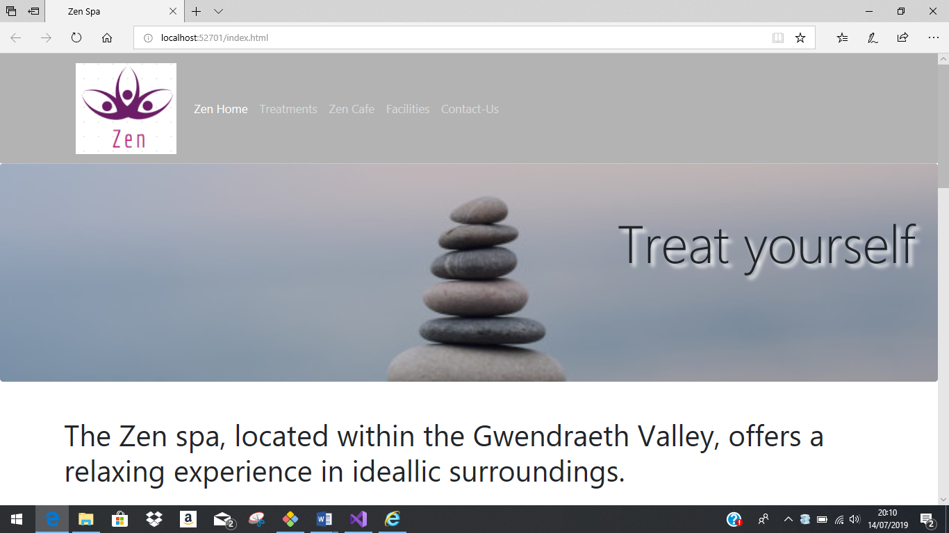
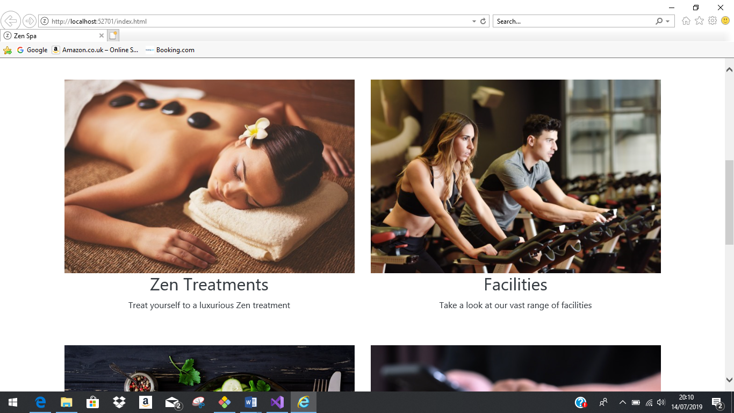
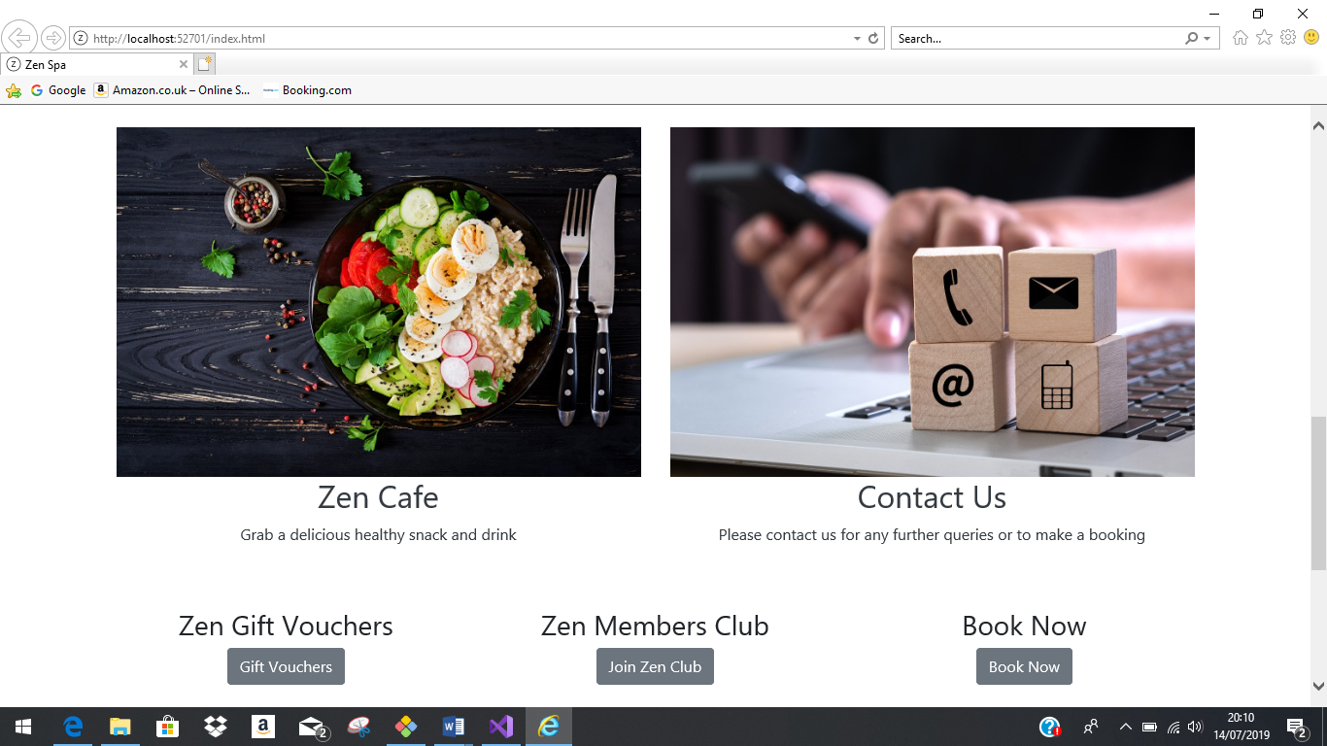

Treatments page (treatements.html)
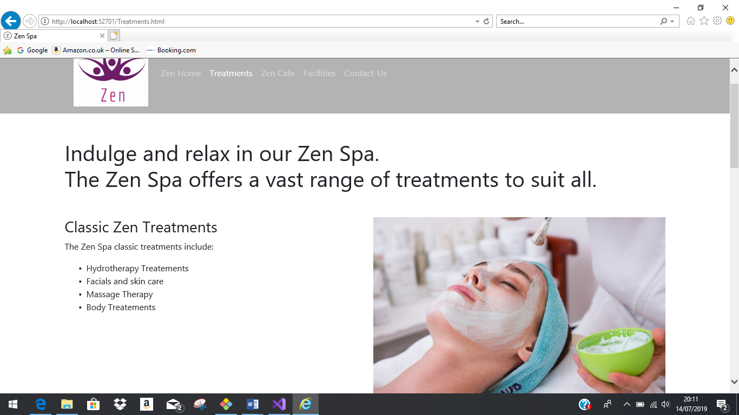
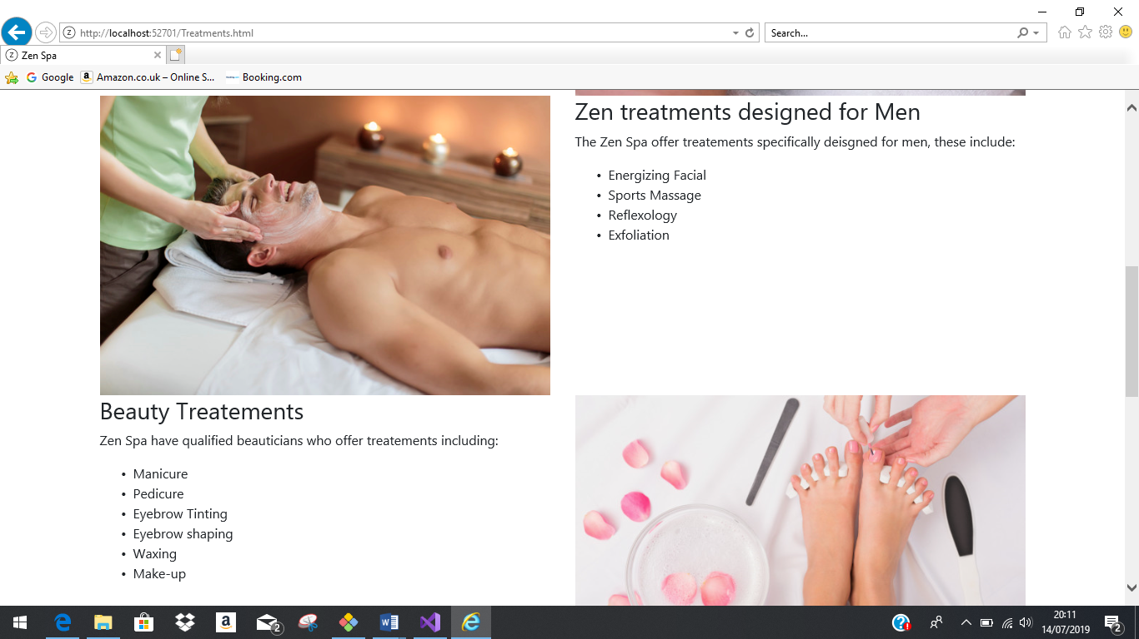

Zen Café page (Café.html)
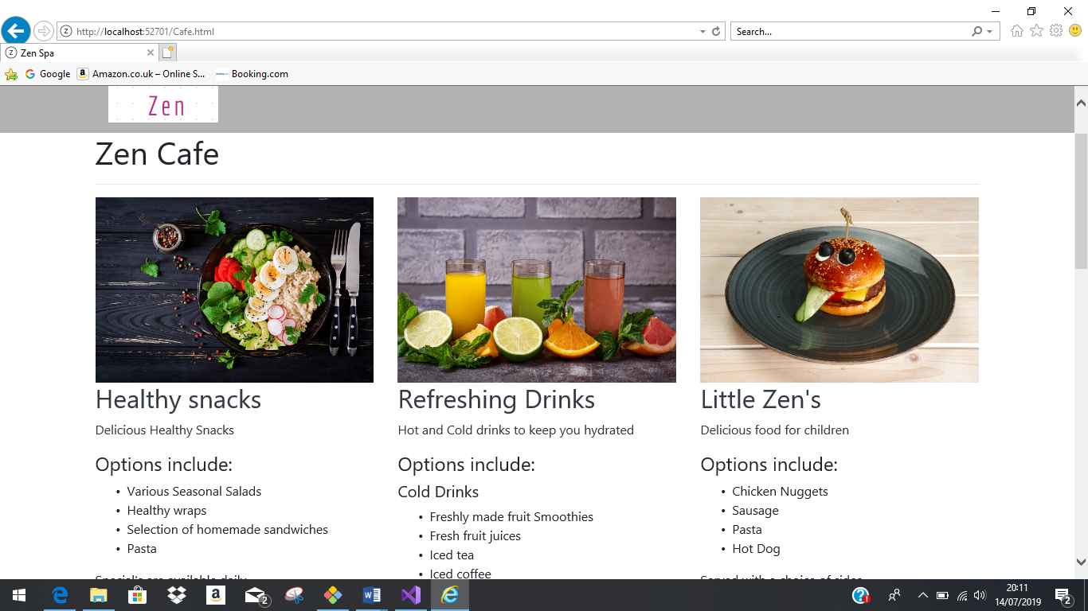
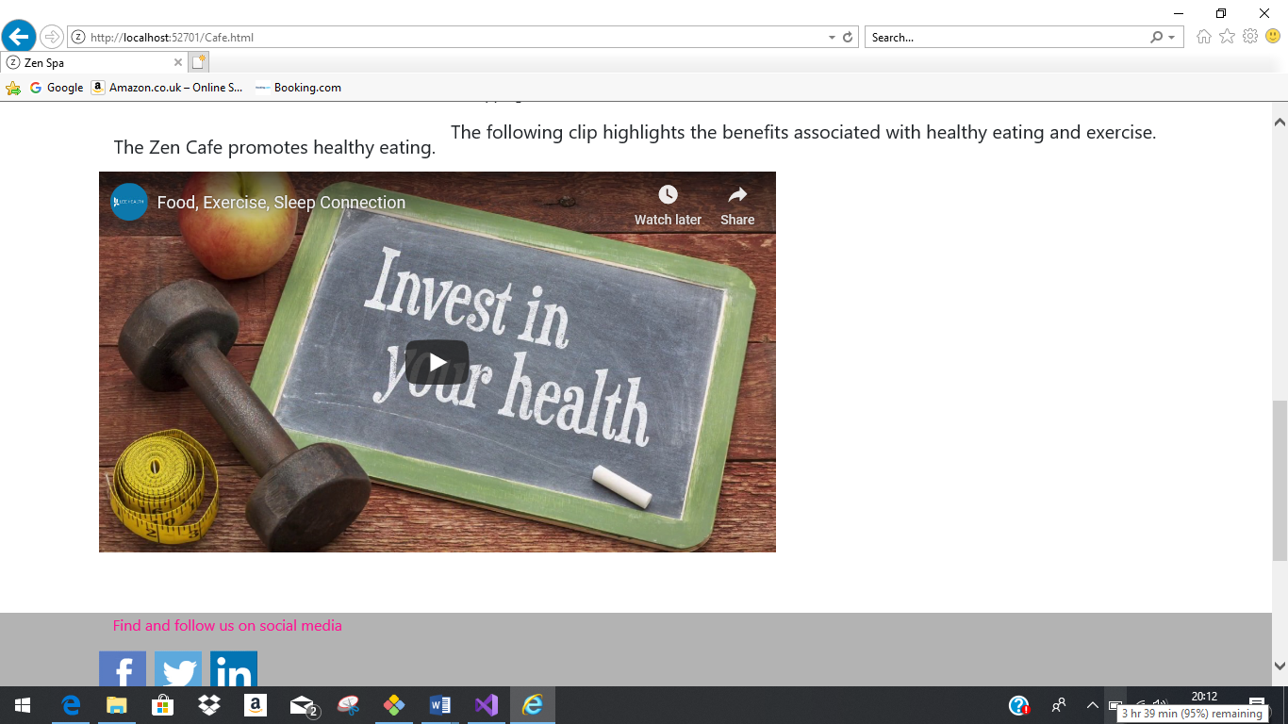

Facilities page (facilities.html)
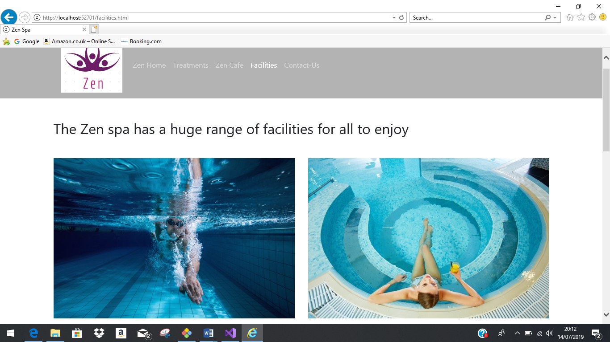
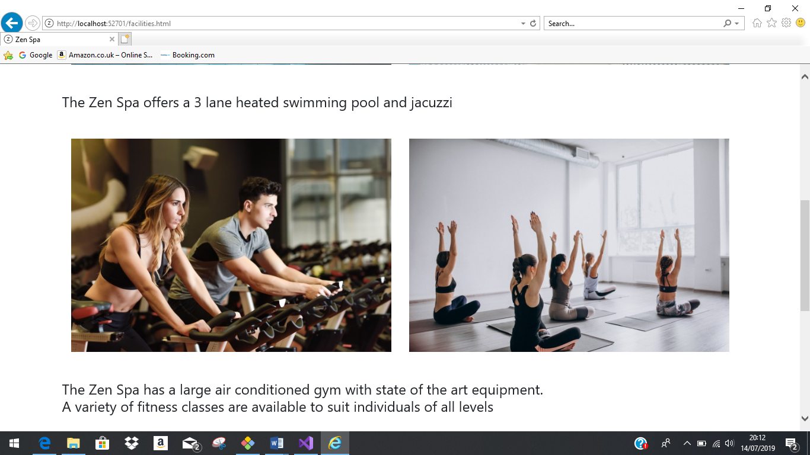

Contact us page (Contact-us.html)
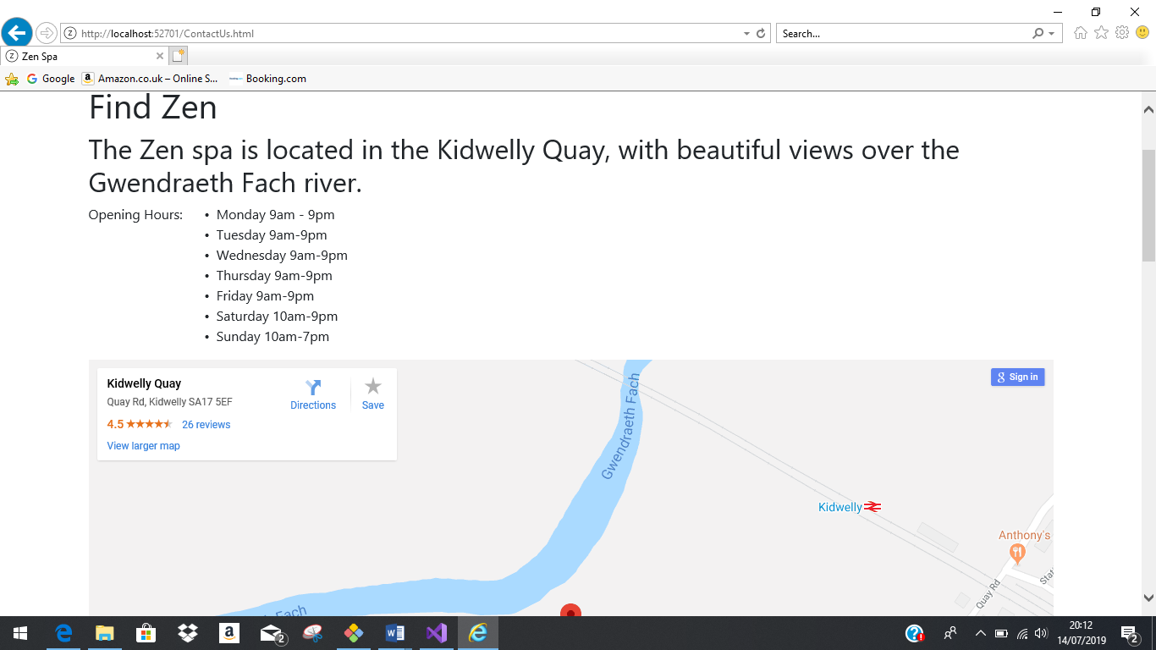
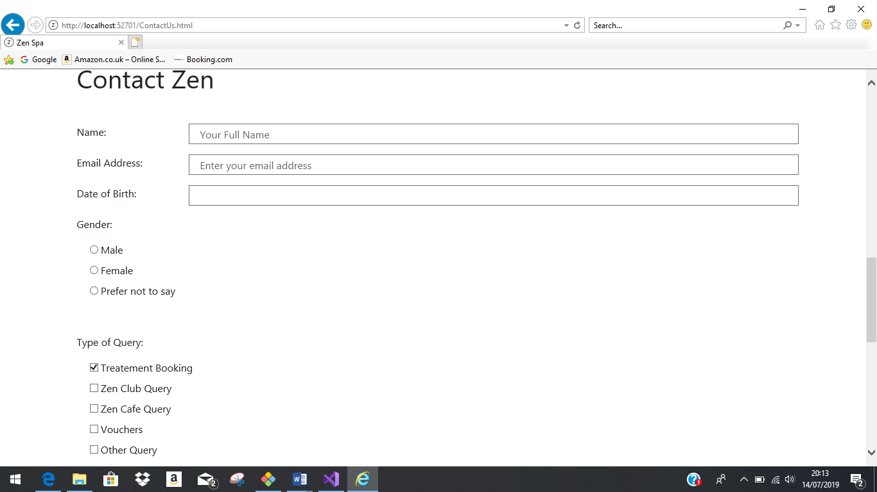
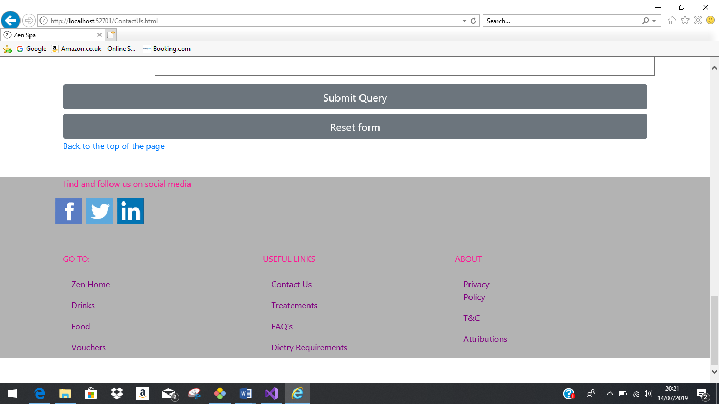

Validation

The index.html page code was input into the W3C mark-up validation service [1] in order to verify the content, to highlight any errors or warnings. The image below [1] illustrates the results of the validation, providing a return of 2 warnings, however no errors reported. The warnings indicate the need to consider the use of additional headings in order to separate the content, and also the use of the h1 tags for top-level headings only. The ‘h1’ element was chosen by the author for sections purely due to the font size. On reflection the amendment of the font size and style in CSS may have been a more suitable method to use for this function, ensuring that screen readers and other tools would read the content appropriately for accessibility.
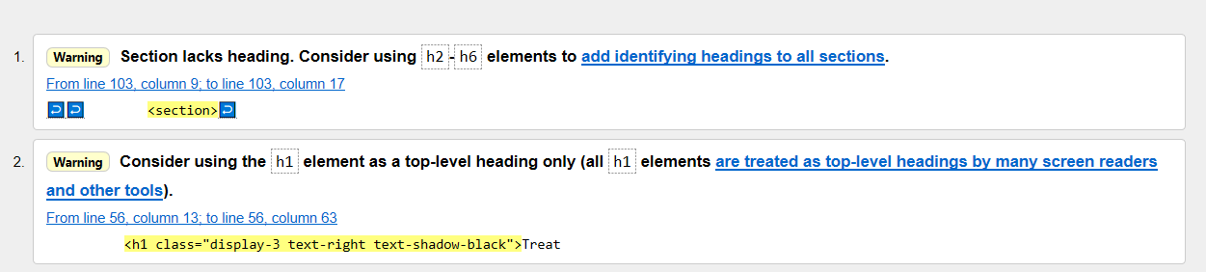
The CSS page was also validated using the w3 CSS Validation service [2] with the image below providing a result of no errors found.
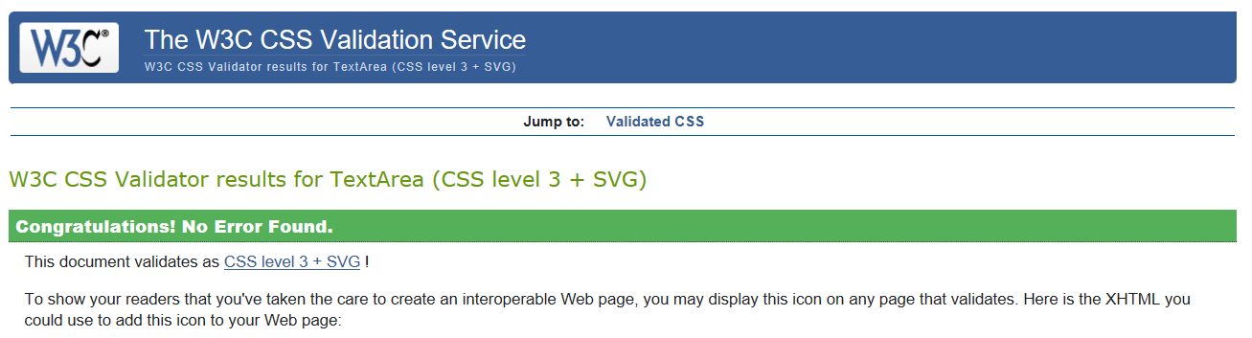

Validating the code content of a website is important as it provides an uncomplicated way of checking whether the page was constructed in accordance with web standards and also provides an assurance that it will function in future web platforms and any maintenance can be performed easily. The use of validating assists in recognising error and considering accessibility [3].

Evaluation

Evaluating the Zen website the author considers the look and feel, content and usability.
Look and feel
The use of images makes the webpage visually appealing and are all appropriate for their purpose and correspond to the section they refer to. The pages of the site all have a different main content layout, however all are thought to be engaging, clear and easily navigated.
The inclusion of a video and map provide an additional dimension and are effective in retaining interest and displaying the author’s message in a clear and concise way.
Upon reflection there are however some blank sections that have no content included. Consideration should be given to reducing the amount of blank space through effective use of layout and/or additional content.

Content
The content is written in understandable language whilst using descriptive and attractive words to encourage users to visit/book the facilities on offer. The content is formatted using various size headers and the use of bullet points and lists constructs the content in a clear, easily read manner.
Although there is not a vast amount of written content, it is believed that the content is relevant and that there is sufficient information included for the user to comprehend. The content is considered by the author to be appropriate to the subject matter and towards the target audience.

Usability
The Zen website is easy to navigate with many sections exposing links to appropriate sections. The navigation bar options display clearly which page is currently active, whilst the sections on the footer adapt colour upon hovering to show visibly which section is to be selected.
The use of the ‘_blank’ target function causes sections, including the social media links, to open in a separate tab. This function ensures that the Zen webpage remains open and the user is not distracted away permanently promoting the user to return and continue to browse and operate the Zen pages.

Accessibility Evaluation

The term web accessibility refers to the intention of ensuring web information and services are available and useable to as many people as possible [4]. Accessibility must consider a wide range of disabilities including visual, physical, auditory, language, speech, cognitive and neurological [5]. The UN Convention on the Rights of Persons with Disabilities, as cited on the w3 website [6], acknowledges that having “access to information and communications technologies, including the web, as a basic human right.” Consideration must be given that in many instances appropriate web accessibility is required by law [6].
To ensure web pages and content is as accessible as possible Web Content Accessibility Guidelines (WCAG) were introduced. The WCAG are constructed around four key principles. These principles are defined as follows [7]:
Perceivable- Interface components and the information must be presented to users in a recognised format.
Operable-All interface components and navigation must be operable.
Understandable- The control of the interface and information held within must be understandable.
Robust- The content must be considered robust in that it can be deciphered by a variety of user agents.
It is considered that should any of these four principles not be met then users with disabilities will not be able to use the web [7]. Each principle, noted above, also have set guidelines and success criteria’s that assist in adopting these principles for individuals with disabilities.
Following the latest WCAG 2.1 standards will ensure content is made as accessible as possible to a wider range of individuals with disabilities. Consideration must also be given that web accessibility is also in relation to its accessibility on various browsers and agents [5], and benefits of implementing accessibility strategies also benefits individuals without disabilities.
It is considered that despite the standards and guidelines available web accessibility continues to be at a disappointing level [4]. Vollenwyder et al [4] considers the challenges to conforming to these requirements include lack of general awareness and insufficient knowledge. Although there is an increase in compliance [8] Asakawa considers that “some sites only try to comply with regulations and guidelines, but without understanding the needs underlying Web accessibility”.
Evaluating the Zen Spa website, the author considers how it conforms to the principles of the WCAG 2.1 accessibility standards.
The images and icons inserted by the author include the ‘Alt text’ attribute – this ensures that the image information is accessible for those individuals that are visually impaired and use a screen reader. As many of the images included in the website are for decoration only there is no alternative description. In addition to those individuals with a visual impairment this function is also ensuring accessibility for those that have chosen to turn off the downloading of images due to low bandwidth or expensive tariffs [6].
Consideration must be made to the use and suitability of the contrast in the background colour. This is important for those who are colour blind and rely on the ‘proper’ design and use of colour contrast [6]. The effective use of colour and contrast is also important to consider for elder individuals with reduced colour perception and near-focus. On reflection the colour choices and contrast used in the header and the text in the navigation bar may not be suitable and could be difficult to be read easily by all.
To ensure the pages are usable, and aesthetically appealing on various size devices, the use of the ‘fluid’ function was utilised by the author.
The auto play function has been consciously removed from the video, held in the café.html page, to ensure that it is not automatically played to avoid distraction and consequently the user can play, pause and adjust the volume when required. This is important for those using assistive tools i.e. an assistive listening device. In addition to this purpose it is also important to consider accessibility to elder individuals with hearing difficulties.
The content is considered to be organised efficiently, by ensuring all pages have clear titles with descriptive section headings and more than one link available to each page. The navigation bar informs the user which page they are currently active on. These factors are imperative as individuals navigate through websites in varying ways depending on their own preferences and needs [6]. Attempts were made to ensure that the code was written in a logical order, important for the use of assistive devices.
The buttons and links are considered large enough for ease of use. The labels used in the ‘contact us page’ are defined in the HTML code by a corresponding name, this ensures support by the use of any voice supporting programme. [6] The HTML page also defines the language to be use, and the language used is considered clear and understandable.
The webpages created on the Zen web page all encompass the same header and footer format. This provides consistency and predictability. W3 [6] advises various individuals may rely on this predictability to avoid disorientation or distraction. The use of consistency also allows those users who memorise various steps or have assigned personalised shortcut functions to frequently used pages [6]. The cognitive ability of older people includes reduced short-term memory and being easily distracted. The ease of use of the navigation and consistency ensures accessibility to older users as well.
The contact-us page comprises of a form for user completion. Accessibility was considered in the creation of the fields ensuring descriptive instructions to what information the field requires and the opportunity for the user to reset the form if necessary.
An accessibility test was completed on the website solution using Visual Studio 2017. The extract below illustrates that 18 issues were identified in the results, all being warnings with no errors.

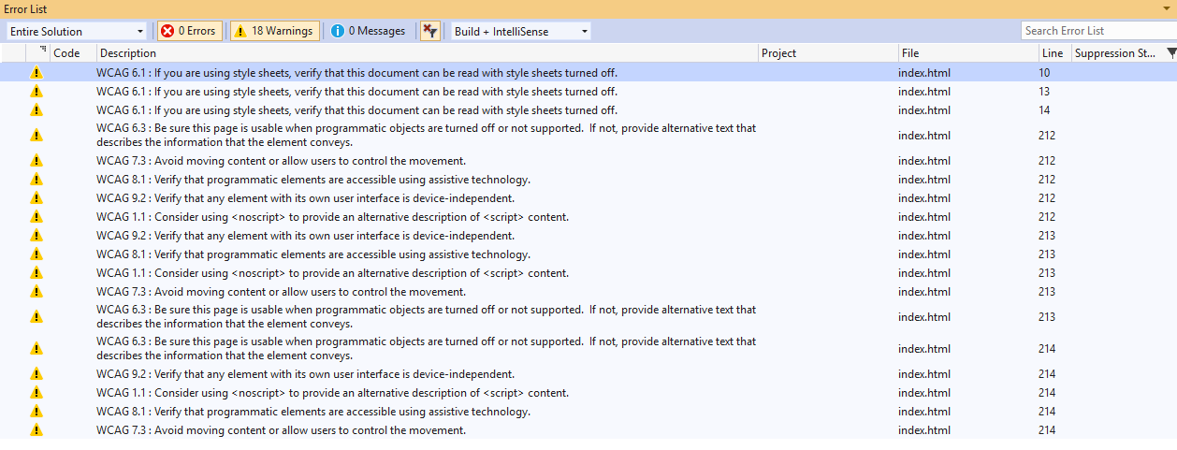
Observing the errors a test was completed by the author, using the ‘inspect’ function within google chrome, deleting the elements using CSS, to view the website. The image below demonstrates the result of this amendment, showing that the web page although not attractive is readable without the use of the style sheet.

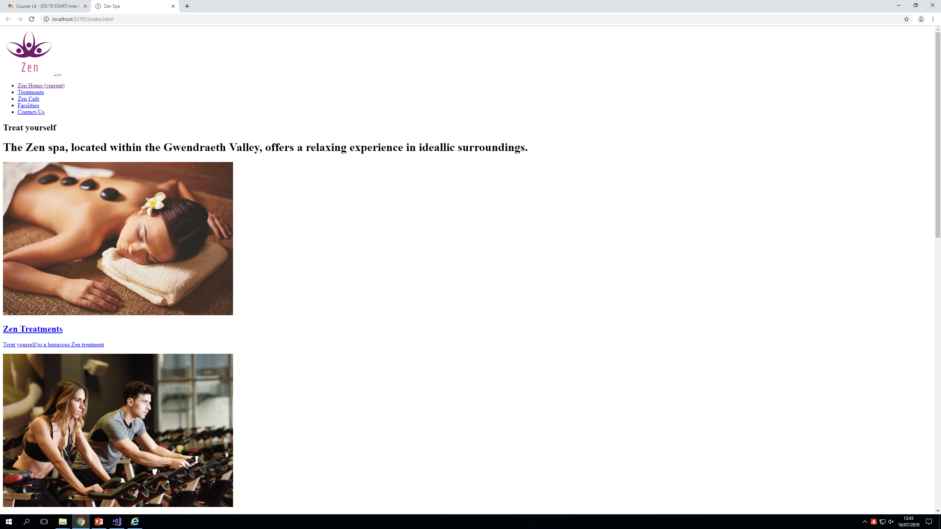

An accessibility evaluation was completed using the ‘Wave’ tool [9]. The image below demonstrates the results, identifying the contrast errors within the header and footer – identified as being very low contrast between foreground and background colours. Adequate contrast is required for all users, especially those with low vision.

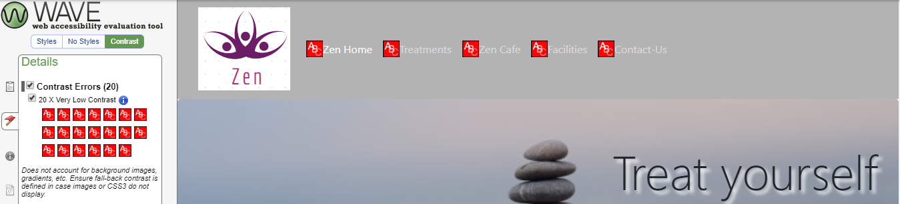
Robust content is considered “compatible with different browsers, assistive technologies, and other user agents” [6]. The Zen website includes the use of appropriate names and values for various functions for assistive technologies and user agents, however giving consideration for the site to be compatible with different browsers the use of additional code would be of benefit, using tools such as https://autoprefixer.github.io/.

Search Engine Optimisation

Search engine optimisation ensures a website can be found by online search engines through the use of descriptive words and phrases.
Within the Zen website the author has utilised the Meta description tags. The keywords ‘Zen, spa, relax, massage’ have been chosen to describe the website. The organisation name ‘Zen’ has been utilised as the page title. Use of appropriate title tags tells the user and search engines the content of the page. Correct layout of these titles, within the ‘head’ element ensures optimisation. Upon reflection the use of different title tags would have increased its search engine optimisation.
The responsive design of the pages within the Zen website ensures the pages are accessible on various size devices, including mobiles, this increases its search optimisation for various devices.
The author has made use of the Alt tags on the images included in the website, along with increasing accessibility this also provides search engines with a description of the image, if applicable, increasing the possibility of it appearing on a search.

Recommendations

Examining the evaluation of the Zen website the author considers that there are a number of improvements that could be made for future developments.
Taking into account the use of colour and contrast, alternative options would be chosen, to increase accessibility. An online tool i.e. https://webaim.org/resources/contrastchecker/ would be utilised to confirm best use of contrast.
Evaluating the ‘Contact us’ page, the use of the ‘get’ method in the form section must be deliberated. Consideration is required that the ‘get’ option is not a secure option and consequently not suitable for the use of personal, secure data. The use of the ‘post’ method would be more suitable due to its security precautions. The inclusion of a confirmation page upon submitting the contact form would also be an advantage to inform the user that their form has been received and managing expectations of a response.
The use of animations, including transitions and transformation may be a valuable addition to add interest and generate attention to certain aspects i.e. adding effects to the book now button.
The footer of the website, reflected identically on each page, contains some links to sections which have not yet been created i.e. FAQ’s and T&C’s. These have been included to provide an example of the content that would be included, prior to publishing the website the author would ensure all links are active, directing to appropriate pages.
Reflecting on the accessibility warnings, future developments of the site would embrace the recommendations, including appropriate use of the heading structures, effective us of the ‘meta tags’ and titles on each page, whilst also including additional code to ensure compatibility with all browsers.
Recognition is given that web accessibility guidelines and user requirements are continuously updating and consequently regular reviews and examinations of the pages are required to ensure compliance and to ensure the site remains relevant and appealing.

References

[1] | “w3,” [Online]. Available: https://validator.w3.org/#validate_by_input .
[2] | “CSS Validation Service,” [Online]. Available: http://jigsaw.w3.org/css-validator/. [Accessed 12 July 2019].
[3] | “Why Validate?,” [Online]. Available: https://validator.w3.org/docs/why.html. [Accessed 15 July 2019].
[4] | B Vollenwyder, G H.Iten, F Bruhlmann, K Opwis and E D.Mekler, “Salient beliefs influencing the intention to consider Web Accessibility,” Computers in Human Behaviour, vol. 92, pp. 352-360, March 2019.
[5] | “Web Content Accessibility Guidelines (WCAG) 2.1,” 05 June 2018. [Online]. Available: http://www.w3.org/TR/2018/REC-WCAG21-20180605/#sotd. [Accessed 10 July 2019].
[6] | “Accessibility,” [Online]. Available: http://www.w3.org/standards/webdesign/accessibility. [Accessed 11 July 2019].
[7] | “Introduction to Understanding WCAG 2.1,” [Online]. Available: http://www.w3.org/WAI/WCAG21/Understanding/intro#understanding-the-four-principles-of-accessibility. [Accessed 10 July 2019].
[8] | C. Asakawa, “What's the web like if you can't see it?,” W4A '05 Proceedings of the 2005 International Cross-Disciplinary Workshop on Web Accessibility (W4A) , pp. 1-8, 10 May 2005.
[9] | “wave.webaim.org,” [Online]. Available: https://wave.webaim.org/. [Accessed July 2019].

marking criteria and Student FEEDBACK

This section details the extent to which the assessment criteria are demonstrated by you, which in turn determines your mark. The marks available for each category of skill are shown. Lecturers will use the space provided to comment on the achievement of the task(s), including those areas in which you have performed well and areas that would benefit from development/improvement.

Common Assessment Criteria Applied (Assignment 1) | Marks available | Marks  awarded
1. Engagement with Literature Skills

Overall, demonstrates excellent engagement with literature skills and materials have been appropriately referenced including third-party content used for the website. I would have also liked to see some evidence of research for the on-page SEO evaluation section. (Grade mark: 90.00%) | 5 | 4.5
2. Knowledge and Understanding Skills

Demonstrates a very good understanding of the standards used to design and implement a website as demonstrated by the interpretation of the validation results and overall valid HTML and CSS implemented in the website. As mentioned above, the research on web accessibility was very detailed and this is further evidenced by the excellent accessibility evaluation of the implemented website - well done. The on-page SEO evaluation is good but could be improved. Detailed recommendations for improvements have also been discussed. (Grade mark: 85.00%) | 30 | 25.5
3. Cognitive and Intellectual Skills

NA | NA | NA
4. Practical Application Skills

A very good attempt featuring a well-thought-out website with good and relevant content and a very good attempt at making it responsive. There is, however, some room for improvement in the layout and responsiveness of some sections. Also, be careful with your choice of colours as you have also identified in your evaluation section. See your report for detailed, suggested improvements and some corrections. (Grade mark: 77.50%) | 60 | 46.5
5. Transferable Skills for Life and Professional Practice

The report is generally well-written and presented. (Grade mark: 70.00%) | 5 | 3.5

Assignment Mark (Assessment marks are subject to ratification at the Exam Board. These comments and marks are to give feedback on module work and are for guidance only until they are confirmed. ) | Late Submission Penalties (tick if appropriate) |  | 80%
 | Up to 1 week late (40% Max) |  | 80%
 | Over 1 week late (0%) |  | 80%

