
BTEC Higher National Certificate / Diploma
Health and Social Care
Title: The Role of a Social Worker in Safeguarding
Vulnerable Individuals in Health and Social Care
Name: | Fernanda Egypc Ponta Garca Carvalho
Student ID: | 2525127
Module Code: | LCHS4001
Module: | Health and Social Care
Lecturer: | SAM PARKER
Submitted on: | 20/04/2026

Table of Contents
1.1 Introduction 3
2 Health and Social Care Social Worker. 4
2.1 Overview of Social Worker in Health and Social Care. 4
2.2 Essential skills in social work in health and social care. 4
3 Skill Improvement Strategies of Social Workers. 6
3.1 Three Strategies to enhance the Skills of Social Workers. 6
4 Conclusion 7
5 References 8

1.1 Introduction
Health and social care services have a solid foundation on the hard work of different professionals who safeguard the rights and well-being of the members of the society who are the most vulnerable. Of them, the social worker plays an especially crucial role. The job of social workers is to identify risk, coordinate care and provide individuals who are at risk of being harmed with timely and adequate support (Chisnell and Kelly, 2019). The report looks at the role of the social worker in protecting vulnerable persons in health and social care environments. It outlines the job and its fundamental responsibilities, explains the top three most important skills to do it, and ultimately, some of the main actions of cultivating and enhancing these skills.

2 Health and Social Care Social Worker.

2.1 Overview of Social Worker in Health and Social Care.
Health and social care social workers are the main agents of protection to those who cannot protect themselves because of age, disability, mental health disorder, and/or other vulnerabilities. Their contribution is important in that it helps to fill the gap between a statutory obligation and the human need of an individual in the sense that legislation like the Care act 2014 should be translated into a reality and as such, practical protection of the vulnerable is guaranteed. Risk-assessment, safeguarding plans, multi-agency response, and advocacy of the rights of service users are the main tasks of a social worker (Copperman and Brown, 2021).
This position also requires direct contact with people and their families especially under sensitive situations such as abuse, neglect, or self-neglect. As an illustration, social workers tend to respond to police or other healthcare provider referrals to evaluate the need to initiate formal safeguarding actions (Ford et al., 2020). Some of the abilities that are important to this position are good communication, legal awareness, and the capacity to make quality professional decisions in crisis situations. The skills are not effectively extras, but the basic course of ensuring that vulnerable individuals remain safe (Stevens et al., 2018).

2.2 Essential skills in social work in health and social care.
The most vital skill that a social worker engaged in safeguarding must have is effective communication. Social workers should be in a position to secure the right information out of the distressed, confused or indifferent service users. Effectual communication also makes sure that issues are properly communicated to multidisciplinary teams and documented properly. Lack of this skill risks critical risks remaining unnoticed and vulnerable people staying in the dangerous situation (Lonbay, 2018). As an example, a social worker evaluating a demented older adult has to employ simple, patient language to determine whether neglect is present, and also explain to a GP and care manager in a manner that is easily understood and responsive
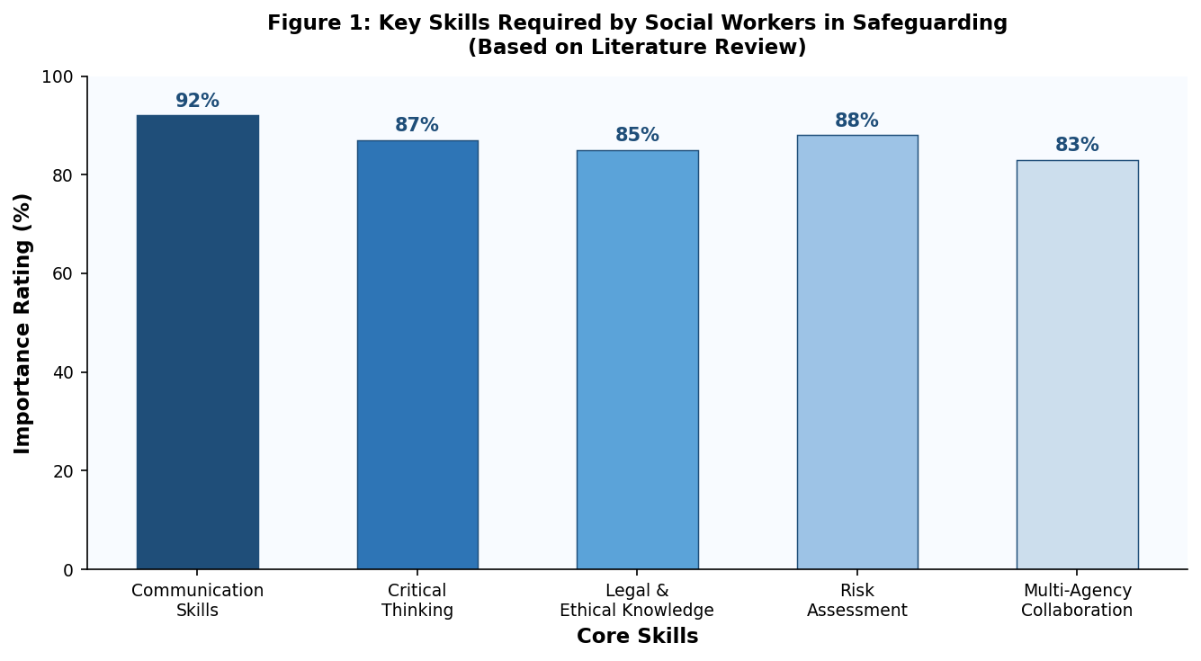
Figure 1: Key Skills Required by Social Workers in Safeguarding (Based on Literature Review)
Communication and risk assessment skills are also among the highest-rated competencies as shown in Figure 1 above as they represent the requirements of the challenging safeguarding environments. The second most important skill is critical thinking because social workers have to make professional decisions about the degree of risk a service user is at and analyse complex and unfinished information on a regular basis. It is all about evidence evaluation based on several sources, contemplating the situation of the person, and making a decision about the most suitable way of action (Engen et al., 2021).
The third core competency is legal and ethical knowledge, as the social worker should work within a set of legal frameworks. Understanding of applicable legislation- the Mental Capacity Act 2005 and the Children Act 1989, which make sure such decisions are made lawfully and ethically. Farkas and Romaniuk (2020) emphasise that ethical practice is particularly challenging in the time of emergency, like the COVID-19 pandemic, when the normal process of safeguarding was disrupted, and practitioners needed to make challenging decisions about risk and autonomy with limited information (Farkas and Romaniuk, 2020). In the absence of such skills among social workers, the service users may have a dismal future. Melville-Wiseman (2016) also discovered that professional oversight and the moral basis of registered social workers were often inadequate, which resulted in direct harm, proving that the lack of legal and ethical knowledge may cause harm (Melville-Wiseman, 2016).

3 Skill Improvement Strategies of Social Workers.

3.1 Three Strategies to enhance the Skills of Social Workers.
One such evidence-based method of enhancing the development of communication skills in social work practice is reflective supervision. It is a method in which a practitioner meets with a senior colleague in regular structured meetings where service users are reviewed and their contacts with a service user are critically analysed. The process will create an understanding of self and assist practitioners to recognize practices that might inadvertently avoid or distort the voice of the service user (Cooper et al., 2018). In practice, a new social worker can be supervised in terms of the way a safeguarding issue was communicated to a family, to get specific feedback on the tone and clarity. The consistent communication between practitioner and supervisor and discussion serves directly to enhance future casework through more confident and person-centred communication.
Case-based learning is an evidence-based route to critical thinking development through further professional development (CPD). This approach provides practitioners with realistic, challenging situations that provide an opportunity to think critically over the evidence, take into account divergent viewpoints, and use the principles of the law, which are much similar to the requirements of a real-world safeguarding practice. Harris et al. (2023) established that social workers who participated in training that used vignettes about self-neglect exhibited better professional judgement on when and how to intervene, appropriately. Business organisations can incorporate case-based learning into the yearly CPD cycles so that analytical capacity throughout the workforce is continually enhanced as opposed to being gained by direct experience.
The most appropriate approach to the development of legal and ethical knowledge is multi-agency training because it introduces the frameworks of the working process of partner agencies such as healthcare, police, and education. Inter-professional collaboration can be more consistent when the practitioners are aware of how their statutory duties are interpreted by other agencies and the gaps in the protection can be discovered easier (Ford et al., 2020). Stevens et al. (2018) discovered that joint training of social workers and health professionals led to a more coherent perception of risk and better joint decision-making in ambiguous safeguarding scenarios. Joint safeguarding boards offer a realistic venue on which local authorities and NHS trusts can undertake this training on using actual case material.

4 Conclusion
One of the most challenging tasks in the sphere of health and social care is the protection of vulnerable people, and the social worker is the key figure in this vital activity. This report has shown that the position needs effective and safe execution through good communication, critical thinking skills as well as legal and ethical knowledge. Reflective supervision, case-based CPD, and multi-agency training are just some of the strategies providing feasible and evidence-based avenues toward skill development. These strategies should be renewed at all times in order to have an able and ethically sound safeguarding workforce. Finally, safe practice relies on lifelong learning and a strong adherence to making the vulnerable person the center of intense focus of every decision (Copperman and Brown, 2021).

5 References
Chisnell, C. and Kelly, C. (2019) Safeguarding in Social Work Practice: A Lifespan Approach. London: Sage Publications.
Cooper, A., Cocker, C. and Briggs, M. (2018) 'Making safeguarding personal and social work practice with older adults: findings from local-authority survey data in England', British Journal of Social Work, 48(4), pp.1014–1032.
Copperman, J. and Brown, H. (2021) 'Managing safeguarding across health and social care', in Leading, Managing, Caring: Understanding Leadership and Management in Health and Social Care. London: Routledge, pp.377–400.
Engen, M., Petersen, S.K., Bjerre, L.S. and Nissen, M.A. (2021) 'Does social work care? Practising care in social work with vulnerable children and their families', European Journal of Social Work, 24(1), pp.34–46.
Farkas, K.J. and Romaniuk, J.R. (2020) 'Social work, ethics and vulnerable groups in the time of coronavirus and Covid-19', Society Register, 4(2), pp.67–82.
Ford, K., Newbury, A., Meredith, Z., Evans, J., Hughes, K., Roderick, J., Davies, A.R. and Bellis, M.A. (2020) 'Understanding the outcome of police safeguarding notifications to social services in South Wales', The Police Journal, 93(2), pp.87–108.
Harris, J., Martineau, S., Manthorpe, J., Burridge, S., Ornelas, B., Tinelli, M. and Cornes, M. (2023) 'Social work practice with self-neglect and homelessness: Findings from vignette-based interviews', The British Journal of Social Work, 53(4), pp.2256–2276.
Lonbay, S.P. (2018) 'These are vulnerable people who don't have a voice: exploring constructions of vulnerability and ageing in the context of safeguarding older people', British Journal of Social Work, 48(4), pp.1033–1051.
Melville-Wiseman, J. (2016) 'The sexual abuse of vulnerable people by registered social workers in England: an analysis of the Health and Care Professions Council Fitness to Practise cases', The British Journal of Social Work, doi:10.1093/bjsw/bcw150.
Stevens, M., Woolham, J., Manthorpe, J., Aspinall, F., Hussein, S., Baxter, K., Samsi, K. and Ismail, M. (2018) 'Implementing safeguarding and personalisation in social work: findings from practice', Journal of Social Work, 18(1), pp.3–22.

