Project name | Plot 1A SA1 Swansea | Project No | 245 | Date Issued | 16/01/2022
Period covered | December 2021 - January 2022 |  |  | Issue No | 02
Completed by | Jacob Thomas | Issued To | Project Team - JT construction
Progress report JTConstruction

Contents
1. Introduction – Page 1
2. Summary – Page 1
3. Progress Since Last Report & Programme updates – Page 3
4. Issues Affecting Progress & Outstanding Deliverables – Page 3
5. Performance & Incentivisation – Page 4
6. Conclusion – Page 5
7. Appendix – Page 5

- Introduction
The development of high-rise student accommodation on Kings Road SA1 will be an exciting new addition to Swansea’s cityscape. Built in a thriving area, students can experience further education in one of the most vibrant areas of the city. This facility will boast modern and comfortable dwellings for students allowing for the best possible university experience. At JT Construction we’ve have gained a wealth of experience completing many similar projects of this nature, building our reputation through quality products. We pride ourselves on our ability to deliver a project within budget and on schedule, whilst maintaining highest standard of workmanship. Achieving such results is due to meticulous planning and continuous progress reporting through the lifetime of the project. This report dissects the project chronologically, providing in-depth analysis of resources, durations, and costs. Variables affecting project deliverables have been inputted into the programme to highlight delays and give adequate time to remedy.
Strike action taken by the local Concrete manufacturer is due to halt progress on site, causing much disruption. As delays are likely to affect the project completion date resulting in additional cost implications, this report contains guidelines on methods of incentivisation which can be used to offset these additional costs. In addition to this, the report describes how measuring and maintaining performance is essential for achieving projected targets.
- Summary – 12 Week progress expected
Site setup:
Week 1: W/E 11/02/2022
- Site boundary fencing panels installation and site secured.
- Clearance of existing car park and landscape features and remove from site.
Week 2: W/E 18/02/2022
- Ground clearance.
- Make up levels for site compound.
- Welfare facilities and site offices delivered and situated.
- Safety walkways, crossings and delivery access areas constructed.
- Storage and waste management – Site setup complete
Earthworks:
Week 3: W/E 25/02/2022
- Setting out.
Week 4: W/E 04/03/2022
- Inert strip.
Week 5: W/E 11/03/2022
- Piling mat
- Temporary sheet piles installation.
- Excavation to reduce levels – 30% completion
Week 6: W/E 18/03/2022
- Sheet piling
- Earthwork support to sheet piles.
- Continue excavation to reduce levels – 60% completed.
- Relocate piling mat
Week 7: W/E 25/03/2022
- Earthwork support to sheet piles.
- Continue excavation – 80% complete.
Week 8: W/E 01/04/2022
- Continue excavation 100%
- Level and compact surface – Excavation complete
Substructure:
Week 9: W/E 08/04/2022
- Piles bored
- Concrete cast in situ pile casings – DELAYED 5 weeks
Week 13: W/E 06/05/2022
- Concrete cast in situ pile casings
- Reinforced steel cage added to concrete piles
- Remove Piling mat
- Concrete cast in situ (pile caps)
- Pile cropping – Substructure complete
Basement construction:
Week 21: W/E 03/07/2022
- Hardcore fill
Week 25: W/E 22/07/2022
- Concrete cast in situ (Structural columns)
- Level and compact hardcore
Week 26: W/E 29/07/2022
- Blinding
Week 27: W/E 05/08/2022
- DPC
- Steel reinforced mesh
Week 28: W/E 12/08/2022
- Concrete cast in situ (Basement floor slab)
Week 31: W/E 09/09/2022 – Basement complete

3. Progress Since Last Report & Programme Updates
Structural Engineering
- Pre-construction Approval Issue package issued 29/11/2021.
- Stairway drawing updated in compliance with Approved Document B. Drawing issued 03/01/2022.
- Substructure and Superstructure construction specification pack issued 03/01/2022.
- Site Programme updated and issued to include concrete delays 05/01/2022.
- Steelwork specification to be issued 17/01/2022.
- Roof drawing updated. Drawing issued 10/01/2022.
- Rainwater disposal system under analysis due to roof redesign. Compliance with Part H – Building Regulations.
Civil Engineering
- Pre-construction Approval Issue package issued 29/11/2021.
- Pile Layout drawing updated. Drawing issued 10/01/2022.
- Site Programme updated and issued to include concrete delays 05/01/2022.
- Site Layout updated. Compound reconfigured to improve access. Build direction updated. Pack issued 05/01/2022.
- Services redesign in compliance with Part L – Building Regulations. Carpark area subsequently subject to redesign.
- Attenuation tank design specification to be confirmed. Awaiting further information from Dwr Cymru. Email sent 18/12/2021.
- Groundworks Bill of Quantities Rev C agreed 10/01/2022.
- Inclusions and Exclusions agreed 10/01/2022.
4. Issues Affecting Progress & Outstanding Deliverables
Structural
- Awaiting steelwork specification to be issued. Superstructure design could be subject to change.
Civil
- Concrete supplier strike will halt progress at week 8 of the programme. The programmes critical path will be interrupted and delayed by 5 weeks.
- Awaiting Dwr Cymru survey information regarding potential clash with existing services.
- Awaiting updated bending schedule and updated pile specification.
- Engineering drawing 10073-100 - Rev K. Levels require rework.
- Omicron variant outbreak affecting labour resources.
Strike action taken by the local supplier of concrete has become the most pressing issue likely to affect project deliverables. The strike planned coincides with our concrete works according to our as-planned programme, causing extensive delays. In reference to the Gantt Chart attached, we can see the project scope and sequence has suffered a knock-on effect as a consequence. The critical path is identified, and the dates of the affected tasks are subsequently altered through Time Impact Analysis. By factoring in the 5-week delay we can use this updated site programme to assess the impact and take action to attenuate resulting cost implications. The site programme allows us to prioritise tasks by directing or intensifying labour as required. A cost is attributed to each resource giving a continuous cost update as changes are made to the tasks.
With the unfortunate arising of such a delay comes financial burden to be incurred by the party at fault. Due to the nature of the neutral delay being availability of product, the employer is liable to defray subsequent costs as this constitutes an employers risk. The five-week delay will be considered an excusable delay. Therefore, we will not be applying for an extension of time on the contract (Infraspec, 2017).
JT Contractors are committed to providing our customers with the highest quality service. Despite the setbacks, we will work collectively to minimise the effect on project delivery date whilst providing expected standard. Outlined below is guidance on boosting productivity and methods of incentivisation to increase performance and meet required deadlines. Implementing these methods will aid project progression and reduce the consequence of such delays.

5. Performance & Incentivisation
Project progression and contractor performance can be monitored by yourselves through Key Performance Indicators. The completion of important project deliverables or project milestones are typically used as a KPI. These help to gauge success from conception to completion as the as-built information is analysed and compared with the site programme. Using such a milestone can give an accurate representation of how the contractor is performing in terms of cost and time which allows for better management of budget and allocation of resources. Each phase can be subject to a full elemental cost breakdown to audit the project thoroughly and make changes if necessary. By continuously monitoring performance, project efficacy increases as poor performance is quickly identified and redressed. KPI’s go further than cost-based analysis as the quality, productivity and worker satisfaction are all among items that can be quantified to give a better picture of the project success (Ellis, 2021).
In order to keep the workforce motivated, there are a number of methods of incentivisation. People are typically motivated through psychological or financial rewards. As the strength of relationship between client and contractor is typically based on good performance and subsequent increases in revenue generated, a financial incentive is usually the preference at a macro level. Immediate rewards for achieving targets are known as direct positive incentives and the introduction of such incentives can increase performance by reducing cost, improving quality, and ensuring project deliverables are completed on time(Collaborative Working Centre, 2000). However, it is argued that this method of incentivisation can have the adverse intended affect. Individual based incentive pay is typically associated with increased intensity of work which subsequent additional pressure could be detrimental to other positive influences on the worker such as job satisfaction and trust in management. This method is therefore best suited to achieve short term targets as the sustainability of extended terms of intense work is brought into question (Ogbonnaya, Daniels, & Nielsen, 2017). The programme delays caused by the concrete company strikes could be reduced through this type of incentivisation providing it is not actioned long term.
JT Contractors have been issued with a performance specification detailing the expected standard of work required to be completed. Through our vast experience we know the depth of the specification varies from client-to-client dependent on their specific requirements. The performance specification was considered throughout the tender process and can be used to challenge the performance, should it be deemed substandard. A percentage of the project value is typically withheld by the client as retention in order to safeguard against any defects which may arise. If contractor performance is in breach of contract, this includes delivering the project late or poor performance, the client is eligible to keep the retention through liquidated damages. This is known as a direct negative incentive as it motivates through the possibility of incurring penalties (Pye Tait Consulting, 2017, p. 32).
Alternatively, client and contractor could enter into a painshare and gainshare contract to improve collaboration and share the financial denouement. Alliance contracting provides incentives for each party while its principles encourage better relationships and greater transparency. A joint management structure promotes a no-disputes culture and a system which requires a collective effort to achieve desired outcomes. An alliance contact can be tailored as complex agreements can dictate the percentage split of pain/gain between employer and employee, dependent on the circumstances. Ideally, parties involved in such contracts should be of similar capacity as decisions made would typically favour the larger and more dominant party (Walsh, 2015).
6. Conclusion
A myriad of moving parts in a construction project means that issues are commonplace and delays inevitable. Fortunately, we can use information available to our advantage and plan for such eventualities by actioning changes to mitigate these effects. Breaking the project down into an in-depth report such as this, allows us to amend the project schedule and analyse costs should such a delay arise. Furthermore, we can monitor performance from micro to macro level and use different techniques to ensure good performance is maintained and substandard performance improved. In some cases, incentivisation is required to boost productivity and achieve best possible results. But as previously discussed, throwing money at a problem is not always the best solution.
7. Appendix
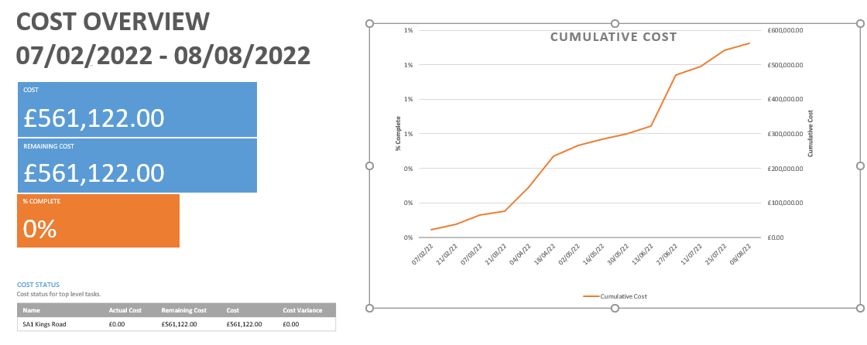
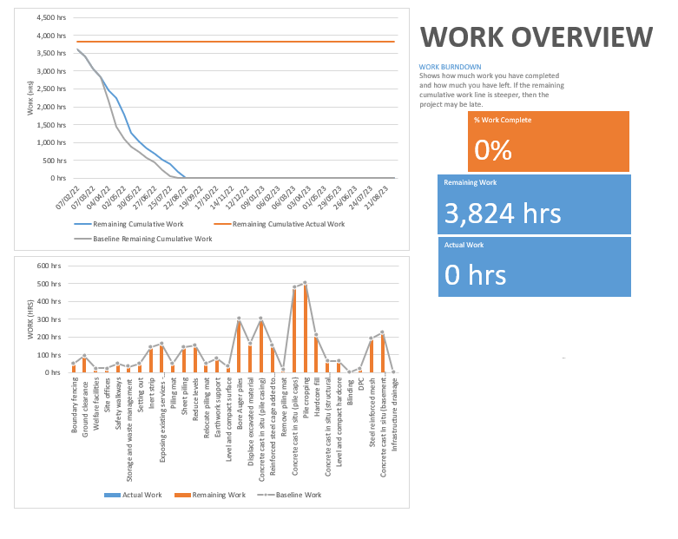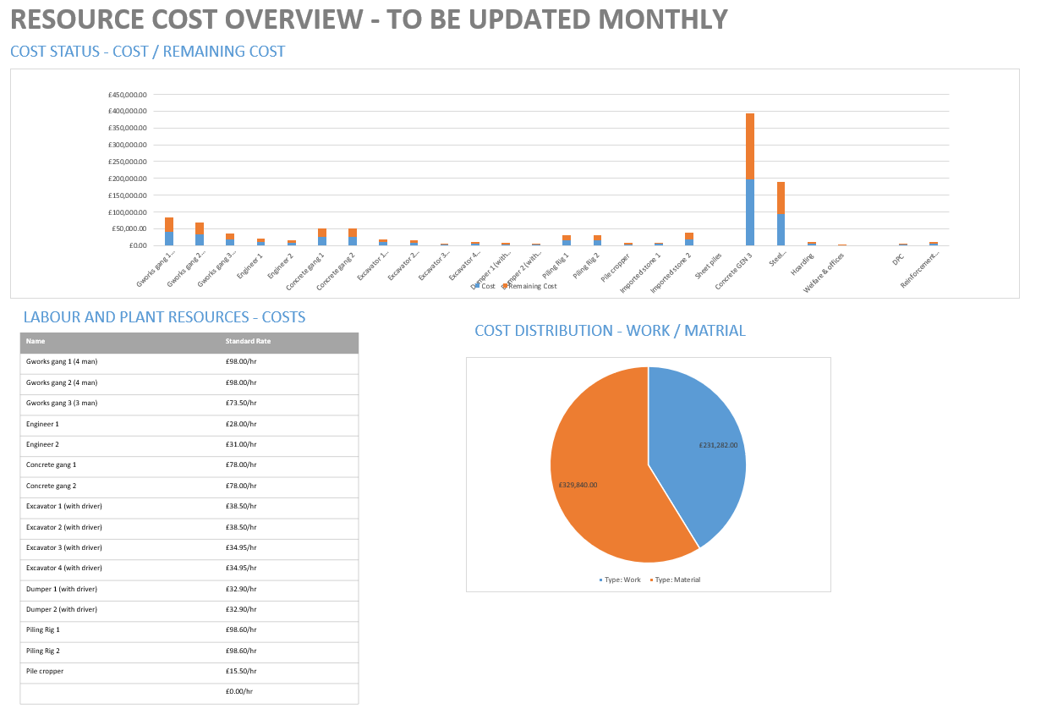

Bibliography
Benarroche, A. (2019). Which Type of Construction Delay: Excusable, Compensable, or Critical? Levelset.
Broome, D. (2012, 03 10). Incentivisation under NEC3. Retrieved from jonbroome.com: https://www.jonbroome.com/getattachment/74490c94-d9bc-46b1-aabb-7d261818a237/Incentivisation-under-the-NEC.aspx
Collaborative Working Centre. (2000). Setting Incentives and Shared Saving Schemes. London: The Tavistock Institute. Retrieved from https://constructingexcellence.org.uk/wp-content/uploads/2015/03/D6Disc-inc.pdf
Croner-i. (2013, 10 9). Gain share contracts — could you benefit? Retrieved from Croner-i: https://app.croneri.co.uk/feature-articles/gain-share-contracts-could-you-benefit
Ellis, G. (2021, March 12). Essential Construction KPIs to Improve Profits and Productivity. Retrieved from Autodesk: https://constructionblog.autodesk.com/construction-kpis/
Hughes, W., Yohannes, I., & Hillig, J.-B. (2007). Incentives in Construction Contracts: Should we pay for Performance? Cape Town, South Africa: CIB World Building Congress. Retrieved from https://www.irbnet.de/daten/iconda/CIB5038.pdf
Infraspec. (2017, 10 2). Types of Schedule Delays in Construction Projects. Retrieved from Infraspec: https://www.infraspec.co.uk/types-of-schedule-delays-in-construction-projects/
Ogbonnaya, C., Daniels, K., & Nielsen, K. (2017). Research: How Incentive Pay Affects Employee Engagement, Satisfaction, and Trust. Brighton, MA: Harvard Business Review. Retrieved from https://hbr.org/2017/03/research-how-incentive-pay-affects-employee-engagement-satisfaction-and-trust
Pinsent Masons. (2019, December 2019). Using incentives to drive contractor behaviour. Retrieved from Pinsent Masons: https://www.pinsentmasons.com/out-law/analysis/using-incentives-to-drive-contractor-behaviour
Pye Tait Consulting. (2017). Retentions in the construction industry. Harrogate: Department for Business, Energy & Industrial Strategy. Retrieved from https://assets.publishing.service.gov.uk/government/uploads/system/uploads/attachment_data/file/654399/Retention_Payments_Pye_Tait_report.pdf
Scottish Futures Trust. (2016). Review Of Scotish Public Sector Procurement In Construction. Edinburgh: Scottish Futures Trust. Retrieved from https://www.scottishfuturestrust.org.uk/storage/uploads/Target_Cost_Guidance.pdf
Walsh, P. (2015, 11 30). Practical Law Construction Blog. Retrieved from Thomson Reuters: http://constructionblog.practicallaw.com/painshare-and-gainshare-provisions-in-alliancing-contracts-the-benefits-of-pulling-together/

References
Collaborative Working Centre. (2000). Setting Incentives and Shared Saving Schemes. London: The Tavistock Institute. Retrieved from https://constructingexcellence.org.uk/wp-content/uploads/2015/03/D6Disc-inc.pdf
Ellis, G. (2021, March 12). Essential Construction KPIs to Improve Profits and Productivity. Retrieved from Autodesk: https://constructionblog.autodesk.com/construction-kpis/
Infraspec. (2017, 10 2). Types of Schedule Delays in Construction Projects. Retrieved from Infraspec: https://www.infraspec.co.uk/types-of-schedule-delays-in-construction-projects/
Ogbonnaya, C., Daniels, K., & Nielsen, K. (2017). Research: How Incentive Pay Affects Employee Engagement, Satisfaction, and Trust. Brighton, MA: Harvard Business Review. Retrieved from https://hbr.org/2017/03/research-how-incentive-pay-affects-employee-engagement-satisfaction-and-trust
Pye Tait Consulting. (2017). Retentions in the construction industry. Harrogate: Department for Business, Energy & Industrial Strategy. Retrieved from https://assets.publishing.service.gov.uk/government/uploads/system/uploads/attachment_data/file/654399/Retention_Payments_Pye_Tait_report.pdf
Walsh, P. (2015, 11 30). Practical Law Construction Blog. Retrieved from Thomson Reuters: http://constructionblog.practicallaw.com/painshare-and-gainshare-provisions-in-alliancing-contracts-the-benefits-of-pulling-together/

