Acknowledgement of AI Tool Use
I acknowledge the use of Grammarly (https://www.grammarly.com/) on 7th of June 2025 to proofread my research report for grammar, punctuation, and academic tone using the prompt(s):
- Please check the following research report text for grammar, spelling, and clarity.
- Please suggest formal alternatives and improve sentence structure suitable for academic writing.
I also acknowledge the use of ChatGPT (https://chatgpt.com/) on 7th of June 2025 to support the structure of my research report using the prompt(s):
- Please provide a professional format for a research report.
I confirm that I have not presented any AI-generated text as my own work. I confirm I have copies of my drafts, notes, and other resources I used before, and after the use of AI tools which I may be asked to provide in evidence.

Student Name: Mohammad Assadujjaman
Student ID: 2207975
Module: Contemporary Themes in Hotel and Hospitality Sector
Module Code: BMIH6001
Assignment Title: Conference Presentation
Lecturer: Chris Wilkin

Contents
Slide 1: Title Slide 3
Slide 2: Introduction 4
Slide 3: Key Theories and Concepts 5
Slide 4: Causes of Labour Shortage 6
Slide 5: Impacts on Hotel Operations 7
Slide 6: Methodology and Analytical Approach 8
Slide 7: PEST Analysis – Political & Economic Factors 9
Slide 8: PEST Analysis – Social & Technological Factors 10
Slide 9: Industry Responses & Limitations 11
Slide 10: Conclusion 12
Slide 11: Recommendations 13
References 14

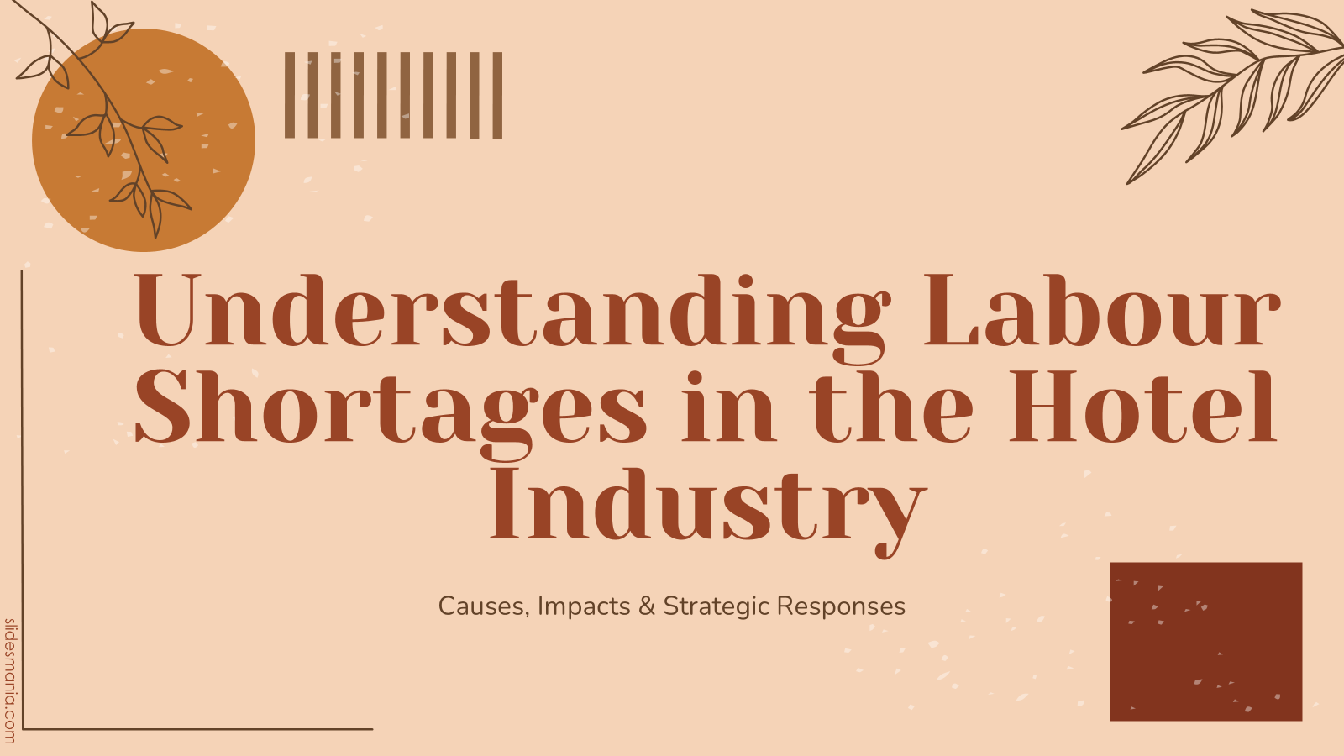
Good morning, everyone. Thank you for joining this session. My name is Mohammad Assadujjaman, and today I will be presenting my research on a critical contemporary theme affecting the hotel and hospitality sector: the labour shortage crisis. This presentation is based on my submitted conference paper, which examines the root causes, the operational impacts, and industry responses to this global issue. I will draw on recent academic literature, industry reports, and analytical frameworks to explore how labour shortages are reshaping workforce strategies in hospitality.

Slide 2: Introduction
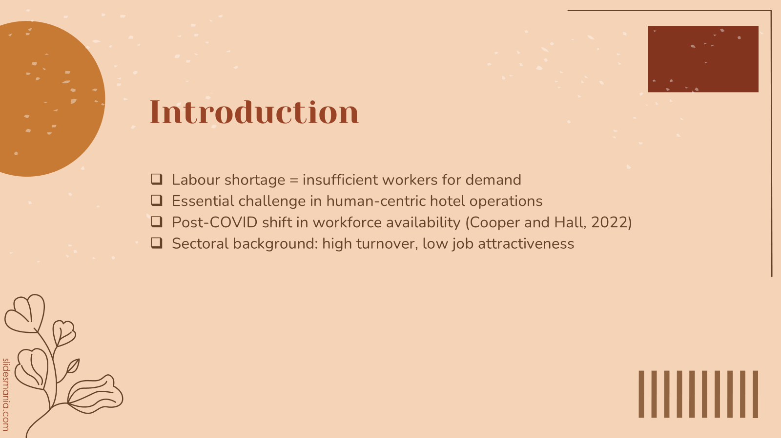
Labour shortages refer to the condition where the demand for workers exceeds the supply, creating extended vacancies and operational inefficiencies. In the hotel industry, where service quality and guest experience heavily rely on frontline staff, the implications are profound. The industry is already known for high staff turnover, low pay, and long hours (Cooper and Hall, 2022). The COVID-19 pandemic further intensified these issues by pushing many workers to leave the industry permanently. Post-pandemic recovery has increased guest demand, but the staffing crisis persists, especially in housekeeping, food services, and front desk operations (Spurk and Straub, 2020). Understanding this shortage is crucial to the future resilience of the hotel sector.

Slide 3: Key Theories and Concepts
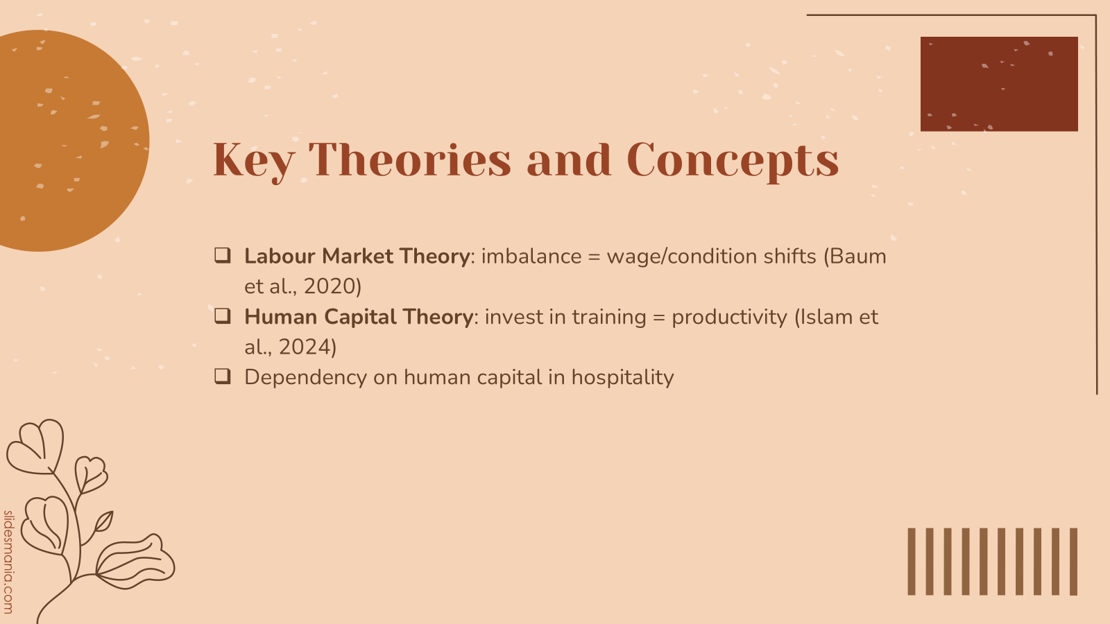
To understand the labour shortage, two key economic theories are helpful. First, Labour Market Theory explains how mismatches in the supply and demand for labour lead to changes in wages and employment conditions (Baum et al., 2020). For example, shortages increase wage expectations and turnover pressure. Second, Human Capital Theory highlights how investing in employee training and development enhances productivity and job satisfaction. In hospitality, the workforce is a core operational asset (Islam et al., 2024). The application of these theories clarifies why staff attraction and retention must be strategic priorities for hotel managers today.

Slide 4: Causes of Labour Shortage
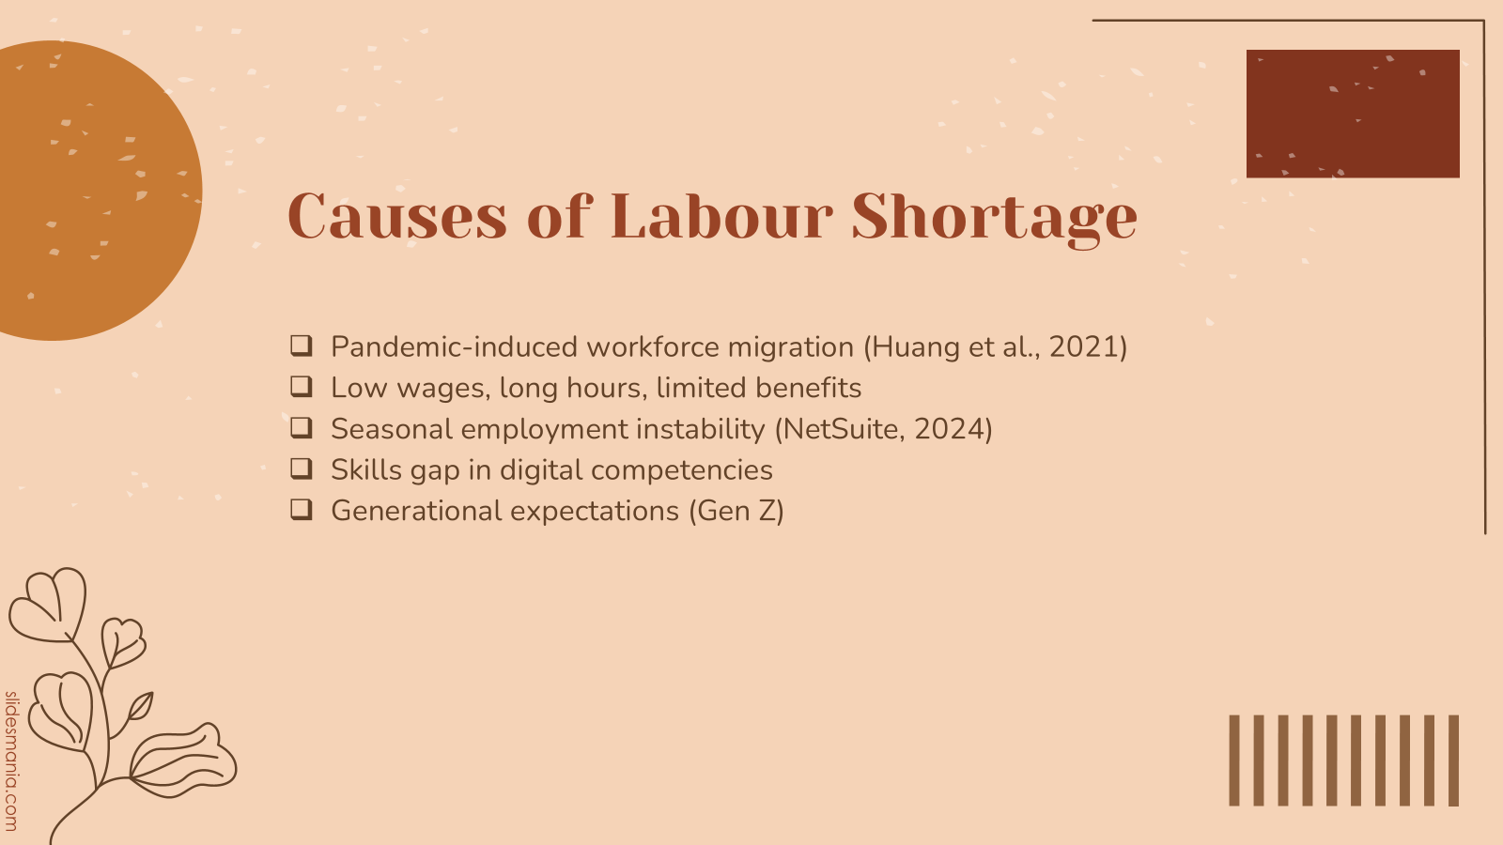
The causes of labour shortages in hotels are multi-dimensional. Firstly, the COVID-19 pandemic led to mass job losses, and many workers found new employment in sectors with better pay and stability (Huang et al., 2021). Health concerns also discouraged many from returning. Secondly, long-standing issues like poor compensation, long hours, and limited career progression have made the sector unattractive. Thirdly, the seasonal nature of many hotel roles contributes to job insecurity (NetSuite, 2024). Additionally, there’s a growing gap between required and available skills, especially with the integration of technology in service delivery. Lastly, younger generations—particularly Gen Z—demand flexibility, work-life balance, and meaningful work, which the traditional hospitality model often fails to offer.

Slide 5: Impacts on Hotel Operations
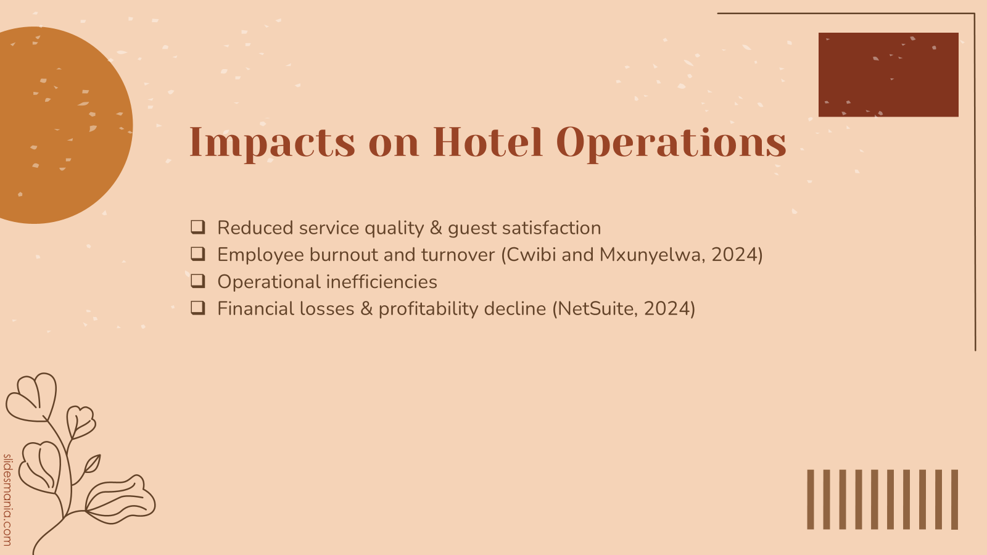
Labour shortages severely impact hotel operations. Fewer staff result in longer wait times, reduced cleanliness, and lower overall service quality. This affects guest satisfaction and brand reputation. Existing employees are burdened with heavier workloads, increasing burnout and prompting further resignations (Cwibi and Mxunyelwa, 2024). Operational delays and errors become more frequent. Financially, hotels are forced to reduce capacity or rely on costly temporary labour, reducing profit margins. Together, these factors create a negative feedback loop that reinforces the staffing crisis (NetSuite, 2024).

Slide 6: Methodology and Analytical Approach
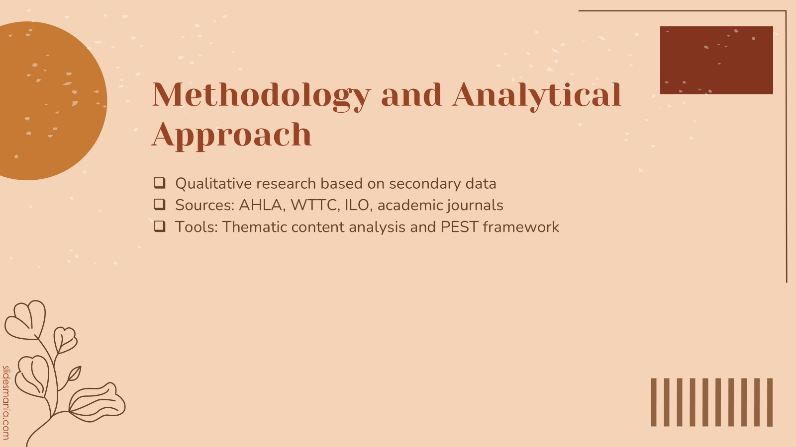
This study employs a qualitative, exploratory methodology using secondary data sources. These include peer-reviewed journal articles, reports from the American Hotel & Lodging Association, the World Travel & Tourism Council, and labour statistics from international organisations like the ILO. Thematic content analysis was used to identify recurring patterns and themes, while the PEST framework—examining political, economic, social, and technological factors—was applied to evaluate external influences on the labour shortage. This analytical approach provides a structured and comprehensive view of the issue.

Slide 7: PEST Analysis – Political & Economic Factors
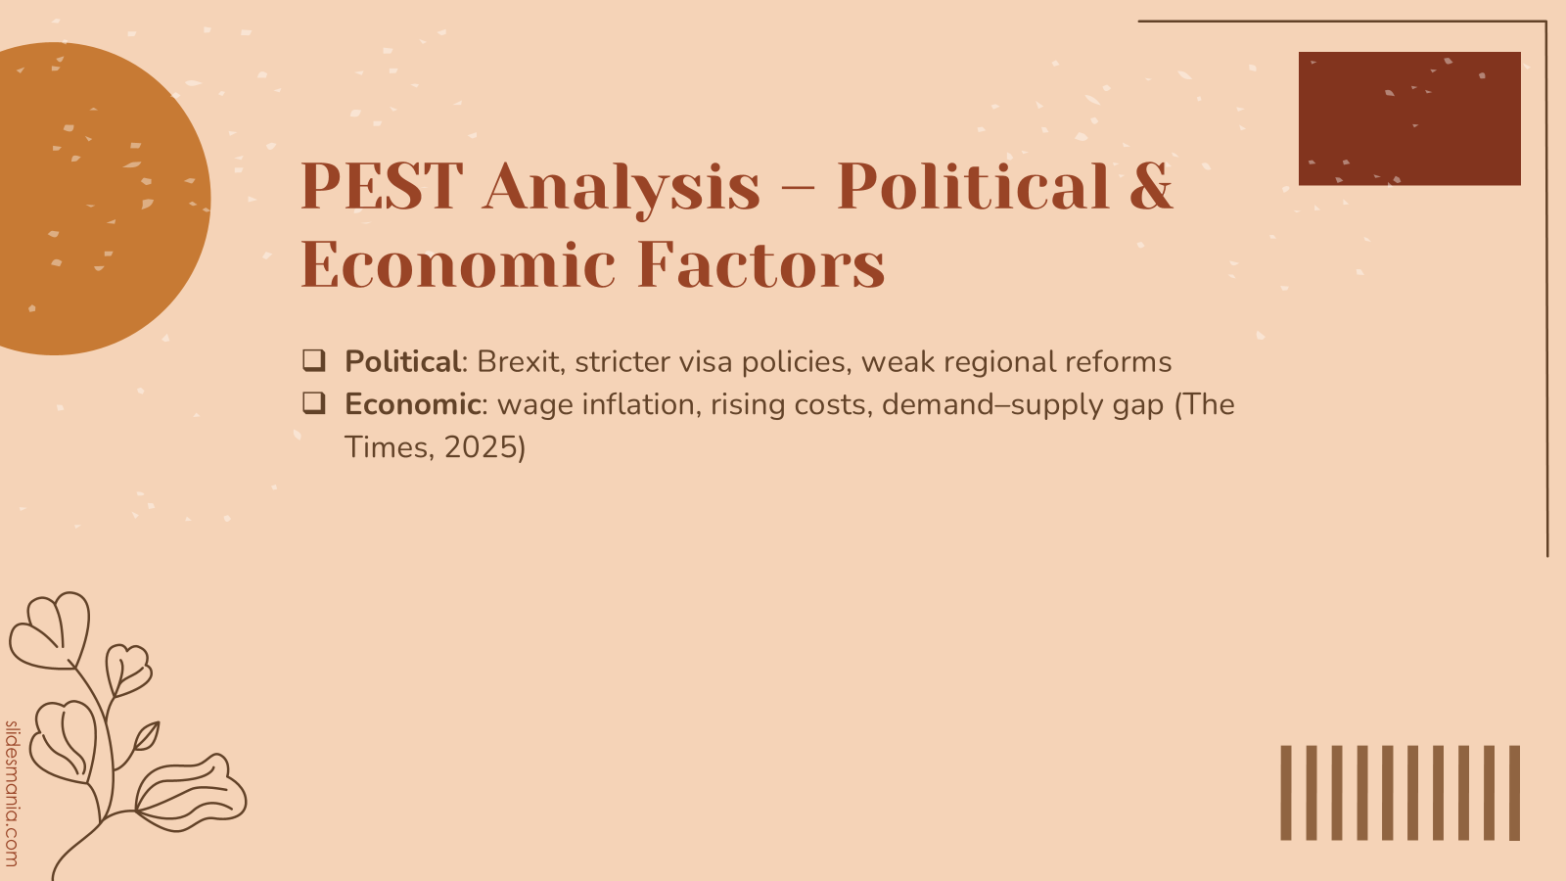
Political factors have significantly contributed to labour shortages. In the UK, Brexit restricted the flow of EU workers who previously filled many hospitality roles. The new immigration policies have made it difficult to recruit international talent. Efforts like training programs are in place but take time to yield results. On the economic side, hotels face rising wage expectations due to inflation and competition for talent. At the same time, the post-COVID demand recovery has outpaced workforce availability, forcing hotels to cut services or limit operations to cope with staff shortages (The Times, 2025).

Slide 8: PEST Analysis – Social & Technological Factors
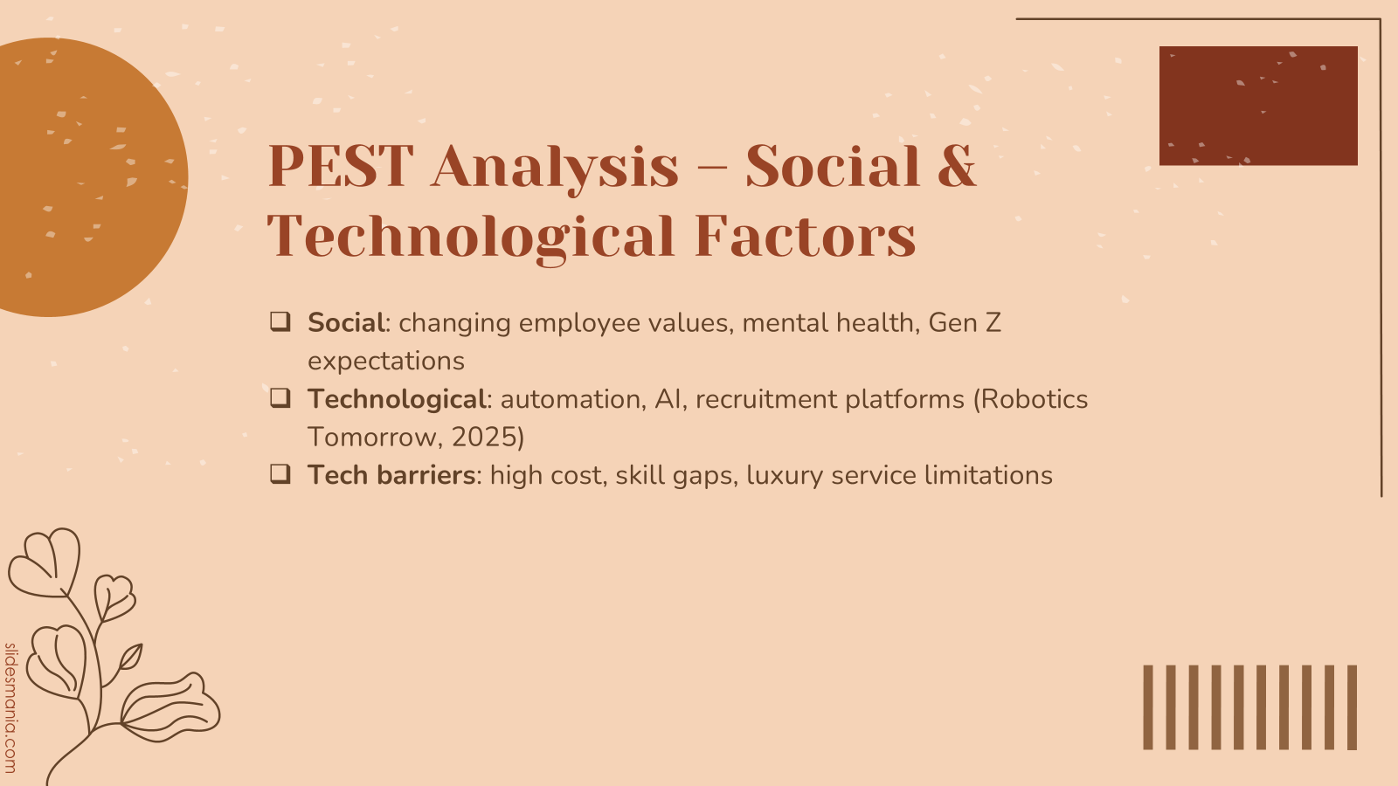
Social trends are transforming hospitality employment. Employees now prioritise well-being, flexibility, and job purpose. Gen Z workers are particularly vocal about work-life balance and career development. The rigid structure of traditional hotel jobs no longer appeals to them. In response, hotels are turning to technology—automation for repetitive tasks, AI for scheduling, and digital recruitment platforms. While helpful, these solutions are expensive and can’t fully replicate the human touch, especially in luxury hotels (Robotics Tomorrow, 2025). Additionally, small and independent hotels often lack the capital and infrastructure to adopt such systems effectively.

Slide 9: Industry Responses & Limitations
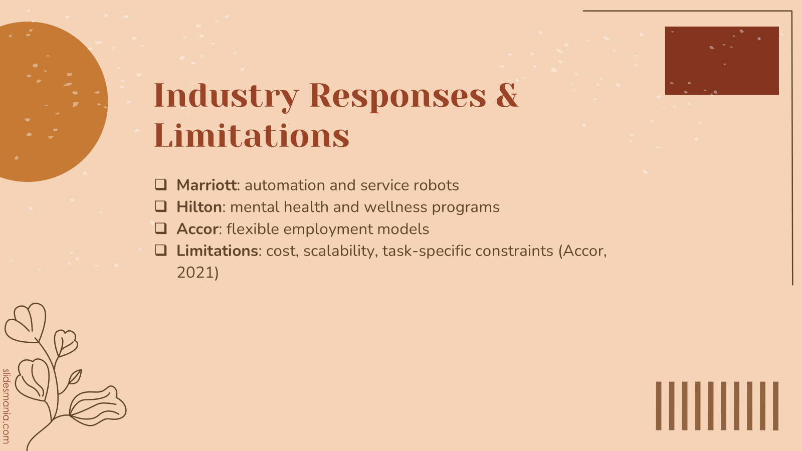
Major hotel chains have implemented several initiatives to mitigate labour shortages. Marriott introduced service automation, reducing the burden on human workers. Hilton emphasised employee wellness by providing mental health support and flexible scheduling. Accor launched its “Work Your Way” programme, allowing employees to choose shifts that suit their lifestyle. These responses show promise but are not without limitations. High implementation costs, varying operational needs, and inconsistent scalability restrict their widespread adoption, particularly in small or regional hotels. A one-size-fits-all model does not work in this context (Accor, 2021).

Slide 10: Conclusion
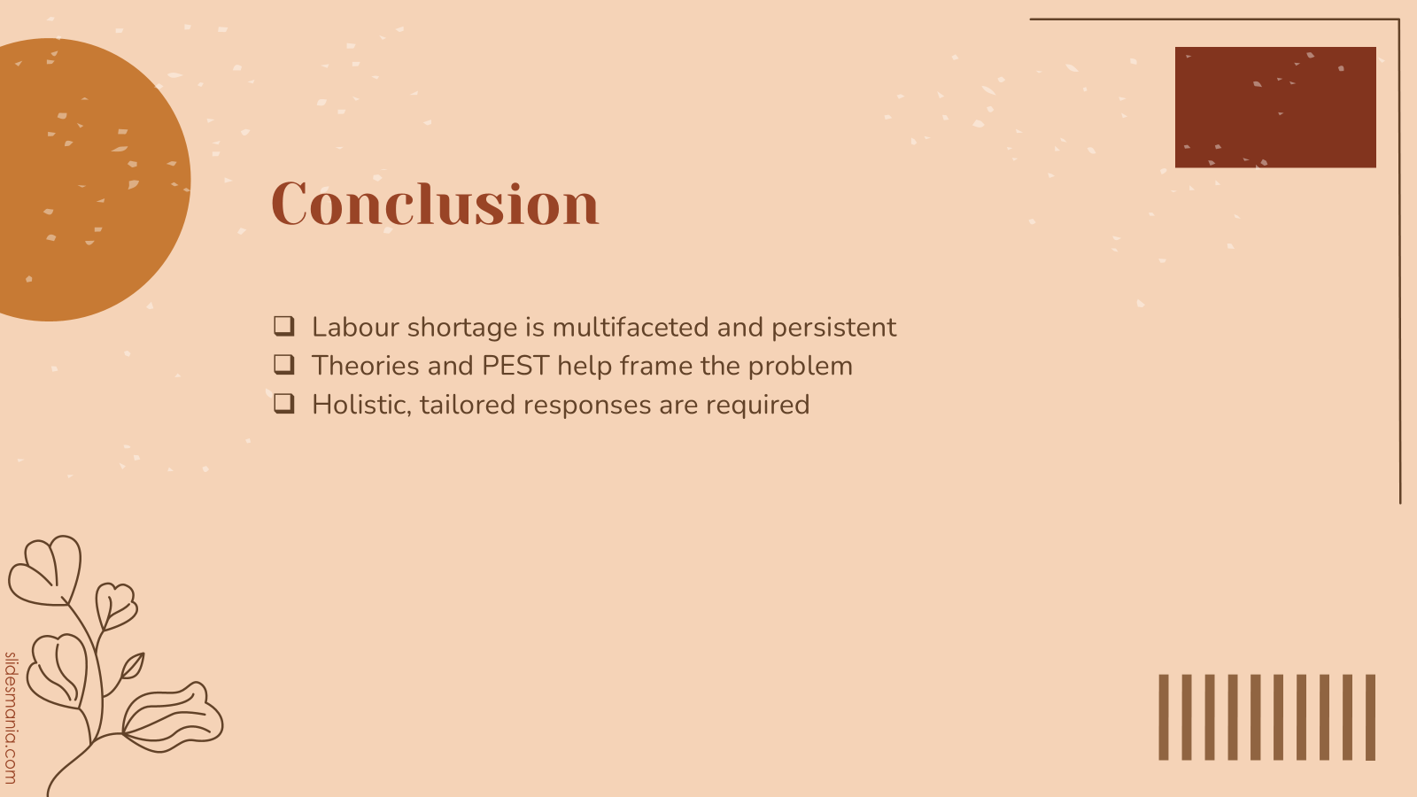
To conclude, labour shortages in the hotel industry are caused by an intersection of political, economic, social, and technological factors. Theories like Labour Market Theory and Human Capital Theory help explain the patterns of workforce availability and productivity. The shortage negatively impacts service quality, employee morale, and business profitability. While large hotel groups are adopting innovative strategies, solutions must be flexible and tailored to organisational scale and context. Sustainable staffing models will require a long-term commitment to employee development, technology investment, and strategic human resource management.

Slide 11: Recommendations
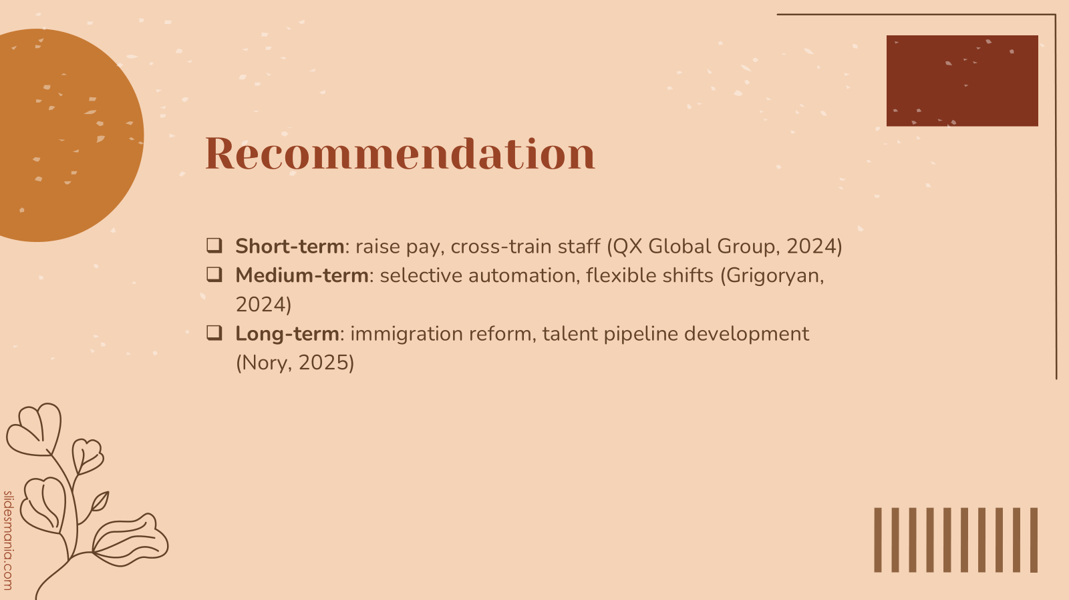
Based on the research findings, several recommendations can be made. In the short term, increasing wages and offering multi-skill training will help retain existing staff (QX Global Group, 2024). In the medium term, integrating automation for administrative tasks and offering flexible shifts can reduce burnout and align with Gen Z preferences (Grigoryan, 2024). In the long run, hospitality organisations must advocate for policy reform to address immigration gaps and invest in talent development through internships, apprenticeships, and partnerships with educational institutions. These multi-level strategies will build workforce resilience and enhance operational sustainability (Nory, 2025).

References
Accor, (2021). Accor's 'Work Your Way' program revolutionises recruitment in the tourism sector. Accor Press Room. [online] Available at: https://press.accor.com/middle-east-africa-turkey-asia-pacific/accors-work-your-way-program-revolutionises-recruitment-in-the-tourism-sector/?lang=en [Accessed 14 May 2025].
Baum, T., Mooney, S.K.K., Robinson, R.N.S. and Solnet, D., (2020). COVID-19’s impact on the hospitality workforce – new crisis or amplification of the norm? International Journal of Contemporary Hospitality Management, 32(9), pp.2813–2829. https://doi.org/10.1108/IJCHM-04-2020-0314
Cooper, C. and Hall, C.M., (2022). Contemporary tourism: An international approach.
Cwibi, M. and Mxunyelwa, S., (2024). Employee motivation and the impact of the pandemic on the hospitality industry. SA Journal of Human Resource Management, 22, pp.1–7. https://doi.org/10.4102/sajhrm.v22i0.2131
Grigoryan, K., (2024). Labor shortages in the hospitality industry: The effects of work-life balance, employee compensation, government-issued unemployment benefits and job insecurity on employees’ turnover intentions. Westcliff International Journal of Applied Research, 8(1), pp.59–73. https://doi.org/10.47670/wijar202481KG
Huang, A., De la Mora Velasco, E., Marsh, J. and Workman, H., (2021). COVID-19 and the future of work in the hospitality industry. International Journal of Hospitality Management, 97, p.102986. https://doi.org/10.1016/j.ijhm.2021.102986
Islam, M.A., Hack-Polay, D., Rahman, M., Hosen, M., Hunt, A. and Shafique, S., (2024). Work environment, HR practices and millennial employee retention in hospitality and tourism in Bangladesh. International Journal of Emerging Markets, 19(4), pp.846–867. https://doi.org/10.1108/IJOEM-01-2023-0073
NetSuite, (2024). 13 Common Challenges in the Hospitality Industry in 2024. NetSuite. [online] Available at: https://www.netsuite.com/portal/resource/articles/erp/hospitality-industry-challenges.shtml [Accessed 14 May 2025].
Nory, (2025). Technology: The Answer to Hospitality Labour Shortages. Nory Blog. [online] Available at: https://www.nory.ai/blog/how-technology-solve-labour-shortages-in-the-hospitality [Accessed 14 May 2025].
QX Global Group, (2024). Impact of Rising Staffing Costs on the Hospitality Industry. QX Global Group. [online] Available at: https://qxglobalgroup.com/fa/uk/blog/rising-costs-of-staffing-in-hospitality/ [Accessed 14 May 2025].
Robotics Tomorrow, (2025). Marriott and LG chose RobotLAB to Revolutionize Hotel Automation. Robotics Tomorrow. [online] Available at: https://www.roboticstomorrow.com/news/2025/03/25/marriott-and-lg-chose-robotlab-to-revolutionize-hotel-automation/24504 [Accessed 14 May 2025].
The Times, (2025). Labour has put a soft landing for the economy at risk. The Times. [online] Available at: https://www.thetimes.co.uk/article/labour-has-put-a-soft-landing-for-the-economy-at-risk-jdks683cr [Accessed 14 May 2025].

