Risk Assessment Technical Report
Michael Curtis

Table of Contents
Introduction 2
Research Review 2
Initial FMEA 2
Post-Mitigation FMEA 3
Conclusion 4

Introduction
In this document I will be conducting a study into the brake component installation process risk management using the Failure Mode and Effect Analysis (FMEA). Risk management is important in engineering as without it, severe injuries would be a regular occurrence with large legal fees as well as the sadness that comes with loss of life as well. I aim to improve the risk management on the installation process by implementing new measures after an initial FMEA which would then be followed with a second FMEA seeing the risks left after the mitigations were implemented. This is because there might be risks still outstanding as in some cases some form of risk will always be present.

Research Review
Risk management is important as without it, severe injuries would be a regular occurrence with large legal fees as well as the sadness that comes with loss of life as well as well as making sure that the equipment and objects we use are up to a good standard of engineering.
There are several tools for risk management including the IMechE Code of Conduct for professional engineers which is one of the documents I researched. It outlines the code of conduct for engineers including guidelines to protect members of the public, protecting IMechE members, and upholding the reputation of engineering and the institution with the expectation that you would reference the document regularly. It focuses on 4 main principles: practice competently and maintain correct knowledge, act with integrity and respect, promote sustainability, and exercise engineering leadership. (IMechE, 2021) These four principles are important in risk management as they should all be accounted for when risk managing something or someone as they are good guidelines on what should be done.
Another tool for risk management is the FMEA process which is the one we are using in this document for our risk management process. It is used as a guide for the development of actions for improving a processes health and safety and its primary focus is to improve the process as well. (Carlson, 2017) Health and safety legislation is important as it protects workers rights to health and safety as well as protecting anyone else’s safety who would be involved such as the general public and visitors. (WorkSmart, 2020)
From a production line of brake production, I have gathered the risks involved in it from seeing how it has been made. They use tools by hand to fit and install the parts from the part storage leading to possible manufacturing errors very easily and without much protective equipment. These issues are important to resolve and can be solved by using the FMEA process. (Parmerit, 2016)

Initial FMEA
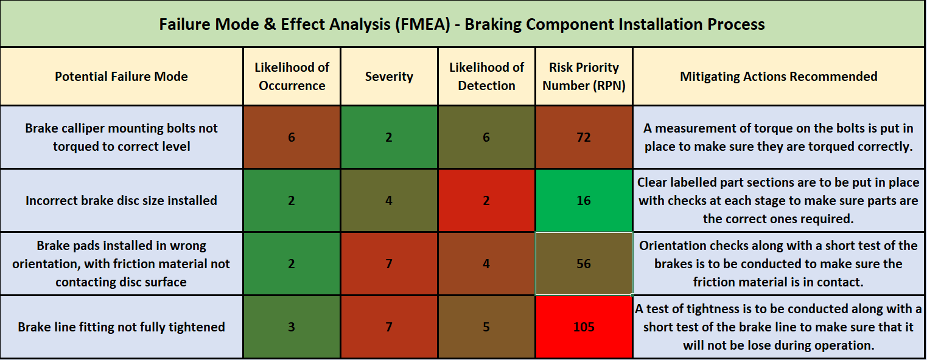
Figure 1. Initial FEMA report of the braking component installation process.
For the initial FEMA I used my research to decide on the likelihood of occurrence with the mounting bolts not being torqued properly to be the most likely to occur with no check in place. The incorrect brake disc installed, and the brake discs installed wrong were both quite unlikely unless a large issue with the production line would occur. The brake line not being fully tightened is also quite unlikely, but still more likely than the 2 previous.
For the severity I based it on my research as well as the issues it could cause with the end customer as if the brake line was to fail the brakes wouldn’t work causing a possibly large accident. Using that as my basis I found that the 3rd and 4th failure mode were the most severe with the 2nd being the second least severe and the 1st the least severe.
For the likelihood of detection, I used my research to determine the values with the torque bolts not being at the correct level would be hard to test for so has a high chance of detection. The brake calipers has a high likelihood of detection due to the fact it would be easily visible however it might not be easily visible if you were to be unfamiliar with the production line. The last two failures modes are both sort of likely to be detected however proper checks would need to be put in place to prevent them from occurring.
The risk priority number is calculated from the multiplication of the three variables before giving us a value for the risk. The incorrect brake disc size is the least risk as it would be detected the easiest as well as a low severity. The brake pads being installed incorrectly is the next as the severity is very high however the likelihood of occurrence is quite low giving it a score of 56. The brake caliper not torqued correctly is at risk at 72 due to how likely it is and how unlikely it is to be detected. The highest risk is the brake line not being fully tightened due to how severe it is along with the likelihood of detection being so low. It also has a mildly high chance of occurring giving it a risk score of 105.

Post-Mitigation FMEA
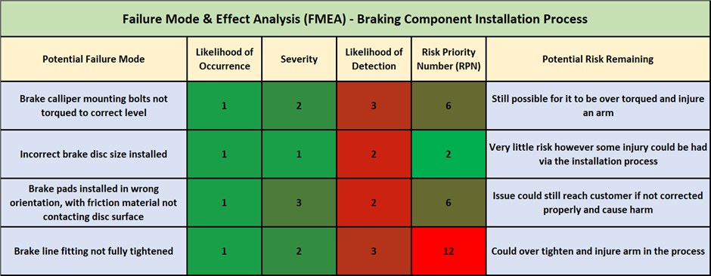
Figure 2. Post-mitigation FEMA report of the braking component installation process.
After mitigation the processes put in place reduce the likelihood of occurrence to a low amount with very little chance of an issue occurring except for major equipment failures or major worker failures. The severity of the failure modes is also all reduced as the major issues that were present before are no longer an issue however some issues as outlined in the potential risk remaining are possible. The likelihood of detection is also increased as the steps taken in the mitigation allow for a higher chance of seeing the issue before the vehicle reaches the customer. There are some potential risks remaining which have been outlined on the FMEA.

Conclusion
To conclude, I believe that health and safety is extremely important in a production line along with taking the specific steps to mitigate the risks in place. This involves the FMEA carried out twice to see the risks in place with the risks found to be worrying and after actions taken against them returned to normal levels of danger in a production line outlined in my research. The FMEA process was easy to understand and use which is good for the workplace as these reports should be carried out regularly to make sure the workplace follows the IMechE code of conduct as well as general health and safety legislation. I believe that FMEA is a good tool for managing risk in the workplace however I would use a different layout for the figures in future.
Overall, I found that the workplace wasn’t safe, but after my mitigation measures are put in place the workplace would become safe as long as they are followed. This is due to the checks put in place in the mitigation as they are vital to making sure each component is installed correctly for the end user’s health and safety. This goes alongside keeping workers safe as there are still possibilities for injury outside of the measures taken.

References
Carlson, C., 2017. What is FMEA?. [Online]
Available at: https://accendoreliability.com/fmea-2/
[Accessed 06 03 2021].
IMechE, 2021. CODE OF CONDUCT EXPLAINED. [Online]
Available at: https://www.imeche.org/about-us/imeche-governance/governance-and-finance-reviews/code-of-conduct-explained
[Accessed 06 03 2021].
WorkSmart, 2020. What is the Health and Safety at Work Act?. [Online]
Available at: https://worksmart.org.uk/health-advice/health-and-safety/employer-duties/what-health-and-safety-work-act
[Accessed 06 03 2021].

