

BA (HONS): Marketing Management

ASSIGNMENT TOPIC: ANALYSIS OF PRADA BRAND EQUITY AND CUSTOMER'S JOURNEY MAP.

Module Lecturer: Tushara Balendrian
Module Code: LCMB7001
Student: Drumea Marina
Student ID: 2125126
Submission Date: 28.04.2022

April 2022
TABLE OF CONTENTS
1. INTRODUCTION 3
2. COMMUNICATION 3
3. PRADA'S PROMOTIONAL STRATEGIES 5
3.1. ONLINE PROMOTIONAL STRATEGY 5
3.2. OFFLINE PROMOTIONAL STRATEGY 5
4. BRAND AND BRAND EQUITY 5
5. CUSTOMER JOURNEY 7
5.1. CUSTOMER TOUCHPOINTS 8
6. CRITICAL ANALYSIS OF THE CUSTOMER JOURNEY MAP 9
6.1. STRENGTHS AND WEAKNESSES OF PRADA CUSTOMER JOURNEY MAP 11
7. THE TOTAL ENGAGEMENT MODEL 11
8. CONCLUSIONS 12
9. RECOMMENDATIONS 13
REFERENCES 14

1. INTRODUCTION
Nowadays, people are focused on fashion and accessories. A luxury brand Prada was established in 1913. It is located in Milan, Italy. This Italian aristocratic brand developed their specific areas as travel accessories, handbags, shoes, perfumes, clothing, fashion accessories, and watches. The name Prada has conquered the world, and it is recognised as the most luxurious and fashionable brand.
In a number of the Journal of Marketing, Keller (2016) noted that Prada represents a major player amongst the industry as a result of its unique designs, smart marketing strategies, business diversity, qualitative and quantitative products, which satisfy customers' requests and needs.
Heine (2010) outlined Prada's principles focused on innovation, reinvention, and independence. Following this strategy, the brand offers the assurance of a foreseeable future and going concern of the business.
In a nutshell, the assignment has the purpose of analysing the Prada Brand and the story aspects behind the name. The specific analysed will be: brand strategy and equity, how a strategy can communicate an idea to the customer, and what are the brand's strengths and weaknesses. Last but not least, we will use the engagement model to offer a critical analysis of their path to building a strong name.
In conclusion, we will outline some recommendations for the areas that need more improvement to sustain the customers.

2. COMMUNICATION First of all, we want to describe the term communication, which has several definitions, but we adapted to the topic we chose to analyse. Shannon and Weaver (1949), in their book, explained it as: ''A systemic process, the main components which include: source (sender), message, transmission, noise, channel, reception and receiver.'' In other words, communication is defined as a process designed to express information from the sender to the receiver (for ex: sender Prada produced a new leather bag with expensive details, the receiver - customer has to appreciate that the product has improved quality and as a result, it is more expensive).

The fig.1 (below) expresses the communication process. Linked to our case, we can say that this communication cycle is the more effective in the fashion industry because it is a mother model for all communications and can be adapted according to the specific area.

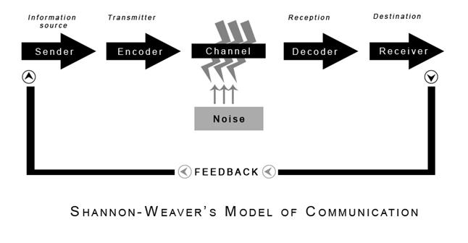
Fig.1: SHANNON AND WEAVER COMMUNICATION MODEL
Source: Shannon and Weaver (1949), p. 5;
Nowadays, the fashion industry is selling a luxury style. Linked to our case, Prada is using an integrated marketing communication strategy (IMC) to influence and cause an effective benefits for customers, but the priority being the business performance implementing persuasive communication. (Ferrell,2016)
The recent research outlined that the fashion industry has a dynamic change involving customer trends. Prada used IMC to satisfy the choice of the top customers, profit increase, and maintain business performance. The measures taken are: fashion marketing campaigns, social media tools in targeting the audience to sell the products, advertising digitalisation, using emails, nevertheless, websites as we are living in a mobile-friendly community. (Percy, 2015)
Briefly, IMC tools helped Prada carefully to integrate and coordinate its communications channels to deliver a clear and consistent message using media tools. Moreover, it has been fused to position the relationship between brand awareness and brand attitude.

3. PRADA'S PROMOTIONAL STRATEGIES
According to our early discussions, we mentioned that Prada is focused on innovation, reinvention and diversity of the product. These principles maintain the company's performance and follow customers' trends and needs. Prada is being globalised, and the products are sold using platforms at a click distance, such as: fashion shows, websites, and boutiques. Following its IMC strategy, we can distinguish promotional strategies: online and offline.

3.1. ONLINE PROMOTIONAL STRATEGY
During the globalisation process, Prada had to digitise the brand information, presenting products and selling. To present this luxury fashion brand in a website version in a creative advertising manner was a difficult task because of the customer factor. To attract the consumers, the marketing strategy has to be more persuasive, reliable into, and accurate display. The virtual image created always has to relate the reality according to the brand quality and standards. (Percy, 2015)

3.2. OFFLINE PROMOTIONAL STRATEGY
Another promotional tool is the offline strategy. It is easier to be monitored and controlled over the product and service provided. An excellent offline promotional strategy for Prada is to improve customer relationships and open more stores in South America and Russia. As a suggestion, Prada needs some fashion alliances that can organise huge fashion events to promote brand awareness. These names are: Cosmopolitan, Vogue, Business Summits, Cricket World Cup Federation and Football World Cup Federation. (Marketline, 2012)

4. BRAND AND BRAND EQUITY
Brand and Brand Equity have a strong relationship over marketing strategy. These two terms are having a different meanings. The American Marketing Association defined the term as:,, A name, term, sign, symbol or design or a combination of them with the purpose to express the identity of a product/service provided by a seller/group of sellers to be distinguished from the competitors.''(Wood, 2000)
On the other hand, we need to operate with the term brand equity. According to the Keller's findings (2012),'' Brand equity is a value added on products/services. It may be reflected in the way consumers think, feel, and act with respect to the brand, as well as in the prices, market share, and profitability the brand commands.''
The subject brand equity model has been widely investigated by Keller. He started to research it in 1993, and as a result, he could outline the process of evolution. At this point, Keller (2009) outlined that the concept has been built in time as a response from customers to the brand marketing activities.
The fig.2 below is the Keller's Brand Equity Model (2012), and we briefly will explain the Prada Brand through the stages.
It has a pyramid base, six-block elements and two sides. The left side is the rational path, and the right side is the emotional path. To reach the brand equity Keller suggested achieving the resonance point where Prada's standards meet the customer's touchpoints.
The base stage salience is the brand awareness linked to the associations of the name, logo and symbol. The stage is divided into dual dimensions performance (customer satisfaction) and imagery (identification). Performance, in our case, is a qualitative product/service using the customer's psychology, and the image is the superiority to other brands over quality.
The judgement and Feelings stage expresses the customer's engagement as a result of marketing strategies, and its responses to the brand question about what they feel about the brand.
The last stage, resonance, is the relationship customers have with the brand and the extent to which they feel they're "in sync" with it. Resonance is the intensity of customers' psychological bond with the brand and the level of activity it engenders.
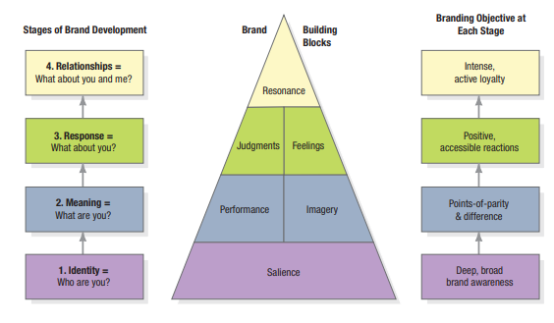
Fig.2: KELLER’S BRAND EQUITY MODEL;
Source: Keller, K. (2012), Marketing Management, p.249;
During our research, we found some advantages and disadvantages regarding the Keller's brand model. The most highlighted advantage is related to the resonance stage, which helps to create a guide list to complete, order and monitor marketing activities and how it affects the customer's loyalty. But, Kuhn et al. (2008) argued that in the context of resonance, the emotional part is not a major player in the marketing content, only if they are adapted and improved to build the B2B brand equity model to be more suggestive for the human facilitator.
5. CUSTOMER JOURNEY
In the Marketing Dictionary, we found a reliable explanation of the concept of the customer journey as: “The multiple online and offline touchpoints that determine how a consumer comes into contact with a brand seeks more information and makes a purchase decision. Successful brands focus on developing a seamless journey from awareness to engagement to purchase that ensures that touchpoints interconnect and enhance the experience. Also known as Path to Purchase (P2P).” (Marketing Dictionary)
The academic scholars and marketing experts agreed to mention that innovation driver influences customer experience or customer journey. Moreover, the customer aims to take advantage of the product/service instead o purchasing and wasting money. Customer experience is a response to business during the journey and, as a consequence to add value to the brand. ( Kokins, 2021)

Customer Journey is composed of stages as: Awareness, Evaluation and Purchase - suitable for offline purchases, Retention and Advocacy-brand touchpoints with online shoppers. The fig.3 below represents a visual image of the whole process. We will use Hundders’ (2012) findings to explain how is affected consumer in the result stages of development.
Awareness: This stage describes which tools the brand uses to attract consumers and the chance to be observed. The point is to deliver the content to gain customer loyalty. As an example is social media posts, tutorials and website pages.
Consideration: At once, if the customer discovers the brand it is looking for, there are looking for a product/service to meet their needs according to the business standards shared in the content. The consideration level is measured according to the customer’s decision in time, which can take days, weeks, or even months, depending on the product). Prada is using demo videos and customer reviews with the purpose of encouraging more customers to trust the brand.
Purchase: The next stage in the customer journey is the decision-making to buy or not, trust or not trust the brand. To obtain success, Prada is investing in delivering great customer service using a skilled workforce, sales and coupons as a reward system and Customers Feedback. Benefits for a brand - increasing the income, customers- qualitative product.
Retention: This stage refers to customer loyalty. The Customer is enjoying the consumption process of the goods. This stage focuses on keeping the customer happy with your business even after their purchase arrives at their doorstep. Brand uses the marketing strategy of customer value as asking for: feedback, testimonial, sending them tips for product use, sending them loyalty sales/discounts etc., and setting up a VIP program.

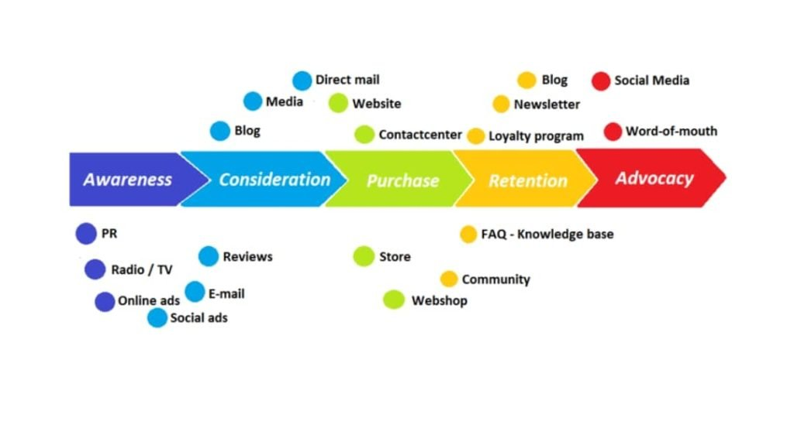Fig.3 Customer journey stages
Source: Wikimedia

Advocacy: Is the performance stage of the business than a loyal customer is an expert of the brand and helps to share awareness of the brand with others by simply taking and posting the brand product on their social media page. The company is more than happy to offer rewards to maintain their performance and saving money for other brand investments. We can outline a strong relationship between the brand and consumers.
5.1. CUSTOMER TOUCHPOINTS The concept “touchpoint” has been recently discussed among researchers and experts and used in the academic literature. The meaning is defined by Baxendale (2015) cited in Kokins (2021) as business interaction with the potential customers in before, during and after purchase phases. Furthermore, we will explain and outline the characteristics of these phases linked to our luxury Prada Brand.
5.1.1.Brand Pre-Purchase: Pre-purchase touchpoints refer to the customer judgement before experiencing engagement with a product of the business. Usually, these refer to the brand awareness using social media content, advertising ( TV, radio, websites) or sponsorship agreements. 5.1.2. Brand Purchase: Purchase touchpoints express the most important interaction between product and consumer. These refer to business websites, social networking sites that feature shopping capabilities, live chat, sales teams, customer service teams, events like pop-up shops or shows, distributor, retailer or supplier channels. 5.1.3. Brand After-Purchase: Post-purchase touchpoints refer to the touchpoints and what benefits can a customer achieve after purchase. Brand's rewards used are: referrals, reviews, social media platforms, email marketing and communications, newsletters, loyalty programs, and customer satisfaction. We created a scenario to be more easier for the reader to understand the stages. Let's assume that Katie is a potential customer. She is a woman and likes bags. The first touchpoint is in the meantime when Katie saw an attractive advertise on Instagram. To satisfy her curiosity (second touchpoint), she searched for more details on the official website. She found a bag that meets her taste for a luxury piece, and here we will have the third touchpoint when she goes in the store and likes the package, and she is more than impressed to invest as it is multifunctional, qualitative and worth the money. While she was paying for the product, the Customer Service Team highlighted that she was rewarded with a coupon discount of 15% for the next purchase. In conclusion, we can easily observe how can customer's feelings can be manipulated if the information is displayed in the right framework. Typically, all these different touchpoints are grouped together and capitalised on to create a consistent brand experience and get people to think positively about a brand and its interactions.

6. CRITICAL ANALYSIS OF THE CUSTOMER JOURNEY MAP Nowadays, Customer journey mapping is one of the most used business expansion tools, including online-offline engagement, purchasing phases, and customer experience. The aim of the mapping is to help managers and marketing experts to understand customer value and engagement across touchpoints.
In fig.4 below, we wanted to illustrate Prada's customer Journey Map for a bag purchase.

Customer Journey Map | Awareness | Discover | Purchase | Use | Bond
Support |  |  |  |  | 6.  Received an email with apologies about this situation and a discount for the next purchase.
Pain point |  |  | 5.  The delivery time of the product was delayed.
Usage of product |  |  |  | 7.  Excellent design and quality.
Purchase |  |  | 4.  Customer service help with guidance.
Visit store |  | 2.  Visit near the store to be sure of the decision.
Research option | 1.  Online research (official website) and try to find reviews about future purchase.
Need to purchase |  |  |  |  | 3.  Buy Prada bag customer (order in-store or online).

Fig. 4 Prada Customer Journey Map (Source: Author)

This journey map (fig.4) includes all the information for understanding and analysing the customer experience of shopping for a new bag of Prada. In this case, step by step, the customer journey map help to refine and optimise the product and service, making it as enjoyable and easy as possible for customers to use. Delivering a good product or service improve customer retention and brand loyalty.

6.1. Strengths and Weaknesses of Prada customer journey map
To outline brand Strengths and Weaknesses, we used SWOT Analysis. A brief overview of Prada in the fashion industry needs to draw attention to the worldwide globalisation of the brand. The geographical locations of the outlets help to distribute the company's goods/services. As a result, it has loyal customers.
Prada's strengths are:
- products at a reasonable and affordable cost;
- return on investments- skilled workforce- qualitative product-increase in income;
- satisfied customers.
Prada's weaknesses are:
- a large competitive market where competitors are trying to be more creative to sell new innovations;
- currency fluctuation during rental spaces;
- less engagement in environmental policy;
- weak participation in e-commerce.

7. THE TOTAL ENGAGEMENT MODEL

Pansari and Kumar (2017) defined engagement as the process of a customer's value, including negative effects and positive aspects. Customer”s Satisfaction highlights the company’s performance. The Kano Model is a method that helps to understand customers’ demands and its nature.
Ulman (1997) noted that Kano Model Approach is being used to understand if the customer "is answering the brand offers. The model divided product attributes in three:
Threshold outlines the musts of the product. The increased performance, decreases customer satisfaction. An example is Prada's bag raw material (leather).
Performance outlines the company engagement to satisfy the customer's demand. If the performance is reduced, the customer is not satisfied. For example, the consumer is able to pay more for the bag if the leather will have the same quality after three years of usage.
Excitement outlines are the needs that are less spoken. It does not bring any satisfaction or dissatisfaction.

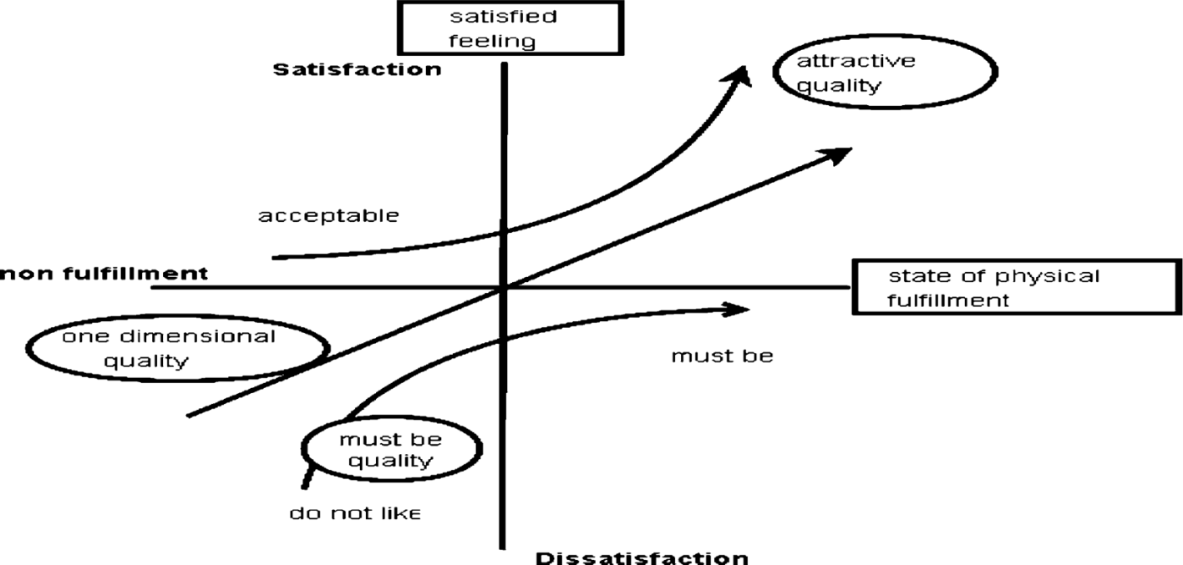
Fig. 5 Original Kano model
Prada is offering its customers the premium quality of the products. The brand is famous for its luxury designer clothes and accessories, shoes, bags and pieces of jewellery (Kotler and Armstrong, 2012). All the products are exceptional in design, quality, and price. Prada tries to make its product more attractive and sophisticated with the help of advanced design creation and technology. All the products are the best in quality and excellent in case of providing comfort to make the brand attractive to customers.

8. CONCLUSION

The marketing management of any company plays an essential role in promoting the products or services and helping the company to achieve its target by getting more and more customers marketing sector works with the market by developing strong relationships among the people to retain them for a long time and need to communicate with them to know their demands and expectation by producing the products according to their demand.
As a very popular, high-class luxury brand, Prada is facing marketing challenges. We analysed some specific marketing strategies used as: Keller's Communication Model adapted and improved to the brand-specific standards, brand equity considering customers loyalty, consumer mapping and the touchpoints during the purchase phases.

In a nutshell, the fashion industry is in a dynamic change that drives marketing strategies and new consumer trend. An important role to maintain the going concern of the business is to add value to the brand by engaging the customer’s satisfaction.
Customers’ satisfaction and journey gave a huge awareness to the potential consumers. Prada has innovative and creative power and a suitable financial position to attract investors and to obtain an increase in the return on the investment.
We noted that an important impact has SWOT analysis and touchpoints, which we examined, and we conclude that there are some gaps which need improvement; hence the company has an excellent performance. Being a major player in the competitive global market is not easy to manage the customer demand using the same marketing tools. First, we are mentioning geographical expansion and business internationalisation. At this point, the brand has to take a high risk in making a such strategic decision. Last but not least, we will use Keller (2012) to highlight the improvement areas in our opinion.

9. RECOMMENDATIONS

It is considerable work to built and maintain brand equity along with customer satisfaction and income increase. Recently, took a smart decision to expand the business in the United Kingdom due to a high audience of rich people. The brand awareness will have a strong position if:
- Prada will take into consideration the environmental and political policy of the host country, launching sustainable campaigns and green development;
- Use the digitisation at maximum to focus on the online services and deliver a great experience exactly as the offline;
- Explore the potential geographical market in Brazil -even if the trading and export taxes are higher than exports in China, Russia is another spotlight as a third economic centre in the World; Saudi Arabia is a luxury centre with dynamic potential infrastructure development.
- Create partnerships, and sponsorships with Cosmopolitan, Vogue, FIFA etc., to expand more the brand recognition.
- Create a wide range of products for plus-size women in the context of globalization

REFERENCES
Baxendale, S., Macdonald E.K. , Wilson H. N., (2015).The Impact of Different Touchpoints on Brand Consideration. Journal of Retailing .91 (2, 2015) 235–253
Ferrell, O. (2016). Marketing strategy. [Place of publication not identified]: Cengage Learning.
Heine, K. (2010). The personality of luxury fashion brands. Journal of Global Fashion Marketing, 1 (3), 154–163. Global Marketing Strategies for the Promotional of Luxury Goods. Available at: https://www-igi-global-com.ezproxy.uwtsd.ac.uk/gateway/book/141910, [Accessed 10.04.2022]
Hudders, L. (2012). Why the devil wears Prada: Consumers’ purchase motives for luxuries. Journal of Brand Management, 19(7), pp.609-622.
Journal of Marketing, (November 2016). Understanding Customer Experience Throughout the Customer Journey. Available at: https://web-p-ebscohost-com.ezproxy.uwtsd.ac.uk/ehost/pdfviewer/pdfviewer?vid=0&sid=90e95847-1873-425c-a91d-cfe8359545a7%40redis [ Accessed 10.04.2022]
Keller, K. L. (2009). Building strong brands in a modern marketing communications environment. Journal of marketing communications, 15(2-3), 139-155.
Keller, K. L. (2012). Marketing Management. Chapter 11, 14th and, Pearson Education,
Kokins, G., Straujuma, A., Lapina, I.,(2021). The Role of Consumer and Customer Journeys in Customer Experience Driven and Open Innovation. Journal of Open Innovation: Technology, Market and Complexity. Issue 2021, 7, 185
Kuhn, T. , and Michele H. Jackson (2008 ).Accomplishing knowledge: A framework for investigating knowing in organizations'. Management Communication Quarterly 21: 454-485.
Marketline, (2012), "Prada Case Study: Transforming a Family Business into a Luxury Goods Powerhouse", United Kingdom;
Percy, L., (2015), Strategic integrated marketing communication, Taylor & Francis Group, London; Routledge, New York;
Shannon, C., E., W, W., (1949). The Mathematical Theory of Communication. University of Illinois Press. ISBN 978-0-252-72548-7; [Accessed 18.04.2022]
Wood, L. (2000). Brands and brand equity: definition and management. Management decision.

