  UWTSD Swansea business school  Digital Marketing | Abstract  This report outlines the importance of social media platforms to UWTSD Swansea Business School. Digital marketing goals and strategies are outlined and evaluated. Traditional forms of marketing are compared to digital marketing. Social media platforms are listed, and the purpose and benefits of monitoring social media activities are critically assessed. Finally, this report includes recommendations on what should be implemented by the university to increase digital marketing results.  Rhea Pittaway (P149829)

Executive summary

This report outlines the definition of digital marketing as well as the importance of social media channels to the University of Wales Trinity Saint David, Swansea Business School (SBS). Key findings were that Facebook is the most popular social media platform, followed by YouTube and then Instagram. Other findings suggested that the number of internet users and active social media users has risen since 2017. In order to monitor these social media channels and track their progress, SBS could implement social media monitoring platforms such as Hootsuite and Google Analytics.

The report finds that in order for SBS to remain relevant and gain competitive advantage SBS need to stay updated with social media platforms so that students can get in contact and they don’t lose a potential new student. Finally, this report includes recommendations such as creating a free website containing blogs. This can be done on WordPress that includes engaging content regarding current student’s experiences and views on the university so that the target audience has first-hand insight on the university.
Table of Contents
Executive summary 1
Introduction 1
Development of digital marketing 1
Main Body 1
Digital marketing defined 1
Advantages and disadvantages of social media marketing 2
Implementing relevant social media sites 3
The importance of social media to UWTSD Swansea Business School 3
Social media analytics and monitoring platforms 5
Conclusion 6
Recommendations 7
Appendix 7
Bibliography 7

Introduction

Development of digital marketing

According to Ryan (2016), marketing has evolved over the past twenty years, particularly as an effect of technology advancements. He claims that “advertising and technology have converged to define a new marketing landscape” Hence the popularity of digital marketing. The printing press, television, internet and the radio are all examples of major developments in technology which fundamentally changed the relationship between marketers and consumers. However, marketing’s main focus is consumers and therefore, technology is only perceived as being useful when it helps to connect people more effectively. Digital marketing isn’t all about technology in fact, its key focus is people. This is relatable to traditional marketing, where it’s focus is about connecting marketers to consumers to build relationships and ultimately increase sales.

Main Body

Digital marketing defined

Chaffey (2012), summaries digital marketing as “Achieving marketing objectives through applying digital technologies” Digital marketing involves, managing a business’s online presence which includes the business’s websites, social media, search engine marketing, online advertisement, e-mail marketing and partnerships marketing.

Statistics from ‘We Are Social’ and ‘Hootsuite’ in January 2018 suggest that over four billion people across the world are using the internet. This is a vast amount of volume of internet users and re-enforces the potential opportunities that social media can bring to businesses.
Figure 1: Global Digital Snapshot

Source: Kemp (2018), amended by Rhea Pittaway (2018)

Advantages and disadvantages of social media marketing

Chaffey, et al., (2006), suggests that the internet allows for huge opportunities for businesses such as advertisement and creating consumer relationships. For consumers, they gain useful content from businesses. He also explains that organisations like ‘easyJet’, heavily rely on the Internet to market its products. The Internet has become a crucial part of the customer journey as consumers can choose the most competitive supplier with the best prices. Research suggests that EasyJet now achieves over 95% of their ticket sales online and they aim to achieve the majority of their customer service queries through their website. Research also suggests that easyJet use the Internet to support their growth into new markets. Swansea Business School (SBS) should implement this approach of using social media as a gateway to other markets for example, the majority of UWTSD students are full time, therefore using social media platforms effectively could help expand other courses such as part-time courses.

Implementing relevant social media sites

Figure 3: Most popular social media sites

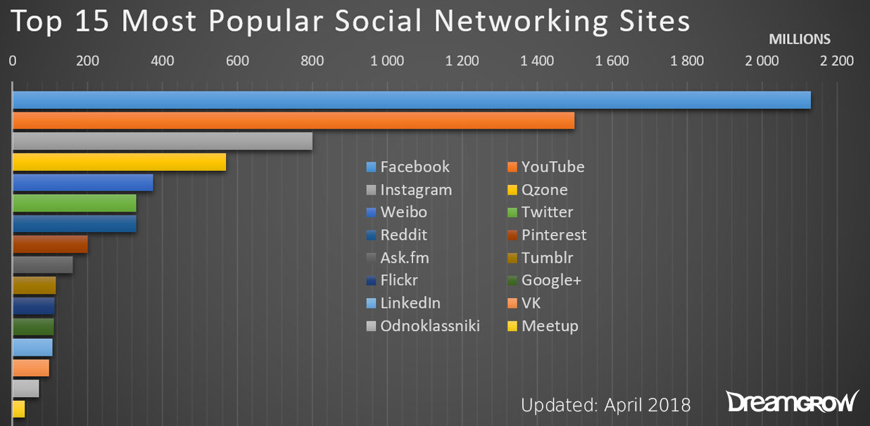
Source: DreamGrow (2018)

According to figure 3, the most popular social media platform is Facebook, followed by YouTube and then Instagram. SBS should focus on improving their Facebook page, not only because of its demand but also the numerous marketing strategies that it offers. This includes tools such as messenger, posts, event manager and groups which helps with brand awareness and consumer relationships. On the other hand, using other platforms such as YouTube and Instagram is also important due to the ever-changing digital social environment. Trends continuously change, therefore it is important to have variety. Different consumers have different preferences to content for example, some may prefer video content over reading Facebook posts, where others are more visual and would prefer Instagram.

The importance of social media to UWTSD Swansea Business School

It is important that SBS embraces social media platforms because today’s students are no strangers to communicating and sharing experiences on social media websites such as Facebook and newer platforms such as Instagram. Kayla Germain, an E-Media Coordinator of The College of Saint Rose claims that “Social media has been key for us and has been a great audience connector not only with prospective students but with prospective parents.” This highlights that through the use of social media, potential students and their parents can be reassured of any concerns or queries.

Using social media platforms can also help attract students, engage with present students and stay connected with graduates. A blog by Ridley (2018), suggests that when looking for a university, students desire a high-quality course and facility. On the other hand, they also want somewhere homely, where they can fit in and what better way than having a face-to-face informal chat through Skype with a representative of the university to demonstrate this. Currently, the university utilises Skype but not for consumer engagement. This is something that can be adopted by the university, which can benefit both potential students and the university. The students will gain confidence about attending the university and the university could potentially gain more students.

Due to the power of social media, students no longer require campus visits or printed booklets for information on the university. Currently, SBS offers information on several media platforms, the following include the UWTSD website, Facebook, YouTube, Twitter, Instagram, Skype and for present students, they have a specialised website and app called ‘MyDay’. Although SBS are accessible on several relevant media platforms, some are more important than others and can be further developed.

The Lifecycle Marketing model, created by Chaffey identifies four key areas to follow, that are designed to help businesses engage their target audience. Utilising this model will help SBS to identify specific weaknesses in any of their social media strategies.

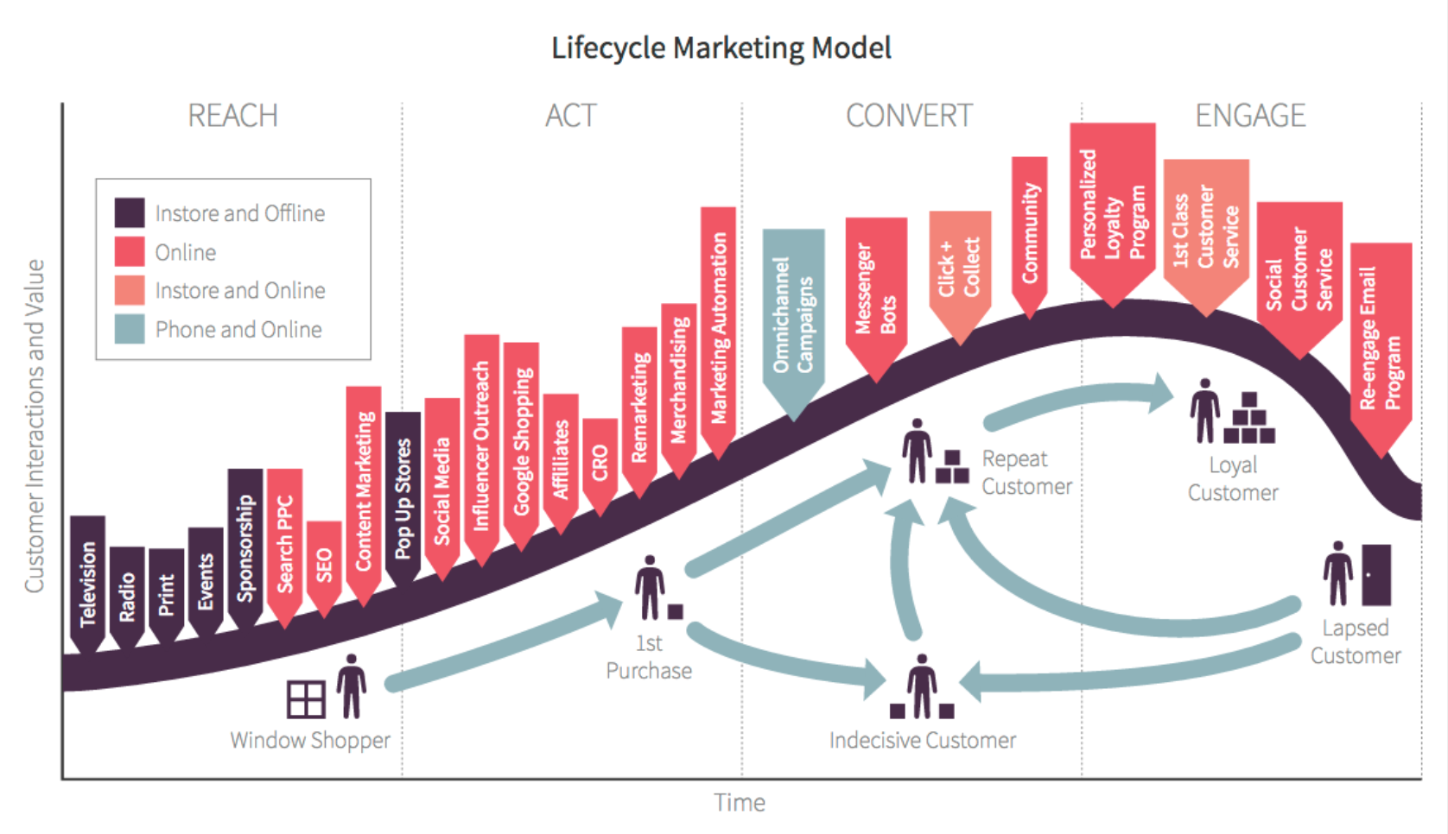
Figure 2: The Lifecycle Marketing Model
Source: Chaffey (2018)

Figure 3, highlights the key online marketing channels that should be implemented by SBS to achieve the best results from what digital marketing has to offer. Channels such as social media and search engine optimisation (SEO) have been implemented by the university, however other useful online marketing channels like remarketing and influencer outreach aren’t so common.

Figure 3: RACE model

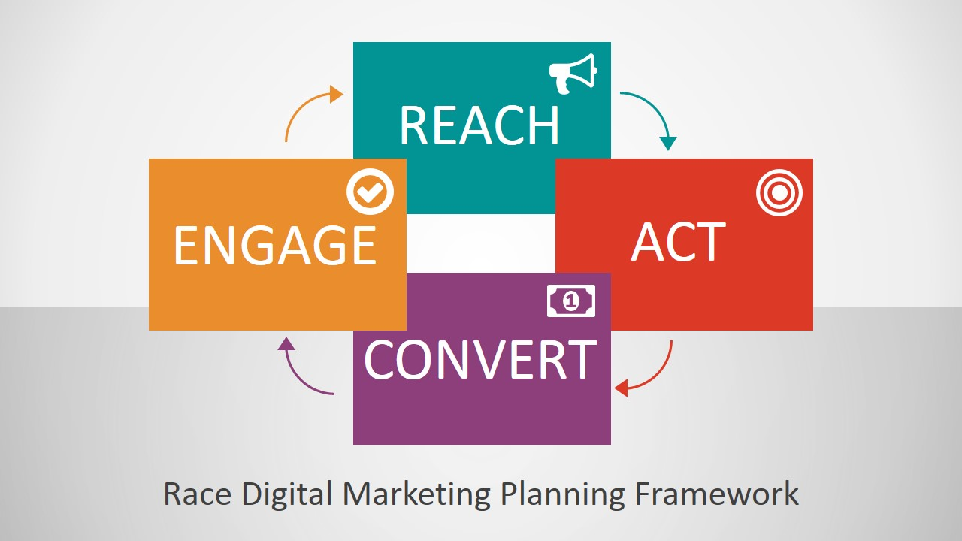
Source: SlideModel (2018)

RACE Model applied to Facebook

Reach
- Posting engaging and relevant content to entice students to engage
- Advertising open days through Facebook’s advert manager so that students receive reminders of the upcoming event

Act
- Responding through messenger tends to be a preferred method of communication for students as most will receive instant messages on mobile phones
- Reply to queries by commenting on posts, which is time effective because that response could cover other student’s queries

Convert
- Using weblinks on posts so that students can register for open days and for the university easier
- Invite target audience to university Facebook groups to encourage registering and current students in that particular group can respond to any queries regarding their university experience

Engage
- Asking the target audience for their reviews on the services provided by the university such as open days through messenger and posts
- Follow, like and share student posts in relation to university content to encourage more involvement in university activities and events
- Involve students by tagging them into posts relevant to university life so that students and target audience can remain updated

Social media analytics and monitoring platforms

Bekkers, et al. (2013), proposes that social media monitoring is slowly becoming a common practice in public organisations. Its main purpose is strategic control and receptivity. The process begins with the business’s goals for example, the university may focus on getting more views on the university’s website. The next step would be determining key performance indicators (KPIs) in this case, the focus would be based on engagement statistics. This would involve reviewing the number of website views and how many clicks the links and contents receive. Collecting this data helps determine how successful the website is and also whether it is contributing to achieving the business’s goals, in this case whether it is resulting in potential students enquiring about the university and then applying.

Social media monitoring allows for transparency and security, however it does pose some ethical rights such as people’s privacy. Numerous software tools are available for social media monitoring. According to G2Crowd, (2018), one of the best social media monitoring platforms is Hootsuite. Hootsuite is a social media control panel that monitors several social media channels at once. It allows posts to be scheduled across all media channels which is great for time management as well as being an analytics tool. This platform measures social media performance as well as tracks engagement statistics, for example, SBS can use this platform to compare each of its channels to see which has the most engagement. The disadvantage to using Hootsuite is that charges apply to the advanced version.

Similarly to the Hootsuite platform Keyhole (2018), mentions that Google Analytics also evaluates social media data. Moreover, Google Analytics is the top choice for analysing website traffic. This platform also determines the behaviour of visitors and whether they convert. This is essential for the university to sustain competitive advantage. Opposed to traditional monitoring where data is gathered over a period of time, social media monitoring is instant and continuously monitors any occurred issues. Furthermore, social media monitoring enables organisations such as SBS to gain valuable customer insights, for example, consumers feedback. However, the use of trend prediction by analytic tools such as Google Analytics can sometimes be inaccurate. Ultimately, it is vital that SBS use a form of social media monitoring platforms to ensure the safety of its students on the internet and furthermore, it enables SBS to track their progress. Finally, social media monitoring is a great way of changing negative feedback into positive publicity.

Conclusion

To conclude, it is evident that by using social media monitoring platforms effectively, the Swansea Business School can optimise their social media activities, in order to attract students and convince them to study at UWTSD Swansea Business School. Using Hootsuite, a recommended social media monitoring platform can also provide a warning if there are any security issues on any of the university’s social media platforms. Remaining relevant and gaining competitive advantage is vital to the university so that the organisation can continue operating, therefore SBS need to stay updated with social media platforms so that students can get in contact and the organisation doesn’t miss out on a potential new student. Facebook appears to be the most influential social media site, that has been adopted by the university due to its popularity and frequent use by students. Traditional forms of marketing, such as posting leaflets isn’t cost effective and now appear to be replaced by e-mails which is a quicker and more effective way of receiving information. It is more reliable due to the potential threat of delays with post and delivery times that vary. Ultimately, digital marketing appears to be of more value to the university than traditional forms of marketing.

Recommendations

In order to improve SBS’s digital marketing strategies, new recommendations can be implemented. Recommendations include creating a free website containing blogs, this can be done on WordPress that includes engaging content regarding current student’s experiences and views on the university. Blogs can contain humour and therefore, this would highlight that the university can be homely and not all serious. Further recommendations include radio advertisement, which isn’t cost effective but if successful, the results outweigh this disadvantage. Radio advertisement can be engaging and memorable. Lastly, feedback from students is key in order to improve. Therefore, using incentives and prizes that are related to the university such as a free tablet or laptop would benefit the student and to some extent the university. This could be a good strategy to gain feedback from students and posting the surveys across all social media channels will maximise the volume of participants.

Appendix
(Chaffey & Ellis-Chadwick, 2012)
(Khan & Siddiqui, 2013)
(Webber, 2013)
(Irons, 2017)

Bibliography
Bekkers, V., Edwards, A. & de Kool, D., 2013. Social media monitoring: Responsive governance in the shadow of surveillance?. Government Information Quarterly, 30(4), pp. 335-342.
Chaffey, D., 2018. What is customer lifecycle marketing?. [Online]
Available at: https://www.smartinsights.com/ecommerce/web-personalisation/what-is-lifecycle-marketing/
[Accessed 26 April 2018].
Chaffey, D., Ellis-Chadwick, F., Johnston, K. & Mayer, R., 2006. Internet Marketing: Strategy, Implementation and Practice. 3rd ed. s.l.:FT Prentice Hall.
DreamGrow, 2018. Top 15 Most Popular Social Networking Sites and Apps. [Online]
Available at: https://www.dreamgrow.com/top-15-most-popular-social-networking-sites/
[Accessed 23 April 2018].
easyJet, 2018. Help. [Online]
Available at: https://www.easyjet.com/en/help
[Accessed 13 April 2018].
G2Crowd, 2018. SOCIAL MEDIA MONITORING SOFTWARE. [Online]
Available at: https://www.g2crowd.com/categories/social-media-monitoring
[Accessed 20 April 2018].
Kemp, S., 2018. Blog. [Online]
Available at: https://wearesocial.com/blog/2018/01/global-digital-report-2018
[Accessed 12 April 2018].
Keyhole, 2018. A List of the Top 25 Social Media Analytics Tools. [Online]
Available at: http://keyhole.co/blog/list-of-the-top-25-social-media-analytics-tools/
[Accessed 26 April 2018].
Likeable, 2017. Blog. [Online]
Available at: https://www.likeable.com/blog/2017/6-reasons-why-social-media-is-an-absolute-must-for-branding-your-business/
[Accessed 10 April 2018].
McLuhan, M., 1964. Understanding Media: The Extensions of Man. 2nd ed. s.l.:New American Library.
Ofcom, 2017. Internet use and attitudes: 2017 Metrics Bulletin, s.l.: Ofcom.
Ridley, D., 2018. How Today’s Colleges and Universities are Using Social Media. [Online]
Available at: https://vtldesign.com/digital-marketing/social-media/how-todays-colleges-and-universities-are-using-social-media/
[Accessed 14 April 2018].
Rodriguez, G., 2018. Articles. [Online]
Available at: https://www.nike.com/gb/en_gb/c/running/nrc-articles/success-story?ref=https%253A%252F%252Fwww.google.co.uk%252F
[Accessed 14 April 2018].
Ryan, D., 2016. Understanding Digital Marketing: Marketing Strategies for Engaging the Digital Generation. 4th ed. s.l.:Kogan Page Publishers.
SlideModel, 2018. PowerPoint Templates. [Online]
Available at: https://slidemodel.com/templates/race-digital-marketing-planning-framework-powerpoint-template/
[Accessed 15 April 2018].

