

Assessment 1 – Reading Task Template
Upload your photo of your A3 in-class notes here:
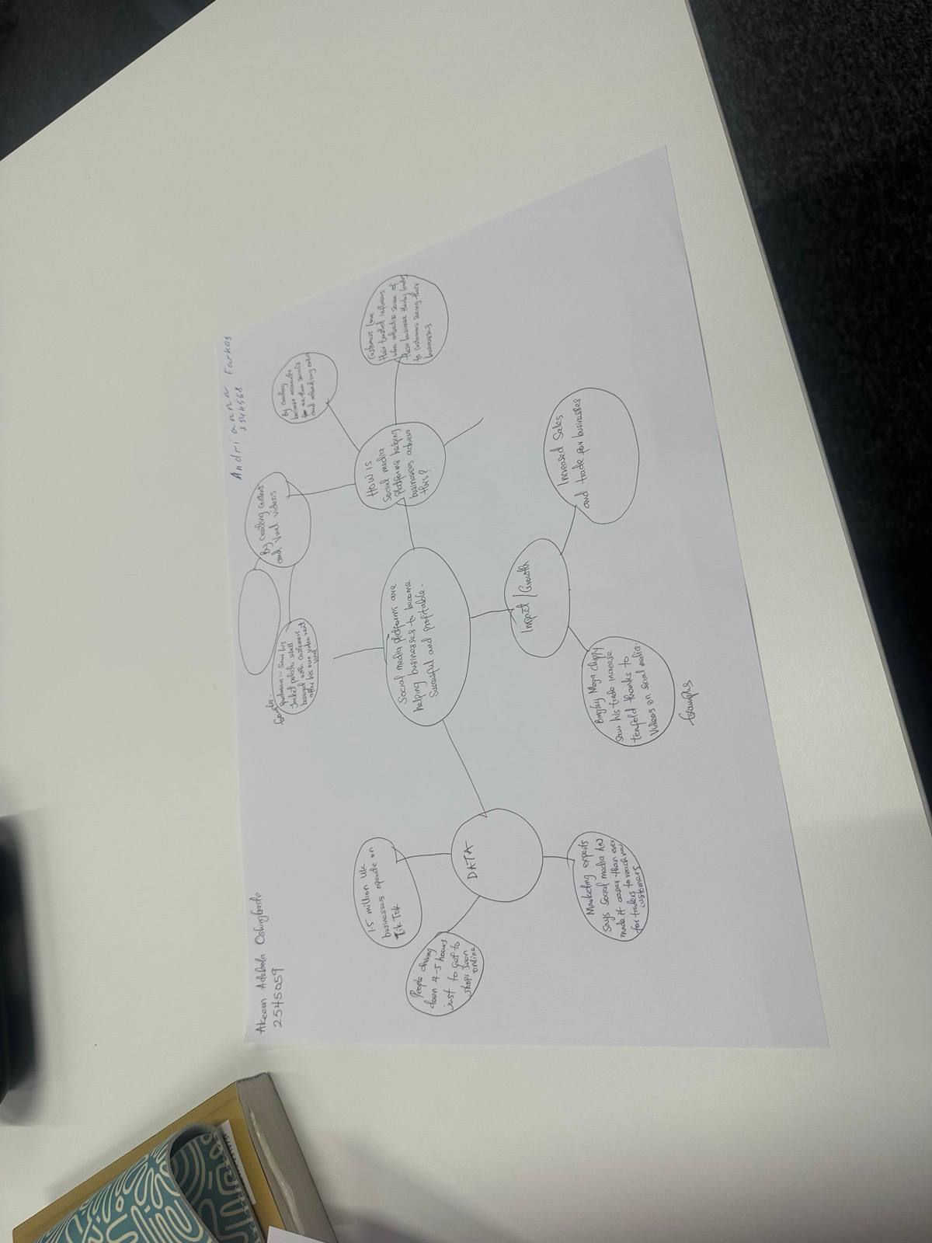

1. Answer these questions using the sentence starters below
a. What is the main idea of the text?
The main idea is that all social media helps your business to get noticed quickly and also its affordable as it is free to use.
b. What are two key points?
One key point is that using media platforms more people get to know about your product or your company
Another key point is that online business could be as profitable as physical but with less money needed to invest.
c. What part of the text did you find most important? Why?
The most important part is the first as it explains that you can use any social media like TikTok, Instagram for your future business and its working.
d. Was anything unclear or difficult to understand?
The text was understandable, and I pointed for myself lots of new useful information
e. How did your group help you understand the text better?
My group helped me when we discussed the text. I heard a lot of different opinions, and it helped me to focus on the key points.
2. One sentence reflection
Question: What did you find challenging about this task?
The text, as some words in the text was hard to understand

