The First 1000 Days- Stephanie Rees 2100655- ECEY4005
Introduction
The first 1000 days identifies the time from the start of pregnancy to a child's second birthday. This is a period which evidence shows plays a vital role in whether children grow up happy, healthy and well adjusted (New Parent Support (NPS), n.d.).
The first 1000 days is an extremely important time, whether mums are poorly, and children nourished and cared for during this time can have a profound impact on a child's ability to grow learn and thrive. This is because the first 1000 days is when a child's brain begins to grow and develop and when the foundations for their lifelong health are built (NSP, n.d.).

Pregnancy


(1000days.org 2022)
Good nutrition during the first 1,000 days provides the building blocks for healthy brain development.
During the 1,000 days the brain can grow very quickly than any other time om a person's life. nutrition provides the fuel that drives much of the brain growth and development. Beginning early in pregnancy and throughout their childhood, nutrition provides the building blocks for a
child's cognitive ability, motor skills and socio- emotional development, which in turn impacts their future success in school or opportunities later in life.
Parliament UK (2014) states When a baby’s development falls behind the norm during the first year of life, for instance, it is much more likely that they will fall even further behind in subsequent years than catch up with those who have had a better start.
With support, it is possible to rebuild the brain properly and put the children back on a course of a healthy development, but doing it is very challenging. Sir Michaels Marmot’s review of health inequalities (2010, p325) stressed that ‘what happens in these early years, starting in the womb, has lifelong effects’

Holistic Play
The holistic Development in EYFS is an approach to learning that emphasises the importance of the physical, emotional psychological well-being of children especially in early childhood (Twinkl, 2022). This can help children to connect with the world around them and learn in a way that differs from the conventional form of schooling that many people choose to adopt.
What is Holistic Development in the Early Years?
Holistic development in the Early Years can recognise the connectedness of mind, body and spirit. When the Early Years practitioners take a holistic approach to child development, they pay attention to the children’s physical, personal, social and emotional and spiritual wellbeing, as well as cognitive aspects of their learning (Twinkl, 2022).
Holistic development approach in the early years is important when planning and assessing the needs of the child. This allows practitioners to assess the child as an individual and understand what they have achieved, as well as what they have not achieved by looking at how their developmental areas link up and how progress in one area can affect progress in another.
There are five aspects to early holistic development.
❖ Physical
❖ Emotional
❖ Social
❖ Mental
❖ Intellectual (Twinkl, 2022).

How can we support a child’s holistic development in the early years?
Holistic Development in the early years allows practitioner’s to develop an activity that a child enjoys and turn it into a learning opportunity. You should always create a comfortable and safe environment for children to connect and be themselves and make individual small groups and space for some creative play.
Why not use colourful classroom area signs for early years to brighten up your classroom and add a splash of colour to your setting? Create some interest and corners that individual children and small groups like to play in.

Here is an example of areas you can have for the early years
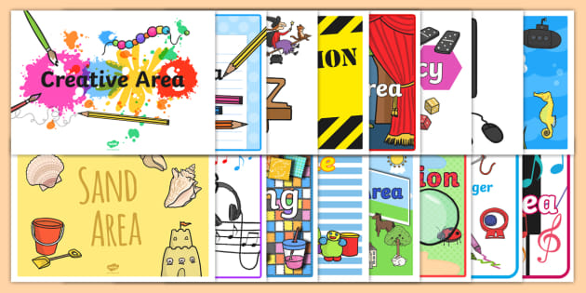
(Twinkl classroom areas 2022)
This is an example of early overall development. Babies and toddlers can learn and develop as a whole. That is, many areas develop at the same time and can usually occur during one activity (Williams, 2020). For example, a child may use a spoon. This means meeting their physical needs which increases independence and self-esteem to meet emotional needs. The overall developmental approach allows early childhood professionals to plan future activities with their children which will benefit their overall learning,development and well-being (Williams, 2020).
What are the benefits of early holistic development?
The greatest benefit of the overall developmental approach lies not only in the child's intellectual development, but also in the location and importance of the child's psychological, social and emotional growth. This will improve communication and social skills and give birth to a confident child(Williams, 2020).
Practitioners may find it very enjoyable to learn and challenge a particular topic practitioners as associate positive reactions with learning.

Treasure Baskets
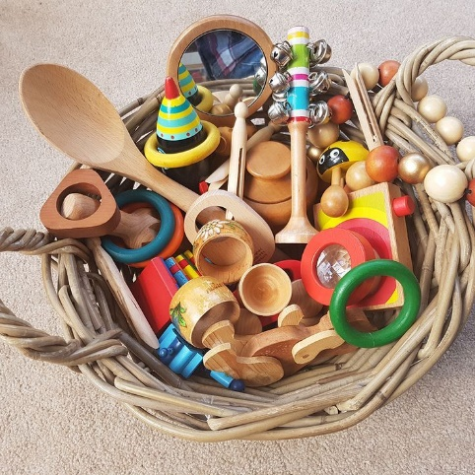 (Williams 2022)

Treasure baskets are flat baskets, usually made of rattan, however, any type of basket can be used can hold a lot of random everyday items. These objects are chosen to stimulate the baby's curiosity and allow the baby to interact independently with the object while sitting (Williams, 2020).
Treasure basket games are easy to create and very rewarding. The Treasure Basket is perfect for creating awe and mysteries , inspiring your baby and allowing them to fully focus on what they are doing. Babies like to use them. When mothers first sit down, your baby ill be old enough to play in the treasure basket. Initially, the baby can sit straight with the support Some babies are approximatley months old when they stand up with help. Normally, mothers can continue to play in the treasure basket without worry until the baby crawls a little and tries to move around in outer spaceWilliams 2020)
Piaget states that development is divided into four phases (Sherrell, 2021). Sensorimotor Stage 2002 is when Babies begin to deepen their understanding of the world through their senses by touching, grasping, observing and listening. The baby also begins to develop a sense of permanence for the object. In other words, understand that the object exists even if they cannot see it (Sherrell, 2021).
Preoperative Stage is when 2–7-year-old child develops language and abstract thinking. This means that they can develop non-physical concepts and ideas. They also start with an iconic game (pretend), unzip the photos and tell them what happened in the past (Sherrell, 2021).
Concrete operational stage -11-year-old children learn logical and concrete rules about objects such as size, weight, and volume. Children can also see that the properties of the object remain the same even if the appearance of the object changes (Sherrell, 2021)
Formal operational stage (12+years) is when adolescents understand abstract concepts and learn logical rules for solving problems. For example, they can understand the concept of justice (Sherrell, 2021)

(Simply psychology 2022)

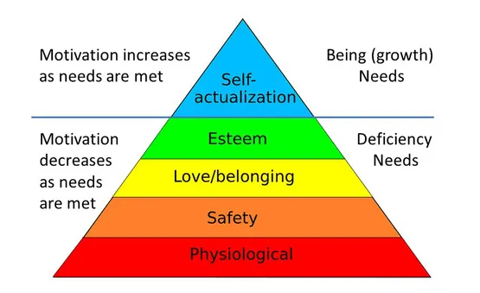
Maslow's Pyramid of Desire is a psychological motivational theory that covers a five-level model of human desire, often represented as a hierarchical level within the pyramid. From the bottom of the hierarchy, the needs are: Physiology (food and clothing), security (work security), love and attribution needs (friendship), self-esteem, self-actualization. The lower needs of the hierarchy must be met before the individual can meet the needs of the higher up

Story Telling
Story telling is one of the maximum effective methods that leaders ought to influence, train and inspire (Boris, 2017). What makes storytelling so powerful for learning, is from the beginning of evolution storytelling forges connections amongst human beings and among human beings and ideas. Stories can bring the culture, records and values that may unite human beings. When it involves countries, groups and households people are able to apprehend intuitively that the tales kept are not unusual and are an essential part that binds people together (Boris, 2021).
Stories are available in a number of bureaucracy: poetry, song, movement, pictures, performs or even Dad jokes. The creators of the tales can use numerous mediums along with braille, signal language and dance to percentage the tales with others (Hurst, n.d.). Some tales also can be dynamic people will listen and enjoy them even after the are gone. Stories grow to be a static whilst we write them down or report them in a few manner so we are able to revisit them time and again.
Children who are visually impaired deaf or blind can also additionally enjoy a tale with the aid of using tactually exploring gadgets gathered on a stroll or gambling with the substances used to take a tube for those are located in an enjoy container or bag. A baby with low imagination and perception can also additionally revel in an easy image book or e-book with restricted print. Audio and braille are different mediums that can be used to percentage a tale with others. The shape or the medium are not as essential because the tale itself or the advent of the tale (Hurst, n.d.).
The challenges people face in when working in childcare
Practitioners come across many challenges when working with children in childcare settings for example: lack of time, limited funding, demanding parents and excessive paperwork. Practitioners have the perception when working with children can be easy when in fact it is the complete opposite. Sometimes it can have rewards and it can have challenges.

Respectful care in childcare setting
The care inspectorate is framed around key questions. During covid-19 they have introduced the key question 5: How good is their care and support during covid, the question will remain in the framework and will be used in childcare settings

Reference list

Boris, V. (2017) What Makes Storytelling So Effective For Learning? Available at: https://www.harvardbusiness.org/what-makes-storytelling-so-effective-for-learning/ (Accessed: 20 January 2022).
Hurst, K. The Importance of Storytelling and Story Creation. Available at: https://www.pathstoliteracy.org/playing-words/why-it-important/importance-storytelling-and-story-creation (Accessed: 20 January 2022).
Parliament UK. (2014) Written evidence submitted by Barnardo’s. Available at: https://publications.parliament.uk/pa/cm201314/cmselect/cmeduc/364/364we20.htm (Accessed: 20 January 2022).
Sherrell, Z. (2022) What are Piaget’s stages of development, and what are examples of each. Available at: https://www.medicalnewstoday.com/articles/325030 (Accessed: 20 January 2022).
Twinkl. (2022) What is Holistic Development (EYFS) Available at: What is Holistic Development (EYFS)? - Answered - Twinkl Teaching Wiki (Accessed: 20 January 2022).
Williams, M. What Is A Treasure Basket? The Essential Guide. Available at: https://earlyimpactlearning.com/what-is-a-treasure-basket/#:~:text=A%20treasure%20basket%20is%20a,the%20objects%20whilst%20sitting%20up. (Accessed: 20 January 2).

