

Student name: Jenny Hermoso
Student ID: 2436151
Module name: Introduction to Health and Social care
Module code: [LCHS4003_LON]
Lecturer name: Mohammed Aliyu

Contents
TASK 2 4
PAST HISTORY 4
MODERN HISTORY 4
Reference list: 6


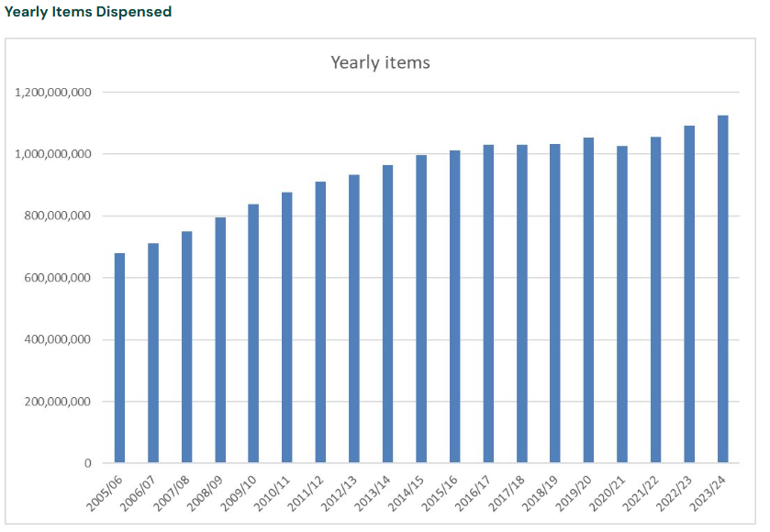
History:
The trade in medicines in the UK was regulated initially by the Guild of Pepperers. The Worshipful Society of Apothecaries was founded after, marking the beginning of formal pharmacy practice in England.
Since 1948, pharmacy within the NHS has been transformed from a dispensing-focused role into a pivotal component of clinical care and public health. Pharmacists are now regarded as essential contributors to patient-centred services, therapeutic management, and health promotion.
The Linstead Report (1953) expanded their roles and involvement in medical education, with the Medicines Act (1968) establishing a licensing process for pharmacists.
What can a pharmacist do for you? What should you do in a pharmacy?
Pharmacists also give free medical and medication advice for certain conditions, can also remind people to pick up their medication, and occasionally deliver medication.
When in a Pharmacy, as a civilian, you can ask questions regarding your prescriptions. Details such as side effects and additional information about the medication.
You can also ask for advice on a range of illnesses, medicines, and treatments from them.
You can also collect prescribed medication and buy several over the counter medication from them.

Challenges:
Digital Transformation: The healthcare sector is undergoing significant digital changes, impacting how pharmacists manage patient data and interact with healthcare systems. Adapting to electronic health records, telepharmacy, and digital prescription services requires pharmacists to continuously learn and adjust their workflows.
Increased Workload and Pressure: Pharmacists are experiencing higher workloads due to increased demand for services, staffing shortages, and expanded responsibilities, such as administering vaccinations and providing patient counselling. This is an addition to the reduction in budget pharmacy in 2017.

Current Functioning:
According to Community Pharmacy England (2025), there has been a relatively steady increase in the dispensary of pharmaceutical items throughout the years. It is even evident from the statistics shown for the years Apr 2022-Mar 2024 that the increase has been steady

Introduction:
What is a Pharmacy and How does it operate?
A Pharmacy is a either a shop or hospital depository of medicinal drugs.
You can buy many of the more basic medications from the Pharmacy, however some medication requires a prescription from your GP or doctor.

e
Pharmacy Services

TASK 2

PAST HISTORY
Similarly, the origin of medicine production predates historical records available. However, we can trace the initial regulations by the Guild of Pepperers in 1180 as a definitive beginning of Pharmacology. This guild initially focused on the trade of spices and medicinal ingredients, which were crucial in both culinary and therapeutic contexts. Over time, their oversight began to shape the standards for the preparation and sale of medicinal compounds, laying the groundwork for later professional pharmaceutical bodies.
In 1518, the College of Physicians was founded and took over licensing of doctors in London. It was an institution founded by physicians in order to create qualified practitioners and limit the presence and influence of unqualified practitioners. This marked a significant step toward organized medical governance and the protection of public health. The College not only assessed the competence of practitioners but also sought to establish ethical codes that would guide medical conduct and education.
The Guild of Pepperers was then relieved of its duty towards pharmaceuticals by the Worshipful Society of Apothecaries in 1617 through the support of King James I, who put forward the idea of training apprentices to encourage knowledge. The establishment of formal apprenticeship systems ensured that practical training became a fundamental part of medical and pharmaceutical education. This was then replaced by the Pharmaceutical Society of Great Britain in 1841. Additional regulation, in the form of the Pharmacy Act 1888, solidified the idea of pharmacist qualification by limiting the sale of dangerous substances to qualified professionals. These developments reflected a growing awareness of the need for public safety and accountability in the distribution of medical products.

MODERN HISTORY
The National Health Service (NHS) was officially inaugurated on 5 July 1948, representing a pivotal shift in British social policy. Its establishment was influenced by the Beveridge Report (1942), in which a welfare state was proposed to address the "five giants" of Want, Disease, Ignorance, Squalor, and Idleness. The widespread devastation caused by World War II was recognised as a catalyst for the urgent implementation of a universal healthcare system, designed to serve the population irrespective of financial means.
In contemporary England, the National Health Service (NHS) is no longer regarded as a singular entity, but rather as a multifaceted system composed of numerous organisations functioning at national, regional, and local tiers. It has been recognised as the largest employer in Europe, with a workforce exceeding 1.7 million individuals across the United Kingdom. The current framework is characterised by several core components. NHS England is entrusted with the oversight of financial resources, strategic development, and service commissioning. Integrated Care Systems (ICSs) have been formed as regional collaborations tasked with the coordination of health and social care services. Primary care is mainly provided through general practitioner clinics, dental offices, optometry practices, and community drugstores. NHS Trusts provide secondary and tertiary care, which includes hospitals and specialized healthcare facilities. Regulatory functions and public health initiatives are overseen by statutory organizations like the Care Quality Commission.
Britain’s first majority Labour government, led by Clement Attlee, formulated plans for a comprehensive Welfare State. An NHS, free at point-of-delivery, was the cornerstone of these plans. As part of that, the National Health Service Act was passed in 1946. When the NHS officially launched in 1948, it symbolized a profound social commitment to equity and collective responsibility. The model influenced healthcare systems around the world and remains one of Britain’s most defining institutions.
The Pharmaceutical Society of Great Britain was replaced by the Royal Pharmaceutical Society and the General Pharmaceutical Council in September 2010. This change aimed to clearly separate professional representation from regulatory functions, ensuring greater transparency and accountability. Then, the Health and Social Care Act 2012 introduced major structural changes, promoting competition and the involvement of private providers in the NHS. This sparked considerable debate about the future of the NHS and its funding. Some argued that these reforms could increase efficiency, while others feared they would undermine the founding principles of universal, free healthcare. Despite ongoing challenges, the NHS and its regulatory bodies continue to evolve, and adapt to new technologies, changing population needs, and modern day economic pressures while striving to uphold the standards established over centuries of medical development.

Reference list:
Clement, M. (2023). The founding of the NHS: 75 years on - History of government. [online] history.blog.gov.uk. Available at: https://history.blog.gov.uk/2023/07/13/the-founding-of-the-nhs-75-years-on/.
General Medical Council (2024) History of medical regulation. Available at: https://www.gmc-uk.org/about/who-we-are/our-history
Health Service Navigator. (2025). A short history of the NHS - Health Service Navigator. [online] Available at: https://www.myhsn.co.uk/top-tip/a-short-history-of-the-nhs/.
Sloan, R. (2018). NHS England» 100 years of General Practice. [online] www.england.nhs.uk. Available at: https://www.england.nhs.uk/blog/100-years-of-general-practice/.
Wikipedia Contributors (2025). Worshipful Company of Grocers. [online] Wikipedia. Available at: https://en.wikipedia.org/wiki/Worshipful_Company_of_Grocers.

