
Coursework Title:
Module Name: Analysing and Solving Problems
Module code: ACCA4019
Student Name: Hanzala Irshad
Student ID: 2508961
Lecturer Name: Dr Abida Perveen

Submission date: 17/03/2026

Contents
1. Deconstructing the Problem 3
1.1 MoSCoW Analysis 3
1.2 Key Variables and Constraints 4
2. Proposed Solution 4
2.1 Flowchart 5
2.2 Detailed Explanation of the Allocation Process 7
2.3 Key Decision Points in the Model 7
2.4 Assumptions Made in the Solution 8
2.5 Ensuring Efficient Room Usage 9
2.6 Minimizing Movement Time 9
2.7 Avoiding Scheduling Conflicts 9
3. Reflection and Justification 10
References 11

Deconstructing the Problem
The allocation of college classrooms is a space constraint resource optimization problem with time bound schedules and classes of varying sizes. This issue is based on inefficiency supply (rooms offered and time slot) and its demand (student enrolment needs and time schedule needs). At the systemic level, the college constitutes a web where manipulation of a given entity (i.e. room assignment) can have direct impact on other entities (i.e. student movement time, punctuality, and learning experience). In turn, this issue can be classified into movement optimization, scheduling accuracy, and allocation efficiency.
The MoSCoW method is a methodical approach [1] which prioritizes requirements on the basis of Must, Should, Could and Won't (at least).

MoSCoW Analysis
Must Have (Critical Requirements):
- Accurate matching of class size to room capacity.
- Prevention of timetable clashes (no double-booked rooms or overlapping lecturer schedules).
- All sessions assigned a room before timetable publication.
- Compliance with health and safety capacity limits.
Should Have (Important but not vital):
- Minimized walking distance between consecutive classes for students and staff.
- Balanced utilization of all rooms to avoid overuse and underuse.
- Consideration of special requirements (e.g., labs, IT equipment).
Could Have (Desirable enhancements):
- Automated allocation system with real-time adjustments.
- Preference-based allocation (e.g., lecturer preferences).
- Data analytics to predict future capacity needs.
Won’t Have (Current scope exclusion):
- Construction of new buildings.
- Major timetable restructuring beyond allocation optimization.

Key Variables and Constraints
The relevant variables include:
- Number of students per class.
- Room capacity.
- Number of available classrooms.
- Time slots per day/week.
- Lecturer availability.
- Building layout and room locations.
- Special room requirements (e.g., laboratory, computing facilities).
Key constraints include:
- Fixed room capacities.
- Limited timetable slots.
- Institutional policies and safety regulations.
- Predefined course timetables.
- Physical distance between buildings.

Proposed Solution
The solution suggested is premised on a structural, algorithmic model, of classrooms optimized allocation against optimized schedule. It uses constraint-based allocation and optimization logic to provide systematized decision-making processes. This is supplemented by the flowchart illustrating a systematic flow of decisions on the capacity, availability, movement and subsequently allocation of rooms. Its overall objectives include: 1) ensuring the room is utilized at maximum capacity, 2) minimizing time difference between the consecutive classes, and 3) avoiding conflicts in scheduling.

Flowchart
Flowchart illustrating efficient classroom allocation is:

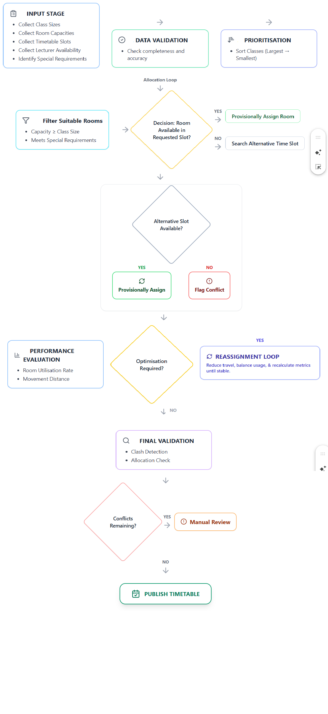

Detailed Explanation of the Allocation Process
Data collection and input processing are the starting points of the allocation process, and the key to the accuracy of the model. Vital variables consist of the class size, the room capacity, the building location coordinates (to estimate the movement time), and lecturer schedules. Proper and full information is imperative since faults at such a level will trickle into the system resulting in ineffective or impractical allocations. Hence, the data validation is undertaken prior to the start of the allocation process, making sure that the enrolment is completed, the room capacities do not exceed safety rules, and time slot arrangements are laid out effectively.
The second stage is associated with the priority-based allocation strategy, in which the bigger classes are planned first. Bigger cohorts lack appropriate rooms since the capacity is limited. Early allocation will minimize the risk of subsequent infeasible placements. This is an embodiment of a constraint-first optimization method popular in resource allocation problems, in which the most constraining variables are solved first followed by flexible ones.
The third phase entails sequential constraint filtering. The rooms get filtered by capacity (room capacity ≥ class size), by class size, special facility needs (i.e. a laboratory or IT suite), and time-slot availability. This multi-layered filtering will prevent the overcrowding of rooms or double booking of lecturers.
Lastly, conflict resolution is implemented. In case there is not a room in the requested slot, alternative time slots are sought. Where no viable option is possible, the system alerts the problem to be solved manually. Sequential filtering models are simpler to compute, since the infeasible options are removed in the initial stages, making the model still efficient and logical.

Key Decision Points in the Model
The model involves several critical decision nodes that facilitate the logical branching and efficiency of the system. The first decision asks:
- Does room capacity meet class size requirements?
This helps to avoid excess congestion and guarantees safety requirements. When the condition fails, the option is automatically eliminated, avoiding inefficient allocations.
The second decision evaluates:
- Is the room available at the requested time?
This would assist in eliminating schedule conflicts and overbooking rooms or lecturers. The system guarantees integrity of its schedules since time constraints are checked at an early stage.
Another optimization decision may take into account:
- Is there any better room with less travel distance?
This will help to reduce movements by favoring the proximity of spaces between consecutive classes. It thus, minimizes transition time and guarantees punctuality.
Finally, the model checks:
- Do we address all the constraints??
This ensures complete validation control before publication of schedules. Cumulated together, these structured decisions ensure that inefficiencies do not propagate through the system. It also provides logically consistent and efficient allocation products.

Assumptions Made in the Solution
The proposed model is based on several simplifying assumptions.
- Fixed class sizes: Assuming that the sizes of classes do not change after they are allocated.
- Fixed lecturer availability: The lecturer schedules are regarded as immutable and fixed throughout the scheduling process.
- Static room capacities: The room capacities are considered fixed and in line with the safety regulations.
- Accurate building layout data: The building layout and position of rooms are assumed to be reliable in determining the distance between rooms.
- Standardized time slots: Time slots are regular (e.g., one-hour blocks) to ensure uniformity in allocation.
Such assumptions are useful in modelling and can infer structured optimization. However, they may reduce flexibility in more realistic scenarios where enrolments, or staffing, or space availability change dynamically.

Ensuring Efficient Room Usage
Strategic capacity matching and post-allocation evaluation can help to achieve efficient room usage.
- Capacity Alignment: The alignment of room size with room capacity ensures overcrowding.
- Priority Allocation: When large classes are scheduled initially, there will be no ineffective left-over allocations in small rooms.
- Utilization Monitoring: Room use is evaluated at the post-allocation stage using a quantifiable measure:
$$\text{Utilization}=\frac{\text{Total Students Assigned}}{\text{Total Capacity Used}}$$
These measures assist in identifying underutilized and overutilized occupied rooms and, consequently, help in reallocating them in an iterative fashion. Performance measurement enables the system to transcend beyond intuition and adopts quantifiable optimization principles.

Minimizing Movement Time
Spatial optimization reduces the time of movement. The travel distance of classes is approximated by the location data of buildings. Back-to-back classes should preferably be located in the same structure or nearby rooms. When walking distances are found to be inconveniently large, a loop of optimization can be made to reallocate. The model minimizes transition time to maximize punctuality, minimize fatigue, and, generally, the learning experience of students and staff.

Avoiding Scheduling Conflicts
Any conflict encountered in schedules is avoided by layered validation checks. Prior to provisional assignment, availability of rooms is confirmed so that there is no risk of a double booking. Scheduling of lecturers is cross-checked to ensure that there are no conflicts in the schedules given to personnel. A final system-wide conflict scan is made before the timetables are published. Validation is not a single step verification but rather iterative process. Any conflict identified during the process of optimization is corrected prior to the respective confirming wave, which further helps to enforce the reliability of the timetable.

Reflection and Justification
A repertoire of systematic problem-solving tools informed the design of this solution. These tools are abstract thinking, decomposition, constraint based reasoning, systems thinking [2]. The need to think abstractly enabled the problem of classroom allocation to be re-conceived as a resource optimization problem [3] as opposed to an administrative problem. The problem was redefined as a rational allocation model conquering the constraints of a single institutional setting by setting up fundamental variables which include capacity, time, place and availability.
The situation was complicated requiring its breakdown into manageable elements. These elements are input processing, prioritization, constraint filtering, optimization, and validation. This simplified the logical thinking and systematic analysis of every step. The representation of the sequential decision-making processes and conditional branching as a flow diagram further supported the algorithmic thinking as it gave clarity and logical accuracy.
Larger classes were favored in the optimization model on the basis of constraint-based reasoning [4]. This prioritization involved system thinking analyzing the inter-relation of allocation decisions, movement time and stability of timetables in a college system. Thus, this model solves the resource constraint issue on a system level as opposed to individual level.
This approach is appropriate because it provides an intuitive and scalable holistic framework. Its ability to be implemented either manually or digitally supports it. However, limitations exist. The assumptions of this model including fixed class sizes, fixed availability of lecturers or accurate spatial data don’t reflect dynamic real world. Moreover, human factors like preference or lecturer pedagogy are oversimplified. Despite all these restrictions, the systematic approach offers a justifiable and rational solution within certain operational constraints.

References
[1] T. Chandrasekaran, N. A. Mohammed, and C. Srinivasan, "A Structured Approach to Feature Prioritization for Dynamic Roadmap Optimization," in 2025 11th International Conference on Communication and Signal Processing (ICCSP), 2025: IEEE, pp. 1790-1795.
[2] P. Shojaee, I. Mirzadeh, K. Alizadeh, M. Horton, S. Bengio, and M. Farajtabar, "The illusion of thinking: Understanding the strengths and limitations of reasoning models via the lens of problem complexity," arXiv preprint arXiv:2506.06941, 2025.
[3] E. Yurt, "An Analysis of the Relationship Between Problem-Solving and Creative Thinking Skills in a Theoretical Context," Proceedings of ICHES, pp. 44-52, 2025.
[4] G. Tsamis, G. Vassiliou, S. Chatzinikolaou, H. Kondylakis, and N. Papadakis, "A Multi-Constrained Knapsack Approach for Educational Resource Allocation: Genetic Algorithm with Category-Specific Optimization," Electronics, vol. 14, no. 19, p. 3898, 2025.

