
Designing a kiteboard hydrofoil: Structural Design
Gabriel Phillips

June 24, 2026
University of Wales Trinity Saint David
ACMA6010

Abstract
This report presents the finite element analysis and optimisation of a CFRP kitesurf hydrofoil wing, with the objective of reducing structural mass while maintaining sufficient stiffness. A 2 mm steel hydrofoil was first analysed as a baseline, producing a maximum displacement of 8.6 mm under a 500 N load. An equivalent CFRP model was then assessed and optimised by varying laminate layer thicknesses and ply orientations to meet the same displacement constraint. The final manufacturable CFRP design achieved a maximum displacement of 7.7 mm and a mass of 0.195 kg, representing only 42% of the steel baseline mass. An experimental validation method was also proposed using a rigid test jig, actuator loading and displacement measurement to compare physical prototype behaviour with simulation results.
Word Count: 3149

Table of Contents
List of Figures 3
List of Tables 3
1. Introduction 4
2. FEA History and Development 5
2.1 FEA Principle 5
2.2 FEA History 5
2.3 The Digitalisation and Evolution of FEA 5
3. FEA model and assessment 7
3.1 Boundary Conditions & Baseline Model 7
3.2 Non-Optimised Composite Model Performance 8
4. Model optimisation 9
4.1 Optimising Composite performance partially disregarding manufacturing constraints. 9
4.2 Layer Variation during Optimisation 11
4.3 Optimising for Manufacturing 12
5. Experimental Validation 15
6. Component Relation to Technical Literature 17
7. Conclusion 18
8. Bibliography 19

List of Figures
Figure 1 - 3D-printed topology optimised brake housing (Gitlin, 2023) 6
Figure 2 - Foil Constraints 7
Figure 3 - Maximum Steel Displacement 7
Figure 4 - Non-Optimised Foil Displacement 8
Figure 5 - Design Variable 9
Figure 6 - Material Constraints 9
Figure 7 - Optimised Composite Foil Displacement 10
Figure 8 - Design Optimisation Graphs 11
Figure 9 - Thickness variation plots throughout the 9 iterations of blade optimisation. 12
Figure 10 = Thickness variation with discrete design variable. 13
Figure 11 - Composite Foil Optimised for manufacturing with design constraints achieved. 14
Figure 12 - Example Jig 15

List of Tables
Table 1 - Steel Baseline vs Non-Optimised Composite Foil 8
Table 2 - Baseline vs Optimised Composite 12
Table 3 - Optimised Layer Thicknesses (manufacturing disregarded) 13

1. Introduction
This report presents the design and optimisation of a kitesurf hydrofoil wing using Finite Element Analysis. The hydrofoil is designed with unidirectional (UD) carbon fibre reinforced plastic (CFRP), with the objective of minimising structural mass while maintaining sufficient stiffness.
The technical report will address the following as per task brief:
- Review of finite element analysis techniques, including their historical development and emerging trends in FEA methodologies.
- Development and evaluation of a finite element model of the board, incorporating appropriate material properties, boundary conditions, and representative fluid-induced loading.
- Structural optimisation of the model to determine the optimal laminate stacking sequence, specifically the required number of plies oriented at -90°, -45°, 0°, 45°, and 90°.
- Development of an experimental testing methodology to validate the optimised design and establish correlation between numerical simulation results and real-world structural performance.
- Critical review of relevant technical literature, with particular emphasis on composite laminate design principles and composite failure criteria.

2. FEA History and Development

2.1 FEA Principle
Finite element analysis is a method used to predict how an object will react when forces, loads, or other conditions are applied to it. Instead of trying to analyse one large and complex structure, such as a hydrofoil, the object is discretised into many smaller, simpler shapes called elements using the finite element method (FEM) (ANSYS, n.d.). Each element is connected to the elements around it through points called nodes. These nodes are the main points where the computer performs calculations, such as how much the object moves, bends, stretches, or experiences stress (Enterfea, 2019).
When a force is applied to the object, the load is distributed through the interconnected network of nodes and elements. The software calculates the response of the model based on the applied loads, material properties, element type, mesh quality, and boundary conditions, such as how the object is fixed or supported (Engineering LibreTexts, 2023). Once these individual calculations are assembled, the program can predict the overall behaviour of the component.
In simple terms, finite element analysis works by dividing a complicated object into many small pieces, calculating how each piece reacts, and then combining those results to estimate the movement, stress, and deformation of the full structure.

2.2 FEA History
Before the widespread use of digital computers, finite element analysis was not available in its modern software-based form. Engineering analysis therefore relied mainly on analytical solutions, empirical data, simplified assumptions, and physical testing (ASR Engineering, 2019). Simple structures, such as beams and plates, could be calculated using classical analytical methods (Parks, 2004), including Euler-Bernoulli beam theory and stress analysis equations. However, these approaches were generally limited to simple geometries and idealised loading conditions. More complex shapes and designs were difficult to assess accurately.
The origins of finite element analysis can be traced to the development of the finite element method in the 1940s. According to FEA Academy (2021), the method emerged from the need to solve practical structural problems in aerospace, mechanical, and civil engineering. Early contributions were made by Alexander Hrennikoff and Richard Courant, whose approaches both involved discretising a continuous domain into smaller regions. Hrennikoff’s 1941 work used a lattice analogy to model elasticity problems, while Courant’s 1943 approach used triangular elements and variational methods to solve equilibrium and vibration problems. The method developed further during the 1950s, particularly through the work of Turner, Clough, Martin, and Topp, who published one of the first papers applying FEM to complex structural stiffness and deflection analysis in 1956. These developments formed the foundation of modern FEA, which became increasingly practical as digital computers allowed large systems of equations to be solved efficiently.

2.3 The Digitalisation and Evolution of FEA
The digitalisation of finite element analysis transformed FEM from a mainly theoretical and research-based method into a practical engineering design tool. A key stage in this development was the introduction of commercial FEA software. Programs such as NASTRAN, originally developed by NASA in the late 1960s, helped establish FEA as an industrial design standard. This was followed by the development of several widely used analysis programs, including ANSYS, DIANA FEA and SimScale (Anderson, 2018).
As computational capability continued to improve, FEA became capable of performing more advanced forms of analysis. Non-linear FEA allowed engineers to simulate complex loading conditions, large deformation and material behaviour with greater accuracy. Composite material modelling also became increasingly important, as it allowed layered anisotropic materials such as CFRP to be represented in terms of fibre direction, ply thickness and laminate stacking sequence (Formtech Composites, n.d.). This is particularly relevant to the hydrofoil design in this report, where the stiffness and mass of the CFRP foil were directly influenced by ply orientation and layer thickness.
Further development of FEA also led to the introduction of topology optimisation. This method allows engineers to define a design space, apply boundary conditions and constraints, and use optimisation criteria to determine the most efficient material layout within that space. When combined with additive manufacturing, topology optimisation can produce efficient and complex geometries that would be difficult to manufacture using traditional methods, as shown in Figure 1.
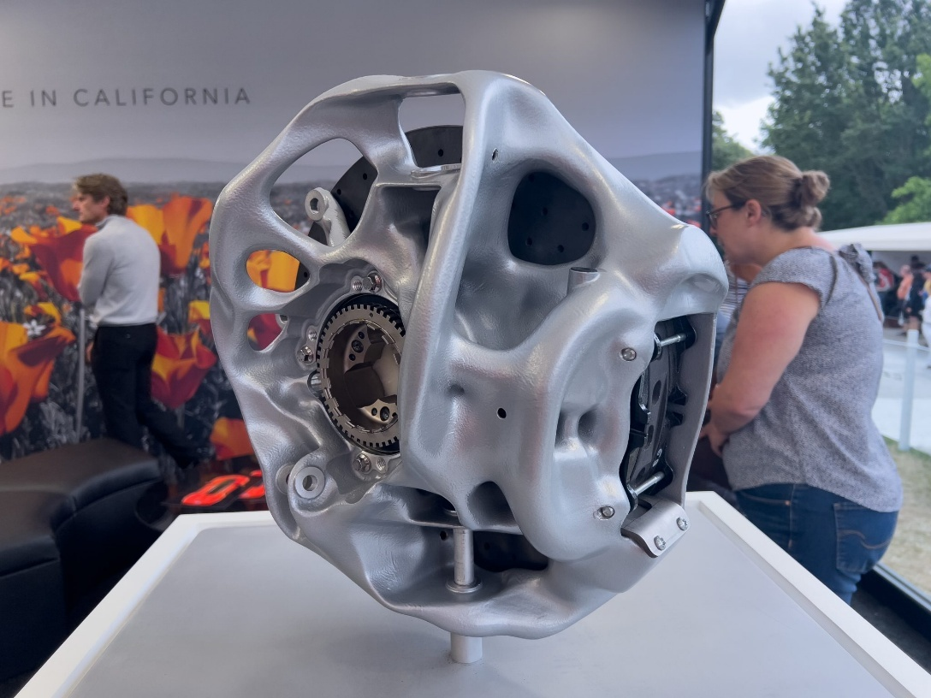
Figure 1 - 3D-printed topology optimised brake housing (Gitlin, 2023)
The future of FEA will likely involve greater integration of AI into simulation software, helping to improve workflows and reduce lead times (Sahani, 2025). AI could support tasks such as meshing, model setup and result interpretation, while also predicting the effect of design changes more quickly. However, AI-assisted FEA would still require careful validation to ensure that results remain accurate, reliable, and suitable for engineering use.

3. FEA model and assessment
In accordance with the report requirements, a 2 mm thick steel hydrofoil was first assessed to establish a baseline model. An identical composite hydrofoil geometry was then developed, optimised, evaluated, and further refined to ensure manufacturability.

3.1 Boundary Conditions & Baseline Model
Before developing the CFRP composite hydrofoil, a baseline model was created using a 2 mm thick steel hydrofoil. Steel was selected for the baseline assessment as it is an isotropic material, meaning its mechanical properties are the same in all directions. Therefore, unlike the CFRP model, no optimisation of fibre or grain direction was required. The base of the foil was fixed in all six degrees of freedom, representing a fully constrained cantilever support. In accordance with the task brief, a 500 N force was applied at the mid-span of the foil, perpendicular to the foil surface, as shown in Figure 2.
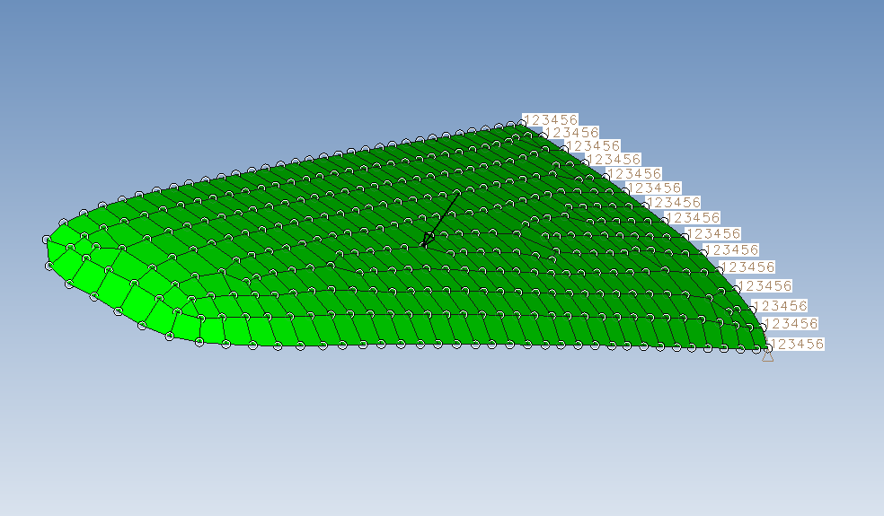
Figure 2 - Foil Constraints
The mass of the 2 mm thick steel foil was 0.456 kg. Following the simulation, the maximum displacement was found to be 8.6 mm, occurring at the wing tip, as shown in Figure 3.

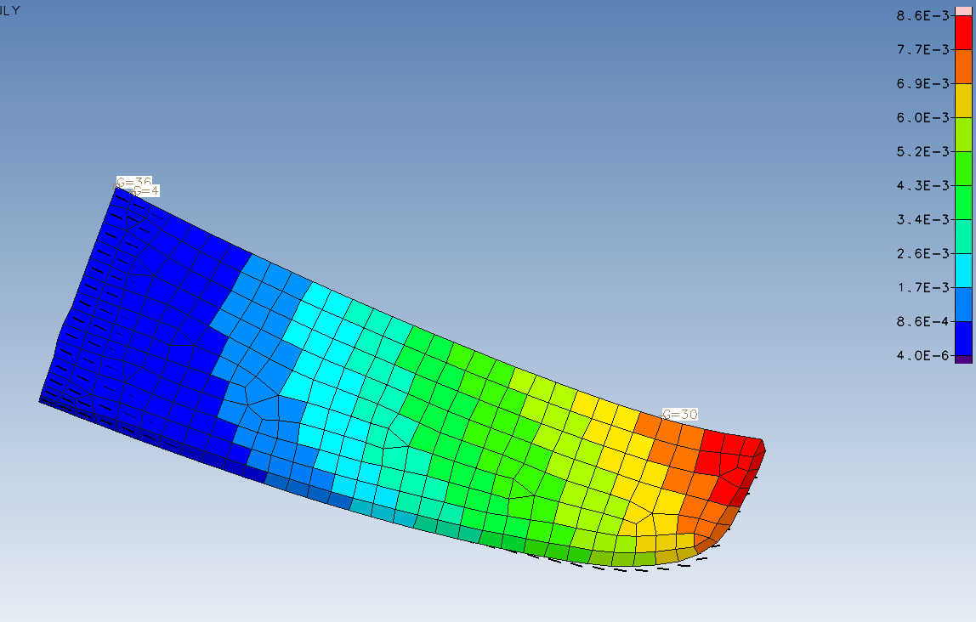
Figure 3 - Maximum Steel Displacement
Using the simulation results, the stiffness of the steel hydrofoil was calculated using: $k=\frac{F}{x}$ where k is stiffness, F is the applied force, and x is the resulting displacement. Based on the applied 500 N load and the measured displacement of 8.6 mm, the steel hydrofoil achieved a stiffness of 58.139 N/mm. The stiffness-to-weight ratio was then calculated by dividing the stiffness by the foil weight. The steel baseline produced a stiffness-to-weight ratio of 12.996 N^2/mm. The maximum displacement of 8.6 mm was therefore used as the limiting displacement constraint for the optimisation of the CFRP composite hydrofoil, alongside the additional objective of maximising mass reduction.

3.2 Non-Optimised Composite Model Performance
The initial composite foil design was developed in accordance with the task brief using 0.1 mm CFRP plies. The laminate consisted of five ply stacks, with each stack containing five plies. These stacks were orientated at 90°, 45°, 0°, -45° and -90°, respectively, with the 0° orientation running perpendicular to the base of the foil. This produced a thickness of 0.5 mm per stack and an overall laminate thickness of 2.5 mm. The composite model was significantly lighter than the steel baseline, with a total mass of 0.116 kg. However, the initial simulation results showed that the non-optimised composite foil had considerably lower stiffness than the steel model. Under the same applied load, the composite foil produced a maximum displacement of 34 mm, as shown in Figure 4.
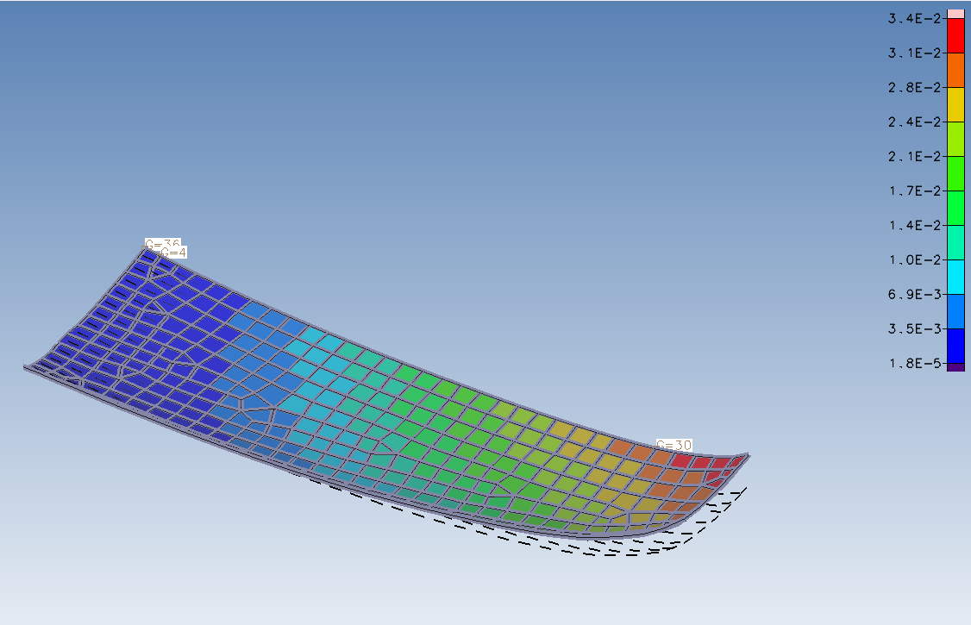
Figure 4 - Non-Optimised Foil Displacement
The resulting displacement was then used to calculate the stiffness and stiffness-to-weight ratio of the non-optimised composite foil, as shown in Table 1.
Table 1 - Steel Baseline vs Non-Optimised Composite Foil
The results show that although the mass and stiffness values differ between the steel and composite models, their stiffness-to-weight ratios are relatively similar. However, because the absolute stiffness of the non-optimised composite foil is significantly lower, it experiences a much larger displacement under the same applied load.

4. Model optimisation

4.1 Optimising Composite performance partially disregarding manufacturing constraints.
The composite foil was then optimised in accordance with the report requirements. To achieve this, the model was rerun with defined design variables, constraints and objectives to guide the optimisation process towards the required performance target.
The design variables were applied to the composite laminate to allow the number of plies in each layer to be adjusted. At this stage, manufacturing constraints were partially disregarded, meaning the simulation was permitted to vary the thickness of each laminate layer continuously, rather than being limited to the real-world 0.1 mm ply thickness. The design variable setup used for the optimisation is shown in Figure 5.
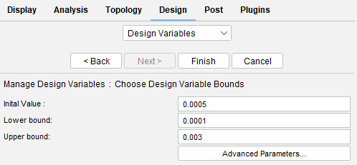
Figure 5 - Design Variable
The conditions applied to the design variables allowed each CFRP layer to vary between 0.1 mm and 3 mm, with an initial starting thickness of 0.5 mm, equivalent to five plies. The laminate consisted of five layers in total, with each layer constrained to its original fibre orientation, as shown in Figure 6. These fibre angles were not permitted to change during optimisation, as altering the ply orientations would increase the complexity of the manufacturing process.
z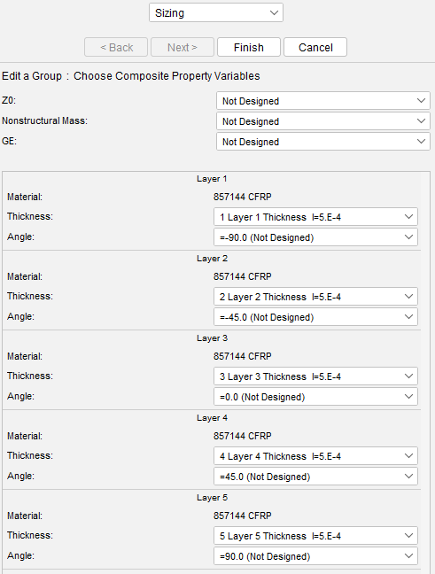
Figure 6 - Material Constraints
After defining the material design variables, the optimisation objectives and component constraints were applied. The primary constraint required the composite foil displacement to remain below the steel baseline displacement of 8.6 mm. The objective of the optimisation was to minimise the overall laminate thickness while ensuring that this displacement limit was not exceeded. The simulation results produced a displacement close to the target constraint, as shown in Figure 7.
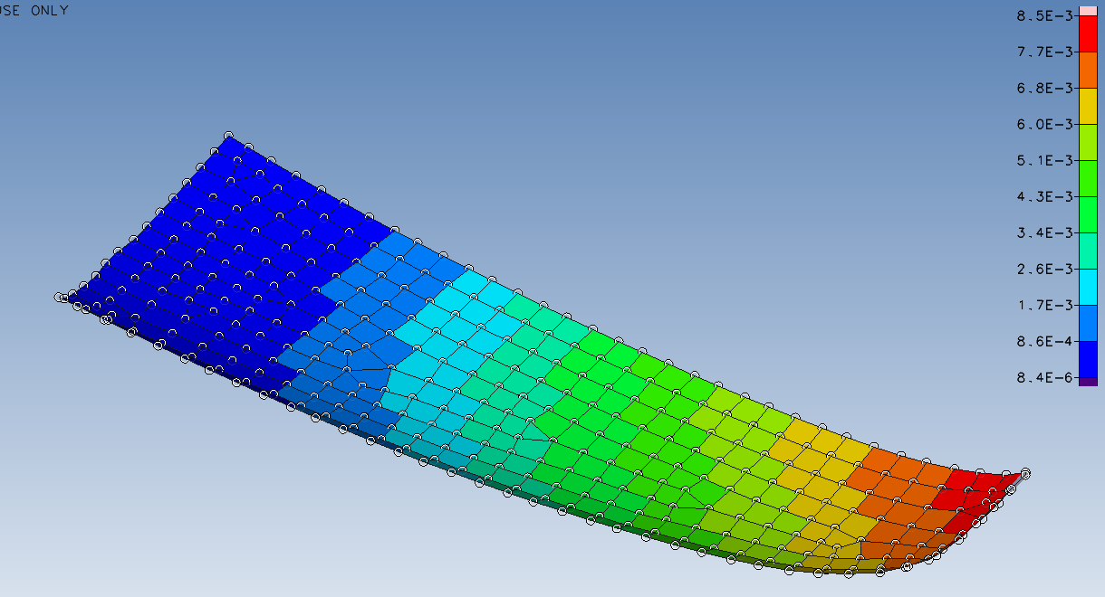
Figure 7 - Optimised Composite Foil Displacement
As shown in Figure 8, the design required 10 iterations to converge. However, the displacement constraint was first satisfied by the second iteration from the base model. This suggests that the optimisation initially prioritised meeting the deflection constraint, while the mass reduction objective was treated as secondary. Once the displacement limit had been achieved, the optimisation process then reduced excess material from the laminate. This continued until the design approached the maximum allowable displacement as closely as possible, while minimising the overall thickness and mass of the composite foil. In this way, the optimisation reduced weight while ensuring that the deformation limit was not exceeded.
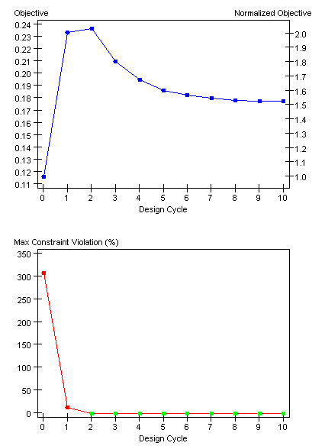
Figure 8 - Design Optimisation Graphs

4.2 Layer Variation during Optimisation
During the 10 optimisation iterations, the individual layer thicknesses varied significantly. Initially, the simulation increased the thickness of all layers to improve the overall stiffness of the composite foil. As the optimisation progressed, the 0° layer was identified as the most influential layer for increasing structural stiffness. This is because the CFRP material has a much higher longitudinal Young’s modulus than transverse Young’s modulus, with values of 132 GPa and 10.8 GPa, respectively. As a result, the optimisation increased the 0° CFRP layer to the maximum allowable thickness of 3 mm. In contrast, the 90° layers contributed less to stiffness in the primary loading direction and were therefore reduced towards the lower thickness limit as the iterations progressed.
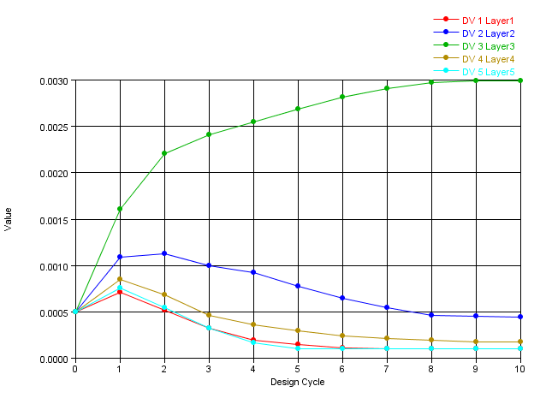
Figure 9 - Thickness variation plots throughout the 9 iterations of blade optimisation.
DV 1 = 90°, DV 2 = 45°, DV 3 = 0°, DV 4 = -45° & DV 5 = -90°
Table 2 demonstrates the new optimised composite foil compared to the steel baseline counterpart.
Table 2 - Baseline vs Optimised Composite
The results show that the overall mass of the composite hydrofoil increased by 62 g compared with the non-optimised composite model. However, the optimised design remained within the specified displacement constraint. The stiffness of the optimised CFRP hydrofoil is now very similar to that of the steel baseline. This is expected, as both models were subjected to the same 500 N load and produced similar displacement values. The main difference between the two designs is mass. The optimised CFRP hydrofoil is just over one-third of the mass of the steel baseline, resulting in a significantly higher stiffness-to-weight ratio.

4.3 Optimising for Manufacturing
When optimising the foil to meet the specified design constraints, some manufacturing limitations were initially disregarded. As a result, the optimised foil produced the following layer thicknesses:
Table 3 - Optimised Layer Thicknesses (manufacturing disregarded)
From Table 3, the optimised layer thicknesses are not all divisible by 0.1 mm. Therefore, to allow the foil to be manufactured using standard 0.1 mm plies, the design variables were changed from independant variables to discrete variables with 0.1 mm increments. This theoretically forces the optimised layer thicknesses to be rounded up to the nearest manufacturable ply thickness. The values were rounded up rather than down because the optimised laminate was already close to the minimum thickness required to satisfy the displacement constraint. Reducing any layer thickness could therefore cause the foil to exceed the maximum allowable displacement. The results of this manufacturable optimisation are shown below.
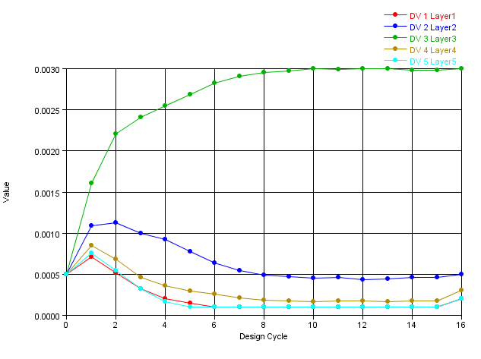
Figure 10 = Thickness variation with discrete design variable.
When the design variables were discretised, the analysis effectively used the continuous optimisation result as a basis before adjusting the final layer thicknesses to the nearest manufacturable 0.1 mm ply increment. This affected the final foil performance, as rounding the layer thicknesses upward increased the foil mass to 0.195 kg. However, the additional material also increased stiffness, reducing the maximum displacement further below the 8.6 mm limit to 7.7 mm, as shown in Figure 11.
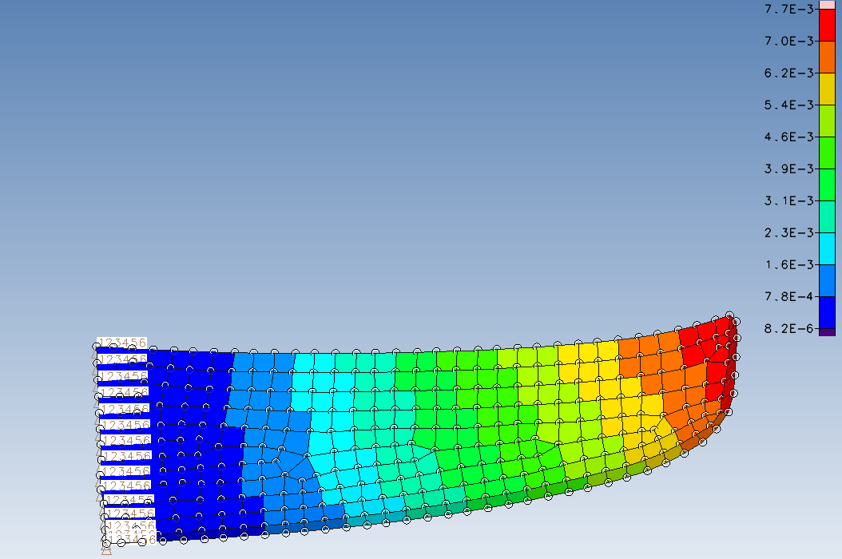
Figure 11 - Composite Foil Optimised for manufacturing with design constraints achieved.
Now that the foil satisfies the specified design constraints and is manufacturable, the simulation results can be used as a basis for comparison against physical prototype testing.

5. Experimental Validation
After optimisation, an identical physical prototype of the foil should be produced for experimental testing. This is required so that the physical test can replicate the same conditions applied in the simulation, following standard validation practice (Nicolosi et al., 2022). The test jig must therefore be capable of constraining the base of the foil in all axes while applying a 500 N load at the centre of the span. This will allow the experimental displacement results to be compared with the simulated results and used to assess the validity of the optimisation.
The testing should be carried out using a jig that closely replicates the boundary conditions used in the finite element model. An example of a simplified jig design is shown in Figure 12.
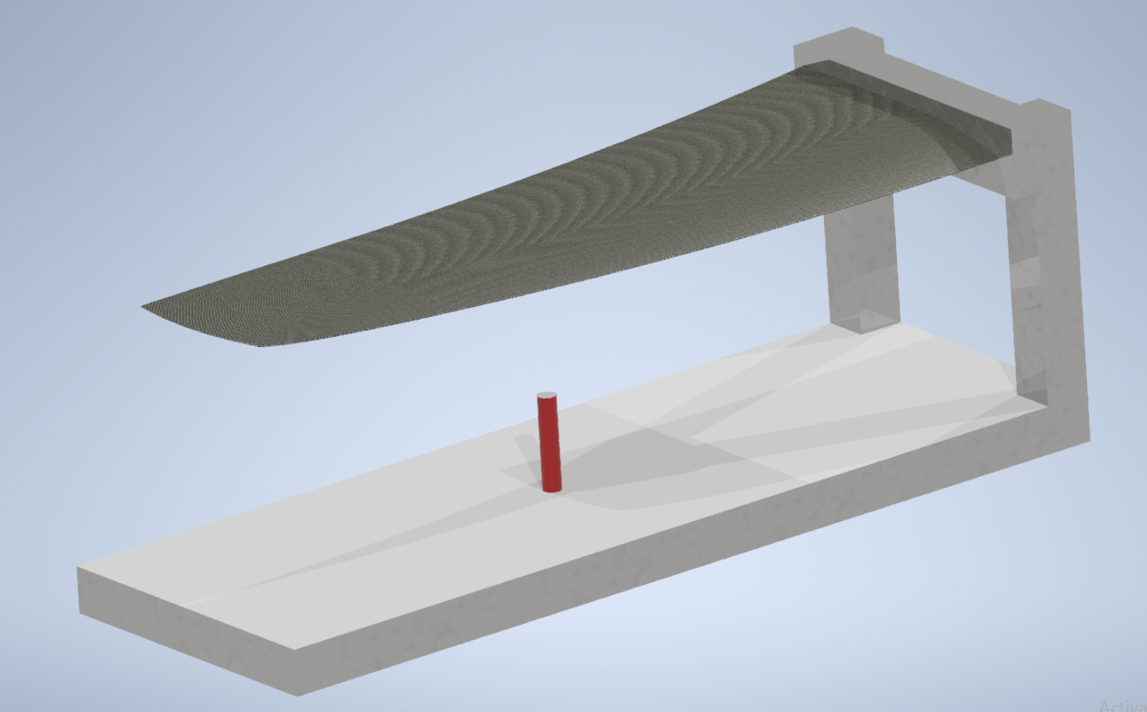
Hydraulic Actuator
DTI Gauge placed at end point for maximum displacement as per simulation.
Reinforce possible weak points in the jig with stiffeners.
Figure 12 - Example Jig
This example jig should theoretically replicate the conditions applied in the simulation. The main structure of the jig should be manufactured from a material with a higher stiffness than the CFRP foil. Any potential weak points, such as the highlighted 90° joints, should be reinforced to ensure that the foil remains the weakest component in the test setup. The jig must remain effectively rigid during load testing so that the measured displacement is caused by deformation of the foil rather than movement or flexing of the fixture. As in the simulation, the wing should be fixed in all six degrees of freedom at the base. A 500 N load should then be applied at the centre of the span in the same position as the simulated force. A hydraulic actuator would likely be the most suitable method of applying this load, as it can provide a controlled and repeatable force during structural testing (Boom Supersonic, 2020; Glass, 2024).
To monitor the displacement of the foil, the simplest method would be to use dial test indicator (DTI) gauges (HK Calibrations, 2025). The plunger of each DTI gauge should be positioned vertically to measure displacement in the Z-axis. Since the simulation provides displacement results across the full finite element model, multiple DTI gauges could be positioned along the span of the foil. This would allow the experimental displacement profile to be compared with the simulated deformation pattern and help determine whether the foil is deforming in the same way along its span. It would also be recommended to place additional DTI gauges on the jig itself to monitor any fixture deformation during testing. This is important because any movement of the jig could affect the accuracy of the foil displacement measurements.
LVDT sensors could also be used in a similar way to DTI gauges to measure displacement (Nicolosi et al., 2022). However, LVDTs may provide improved measurement accuracy, as they are not affected by plunger friction in the same way as mechanical DTI gauges and are not limited by dial gauge travel range.

6. Component Relation to Technical Literature
The methodology used in this report can be related to existing technical literature, such as the study by Nicolosi et al. (2022) on the static structural analysis and experimental testing of a composite wing. Nicolosi et al. (2022) used finite element analysis to predict the deflection and stress behaviour of a carbon-fibre composite wing under applied loading. A physical prototype was then manufactured and tested, with the experimental results showing close agreement with the theoretical and numerical predictions.
This relates to the current hydrofoil wing design because a similar finite element-based approach was followed using Design Studio for GENESIS. The hydrofoil was assessed by applying representative loads, constraining the root region, and evaluating displacement to determine stiffness and structural performance. The agreement between experimental and theoretical results in Nicolosi et al. (2022) supports the use of finite element analysis as a valid method for assessing composite wing-like structures and further justifies the methodology used in this hydrofoil design.

7. Conclusion
The hydrofoil optimisation was carried out using industry-standard finite element analysis and structural optimisation methods. The final design was successfully optimised theoretically, reducing mass while ensuring that the maximum displacement constraint was not exceeded.
Although the mass of the optimised CFRP foil increased compared with the original non-optimised composite model, this was necessary because the initial design significantly exceeded the allowable displacement limit. Additional plies were therefore required to improve stiffness and bring the design within the specified constraint. Despite this increase in mass, the final CFRP hydrofoil was only 42% of the mass of the original steel baseline, demonstrating a significant improvement in weight efficiency while maintaining the required structural performance.

8. Bibliography
Anderson, S. (2018) ‘Breaking down FEA’, Mechanical Science & Engineering, University of Illinois Urbana-Champaign, 12 December. Available at: https://mechse.illinois.edu/news/blogs/breaking-down-fea (Accessed: 27 June 2026).
ANSYS (n.d.) What is finite element analysis (FEA)? Available at: https://www.ansys.com/simulation-topics/what-is-finite-element-analysis (Accessed: 23 June 2026).
ASR Engineering (2019) ‘FEA vs hand calculations’. Available at: https://asrengineering.com/2019/04/02/fea-vs-hand-calculations/ (Accessed: 24 June 2026).
Boom Supersonic (2020) ‘What are wing bend tests and how are they performed?’, FlyBy Blog, 19 May. Available at: https://boomsupersonic.com/flyby/what-are-wing-bend-tests-and-how-are-they-performed (Accessed: 26 June 2026).
Engineering LibreTexts (2023) ‘Nodes, elements, degrees of freedom and boundary conditions’. Available at: https://eng.libretexts.org/Bookshelves/Materials_Science/TLP_Library_I/30%3A_Finite_Element_Method/30.2%3A_Nodes_Elements_Degrees_of_Freedom_and_Boundary_Conditions (Accessed: 23 June 2026).
Enterfea (2019) ‘What are nodes and elements in finite element analysis?’ Available at: https://enterfea.com/what-are-nodes-and-elements-in-finite-element-analysis/ (Accessed: 23 June 2026).
Formtech Composites (n.d.) Finite element analysis. Available at: http://www.formtech-composites.co.uk/composites-engineering/finite-element-analysis/ (Accessed: 27 June 2026).
Gitlin, J.M. (2023) ‘3D printing isn’t just for supercars, now it’s for drones, too’, Ars Technica, 10 August. Available at: https://arstechnica.com/cars/2023/08/3d-printing-isnt-just-for-supercars-now-its-for-drone-wings-too/ (Accessed: 27 June 2026).
Glass, J. (2024) ‘Actuators and sensors combine forces in test and measurement’, Interface, 26 September. Available at: https://www.interfaceforce.com/actuators-and-sensors-combine-forces-in-test-and-measurement/ (Accessed: 27 June 2026).
HK Calibrations (2025) ‘What is a dial test indicator and how does it work?’, HK Calibrations, 16 December. Available at: https://hkcalibrations.com.au/blogs/news/what-is-a-dial-test-indicator-and-how-does-it-work (Accessed: 26 June 2026).
Nicolosi, G., Lunghitano, A., Lombardi, S., Talamucci, T., Caivano, A., Simone, N., Cestino, E. and Sapienza, V. (2022) ‘Wing static structural analysis and experimental testing of a composite 1:8 S55-X replica’, 33rd Congress of the International Council of the Aeronautical Sciences, Stockholm, 4–9 September. Available at: https://www.icas.org/icas_archive/ICAS2022/data/papers/ICAS2022_0280_paper.pdf (Accessed: 26 June 2026).
Parks, D.M. (2004) Euler-Bernoulli beams: bending, buckling, and vibration. 2.002 Mechanics and Materials II, Department of Mechanical Engineering, MIT. Available at: https://ocw.mit.edu/courses/2-002-mechanics-and-materials-ii-spring-2004/bc25a56b5a91ad29ca5c7419616686f7_lec2.pdf (Accessed: 24 June 2026).

Sahani, S.K. (2025) ‘AI-enhanced finite element method (FEM) for structural analysis’, Journal of Electrical Systems, 20(1), pp. 661–676. doi:10.52783/jes.8946.

