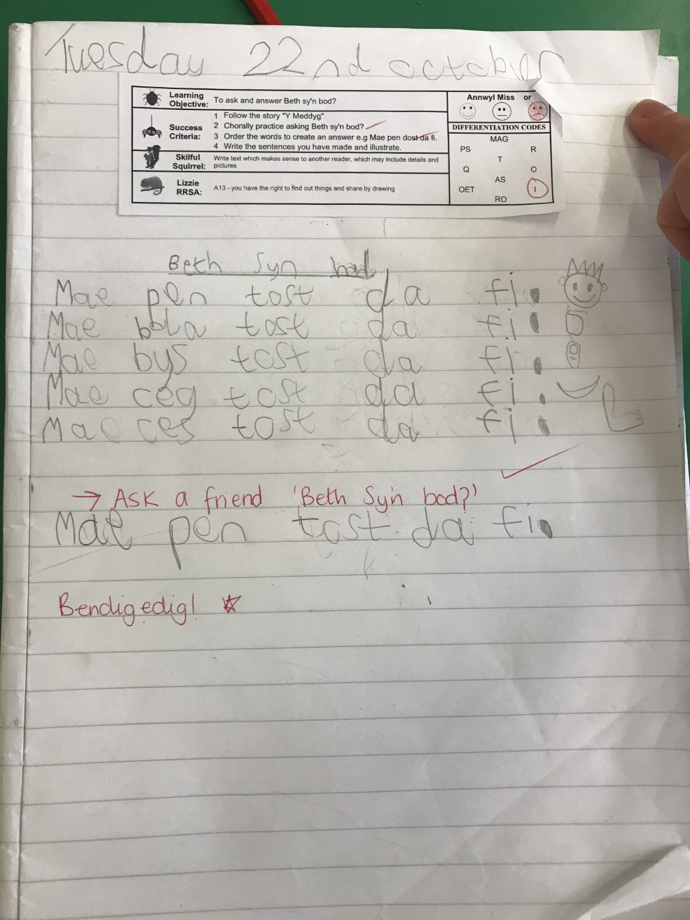
The picture above is evidencing a lesson I implemented to a year 2 class on 22.10.19.
We spoke about welsh body parts; welsh sentence patterns and all children were encouraged to orally ask a friend ‘beth Syn Bod?’. Resources were well planned, children were able to use flash cards to create the welsh sentence pattern to support their welsh writing.


