Preston Thomas (2305918)

The expectations and societal needs of Engineers.
Workshop and Practice (ACHA4011)
Contents

Table Of Figures 1
Introduction 2
Chapter 1- Health and Safety with Risk Assessments 3
1.1 Health and Safety Legislations Involved with Removing Oil Sump 3
1.2 PPE and Health Concerns Related to Dealing with Oil 3
1.2 Risk Matrix- 3
Chapter 2- Engineers Role in Society 4
2.1 Code of Conduct (ImechE) 4
2.2 Code of Conduct (RAE) 4
Chapter 3 Problem Solving 5
3.1 Development 5
3.2 Market 5
3.3 Supplier 5
Chapter 4- Team Structure 6
4.1 Summary of My Team Experience 6
4.2 Our Team Structure 6
4.3 Alternate Team Structures 6
Chapter 5- Personal Development Plan 7
Conclusion 8
References 9

Table Of Figures
Figure 1 3
Figure 2 5
Figure 3 5
Figure 4 6

Introduction

In this assignment the topic of engineer’s societal needs and expectations is explored, with specific focus on: health safety legislation, an engineer’s role in society, problem solving and team structure. The assignment is concluded with a personal development plan in order to reflect on goals. In chapter one, the subject of health and safety is explored, including discussions around the concerns regarding engineers staying safe, as well as exploring the variety of legislations that encompass health and safety rules and procedures when completing an engine strip and more specifically, removing the oil sump. Additionally, this assignment looks at the necessary PPE and potential issues when dealing with oil, partnered with a risk assessment matrix and an evaluation of the task in order to show knowledge and understanding of the system. Further on in chapter two, an engineer’s role in society is analysed as well as the different codes of conduct that engineers must follow to deliver satisfactory work for employers as well as keeping themselves and the environment safe. Chapter 3 delves into the many different challenges engineers face in numerous fields throughout the process of product creation. Different problems and methods of solving these issues are covered including issues in development, supplier issues and problems that can occur once the vehicle is on the market. Chapter 4 is a personal account and evaluation of a previous team structure experience and analysis; this is furthered by chapter 5 which is a personal development plan.

Chapter 1- Health and Safety with Risk Assessments

1.1 Health and Safety Legislations Involved with Removing Oil Sump
Whilst striping the engine the oil sump is removed from it, although the engines that were used for striping at university were completely dry, in a real-world application this would not be the case. The oil would have to be drained from it prior to removing the sump as if this is not done the oil will spill everywhere causing a slipping hazard as well as slowing down any progress with the task of stripping the engine. To complete this task there are many health and safety legislation that are relevant such as: The control of Pollution (oil storage) Regulations 2001 (Gov.uk), RIDDOR, COSHH (hse.gov, 2002) and The Environmental Protection Act 1990. (Purdue, 1991, pp. 534-551) refers to the safe disposal of used oils to prevent water contamination, the duty of care is with the persons that hold transport and dispose of any oil. This act enforces that companies must contact a local authority to come and collect their old used oil so it can be recycled, this also prevents people from dumping their oils in anywhere they can, instead they must put it into a container to be collected or pumped for transportation to an oil bank.

1.2 PPE and Health Concerns Related to Dealing with Oil
Engine oil, although not toxic or corrosive, can still cause long term health complications such as dermatitis and skin cancer. This is easily avoidable with the use of nitrile gloves and making sure that once you have completed a task you clean your hands thoroughly using Swarfega or another hand soap that has similar properties to help make sure you don’t have any lingering oil on your skin especially if you are going to be eating after the task to help prevent ingestion of engine oil. It states in (Ramalingam, et al., 2023, pp. 1618-1623) that when dealing with used engine oils you should have the relevant PPE which includes safety goggles, nitrile gloves, long sleeved overalls (to help prevent getting oil on yours and in the case of a fire).

1.2 Risk Matrix-
Consequences
High
Low
High

High

Likelihood
Medium

Low

Low

Figure 1
Observing the Risk Matrix above you can view the relationship between Likelihood and Consequences. Using this we can quickly assess a situation and its potential to harm something. Removing a sump in a controlled environment with a low chance of fire and making sure the correct PPE is worn whilst completing the task, a risk such as someone slipping on oil that is spilt could be identified by simply deciding on the likelihood and then the consequence and finding where they meet, the task previously mentioned would have a low likelihood but could have a some serious consequences so I believe it would fall into the medium category. To make this task safer you could make sure to complete this task away from any gangways to make sure nobody passing through will slip as well as having the equipment to clean the spilt oil on hand just in case so it can be dealt with straight away and isn’t left and forgotten about.

Chapter 2- Engineers Role in Society

2.1 Code of Conduct (ImechE)
ImechE and the engineering council came together in 2017 to create a joint code of conduct for engineers to follow. On page 2 of this code of conduct it states “All members shall engage responsibly with the environment.” It then continues to state “they shall balance the needs of the present with the needs of the future” this point is highly important as a lot of people especially in motorsport, although it may not seem like it the engineers in any race team are constantly trying to make the vehicles more environmentally friendly (ImechE, 2021, pp. 2-3). In 2019 Stefano Domenicali stated that by 2030 F1 was going to be a net zero carbon organisation. Any decision made either by an engineer or anyone else in the industry must be made with this net zero goal in mind.

2.2 Code of Conduct (RAE)
In the RAE’s separate code of conduct they list a few attributes that are expected from chartered engineers whilst they are doing their jobs these are: Honesty- this breaks down further into prevention of bribery and communication, Care- in this section it asks all chartered engineers to think about their surroundings when working whether it’s the environment or the surrounding people, Respect- in article 8 it speaks about cultural sensitivity and making sure everyone feels welcome and Fairness- any instances where an area or persons is negatively affected the correct support for this must be found as well as if someone contributes to a project they must be credited for their work. The RAE’s conduct code goes into more depth having multiple articles about how engineers should act whilst working where as ImechE’s conduct codes sections are about the work itself and how that should be completed as well as the ethics behind what is being done making sure everyone is safe.

Chapter 3 Problem Solving

3.1 Development
Replan the part that is at fault, typically this is done through CAD which allows for the solving of problems without the use of expensive materials. Once this is done you can use 3-D printing to create a polymer version so you can physically see the piece and can help find any minor issues such as sizing that has been overlooked. If a company is having problems designing a part that has been previously created by another company, they can do research on these parts by taking photos or purchasing the car or parts.
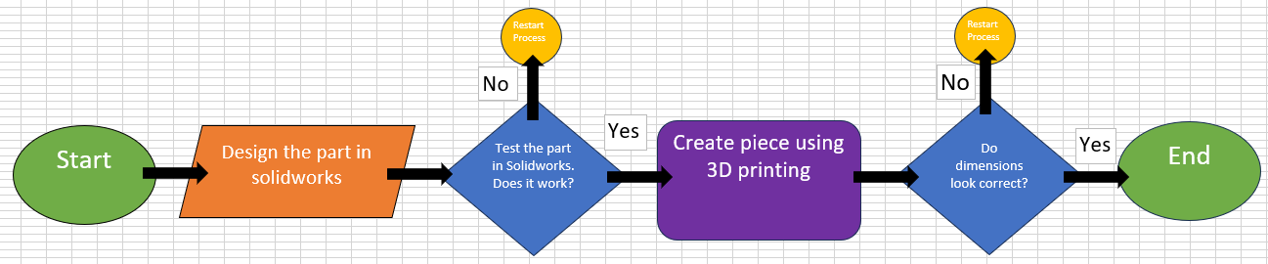
Figure 2

3.2 Market
When a vehicle has a problem that is discovered after it has been sold it’s in the company’s best interest to find where the problem is coming from and a cost-effective and fast fix for the issue. If the problem could cause serious injury especially to children, the vehicles will usually have to be recalled. In 2009 Toyota designed a floor mat that tended to slip forward and trap the accelerator. This resulted in 30 deaths with an additional 52 deaths that have been suspected to be connected, Toyota recalled over 3.8 million of their vehicles. (Hammond, 2013, pp. 78-100)
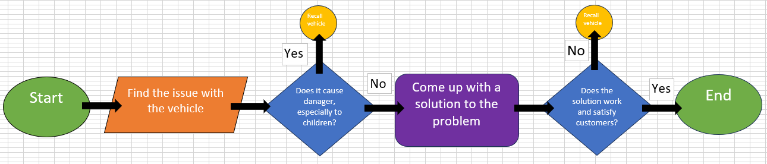
Figure 3

3.3 Supplier
Once a part has been designed and sent off to the supplier to be mass produced the supplier may have an issue with sourcing the material due to the high quantity or rarity of the material that is desired for the piece. If this is the case the piece may have to be redesigned with extra support or less weight so that it can still be used but with a different material that is more easily sourced. It could also be that the material has arrived, and the quality isn’t consistent across the material, this could then lead to having to change where the material is coming from.
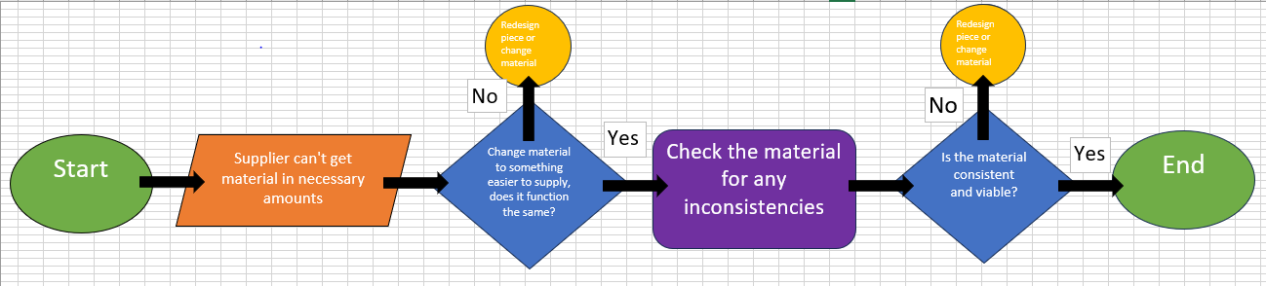
Figure 4

Chapter 4- Team Structure

4.1 Summary of My Team Experience
When I was in Year 10, I did work experience with Intel for a week, this entailed coming up with a mock product using Arduinos which we would then have to pitch to some of the employees at Intel. We gave each team member a role which helped us excel at this task because we were all working on something at once however, this did lead to some problems where people would overstep causing the team to clash at points, these issues were always solved quickly as we would talk it out and allow for our project manager to make the final decision. There were 5 of us in the team and the roles were as follows: Project Manager, Coder, Marketer and two team members came up with the pitch ideas.

4.2 Our Team Structure
The project manager oversaw all tasks and making sure they were done to a standard that could be upheld whilst still being efficient. The coders job was to make the product as usable as possible in our short amount of time available. The Marketer did a lot of research into other kinds of products that were like ours so we could get an idea of how to increase the appeal of our product, this could be through adding features to the code and making changes to the name or design to make it appeal to a wider audience than our competitors. The last two team members compiled all the facts along with a example and presentation into a pitch for the employees to see. Through the initial idea process and testing stages we all worked on this as we thought it would be a good way for us to take a break from the tasks we were working on so that when we go back to them we would have a fresh set of eyes which I think really benefitted us in the long run.

4.3 Alternate Team Structures
I think the workload could have been better distributed if we had looked into people’s strengths a bit more instead of using their preferences as although some people wanted to be the team leader for example, they would have been better off with making the pitch come to life due to more confidence when presenting. We also found that some jobs were much easier than others which meant some people had a lot of spare time that could have been used to assist other team members with tasks they were struggling with or fill in whilst people were on breaks to help our efficiency. Overall, I think we had a good team structure that worked well for us but we definitely would have benefitted from thinking about the work distribution more and considering peoples strengths and weaknesses.

Chapter 5- Personal Development Plan

Personal Development Plan

Name - Preston Thomas
Degree – Motorsport Engineering
Previous Qualifications – Motorsport Engineering Level 3
Previous Experience – 100 hours of work experience in a local garage.
Long Term Goals (5 to 10 years)
In the long term I would like to own my own race team or garage because I have a passion for engineering as well as business and management.
I would also like to start my own business that is centred around motorsport in some way.
Additionally, by the ten year mark I would like to own my house.

Short Term Goals (0 to 5 years)
Short term I am hoping to finish my degree and go on to do a course on engineering management so that I have the necessary skills for my long-term goals.
By the end of the five years I would like to have saved the funding to start my own business.
After completing university, I would like to be able to get a job with a race team to gain relevant experience.

Goal | Objective | Resources Required | Measurement | Target Date
Short Term- Complete all my education. | Finish my motorsport degree and my engineering management so I have the relevant skills for the future. | Its going to take the next 3-4 years to complete. I will need help from university lecturers, and I will need to work hard | My grades over the years will be my method of measurement for this goal. | This goal should be completed in the 2026/27 academic year.
Short Term- Get a job in motorsport. | Get a job as an engineer in a race team to start my career. | I’m going to need an extensive CV that truly displays who I am. As well as proof of course completion. | My measurement for this for this goal will be when my application is accepted by a race team. | Hopefully this goal is reached by 2027.
Short Term/Long Term- Save funding and start my own business. | By the 5 year mark I want to have funding for my own business and by the 10 year point I want to have started putting time into it. | I will have to save some money and have a strong game plan for entering the business world. | A measurement for this goal would be if I am able to follow a saving plan. | I would like this goal is achieved by 2028-2033.
Long Term- Have my own race team or garage. | Construct a brand and have a competitive race team or garage. | I will need my own funding and/or sponsors. I will also need help from someone that is experienced in business. | A measurement of this task being successful would be if I am able to have the funding and relevant skills for the task. | This goal may be further in the future than 10 years but around that mark I would like to know what my brand is.
Long Term- I would like to own my own house. | I would like to be able to have moved out and have my house by the end of the 10 years as not many people my age will own their own houses. | I will need to keep a good credit score as well as saving up for a deposit. | A measurement of this is that I will be able to pay my student loan of successfully each month and still put money aside. | This goal again my exceed the 10 year mark but I would like to be able to be comfortable in my living condition by the 10 year point.

Conclusion

In this assignment many topics were covered and delved into. Using the Personal Development Plan to express future goals and hopes and sharing experience with previous team structure and showing the ability to analyse work and solve problems in an efficient and effective manner. In Chapter three, multiple flowcharts were designed to help with a visual aid to assist the reader. Additionally, an engineer’s role in society was explored using extensive research to find information around the topic. In the first chapter knowledge of Health and Safety legislation as well as research was presented as well as the use of a risk matrix. Overall, this assignment has helped increase understanding on what an engineer’s societal need and expectations are.

References
Gov.uk, n.d. Oil storage regulations for businesses. [Online]
Available at: https://www.gov.uk/guidance/storing-oil-at-a-home-or-business
[Accessed 27 November 2023].
Hammond, R. G., 2013. Sudeen Unintened Used-Price Deceleration? The 2009-2010 Toyota Recalls. Journal of economics and management stratergy, 22(1), pp. 78-100.
hse.gov, 2002. Control of Substances Hazardous to Health 2002 (COSHH). [Online]
Available at: https://www.hse.gov.uk/nanotechnology/coshh.htm
ImechE, 2021. Code of Conduct Regulations. Revised ed. London: ImechE.
Purdue, M., 1991. Integrated Pollution Control in the Environmental Protection Act 1990: A Coming of Age of Environmental Law?. The Modern Law Review, 54(4), pp. 534-551.
Ramalingam, S., Thamizhvel, R., Sudagar, S. & Silambarasan, R., 2023. Production of third generation bio-fuel through thermal cracking process by utilizing Covid-19 plastic waste. Materials Today Part 3, Volume 72, pp. 1618-1623.

