Network Security: Simulation of a Potential Real-Life Scenario
Jordan Phillips
MSc Computer Networks and Cybersecurity
University of Wales, Trinity Saint David
jphillips.147607@student.uwtsd.ac.uk

Table of Contents
I Introduction 2
II Guidelines and Testing Exclusion 3
III Platform and Software Tools 3
IV Scans, Vulnerabilities and Improvements 4
A. Information Gathering Scans, Results and Solutions. 5
B. Vulnerability Analysis Scans, Results and Solutions. 8
C. Web Application Analysis Scans, Results and Solutions 10
V Conclusion 11
References 12
Appendices 15

Table of Figures
Figure 1: Ping to Discover IP Address 5
Figure 2: nmap Port Scan Command 5
Figure 3: nmap Ports Scanned 5
Figure 4: Port 25 Details 6
Figure 5: Port 53 Details 7
Figure 6: Port 80 Details 7
Figure 7: nmap Operating System Scan 7
Figure 8: Open XSS Module in Recon-ng 8
Figure 9: Recon-ng XSS Scan Results 8
Figure 10: Nikto Scan Results 8
Figure 11: WPScan Command 10
Figure 12: WPScan Server Result 10
Figure 13: WordPress Version 10
Figure 14: wordpress-seo plugin 10
Figure 15: SQL Injection Scan Results 11

Abstract – As the Internet continues to advance, the need for network security increases. Tevel Cyber Corps Private Limited has requested a live penetration test of their website: https://tevelcyber.com/. Utilising Hyper-V software to run Kali Linux OS, several scans were conducted to isolate vulnerabilities and document findings, including potential threats and solutions. Areas of interest were identified, such as the use of SSL protocol for securing connection between server and client. It was noted in RFC 6176 and 7568 that SSL has several vulnerabilities and is therefore less secure than TLS. Therefore, it was recommended that protocols should be changed to TLS for added security. By undertaking nikto scans, the potential for BREACH attacks was identified. In response, it was found that the use of non-adaptive fixed-dictionary for data compression would mitigate the risk and reduce successful BREACH attacks. Further security vulnerabilities, such as XSS, SQL injection and outdated plugins were revealed. To mitigate these vulnerabilities, it was recommended that: HttpOnly and Secure flags should be used for XSS; for SQL injection, proper application design in areas where user input is required; and guarding against outdated plugins requires all software to be kept up to date.
Key words – Security, Kali Linux, Penetration Test, Tevel Cyber, Vulnerabilities, Scanning.

I Introduction
The Internet has continued to evolve over the years and has become an instrumental aspect of everyday life, company infrastructure and even military and healthcare [1] [2]. As more and more devices become connected, this leads to an increase in network and data vulnerability within companies and any network infrastructure with a connection to the Internet [1] [3]. This leads to increased responsibility for network security managers as they must consider potential threats that may harm network performance, as well as compromise the integrity of network data [1] [4]. Data leakage and data loss are common types of security risk involved, especially within wireless network designs such as cloud computing [4]. However, network security is a major aspect of all forms of network architecture [1] [3]. As such, it is vital that network security professionals keep up to date with technology trends, operating system vulnerabilities and patches, software vulnerabilities and solutions to existing software problems, and the cost associated with security breaches and potential fix costs.
As a result, a task was given to perform Black Box Penetration Testing on an active website belonging to Tevel Cyber Corps Private Limited. Web services are vulnerable to several attacks, such as Denial of Service (DoS), that can affect the integrity, authenticity and confidentiality of information, as well as the availability of web services [3] [5]. Other threats include attacks such as XSS, which is ranked third in the OWASP Top 10 Vulnerabilities [6]. Penetration Testing of web applications is a method of searching for security vulnerabilities and problems of a web application [7]. White-box methods range from analysis to dynamic monitoring of instrumented code, while Black-Box approaches generate inputs and observe responses [6]. Black-Box methods replicate the appearance of an external attacker, therefore are useful for testing defences set in place to prevent attacks [6].
As such, this report will utilise Penetration Testing software to conduct Black Box testing on https://tevelcyber.com/ in order to find any potential vulnerabilities. This paper will discuss the following:
- A brief list of the guidelines and testing exclusions given by Tevel Cyber Corps Private Limited.
- A look at the penetration platform and software used within the tests.
- Penetration Test tools used to conduct various scans.
- Scans conducted including any vulnerabilities found, as well as potential threats which could arise from these vulnerabilities.
- Solutions to prevent potential attacks, which includes any configuration changes, software and hardware updates, as well as defence strategies to avoid potential attacks.

II Guidelines and Testing Exclusion
Tevel Cyber Corps Private Limited has given consent to perform live Penetration Testing on their website. However, they have given a list of rules and exclusions in order to prevent any web services from becoming compromised.
Guidelines for penetration testing include:
- Not modifying any contents in the website, encouraging vulnerability reports only.
- Provide detailed descriptions of any vulnerabilities and exploit methodology, including any information required in order to replicate and validate the vulnerability.
- Avoid privacy violations, causing damage to data and interruption or degradation of web services.
- No modifying or accessing any data belonging to Tevel Cyber.
- No using vulnerabilities (reported or not yet reported) to discover further vulnerabilities.
Furthermore, they have requested the following exclusions from the Penetration Testing process:
- In no scenario are penetration testers permitted to access, download or modify any data located in any account not registered to them
- Executing or attempting any form of Denial of Service (DoS) attacks.
- Knowingly posting, transmitting, uploading, linking, sending or storing any form of malicious software into the website.
- No testing that would result in sending of unsolicited or unauthorised junk mail, spam, pyramid schemes or other forms of duplicated messages.
- Testing third party applications, websites or services that are linked to the main Tevel Cyber service.
These rules and exclusions were given in order to maintain their web services to both customers and employees, ensuring the availability of their data to all consumers. However, due to the exclusions requested, this leads to the penetration testing process becoming focused purely on vulnerability scanning. From these scans several potential attacks will be discussed based on any vulnerabilities found or theorised.

III Platform and Software Tools
Penetration Testing was conducted using Kali Linux Operating System (OS) [8]. Kali Linux is an Open Source OS which can be utilised to exploit the vulnerabilities of a system or network [8] [9]. The main design of Kali is digital forensics and penetration testing [8] [9]. Kali Linux is preinstalled with numerous penetration testing programs [9]. Such programs include nmap, wpscan, recon-ng, wireshark etc. [9].
Nmap is a network port scanning tool which has the ability to perform TCP based scans instead of UDP based scans [9] [10]. It is also possible to scan areas of interest using nmap, allowing for scanning of specific network sections [10]. Nmap is a free and open source utility, primarily focusing on network discovery and security auditing [10] [11]. IP addresses are used to determine what hosts are available within the network [11].
WPScan is a free black box WordPress vulnerability scanner [12]. WordPress is an online open source website creation tool, therefore, WPScan can be useful penetration test tool to discover if a specific website utilises WordPress, as well as other potential vulnerable plugins.
Cross-Site Scripting (XSS) has become been listed within the top 10 most dangerous attack, according to a survey by OWASP [13]. An attacker performs an XSS attack by injecting carefully made malicious code through the input parameters at the client-side [13]. Recon-ng is a reconnaissance tool similar to Metasploit [14]. There are a number of scans available within recon-ng, including the ability to scan for XSS vulnerabilities [14].
Other vulnerability scanning tools such as nikto are also present within kali [15] [16]. Nikto is a web scanner that tests web applications and servers for dangerous files, outdated software and other such issues [16]. Due to nikto being an Open Source scanning software, and performing comprehensive tests for multiple items, including dangerous files, it is a useful tool for reconnaissance and locating vulnerabilities, while being readily available [15] [16].
Scanning for potential SQL injections was also conducted using an SQL injector scanner [17]. SQL injection vulnerabilities are a common vulnerability known to hackers and consistently appear top of the list of security vulnerabilities [16]. Some security firms state that SQL injection is one of the more severe vulnerability [16]. This is because of the damage that can be inflicted to a system using this form of attack [16]. Therefore, scanning for this vulnerability is necessary in order to protect against potential threats.
As mentioned, these programs come pre-installed within Kali Linux, making this platform an ideal choice for conducting vulnerability scans [8] [9]. However, in order to run Kali Linux, a virtual machine was created using Hyper-V [18]. Hyper-V allowed the use of a Kali Linux OS without the need for a standalone device. This allowed the OS to be run from any machine with the Hyper-V software present. Other virtualisation options include Oracle VirtualBox, which operates in an identical manner to Hyper-V. Initially, Oracle VirtualBox was utilised to perform the penetration testing scans. However, certain scans did not operate as expected which required a switch in software in order to complete the scan. This issue was discovered while attempting an OS scan, using nmap [10], where the scan could not identify the OS of the target. Instead, Oracle VirtualBox was flagged as the scan believed it to be the OS in use at the target destination.

IV Scans, Vulnerabilities and Improvements
This section will cover scans conducted using the previously mentioned software, as well as any findings discovered from the scans. Scans utilised in these tests fall under three categories, namely:
- Information Gathering, which are scabs used to discover information such as open ports, devices etc. These are also known as reconnaissance tools and are typically the first step before launching any attack [19]. Acquiring detailed information improves accuracy, shortens execution time and allows attackers to bypass existing security measures [19].
- Vulnerability Analysis, which are scans used to identify possible vulnerabilities of a target network. Goals of these scans are to evaluate targets for weaknesses, identify vulnerable systems and map vulnerable systems and other findings [19].
- Web Application Analysis, which are scans used scan websites for vulnerabilities, including vulnerable plugins, as well as outdated software used within the site [19].
Firstly, it was necessary to discover the IP address of https://tevelcyber.com/, which can simply be discovered by issuing a ping command from the command prompt seen in Figure 1 below.
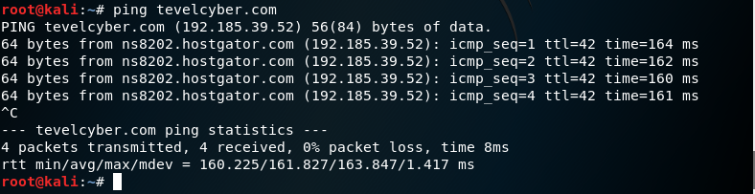
Figure 1: Ping to Discover IP Address

A. Information Gathering Scans, Results and Solutions.
Using the IP address, it was possible to utilise nmap to probe for open ports and determine service and version information, as well as detect the OS, using the command seen in Figure 2.
Figure 2: nmap Port Scan Command
Figure 2 shows the command used to probe tevelcyber.com for open ports, where -A enabled OS and version detection, as well as script scanning and traceroute options, while -sV signalled to probe for open ports in order to determine service and version information.
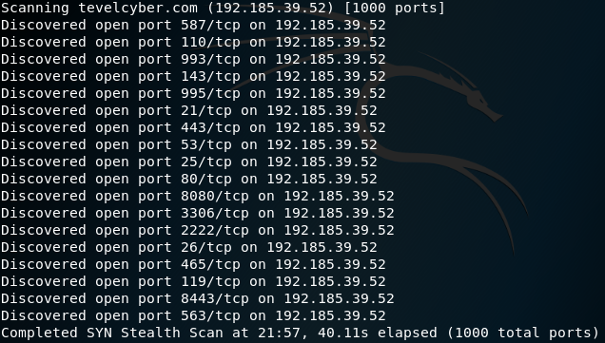
Figure 3: nmap Ports Scanned
Figure 3 shows a list of open ports discovered via nmap, as well as the protocols associated with each port and the maximum number of available ports. It was discovered that ports used TCP protocol stack, which defines how to establish and maintain an exchange of data between devices [20]. This is an advantage nmap has over other port scanning tools, as it can perform scans through TCP protocols, in addition to being more reliable than other tools, such as Masscan [10]. TCP has certain vulnerabilities such as:
- Port Scanning, where spoofed IP packets with SIN flag set are utilised to discover which ports are open [20]. These can later be used to access a host system [20]
- Denial-of-Service (DoS) attack, where many packets are sent to a host or server [9] [20]. The rate of which prevents devices from responding to genuine traffic, thus degrading network performance [9] [20].
However, these ports being open is not unexpected as a number are required for specific connectivity, i.e. port 25 is for SMTP, which is used for email routing between mail servers. Using port 25 as an example again, it was discovered that the version used by tevel cyber for SMTP is Exim smtpd 4.91, seen below in Figure 4.
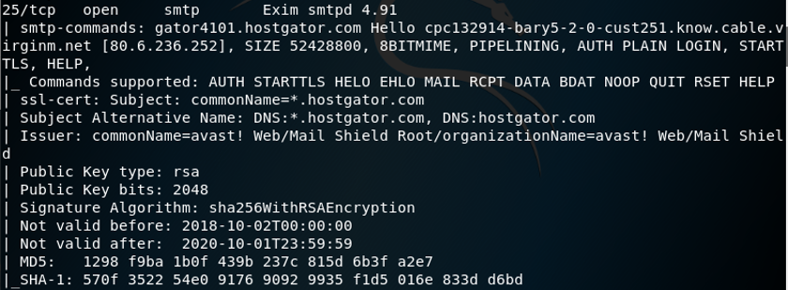
Figure 4: Port 25 Details
Hostgator.com was also identified as the Secure Sockets Layer (SSL) and website hosting provider, as seen in Figure 4. SSL is one of two of the most widely deployed security protocols when a client and server require a secure exchange of data [21]. The second being Transport Layer Security (TLS) [21]. Online businesses utilise SSL and TLS to protect sensitive customer information and ensure that their information is not compromised [21].
It is possible to exploit the Renegotiation feature of SSL and TLS by performing a Man-in-the-Middle (MitM) Attack [22] [23]. In SSL and TLS, a client and server negotiate encryption algorithms and key information by handshake protocol [22]. Renegotiation is used to update algorithm and key information [22]. The vulnerability exists where an attacker can intercept the SSL and TLS communications using MitM attacks [22] [23].
Once intercepted, an attacker can combine their request with that of a legitimate user and send them to the server [22]. The user’s data is encrypted during the process; therefore, the attacker cannot read the information [22]. However, as the attacker does not alter the information, the server will interpret both the legitimate user’s request, and the attacker’s request, as coming from the same person, leading to the attacker’s request being accepted and processed [22].
It should be noted that SSL, both version 2.0 and 3.0, have been criticised by IETF due to vulnerabilities associated with this protocol [24] [25] [26]. As such, TLS has been designed to overcome vulnerabilities found in SSL, and therefore, TLS should be considered over SSL [24]. A combination of both can also be utilised until the usage of TLS becomes more familiar [24] [25] [26].
Rivest-Shamir-Aldeman (RSA) was identified as tevel cybers’ method of encryption, with a key length of 2048 bits. This is an algorithm-based encryption strategy and is considered as a consistent encryption method in public key cryptosystems [27] [28]. There are three steps in RSA algorithm: key generation, encryption and decryption [28]. RSA uses two keys, a public and private [27] [28]. Messages encrypted using a public key can only be decrypted with the private key [27] [28].
A weakness was discovered in the creation of RSA keys, known as the Return of Coppersmith’s Attack (ROCA) [29] [30]. This vulnerability is tracked as CVE-2017-15361 [29] [30]. The vulnerability comes from a software library used in cryptographic hardware used for RSA key generation, created by Infineon Technologies AG [29] [30]. This attack permits an attacker to target a public key and create a private key [29] [30]. The process takes time, however, it is possible for common key lengths, including 1024 and 2048 bits, to be targeted [29] [30]. Detection method involves finding the usage of a chip with a vulnerable library, by testing a public key generated against the ROCA flaw [29] [30].
One other aspect shown in Figure 4 is the authentication method utilised within the SMTP server. In this situation, the server utilises BASE64 method of authentication, depicted via “AUTH PLAIN” discovered by nmap [31] [32]. Despite the use of the word “plain”, usernames and passwords are not sent across the internet in plain text [32]. BASE64 is one of the more popular encoding methods for transmitting 8-bit byte codes [31]. While these forms of authentication can keep passwords secure over untrusted channels, they provide limited protection from MitM attacks without the use of an SSL style encryption [22] [23].
Other ports of note discovered via nmap are ports 53 and 80, which are the DNS and HTTP ports, respectively.
Figure 5: Port 53 Details
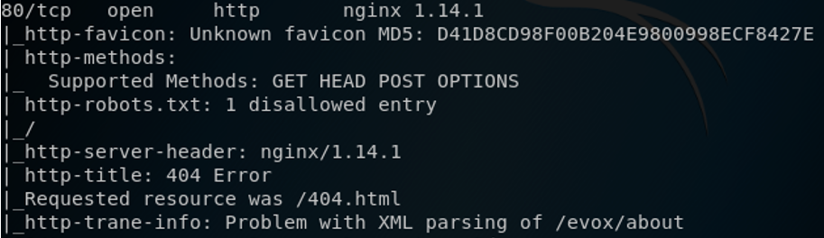
Figure 6: Port 80 Details
Figure 5 shows that Redhat Enterprise Linux 6 is used within the DNS with a bind version of 9.8.2rc1. Red Hat Enterprise Linux is an open source Linux Operating System development company. Their OS supports diverse workloads in physical, virtualised and cloud environments [33].
Figure 6 shows the HyperText Transfer Protocol (HTTP) port running the TCP protocol with a version of nginx 1.14.1. Nginx 1.14.1 was released on 6/11/2018 to fix vulnerabilities in HTTP/2 (CVE-2018-16843, CVE-2018-16844) and MP4 module (CVE-2018-16845), which lead to excessive memory consumption and processing specifically crafted mp4 file might result in process memory disclosure [34]. This version used is slightly out of date, with the 1.14.2 stable version being released on 4/12/2018 [34]. However, this is ultimately unlikely to affect overall security, as the update simply fixed minor bugs in certain OSs.
The OS was also identified utilising nmap, seen below in Figure 7.
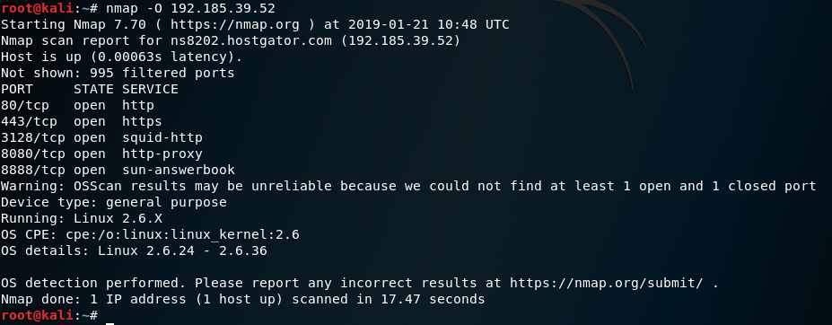
Figure 7: nmap Operating System Scan
Figure 7 shows the OS reported is Linux based, specifically 2.6.x, between 2.6.24 and 2.6.36. The inability to properly narrow down findings is unsurprising as the scan could not find specific ports in specific conditions to find more reliable results.
Another Information Gathering scan conducted was using recon-ng. As mentioned, this tool possesses the ability to scan for XSS vulnerabilities. XSS is a security bug affecting web applications which allows attackers to inject malicious code into HTML pages that are displayed to users [13] [35]. This code changes the behaviour of the website and can be used to steal a user’s private data [35]. XSS occurs due to security flaws in client-side scripting languages, such as JavaScript and HTML [35]. There are three forms of XSS attacks: Persistent or Stored, Non-persistent or Reflected, and DOM-Based [13] [35]. Persistent attacks are when attackers inject malicious code into the web form, which is then saved in the database [35]. Reflected and DOM based XSS attacks, the attacker requires a user to visit their malicious web page or click a malicious link [35]. As such, scanning for this vulnerability to ensure proper security measures are in place is important.
Figure 8: Open XSS Module in Recon-ng
Recon-ng possesses several modules for many different scans. In this scenario, to enable recon-ng’s XSS vulnerability scan, the command seen in Figure 8 must be imputed. From there, the scan involves simply setting a target and running the scan, seen in Figure 9.
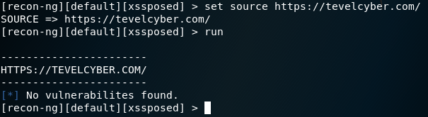
Figure 9: Recon-ng XSS Scan Results
As seen in Figure 9, the XSS scan was run using xssposed module within recon-ng after setting https://tevelcyber.com as the target. However, this scan showed no XSS vulnerability on tevel cybers website.

B. Vulnerability Analysis Scans, Results and Solutions.
The nikto scanning tool was used as a form of vulnerability analysis. As mentioned, nikto scans websites for dangerous files and outdated software [16].
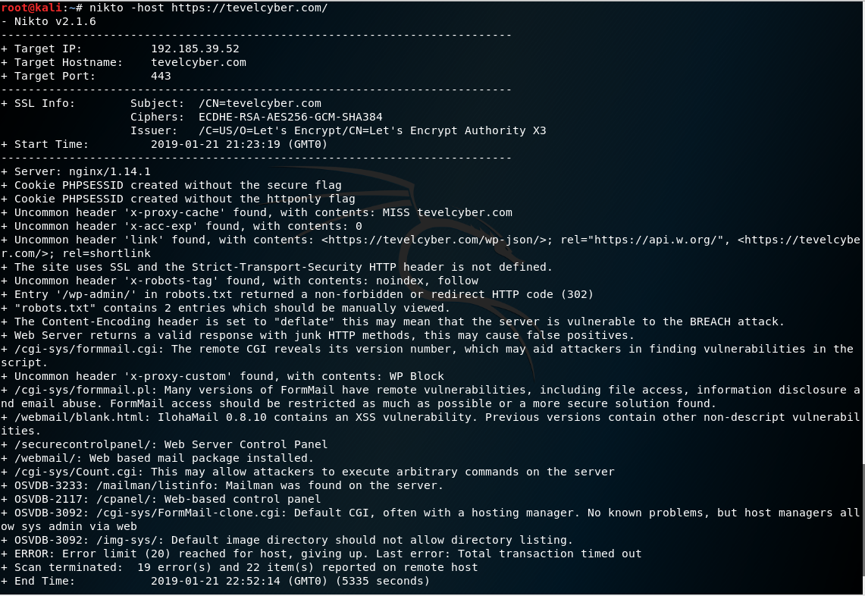
Figure 10: Nikto Scan Results
Results of the nikto scan, seen in Figure 10, both confirm previous observations as well as note new bits of information. Firstly, this scan shows the server running nginx 1.14.1, which reinforces results found from the nmap scan, specifically port 80 HTTP section. Furthermore, nikto also confirms the use of SSL shown in the nmap scan but notes that the HTTP Strict-Transport-Security (HSTS) header is not defined. HSTS header is among the first HTTP response headers [36]. Its used for additional security in communication between web server and web browser, and between devices communicating in Internet of Things (IoT) networks [36].
Several uncommon headers were identified, namely: x-proxy-cache, x-acc-exp and x-robots-tag. However, these do not reveal any vulnerability within the website.
It was noted that the Content-Encoding header is set to “deflate”. This means that the server may be vulnerable to the BREACH attack. The Browser Reconnaissance and Exfiltration via Adaptive Compression of Hypertext (BREACH) attack is a compression side-channel attack that targets information compressed in HTTP response bodies [37]. This attack can be utilised in order to extract login credentials, login tokens, email addresses and other personal or sensitive information from SSL-enabled websites [37] [38].
HTTP compression is the process of compressing server-side responses before sending them to the client [37] [38]. Compression is typically performed through the DEFLATE algorithm [37]. This algorithm uses a combination of LZ77 algorithm and Huffman coding [37]. The adaptive compression-dictionary used in DEFLATE algorithm, which allows the algorithm to develop a compression-dictionary based on the information that is to be compressed, is the main reason the BREACH attack is possible [37]. Even when compressed and encrypted, the length of the compressed data is still visible [37].
Therefore, during the BREACH attack, an attacker injects his guesses of the secrets into the HTTP response bodies [37]. These guesses are plaintext words injected into the HTTP request [37]. Thanks to the nature of the adaptive compression-dictionary, the attacker can measure how much of the attacker-injected bytes are contained in the sensitive pieces of data within the system [37].
Several possible mitigation methods against BREACH attacks are available, such as:
- Disabling HTTP compression [37].
- Randomising secrets per request [37].
- Masking Secrets [37].
- Length Hiding [37].
- Rate-limiting the requests [37].
- Using non-adaptive fixed-dictionary for compression [37].
Disabling compression is not advised as it can lead to high overhead in communication [37]. Utilising the non-adaptive fixed-dictionary for compression method may be the best method of countering BREACH attacks, as attacker injected guesses cannot affect the dictionary; therefore, the data will be compressed if it matches, while a mismatch would result in the data not being compressed [37].
Despite earlier scans conducted with recon-ng showing no XSS vulnerability, the scan conducted using nikto discovered an XSS vulnerability with Ilohamail 0.8.10, while noting that previous versions of this contain other non-descript vulnerabilities. Ilohamail is a webmail system written in PHP licensed under General Public License. Nikto scan noted that this may allow attackers to execute arbitrary commands on the server. This would allow an attacker to initiate further attacks against users. It is recommended to replace Ilohamail with an alternative product to guarantee data integrity.
It was also noted that FormMail was discovered, and that many versions of FormMail have remote vulnerabilities. These include file access, information disclosure and email abuse. FormMail is an open source web server CGI script that captures and processes form contents and typically emails them to one, or many, recipients. It is advised that either FormMail be restricted as much as possible or a more secure solution found to replace this software.
One final observation from the nikto scan is that cookies are created without the use of “Secure” and “HttpOnly” flags. The secure flag is set by the application server when sending new cookies to the user within a HTTP response [39]. Purpose of this flag is to prevent cookies from being observed by unauthorised groups [39]. Setting secure flags prevents browsers from transmitting cookies over unencrypted channels [39]. HttpOnly flags mitigate the risk of client-side scripts accessing the protected cookies [40]. This flag is optional but prevents cookies from being accessed client-side; therefore, even if an XSS flaw exists, browsers will not reveal cookies to third parties [40]. The addition of these flags within tevel cybers communications would increase security of transmissions, as well as mitigate the risk of any XSS attacks.

C. Web Application Analysis Scans, Results and Solutions
For web-based application analysis, the wpscan tool was utilised to identify the presence of WordPress and any other vulnerable plugins [12].
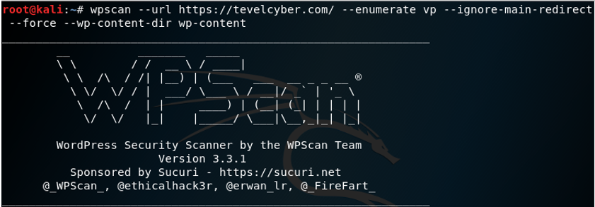
Figure 11: WPScan Command
Figure 11 shows the command used in order to identify WordPress and other plugins. The enumerate vp causes the scan to list all vulnerable plugins identified, while the ignore-main-redirect and force commands were utilised to circumvent the websites redirect function and to force the scan to proceed.
One small note found from this scan can be seen in Figure 12 below.
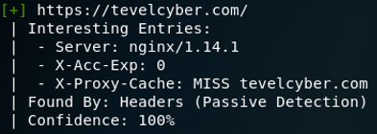
Figure 12: WPScan Server Result
This has been discovered via both nmap and nikto scans, as well as via this wpscan, further reinforcing the accuracy of the information.
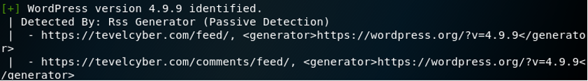
Figure 13: WordPress Version
Figure 13 shows that WordPress version 4.9.9 is in use, identified by the wpscan. There are more advanced versions available [41]; however, these are very recent releases and are unlikely to affect security now but should be considered in the future.
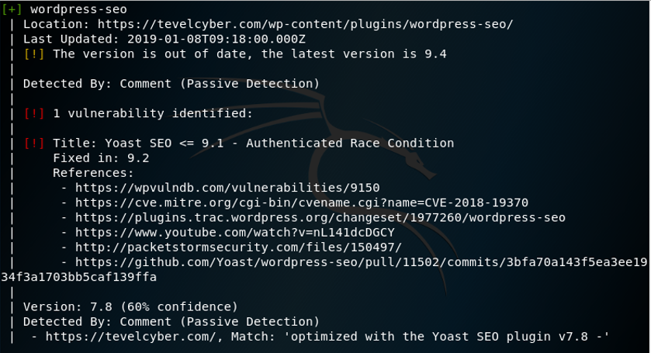
Figure 14: wordpress-seo plugin
One final note of interest from the WPScan is the detection of an outdated plugin which possesses a vulnerability known as Race Condition [42]. The version identified is version 7.8; however, the most up to date version is 9.4. Race Condition is a vulnerability where a software expects an operation to happen in a certain order and should this order be changed; the result is an opening where an attack can happen [42]. It is recommended that this plugin be updated to at least version 9.2 where this issue is fixed. However, updating fully to 9.4 would be more advised.
The final scan conducted was to determine if https://tevelcyber.com/ is vulnerable to SQL injections. This scan was conducted using SQL injection scanner online tool [17]. Kali was not used for this scan as most scans would breach the rules and restrictions set by Tevel Cyber; therefore, an alternative method was required. Results of this scan are seen in Figure 15 below and within the appendices.
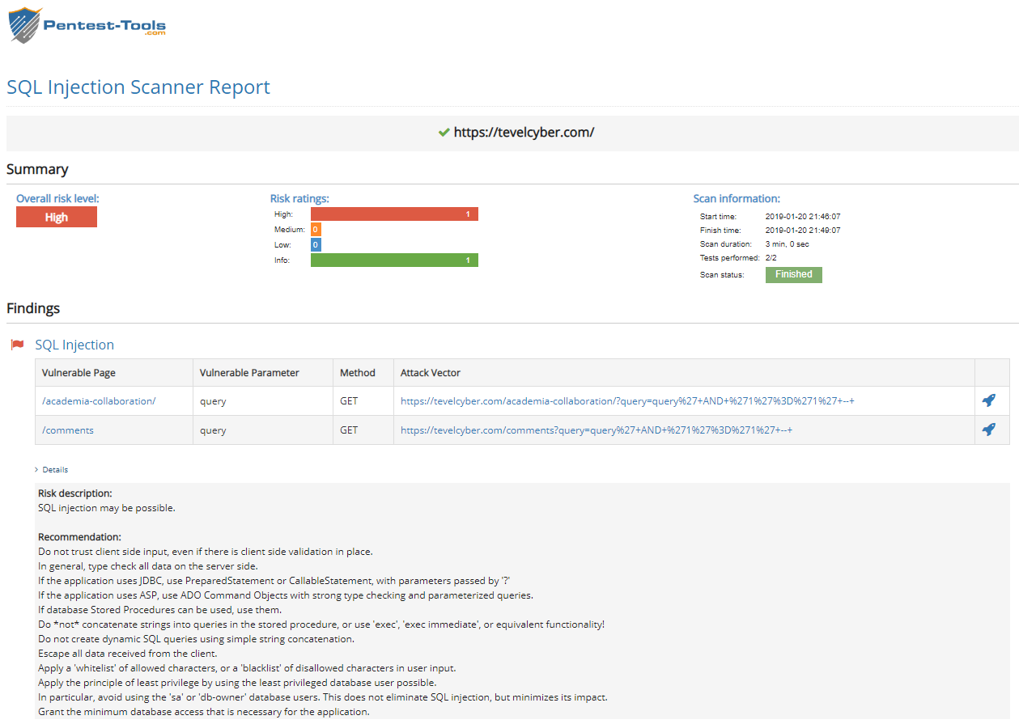
Figure 15: SQL Injection Scan Results
Figure 15 shows that an SQL injection attack is possible. SQL injection is a widespread security issue in web applications [43] [44]. The process involves an attacker altering SQL statements in order to gain access to the SQL database [43] [44]. Attackers can change query statements by modifying or altering input data [43] [44]. Therefore, the intended purpose of SQL queries gets altered and the database executes actions that are unintended and often harmful [43] [44]. The vulnerability occurs if the user input is incorrectly filtered for string literal escape characters implanted in SQL statements [43] [44]. SQL injection attacks can be mitigated by ensuring proper application design, especially in areas which require user input to run queries or commands [43] [44].

V Conclusion
The Internet has evolved over the years and as a result, several issues have arisen, namely in security related aspects. Tevel Cyber Corps Private Limited requested a penetration test on their network web server, https://tevelcyber.com/. There were several guidelines and exclusions given to ensure continued operation of their network infrastructure. However, this did limit how thoroughly the penetration test could be. Despite this, several scans were done using Kali Linux OS running from a virtual machine.
Nmap scans yielded large amount of data, including open ports, the network utilising TCP protocol for communication, SSL security protocol and RSA encryption. Vulnerabilities found in SSL noted in RFC numbers 6176 and 7568 led to the recommendation of transitioning to TLS security protocols instead. Further information includes tevel cyber utilising Linux based operating systems and a TCP protocol of nginx 1.14.1. This was later confirmed using both nikto and wpscan.
Nikto noted several pieces of information, such as a vulnerability to the BREACH attack. Several countermeasures were identified, ultimately leading to the conclusion that using non-adaptive fixed-dictionary for compression would mitigate the risk with less network reconfiguration. It was also noted that HttpOnly and secure flags were not utilised. These flags help improve security by mitigating risks of XSS attacks.
WPScan identified version 4.9.9 of WordPress in use. Further research shows there are newer version, but these were only recently released in the month of January 2019. Therefore, it was decided that this ultimately would not impact security to a large degree right now but should be considered in the future. Other vulnerabilities discovered were an out of date plugin, which allowed for Race Condition attacks to be conducted, and the potential for an SQL injection attack. Race Condition can be mitigated simply by upgrading the version of wordpress-seo to at least version 9.2, where this vulnerability has been corrected. SQL injections can be prevented by ensuring proper application design, especially in areas which require user input.

References
[1] H. Ge, L. Gu, Y. Yang and K. Liu, "An attack graph based network security evaluation model for hierarchical network," 2010 IEEE International Conference on Information Theory and Information Security, Beijing, 2010, pp. 208-211.
[2] D. A. Robles-Ramirez, P. J. Escamilla-Ambrosio and T. Tryfonas, "IoTsec: UML Extension for Internet of Things Systems Security Modelling," 2017 International Conference on Mechatronics, Electronics and Automotive Engineering (ICMEAE), Cuernavaca, 2017, pp. 151-156.
[3] M. Imani, M. Taheri, M. E. Rajabi and M. Naderi, "Vulnerabilities in network layer at wireless mesh networks (WMNs)," 2010 International Conference on Educational and Network Technology, Qinhuangdao, 2010, pp. 487-492.
[4] S. V. Thakare and D. V. Gore, "Comparative Study of CIA and Revised-CIA Algorithm," 2014 Fourth International Conference on Communication Systems and Network Technologies, Bhopal, 2014, pp. 713-718.
[5] A. Falkenberg, C. Mainka, J. Somorovsky and J. Schwenk, "A New Approach towards DoS Penetration Testing on Web Services," 2013 IEEE 20th International Conference on Web Services, Santa Clara, CA, 2013, pp. 491-498.
[6] F. Duchène, S. Rawat, J. Richier and R. Groz, "LigRE: Reverse-engineering of control and data flow models for black-box XSS detection," 2013 20th Working Conference on Reverse Engineering (WCRE), Koblenz, 2013, pp. 252-261.
[7] A. Tetskyi, V. Kharchenko and D. Uzun, "Neural networks based choice of tools for penetration testing of web applications," 2018 IEEE 9th International Conference on Dependable Systems, Services and Technologies (DESSERT), Kiev, 2018, pp. 402-405.
[8] R. Gaddam and M. Nandhini, "An analysis of various snort based techniques to detect and prevent intrusions in networks proposal with code refactoring snort tool in Kali Linux environment," 2017 International Conference on Inventive Communication and Computational Technologies (ICICCT), Coimbatore, 2017, pp. 10-15.
[9] L. Liang, K. Zheng, Q. Sheng and X. Huang, "A Denial of Service Attack Method for an IoT System," 2016 8th International Conference on Information Technology in Medicine and Education (ITME), Fuzhou, 2016, pp. 360-364.
[10] R. R. Rohrmann, V. J. Ercolani and M. W. Patton, "Large scale port scanning through tor using parallel Nmap scans to scan large portions of the IPv4 range," 2017 IEEE International Conference on Intelligence and Security Informatics (ISI), Beijing, 2017, pp. 185-187.
[11] nmap, “https://nmap.org/”, Data Accessed Jan 21, 2019.
[12] WPScan, “https://wpscan.org/”, Date Accessed Jan 21, 2019.
[13] P. Chaudhary, B. B. Gupta and S. Yamaguchi, "XSS detection with automatic view isolation on online social network," 2016 IEEE 5th Global Conference on Consumer Electronics, Kyoto, 2016, pp. 1-5.
[14] Recon-ng, “https://hackertarget.com/recon-ng-tutorial/”, Date Accessed Jan 21, 2019.
[15] R. Lukanta, Y. Asnar and A. I. Kistijantoro, "A vulnerability scanning tool for session management vulnerabilities," 2014 International Conference on Data and Software Engineering (ICODSE), Bandung, 2014, pp. 1-6.
[16] O. Ojagbule, H. Wimmer and R. J. Haddad, "Vulnerability Analysis of Content Management Systems to SQL Injection Using SQLMAP," SoutheastCon 2018, St. Petersburg, FL, 2018, pp. 1-7.
[17] SQL Injection Scanner, “https://pentest-tools.com/website-vulnerability-scanning/sql-injection-scanner-online”, Date Accessed Jan 20, 2019.
[18] T. Kovalenko, "Server virtualization management of corporate network with Hyper-V," Proceedings of International Conference on Modern Problem of Radio Engineering, Telecommunications and Computer Science, Lviv-Slavske, 2012, pp. 381-381.
[19] Kali Linux TutorialsPoint, “https://www.tutorialspoint.com/kali_linux/index.htm”, Date Accessed Jan 21, 2019.
[20] S. G. Bhirud and V. Katkar, "Light weight approach for IP-ARP spoofing detection and prevention," 2011 Second Asian Himalayas International Conference on Internet (AH-ICI), Kathmandu, 2011, pp. 1-5.
[21] S. Pukkawanna, G. Blanc, J. Garcia-Alfaro, Y. Kadobayashi and H. Debar, "Classification of SSL Servers based on their SSL Handshake for Automated Security Assessment," 2014 Third International Workshop on Building Analysis Datasets and Gathering Experience Returns for Security (BADGERS), Wroclaw, 2014, pp. 30-39.
[22] Y. Suga, "SSL/TLS Status Survey in Japan - Transitioning against the Renegotiation Vulnerability and Short RSA Key Length Problem," 2012 Seventh Asia Joint Conference on Information Security, Tokyo, 2012, pp. 17-24.
[23] K. Bicakci, D. Unal, N. Ascioglu and O. Adalier, "Mobile Authentication Secure against Man-in-the-Middle Attacks," 2014 2nd IEEE International Conference on Mobile Cloud Computing, Services, and Engineering, Oxford, 2014, pp. 273-276.
[24] TLS or SSL, “https://www.globalsign.com/en/blog/ssl-vs-tls-difference/”, Date Accessed Jan. 23, 2019.
[25] SSLv2 RFC 6176, “https://tools.ietf.org/html/rfc6176”, Date Accessed Jan. 23, 2019.
[26] SSLv3 RFC 7568, “https://tools.ietf.org/html/rfc7568”, Date Accessed Jan. 23, 2019.
[27] A. Chatterjee, J. Dhanotia, V. Bhatia and S. Prakash, "Virtual optical encryption using phase shifted digital holography and RSA algorithm," 2018 3rd International Conference on Microwave and Photonics (ICMAP), Dhanbad, 2018, pp. 1-2.
[28] S. Y. Bonde and U. S. Bhadade, "Analysis of Encryption Algorithms (RSA, SRNN and 2 Key Pair) for Information Security," 2017 International Conference on Computing, Communication, Control and Automation (ICCUBEA), Pune, 2017, pp. 1-5.
[29] Return of Coppersmith’s Attack (ROCA), “https://www.secpod.com/blog/roca-rsa-encryption-key-flaw/”, Date Accessed Jan. 22, 2019.
[30] Return of CopperSmith’s Attack (ROCA), “https://crocs.fi.muni.cz/public/papers/rsa_ccs17”, Date Accessed Jan. 22, 2019.
[31] S. Wen and W. Dang, "Research on Base64 Encoding Algorithm and PHP Implementation," 2018 26th International Conference on Geoinformatics, Kunming, 2018, pp. 1-5.
[32] AUTH PLAN Explanation, “http://www.samlogic.net/articles/smtp-commands-reference-auth.htm”, Date Accessed Jan. 23, 2019.
[33] Red Hat Enterprise Linux, “https://searchdatacenter.techtarget.com/definition/Red-Hat-Enterprise-Linux-RHEL”, Date Accessed Jan. 23, 2019.
[34] nginx versions, “https://nginx.org/”, Date Accessed Jan. 23, 2019.
[35] A. Shrivastava, S. Choudhary and A. Kumar, "XSS vulnerability assessment and prevention in web application," 2016 2nd International Conference on Next Generation Computing Technologies (NGCT), Dehradun, 2016, pp. 850-853.
[36] I. Dolnák and J. Litvik, "Introduction to HTTP security headers and implementation of HTTP strict transport security (HSTS) header for HTTPS enforcing," 2017 15th International Conference on Emerging eLearning Technologies and Applications (ICETA), Stary Smokovec, 2017, pp. 1-4.
[37] I. Sankalpa, T. Dhanushka, N. Amarasinghe, J. Alawathugoda and R. Ragel, "On implementing a client-server setting to prevent the Browser Reconnaissance and Exfiltration via Adaptive Compression of Hypertext (BREACH) attacks," 2016 Manufacturing & Industrial Engineering Symposium (MIES), Colombo, 2016, pp. 1-5.
[38] BREACH Attack, “https://resources.infosecinstitute.com/the-breach-attack/#gref”, Date Accessed Jan. 23, 2019.
[39] SecureFlag, “https://www.owasp.org/index.php/SecureFlag”, Date Accessed Jan. 24, 2019.
[40] HttpOnly Flag, “https://www.owasp.org/index.php/HttpOnly”, Date Accessed Jan. 24, 2019.
[41] WordPress Versions, “https://wordpress.org/news/category/releases/”, Date Accessed Jan. 24, 2019.
[42] Yoast seo Vulnerability race condition, “https://www.searchenginejournal.com/yoast-seo-vulnerability/281675/”, Date Accessed Jan, 24, 2019.
[43] R. A. Katole, S. S. Sherekar and V. M. Thakare, "Detection of SQL injection attacks by removing the parameter values of SQL query," 2018 2nd International Conference on Inventive Systems and Control (ICISC), Coimbatore, 2018, pp. 736-741.
[44] C. Ping, "A second-order SQL injection detection method," 2017 IEEE 2nd Information Technology, Networking, Electronic and Automation Control Conference (ITNEC), Chengdu, 2017, pp. 1792-1796.

Appendices
These screenshots are larger versions of the ones used within the main report for a more detailed view. They are precise pieces of information from an overall scan conducted using Kali Linux and other scanning tools. The entire scans are not included, only the pieces of information that was used within the report are included.
Figure 1: Ping to Discover IP Address
Figure 2: nmap Port Scan Command
Figure 3: nmap Ports Scanned
Figure 4: Port 25 Details
Figure 5: Port 53 Details
Figure 6: Port 80 Details
Figure 7: nmap Operating System Scan
Figure 8: Open XSS module in Recon-ng
Figure 9: Recon-ng XSS Scan Result
Figure 10: Nikto Scan Results
Figure 11: WPScan Command
Figure 12: WPScan Server Result
Figure 13: WordPress Version
Figure 14: wordpress-seo plugin
Figure 15: SQL Injection Scan Results

marking criteria and Student FEEDBACK

This section details the assessment criteria. The extent to which these are demonstrated by you determines your mark. The marks available for each criterion are shown. Lecturers will use the space provided to comment on the achievement of the task(s), including those areas in which you have performed well and areas that would benefit from development/improvement.

Common Assessment Criteria Applied (Assignment 1) | Marks available | Marks  awarded
1. Research-informed Literature
Extent of research and/or own reading, selection of credible sources, application of appropriate referencing conventions.
Exceptional engagement with an extensive range of relevant and credible literature. Informed by the latest research. High level of referencing skills consistently applied. (Grade mark: 100.00%) | 10 | 10
2. Knowledge and Understanding of Subject
Extent of knowledge and understanding of concepts and underlying principles associated with the discipline.
Exceptional mastery of a complex and specialised area of knowledge. An exceptionally critical awareness of current problems and insights. An outstanding of the concepts of the subject, well informed by current research. (Grade mark: 100.00%) | 10 | 10
3. Analysis
Analysis, evaluation and synthesis; logic, argument and judgement; analytical reflection; organisation of ideas and evidence
Cost such as your consultancy time, timetable i.e. time plan taken to carry out planning and testing, link analysis to your findings in other words, cost solution was not done. Overall exceptional critical evaluation/critique of the current research and testing carried out.  Excellent conclusion but it would be good to have a sub heading outlining recommendation and or future work.  (Grade mark: 85.71%) | 35 | 30
4. Practical Application and Deployment
Deployment of methods, materials, tools and techniques; application of concepts; formulation of innovative and creative solutions to solve problems.
A range of advanced tools used to gather information and launched attack to tests for vulnerabilities on Tevel Cyber Corps Private Limited site. Results of the actual test was provided with discussions with additional output/information in appendix. Nature of how it was done, application used and protocol involved was discussed. (Grade mark: 97.14%) | 35 | 34
5. Skills for Professional Practice
Attributes in professional practice: individual and collaborative working; deployment of appropriate media; presentation and organisation.
Can communicate with an exceptionally high level; Flow, professionally done, excellently presented. (Grade mark: 100.00%) | 10 | 10

Assignment Mark (Assessment marks are subject to ratification at the Exam Board. These comments and marks are to give feedback on module work and are for guidance only until they are confirmed. ) | Late Submission Penalties (tick if appropriate) |  | 94%
 | Up to four weeks late |  | 94%
 | First Attempt? |  | 94%

