
MENU ENGINEERING
(Luca Italian Restaurant)
BY MORYOM QURESHI
STUDENT ID: 2238616
MODULE: BMIH4002
TUTOR: Philippa Fitzgerald


Introducing the Italian cuisine at Luca Italian Restaurant, located in London. Our restaurant preserves the genuine warmth, robust flavor, and straightforward character of traditional Italian cuisine. Luca endeavors to provide an authentic Italian flavor that is precisely crafted and rooted in tradition (John, Bowen, Anne, & Morris, 1995).
The Luca Italian Restaurant epitomizes the essence of Italian cuisine. Our concept represents the essence of classic Italian cuisine. While preserving Italian traditions, we modernize them (Khwaldeh, Al-Hadid, & Alrowwad, 2017). On our menu, we have introduced both traditional and modern Italian cuisine.
Our restaurant serves a diverse and well-informed clientele. Luca welcomes with open arms both curious travellers and discerning Italian food enthusiasts. The welcoming atmosphere at Luca Italian Restaurant makes it an ideal location for a variety of occasions, including family gatherings, intimate dinners, and casual picnics with friends (Kim & Kachersky, 2006).
menu features a wide variety of Italian dishes to accommodate a variety of preferences. Each dish is meticulously prepared according to Italy's culinary traditions, providing guests with a delightful gastronomic voyage across the country (Lewis & Shoemaker, 1997).
The Italian restaurant Luca, located in the heart of London, is a culinary treasure that honors Italy's rich culinary traditions (Masa’deh, Gharaibeh, Maqableh, & Karajeh, 2013). Our attitude respects the rich historical heritage, complex flavor profiles, and straightforward essence of Italian cuisine. Our menu is prepared with authentic Italian ingredients and techniques (Lundberg, E, Walker, & John., 1993).
Our prices reflect the superior quality of our cuisine, the expertise of our staff, and the authentic Italian dining experience we provide. We ensure that our menu prices are reasonable, allowing tourists with limited funds to appreciate Italian cuisine (Mills & Thomas, 2008).

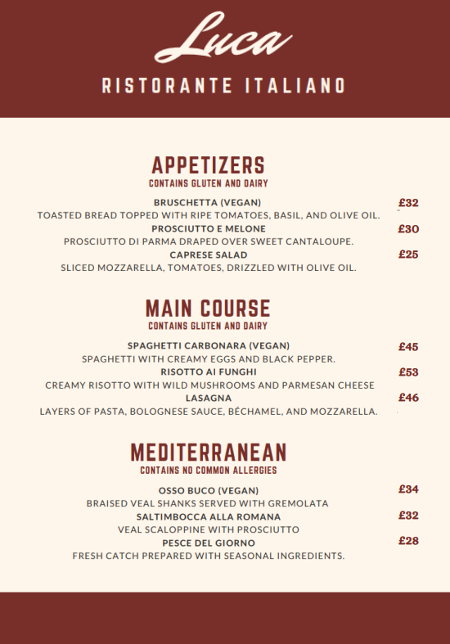
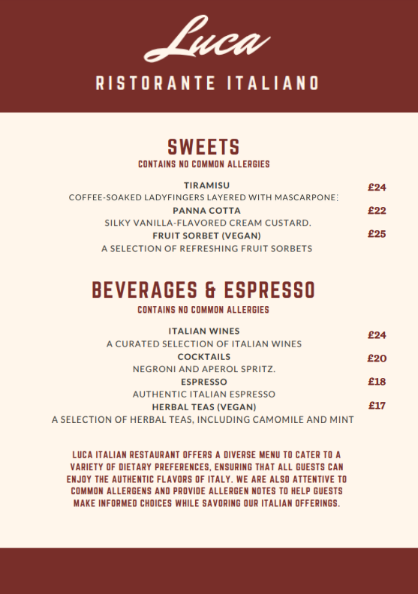

The menu design at Luca Italian Restaurant uses warm Italian colors, an excellent typeface, and Italian motifs to create a modern and authentic atmosphere (Mohammed, et al., 2014). It enhances the Italian experience, aesthetically appealing, and complements the theme of the restaurant.
Our menu descriptions are crafted to emphasize the flavors, ingredients, and cooking methods of each dish, using captivating language to capture the customer's attention. The authenticity of Italian cuisine enables tourists to completely appreciate the country's abundant culinary heritage (Murphy & Smith, 2009).
At Luca Italian Restaurant, seasonality and sustainability are prioritized. Our organization's primary objectives include regulating portion sizes, sourcing ingredients locally and by the current season, and implementing environmentally friendly food disposal methods. (Obeidat, Sweis, Zyod, & Alshurideh, 2012).

References
John, T., Bowen, Anne, J., & Morris. (1995). Menu design: can menus sell? International Journal of Contemporary Hospitality Management, 49.
Khwaldeh, S., Al-Hadid, I., & Alrowwad, A. (2017). The association between e-services web portals information quality and ICT competence in Jordanian universities. . Asian Social Science, 156-169.
Kim, H., & Kachersky, L. (2006). Dimensions of price salience: a conceptual framework for perceptions of multi-dimensional prices. Journal of Product & Brand Management., 139–147.
Lewis, R., & Shoemaker, S. (1997). Price-sensitivity measurement: A tool for the hospitality industry. Cornell Hotel and Restaurant Administration Quarterly, 44-54.
Lundberg, E, D., Walker, & John. (1993). The Restaurant. NY: John Wiley & sons, Inc. .
Masa’deh, R., Gharaibeh, A., Maqableh, M., & Karajeh, H. (2013). An empirical study of antecedents and outcomes of knowledge sharing capability in Jordanian telecommunication firms: A structural equation modeling approach. Life Science Journal,, 2284-2296.
Mills, J., & Thomas, L. (2008). Assessing customer expectations of information provided on restaurant menus: A confirmatory factor analysis approach. Journal of Hospitality & Tourism Research, 62-88.
Mohammed, A., Abu-Rumman, Omar, A., Jawabreh, Khaled, M., Alhyasat, & Husam, M. A.-H. (2014). Business Management and Strategy, 111-128.
Murphy, J., & Smith, S. (2009). Chefs and suppliers: An exploratory look at supply chain issues in an upscale restaurant alliance. International Journal of Hospitality Management,, 212-220.
Obeidat, B., Sweis, R., Zyod, D., & Alshurideh, M. (2012). The effect of perceived service quality on customer loyalty in internet service providers in Jordan. Journal of Management Research,, 224-242.

