Academic Survival Skills – Assignment 5 – Primary Source Analysis

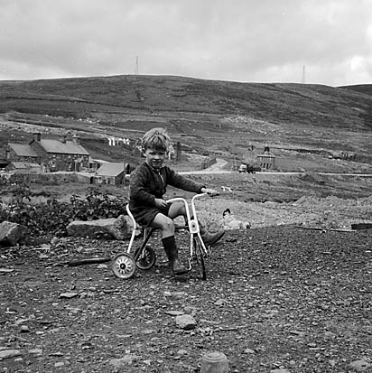
A child playing above Capel Celyn (Cwm Tryweryn), 14 November 1963(Image: Geoff Charles/National Library of Wales)

Introduction
The drowning of the village of Capel Celyn was significant, not just on the psyche of Welsh people but as a touchstone that reignited Welsh Nationalism. The impact of this is still strong today, demonstrated by the many ‘Cofiwch Drywerin’ stickers on cars, public spaces, and merchandise. This assignment aims to analyse one of the iconic images of this event, showing the impact, it had as a primary source at the time and how it has been used since.
Image details
The photograph shown on the title page was taken by Geoff Charles (1909-2002), a Welsh photojournalist. This is a digitised image created using the original negative which is part of the Geoff Charles Collection housed at the National Library of Wales. It was taken at Capel Celyn on the 14^{th of} November 1963 and shows the ruins of the village prior to its flooding. The boy on the bicycle shown in the image is Deiniol Prys Jones (National Library of Wales, 2026).
Photographer Biography
Geoff Charles was born in Brymbo, North Wales in 1909. After studying journalism at university, he worked as a photojournalist for local newspapers but gained recognition once he started working for Y Cymro, a north Wales based Welsh language newspaper. Charles was renowned for his portrayal of Welsh culture and daily life. He donated his collection of 120,000 negatives to the National Library of Wales (National Library of Wales, 2026).
Photograph Context
Capel Celyn is a Welsh village requisitioned and destroyed by the UK government to create a new reservoir for Liverpool, England. The initial proposal was in 1955 with the works completed in 1965. This controversial decision sparked mass protests in Wales and Liverpool, with multiple attempts to sabotage of the works by Welsh Nationalists (BBC, 2023).
As Charles’ views were never published it is hard to explicitly understand his perspective, however looking at how the image is framed with the young boy looking directly at the photographer with the scene of destruction of the village in the background, the feelings of loss and hopelessness are implicit. The original image was published in ‘Y Cymro’ however the archives have not been digitised so I am unable to verify this. This photograph has been reproduced many times, often edited with the boy cropped out, so focus is solely on the destruction (appendix 1). The photograph was amongst those chosen for an exhibition on Charles’ work in Cardiff in 2013 called Diffusion (National Library of Wales, 2026)
Summary
The details of the boy are irrelevant, as it is emotional response it elicits, even without knowledge of the history of the events surrounding it, that are important. Further investigation of the archived newspapers of this time would be needed to be accessed to accurately assess its impact at the time though the continued reproduction of this image over 60 years demonstrates the feelings it evokes amongst those with a keen interest in Welsh history and culture.

Bibliography
BBC, 2023. British Broadcasting Corporation. [Online]
Available at: https://www.bbc.co.uk/news/uk-wales-64560239
[Accessed 01 04 2026].
National Library of Wales, 2026. National Library of Wales. [Online]
Available at: https://www.library.wales/discover-learn/digital-exhibitions/photographs/geoff-charles/
[Accessed 31 March 2026].

Appendix 1
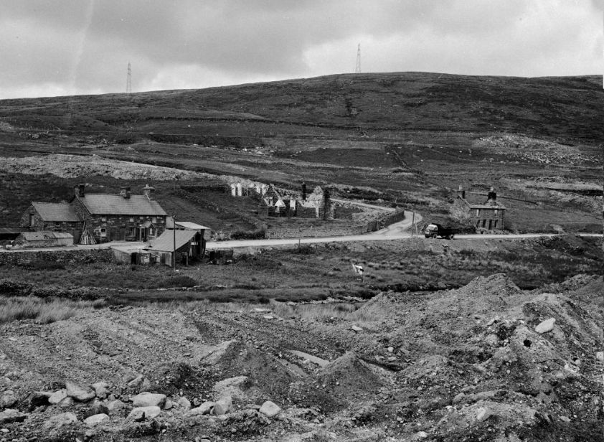
Image courtesy of National Library of Wales

