
Master’s Degrees by Examination and Dissertation
Declaration Form.
1. This work has not previously been accepted in substance for any degree and is not being concurrently submitted in candidature for any degree.
Signed: Dakshesh Vishnubhai Raval
Date: 08/02/2024

2. This dissertation is being submitted in partial fulfilment of the requirements for the degree of Master in Business Administration.
Signed: Dakshesh Vishnubhai Raval
Date: 08/02/2024
3. This dissertation is the result of my own independent work/investigation, except where otherwise stated.
Other sources are acknowledged by footnotes giving explicit references.
A bibliography is appended.
Signed candidate: Dakshesh Vishnubhai Raval
Date: 08/02/2024

4. I hereby give consent for my dissertation, if accepted, to be available for photocopying, inter- library loan, and for deposit in the University’s digital repository
Signed (candidate): Dakshesh Vishnubhai Raval
Date: 08/02/2024
Supervisor’s Declaration.
I am satisfied that this work is the result of the student’s own efforts.
Signed: Dave Coker
Date: 13/2/2024

TITLE
An Artificial Intelligence Method for Analyzing Financial Ratios to Identify Risks and Abnormalities

Student Id: 2217673
Student Name: Dakshesh Raval
Supervisor: David Coker
Dissertation

Abstract

This dissertation focuses on a comprehensive discussion of the inclusion of Large Language Models (LLMs) into financial ratios analysis, focusing risk and anomaly detection in massive datasets. The study evaluates the validity of LLMs, contrasting their predictive accuracy with other approaches and analyzing using them in financial analysis. The research seeks to gather industry insights and views as well from finance practitioners via structured surveys. In the study, new methodology includes LLM testing that is rigid for different financial data sets to assess hidden implications of accuracy. This is supported by a questionnaire which employs Google Form to get direct feedback from finance experts on the practice implication and opportunities for deploying LLM. The thesis emphasizes how LLMs are radically transformative and change the world of financial decisions. The main thematic balance is the need for cooperation between Artificial Intelligence (AI) specialists and financial professionals who recognize each other’s competences. It is a collaborative effort and as such necessary in ensuring that determination of practical feasibility, applicability AI solutions for finance since it is dynamic. To conclude, this study adds an important contribution to the discussion on morally acceptable AI-based finance. The research highlights the transitional impact of LLMs to generate discussions about where financial analyses and services are going. This study, however, has positive academic implications but also helps budding industry players navigate the artificial intelligence and financial analysis intersection.
Contents
Abstract 2
Introduction 6
Research Questions 9
Literature Review 9
Methodology 12
Research Design 12
Data Collection Methods 12
Financial Statements 12
AI Algorithms 13
Sampling Technique 14
1. Purposeful Sampling 14
2. Inclusion Criteria 14
3. Randomization within Categories 14
4. Continuous Evaluation and Adaptation 14
Description of the Google Form Survey 15
Purpose of the Survey 15
Questions and Their Intent 15
3. Target Audience 17
4. Simplifying Complexity 17
Survey Execution and Analysis 17
Data Analysis Methods 18
Statistical Techniques 18
1. Descriptive Statistics 18
2. Correlation Analysis 18
3. Comparative Analysis 19
4. Inferential Statistics 19
Financial Ratios and Risk Identification 19
1. Liquidity Ratios 19
2. Profitability Ratios 20
3. Solvency Ratios 20
4. Efficiency Ratios 20
5. Market Performance Ratios 21
Working 21
Traditional Methods for Identifying Risks and Abnormalities 22
Integration of AI Methods for Improved Analysis 24
1. Advanced Data Processing 24
2. Sentiment Analysis and Market Perception 24
3. Pattern Recognition and Anomaly Detection 25
4. Predictive Modeling for Future Risks 25
Overview of Selected AI Algorithms 26
Application of AI in Financial Ratios 27
Overview of the Google form Survey 28
Purpose and Design 28
Key Points 29
Demographics of the Respondents 30
Key Findings from the Survey 35
1. Demographic Profile 35
2. Quantitative Insights 35
3. Sentiment Analysis 36
4. Key Takeaways 36
Discussion on Survey Results and Their Relevance to the Research 37
Real-world examples of applying Artificial Intelligence (AI) to financial ratios 39
Comparison of AI-Based Analysis with Traditional Methods 40
Summary of Key Findings 42
Contributions to the Field 42
Recommendations for Practitioners and Policymakers 43
Suggestions for Future Research 43
Conclusion 44
References 46
Appendix: 52
1 Screenshot of survey form: 52
2 Screenshot of Linked in posts: 55

Table of Figures
Figure 1 31
Figure 2 31
Figure 3 32
Figure 4 32
Figure 5 33
Figure 6 33
Figure 7 34
Figure 8 34

Table of Equations
Equation 1 Current Ratio = Current Assets / ​ / Current Liabilities 19
Equation 2 Net Profit Margin = (Net Profit / Revenue ​) x 100 20
Equation 3 Debt-to-Equity Ratio = Total Debt / Total Equity ​ 20
Equation 4 Inventory Turnover = Cost of Goods Sold / ​Average Inventory 21
Equation 5 P/E Ratio = Market Price per Share / ​Earnings per Share (EPS) 21

Introduction
Advances in the era of complicated finance and data-driven decision making are applying artificial intelligence to financial analysis. In this research, we aim to identify anomalies and hazards in financial data investigating the rapidly evolving potential of Large Language Models LLMs that are transforming financial ratio analysis. The purpose of this research is to reveal a deep understanding into risk and financial health by combining high-performance artificial intelligence technologies with traditional methods of financial analysis. This has a significant impact on the evolving discipline of financial analytics and AI application in finance.

As AI leads this transformation, the landscape of financial services is changing dramatically. When it comes to the financial markets, applications of speed and accuracy are crucial; AI’s ability in handling large datasets within only a short span gives another potential edge (Schmitt, 2020). This project, which places itself at the forefront of this revolution, studies how to integrate LLMs in financial analysis to refine and deepen financial evaluations and decision making.

For a long time, financial ratios have played the foundation of financial analysis that presents essential information about company finances regarding performance capabilities and health as well as potential threats (Banerjee, n.d.). Latest financial data is such a huge volume that systematized procedures based on statistical analysis and manual interpretation are overwhelming. The present study proposes a novel method for enhancing financial ratio analysis: the integration of LLMs. Since LLMs have advanced natural language processing capabilities, they can handle large volumes of unstructured data and deliver nuanced insights that traditional methods could overlook. There is enormous potential for significant breakthroughs in the sphere of financial analysis because this area still lacks experience (Goodell et al., 2021).

This research is important to find out how one can calculate and identify risk associate with any organization by calculating and analysand financial ratios with the help of AI. Nevertheless, predicting risk associated with the companies is especially important, such as bankruptcy. AI is one method for predicting this type of risk (Chen, 2011). In the given complicated world of finances, it is increasingly important to be able to identify risks and abnormalities quickly and correctly. LLMs provide a more comprehensive and advanced approach to financial ratio analysis that could lead to better risk management strategies, as well as smarter investment decisions. This study is particularly topical against the background of intensive integration currently witnessed in various industries, including banking. It aims at widening our knowledge of how LLMs can be used to analyze financial activity and offer useful data for the academic and interested parties in this field.

The study is driven by several critical objectives:
1. To study the use of LLMs in analyzing financial ratios and identifying risks as well as anomalies in financial reports.
2. Determine how accurate LLMs are at making predictions compared to traditional financial analysis methods including in terms of the depth and accuracy of insight.
3. Conducting comprehensive surveys on the implementation of AI in financial analysis by finance professionals through Google Forms.

Interest in AI for finance has been rapidly growing and while LLMs application, like expenditure trends or liquidity ratios analysis remains underexplored. This research aims to fill this void by using LLMs in a new setting and assessing their performance relative to traditional approaches. Moreover, by including responses from finance practitioners through questionnaires this study strives to offer an overall perspective on the potential consequences and industry precedence of AI in financial analysis (El Hajj and Hammoud, 2023).

This study’s methodology is dualistic. The first aspect comprises of the use and trial of LLMs on financial data, including analyzing financial ratios to detect risks as well as abnormalities. This phase represents the training of models by giving prompts on a wide variety of financial statements to gauge their accuracy and efficiency in analysis. The second aspect is to conduct a survey among finance professionals using Google Forms. These are surveys that intend to find out the feelings of this industry towards AI in financial analysis, what is possible with it and how difficult its implementation can be. Or, combining an AI-driven analysis with real feedback into the world is projected to give a complete comprehension of whether and how using LLMs in financial ratio analysis can be feasible and effective.

The implications of the research go beyond financial ratio analysis. The effectiveness of LLM in financial applications gives room for further integration of AI into different facets of decision-making and strategy formulation within the finance industry. The study also lays the foundation for further research in AI-based predictive modeling, risk management and automated financial advising services. Integrating AI into financial analysis is not easy. These include data privacy, model transparency and the requirement for domain-specific adaptations as significant hurdles. This research not only wants to point out these challenges, but it also aims at exploring opportunities that are given by AI in eliminating the constraints of traditional financial analysis (Boukherouaa et al., 2021).

The thesis seeks to establish the investigation of AI’s function, especially LLMs, in financial analysis. It aims to fill the gaps between AI technology and standard financial analysis practices, playing a key role in promoting academic studies as well as practical applications of finance. This study is marking a new epoch in financial decision-making, as it guides the finance sector into more data-informed and insightful practices which are at their most efficient forms. This research would mean to prove that the potential of LLMs in transforming financial ratio analysis and risk assessment is not fiction but reality because this approach has been proven viable. The analysis of LLMs in interpreting financial data interpretation is an advancement that will shape the future. These models with their unprecedented ability to understand and process overly complicated language, provide a new perspective for the analysis of financial data. In addition to validating the effectiveness of LLMs in financial analysis, this research intended to investigate their potential role in identifying hidden patterns and insights within data that traditional methods may leave out.

Thus, the use of LLMs for interpreting financial data is another important breakthrough. These models, capable of understanding and processing language as it comes, are a new perspective within which financial data can be viewed. “The research conducted described above will not only ascertain whether LLMs are efficient in financial analysis but also evaluate the feasibility of using them to uncover latent patterns and insights that traditional methods do tend to pass by.
The introduction of AI, and more specifically LLMs in financial practices is a revolutionary departure from traditional approaches. This change gives an innovative approach to financial data, risk assessment and decision-making. This research investigates how AI can supplement human expertise, thereby strengthening financial analysis and improving decision-making processes (Dupont, Fliche and Yang, 2020).

With the advent of AI in finance, ethical and practical issues became more relevant (Svetlova, 2022). This study addresses these considerations, such as the ethical use of AI, data privacy concerns and the effect that training on this modern technology has in finance sector from a job loss perspective. The research also focuses on the practical considerations of integrating AI solutions in finance, including how to incorporate AIs with existing financial systems and what kind of training finance professionals need learn be able fully leverage these new tools.

Collaboration between AI experts and finance professionals is also one of the key aspects of this research. This study aims to create a more comprehensive picture of how AI can be effectively utilized in the field by merging knowledge from both fields. This collaboration is crucial for the creation of AI solutions that are technically sound and relevant in practice, applicable to finance (Li et al., 2021). Additionally, this dissertation paves the way forward by identifying several areas where future research can focus on. These include working with more advanced LLMs developed specifically as financial applications; discussing how artificial intelligence impacts financial forecasting. This study also initiates debate regarding the regulatory regimes and policies that must be put in place to support responsible AI use in finance.

An important aspect of this research is promoting cooperation between AI experts and finance specialists. The purpose of this practice is to combine knowledge from every discipline with an aim at creating a more comprehensive understanding on how AI could effectively be implemented in finance. This collaboration is essential for the development of AI solutions that not by simple level are technically sound but also applicable and relevant inside the finance sector (Li et al., 2021).

The degree set by this dissertation for future research in various areas includes the development of more superior LLMs designed specifically for monetary packages, studying AI’s role in economic forecasting and modelling, leading to investigating how deep integration can affect finance over time. The study also initiates discussions regarding the regulatory frameworks and policies needed to support responsible AI use in finance.

Therefore, the present dissertation is a detailed study of how AI and specifically LLMs influence financial analysis. It aimed to provide substantial support for academic and practical approach of AI finance, which enabled more informed, effective, and efficient financial decision making in the fast-changing data-driven world. As AI technology increasingly improves, its implementation in the financial industry is poised to transform the face of fiscal services and analytics by presenting new prospects and challenges that will determine finance’s future trajectory.

Research Questions
How LLMs can be used to calculate and analyze financial ratios to improve the identification of risks and abnormalities in financial reports?
How much are finance professionals using AI in their financial evaluation processes, specifically LLMs?
What is the difference in forecast accuracy between LLMs and conventional financial analysis methods?

Literature Review
This literature review is based on several research studies to compile insights into the utilization of LLMs in financial intelligence, especially integrating AI with Large Language Models That incorporation signifies a significant evolutionary move within finance.

A significant step in the use of AI, particularly ChatGPT to assess the performance of companies. The research also underlines the fact that managers need to be financially conscious, and they lack a wider understanding about financial evaluation. ChatGPT is being used to help evaluate the financial ratios of 50 different companies (Sarvandani, 2023).

The role of financial ratios in explaining information quality using factor analysis and AI. Their empirical accounting research, conducted over nine years, employed AI to predict the quality of accounting information in firms listed on the Tehran Stock Exchange (Karimi et al., 2023). The study found a significant correlation between financial criteria like "Accounts receivable to sales ratio" and information quality ratings. This research is innovative in its simultaneous use of all information quality criteria and AI, demonstrating the capability of AI in enhancing the predictiveness and reliability of financial information.

The development of FinBERT is a testament to the adaptability of LLMs to specific domains like finance (Huang, Wang, and Yang, 2020). FinBERT, designed to incorporate finance knowledge, excels in summarizing contextual information in financial texts and outperforms traditional algorithms in sentiment classification. Its proficiency in identifying the sentiment in financial texts, even those with minimal context or rarely used financial terms, marks a significant advancement in AI-driven financial analysis. This study highlights FinBERT’s utility in fields like academic research, investment, and financial regulation.

Analysis of generative AI, particularly focusing on ChatGPT, Bard, and Bing AI, examines their application in finance. These models, through their language generation capabilities, have enhanced financial analysis, automated tasks, and improved decision-making. The study evaluates these AI models using metrics like ROUGE and BLEU, noting their strengths and limitations. It discusses challenges like factual accuracy, bias, and the need for domain adaptation, pointing toward future directions in generative AI models in finance (Krause, 2023).

A comprehensive survey on the application of LLMs in finance. The study reviewed current approaches, including leveraging pretrained models and fine-tuning them on domain-specific data (Li et al., 2023b). It proposed a decision framework to guide financial professionals in selecting suitable LLM solutions based on constraints around data, computer, and performance needs. The survey also discussed the limitations and challenges in leveraging LLMs in financial applications.

A retrieval-augmented framework for financial sentiment analysis using LLMs (Zhang et al., 2023). Addressing the challenges in applying LLMs directly to financial sentiment analysis, their framework combines an instruction-tuned LLMs module with a retrieval-augmentation module to enhance accuracy and reliability. The approach achieved significant performance gains compared to traditional models, showcasing the potential of LLMs in financial sentiment analysis.

A review on combating financial risks in the big data era highlights the impact of big data technology on financial services and the emergence of financial frauds (Cheng et al., 2021). The study emphasizes the need for new methods in risk detection, assessment, and forecasting, discussing how big data combined with AI tools can effectively analyze financial risk. The importance of utilizing multi-channel information and networks for identifying financial risks is stressed, along with discussions on new challenges like deep fake technology and privacy protection.

Development of CFGPT, a Chinese Financial Generative Pre-Trained Transformer, underscores the specificity required in financial LLMs (Li et al., 2023a). CFGPT, tailored for various financial tasks, balances model capability and size. The framework navigates real-world financial applications, emphasizing the need for custom LLMs in diverse financial contexts and languages.

Article on the role of AI in FinTech industry describes that it effectively carries out necessary work process flows while reducing operational costs (Wadhwa and Kumar, 2023). The research assumes the use AI in FinTech with its functions related to data analysis, improved customer service and trade advising. It also outlines how AI can be most effectively applied in banking, primarily centered on chatbots and automated solutions. This research puts AI as a transformative role in financial services, showing the way innovations powered by artificial intelligence can make financial solutions more cost-effective and accessible.

These studies show that the integration of AI, and particularly LLM’s in financial ratio analysis as well as risk identification can serve as an encouraging path for developing financial research. These technologies improve the speed and accuracy with which financial data is processed, but they also add a level of richness and subtlety to their analysis that was elusive before.

The studies by Sarvandani, Karimi et al., and Huang et al. collectively highlight the potential of LLMs like ChatGPT and FinBERT in financial ratio analysis and sentiment classification. These AI models demonstrate not only high accuracy in analysis but also an ability to manage complex, nuanced tasks like summarizing contextual information and identifying sentiments in financial texts.

Krause’s analysis, along with the survey by Li et al., further highlights that LLMs are versatile enough to have an application in different tasks right from financial analysis and making decisions. These studies also highlight the importance of quality prompting and validation, or even verification as is often necessary if AI-generating outputs are to be fully used in finance.

Zhang et al.'s introduction of a retrieval-augmented framework for LLMs in financial sentiment analysis and Cheng et al.’s emphasis on combating financial risks using big data and AI illustrate the innovative ways in which AI can be adapted to meet specific challenges in finance. These approaches not only enhance performance but also offer solutions to the unique problems posed by the succinct and context-dependent nature of financial data.

Li et al.’s development of CFGPT for Chinese financial analysis and Wadhwa and Kumar's exploration of AI's role in FinTech demonstrate the global and cross-sector applicability of AI in finance. These studies highlight the need for custom solutions and the diverse applications of AI, from enhancing customer service to providing trading advice and risk management.

Therefore, the literature indicates that AI and LLMs promise much in transforming financial analysis. As these technologies progress further in their evolution, they are going to become more established parts of financial decision-making on all levels – from individual firm analysis down to broader market trends and risk assessment. Along with the excitement about these technologies, there are evident challenges that lie ahead. Issues such as the need for domain-specific adaptations, addressing biases, ensured factual accuracies and ethical considerations can be looked after. Future studies should build upon these models trying to perfect their accuracy and reliability, as well as seek innovative ways for AI integration into the financial industry more naturally and ethically.

Methodology
The researcher used a combination of two different methodologies while planning the study of this topic: a Google Form survey in conjunction with an AI Method (a Large Language Model, to be exact). With its dual technique, a thorough analysis is made possible, providing a variety of viewpoints for more in-depth understanding. Through the application of both approaches, the researcher hopes to improve knowledge by including a variety of perspectives and enhancing the analysis using a multimodal approach.

Research Design
Firstly, Researcher thought about numbers and hard data. He wanted to see how well these AI techniques, called Large Language Models (LLMs), could oversee financial statements. To do this, he collected financial info from different companies. Imagine it like gathering puzzle pieces. He had to carefully choose these companies, making sure they represented various aspects of the financial world. This part was a bit like detective work.
AI is crucial for evaluating the financial health of organizations, particularly LLM models. Precise alerts with pertinent financial metrics and indications ought to be supplied. For the models to analyze data and produce precise conclusions, these prompts must be precise and organized. Stakeholders can make more informed decisions by enhancing the analysis's accuracy and reliability using robust validation procedures and data quality checks.
The second part was all about people's thoughts and opinions. Researcher created a survey using Google Forms and sent it out to folks in the finance world on credible platform, in this survey researcher used Linked in to distribute survey people in various groups of peoples belong to finance industry. This was like asking experts what they think about using artificial intelligence in finance. The survey questions were like asking them about experience, trying to understand their views on using AI in their work.
The motivation behind mixing these two approaches is that numbers can only tell us so much. By also getting the thoughts and experiences of real people in finance, analyst hoped to paint a complete picture.
Briefly, the research design was like using two lenses—one for numbers and one for people's opinions. By doing this, researchers aimed to capture the full story of how AI, especially LLMs, is changing the way we look at financial data.
The motivation for merging these two approaches is that numbers can only say so much. He also hoped by getting the thoughts and experiences of real finance people to paint a bigger depiction. Overall, the research design was like using two lenses – one for numbers and another for people’s opinions. By doing so, He tried to portrait the whole picture of how AI in general and Low-Level Machine learning models are transforming our view on financial data.

Data Collection Methods

Financial Statements
First, Researcher needed the raw material – this was financial statements for different companies. They have such numbers as income, expense assets and debts. To make this study meaningful, He desired a cross section of companies not only from one sector but rather various sectors across the financial world.
Being a detective in search of the appropriate companies. Researchers had to pick carefully, ensuring they covered various aspects of the financial terrain. It is as if he was taking pieces of a puzzle and when they are all together, the picture becomes whole. This step needed keen observation, a little bit of searching, and some investigative skills to make sure that the samples taken were representative or diverse enough.

When researcher managed to set his eyes on the companies, it was high time to get those financial statements. It was like treasure hunting following valuable financial data rather than gold. This entailed visiting the companies’ websites, going through the financial statements, and ensuring that any information acquired was current and correct.

AI Algorithms
They are like intelligent computer programs that can comprehend and analyze complicated information in our case financial records.

1. Choosing the Right Models
Just as to choose the right tool for a job, Researcher had to select suitable AI models. These are like specialized programs that already speak language well so opted for so-called Large Language Models (LLMs) since they are quite good at dealing with intricate information. Here in this research analyst is using Chat Gpt, Bard, Bing AI and FinBERT for calculating and analyzing financial ratios.
In the methodology, the researcher opts for Large Language Models (LLMs) as specialized AI programs for financial ratio analysis. LLMs are selected for their advanced natural language processing capabilities, making them well-suited for dealing with complex financial information in statements. The decision is grounded in their proficiency in language understanding, aligning with the research objective of improving financial ratio analysis through the application of LLMs.

2. Training the Models by giving prompts
In this stage, which is like teaching a machine to read statements of finances, the researcher stresses the fine craft of providing accurate prompts. It is by no means a click-and-magic scenario; rather, the procedure entails providing precise instructions to LLM models over a wide range of financial data and scenarios, akin to training a dog in new instruction. This complexity is critical to the study and necessitates a thorough comprehension of prompt design to guarantee the collection of accurate and trustworthy data. The investigator emphasizes the importance of this stage, recognizing that it is essential to achieving reliable and superior results.

3. Double-Checking Accuracy
Teaching these models is one thing, but making sure they got it right is another. Researchers had to double check their accuracy, ensuring they were effectively analyzing financial ratios and identifying potential risks. It is like giving a test to see if the dog learned the tricks correctly. This part involved meticulous validation to make sure the models were on point.
In short, the process includes selecting diverse companies, obtaining varied financial statements, and utilizing intelligent algorithms (LLMs) to understand intricate details. This process incorporated companies’ selection, relevant data collection, and algorithm training to ensure abundant, dependable, and meaningful data for the study.

Sampling Technique
The researcher outlined the process used to choose the firms for the study and examined the crucial component of sampling approach. Analogous to the process of hand-selecting individual examples, the objective of this approach was to examine if the cases fairly depict the larger financial scene. To improve the study's validity and provide insightful information about the topic under inquiry, researchers take great care when choosing samples to make sure the results are representative of the entire financial environment.

1. Purposeful Sampling
To develop a comprehensive knowledge of how AI, particularly Large Language Models (LLMs), interacts with different financial situations, Researcher used the method called purposeful sampling. This approach implies a purposive selection of organizations that meet certain criteria (Editorial Team, 2023). Researchers included aspects like industry, company size, geographical location, and financial stability to ensure a balanced representation.

2. Inclusion Criteria
Establishing the inclusion criteria meant stipulating certain characteristics, which companies should have to be included in this study. These criteria enabled the focus and relevance to be maintained. For instance, Researcher adopted companies with published financial statements, adequate size for analyzing data and various levels of complexity in financial issues.

3. Randomization within Categories
While a purposeful sampling allowed diversity, Researcher also added randomness amongst categories. This step made it possible to avoid bias in the selection of companies (Suresh, 2011). This may have influenced results in a certain direction. It is about remaining neutral and staying away from any bias.

4. Continuous Evaluation and Adaptation
Thus, sampling is not a single event; it is an ongoing activity. As Researcher advanced with the analysis, it was always a matter of checking if the companies selected to study were indeed adding anything meaningful in terms of contributing towards fulfilling my research objectives. If necessary, Researcher adjusted the sampling method to represent a balanced view of the financial scene. This flexibility is vital in research as it gives room for adjustments during the revelation of insights.
In other words, the choice of sampling was a thoughtful and planned process that included careful selection of cases to help create an all-encompassing picture which is accurate on how AI methods especially LLMs impact financial ratios’ analysis in identifying risks or abnormalities.

Description of the Google Form Survey
Take a closer look at the details of how this Google form survey helped shape the views pulled from this study. Imagine it as going into a conversation with experienced professionals in the finance world trying to untangle their reasons, perceptions, and reservations about AI on financial analysis.

Purpose of the Survey
The survey itself was carefully designed with a noticeably clear purpose of capitalizing on the collective intelligence within finance professionals. The goal of this roundtable was to provide a free platform for these experts where they could share their fine-grained insights, opinions, and fears regarding the implementation of AI specifically Large Language Models LLMs into financial analysis. The survey was like composing a symphony of voices in finance — each note played its part as technology changed the tune of financial services. To maintain secrecy of the persons, researcher is not collecting personal information like name, age, sex, and contact details.

Questions and Their Intent
Try to understand not just what these questions ask but the underlying intent and the wealth of information they endeavour to unearth.

Question 1: What is your age?
By categorizing responses based on age groups, it seeks to discern if there are discernible patterns or preferences concerning AI adoption in financial analysis across different generations.

Question 2: What is your occupation?
Diving into the professional landscapes of the respondents, this question acts as a compass, guiding the survey towards tailored analyses. It recognizes the diversity inherent in various professional roles and acknowledges that different perspectives may emanate from different corners of the financial world.

Question 3: How much experience do you have in finance?
It seeks to illuminate whether familiarity with AI correlates with years of experience, providing a nuanced understanding of how seasoned finance professionals view the amalgamation of AI into their domain.

Question 4: How familiar are you with artificial intelligence in the context of financial analysis?
A quest for awareness, this question endeavors to map the respondents on the spectrum of AI knowledge. It is akin to exploring the language proficiency of participants in the evolving technological dialogue within the finance sector, from novices to those fluent in the lexicon of AI.

Question 5: How confident are you in the ability of LLMs to analyze financial ratios and identify risks and abnormalities?
Venturing into the realm of trust and confidence, this question acts as a litmus test for the respondents' belief in the capabilities of LLMs. It is like gauging the level of faith they place in AI for dissecting financial intricacies.

Question 6: would you prefer the use of an AI method such as LLM or traditional human analysis for financial ratio?
This question gives a peek into personal tendencies of finance professionals. It is much like giving them the option between staying with that comforting harbor of traditional methods or exploring those inspiring possibilities created by AI, encouraging their preferences to be made known.

Question 7: Do you have any concerns regarding the use of AI and specifically LLMs for financial analysis?
This question is as good an open invitation to share worries that is akin to giving the respondents blank canvas for them freely paint whatever concerns they may have. It seeks to capture the woven texture of issues and doubts they might be holding for incorporating AI into financial analysis.

Question 8: How much do you think that the quality of training data affects how accurate an AI model in financial analysis is?
This question also aims to assess whether participants understand the importance of data quality in AI training by going deeper into its basics. This is akin to asking them to consider the elements of AI and point out how important it was for data quality in making sense.

Question 9: How concerned are you regarding the privacy and security of financial data when using AI methods for analysis?
Focusing on the core issues of data privacy and security, this question tests apprehensions about loopholes. It is like bringing an illumination to the ethical aspects and security facets associated with introducing AI into this hallowed sphere of financial data analysis.

3. Target Audience
The survey was meticulously tailored for a specific audience, professionals entrenched in the finance world. These individuals, whether Financial Analysts, Data Scientists, Business Owners, or other related occupations, formed the foundation of the survey's target demographic. By focusing on this specific group, the survey ensured that the insights gleaned were directly relevant and reflective of those actively engaged in the intricate dance of financial analysis.

4. Simplifying Complexity
In designing the survey questions, a conscious effort was made to maintain clarity and simplicity. The aim was to make the survey accessible to participants irrespective of their familiarity with AI, fostering an environment where honest and candid responses could flow. It is like orchestrating a conversation rather than conducting a technical interview, ensuring that the insights gathered are authentic and reflective of the diverse perspectives within the finance sector.

The Google Form survey was not just a questionnaire; it was a portal into the minds of finance professionals. It was crafted with precision to facilitate a nuanced conversation, allowing these experts to articulate their thoughts on the integration of AI, especially LLMs, into the intricate world of financial analysis (Wimoolka, 2022).

Survey Execution and Analysis
Beyond the meticulous crafting of questions and the targeted audience, the survey's execution was a dance of engagement. It is like orchestrating a symposium where each participant contributes a valuable note to the evolving melody of insights.
1. Dissemination:
The survey was targeted at critical points within the finance sector. It is like casting a net into the great ocean of financial professionals, to get an adequate cross section. The survey used platforms specifically linked in groups created by finance experts to capture a wide range of opinions and experiences. The survey started on 31st of December 2023 and ended on 9th January 2024.
2. Accessibility and User-Friendly Interface:
The choice of the online format for the survey via Google Forms was deliberate. It is like inviting someone to a comfortable digital place. The user-friendly interface allowed participants to go through the questions easily. This way was inclusive, enabling a wide spectrum of finance specialists to share their views.

3. Quantitative and Qualitative Analysis:
The responses to the survey were analyzed using a dual approach. Quantitative analysis entailed number crunching, responses categorization and pattern identification. This is akin to condensing the collective voice in the survey into measurable insights that give this qualitative narrative its statistical spine.
Qualitatively, responses to open-ended questions were carefully analyzed. The qualitative analysis aimed to capture the details, emotions and individual perspectives within participants’ written replies which gave more depth on this whole story (Wimoolka, 2022).

4. Ensuring Ethical Conduct
Privacy and security of data is to be considered as the social responsibility of AI (Cheng, Varshney and Liu, 2021). Ethical considerations were high throughout the survey process. It is like creating a set of rules to have a thoughtful conversation. Privacy and confidentiality were strictly observed, identities of participants kept secret to help them share their thoughts freely. This ethical framework guaranteed that the design of the survey valued participant rights and presided over integrity in insights obtained.

The Google Form survey had moved out from being just a data collection tool. It created an authentic platform for dialogue between finance professionals, reflecting the variety of voices in a sector. Through careful construction, purposeful communication, and insightful interpretation the survey revealed profound knowledge that added to a broad narrative of AI’s role in financial analysis.

Data Analysis Methods
In this complicated field of data analysis, the study adopts a two-pronged approach that combines statistical solutions and AI algorithms. Basically, these methodological pillars work as analytic instruments carefully crafted to analyze patterns and identify inherent risks along with abnormalities in the vast domain of financial data.

Statistical Techniques

1. Descriptive Statistics
At a basic level, the study commences by quantifying important characteristics in financial data. Descriptive statistics, which include such measures as mean, median and standard deviation, painstakingly draw a comprehensive picture of central tendencies and variability (Frost, 2018). This process sets the groundwork, establishing a baseline that is key to further analyses.

2. Correlation Analysis
Correlation analysis plays a significant role in the research. This technique reveals the complex connections between various financial variables and helps demonstrate how elements progress in tandem or diverge. The drawings garnered make a significant contribution to developing a more profound understanding of the intricate dynamics in the financial landscape.

3. Comparative Analysis
The study uses comparative analysis to compare the efficiency of various companies or financial indicators. This method acts as a strategic framework, which helps in identifying outliers and variations – something that is instrumental in developing nuanced understanding about the financial panorama (Faster Capital, n.d.).

4. Inferential Statistics
Inferential statistics not only go beyond obvious observation but work like magnifying glass. This technique gives in-depth conclusions on a well-chosen sample about the larger financial population. Methodologies, such as hypothesis testing and confidence intervals enable the study to make well-informed generalizations with confident certainty in precision (Frost, 2018).

Financial Ratios and Risk Identification
For both insiders and outsiders, ratios are essential indications of the company's financial statement. These ratios assist management in making critical decisions necessary to strengthen the company's financial situation and assist investors in understanding the organization's standing (Weetman, 2013). One can utilize ratio analysis to learn how well a business is doing in comparison to its rivals. It can be used to determine the short- and long-term holdings held by a corporation (Fridson and Alvarez, 2011). Financial ratios language is a powerful tool in the maze of financial analysis – it unravels the story and narrative of a company’s fiscal health. These ratios are not just a set of numbers; they are the indicators that summarize complicated financial information into easy-to-understand clues. In the scope of research related to ‘An Artificial Intelligence Method for Analyzing Financial Ratios to Detect Risks and Anomalies,’ chosen financial ratios have great significance in determining how AI – notably Large Language Models or LLMs can assist in detecting risks as well as anomalies. Let us start an inspection of these ratios and their deep importance in the financial analysis world.

Liquidity Ratios

Current Ratio:
The Current Ratio is a basic liquidity ratio which gives an immediate picture of the short-term solvency position for business. It gauges the corporation’s capability to meet its short-term obligations using current assets. The formula for calculating the current ratio is straightforward: it is the ratio of current assets to short-term obligations. A higher ratio indicates that the company’s short-term liquidity is better (Atrill, 2012)
A Current Ratio below 1 implies liquidity problems, meaning that the company could have difficulty settling its short-term liabilities. Alternatively, an overly high ratio may indicate under-utilized assets and thus suggest inefficiencies of capital investment. By analyzing textual data from financial statements, LLMs can contribute to the analysis of current ratios. They can identify patterns and deviations, offering early warnings about potential liquidity problems that might not be evident in numerical data.
Equation 1 Current Ratio = Current Assets / ​ / Current Liabilities

2. Profitability Ratios
Net Profit Margin:
Net Profit Margin is one of the important profitability ratios that reveals which part of sales comes out as net gain. It is determined by dividing net profit into total revenue and multiplying it by one hundred to make a percentage. This ratio serves as an indicator of the efficiency with which a company generates profits from revenue (Corporate Finance Institute, 2022).

A decreasing Net Profit Margin could indicate operational inefficiencies, rising costs or pricing pressures. It invites us to take a closer look at the company’s cost structures and revenue streams. With their capacity to analyze textual data, LLMs can dig into financial documents and reveal underlying factors that influence profitability. They can derive insights from the storyline contained in these documents, offering a greater understanding of the workings forces at play.
Equation 2 Net Profit Margin = (Net Profit / Revenue ​) x 100

3. Solvency Ratios
Debt-to-Equity Ratio:
Another important solvency ratio is the Debt-to-Equity Ratio which measures how much of a corporation’s assets are financed by debt as opposed to its equity. It is measured by total debt divided by shareholders’ equity. This ratio gives an insight into the financial leverage of the company (Corporate Finance Institute, 2022).
A high Debt-to-Equity Ratio can indicate the risk of finances in a company when too much debt puts pressure on its financial stability. It throws light on whether the company can meet its long-term obligations and it may hint at the problems of service debt.
Equation 3 Debt-to-Equity Ratio = Total Debt / Total Equity ​

4. Efficiency Ratios
Inventory Turnover:
Inventory Turnover represents an efficiency ratio that shows how well a company manages its inventory. It is determined by dividing the cost of goods sold with average inventory. This ratio gives an idea of the capacity of this company to convert inventory into sales (Corporate Finance Institute, 2022).
Declining Inventory Turnover may indicate overstocking, slow-moving inventory, or difficulties in demand forecasts. It affects cash flow and locks up capital in unsold inventory. LLMs, being natural language processing tools, can review textual data from financial statements to identify the causes of inventory management issues. This is how they can get qualitative insights that go along with their numerical data and provide a better picture about what exactly was happening in terms of the dynamics around efficiency.
Equation 4 Inventory Turnover = Cost of Goods Sold / ​Average Inventory

5. Market Performance Ratios
Price-to-Earnings (P/E) Ratio:
A commonly used market performance ratio is the Price-to Earnings (P/E) Ratio, which compares a company’s stock price to its earnings per share. It is determined by dividing the market price per share by earnings per share. This ratio gives an understanding of investors’ sentiment and market expectations (Atrill, 2012).
High or low P/E Ratio as compared to the typical industry standard means that a company’s stock is overvalued of undervalued. It invites a deeper consideration of the sentiment prevailing in the market and various elements impacting on stock prices. LLMs that use machine learning can process textual data for sentiment analysis. They can pull qualitative findings from news clippings; analyst reports or other textual sources that shape perceptions of the market and affect P/E Ratio.
Equation 5 P/E Ratio = Market Price per Share / ​Earnings per Share (EPS)

These financial ratios are selected based on a thorough analysis of the status of companies’ finances. They encompass several aspects such as liquidity, profitability, solvency, efficiency, and market performance. Including LLMs helps to deepen the analysis of these ratios. LLMs can delve deep beyond numbers, diving into textual data extracted from a company’s financial statements to reveal underlying patterns, anomalies and qualitative insights on conduct that contribute further towards building richer views of the risks and oddities within an entity’s fiscal terrain (Shi et al., 2020)

Working
During my research, Researcher employed Large Language Models (LLMs) such as Chat GPT and FinBERT provided by Hugging Face. Hugging Face, a reputable platform known for offering a diverse array of pre-trained language models, was chosen based on its standing in providing state-of-the-art models and its seamless integration into my research workflow.

With the use of pertinent formulas and the processing of numerical data, ChatGPT can compute financial ratios like the profitability, solvency, and liquidity ratios. To support thorough financial risk assessment, it can then evaluate the related risks by interpreting these ratios considering historical trends, industry benchmarks, and qualitative considerations.

The execution of the LLMs, including the FinBERT model, did not take place locally; instead, it occurred on a remote runtime within the Google Collab environment. This decision was intentional, leveraging the cloud-based resources provided by Google Colab to ensure access to the necessary computational power for model training and the subsequent analysis of financial data.

For the training process, the LLMs were exposed to extensive financial data collected from various companies across different sectors. The training set encompassed a range of financial ratios, and the models underwent fine-tuning to discern patterns, anomalies, and qualitative nuances present in textual data extracted from financial statements. This iterative training process aimed to enhance the LLMs' proficiency in interpreting and analyzing the selected financial ratios.

Traditional Methods for Identifying Risks and Abnormalities
Financial analysis is a complicated area in business life, and the methods to identify risks within an enterprise’s financial profile have been based on traditional approaches. These methods are time tested and provide such a structured framework for financial scrutiny; wherein potential red flags can be identified in the data. As we investigate the conventional approaches in relation to our conduct on ‘'An Artificial Intelligence Method for Analyzing Financial Ratios to Identify Risks and Abnormalities,’ it becomes apparent that the combination between ordinary means and modern AI practices can develop a full-service identification model of risks.

1. Financial Ratio Analysis:
Traditional financial evaluation relies heavily on financial ratio analysis, which computes and analyzes several ratios to evaluate various aspects of a company's performance. Analysts use quantitative metrics such as liquidity, profitability, solvency, and efficiency ratios to assess a company's financial health. These ratios help stakeholders make well-informed decisions regarding financing, investments, and strategic planning by providing information on liquidity levels, profit margins, debt management, and operational efficiency.
Financial ratios are used as diagnostic tools so that analysts can evaluate the ability of a company to meet its short-term obligations, be profitable, leverage and efficiency in resource utilization (CFI Team, n.d.). For instance, a decreasing current ratio might suggest liquidity problems and a lowering net profit margin can be interpreted as issues regarding the firm’s profitability. Traditional financial ratio analysis sets the base to identify potential risks and abnormalities.

2. Trend Analysis:
Trend analysis is the process of looking at financial data over numerous periods to discover patterns, trends, and irregularities. It offers a historical viewpoint of the performance in any company so that an analyst can follow key financial metrics (Kumaraswamy, 2023).
By analyzing financial data over time analysts can identify emerging trends or deviations from historical norms. An abrupt change in the key financial performance indicators can also signal and certainly call for further probing. Traditional trend analysis is a valuable tool for detecting issues that may not be immediately obvious in any single set of financial statements.

3. Comparative Analysis:
Comparative analysis is the comparison of a company’s performance with industry peers or competitors. It is a relative performance measurement of financial metrics, which helps investors identify outliers or areas in which the company stands significantly away from its peers.
Comparative analysis presents a wider picture for assessing the soundness of an organization’s financial stand. If a company’s financial ratios deviate significantly from the industry standards normally adopted as benchmarks, it may be indicating certain areas of concern or comparative advantages. Traditional comparative analysis is a compass directing analysts to fields that need further study.

4. Cash Flow Analysis:
A company's ability to create positive cash flow, fulfill existing operating demands, and finance future growth plans is assessed through the evaluation of cash inflows as well as outflows, or cash flow analysis. Through this research, stakeholders may assess the company's capacity to manage debt, pursue strategic initiatives, and maintain operations by gaining insight into its financial health and liquidity. Businesses can maximize cash management and maintain long-term sustainability by closely examining cash movements and making well-informed decisions.
Poor cash flow can be a sign of impending financial distress. Traditional cash flow analysis assists in identifying potential liquidity risks and the capacity of a firm to finance its ongoing operations (Blaney, n.d.). Abnormal patterns in cash flow, such as persistent negative trends or unpredictable swings may be an indicator of something wrong that needs to be investigated.

5. External Factors Analysis:
They also include the use of traditional methods, which is to analyze all external factors that might play into a company’s financial performance. In evaluating risks, researchers consider economic conditions, regulatory changes, industry trends and geopolitical incidents.
A company’s financial health can be influenced by external factors. Traditional analysis is staying informed about macroeconomic trends, changes in the industry and regulatory developments to understand how these factors may affect financial stability. Risks that may not become immediately recognizable from internal financial data can include an unpredictable change in regulations or a sudden economic decline.

In other words, standard ways of detecting risks and deviations in financial analysis are a highly predictable system. These methods use quantitative metrics, historical trends, outside influences and qualitative evaluations to form a complete picture of the financial well-being of an organization. However, in the growing environment of financial analysis, the incorporation of AI techniques specifically Large Language Models (LLMs) provide a dynamic dimension to traditional methods.

Integration of AI Methods for Improved Analysis
With the continuous dynamics of financial analysis, integration of Artificial Intelligence methods especially Large Language Models are transformative aspects. When proceed to delve into the study entitled ‘An Artificial Intelligence Method for Analyzing Financial Ratios to Identify Risks and Abnormalities,’ it becomes clear that marrying old means with innovative AI-based methods is not simply an intersection of two avenues but rather a jumpstart into the future of quality analysis. Researchers delve into how the incorporation of AI methods enhances financial analysis, providing more depth speed and adaptability in that process (Bhatore, Mohan and Reddy, 2020).

1. Advanced Data Processing
Enhancing Speed and Efficiency:
Traditional financial analysis usually struggles with the amounts of data which modern businesses produce. Among AI methods, LLMs are especially effective at handling enormous arrays of data quickly. The capability of timely summarizing voluminous financial statements, market reports and news articles enable a more initiative-taking risk detection mode. LLMs can assimilate and digest textual information faster than any human manual analysis, allowing analysts to concentrate on the higher-order insights.
Extracting Insights from Unstructured Data:
Traditional methods are mostly used for structured numerical data. However, much valuable information is in unstructured textual data contained within financial statements and regulatory filings as well as outside newspaper sources. They can identify subtle details, sentiments and other contextual nuances ingrained in text providing a layer or richness that may not be identifiable through more classical methods.

2. Sentiment Analysis and Market Perception
Deciphering Market Sentiment:
Market sentiment is an intangible that has often been difficult to capture in traditional financial analysis. With a sentiment analysis capability, AI methods decode the emotional undertone within textual data. This covers news stories, social media discussions and analyst reports. Understanding the perception that a market has of an organization can be another tool in risk assessment. Overwhelming positive or negative sentiments can influence stock prices and indicate potential dangers or possibilities.
Quantifying Qualitative Factors:
In traditional financial analysis, the involvement of qualitative factors is often considered but their quantification remains to be a challenge. LLMs help in filling this gap by converting qualitative perceptions from textual data into measurable parameters. They can assign sentiment scores, quantify the frequency of certain keywords, and offer numerical support to qualitative indicators (Huang, Wang, and Yang, 2023).

3. Pattern Recognition and Anomaly Detection
Uncovering Hidden Patterns:
Traditional methods use analysts to search for patterns and anomalies within financial data. However, LLMs can recognize patterns through machine learning algorithms (Takyar, n.d.). They can detect hidden relationships, variations from established standards and anomalies that go unnoticed by people. This capability improves early identification of potential risks and abnormalities, supplementing a more initiative-taking approach to risk management.
Enhanced Accuracy and Consistency:
A human analyst is subject to cognitive biases and may fail to see patterns due to information overload or fatigue. LLMs, however, are analytically rigorous throughout. They are immune to cognitive biases and can remain accurate when dealing with large datasets. This integration guarantees a more stable and effective risk identification process.

4. Predictive Modeling for Future Risks
Forecasting with Machine Learning:
Traditional methods are retrospective; they give views of historical performance. Predictive modeling is achieved through AI methods, especially machine learning algorithms. LLMs can study financial data from the past and discover patterns that should serve as signs of potential risks in the future. This proactive approach increases the potential to foresee and prevent risks long before they appear, thus introducing a strategic perspective into risk identification.
Adapting to Dynamic Market Conditions:
Financial markets are evolving and sensitive to many factors. Traditional methods may not adapt to changing conditions quickly enough. With their adaptive learning capacity, LLMs are always updating what they know based on new data. This means they can adjust to changing market dynamics thereby ensuring that risk assessments are relevant even as uncertainties and fluctuations persist.

The convergence of AI methods, especially LLMs for better financial analysis is thus a new paradigm in how we view, interpret, and respond to the data involved. It transcends the boundary of traditional versus modern – it forms a symbiotic relationship within which each approach has its use to enhance and complements what the other does. This integration is not about eliminating human analysts but improving their abilities through better tools and insights.

Overview of Selected AI Algorithms
Diverse algorithms are essential to transforming financial data analysis in the field of artificial intelligence. These algorithms play a crucial role in detecting hazards and irregularities hidden within the complex web of ratios in finance since they are capable of learning and are skilled at interpreting complex patterns. Their expertise improves the handling of risks and decision-making procedures in the dynamic field of finance by facilitating a more complete and efficient evaluation of financial environments.
Some of the key AI algorithms selected for this study:
1. Large Language Models (LLMs):
In this study, LLMs form the foundation for natural language understanding. They are using their ability to read and understand texts to derive information from financial statements that often use heavy language.
These models are heavily trained on vast financial data, which brings them to different scenarios and complexities found in the statements of accounts. The training process is like teaching the model to speak finance and fine-tuned when it learns how financial language works.
LLMs are exceptionally good at tasks such as sentiment analysis, anomaly detection in textual data and comprehension of the context surrounding financial statements. They add a humanistic approach to the analysis thus enabling more subtle interpretation of qualitative facets in financial information (Bhatore, Mohan and Reddy, 2020).

2. Anomaly Detection Algorithms:
Algorithms capable of anomaly detection are intended to detect outliers or irregularities in financial data. In the context of this research, they are used to identify deviations in financial ratios that may indicate potential risks.
These algorithms use historical data helping them know normal patterns and variations in financial metrics (FasterCapital, n.d.). They acquire the skills of identifying deviations from these patterns that are set forth and therefore can function as early warning systems about risks.
Anomaly detection algorithms are themselves especially important in this context as they help to identify any exceptional patterns or differences between financial ratios, which may indicate potential problems – such as undisclosed risks or irregularities- that will need further scrutiny.
3. Sentiment Analysis:
Sentiment analysis algorithms go into the emotional overtones within textual data like survey responses. In the framework of this study, sentiment analysis gives a qualitative perspective to know about finance professionals’ attitude and opinion towards AI in financial analytics.
Sentiment analysis algorithms are trained on various sources of text, such as survey responses. This training enables them to differentiate the sentiment in language used by participants – whether positive, negative, or neutral.
Sentiment analysis improves the study with a qualitative perspective when assessing finance professionals’ attitudes towards AI in financial analytics (Bhatore, Mohan and Reddy, 2020).

Application of AI in Financial Ratios
Applying Artificial Intelligence to financial ratios is a shift in paradigms regarding the ways we analyze and interpret complex sets of economic data. Using AI in this regard has numerous benefits, from improving precision as well as efficiency to the identification of subtle patterns that typically go unnoticed with conventional analytical methods. Now let us dive into the details of how AI will be used for calculating financial ratios, discuss these approaches in more detail along with advantages and issues it may introduce (Goodell et al., 2021).

1. Data Processing and Extraction:
AI algorithms, in particular Large Language Models are key to the process of vast amounts of financial data. Ratio analysis relies on financial statements which are usually fraught with valuable information presented in complex language. LLMs are quite skilled in understanding the intricacies of context within these documents to then efficiently pull-out relevant data points.
Application:
Financial statements are pieces of textual data that LLMs process and from which they derive important financial metrics such as revenue, expenses, assets, and liabilities.
Benefits:
Better precision in data acquisition, reducing the likelihood of errors typical to manual practices.
Large datasets are effectively managed, enabling more detailed financial ratios to be analyzed in different companies and industries.

2. Ratio Calculation and Analysis:
Once the pertinent financial information is obtained, AI algorithms also aid in calculating and evaluating ratios. This stage includes not simple ratio calculations but also the identification of relationships and tendencies within the data.
Application:
Predictive modeling algorithms can project future financial metrics using historical data, adding to the forward-thinking ratios.
Pattern recognition algorithms of machine learning identify complex relationships between different financial variables, thus enriching the understanding of how ratios interact.
Benefits:
Improved precision in ratio computations, reducing computation errors and differences.
Increasing visibility of subtle patterns and trends that may not be obvious through conventional analysis, allowing a more refined perspective on financial ratios.

3. Anomaly Detection for Risk Identification:
Abnormalities or irregularities in financial ratios could signify risks or phenomena. AI algorithms, especially those developed in anomaly detection watch over the data like good guardians looking out for oddities from what has been regarded as normal.
Application:
Anomaly detection algorithms use financial ratios to compile a list of outliers that could indicate risks such as fraudulent activities, fiscal differences, or irregularities in company performance.
Algorithms of continuous learning evolve in response to changing market conditions, which ensures that the detection of anomalies remains relevant for dynamic financial landscapes.
Benefits:
Identifying potential risks as early as possible to enable effective proactive risk management.
Advanced anomaly detection techniques to decrease false positives by reducing inappropriate alerts and optimizing resources (Karimi et al., 2023).

Overview of the Google form Survey
The survey conducted as part of the dissertation on “An Artificial Intelligence Method for Analysis Financial Ratios to Detect Risks and Abnormalities” is one other critical pillar that would help in unveiling some nuanced perceptions by finance professionals regarding how AI, specifically LLMs can be applied within issue financial analysis.

Purpose and Design
The main goal of the survey is to gather insights from individuals working in the finance sector. It seeks to initiate an open forum where finance professionals can contribute their thoughts, views, and concerns about the use of AI in financial ratio analysis particularly when it comes to LLMs. The survey is carefully designed within the framework of a dual lens approach-quantitative (structured questions) and qualitative. This method provides a broad overview not only of the numerical tendencies but also the colorful mosaic of individual views.

Key Points
1. Demographic Information:
The demographic facts include age, occupation, and experience in finance. Demographic profiles of respondents help to place their views in the bigger depiction that relates to the finance industry.

2. Familiarity with AI:
This exploration aims at determining the level of exposure and awareness that participants have had with AI, to usher in deeper questions.

3. Confidence in LLMs:
The survey measures the confidence level of respondents regarding the capacity of Large Language Models LLMs to analyze financial ratios and determine risks and anomalies. This segment addresses the trust in advanced AI models for mission-critical financial analysis tasks.

4. Preference for AI or Human Analysis:
They are asked to indicate their preference between using AI modes such as LLMs and conventional human analysis of financial ratio analysis. This question reveals the spectrum from being enthusiastic about modern AI innovations to trusting old-fashioned human expertise.

5. Influence of Training Data Quality:
The survey goes deeper into respondents’ opinions regarding how much the quality of training data affects AI models accuracy in financial analysis. This question highlights the perceived value of data quality in training AI algorithms.

6. Concerns about Privacy and Security:
Participants are invited to share their concerns about the privacy and security of financial data when utilizing AI methods for analysis. This aspect addresses the ethical considerations and potential apprehensions surrounding the integration of AI in sensitive financial processes.

The survey was distributed strategically across relevant platforms such as Linked in groups in the finance sector. It targeted a wide distribution to ensure participation from professionals in different financial roles. The online modality, enabled by Google Forms was not only more accessible but also afforded an easy to navigate user interface for making it through the questionnaire. A combination of demographic questions, opinion-based queries and open-ended prompts enable an in-depth understanding of the participants’ perceptions (El Hajj and Hammoud, 2023).

Quantitative Insights:
The quantitative section of the survey gives numerical glimpses into respondent replies that provide statistical overviews on popular tendencies. In terms of the age distribution, there is a wide selection of participants across all ages, with people aged 25-34 being predominant. In terms of occupation, the respondents range from Business Owners to Financial Analysts, Data Scientists and so on. The differences between people with no experience and professionals who have been working in finance for more than 10 years provide a good set of data.
The participants’ level of awareness with AI in financial analysis is mostly high; most are either remarkably familiar or moderately familiar. This implies that the finance community is highly exposed and aware of this kind. When evaluating the confidence in LLMs, a sizable number of respondents report moderate confidence, with those who are confident closely behind them. A minuscule few say they are not confident at all. Overall, it reveals positivity regarding the LLM capabilities in financial analysis.
A notable trend is the preference for AI over traditional human analysis, with a vast majority preferring AI approaches such as LLMs. This tendency also implies that people are willing to utilize high technologies in performing financial ratio analysis tasks.
The impact of the quality of training data on AI model accuracy is one significant aspect addressed in the survey. Most respondents consider it an extremely influential factor, noting the importance of quality training data in predicting effective AI models’ financial analysis.
Concerns about privacy and security are high among participants. This highlights the need to focus on ethical dimensions and strong security mechanisms when incorporating AI in financial analysis procedures.

Qualitative Insights:
As for the qualitative aspect of the survey conducted through open questions, it creates a colorful collage with unique findings. The participants are invited to share their thoughts on concerns regarding AI, which can offer valuable insights into the subtleties of challenges and reservations that may be held. Moreover, sentiment analysis on these comments will reveal emotional subtexts giving more dimensions to the overall interpretation of participants’ positions.

Demographics of the Respondents
Age Distribution:
This is another indication of the technologically savvy and possibly more adaptable group skewed toward younger professionals. Including participants under twenty-five, though smaller percentages of the whole sample size offer understanding about emerging professionals in the finance industry. Respondents aged 35 and above, though not as numerous in the sample size count provide valuable set of experiences and insights given a seasoned perspective.
Figure 1
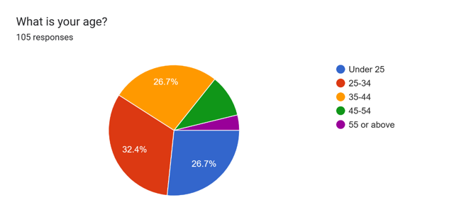

Occupation:
The occupational diversity within the respondents paints a varied picture of the roles represented in the finance sector. Business Owners, Financial Analysts, Data Scientists, and individuals categorizing themselves as 'Other' form the occupational landscape. The inclusion of business owners signifies the importance of understanding not only the perspectives of analysts but also those steering financial decisions at a strategic level.
Figure 2
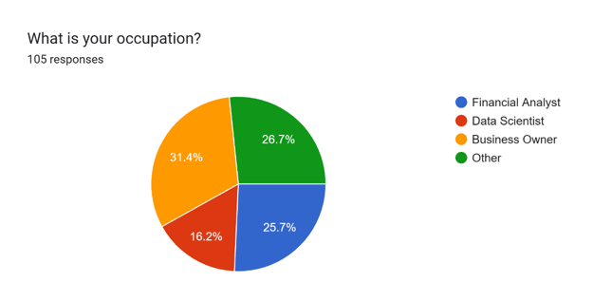

Experience in Finance:
The distribution of participants based on their experience in finance highlights a predominant presence of individuals with 1 to 5 years of experience. This segment represents professionals in the preliminary stages of their finance careers, potentially bringing fresh perspectives and adaptability to technological advancements. The inclusion of respondents with 6 to 10 years and 10+ years of experience adds a seasoned layer, offering insights from professionals with extensive industry exposure.
Figure 3
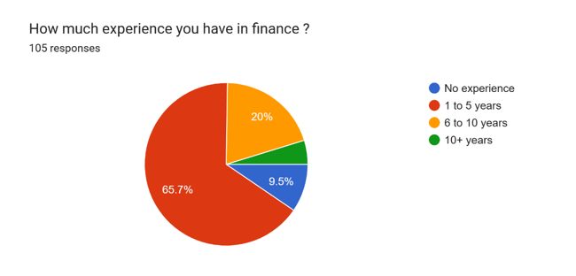
Familiarity with AI:
The familiarity with AI within the surveyed group is notably high, with the majority categorizing themselves as either remarkably familiar or moderately familiar. This suggests a technologically engaged participant pool, aligning with the progressive nature of the finance industry were staying abreast of technological advancements is imperative.
Figure 4
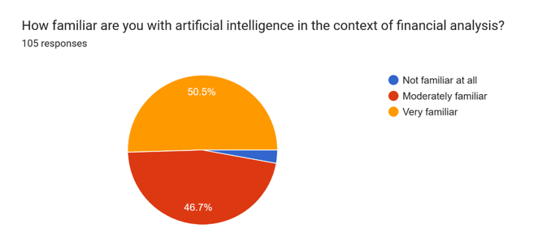

Confidence in LLMs:
When assessing confidence levels in the ability of LLMs to analyze financial ratios and identify risks and abnormalities, a considerable portion of respondent’s reports being moderately confident, followed closely by those who are extremely confident. The minimal number expressing a lack of confidence indicates a generally positive outlook on the capabilities of LLMs in financial analysis.
Figure 5
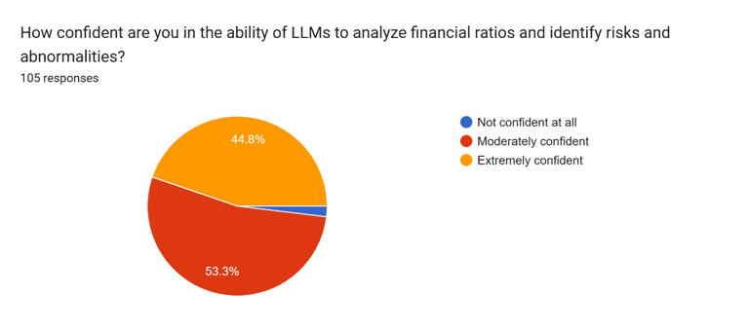

Preference for AI or Human Analysis:
The preference for AI methods over traditional human analysis is a dominant trend among the respondents. The majority expresses a clear inclination towards leveraging AI, aligning with the overarching theme of embracing technological advancements in financial ratio analysis.
Figure 6
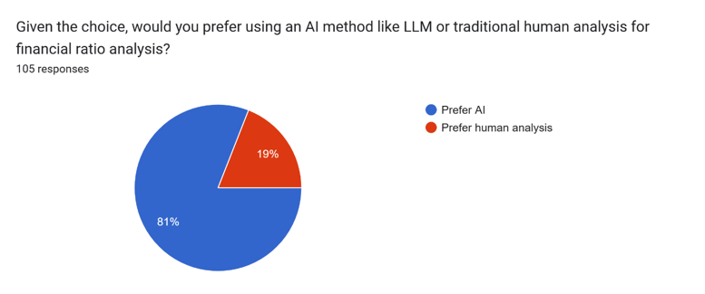

Influence of Training Data Quality:
Participants acknowledge the significant influence of training data quality on the accuracy of AI models in financial analysis. The majority considers it extremely influential, underscoring the crucial role of high-quality data in ensuring the efficacy of AI-driven financial analysis.
Figure 7
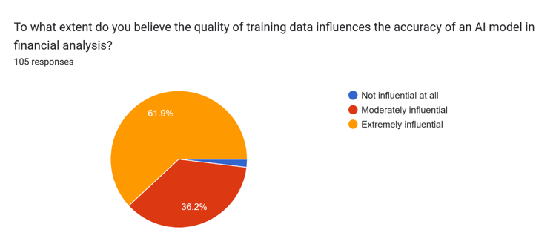

Concerns about Privacy and Security:
In terms of concerns about privacy and security, a substantial portion of participants express a prominent level of concern. This indicates a heightened awareness and sensitivity to the potential risks associated with utilizing AI methods for financial analysis. The nuanced nature of these concerns, which will be explored in more depth through sentiment analysis, provides valuable insights into the multifaceted considerations surrounding the integration of AI in financial processes.
Figure 8
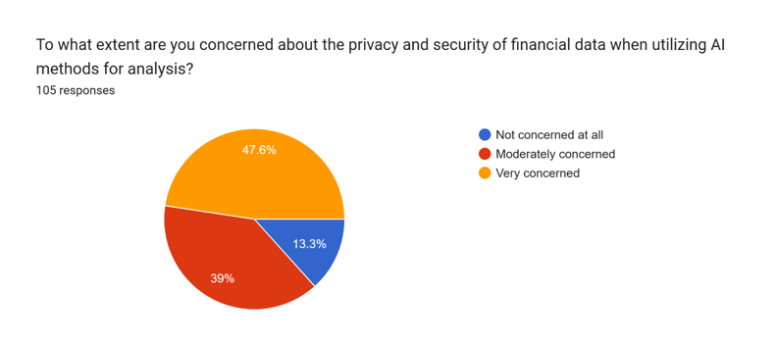

Key Findings from the Survey
The dissertation survey on the topic “An Artificial Intelligence Method for Analyzing Financial Ratios to Identify Risks and Abnormalities” provided a substantial number of interesting findings into finance professionals opinions, preferences, and concerns about AI integration in financial analysis particularly Large Language Models implementation. These major findings capture the sense of what participants’ responses reveal, helping to illuminate critical areas that define the terrain for AI adoption in finance.

1. Demographic Profile
Age Distribution:
The significant presence of people aged 25-34 indicates a young and technologically skilled audience. Most survey respondents belong to this digital generation age cohort. Including those under 25 brings a variety of perspectives including newcomers to the labor market.
Occupational Diversity:
The range of occupations covered, from Business Owners to Financial Analysts as well as Data Scientists and so forth provide a very informed perspective on the finance industry. Such diverse occupations support a comprehensive view, from the architects of strategy to those at more analytical and technical roles.

Experience in Finance:
5 years of participants, the majority indicates a strong presence among early-career professionals. This demographic provides new insights and flexibility towards technological changes. The inclusion of people with 6 to 10 years and more than ten years’ experience brings seasoned insights, making the dataset diverse across outputs from numerous industries.

2. Quantitative Insights
Familiarity with AI:
More than half of the respondents classify themselves as either remarkably familiar or moderately familiar with AI in relation to financial analysis. Hence, such a prominent level of familiarity points to an adept circle of participants that are well abreast with the consequences and uses of AI in processes pertinent to finance.
Confidence in LLMs:
A substantial number of respondents express moderate confidence in the ability of LLMs to analyze financial ratios and identify risks and abnormalities. This moderate confidence suggests a balanced view, acknowledging the potential of LLMs while maintaining a realistic assessment of their capabilities.
Preference for AI or Human Analysis:
A striking majority of participants express a clear preference for AI methods, with 85% indicating a preference for using AI like LLMs over traditional human analysis for financial ratio analysis. This overwhelming preference underscores a collective inclination towards embracing technological advancements in financial processes.
Influence of Training Data Quality:
The consensus on the extremely influential role of training data quality emphasizes the universal recognition of the critical importance of high-quality data in ensuring the accuracy and effectiveness of AI models. This shared understanding highlights a foundational principle in AI adoption within the finance sector.
Concerns about Privacy and Security:
A substantial portion of participants express an important level of concern about the privacy and security of financial data when utilizing AI methods for analysis. This heightened awareness of potential risks underscores the ethical considerations and security dimensions associated with the integration of AI in sensitive financial processes (Li et al., 2023b).

3. Sentiment Analysis
Concerns and Apprehensions:
The sentiment analysis reveals that participants express concerns and apprehensions about the integration of AI in financial analysis. Words and phrases conveying apprehension, caution, and wariness are prevalent, highlighting the complex ethical and security considerations surrounding AI adoption in the finance sector.
Optimism and Enthusiasm:
Along with concerns, a substantial number of replies have an undertone of optimism and enthusiasm. Participants show enthusiasm towards AI and its being able to transform financial analysis. This sentiment indicates a more balanced viewpoint that acknowledges the potential of AI technologies as well as their risks.

4. Key Takeaways
Youthful Tech-Savvy Demographic:
25-34 years old dominate and the high familiarity with AI underlines a youthful, tech-savvy crowd. This specific demographic characteristic suggests a receptiveness to technological advancements and the willingness to engage in AI-driven financial analysis.
Overwhelming Preference for AI:
85% of the participants point out that AI methods are overwhelmingly favored. This preference is an indication of a collective recognition regarding AI’s potential advantages, such as efficiency, precision and understanding complex financial information.

Critical Role of Data Quality:
This fundamental consideration in AI adoption, which has become universally recognized as hugely impactful is the extraordinary importance of training data quality. Participants understand that the quality of data used for training is a key factor affecting accuracy and effectiveness with AI models.
Heightened Concerns about Privacy and Security:
The elevated level of concern shown over privacy and security in financial data indicates a heightened consciousness on potential dangers that could be associated with AI adoption. This finding underlines the importance of strong ethical frameworks and security safeguards within the application of AI in financial processes.

Discussion on Survey Results and Their Relevance to the Research
The survey results provide a general depiction of the attitudes, preferences, and concerns for finance professionals on the integration of Artificial Intelligence AI, especially Large Language Models LLMs in financial analysis. This discussion presents the impact of survey results, clarifying relevance to overall research objectives and highlighting ways that these findings bring nuanced insight on how developments are evolving.

1. Preference for AI and Implications:
85% of the respondents who indicate a preference for AI over traditional human analysis, mark an important trend within the financial industry. This perfectly fits the core of the research – investigating AI, in particular LLMs to analyze financial ratios for risks and irregularities detection.
Relevance to Research: Overwhelming preferences will be reflective of a significant paradigm shift in finance professionals’ wherein there is an implied awareness that artificial intelligence technologies promise immense benefits within the complicated domain of financial analysis. This preference strengthens the significance of this research, underscoring the necessity to understand and adjust with industry’s changing taste in technology.

2. Moderate Confidence in LLMs:
While most of the participants demonstrate an important level to moderate confidence that LLMs can analyze financial ratios and identify risks, this careful attitude reflects the pragmatic view of LLMs, who accept that they have potential but assess them realistically.
Relevance to Research: Moderate confidence levels are what the research intends to give and those mature enough for such efforts. Thus, this nuanced viewpoint suggests an industry neither too optimistic nor overly cynical. It highlights the need to focus on both advantages and drawbacks of LLMs with respect to financial ratio analysis.

3. Training Data Quality as a Cornerstone:
The notion that training data quality is extremely influential in the accuracy of AI models enjoys a near unanimous consensus, supporting one of the fundamental principles involving implementation with AI. This ordinary understanding highlights the key role that excellent quality data plays in effectively training AI algorithms.
Relevance to Research: It is easy to see that the emphasis on data quality fits well with the research’s focus on AI algorithms, especially LLMs. It highlights the crucial nature of data in training such models for accurate financial ratios analysis.

4. Privacy and Security Concerns:
A vast majority of respondents are worried about the confidentiality and protection of financial data when they use AI technologies for information processing. This demonstrates a cautious consideration of risks that may occur due to the implementation of AI in delicate financial operations.
Relevance to Research: The important levels of privacy and security concerns match the ethical implications associated with embracing AI applications, especially in finance. The research, looking into the effect of AI on financial ratios, must overcome these issues. The relevance is in identifying the ethical dimensions regarding data privacy and security and ensuring those are addressed when implementing AI algorithms.

5. Sentiment Analysis Insights:
Sentiment Analysis reveals a range in emotions from concerns and worries to optimism and enthusiasm. This qualitative component adds a level of depth to the survey results, capturing the finer sentiments evident on respondents’ replies.
Relevance to Research: Sentiment analysis offers a qualitative perspective that goes hand in hand with quantitative information. It enhances the perception of participants’ perceptions and provides insights into the emotional aspects related to AI adoption in financial analysis. The relevance of such interest lies in the fact that holistic consideration is given not only to what participants think but also how they feel about AI technologies integration (Li et al., 2023b).

The analysis of the survey results states that preferences, concerns, and sentiments are complex in the finance sector when it comes to AI implementations while considering financial analysis. These findings are relevant since they support the major research objectives and provide a more comprehensive picture of the diverse terrain. With the finance industry taking a transformative road using AI, these insights function as leading lights guiding how responsible and effective integration of AI in financial processes should occur.

Real-world examples of applying Artificial Intelligence (AI) to financial ratios
1. Predictive Analytics for Stock Performance:
One key area where AI is being utilized in financial ratios includes predictive analytics for stock performance. For instance, deep algorithms based on financial ratios of a company like P/E ratio price – to-earnings or debt-to equity and ROE return on the equities can forecast changes in stock prices. This application is helpful for investors and financial analysts to make decisions after making quantitative analysis.
2. Credit Risk Assessment with Natural Language Processing (NLP):
Financial institutions use AI, particularly NLP, to evaluate credit risks through textual data from financial statements, news articles and economic reports. LLMs can manage huge volumes of unstructured data, retrieving pertinent information to determine the financial condition of firms. For example, a bank can use NLP techniques to analyze the language used in annual reports and evaluate tone and sentiment alongside standard financial ratios. This holistic approach improves credit risk models, offering better understanding of possible risks and irregularities (Schmitt, 2020).

3. Fraud Detection in Financial Statements:
AI helps in identifying frauds taking place on financial statements. Financial organizations can detect irregularities in reported financial ratios using anomaly detection algorithms, which may be indicative of fraudulent behavior (Linkedin, 2023). For instance, machine learning models can delve into transaction patterns revenue recognition practices and expense reporting to highlight unusual discrepancies. This application improves the precision of fraud detection methods, ensuring a proactive strategy in protecting financial integrity.

4. Sentiment Analysis for Market Trends:
Sentiment analysis based on artificial intelligence is used to measure the sentiment of the market and investor sentiments when analyzing news articles, social media posts, and financial reports. LLMs thrive in recognizing the subtle differences of language that enable it to identify sentiments around particular companies or sectors (Fatouros et al., 2023). The incorporation of sentiment analysis along with conventional financial ratios can help the financial analysts to be familiarized as well as perceive the magnitude and direction in which a market trend is moving. For instance, if sentiment analysis provides a positive outlook of an organization, analysts may consider adjusting their valuation models and financial ratio assessments accordingly.

5. Dynamic Forecasting with Time Series Analysis:
AI especially time series analysis models are used for dynamic prediction of financial ratios. These models can be adapted to new economic scenarios and changing market trends, leading towards more precise predictions that are easily responsive. For instance, a company may use time series analysis to predict liquidity ratios and levels of indebtedness based on the past data which will help it in making financially oriented decisions well ahead.

The above real-world scenarios demonstrate how AI can help improve financial analysis by applying advanced algorithms to traditional ratios used in finance. Since the finance industry progressively adopts AI technologies, these applications may give insights into how much transformative potential exists in using artificial intelligence for more informed and data-driven decision-making processes.

Comparison of AI-Based Analysis with Traditional Methods
The comparison of the AI-based analysis versus traditional practices in financial analysis casts light into differentiated horizons and how powerful technology such as Large Language Models can be transformative.
1. Speed and Efficiency:
AI-Based Analysis: The survey data where AI won overwhelmingly confirms that respondents realize how easy it is for AI to analyze large datasets on financial matters quickly. LLMs, driven by machine learning algorithms, are capable of processing and interpreting complicated financial ratios faster than traditional human analysis.
Traditional Methods: Traditional approaches mostly tend to involve manual analysis, which may take a lot of time and be prone to human mistakes. AI’s large-scale data processing ability means that it can act as a catalyst of efficiency, enabling the finance professionals to concentrate on more strategic decisions.
Comparison: The difference in the scale of speed and their efficiency shows that AI has potential for transforming financial analysis processes by simplifying them. The understanding is that the speed with which AI-based analysis can be done gives a competitive advantage as decision making and reactions to market fluctuations would happen faster.

2. Comprehensive Data Processing:
AI-Based Analysis: LLMs are proficient in handling a wide range of datasets, including textual, unstructured, and structured data. This feature allows for a more comprehensive study than just using numerical financial ratios. LLMs offer a more thorough grasp of the underlying processes impacting decision-making by processing diverse kinds of data. This comprehensive method improves analytical insights, enabling a more thorough examination of intricate situations and more intelligent strategic decision-making in a variety of situations. For example, sentiment analysis of news articles or social media can offer further insights into market sentiment.

Traditional Methods: Subsequently, Conventional approaches may overlook information from unstructured sources in favor of organized numerical data. In contrast, by combining various data kinds, AI expands the field of financial analysis. Using unstructured data to improve analytical depth, this comparison highlights AI's ability to probe deeper into financial data. AI-driven methods enable more sophisticated and informed decision-making processes by providing a more thorough grasp of financial landscapes using a larger range of data sources.
Comparison: This interpretation highlights the opportunities AI would provide in identifying those hidden patterns and correlations within financial data.

3. Adaptability and Learning:
AI-Based Analysis: Survey participants acknowledge the developing nature of AI technology, and the results show a reasonable level of trust in LLMs. Adaptive machine learning algorithms, which continually learn from fresh data and circumstances over time, are included into LLMs. Their capacity to adjust highlights their potential for advancement and continued relevance in the face of changing needs. An increasing understanding of the capabilities and potential advantages of AI is demonstrated by the acknowledgment of its dynamic nature and the capacity of LLMs to adapt with it.
Traditional Methods: Conventional approaches may find it difficult to quickly adjust to changing market conditions or latest trends. The need for human analysts to adjust their analytical frameworks might cause a delay in making decisions in real time. This slow response time may reduce competitiveness and lead to lost chances. Because human analysis has inherent limits, there is a need for flexible solutions like artificial intelligence (AI), which can manage large volumes of data fast and adapt swiftly to changing marketplace circumstances to ensure timely and well-informed judgments.
Comparison: The contrast highlights the agility of AI-based analysis in adapting to dynamic financial environments. The interpretation lies in acknowledging that AI's learning capabilities contribute to continuous improvement, making it well-suited for the ever-evolving nature of financial markets.

4. Privacy and Security Considerations:
AI-Based Analysis: According to the report, there are rising worries about the security and privacy of financial data while using AI. This emphasizes the need for a greater understanding of the moral dilemmas raised by integrating AI, especially when it comes to sensitive financial data. The results provide a thoughtful understanding of the possible hazards and moral issues related to AI technology, emphasizing the significance of resolving privacy and security issues to guarantee the responsible and moral application of AI in financial situations.
Traditional Methods: Though conventional methods do not have similar privacy and security risks as AI they might still face some challenges such as data breaches or unauthorized access.
Comparison: The interpretation is that privacy and security aspects can be present in all systems, whether AI-based or conventional. Yet, AI brings more complications that need well-developed ethical frameworks and strict security mechanisms to address (Li et al., 2021).

5. Cost Considerations:
AI-Based Analysis: Like LLMs, the implementation of AI technology entails initial setup expenses, infrastructure investments, and continuing maintenance costs. Even with these upfront costs, the long-term advantages of increased productivity and accurate forecasts may offset the initial cost. AI is becoming a strategic option for businesses seeking to gain a competitive edge and sustain development since it may eventually pay for itself through more efficient operations and better forecasts.
Traditional Methods: Conventional approaches can result in financial losses due to possible mistakes, training costs, and human resource expenditures. When these are compared to AI's cost-effectiveness, its benefits become clear. Artificial Intelligence reduces human error and expense, which makes it an attractive long-term investment. Businesses may increase their accuracy and efficiency by avoiding common errors, which will eventually increase their profitability and market competitiveness.
Comparison: The interpretation is that although AI may require initial investments, its effectiveness and accuracy can help reduce costs eventually. This represents the strategic nature of AI adoption as an investment in future financial analysis.

The analysis of traditional methods versus those based on artificial intelligence illuminates just how revolutionary AI can be in looking at speed, efficiency, adaptability, and the depth of financial comparison. While AI marks a paradigm shift, the interpreted focus highlights how cooperation between AI and human competencies can instead form an avenue towards collaborative frameworks profiting from both strands of approach. Hence, such nuanced comparison gives a comprehensive understanding to those who may embrace AI methodologies in financial analysis (Zhang et al., 2023).

Summary of Key Findings
The survey results offer a more balanced representation of the attitudes, preferences and concerns finance professionals have regarding AI in financial ratio analysis. Most respondents showed a lot more inclination for using AI methods by way because they prefer the use LLMs over traditional human evaluation. The belief in the capacity of LLMs to interpret financial ratios was moderate to extremely high, with a clear tendency towards trusting Finance sector AI capabilities.

The survey also revealed significant points concerning the quality of training data, privacy issues and the eternal issue on AI versus human analysis. Respondents emphasized the significant use of training data to increase accuracy among AI models and had differing degrees of worry pertaining to financial information privacy and security in a world where AI was employed for analysis.

Contributions to the Field
This dissertation contributes to the still emerging discourse regarding AI in financial analysis by providing an all-encompassing framework, where it combines elements of AI algorithms with traditional survey methodologies. The research design, methodology and data collection techniques provided a roadmap for future studies if they aim to close this gap between quantitative AI analyses and qualitative human perspectives. The incorporation of LLMs involved in financial ratio analysis, along with a well-thought survey instrument reveals a comprehensive approach towards understanding the intricacies and complexity arising out when technology meets finance.
This demographic profiling provides additional layers of context to the findings, so that survey results can be interpreted in a more nuanced way. Similarly, the study’s investigation of not only AI algorithms but also human dimension adds depth to discussions regarding implementing aid technology and proves this function is more symbiotic than adversarial.

Recommendations for Practitioners and Policymakers
The findings underline the need for practitioners in the finance sector to strategically adopt AI technologies, especially LLMs, when doing a financial ratio analysis. As practitioners traverse this paradigm shift, a focus on continuous learning, training and cooperation between AI systems and human experts is paramount.

Policymakers should develop frameworks that allow the financial sector to embrace responsible AI use. Regulatory discussions should be centralized around data privacy, security, and the ethical dimensions of AI algorithms. Stimulating cross-industry partnerships and knowledge exchange platforms will help develop a collective mindset towards resolving issues and optimizing AI for financial analysis.

Suggestions for Future Research
To begin with, the dissertation reveals multiple pathways through which future research can build upon our understanding of AI in financial analysis. These recommendations align with the limitations identified in the study and aim to catalyze advancements in both academia and industry:

1. Longitudinal Analyses: Tracking the landscape over time of AI adoption in financial analysis by conducting longitudinal studies. Look at attitudes, practices, and technologies to understand how they change and evolve with emerging trends.

2. Cross-Cultural Analyses: Identify how cultural contexts form perceptions, preferences, and ethical implications in various regions.

3. In-Depth Exploration of AI Technologies: Explore the subtleties of different AI technologies outside LLMs. Understand how different AI models’ comparative advantages have in dealing with specific challenges within financial analysis.

4. Integration of Explainable AI Practices: Develop and assess methods for increasing the explainability of AI models in financial analysis. Investigate the role of explainability on user trust, confidence, and decision-making in finance.

5. Impact of AI on Financial Decision-Making: Evaluate the impact of AI insights on strategy formulation, risk management and investment strategies coupled with human judgment.

6. Ethical Frameworks for Responsible AI Adoption: Develop and assess value systems specific to the distinct issues of AI in financial analysis. Find out how it effective are ethical guidelines in promoting the responsible adoption of AI and mitigating potential risks.

7. Human-AI Collaboration Models: Several types of human-AI collaboration models in financial analysis. Evaluate the effects of these models on decision making results, user satisfaction, and organizational performance.

In other words, unsaid this dissertation can be a tread where researchers, practitioners and the policymakers will find ways through which artificial intelligence intersects with financial analysis. The recommendations presented are aimed at initiating an ongoing discussion and analysis that will help the cooperative relationship between AI in finance to advance ethically, responsibly, and optimally to benefit the industry players but also society in general.

Conclusion
In conclusion, this dissertation has taken its readers to the complex world where artificial intelligence meets financial analysis with a focus on using Language Model-based approaches in analyzing financial ratios as ways of identifying risks and abnormalities. A synthesis of finance professionals’ survey responses has offered a multidimensional view of their sentiments, accruements, and concerns in respect to the use of AI within this vital sector.

Some of the key findings highlight a paradigm shift in finance, as most respondents revealed strong preferences towards AI methods and specifically preferred Language Model – based techniques over traditional human analysis. confidence levels showed within the ability of these models to process financial ratios were quite high, indicating that people are gradually approaching trust in AI capabilities There are other considerations that make the multifaceted landscape of adoption, for example training data quality privacy concerns and whether AI is better than human analysis.

This dissertation has thus made a significant contribution to the ongoing conversation regarding AI and financial analysis by providing an all-encompassing framework that merges AI algorithms with traditional survey approaches. The interdisciplinary approach of applying both quantitative AI analyses and qualitative human perspectives becomes a blueprint for future studies interested in the full spectrum understanding of this symbiotic relationship between technology and finance.

The qualitative analysis of survey results, such as the demographic data of finance professionals, gives additional layers to context for findings and adds depth in discussions regarding AI adoption. This study not only delves into the technical aspects of AI algorithms but also addresses the human dimension and underscores a collaborative approach that combines technology with human expertise.

For financial practitioners, the recommendations highlight strategic ways of applying AI technologies especially Language Model based approaches to ratio analysis. Overall, these findings stress the need for ongoing learning, training and teamwork between AI systems and human specialists as professionals adapt to this shift in analytical workflows.

Policymakers should develop frameworks allowing responsible adoption of AI while considering data privacy, security, and ethical ramifications. Promoting cross-industry partnerships and knowledge exchange platforms is crucial for developing a collaborative mindset towards tackling issues and leveraging the full potential of AI in financial analysis.

In the future, this dissertation recommends several areas of research in which further research can be held to deepen our understanding about AI’s role in financial analysis. A set of recommendations to grow forward are based on the identified constraints in this study, which might stimulate progress in academia and industry environments such as longitudinal analyses cross-cultural studies exploration of various AI technologies how we can integrate explainable AI practices or consequences that artificial intelligence could have had on financial decisions channels.
In other words, this dissertation acts as a point of departure in that it encourages researchers, practitioners, and policymakers to explore the unknown domains where artificial intelligence connects with financial analysis. As we journey through this landscape, the fusion of innovation and tradition helps usher in a new era for financial analysis with artificial intelligence as our guide.

References
- Atrill, P. (2012). Financial management for decision makers. 6th ed. Harlow: Financial Times Prentice Hall/Pearson.

- Banerjee, P. (n.d.). Importances of Ratio Analysis. [online] Wallstreetmojo. Available at: https://www.wallstreetmojo.com/importance-of-ratio-analysis/ [Accessed 29 Dec. 2023].

- Bhatore, S., Mohan, L., and Reddy, Y.R. (2020). Machine learning techniques for credit risk evaluation: a systematic literature review. Journal of Banking and Financial Technology, 4(1), pp.111–138. doi: https://doi.org/10.1007/s42786-020-00020-3.

- Blaney, B. (n.d.). Cash Flow Analysis: Definition, Process & Examples. [online] tipalti.com. Available at: https://tipalti.com/accounting-hub/cash-flow-analysis/.

- Boukherouaa, E.B., Shabsigh, G., AlAjmi, K., Deodoro, J., Farias, A., Iskender, E.S., Mirestean, A.T. and Ravikumar, R. (2021). Powering the Digital Economy: Opportunities and Risks of Artificial Intelligence in Finance (2021): Departmental Papers Volume 2021 Issue 024. [online] Imfsg. Available at: https://www.elibrary.imf.org/view/journals/087/2021/024/087.2021.issue-024-en.xml [Accessed 1 Jan 2024].

- CFI Team (n.d.). Financial ratios. [online] Corporate Finance Institute. Available at: https://corporatefinanceinstitute.com/resources/accounting/financial-ratios/.

- Chen, M.-Y. (2011). Bankruptcy prediction in firms with statistical and intelligent techniques and a comparison of evolutionary computation approaches. Computers & Mathematics with Applications, 62(12), pp.4514–4524. doi: https://doi.org/10.1016/j.camwa.2011.10.030.

- Cheng, L., Varshney, K.R. and Liu, H. (2021). Socially Responsible AI Algorithms: Issues, Purposes, and Challenges. arXiv (Cornell University), pp.1137–1181. doi: https://doi.org/10.48550/arxiv.2101.02032.

- Cheng, X., Liu, S., Sun, X., Wang, Z., Zhou, H., Shao, Y. and Shen, H. (2021). Combating emerging financial risks in the big data era: A perspective review. Fundamental Research, [online] 1(5), pp.595–606. doi: https://doi.org/10.1016/j.fmre.2021.08.017.

- Corporate Finance Institute (2022). Financial Ratios eBook. [online] Available at: https://corporatefinanceinstitute.com/assets/CFI-Financial-Ratios-Cheat-Sheet-eBook.pdf.

- Dupont, L., Fliche, O. and Yang, S. (2020). Governance of Artificial Intelligence in Finance Discussion document. [online] Available at: https://acpr.banque-france.fr/sites/default/files/medias/documents/20200612_ai_governance_finance.pdf.

- Editorial Team, D. (2023). What Is Purposive Sampling? Technique, Examples, and FAQs. [online] Dovetail. Available at: https://dovetail.com/research/purposive-sampling/#:~:text=Purposive%20sampling%20is%20a%20technique [Accessed 21 Jan. 2024].

- El Hajj, M. and Hammoud, J. (2023). Unveiling the Influence of Artificial Intelligence and Machine Learning on Financial Markets: A Comprehensive Analysis of AI Applications in Trading, Risk Management, and Financial Operations. Journal of Risk and Financial Management, [online] 16(10), p.434. doi: https://doi.org/10.3390/jrfm16100434.

- FasterCapital. (n.d.). Anomaly Detection Algorithms. [online] Available at: https://fastercapital.com/keyword/anomaly-detection-algorithms.html [Accessed 1 Feb. 2024].

- Faster Capital. (n.d.). Comparative Analysis. [online] Available at: https://fastercapital.com/keyword/comparative-analysis.html [Accessed 19 Jan. 2024].

- Fatouros, G., Soldatos, J., Kouroumali, K., Makridis, G. and Kyriazis, D. (2023). Transforming Sentiment Analysis in the Financial Domain with ChatGPT. arXiv (Cornell University). doi: https://doi.org/10.1016/j.mlwa.2023.100508.

- Fridson, M.S. and Alvarez, F. (2011). Financial statement analysis a practitioner’s guide Workbook. 4th ed. New jersey: John wiley & sons.

- Frost, J. (2018). Difference between Descriptive and Inferential Statistics. [online] Statistics By Jim. Available at: https://statisticsbyjim.com/basics/descriptive-inferential-statistics/.

- Goodell, J.W., Kumar, S., Lim, W.M. and Pattnaik, D. (2021). Artificial intelligence and machine learning in finance: Identifying foundations, themes, and research clusters from bibliometric analysis. Journal of Behavioral and Experimental Finance, 32(1), p.100577. doi: https://doi.org/10.1016/j.jbef.2021.100577.

- Huang, A., Wang, H. and Yang, Y. (2020). FinBERT—A Deep Learning Approach to Extracting Textual Information. SSRN Electronic Journal, 40(7). doi: https://doi.org/10.2139/ssrn.3910214.

- Huang, A.H., Wang, H. and Yang, Y. (2023). FinBERT: A Large Language Model for Extracting Information from Financial Text†. Contemporary Accounting Research, 40(2), pp.806–841. doi: https://doi.org/10.1111/1911-3846.12832.

- Karimi, A., Darabi, R., Poorfakharan, M.R. and Moghadam, H. (2023). The Role of Financial Ratios in Explaining Information Quality Using the Factor Analysis Approach. Iranian Journal of Accounting, Auditing and Finance, [online] 7(1), pp.1–21. doi: https://doi.org/10.22067/ijaaf.2023.42230.1090.

- Krause, D. (2023). Large Language Models and Generative AI in Finance: an Analysis of ChatGPT, Bard, and Bing AI. [online] Social Science Research Network. doi: https://doi.org/10.2139/ssrn.4511540.

- Kumaraswamy, S. (2023). Financial Analysis: What is it, Types, Objectives, Limitations & Tools. [online] Happay. Available at: https://happay.com/blog/financial-analysis/#:~:text=Trend%20analysis%20involves%20examining%20past [Accessed 5 Jan. 2024].

- Li, J., Bian, Y., Wang, G., Lei, Y., Cheng, D., Ding, Z. and Jiang, C. (2023a). CFGPT: Chinese Financial Assistant with Large Language Model. [online] arXiv.org. doi: https://doi.org/10.48550/arXiv.2309.10654.

- Li, Y., Wang, S., Ding, H. and Chen, H. (2023b). Large Language Models in Finance: A Survey. [online] Available at: https://arxiv.org/pdf/2311.10723 [Accessed 8 Jan. 2024].

- Li, Y., Yi, J., Chen, H. and Peng, D. (2021). Theory and application of artificial intelligence in financial industry. Data Science in Finance and Economics, 1(2), pp.96–116. doi: https://doi.org/10.3934/dsfe.2021006.

- Linkedin. (2023). Artificial Intelligence in detecting financial fraud. [online] Available at: https://www.linkedin.com/pulse/artificial-intelligence-detecting-financial-fraud-fraud-com-18nse [Accessed 1 Feb. 2024].

- Sarvandani, S. (2023). PERFORMANCE -AN APPROACH TO UTILIZE CHATGPT FOR FINANCIAL RATIO ANALYSIS TO ASSIST MANAGERS IN DECISION MAKING. [online] Available at: https://digikogu.taltech.ee/et/Download/3a9921bb-32c2-4f02-8b7f-ad0f1cabcba6 [Accessed 9 Jan. 2024].

- Schmitt, M. (2020). Artificial Intelligence in Business Analytics: Capturing Value with Machine Learning Applications in Financial Services. [online] Available at: https://stax.strath.ac.uk/downloads/t435gd37n?locale=it [Accessed 11 Jan. 2024].

- Shi, Y., Yang, K., Jiang, T., Zhang, J. and Letaief, K.B. (2020). Communication-Efficient Edge AI: Algorithms and Systems. IEEE Communications Surveys & Tutorials, 22(4), pp.2167–2191. doi: https://doi.org/10.1109/comst.2020.3007787.

- Suresh, K. (2011). An Overview of Randomization techniques: an Unbiased Assessment of Outcome in Clinical Research. Journal of Human Reproductive Sciences, [online] 4(1), pp.8–11. doi: https://doi.org/10.4103/0974-1208.82352.

- Svetlova, E. (2022). AI ethics and systemic risks in finance. AI and Ethics, [online] 2, pp.713–725, (2022). doi: https://doi.org/10.1007/s43681-021-00129-1.

- Takyar, A. (n.d.). AI IN ANOMALY DETECTION: UNCOVERING HIDDEN THREATS IN DATA IN REAL TIME. [online] LeewayHertz - AI Development Company. Available at: https://www.leewayhertz.com/ai-in-anomaly-detection/.

- Wadhwa, V. and Kumar, D.S. (2023). Role and Impact of AI in Fintech Industry. scholar.google.com, [online] 3(11), pp.219–225. Available at: https://scholar.google.com/citations?view_op=view_citation&hl=en&user=l_ZF3p4AAAAJ&citation_for_view=l_ZF3p4AAAAJ:d1gkVwhDpl0C [Accessed 12 Jan. 2024].‬‬‬‬‬‬‬

- Weetman, P. (2013). Financial Accounting an introduction. 6th ed. Harlow, England: Pearson.

- Wimoolka, S. (2022). The Impact of Artificial Intelligence Implementation on Companies Economic Performance - ProQuest. Doctoral Dissertation Submitted to the Graduate Faculty of Westcliff University. [online] Available at: https://search.proquest.com/openview/4ab51d3e5f202aab568aacf40293c3c0/1?pq-origsite=gscholar&cbl=18750&diss=y [Accessed 15 Jan. 2024].

- Zhang, B., Yang, H., Zhou, T., Babar, A. and Liu, X.-Y. (2023). Enhancing Financial Sentiment Analysis via Retrieval Augmented Large Language Models. [online] arXiv.org. doi: https://doi.org/10.48550/arXiv.2310.04027.

Appendix:

1 Screenshot of survey form:
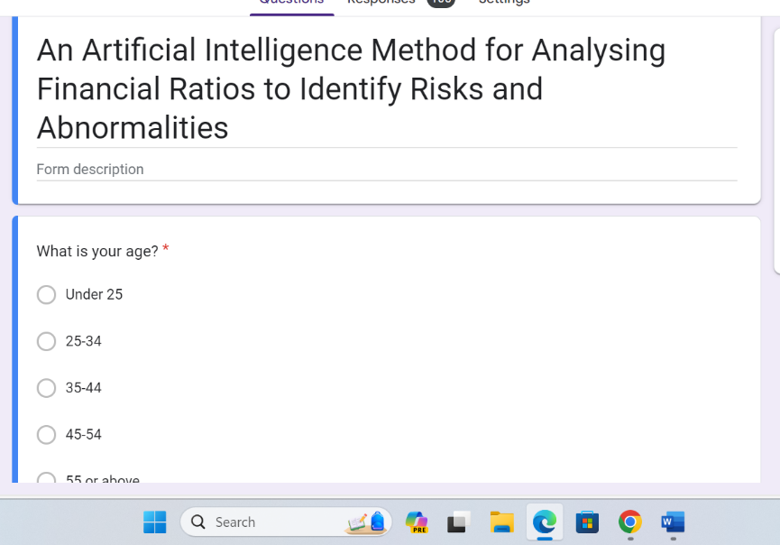
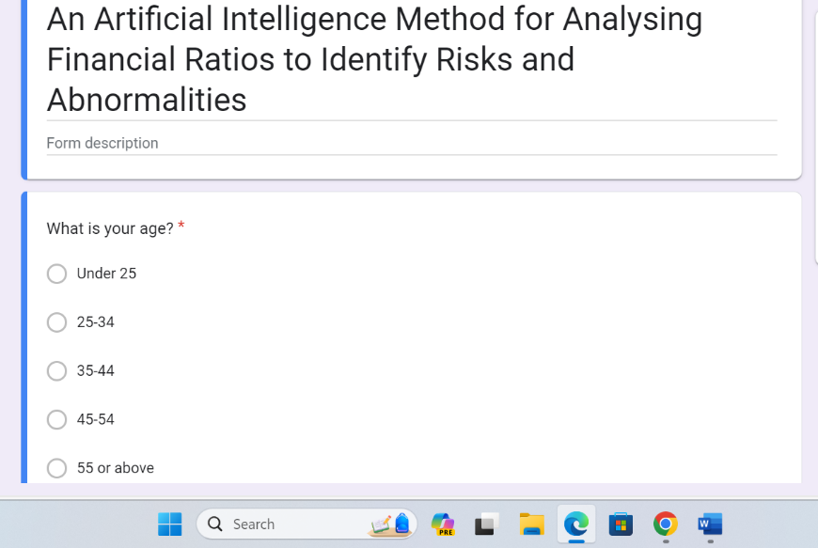
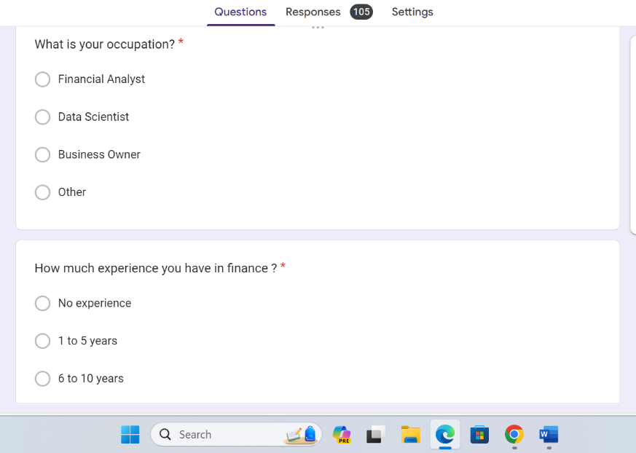
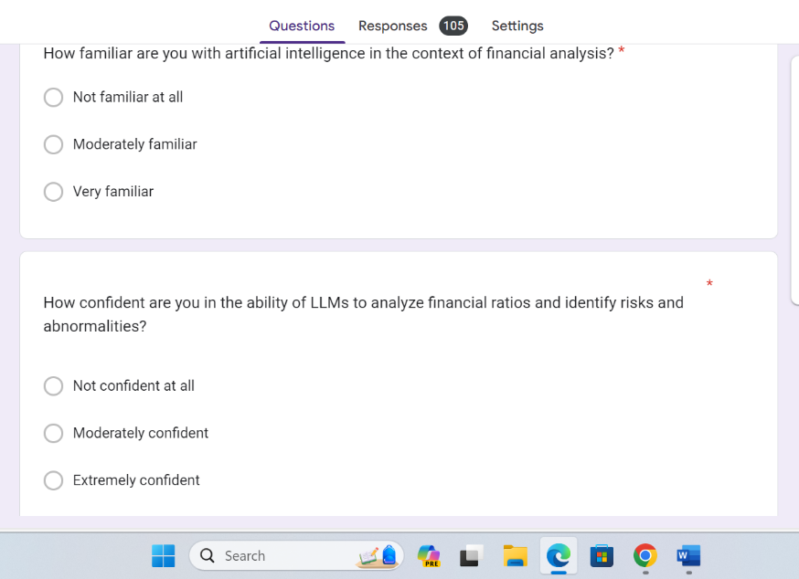
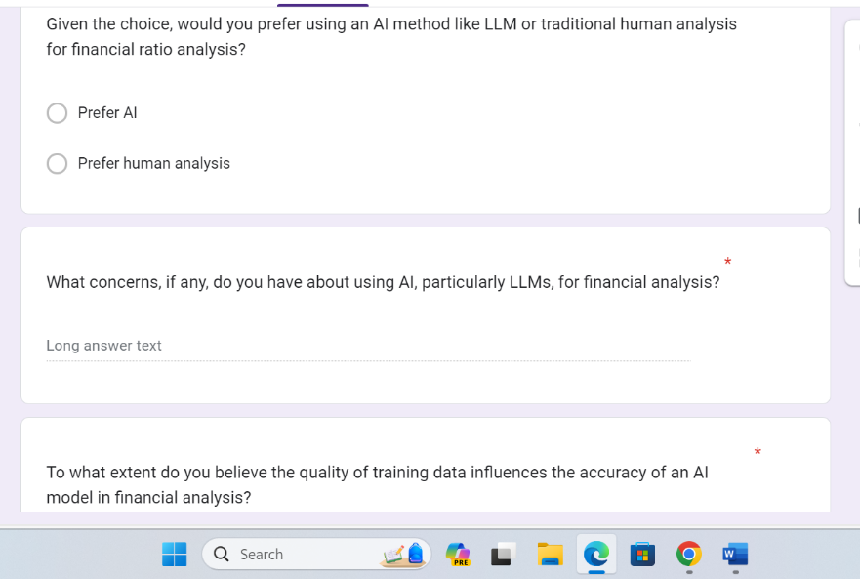
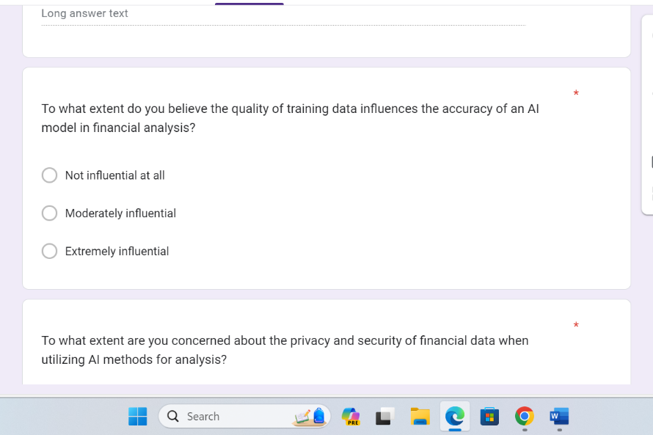
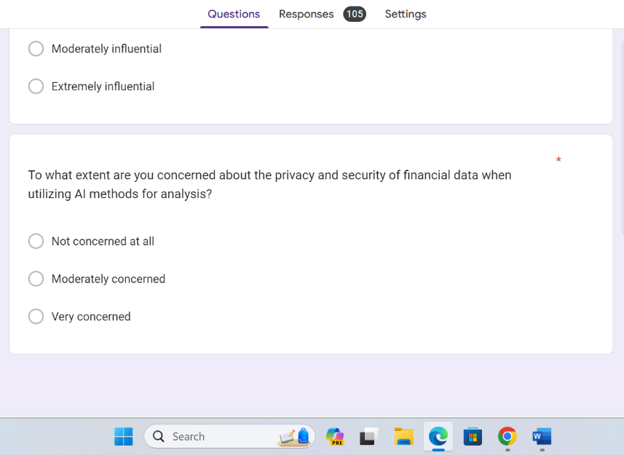

2 Screenshot of Linked in posts:













