
HOTEL STANDARDS, REPUTATION MANAGEMENT AND SERVICE CULTURE
MODULE CODE: BMIH4003

STUDENT NAME: ANAIDA ADAMACHE
STUDENT ID:2026381
LECTURER NAME: CHARLOTTE JOYNER

Executive Summary
The hotel industry relies on the services the hotels provide to enhance customer satisfaction. Customer satisfaction helps to build and retain the reputation of business. The report deals with the aspect of hotel standards in context to the brand of JW Marriott, and ways to maintain the consistency in those standards. The report additionally deals with ways in which the reputation of business can be improved and also helps to highlight the service culture and its importance in the hotel industry. The report also additionally recommends market trend improvements to enhance and improve the quality of business.

Table of Contents

Introduction 3
Main Findings 3
Basic Hotel Standards 3
Consistency Standards 3
Hotel standards differ according to the difference in locations 4
Reputation Management 5
Ways in which Reputation Management can be increased 5
Importance of effective guest review management 5
Impact of Negative reviews 6
Service Culture 7
Basis of Service Culture 7
Difference between service culture and corporate culture 7
Importance of service culture 7
Conclusion 7
Recommendations 8
References 9

Introduction
Hospitality industry is defined as an industry that caters to the needs of the people by welcoming them to the array of services that the industry offers. Hotels in the hospitality industry are referred to as the hub of providing services of lodging, food, drinks, and other specific or general requirements of the customers. The report aims to consider basic hotel standards in the hospitality industry and whether these standards are universal and consistent. The report is going to review the methods in which international hotels, such as Marriott International can review and improve their reputation. The report further is going to talk about the service culture and recommend methods to overcome the obstacles.

Main Findings

Basic Hotel Standards

Consistency Standards
Hotel standards generally refer to the operational and service quality of a hotel. The services provided by these hotels are considered as the yardstick of the quality they provide. Customer needs and requirements are generally considered a subject of priority in the industry in general. Customers receiving value and quality in service are generally the central theme of business (Hu et al., 2019). Customer value creates two kinds of perspectives, one that the customer derives from the quality of service and the other the hotel understands regarding customer needs and wants. Hotel standards rely on the commitment of guest health and safety in the ways they cater to their needs (Chan et al., 2021). A good hotel standard is defined as a parameter the hotel industry has created for their business growth through the quality and kind of services the hotel chains provides to their customers. For example, Marriott International administers 6000 hotels in 122 countries and the quality of business and service standard is always improving in nature showing the consistency (linkedin.com, 2023). Additionally, JW Marriott that operates under the global company of Marriott International attracts affluent customers around the globe in 122 locations around the planet (jw-marriott, 2023). Hotel standards help in the development of a business image and implementing new service standards required with the change in time and maintaining consistency of customer needs.
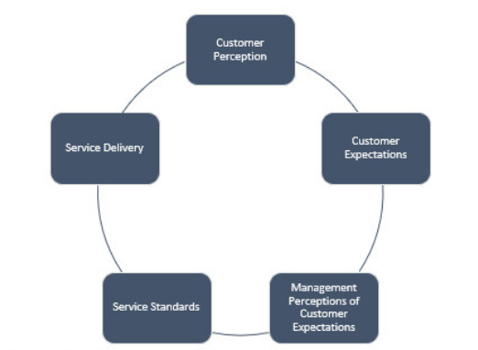
Figure 1: Services offered by Marriot
(Source: linkedin.com, 2023)

Hotel standards differ according to the difference in locations
The standard of the hotel equally depends on the change in managerial decisions and ways in which the hotel decides to meet the customer needs and preferences. The hotel standards also change from the type of visitors the hotel caters to and the place of operations of the hotel (Wang et al., 2020). Differences in the location create a difference in the kinds of services they provide. For example, JW Marriott as a brand has hotels in all locations of the world. The services of JW Marriott hotels will provide in the mountains will differ from the services a Marriott hotel located in the bay area will provide.

Figure 2: Services that are constant in different regions
(Source: Created by Author)
The differences in hotel services can range from basic services such as room heaters in the mountains to air conditioners in the mainland or in the bays. Therefore, hotel standards differ from one location to the other. However, the quality aspect of a service in a hotel has to meet the basic customer standards universally recognised (Ali et al., 2021). Meeting the basic standards help to reach the aspect of customer satisfaction in business. Customer satisfaction in business attained through providing services helps the business to reach consistency (Padma and Ahn, 2020). Guest satisfaction has aided in providing the hotels a customer loyalty and consistency of customers directly contributing to the economic growth of the hotel.

Reputation Management

Ways in which Reputation Management can be increased
Customer satisfaction in the hospitality industry provides the hotels a breathing ground in the competitive market. The growth of customer satisfaction in the hotel industry is portrayed in a direct way (Zhao et al., 2019). Customers rely on the service requests made by them to the hotel and their satisfaction is dependent on the ways those requests are met by the hotel. Hotel reputation can gain from creating happy customers not just by satisfying their needs, but providing them consistency in the services they provide (forbes.com, 2023). The challenge for reputation management for hotels depends on the improving areas of concern in the service provided and elevating customer experiences by elevating the quality of services. Reputation management also depends on the review’s guests provide the hotels with after a service request has been met with or after a stay session has ended. For example, Marriott Hotels has increased their reputation by building core teams that train their skilled staff with additional skills of communication (core.ac.uk, 2023). The added communication skills enhanced service providing skills therefore helping management efficiency to grow.

Importance of effective guest review management
Online portals help in accessing the hotel’s service status but also provide an important tool for the customers to provide the hotels their opinions on the services available. Online reviews posted by a guest helps to understand the standard of services the hotel provides thereby aiding the understanding of the reputation the hotel has earned (Luo et al., 2021). Online reviews are extremely pivotal in understanding the specific requirements the customers have and also helps in the assessment of changing market structure of the hotel industry. For example, online reviews helped in the understanding of perceived differences between a peer-to-peer accommodation and Airbnb (Zhang et al., 2020). Additionally, as an example, JW Marriott hotels take in reviews of guests as a standard of service improvement. The reviews help in identifying how the aforementioned accommodations differ and the kind of services relevant to each of these types of business.
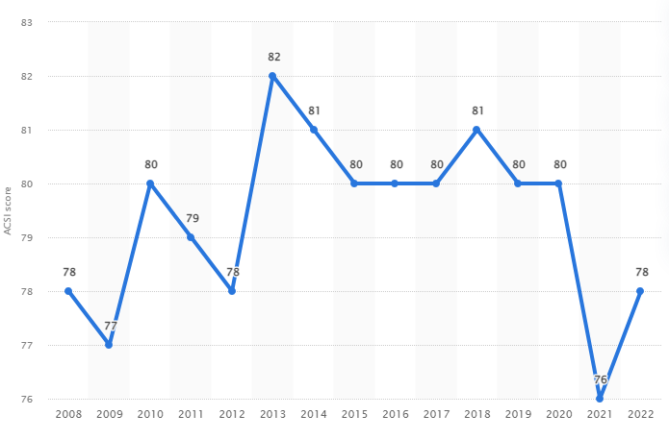
Figure 3: Rate of satisfied consumers in JW Marriott in USA
(Source: statista.com, 2023)

Impact of Negative reviews
Online reviews in a hotel industry serve as a pivotal instrument to provide an understanding of the service quality of the hotel. The negative effects have almost 22% of booking risks that decreases the customer preference in hospitality industry (customer-alliance.com, 2023). It also influences other customers reading the reviews to avoid availing services from the hotel thus creating a loss of business for the hotel. Negative reviews in a hotel industry impact the business reputation, goodwill and image of the hotel industry (Akhtar et al., 2019). In cases of negative reviews, it is imperative for the hotel managers to address the negative reviews to save the business and use the advantage to promote opportunities (El-Said, 2020). Catering to the negative reviews helps to perceive the Negative Review Valence or NPV in business and use it to provide growth in the failing sector of service.

Service Culture

Basis of Service Culture
Service culture in the hotel industry means the creation of an environment in which the staff of the hotel caters to the needs of the customers visiting the hotel. Service culture relies on the application of hospitality in meeting the requirements of the customers (Radojevic et al., 2019). Service culture also relies on a customer-oriented approach in the hotel industry where the customers are given priority to put demands on the hotel managers. For example, JW Marriott puts service and operational excellence above business objectives (marriott.com, 2023). The company puts the customers first, providing integrity and excellence in meeting their demands.

Difference between service culture and corporate culture
Organisational culture in a hotel industry is different from the standard corporate culture. Service culture and corporate culture differs in the ways policies, procedures and objectives are carried out. A corporate culture relies on the vision and mission of the organisation, whereas the service culture of an organisation relies on the facets of customer requests and priorities. Balancing human resources in service culture and corporate culture are important and the ways in which they are managed differ (Paais and Pattiruhu, 2020). For example, a corporate culture uses human resources to meet organisational objectives whereas in a service culture human resources are utilised to meet customer requests.

Importance of service culture
Service culture in the hotel industry is where the organisation or hotel uses its resources and objectives to place the customers first in the business. Service culture in the hospitality industry also helps to attain CSR by improving customer perceptions, service quality and excellence in customer management internationally (Latif et al., 2020). Customer service culture is given importance as it leads to the aspect of customer satisfaction and leads to reaching improvement in service.

Conclusion
The hotel industry runs on the fabric of improvement and setting customers as a priority and basis of such improvement. Customer satisfaction is a pivotal facet in the hotel industry and provides the grounds to assess hotel standards. The report discussed the features that help improve hotel standards and the ways customer satisfaction helps to manage hotel reputation. Customer reviews online helps to attain a responsible understanding of the reputation of the hotel and how a negative review impacts it. Through the report the importance of service culture can be additionally understood and the differences service culture has with corporate culture are also discussed. The report also addresses recommendations to improve business obstacles.

Recommendations
The biggest challenges of a hotel industry are the different areas of customer dissatisfaction and changing market trends. The recommendation therefore consists of ideas in which market trends can be met to satisfy existing customers and increase customer loyalty of the hotel. The recommendation regarding the market trend is to update the existing services the hotel already provides by introducing additional services through different service packages. Introducing service packages help to increase customer satisfaction and customer loyalty.

References
Akhtar, N., Sun, J., Akhtar, M.N. and Chen, J., (2019). How attitude ambivalence from conflicting online hotel reviews affects consumers’ behavioural responses: The moderating role of dialecticism☆. Journal of Hospitality and Tourism Management, 41, pp.28-40.
Ali, BJ, Gardi, B., Othman, BJ, Ahmed, SA, Ismael, NB, Hamza, PA, Aziz, HM, Sabir, BY, Anwar, G.(2021). Hotel Service Quality: The Impact of Service Quality on Customer Satisfaction in Hospitality. International Journal of Engineering, Business and Management, 5(3), pp.14-28.
Chan, J., Gao, Y.L. and McGinley, S., (2021). Updates in service standards in hotels: how COVID-19 changed operations. International Journal of Contemporary Hospitality Management, 33(5), pp.1668-1687.
core.ac.uk (2023), A Study of Cross Cultural Communication Strategy: Case of Marriott Hotels & Resorts Available at: https://core.ac.uk/download/pdf/234693179.pdf [Accessed on: 15 May 2023]
customer-alliance.com(2023), What is the cost of a negative review for your hotel? Available at: https://www.customer-alliance.com/en/resources/article/cost-of-negative-review-for-hotels/#:~:text=It%20is%20estimated%20that%20an,potential%20guests%20for%20a%20hotel. [Accessed on: 15 May, 2033]
El-Said, O.A., (2020). Impact of online reviews on hotel booking intention: The moderating role of brand image, star category, and price. Tourism Management Perspectives, 33, p.100604.
forbes.com (2023), Hospitality Brands Can Succeed With A Customer Experience Philosophy Available at: https://www.forbes.com/sites/forbesbusinesscouncil/2022/09/16/hospitality-brands-can-succeed-with-a-customer-experience-philosophy/ [Accessed on: 15 May 2023]
Hu, N., Zhang, T., Gao, B. and Bose, I., (2019). What do hotel customers complain about? Text analysis using structural topic model. Tourism Management, 72, pp.417-426.
Latif, K.F., Pérez, A. and Sahibzada, U.F., (2020). Corporate social responsibility (CSR) and customer loyalty in the hotel industry: A cross-country study. International Journal of Hospitality Management, 89, p.102565.
linkedin.com (2023), Quality in Hospitality - Marriott Hotels Case Study Available at: https://www.linkedin.com/pulse/quality-hospitality-marriott-hotels-case-study-tsvetan-bankov [Accessed on: 15 May 2023]
Luo, J., Huang, S. and Wang, R., (2021). A fine-grained sentiment analysis of online guest reviews of economy hotels in China. Journal of Hospitality Marketing & Management, 30(1), pp.71-95.
marriott.com (2023), Core Values & Heritage Available at: https://www.marriott.com/culture-and-values/core-values.mi [Accessed on: 15 May 2023]
Paais, M. and Pattiruhu, J.R., (2020). Effect of motivation, leadership, and organizational culture on satisfaction and employee performance. The Journal of Asian Finance, Economics and Business, 7(8), pp.577-588.
Padma, P. and Ahn, J., (2020). Guest satisfaction & dissatisfaction in luxury hotels: An application of big data. International Journal of Hospitality Management, 84, p.102318.
Radojevic, T., Stanisic, N. and Stanic, N., (2019). The culture of hospitality: From anecdote to evidence. Annals of Tourism Research, 79, p.102789.
statista.com (2023), Share of the total gross domestic product (GDP) generated by travel and tourism worldwide from 2000 to 2021 Available at: https://www.statista.com/statistics/1099933/travel-and-tourism-share-of-gdp/ [Accessed on: 15 May 2023]
statista.com (2023), Share of the total gross domestic product (GDP) generated by travel and tourism worldwide from 2000 to 2021 Available at: https://www.statista.com/statistics/1099933/travel-and-tourism-share-of-gdp/ [Accessed on: 15 May 2023]
Wang, L., Wang, X.K., Peng, J.J. and Wang, J.Q., (2020). The differences in hotel selection among various types of travellers: A comparative analysis with a useful bounded rationality behavioural decision support model. Tourism Management, 76, p.103961.
Zhang, G., Cui, R., Cheng, M., Zhang, Q. and Li, Z., (2020). A comparison of key attributes between peer-to-peer accommodations and hotels using online reviews. Current Issues in Tourism, 23(5), pp.530-537.
Zhao, Y., Xu, X. and Wang, M., (2019). Predicting overall customer satisfaction: Big data evidence from hotel online textual reviews. International Journal of Hospitality Management, 76, pp.111-121.

