
Student name: Narcisa Bernardo
Student number: 2332208
Module code: BMHP5014
Lecturer- Laila Surani

Changemakers: Creativity and Value Creation

Component 2: Written Assignment (Poster and Pitch)
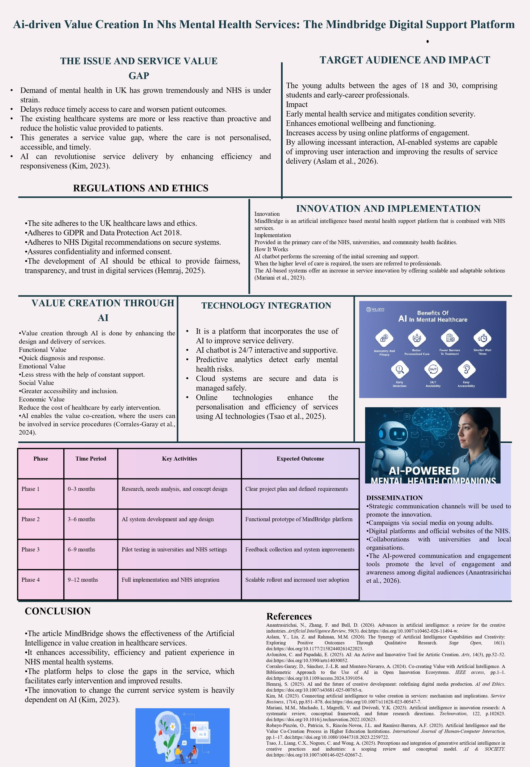
DRIVEN VALUE CREATION IN NHS MENTAL HEALTH SERVICES: THPART 1: POSTER

THE ISSUE AND SERVICE VALUE GAP

- Demand of mental health in UK has grown tremendously and NHS is under strain.
- Delays reduce timely access to care and worsen patient outcomes.
- The existing healthcare systems are more or less reactive than proactive and reduce the holistic value provided to patients.
- This generates a service value gap, where the care is not personalised, accessible, and timely.
- AI can revolutionise service delivery by enhancing efficiency and responsiveness (Kim, 2023).

TARGET AUDIENCE AND IMPACT

The young adults between the ages of 18 and 30, comprising students and early-career professionals.
Impact
- Early mental health service and mitigates condition severity.
- Enhances emotional wellbeing and functioning.
- Increases access by using online platforms of engagement.
- By allowing incessant interaction, AI-enabled systems are capable of improving user interaction and improving the results of service delivery (Aslam et al., 2026).

VALUE CREATION THROUGH AI
- Value creation through AI is done by enhancing the design and delivery of services.
Functional Value

- Quick diagnosis and response.
Emotional Value
- Less stress with the help of constant support.
Social Value
- Greater accessibility and inclusion.
economic Value
Reduce the cost of healthcare by early intervention.
- AI enables the value co-creation, where the users can be involved in service procedures (Corrales-Garay et al., 2024).

INNOVATION AND IMPLEMENTATION

Innovation
- Mind Bridge is an artificial intelligence based mental health support platform that is combined with NHS services.
Implementation
- Provided in the primary care of the NHS, universities, and community health facilities.
How It Works
- AI chatbot performs the screening of the initial screening and support.
When the higher level of care is required, the users are referred to professionals.
- The AI-based systems offer an increase in service innovation by offering scalable and adaptable solutions (Mariani et al., 2023).

TECHNOLOGY INTEGRATION
- It is a platform that incorporates the use of AI to improve service delivery.
- AI chatbot is 24/7 interactive and supportive.
- Predictive analytics detect early mental health risks.
- Cloud systems are secure and data is managed safely.
- Online technologies enhance the personalisation and efficiency of services using AI technologies (Tsao et al., 2025).
TIMELINE

Phase | Time Period | Key Activities | Expected Outcome
Phase 1 | 0–3 months | Research, needs analysis, and concept design | Clear project plan and defined requirements
Phase 2 | 3–6 months | AI system development and app design | Functional prototype of Mind Bridge platform
Phase 3 | 6–9 months | Pilot testing in universities and NHS settings | Feedback collection and system improvements
Phase 4 | 9–12 months | Full implementation and NHS integration | Scalable rollout and increased user adoption

REGULATIONS AND ETHICS
- The site adheres to the UK healthcare laws and ethics.
- BRIDGE DIG Adheres to GDPR and Data Protection Act 2018.
- Adheres to NHS Digital recommendations on secure systems.
- Assures confidentiality and informed consent.
- The development of AI should be ethical to provide fairness, transparency, and trust in digital services (Hemraj, 2025).

DISSEMINATION
- Strategic communication channels will be used to promote the innovation.
- Campaigns via social media on young adults.
- Digital platforms and official websites of the NHS.
- Collaborations with universities and local organisations.
- The AI-powered communication and engagement tools promote the level of engagement and awareness among digital audiences (Anantrasirichai et al., 2026).

CONCLUSION

- The article Mind Bridge shows the effectiveness of the Artificial Intelligence in value creation in healthcare services.
- It enhances accessibility, efficiency and patient experience in NHS mental health systems.
- The platform helps to close the gaps in the service, which facilitates early intervention and improved results.
- The innovation to change the current service system is heavily dependent on (Kim, 2023).

PART 2: PITCH

Introduction
- AI is changing service industries by making them more efficient, personalised, and accessible. The rising demand of mental health services in the health sector, especially in the United Kingdom has demonstrated that a major fault in the conventional model of service delivery. Both long waiting time, poor accessibility and a reactive care strategy lower the overall value of the care received by the patients.
- The value creation concept in services focuses on enhancing service delivery in terms of quality and results. Artificial intelligence is critical in this process as it can facilitate innovative and data-driven and user-centred solutions (Kim, 2023). This pitch suggests the mind Bridge platform, an AI-based mental health support system that can help improve value creation in the NHS services, by enhancing accessibility, efficiency, and patient experience.

Service and Problem Gap
- The mental health issue in the UK is a growing concern, especially among young adults. The NHS services are facing an incremental strain since the demand has been on the increase resulting in the long queue and reduced provision of timely care. This delay normally leads to the decline of the mental health, the emergence of the threat of crisis situations, and the decline of the quality of life in the patients.
- Current mental health services are mainly provided in a reactive model, responding to issues when they become critical. This method restricts the early intervention and does not support the individuals with mild to moderate mental health issues in the long run. Consequently, a service value gap is evident, in which the system fails to provide timely, personalised or accessible care.
- Artificial intelligence is the answer to this gap and alters the process of service delivery. The adoption of AI in the healthcare system is going to assist in making services more attentive to patient needs, efficient, and more proactive (Mariani et al., 2023). This should be filled to enhance the overall service value and patient outcomes.
- AI and Services Value Creation
- The creation of value in services is an act of improving service outcome, experience and efficiency to service users. In the modern service systems, value is increasingly being co-created through the interactions between the providers and the users. Artificial intelligence is added to the process to enable the real-time functioning, personalisation and provision of service 24/7. The availability of AI technologies aids in value co-creation because users take
- patient needs, efficient, and more proactive (Mariani et al., 2023). This should be filled to enhance the overall service value and patient outcomes.
- AI and Services Value Creation
- The creation of value in services is an act of improving service outcome, experience and efficiency to service users. In the modern service systems, value is increasingly being co-created through the interactions between the providers and the users. Artificial intelligence is added to the process to enable the real-time functioning, personalisation and provision of service 24/7. The availability of AI technologies aids in value co-creation because users take
- Innovation Proposed: Mind Bridge Platform
- The mind Bridge is an AI-based online platform that aims to offer accessible and personalised mental health support. It combines artificial intelligence-based technologies with the services of the NHS to provide early intervention and long-term care to young adults.
- The platform works with a mobile app that includes an AI chatbot, able to conduct initial mental health assessments. The system allows users to get in touch with the system at any time, and obtain prompt responses and guidance. The system will consider the predictive analytics on the input of the users with a view to identifying potential mental health risks and prescribing actions.
- The platform will assist in the process of making a referral to the NHS professionals in the case of people who require additional assistance, which will be a seamless transition between the online and human care. It is a hybrid solution, a combination of the power of AI and the expertise of healthcare professionals to create a comprehensive and scalable solution. The innovation lies in the fact that it can transform mental health services into proactive systems, as opposed to reactionary systems. mind Bridge will enhance service performance and patient outcomes with a high level of monitoring and intervention.
Implementation Strategy
A systematic and progressive rollout of the mind Bridge platform will be implemented. The system will first be co-created with the help of digital health developers, NHS professionals and mental health specialists. This guarantees that the platform can be used clinically and fulfil the needs of users.
Pilot will be conducted in a sample of universities and NHS primary care units, and will be targeted at young adults who are at a greater risk of developing mental health issues. Feedbacks (user and professional) will be used to refine the platform and improve its functionality. Once the pilot testing has been carried out, the platform will be integrated into the NHS digital systems, which will enable it to be used by a more extensive audience in the UK. Some of the stakeholders in the implementation include the NHS organisations, policymakers, technology developers and community health organisations.
Technology and Innovation Justification
Artificial intelligence is the key to the success of the mind Bridge platform. AI technologies that help in real-time communication, personalised recommendations and detecting mental health risks are chatbots and predictive analytics.
Such capabilities will significantly enhance service provision with regard to responsiveness and reducing delays in care. With the assistance of the AI systems, the analysis of large volumes of data can be conducted within a short period of time, which will allow making the right assessment and preventing mistakes in time. This assists in improving patient outcomes and the use of healthcare resources.
Studies emphasize that one of the most important aspects of changing the service industries is the AI-driven innovation as it allows making decisions that are data-driven and making consistent improvements (Mariani et al., 2023). Also, AI will improve the interaction with the user by offering personalised, interactive experiences (Aslam et al., 2026). Thus, AI is not only innovative but also crucial in dealing with existing issues in the system. Ethical and Legal issues
Ethical and legal aspects should be taken into consideration when implementing AI in healthcare. mind Bridge platform will be in line with the General Data Protection Regulation (GDPR) and the UK Data Protection Act 2018 to guarantee the privacy and protection of patient data.
The principles of informed consent and confidentiality are the fundamental principles in the healthcare industry, and the platform will ensure that the users are fully informed of how their data is collected and used. Secure cloud system will be implemented to avoid the unauthorised access of sensitive information. Additionally, AI practices will be ethical to minimize bias and ensure decisions are fair. The AI algorithms are expected to be open to create a trusting relationship with the users and the healthcare professionals (Hemraj, 2025).
Impact and Value Creation
Mind Bridge platform will add value to patients, healthcare providers and the society. It increases access to care, provides 24/7, and improves overall wellbeing to patients. The early intervention will reduce the level of mental issues and will improve the long-term results. With the NHS, the platform reduces pressure on the services as it prevents the escalation of mental health issues. This translates into more resources allocation and improved service delivery.

Conclusion

AI can significantly transform the healthcare services and generate value. The Mind Bridge platform is a new platform, which is focused on addressing the issue of NHS mental health services. Accessibility, efficiency, and experience are improved with the help of AI technologies, and the platform encourages the early intervention and lifelong care. It also aligns with the principles of value-based healthcare, as it offers patients better outcomes and reduces the strain on the system.

References

Anantrasirichai, N., Zhang, F. and Bull, D. (2026). Advances in artificial intelligence: a review for the creative industries. Artificial Intelligence Review, 59(3). doi:https://doi.org/10.1007/s10462-026-11494-w.

Aslam, Y., Liu, Z. and Rahman, M.M. (2026). The Synergy of Artificial Intelligence Capabilities and Creativity: Exploring Positive Outcomes Through Qualitative Research. Sage Open, 16(1). doi:https://doi.org/10.1177/21582440261422023.

Avlonitou, C. and Papadaki, E. (2025). AI: An Active and Innovative Tool for Artistic Creation. Arts, 14(3), pp.52–52. doi:https://doi.org/10.3390/arts14030052.

Corrales-Garay, D., Sánchez, J.-L.R. and Montero-Navarro, A. (2024). Co-creating Value with Artificial Intelligence. A Bibliometric Approach to the Use of AI in Open Innovation Ecosystems. IEEE access, pp.1–1. doi:https://doi.org/10.1109/access.2024.3391054.

Hemraj, S. (2025). AI and the future of creative development: redefining digital media production. AI and Ethics. doi:https://doi.org/10.1007/s43681-025-00765-x.

Kim, M. (2023). Connecting artificial intelligence to value creation in services: mechanism and implications. Service Business, 17(4), pp.851–878. doi:https://doi.org/10.1007/s11628-023-00547-7.
Mariani, M.M., Machado, I., Magrelli, V. and Dwivedi, Y.K. (2023). Artificial intelligence in innovation research: A systematic review, conceptual framework, and future research directions. Technovation 122, p.102623. doi:https://doi.org/10.1016/j.technovation.2022.102623.

Robayo-Pinzón, O., Patricia, S., Rincón-Novoa, J.L. and Ramírez-Barrera, A.F. (2023). Artificial Intelligence and the Value Co-Creation Process in Higher Education Institutions. International Journal of Human-Computer Interaction, pp.1–17. doi:https://doi.org/10.1080/10447318.2023.2259722
.

Tsao, J., Liang, C.X., Nogues, C. and Wong, A. (2025). Perceptions and integration of generative artificial intelligence in creative practices and industries: a scoping review and conceptual model. AI & SOCIETY. doi:https://doi.org/10.1007/s00146-025-02667-2.

