Therapy Assistant Practitioner:
Demonstrating Practice Logbook

Name: Debbie Morgan
Supervising Therapist/ Mentor: Manon Jones
Date commenced: 20/01/25

The content page includes a check list of evidence to be collected with columns to help correspond the continents.

Contents | Pages | Appendix
- Log of supporting documents from mentor:  - Log of assessments and goal setting.  - Log of a wide range of assessments.  - Log of clinical interventions within scope of practice.  - Log of risk a risk assessment and how it informs practice.  - Report on learner’s time and workload management.  - Log of compliance with mandatory training.  - Copy of a recent Personal Development Appraisal Review (PDAR).  - Copy of recent supervision records (at least two).  - Completed peer review sheet. | 5 - 6  7 – 9  10 - 12  13 – 15  16  17 – 19  20 – 28  29 - 36  37 - 38 | 1  2  3  4  5  6  7  8  9

The Therapy Assistant Practitioner (TAP) demonstration of competencies in the following areas:
- Log of supporting documents from mentor: | Details to include: | Date of completion: | Mentors signature:
- Log of assessments and goal setting. | A completed initial assessment or detailed screening form, including evidence of patient centred goal document. | 6/2/25 | 
- Log of a wide range of assessments. | A minimum of three assessments completed, demonstrating a range of skills and tools. | 6/2/25
- Log of clinical interventions within scope of practice. | A minimum of three interventions completed, demonstrating a range of skills within scope of practice. | 6/2/25
- Log of a risk assessment and how it informs practice. | A completed risk assessment within the workplace, which can include clinical practice or department procedure. This can include case notes, reports, DATIX or professional discussion, which consists of risk identified, how the learner managed the risk and informed progress. | 6/2/25
- Report on learner’s time and workload management. | A completed report with mentor’s feedback of the learner’s time and workload management. The report can be completed on a word document and will need to be signed and dated. The report will need to include an example of how the learner demonstrates good time and workload management. | 6/2/25
- Log of compliance with mandatory training. | A copy of the learner’s compliance with mandatory training. Compliance is required to be 80% or above. | 6/2/25
- Copy of a recent Personal Development Appraisal Review (PDAR). | A copy of the most recent PDAR document completed with supervisor / mentor. | 6/2/25
- Copy of recent supervision records. | A minimum of two supervision records, demonstrating attendance and contribution to supervision and agreement to actions. | 6/2/25
- Copy of peer review document. | An attached copy of the peer review document completed following observations of others presentations. | 15/2/25

This logbook was completed by:

Mentor’s name: ………Manon Jones………… Mentor’s signature:……… …… Date:………15/2/25…………………….

Learner’s name:………Debbie Morgan……… Learners’ signature:…………DMorgan…… Date:…………15/2/25…………………

APPENDIX 1
A completed initial assessment used by Physiotherapist and Assistant Practitioners for elective patients. This patient was seen post-op day 1 on the Elective Ward after receiving a total knee replacement.
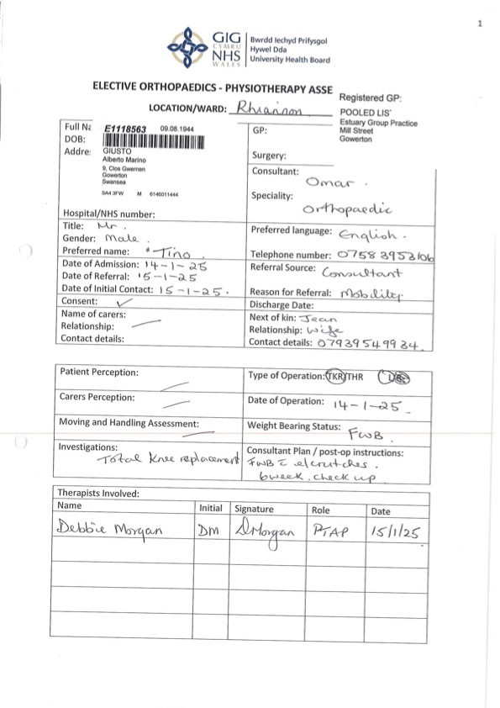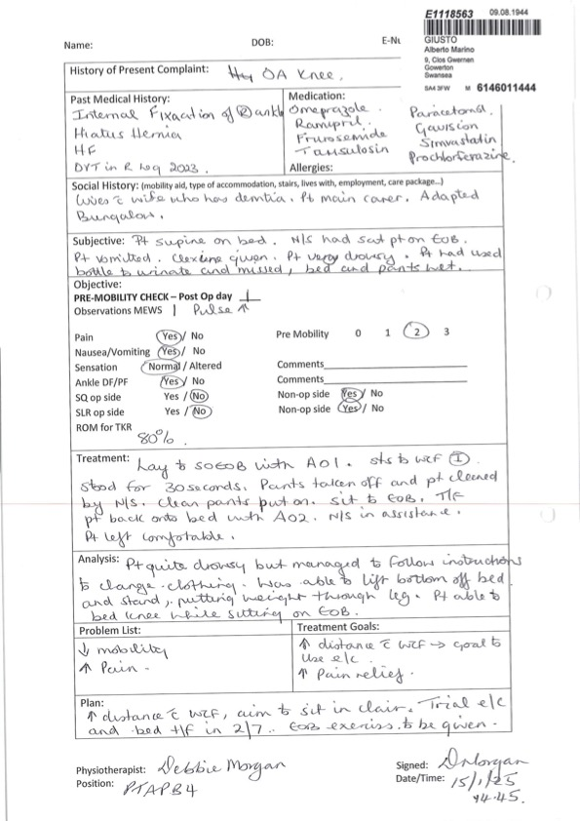

Appendix Two
Notes from a patient that completed a stair assessment

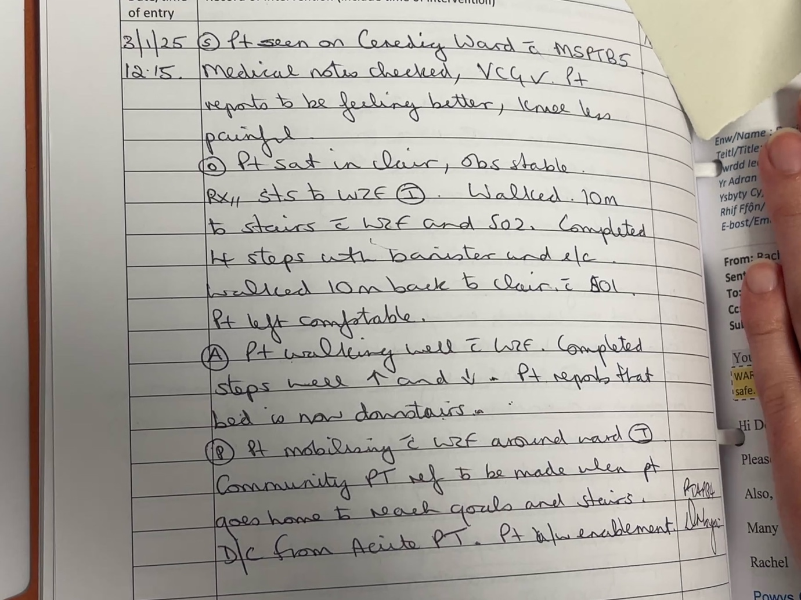

Notes from a patient that was assessed using a Wheeled Zimmer Frame on the Orthopaedic and Trauma Ward
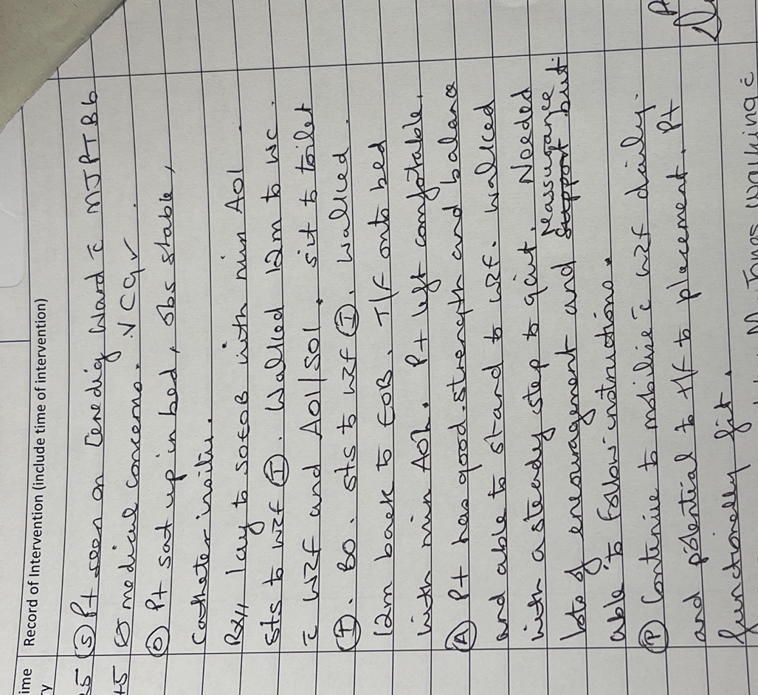

Notes from a patient that was assessed using elbow crutches on the Elective ward.

Appendix 3
Notes taken from a patient on the Trauma and Orthopaedic ward that progressed from a gutter frame to a wheeled zimmer frame.
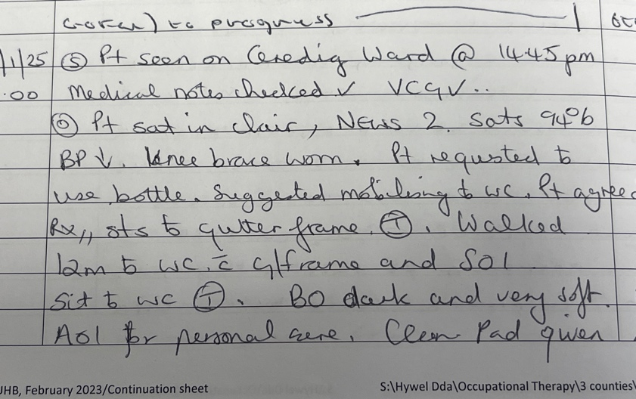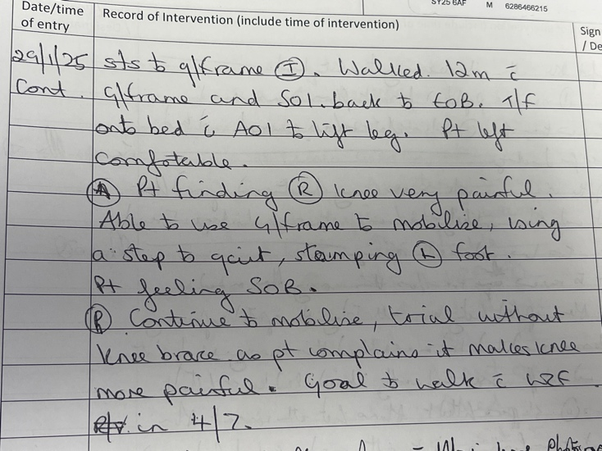

Notes from a patient that was discharged from acute Physiotherapy on the Trauma and Orthopaedic Ward.

Notes from a patient that was assessed in bed and given lower leg bed exercises on the Trauma and Orthopaedic Ward.
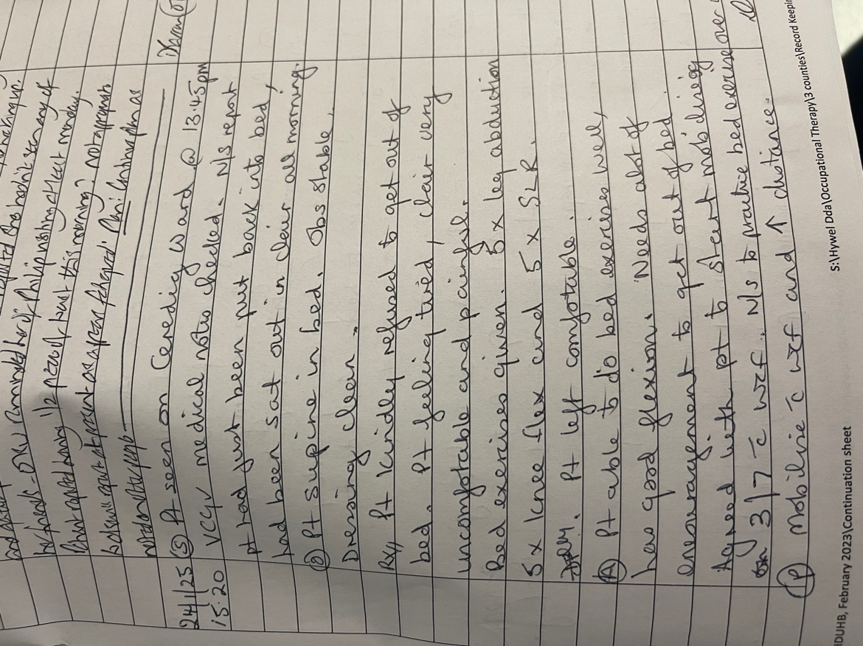

Appendix 4
A completed Risk Assessment that I did to use the day room on the Trauma and Orthopaedic Ward for exercise classes

Appendix 5
Time and Workload Management
Debbie demonstrates effective time and workload management daily in her role as a Therapy Assistant Practitioner. She collaborates closely with physiotherapists to manage the caseload and prioritises tasks during morning board rounds. Debbie has her own responsibilities, such as ordering equipment for patients on the ward and ensuring it is done promptly to facilitate discharges. She is an organised worker, preparing the ward sheets every Friday for the upcoming week, ready for Monday morning.
Debbie is consistently punctual and takes responsibility for her time management when attending board rounds and MDT meetings each week. She successfully balances her assignments and workload every Tuesday. Additionally, Debbie manages her time between the Trauma and Orthopaedic wards and other areas, assisting staff with inputting Welsh PAS data, which is essential for accurate physiotherapy record-keeping. As a valued member of our team, she greatly contributes to the efficiency of the Bronglais Physiotherapy Department. Her time and workload management skills are among her finest qualities, making her an excellent Therapy Assistant Practitioner to work alongside.
M.Jones
Manon Jones (B6 Physiotherapist)

Appendix 6
Copy of my compliance with mandatory training
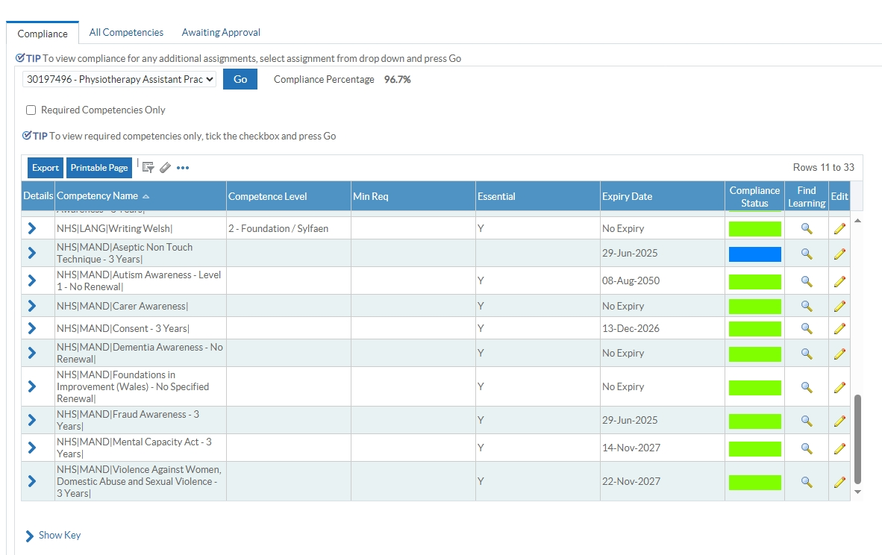
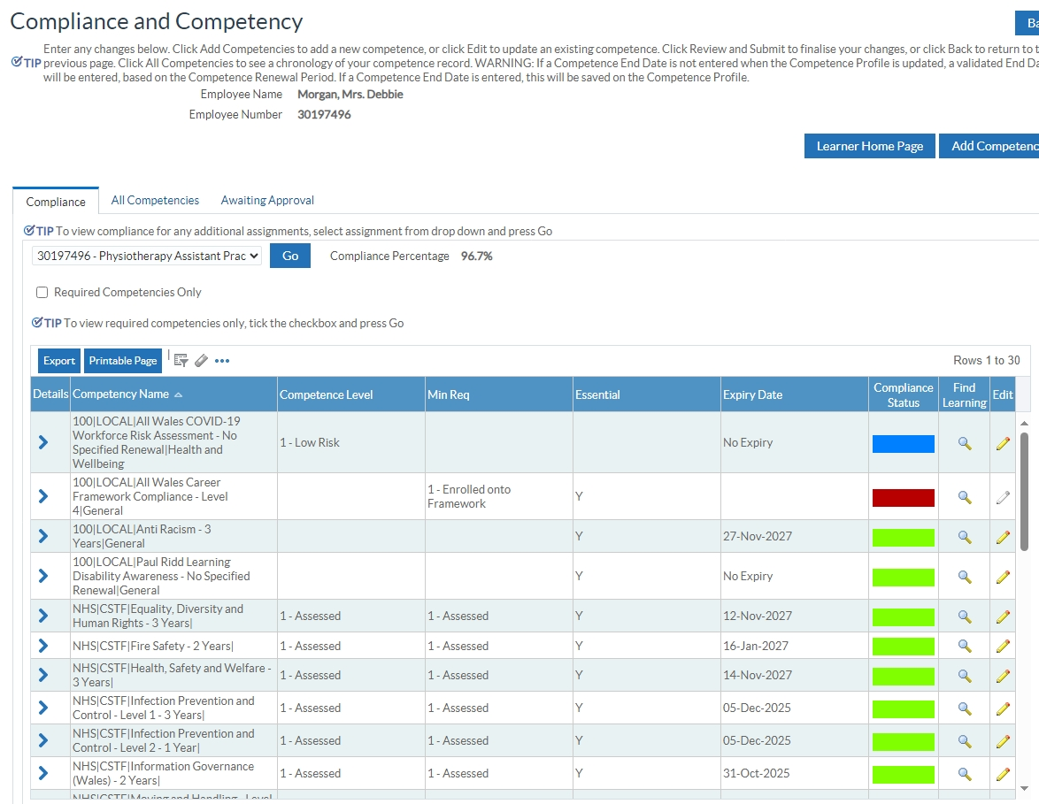

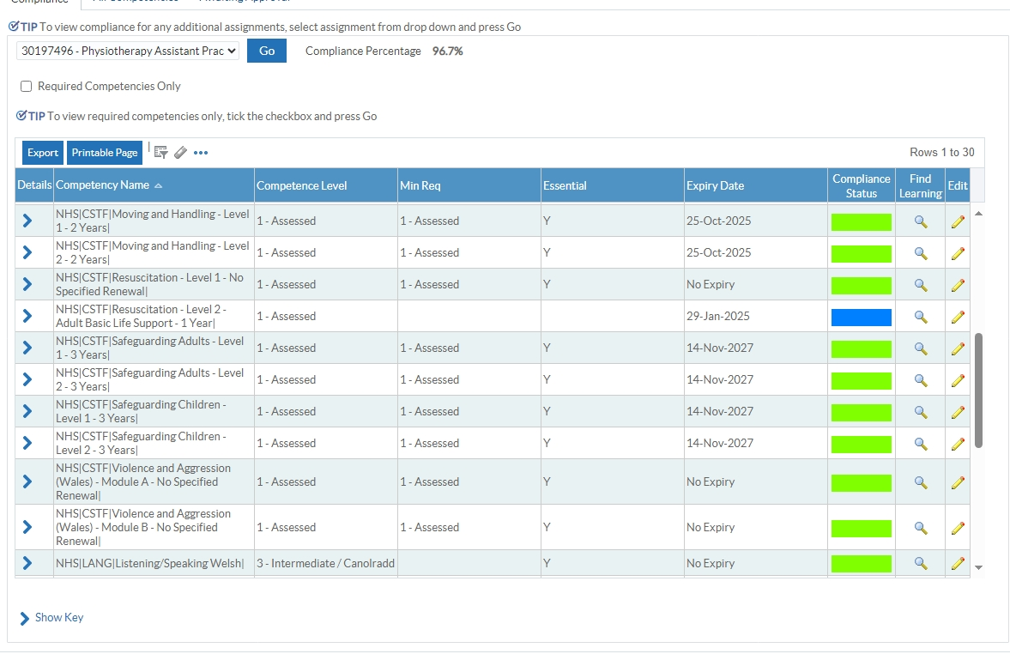

Appendix 7
A copy of my recent Personal Development Appraisal review

PERFORMANCE APPRAISAL DEVELOPMENT REVIEW

CORE PADR

My Details / My Appraiser’s Details
My Name: | Debbie Morgan | My Job Title: | Band 4
Department: | Physiotherapy | County: | Ceredigion
Review Period Start Date: | October 23 | Review Period End Date | October 24
Appraiser Name: | Manon Ellis Jones | Appraiser Job Title | Band 6
Date: | 03/10/24 | My Pay Number:
Personal Review of Objectives– to be completed by the appraisee during the discussion
a) What has gone well for me this year?
Completed Level 3 Diploma.
Promoted to Band 4 T&O Therapy assistant practitioner.
Started Level 4 Diploma with 28 days of study leave.
Gaining competencies in T&O.
Happy in work environment not stressed during work hours.
Assisted with creation of the exercise class on Ceredig with T&O team.
b) What could have gone better for me this year?
Lack of time on Rhiannon ward to gain confidence in gaining competencies on elective orthopaedic patients.
Less time for reflection and CPD due to higher caseload on Ceredig ward, and limited staff on certain days increasing the workload across orthopaedic wards and DSU.
Equipment storage have varied much over the move to Management HQ and stressful when organising frame deliveries.

Objective Setting
What are my SERVICE objectives for the next year?
- Complete Level 4 Diploma in the next 2 years.
- Keeping T&O folder up to date.
- Ordering equipment.
- Mandatory training
- Participate in all IST
- Shadow elective THR or TKR surgery.
- Shadow Arthroplasty clinic.
- Carry out weekly exercise classes along with the T&O team.
- Be competent with Elective patients.

What are my TEAM objectives for the next year?
- Engage with all social events
- Send weekly oncall reminders
- Crosscover on other wards if needed
- Supporting students on placement
- Ordering equipment and keeping a log for other counties

What are my PERSONAL objectives for the next year (Max 8 objectives)? Use SMART Guidance (Appendix 3). How do they relate to the Organisational Values? (click here Hywel Dda University Health Board | Values - Introduction for further guidance)
  Working together to be the best we can be |   Striving to Develop & deliver excellent services |   Putting People at the heart of everything we do

Core Objectives
Objectives | Expected outcome/measure of achievement | Target date | Support/action by Manager/others | Progress Review date
- Complete mandatory training on ESR | 100% compliance |  | No action required at present.
2.  Engage with and complete yearly PADR | ESR data compliance |  | Set reminder | October 2025
3.  Offer welsh language services as able with patients on the ward | WLS compliance |  | Assisted by Band 6 on the ward.
Personal Objectives
4.  Complete Level 4 Diploma in the next 2 years | Qualification certificate |  | Weekly Tuesday classes and 28 days of study leave.  Under regular review | October 2026
5.  Gain exposure to Surgeries for rehab purposes | Experience THR and TKR |  | Liaise with Surgeons on the ward.
6.  Explore community opportunities to follow up orthopaedic patients | Experience |  | Identify opportunities
7.  Complete band 4 competencies | Competencies completed to work independently on Rhiannon. |  | Registered to witness competencies
8.

9.
10.
11.

Personal Development Plan
Identify below the learning & development needs required to fulfil/maintain your personal objectives
Development to meet objectives (click here for Hywel Dda e-Prospectus) Refer to Appendix 5
-ESR compliance
-Take learning opportunities when they arise regarding Orthopaedic work.
-Take part in IST
-Shadow MDT on T&O
-Regular supervisions with band 6.
-Take part in Level 4 Diploma weekly classes and complete workload within work hours.

Nursing Midwifery Council (NMC) Revalidation
Are you on the NMC register? Yes No

If ‘yes’ please refer to Appendix 1

NMC Standards for Education 2018: Practice Supervisor / Practice Assessor (Nursing & Midwifery Staff only)
Please refer to Appendix 2

Clinical Supervision – A guidance plan for nurses in Hywel Dda University Health Board
Please refer to Appendix 3

General Comments
What are my career aspirations for the next 12 months?
Continue with Level 4 Diploma and gain competencies in Band 4 TAP role.
Summary (To be completed by Appraiser)
Debbie has settled well within her new role as Band 4 TAP within the T&O Team. Deb has now completed her competencies on the elective orthopaedic TKR and THR. During her 6 months in the role she has worked well with the MDT on the ward and her knowledge of orthopaedic conditions have improved a great deal. It is a pleasure to see her welsh language skills evolve and her confidence grow whilst interacting with patients. Deb is a very hardworking colleague and I am looking forward to support her in any way possible with her level 4 diploma study for the following year.

Pay Progression (To be completed by Appraiser)
Step 1
Is this PADR a pay affecting progression appraisal? Yes No (if yes go to Step 2 below)
(See the All Wales Pay Progression Policy)
Step 2
Has the appraisee achieved their objectives for the previous year and met the standards of the pay progression policy, see below?

1 | Appraisee has achieved their objectives | Yes |  | No
2. | The appraisal process has been completed within the last 12 months and outcomes are in line with the organisation’s standards | Yes |  | No
3. | The appraise has achieved 100% compliance for mandatory training | Yes |  | No
4. | There is no formal capability process in place for the appraisee | Agree |  | Disagree
5. | There is no formal disciplinary sanction live on the appraisee’s record | Agree |  | Disagree
6. | The appraiser must complete the Pay Affecting Progression Appraisal on ESR (See ESR MSS41 online training) | Completed

I am committing to this by signing : D Morgan | Date: 03/10/24
My appraiser agrees by signing : M.Jones | Date: 03/10/24
Date of Next Review: October 2025

Appendix 8
Two copies of recent supervision records.

RECORD OF SUPERVISION
Type of supervision CLINICAL
PROFESSION
MANAGERIAL
INDIVIDUAL
PEER
GROUP

Supervisee: Debbie Morgan Supervisor: Lucy Jones Date: 07/03/2024
Issues/Items discussed | Agreed Action/Outcome | Timescale
Well-being  Caseload  Diploma  Development / starting new Band 4 job  IT skills  AL  Mandatory Training | Happier no home life and situation with Father is settled. Good balance between work and home life. Training for Challenge, keeping active and healthy.  Happy with caseload, recently had to work independently due to reduced staffing levels. New band 5 has proven challenging to work alongside at times. Debbie feels uncomfortable as feel band 5 is too reliant on her during his assessments of patients. Debbie sometimes does not feel confident supporting band 5 as feels as though too much responsibility is being place on her and is being asked to make decisions out of her scope of practice. Debbie explains she has had a fair bit of experience working with new band 5’s but explains this situation has not arisen before. Advised Debbie to highlight any issues to myself or Charlotte. Reassured Debbie that going forward, I will supervise band 5 and try to reduce joint working with complex patients.  Completed diploma! Awaiting for marking to take place. Looking forward to commencing level 4 diploma in light of her recent success in new job role as a Band 4 PT support practitioner. Debbie explained concerns with difficulty of level 4 diploma given lack of experience in the role. Reassured that she will get regular teaching with delegated time set aside to complete learning. Level 4 is delivered by university teachers and is more supported and organised.  Currently awaiting start date for new job, based on Ceredig/Rhiannon ward. Apprehensive about new journey, looking forward to new challenge. Excited to gain knowledge in new area of rehab and physio. Debbie is happy to assist with teaching new band 3 who is set to come to medicals during the overlap of jobs.  Debbie has recently been a huge help creating flyers for the carers fair. In the process of creating a pull up banner and table cloth for next year’s event – thank you!  Used up all AL for 2023-2024. Encourage to book some time off once settled in new role.  100%! Completed PADR in October.

Signature of Supervisee: Debbie Morgan
Signature of Supervisor: Lucy Jones
Date of next review: 18/04/2024

RECORD OF SUPERVISION
Type of supervision CLINICAL
PROFESSION
MANAGERIAL
INDIVIDUAL
PEER
GROUP

Supervisee: Debbie Morgan Supervisor: Manon Jones Date: 03/10/2024
Issues/Items discussed | Agreed Action/Outcome | Timescale
Well-being  Caseload  Diploma  Development as a Band 4  IT skills  AL  Mandatory Training | Good balance between work and home life. Keeping active and healthy, swimming and walking. Menopause symptoms now under control. Slight apprehension with beginning with the Level 4 diploma.  Happy with caseload, working more independently as a band 4 in T&O for over 6 months. Need to work on Rhiannon more to feel more confident with elective Knees and Hips and how to do paperwork and referrals. Not much DSU patients to see/shadow with physio at present.  Started level 4 Diploma in September 2024. Have received Level 3 Diploma certificates. Every Tuesday weekly in the morning lectures and carry on with the work in the afternoon at home with 28 days study leave.  Started new job since mid April.. Ongoing learning on the job with physio and other band 4 on the ward. No clear job description within the T&O role as to what needs to be learnt, paperwork and patient assessments as different to medical side. Aim to see knee and hip operation to educate and learn more. See more DSU patients.  In the process of creating a pull up banner and table cloth for next year’s event. No concerns with welsh pas or IT skills needed for this new role as band 4. Assisted with completing paperwork for new exercise class on ceredig.  15 days AL left for this year. Booked 3 days over xmas time that has been accepted.  Unable to achieve 100% due to not being accepted to level 4 diploma yet.

Signature of Supervisee: Debbie Morgan
Signature of Supervisor: Manon Jones
Date of next review: 01/01/2025

Appendix 9 – Peer Review Feedback Forms



