Construction of the Loughor Bridge
Submission 2
Patrick Nolan
2018

Contents
Table of Figures 2
1.0 Introduction 3
2.0 Construction Methodology 4
3.0 Expected duration of construction 5
4.0 Expected labour required for each month 5
5.0 Estimated cost for the construction 6
6.0 Conclusion 6
7.0 References 7
Appendix 8

Table of Figures
Figure 1. Showing the drawing provided by the client. The engineer has labelled the sections with numbers, 1 and 6 are the abutments and 2 and 5 are the remaining piers. With 3 and 4 being the piers which are located in the water 6

Figure 2. The produced Gantt chart using Asta PowerProject. The red line showing the critical path of the construction. Each activity number correlates to table 1. 6

Figure 3. This graph is showing the amount of labourers per month, this has been produced using the information provided by the Spons 2018 price book (Aecom, 2017). 7

Figure 4. This graph is showing the estimated cost for the construction in each month, produced using the information within the Spons 2018 price book (Aecom, 2017). 7

Figure 5. Showing a pictoral representation of each activity and an estimation of how many labours will be required each month (see table 2 and Figure 3)), produced alongside the Spons 2018 price book (Aecom, 2017) 8

Figure 6. Is showing the estimated cost for each activity and the monthly cost, associated with the construction (see Table 3 and Figure 4). Produced alongside the information provided in the Spons 2018 price book (Aecom, 2017). 8

Table 1. Showing the activity description and duration, links to the activity numbers in figure 2……….7

Table 2. Showing the estimated figure of labourers needed for each month shown in figure 2. 9

Table 3. Showing the estimated figures for the construction per month, shown in figure 3. 9

Introduction
The client has instructed that a bridge, with four piers and two abutments to span the Loughor River is to be constructed (see figure 1). The exact span of the intended bridge is unknown so this has been assumed to be 100m; therefore each bridge deck section will have a span of 20m. The substrata for the project is four meters of lime and mud, with the bearing layer being situated below this layer of soil (see Figure 1).
The brief has not stipulated any time or cost requirements. Therefore, this design has not altered the process to cater to any external contributing factors. Clamp and Cox (2002) highlight the importance of engineers and working professionals having an ‘eye’ on factors such as time and cost. This leads to more innovative construction methods being implemented. Thus, within this project the engineer has chosen to introduce prefabricated elements where possible. This increases productivity on site which would reduce overall construction duration, reducing the cost for the project (Bernstein, et al., 2011).

Construction Methodology
The construction method chosen will utilize the edge of the abutment to act as a ‘simple joint’, opposed to a ‘ridged joint’ which is where the bridge deck section and the abutment are rigidly connected (Khan, 2014). The use of a ‘ridged joint’ can cause a bending moment to be exerted onto the abutment, which could cause cracking or failure. Therefore, a ‘simple joint’ has been implemented by means of using bridge bearings and expansion joints. This ensures there is no bending moment in the abutment (Jamal, 2017). The same method has been used on the piers to ensure the same outcome.
The piers which stand within the River Loughor have been surrounded by sheet piling, with granular backfill to the pile cap level. This is because the backfill should allow the structure to be sturdier, due to the River Loughor being tidal, which, would subject the piers to a horizontal force due to tidal pressure (Wang, et al., 2015) . The sheet piling has been formed in a rhombus shape; this shape will, in comparison to a standard squared sheet piling, reduce the effect that scouring might have on the piers (Enteasar & Ghorab , 2016). This shape is more expensive to install initially, but the long term effect of scouring being reduced will result in the reduction of the overall cost of maintaining this structure (Enteasar & Ghorab , 2016).
As a result of the scale of this project simultaneous construction methods have been implemented. This allows whole sections to be built whilst other aspects of the construction might be held up, thus allowing for a quicker construction (Khan, 2014). The downside to using this style of construction is that it is more expensive because the client will have to pay for multiple activities at once. The benefit of this is that the project is finished quicker (Khan, 2014). This technique was used for the abutments, piers and also the bridge deck sections (see Figure 2). The disadvantage of using this style of construction is that the success of the project is heavily reliant on the initial planning stages. As a result of this project requiring simultaneous construction methods (Khan, 2014). For example, when bridge deck section three is being constructed, there must be the communication and planning in place to ensure that bridge deck section two does not have any delays, which would result in the whole construction being delayed and therefore waiting for this bridge deck section to be finished. Contradictory to this, if the correct planning and communication channels are in place, this style of simultaneous construction methods could hugely increase productivity, thus reducing the overall construction duration being reduced (Bernstein, et al., 2011)
The decision was made not to use any incremental launching methods (ILM) for the bridge deck sections because of the assumption that the bridge’s span will be 100m. This is not a viable option for ILM because ILM is only used for bridges with a span ≥250m (TheConstructor.org, 2017).

Expected duration of construction
The duration for each activity has been calculated using the equation for work duration below.
- $WD=\frac{Quantity of work}{Number of gangs ×Production rate}$
This equation has enabled a Gantt chart to be produced (see Figure 2), which pictorially displays the information gained using the Spons 2018 Price book, and also the above equation (Aecom, 2017). The expected duration for this project is eighteen weeks, this is comprised of eight hour working days, with labourers working five days a week. If there were factors effecting time, then more labourers could be brought into increase productivity and decrease overall duration (Bernstein, et al., 2011).
This duration is un-factored estimation, which means that there have been no factors of safety applied to this equation. This would therefore allow for a tolerance in regards to weather conditions or unexpected events. Therefore, this duration might fluctuate dependant on factors effecting weather, logistics and other factors (Khan, 2014).

Expected labour required for each month
The labour required for each month has been calculated by using the ‘Spons Civil engineering and Highway price book 2018’. This gives figures and amount of labours per activity. For example, one gang comprised of two plant operators, three labourers and one supervisor, this would be noted as six labourers required for that particular activity (see Figure 3, 5 and Table 2).
The total amount of estimated labours for the entire project is 405 (see Figure 3 and Table 2). In each month of the construction the amount of labourers required changes in conjunction with what activity is occurring that month. For example, month five only requires 14 labourers because there is not as much occurring compared with month three, where 126 labourers are required, because during this phase the bridge deck sections are being constructed (see Figure 2, 3 and 5). Therefore, if there were any delays during the construction the client could request that more labourers work on certain aspects to increase productivity, resulting in a different amount of labourers required (Khan, 2014).

Estimated cost for the construction
The estimated cost for the construction much like the amount of labourers required, will fluctuate depending on what activity is occurring that month (see Figure 4 and Table 3). The cost forecasted for this project is very dependent on the duration of the construction, because if there is any delays with any aspect this will directly consequence the budget (Clamp & Cox, 2002).
The estimated cost for the entire project is £480,575.84. The forecasted cost for the project is that of the lowest cost is associated with month five, which is £4,060.00 (see Figure 4). This, is due to the final month having the least amount of work estimated to occur that month (see Figure 6). The most expensive month during the construction is month two where, £209,897.55 is estimated. As a result of the both ends of the bridge deck sections are being constructed, whilst simultaneously the piers are being constructed; causing the highest associated cost for the client. Therefore, the client must have an understanding on where the associated cost is resting with the construction.

Conclusion
The client should understand that the below figures are an estimation and could fluctuate due to external contributing factors such as weather, cost, and if during the construction in the regional area there is a skills shortage; because this skills shortage would increase the cost of certain trades, changing the estimated cost (Aecom, 2017).
- The estimated cost for the entire project is £480,575.84 (see Table 3).
- The estimated amount of labour required for this project is 405 see Table 2).
- The expected duration for this project is 18 weeks (see Table 1).

References
Aecom, 2017. Spon's Civil Engineering and Highway Works Price Book 2018, London : Taylor and Francis .
Bernstein, H. M., Gudgel , J. E. & Laquidara-Carr, , D., 2011. Prefabrication and Modularization: Increasing Productivity in the Construction Industry, s.l.: McGraw-Hill Construction.
Clamp, H. & Cox, S., 2002. Which contract? Choosing the appreopriate building contract. s.l.:RIBA.
Enteasar, A. S. & Ghorab , E., 2016. Reduction of scour around bridge piers using a modified method for vortex reduction. Alexandria Engineering Journal, 52(3), pp. 467-478.
Jamal, H., 2017. Types of supports for loads. [Online]
Available at: https://www.aboutcivil.org/types-of-supports.html
[Accessed 25 1 2018].
Khan, M. A., 2014. Accelerated Bridge Construction: Best Practices and Techniques. 1st ed. s.l.:Elsevier.
TheConstructor.org, 2017. Incremental Launching Method of Bridge Construction. [Online]
Available at: https://theconstructor.org/structures/incremental-launching-method-of-bridge-construction/6126/
[Accessed 15 2 2018].
Wang, Y.-h., Zou, Y.-s., Xu, L.-q. & Luo, Z., 2015. Analysis of Water Flow Pressure on Bridge Piers considering the Impact Effect. Mathematical Problems in Engineering, Volume 2015, pp. 1-9.

Appendix
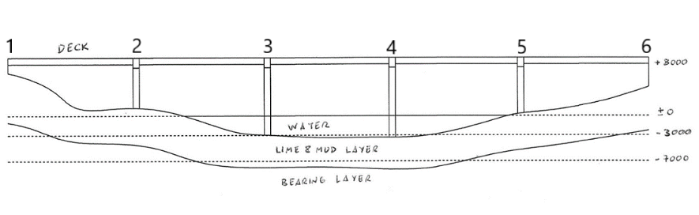
Figure 1. Showing the drawing provided by the client. The engineer has labelled the sections with numbers, 1 and 6 are the abutments and 2 and 5 are the remaining piers. With 3 and 4 being the piers which are located in the water

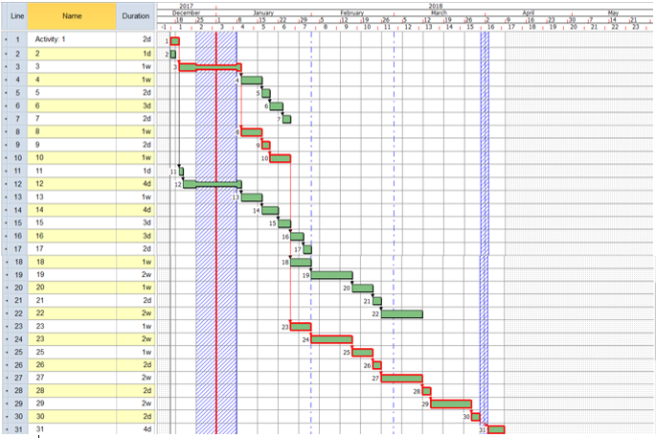
Figure 2. The produced Gantt chart using Asta PowerProject. The red line showing the critical path of the construction. Each activity number correlates to table 1.

Figure 3. This graph is showing the amount of labourers per month, this has been produced using the information provided by the Spons 2018 price book (Aecom, 2017).

Figure 4. This graph is showing the estimated cost for the construction in each month, produced using the information within the Spons 2018 price book (Aecom, 2017).

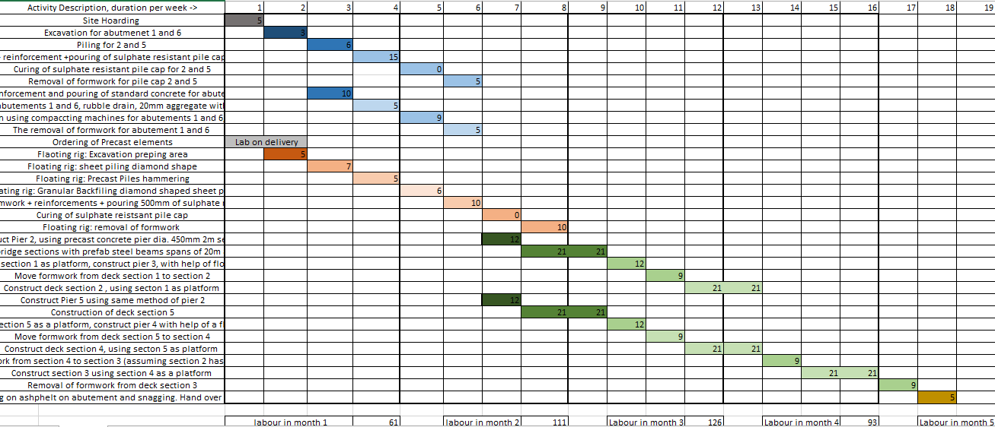
Figure 5. Showing a pictorial representation of each activity and an estimation of how many labours will be required each month (see table 2 and Figure 3), produced alongside the Spons 2018 price book (Aecom, 2017)

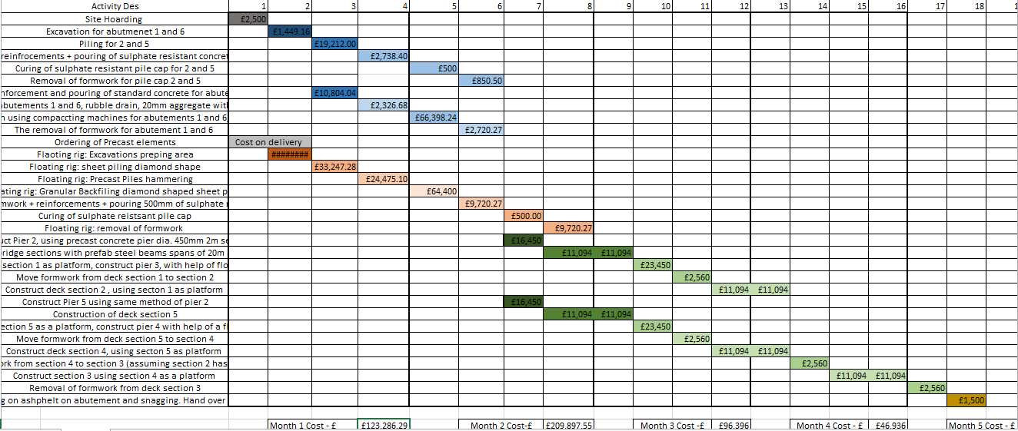
Figure 6. Is showing the estimated cost for each activity and the monthly cost, associated with the construction (see Table 3 and Figure 4). Produced alongside the information provided in the Spons 2018 price book (Aecom, 2017).

Table 1. Showing the activity description and duration, links to the activity numbers in figure 2.
Activity Number | Activity Description | Duration in Days (D)
1 | Site Hording | 2d
2 | Ordering of Precast elements: Piles for 3and 4. Piers for 2.3.4.5. Precast bridge elements ready to install | 1d
3 | Excavation for abutment 1 and 6 | 5d
4 | Piling for 2 and 5 | 5d
5 | Formwork + reinforcement + pouring of sulphate resistant pile cap for 2 and 5 | 2d
6 | Curing of sulphate resistant pile cap for 2 and 5 | 3d
7 | Removal of formwork for pile cap 2 and 5 | 2d
8 | Formwork, reinforcement and pouring of standard concrete for abutments 1 and 6 | 5d
9 | French drain for abutments 1 and 6, rubble drain, 20mm aggregate with graded material | 2d
10 | Backfill and compaction using compacting machines for abutments 1 and 6, using graded material, now ready to be used | 5d
11 | Floating rig: Excavation and prepping of area | 1d
12 | Floating rig: sheet piling Rhombus shape | 4d
13 | Floating rig: Using Precast elements, the piles will be hammered into position | 5d
14 | Floating rig: Granular Backfilling Rhombus shaped sheet piles | 4d
15 | Floating rig: formwork + reinforcements + pouring 500mm of sulphate resistant pile cap | 3d
16 | Curing of sulphate resistant pile cap | 3d
17 | Floating rig: removal of formwork | 2d
18 | construct Pier 2, using precast concrete pier dia. 450mm 2m sections | 5d
19 | Construct Deck section 1, using abutment 1 as a platform, reinforced concrete bridge sections with prefab steel beams spans of 20m and formwork to rest on top of pier 2 | 2weeks
20 | Using deck section 1 as platform, construct pier 3, with help of floating barge | 5d
21 | Move formwork from deck section 1 to section 2 | 2d
22 | Construct deck section 2 , using section 1 as platform | 2weeks
23 | Construction of Pier 5, using abutment 6 as a platform | 5d
24 | Construction of deck section 5 | 2weeks
25 | using deck section 5 as a platform, construct pier 4 with help of a floating barge | 5d
26 | Move formwork from deck section 5 to section 4 | 2d
27 | Construct deck section 4, using section 5 as platform | 2weeks
28 | Move formwork from section 4 to section 3 (assuming section 2 has no hold ups) | 2d
29 | Construct section 3 using section 4 as a platform | 2weeks
30 | Removal of formwork from deck section 3 | 2d
31 | Finishing on asphalt on abutment and snagging. Hand over to client | 4d
Total Duration |  | 18 weeks

Table 2. Showing the estimated figure of labourers needed for each month shown in figure 2.
Month during the construction | Labours per activity per month
Month 1 | 61
Month 2 | 111
Month 3 | 126
Month 4 | 93
Month 5 | 14
Total labour for the project | 405

Table 3. Showing the estimated figures for the construction per month, shown in figure 3.
Month of activity: | Construction cost: Incl Labours, Plant and Material.
Month 1 | £123,286.29
Month 2 | £209,897.55
Month 3 | £96,396
Month 4 | £46,936
Month 5 | £4,060
Total cost | £480,575.84

