

Programme Name: Master of Business Administration

Module Name: Strategic Management
Module Code: LCMB7003

Assessment Title: Strategic Management Report Hyundai Motor India Limited

Student Name: Khatijabibi Mahebubbhai Radhanpuri
Student ID: 2420022
Word Count: 5179

Table of Contents
Section 1 3
1. Organisational Context and Overview 3
1.1 Company Profile and Selected Market 3
1.2 Historical Development 3
1.3 Mission, Vision and Business Model 3
1.4 Industry, Competitors and Market Position 3
2. External and Internal Analysis 4
2.1 Analytical Approach 5
2.2 PESTEL Analysis of Hyundai in India 5
2.3 External Opportunities and Threats: Critical Synthesis 8
2.4 Internal Environment and VRIO Analysis 9
2.5 SWOT Analysis 9
3. Comprehensive and Holistic View of the Organisation 10
3.1 Hyundai India’s Current CSR Approach 10
3.2 CSR Activities and Stakeholder Impact 11
3.3 Alignment of CSR with Business Objectives 11
3.4 Balanced Scorecard Introduction 12
3.5 Financial Perspective 12
3.6 Customer Perspective 12
3.7 Internal Business Process Perspective 13
3.8 Learning and Growth Perspective 13
3.9 Integrated Balanced Scorecard Discussion 13
4. Strategic Choices and Implementation 14
4.1 Strategic Decision Context 14
4.2 Current Business-Level Strategy 14
4.3 Strategic Options Available 14
4.4 Porter’s Five Forces Analysis 15
4.5 Ansoff Matrix 16
4.6 SAFe Evaluation 16
4.7 Recommended Strategy and Expected Value 16
4.8 Implementation Challenges and Mitigation 17
Section 2 17
5. Reflective Account Using Gibbs’ Reflective Cycle 17
5.1 Description 17
5.2 Feelings 17
5.3 Evaluation 18
5.4 Analysis 18
5.5 Conclusion 19
5.6 Action Plan 19
References 20

Section 1

1. Organisational Context and Overview

1.1 Company Profile and Selected Market
Hyundai Motor India Limited (HMIL) is a South Korea-based company, Hyundai Motor Company's Indian subsidiary. India is a suitable geographical focus as it is the third largest revenue generating market for Hyundai and is one of the world's biggest passenger vehicle market. This sets India apart from Hyundai's home market, prompting the company to adapt and extend its distribution and product strategies, as well as produce the vehicles locally (Hyundai Motor India, 2026a, Reuters, 2024). This makes local adaptation strategically necessary rather than optional.

1.2 Historical Development
Hyundai became a part of India in 1996, and began manufacturing vehicles in the country in 1998. The launch of Creta in 2015 marked a major step as it shifted Hyundai's focus towards the booming and lucrative SUV segment. It grew into a domestic manufacturing and international export center in its operation in Chennai. Having the Talegaon facility in Maharashtra adds another avenue for production flexibility to boost domestic expansion, exports, and electrified models (Reuters, 2024; Hyundai Motor India, 2026a). The added capacity strengthens flexibility, but also raises utilisation risk.

1.3 Mission, Vision and Business Model
In a global perspective, Hyundai adopts the vision “Progress for Humanity”, which combines technological mobility solutions and environmental and social value. Its business model in India includes upstreaming global vehicle platforms, in-house design and technologies and upstreaming local procurement, engineering and manufacturing and market adaptation. Its main source of revenue is from sales of vehicles at home, as well as sales and ancillary services via the network of 1,366 sales points and 1,550 service points, as well as replacement parts and exports.
Hyundai is in a “mass-premium” position from a strategic point of view. It has a strategy that's not just to be lowest in price, but to distinguish itself in design, perceived quality, safety, connected technologies, convenience features and after-sales support. This differentiation is possible with local production, which allows for keeping costs down and allowing middle-income folks access to this production. But the model demands constant innovation as Indian players are increasingly coming up with similar technolgy at competitive rates (Deloitte, 2024; Hyundai Motor India, 2026a). As a result, differentiation is useful only when the competitors are not able to close the gap rapidly.

1.4 Industry, Competitors and Market Position
Indian passenger-vehicle wholesales totaled 4.3 million in FY2025, but grew at a slower pace, at 2%, than in FY2024 when it was 8% (Reuters, 2025). The record volume was driven by SUVs and balanced lower small-car and sedan sales.
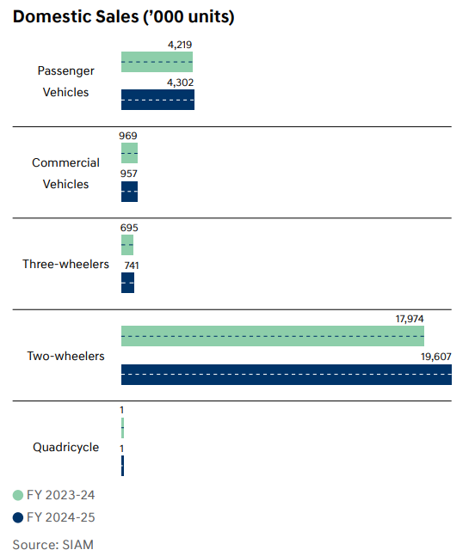
Figure 1: Domestic Sales (’000 units)
(Source: Hyundai, 2025)
Hyundai’s market share fell from 17.5% in 2020 to 14.6% in 2024 (Reuters, 2024), a 2.9-percentage-point or 16.6% relative decline. This was happening during a time of growth in India's market, so the weakness is not due to contraction, but rather because of the weak share taken by the stronger domestic SUV brands.

2. External and Internal Analysis

2.1 Analytical Approach
PESTEL analysis looks at macro-environmental factors, which are controllable by Hyundai; VRIO analysis is about the value, rarity, cost of imitation and organisation of its resources. SWOT then combines the external and internal information. These frameworks are used critically and not merely as checklists – factors are prioritised based on their potential impact on demand, cost, innovation, profitability and Hyundai's competitive position.

2.2 PESTEL Analysis of Hyundai in India
Political factors
Indian industrial policy promotes local manufacturing, localisation and creation of an electric-mobility system. PM E-DRIVE is aimed at promoting electric vehicles and charging infrastructure, providing a platform for Hyundai to expand EVs locally, as well as develop local suppliers and establish the country as a regional hub for EV exports. There are, however, differences in incentives between vehicle types and between states, and PM E-DRIVE is not a car-for-private-passenger subsidy. Policy support usefully decreases ecosystem risk, but it cannot overcome the need for competitively priced products.
Research suggests, in line with this, that EV diffusion is more robust under government coordination of manufacturing incentives, consumer measures, infrastructure standards and technical standards, as compared to government interventions in isolation (Anilan and Vij, 2024; Satrio, Juned and Salam, 2024). The question for Hyundai is also whether they will be subject to geopolitical risks as batteries, semiconductors, rare-earth materials and electronic components are still localized in international supply chains (Ministry of Heavy Industries, 2024). So, there is a surprising lack of policy opportunity because of external supply dependency.
Economic factors
It did not appear that passenger-vehicle growth would slow in FY25, it was just that it would be less robust at 8% growth, but is not contracting at 2% (Reuters, 2025). The interest rates, availability of vehicle financing and fuel prices and household incomes have the most direct impact on demand as monthly instalments are the key factor in Indian buying decisions. The currency devaluation and fluctuations in prices of steel, aluminium, energy and battery materials can also add to the price of production and importation of parts. On the other hand, India has manufacturing scale, relatively well-developed automotive supplier base and export opportunities. While the premiumisation policy can help Hyundai improve margins, an over emphasis on high-value SUVs and EVs may compromise volumes at Maruti Suzuki and value-oriented domestic car makers. Purchase price, total ownership cost, charging access, product availability and policy stability have been found as major factors to determine EV acceptance (Wicki et al. 2023; Gupta et al. 2024; Pamidimukkala et al. 2024). Therefore, for technology to be successful, it must be affordable.
Social factors
The young population, urbanisation and rising middle class in India fuel the vehicle ownership and demand for SUVs, safety features, digital functions and aspiration. According to Deloitte's global consumer study, the quality of the product was a key priority for customers and the Indian customers showed a relatively high willingness to spend on connected services.
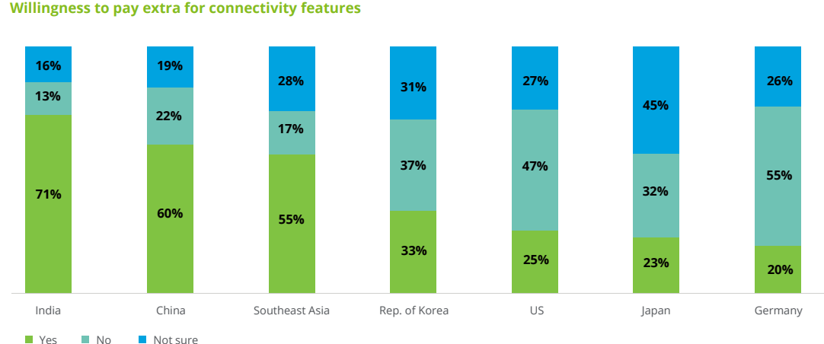
Figure 2: Willingness to pay extra for connectivity features
(Source: Deloitte, 2024)
This furthers Hyundai's feature-dense positioning. However, the market is very fragmented. Connectivity, automatic transmissions, and electric mobility are likely to be more important to customers of the metropolitan areas, while smaller cities and rural areas might focus on affordability, resale value, fuel economy, and service accessibility. Range anxiety, battery-life issues and questionably priced resale values are further limiting factors on EV acceptance. There lies scope for creating a differentiated proposition for customers as India is not a one-size-fits-all national market, as indicated by the Deloitte (2024), Wicki et al. (2023), and Gupta et al. (2024) insights.
Technological factors
The competitive aspects in the automotive industry are shifting: electrification, battery development, software-defined vehicles, advanced driver-assistance systems, connected services and automated production. The Hyundai IONIQ 5 and locally manufactured Creta Electric offer learning opportunities for the market, and Hyundai can share its parent company's knowledge of research, design and EV-platforms with India. While charging reliability, interoperability, battery prices, and grid integration and software quality remain as obstacles to EV diffusion, these challenges are not new as they continue to be identified in academic studies (Haghani et al. 2023; Alonso-Cepeda et al. 2024; Diouf, 2025; Kumar et al. 2025). Hyundai therefore needs ecosystem capability alongside vehicle technology.
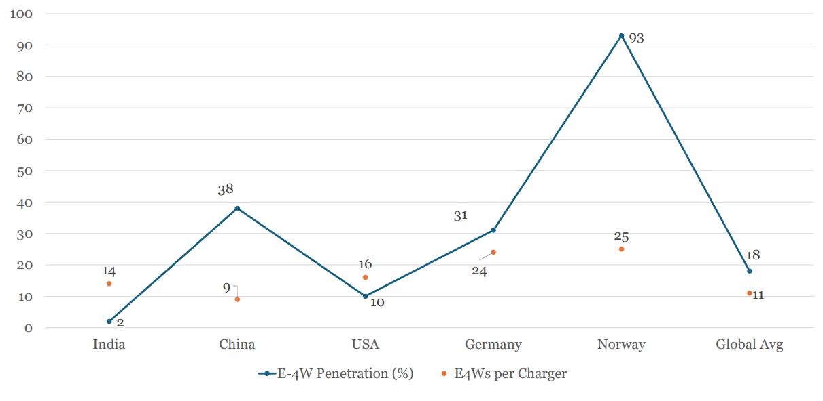
Figure 3: Charging infrastructure availability Vs 4W EV penetration (2024)
(Source: Niti.gov.in, 2025)
While solid-state batteries have the potential to enhance range, charging speed and safety, their high production costs and lack of technology certainty make it too early to rely on them (Alkhalidi et al. 2024; Khawaja and Ismail, 2024; Pourzolfaghar et al. 2024). Hyundai, therefore, should focus on developing modular platforms, battery collaborations, cyber security networks and charging networks rather than on imported technologies for the most part (IEA, 2024). This reduces technological lock-in while improving strategic flexibility.
Environmental factors
While EVs can help to lower urban tailpipe emissions and support Hyundai's sustainability positioning, their full environmental impact will rely on the environmental impact of battery production, generation of electricity, recycling, charging habits, and the size of the vehicle. The Indian way of relying on fossil fuel electricity and material-intensity of large SUVs makes it difficult to make simple statements that every EV is “zero-emission”.
Despite this, there is life-cycle evidence that electrification can offer benefits for air quality and health, including with a cleaner electricity system (Alanazi, 2023; Garcia et al. 2023). Haghani, Ghaderi and Hensher (2024) emphasise the external effects of EVs and Romano et al. (2025) show how EV charging behaviour affects total emissions. Hyundai needs to invest in Energy saving vehicle design, lower carbon suppliers, renewable energy production and manufacturing of cars, battery traceability and recycling. The practices can be more than just regulatory requirements, they can be capabilities that become the "reputational" and "competitive" ones (AP news, 2023; IEA, 2024). Environmental capability can therefore support both compliance and differentiation.
Legal factors
Hyundai now has to face tougher emission, fuel-efficiency and vehicle-safety laws, battery and charging standards, consumer-protection laws, labour laws and environmental permits. However, with the advent of connected cars, manufacturers are facing cybersecurity and privacy challenges, and also have to abide by the data protection regime in India.
Compliance adds development, testing and documentation requirements, but can have a positive impact on large manufacturers with high production volumes. There's more than just financial consequences: Software failures, battery incidents, vehicle recalls or personal-data breaches could impact trust in the Hyundai brand as a whole. The company needs to have safe software updates, lifecycle safety processes, and supplier audits and quick recall procedures (Alonso-Cepeda et al. 2024). Compliance should therefore be treated as a trust capability, not merely a cost.

2.3 External Opportunities and Threats: Critical Synthesis
While Hyundai's best chance of EV growth is having these trends work together, SUV demand is its greatest potential.It is not about EV growth alone, but about the intersection of SUV demand, localisation and connected mobility that is Hyundai's greatest hope. The brand can leverage their SUV credibility to launch locally built electric and hybrid cars, and manufacturing in India will help lower costs and boost exports. When it comes to connected services, this comes in handy as long as there's transparency in customer data management.
The most obvious danger is the level of competition. Tata, Mahindra and Maruti are very knowledgeable, have a good network of suppliers and are steadily building their portfolios. A second is the affordability-Tech gap in which technologically advanced EVs are still not in the mainstream budgets. These pressures are exacerbated by concentration in the supply chain, currency volatility, and charging restrictions and uncertainty over regulation. Hence, Hyundai need to focus more on the development of innovations at low costs, product localisation, and how quickly they can launch products in comparison to relying on imported high-quality products (The Economic Times, 2025; Reuters, 2024). Competitive advantage therefore depends more on execution speed than technology ownership alone.

2.4 Internal Environment and VRIO Analysis
The Hyundai Motor India 2026f selected product is the CRETA, a mid-size SUV that is available in three engine choices—petrol, diesel, turbo—plus manual, IVT, automatic or DCT. The breadth is useful because it meets a variety of price/performance requirements, but competitors can copy the features, making CRETA more valuable than it is a sustainable VRIO advantage.
The manufacturing and export system along with its operations in Chennai and Talegaon and the established system of supplying the parts are valuable, capital intensive and time consuming to duplicate. With the addition of global quality systems, purchasing scale and production knowledge, it can yield a relatively long-lasting benefit. Its sales and service network is also huge but the extent to which it is organisationally embedded is lesser and not as common as Maruti's sales and service network. It thus does not offer anything competitive but rather a temporary edge over others (Hyundai Motor India, 2026a; Hyundai Motor India, 2026b). Its value is significant, but rarity remains comparatively weak.
Additionally, HMIL gets access to its parent company's knowledge in South Korea in the fields of engineering and design, battery electric and connected-vehicle. While other MNEs have comparable technology, capabilities and local firms are investing in and partnering to develop capabilities, this is an area of valuable and challenging capability for a smaller firm to replicate. This translates to strategic significance based on the Hyundai India's capability to indigenise global knowledge quickly.
The key drawbacks are falling market share, reliance on a few high-performing SUVs and lack of a solid market leader going into the mainstream EVs market than Tata Motors. Import exposure is also a result of battery cells, critical minerals and advanced electronics. The only thing Hyundai possesses is a high level of complementary resources (brand, factories, suppliers, distribution and parent company technology) but none of these are absolutely rare and inimitable. This, in turn, will rely on integrating these assets into a faster localisation system, along with lower cost and more reliable electrification, as well as on after-sales services that are superior (Reuters, 2024; The Economic Times, 2025). The strategic challenge is therefore integration, rather than simple resource ownership.

2.5 SWOT Analysis
Strengths | Weaknesses
Recognised brand and successful Creta/SUV franchise | Declining market share and pressure on its second position
Large-scale Indian manufacturing and export capability | Dependence on selected high-volume SUV models
Extensive dealership and service coverage | Weaker mass-market EV position than some domestic rivals
Access to Hyundai’s global R&D, design and platforms | Exposure to imported battery and electronic inputs
Opportunities | Threats
Continuing SUV demand and customer premiumisation | Aggressive competition from Tata, Mahindra, Maruti and Kia
Localised EVs, hybrids, batteries and connected services | EV affordability, charging and resale-value concerns
Additional Talegaon capacity and export expansion | Currency, commodity and geopolitical supply disruption
Sustainable manufacturing and circular battery systems | Tightening regulation and cybersecurity liability
Based on the SWOT analysis, it would seem that Hyundai should neither follow an approach of pure premiumisation nor a pure price competitive approach.
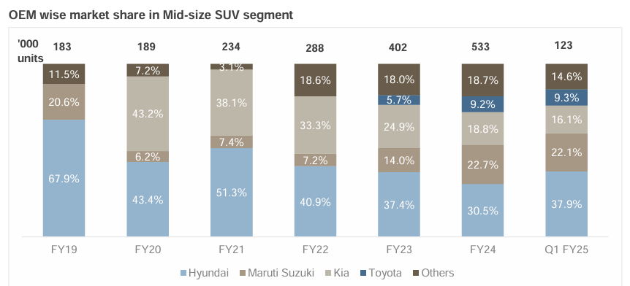
Figure 4: OEM wise market share in Mid-size SUV segment
(Source: CRISIL, 2024)
Figure shows Hyundai’s mid-size SUV share fell from 67.9% in FY2019 to 30.5% in FY2024, then recovered to 37.9% in Q1 FY2025 (CRISIL, 2024). As it rebounds, it has a positive effect but it doesn't fix the structural loss of differentiation.
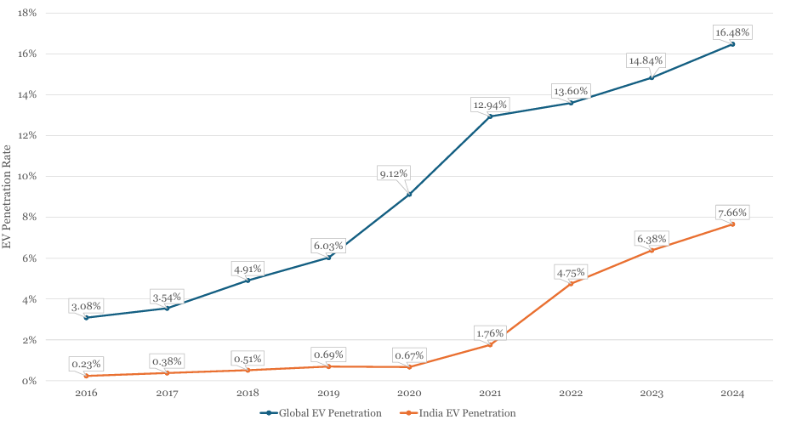
Figure 5: EV Penetration Rate – Global & India
(Source: NITI Aayog, 2025)
Figure shows India’s 2024 EV penetration at 7.66% versus 16.48% globally (NITI Aayog, 2025). This gap represents growth potential, but also lower affordability and infrastructure – Hyundai should grow in stages locally and not assume that global momentum for EVs will filter through.

3. Comprehensive and Holistic View of the Organisation

3.1 Hyundai India’s Current CSR Approach
The Hyundai Motor India Corporate Responsibility is handled by its foundation that has been active since 2006. It has programmes that cater to the needs of the environment, health, education, skills, road safety, inclusion, and community development (2026c, Hyundai Motor India). This large scope provides for legitimacy, but also has the potential to create too broad of a focus and lack of measurable outcomes. Value arises from environmental responsibility when it is correlated with knowledge, innovation and operational sustainability (Li et al. 2023). All of the programmes should therefore be linked to a clear ownership, targets and transparent evaluation.

3.2 CSR Activities and Stakeholder Impact
Current initiatives involve the communities through telemedicine, mobile health care, science lab, driver training, scholarships, and technical education support programs (Hyundai Motor India, 2025a). However, activity scale alone does not demonstrate sustained stakeholder impact.
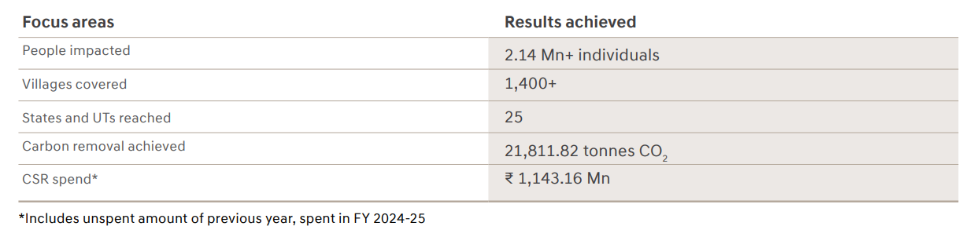
Figure 6: CSR summary FY 2024-25
(Source: Hyundai, 2025)
Such actions can enhance the accessibility, employment, security, and confidence regarding Hyundai's activities and markets. Staff and suppliers gain indirectly as the enhanced potential for local capabilities enhances recruitment, productivity and social stability. Activity numbers do not, however, reflect an ongoing stakeholder value or benefit beyond the time of funding. Resilient supply-chain management needs to be addressed holistically, aiming at social, environmental and economic management of co-connected stakeholders (Tundys and Wiśniewski 2023). Hyundai needs to provide data on employee retention, education enhancements, healthcare access, beneficiary satisfaction, and long-term community results.

3.3 Alignment of CSR with Business Objectives
The Hyundai's CSR portfolio promotes legitimacy, manpower, customer confidence, and environmental capacity. The parent company ties together the carbon neutrality, circularity, responsible sourcing, safety and human capital development (Hyundai Motor Company, 2025). It's important because there is no such thing as a stand-alone philanthropy that will ensure competitiveness in a regulated, tech-driven sector. The results of manufacturing evidence indicate that the improvement of the environmental, social and governance (ESG) performance could be a catalyst for measurable carbon reduction (Ye and Xu, 2023). However, there is no alternative to operational and product impacts reduction except social initiatives. De-carbonising the automotive sector demands coordinated transition in materials, production, energy, vehicles and end-of-life systems (Poligkeit et al. 2023). Inclusive mobility, battery recovery, responsible sourcing, cleaner factories and safer vehicles should thus be complemented by CSR.

3.4 Balanced Scorecard Introduction
A balanced scorecard is a way of translating strategy into a set of interconnected financial, customer, process and learning objectives. Green scorecards can embed environmental metrics into regular performance management and investment processes (Stavropoulou et al. 2023). Hyundai should apply this balance to profitable growth, localisation, innovation, customer value and sustainability. The measures should demonstrate causal relationships, not drive the narrow departmental goal-setting.

3.5 Financial Perspective
Hyundai’s FY2025-26 revenue rose 2.3% to ₹707,633 million, while EBITDA margin fell 0.7 percentage points, from 12.9% to 12.2% (Hyundai Motor India, 2026d). Revenue growth with margin compression implies that the revenue growth is more than the operating profitability so investment focus should be on growth quality, localization, and EV contribution margins.

3.6 Customer Perspective
Customer perspective should reinforce Hyundai's mass premium attributes of quality, safety, affordability, convenience and reliable ownership support. In total, there are over 1,500 Hyundai sales outlets and remote diagnostics, digital repair processes (Hyundai Motor India 2026e). When service quality and repair times vary from one location to another though, network size has little benefit. Scores on recommendations, repeat purchases, complaints closed, warranty frequency, turnover time and rural penetration are some of the measures. Data needs to be broken down by region, powertrain, income and dealership to reveal any potential areas of weakness.

3.7 Internal Business Process Perspective
The internal processes should speed up the localisation process without compromising on quality, safety, cyber security and manufacturing efficiency. This is accomplished when technology facilitates lean routines, engagement of employees, and structured operational problem solving (Goktas and Yumusak, 2024). Hyundai should monitor the local sourcing, development time, initial quality, defects from the suppliers, software troubleshooting, and battery tracking. The adoption of green supply-chain relies on the capabilities of firms, pressure from partners, regulations, and anticipated competitive advantages (Wang and Zhang, 2023). It is therefore relevant to consider the evaluation of suppliers by the following criteria: cost, resilience, emissions, labour practices and ability to innovate. More inter-departmental engineering, purchasing, factory, dealer and service data integration would lead to faster response time.

3.8 Learning and Growth Perspective
The skills for learning and growth should include batteries, software, analytics, automation, sustainably produced skills and customer centered innovation. Digital transformation enhances the performance of research in the automotive field when the organisation creates the necessary conditions for knowledge sharing and the use of technology (Men et al. 2023). Internal mobility, employee engagement, participation in innovation, critical role retention, and technical training and digital skills should be measured at Hyundai. Collaborations with universities, suppliers & technical institutes may foster expertise in power-electronics, software, circular-economy. The value of continuous learning lies in its ability to lead to quicker launches, better quality, and reduced costs.

3.9 Integrated Balanced Scorecard Discussion
SUVs accounted for 68.5% of the domestic sales (Hyundai Motor India Limited, 2025) in the company's FY2024-25 which clearly indicated high concentration risk and product-market fit. The scorecard should measure the profitability of SUVs along with portfolio diversity and electrification to ensure a CRETA/SUV slowdown doesn't have a disproportionate impact on results.

4. Strategic Choices and Implementation

4.1 Strategic Decision Context
Hyundai's domestic sales dropped by 12% as Mahindra's SUV sales increased by 18% during a slow period on the urban markets in June 2025 (Reuters, 2025b). The gap is a strategic one – Hyundai's loss equals other's gain – and a recovery via cheaper prices may be at the cost of sacrificing margin, but not addressing product-speed and segment-fit issues.

4.2 Current Business-Level Strategy
Today, Hyundai is pursuing a policy of 'broad differentiation' with 'local manufacturing' and ‘selective cost efficiency’ strategy. It's all in the design, features, quality, connected technology, safety, dealership support and brand of an SUV. When Electric mobility is developed, coherently associating technology and sustainability with the benefit for the stakeholders creates strategic value for the firms (Gouveia et al. 2024). But differentiation becomes more tenuous as competing products offer similar benefits at a lower cost and/or with quicker delivery. The sales of passenger vehicles in India increased by 7.9% to 4.643 million and exports by 17.5% to 905,000 in FY2025-26 (2026: Society of Indian Automobile Manufacturers). SIAM identifies domestic growth as a result of GST reduction, tax relief and lower financing cost, and exports saw consistent demand from foreign markets. Hyundai need to ride the wave of market tailwinds to secure share gains, not industry growth.

4.3 Strategic Options Available
Deeper premiumisation via bigger SUVs, enhanced safety, hybrid variants and connected services will be one way of doing this. This provides margins but quickly leads to a higher concentration and can lose price-sensitive customers. The second one is penetration via discounts, entry products and lower cost ownership packages. This may bring back volume back rapidly, however their continued discounting could reduce brand and dealer profits. Located electrified growth is best achieved by low-cost electric, hybrid and CNG vehicles and ownership support. Global prices for battery-packs decreased by over 25% in 2024, driven by competition, scale and declining battery prices, which lowered manufacturing costs (IEA, 2025). But lower battery costs aren't equal to comparable vehicle-price reductions, as trims and other factors and pricing still play a part, and Hyundai should see the drop as a chance to localise, not as a sign that mass-market EV profits are a solved problem.
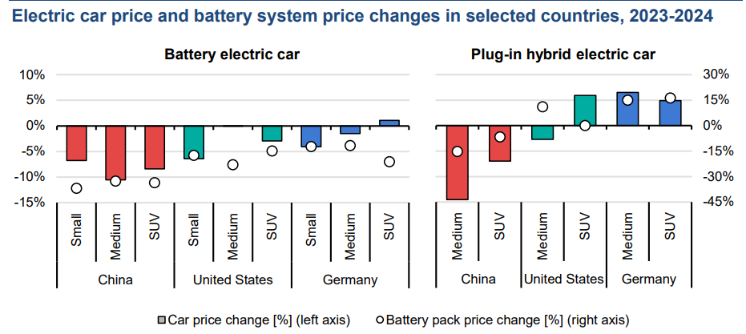
Figure 7: Electric car price and battery system price changes in selected countries, 2023-2024
(Source: Iea, 2025)
However, purchase price, charging station availability, range uncertainty, lack of knowledge, and resale issues are all adoption barriers (Zaino et al. 2024). The environmental value of EVs is also affected by the production of batteries, their power supply, and the recycling process (Mohammadi et al. 2023). A phased multi-powertrain portfolio is thus a balance between transition opportunity and affordability, and infrastructure risk.

4.4 Porter’s Five Forces Analysis
Strong competition, as there are many existing brands competing in similar car segments. Customers are price, finance, feature, economy, service and resale value conscious and there is high buyer power. The overall power of suppliers is moderate, but increases for battery, semiconductors, software and specialised electronics. Technology and integration roles are given to automotive suppliers, which increases dependence on them while also providing opportunities for collaboration (Jagani et al. 2024). There are still moderate threats from new entries as the manufacturing, regulation, distribution and trust necessary to gain entry are high. Substitution is limited, but public transport, ride sharing and car sharing can help to diminish the demand for ownership. Electric supply chains are still complex and ecosystem coordination is still a key competitive demand (Soares et al. 2023). Overall, industry pressure favours localisation, cost control and differentiated ownership value.

4.5 Ansoff Matrix
Market penetration would increase the existing sales via coverage, finance offers, consistency in service and retention. Introduce locally made electric, hybrid, CNG and safer compact vehicles in product development. Supply-chain integration is driven by the coordination of information, resources, and partners, which enhances product innovation and sustainable operations (Ali and Mahmood, 2024). Utilize existing and expanded Indian capacity to meet new emerging demand in the export markets. Charging, subscriptions and mobility services are potential diversification areas, but come with more execution risk. PM E-DRIVE provides ₹10,900 crore, including ₹2,000 crore for public charging infrastructure (Ministry of Heavy Industries, 2025). Hyundai needs to focus on market penetration and product development with a mix of partnerships in the adjacent services.

4.6 SAFe Evaluation
The localised electrified SUVs are well-considered solutions that satisfy regulation, aspiration, localisation and Hyundai’s market reputation. Acceptable, albeit margins may be diluted during initial localisation, as shareholders are supportive of growth. There's a need for dealers to be trained and have viable service revenues, and customers need warranties, resale support and the right battery information. The feasibility is moderate to high due to Hyundai's factory, engineering access, suppliers, distribution and investment. Battery dependency, software capability, the reliability of charging and availability of suppliers are significant constraints, however. Supply-chain integration, by coordinating supply-side resources, information, and risk responses, enhances resilience ( Zhang et al. 2024). Therefore, the option qualifies for SAFe as long as it is slowly carried out in the course of partnerships, milestones and rigorous budget oversight. If there were no infrastructure evidence, the acceptance and feasibility of the immediate nationwide launch would be reduced.

4.7 Recommended Strategy and Expected Value
Hyundai needs to develop localised, affordable multi-powertrain SUV leadership based on electric vehicles as a growing strategic core. Local platforms and parts should be shared among compact SUVs, hybrids, CNG and electric vehicles. A single Battery Ownership Proposal should include Battery warranties, resale support, home charging, and public partnerships. Shared architectures and localisation should help to decrease unit cost, development time, and foreign-exchange exposure. Before making any large commitments of national funds, regional pilots should check the demand and ownership economics.

4.8 Implementation Challenges and Mitigation
Challenges range from battery reliance to supply chain shortages, lack of consistent charging infrastructure, software vulnerabilities, dealer preparedness to demand and the uncertainty of customer demand. Hyundai needs to have a programme office with direct access to the senior leadership and cross-functional authority. The first phase should be focused on prioritising components, defining batteries and quality standards and suppliers. The second phase should begin in cities where there is more charging coverage, and customer interest. Before expanding to other regions, dealer techs, sales and emergency partners must be certified. The data that the pilot report should include should include range, charging failures, warranty claims, service time, and resale expectations. The investment gates should be based upon the demand, localisation, quality and contribution margin thresholds only. Commodity inflation, currency fluctuation, policy changes, and supplier delay should be considered, and it's a scenario planning.

Section 2

5. Reflective Account Using Gibbs’ Reflective Cycle

5.1 Description
This was an assignment that involved strategizing Hyundai Motor India in a dynamic Indian market. I studied the factors of context, external pressures, resources, responsibility, performance management, strategic options and implementation requirements. The frameworks used were: PESTEL, VRIO, SWOT, Porter's Five Forces, Ansoff, balanced scorecard and, SAFe. The primary focus was to link evidence to judgement and not describe the individual frameworks. The recommendation came from a comparison of Hyundai's capabilities, affordability and localisation and electrification needs.

5.2 Feelings
At first, I was sure I could name some obvious Hyundai strengths, such as its brand and SUV lineup. But, as share of the market fell, I began to wonder if these strengths were still relevant. This was difficult since the same capabilities that were well-known before might not necessarily be sustainable advantages. I was also unsure about the environmental opportunities versus the battery, charging, electric and affordability constraints. Gradually, in the course of research, I found a relationship between external pressure, internal ability and implementation.

5.3 Evaluation
The most positive aspect of my approach was the ability to alternate multiple frameworks around a strategic problem. PESTEL tested external changes and VRIO tested if Hyundai could cope with it. SWOT helped synthesize and SAFe kept the recommendation from being unrealistic and from ignoring concerns with stakeholders. There is recent evidence that replaced the broad claims with market, financial, operational and social indicators. My early work did involve too much description, though, because each framework brought up its own set of factor lists. I also overused the good attributes as if they were the only ones rather than going by the comparisons with the domestic competitors. Improvements to critical balance and links to the evidence in the recommendation through revision.

5.4 Analysis
The Assignment proved that strategic analysis needs prioritisation as there are numerous factors that are relevant to an organisation. Using frameworks is only helpful if they explain consequences of demand, costs, capabilities, risks, and competition. I discovered that it is possible to have declining market share, be strong on revenue, be resilient on margins and still be recognized on brands. Thus, any one indicator is not necessarily an accurate measure of strategic health or the appropriate reaction. I also realized the need to examine the concepts of corporate responsibility and competitive strategy in a holistic way. Legitimacy and capability can be provided by environmental investment, technical education, road safety and community health. But these gains are elusive in the case of organisations that report activities without similar results. The balanced scorecard linked the learning, processes, customer outcomes, and financial results via causal logic. Porter's model emphasized pressure and Ansoff model understood growth directions and relative risk. SAFe reinforced judgment by conducting a test that determined if the preferred option aligned with resources' and stakeholders' expectations. This integration resulted in connected reasoning being a more important factor in the quality of recommendations than the number of frameworks. The electrification process is not only one product decision, but is a transition pathway. All of the above must grow along side the battery. As such, my recommendation was to not immediately pursue full electrification, but rather phased, localised, multi-powertrain.

5.5 Conclusion
This analysis enhanced my skills in taking the step from descriptive information to justified strategic judgement. I was taught to exploit the seemingly strengths by their rarity, by being imitated, by organisation and by modifying the competitor's ability. There also needs to be a clear focus on trade-offs, timeline, risk and stakeholder buy-in for strategic decisions. My opinion became more firm than if I'd just considered electrification without considering other alternatives. There was also some numerical evidence that needed interpretation as to growth, for margin pressure or relative weakness may both be hidden in a growth. As a whole, critical structure was able to make individual findings more cohesive and able to respond to Hyundai's strategic problem.

5.6 Action Plan
For my future assignments, I will work out the decision problem first, then gather lots of data. I will create links between evidence and claims, limitations, frameworks and recommendations for each piece of evidence. It should minimize repeating and the unsupported statements from getting into the final analysis. I will make a comparison between corporate and academic, government, industry and news sources later. I will rate the factors in terms of impact, urgency, uncertainty and managerial control, before drafting. Each framework will address a particular question, not be a standalone descriptive exercise. I will evaluate the recommendations by financial, operational, ethical and implementation views. Lastly, I will examine systematically paragraph logic, citations, length of sentences, and balance of sources.

References
Alanazi, F. (2023) ‘Electric vehicles: benefits, challenges, and potential solutions for widespread adaptation’, Applied Sciences, 13(10), article 6016. Available at: https://doi.org/10.3390/app13106016
Ali, A.A. and Mahmood, A. (2024) ‘How do supply chain integration and product innovation capability drive sustainable operational performance?’, Sustainability, 16(1), article 277. Available at: https://doi.org/10.3390/su16010277
Alkhalidi, A., Khawaja, M.K. and Ismail, S.M. (2024) ‘Solid-state batteries, their future in the energy storage and electric vehicles market’, Science Talks, 11, article 100382. Available at: https://doi.org/10.1016/j.sctalk.2024.100382
Alonso-Cepeda, A., Villena-Ruiz, R., Honrubia-Escribano, A. and Gómez-Lázaro, E. (2024) ‘A review on electric vehicles for holistic robust integration in cities: history, legislation, meta-analysis of technology and grid impact’, Applied Sciences, 14(16), article 7147. Available at: https://doi.org/10.3390/app14167147
Anilan, V. and Vij, A. (2024) ‘Taking the wheel: systematic review of reviews of policies driving BEV adoption’, Transportation Research Part D: Transport and Environment, 136, article 104424. Available at: https://doi.org/10.1016/j.trd.2024.104424
AP News (2023) ‘India is one of the world’s fastest-growing EV markets. This is why’, AP News, 30 August. Available at: https://apnews.com/article/electric-vehicles-india-boom-rickshaws-55e7ed315fc41d0ba56461386ad44a4b (Accessed: 9 August 2026).
CRISIL Market Intelligence & Analytics (2024) Industry report on the passenger vehicle industry in India – update: Hyundai Motor India Ltd. Available at: https://device.report/m/7ce67e36bb4d38a06825a99ab5b9e5cfca659d5b650045d735b4ab628c7885fd.pdf (Accessed: 9 August 2026).
Deloitte (2024a) 2024 Global Automotive Consumer Study: key findings—global focus countries. Available at: https://www2.deloitte.com/content/dam/Deloitte/at/Documents/presse/at-deloitte-global-automotive-consumer-study-2024.pdf (Accessed: 9 August 2026).
Deloitte (2024b) 2024 Global Automotive Consumer Study: the evolution of mobility. Available at: https://deloitte.wsj.com/sustainable-business/2024-global-automotive-consumer-study-the-evolution-of-mobility-ea70756a (Accessed: 9 August 2026).
Diouf, B. (2025) ‘Is the grid ready for the electric vehicle transition?’, Energies, 18(17), article 4730. Available at: https://doi.org/10.3390/en18174730
Garcia, E., Johnston, J., McConnell, R., Palinkas, L.A. and Eckel, S.P. (2023) ‘California’s early transition to electric vehicles: observed health and air quality co-benefits’, Science of the Total Environment, 867, article 161761. Available at: https://doi.org/10.1016/j.scitotenv.2023.161761
Goktas, H.O. and Yumusak, N. (2024) ‘Applying the Delphi method to assess critical success factors of digitalization while sustaining lean at a lean automaker’, Sustainability, 16(19), article 8424. Available at: https://doi.org/10.3390/su16198424
Gouveia, S., de la Iglesia, D.H., Abrantes, J.L., López Rivero, A.J., Silva, E., Gouveia, E. and Santos, V. (2024) ‘Electrifying strategic management: leveraging electric vehicles for sustainable value creation?’, Energies, 17(18), article 4581. Available at: https://doi.org/10.3390/en17184581
Gupta, A., Singh, R.K., Paul, J., Sharma, M. and Joshi, S. (2024) ‘Battery-operated electric vehicles adoption in India: analysis of barriers and strategies’, IEEE Transactions on Engineering Management, 71, pp. 7076–7087. Available at: https://doi.org/10.1109/TEM.2023.3253621
Haghani, M., Sprei, F., Kazemzadeh, K., Shahhoseini, Z. and Aghaei, J. (2023) ‘Trends in electric vehicles research’, Transportation Research Part D: Transport and Environment, 123, article 103881. Available at: https://doi.org/10.1016/j.trd.2023.103881
Haghani, M., Ghaderi, H. and Hensher, D.A. (2024) ‘Hidden effects and externalities of electric vehicles’, Energy Policy, 194, article 114335. Available at: https://doi.org/10.1016/j.enpol.2024.114335
Hyundai (2025) CSR summary FY 2024–25. Available at: https://www.hyundai.com/content/dam/hyundai/in/en/images/investor-relations/annualreports/Social%E2%80%93Community.pdf (Accessed: 9 August 2026).
Hyundai Motor Company (2025) Sustainability report 2025. Available at: https://www.hyundai.com/worldwide/en/company/sustainability/sustainability-report (Accessed: 9 August 2026).
Hyundai Motor India (2025) CSR activities 2024–2025. Available at: https://www.hyundai.com/content/dam/hyundai/in/en/data/hyundai-story/csr/csr-intiatives-2024-25.pdf (Accessed: 9 August 2026).
Hyundai Motor India (2026a) About Hyundai Motor India. Available at: https://www.hyundai.com/in/en/hyundai-story/hyundai-motor-india/about-us (Accessed: 9 August 2026).
Hyundai Motor India (2026b) Corporate social responsibility. Available at: https://www.hyundai.com/in/en/hyundai-story/csr (Accessed: 9 August 2026).
Hyundai Motor India (2026c) Hyundai CRETA specifications. Available at: https://www.hyundai.com/in/en/find-a-car/creta/specification (Accessed: 9 August 2026).
Hyundai Motor India (2026d) Hyundai Motor celebrates 30 glorious years in India. Available at: https://www.hyundai.com/in/en/hyundai-story/media-center/press-release/hmil-celebrates-30-glorious-years-in-india (Accessed: 9 August 2026).
Hyundai Motor India (2026e) Hyundai Motor India Limited Q4 and FY26 financial results. Available at: https://www.hyundai.com/in/en/hyundai-story/media-center/press-release/hmil-limited-Q4-and-FY26-financial-results (Accessed: 9 August 2026).
Hyundai Motor India (2026f) Investor relations. Available at: https://www.hyundai.com/in/en/investor-relations (Accessed: 9 August 2026).
Hyundai Motor India Limited (2025a) Integrated annual report 2024–25. Available at: https://www.hyundai.com/in/en/investor-relations/financial-information/reports/annual-report-digital-summary (Accessed: 9 August 2026).
Hyundai Motor India Limited (2025b) Management discussion and analysis: integrated annual report 2024–25. Available at: https://www.hyundai.com/content/dam/hyundai/in/en/images/investor-relations/annualreports/MDA.pdf (Accessed: 9 August 2026).
International Energy Agency [IEA] (2024) Global EV outlook 2024: moving towards increased affordability. Available at: https://www.iea.org/reports/global-ev-outlook-2024 (Accessed: 9 August 2026).
International Energy Agency [IEA] (2025a) Global EV outlook 2025: expanding sales in diverse markets. Available at: https://iea.blob.core.windows.net/assets/7ea38b60-3033-42a6-9589-71134f4229f4/GlobalEVOutlook2025.pdf (Accessed: 9 August 2026).
International Energy Agency [IEA] (2025b) Global EV outlook 2025: trends in electric-car affordability. Available at: https://www.iea.org/reports/global-ev-outlook-2025/trends-in-electric-car-affordability (Accessed: 9 August 2026).
Jagani, S., Marsillac, E. and Hong, P. (2024) ‘The electric vehicle supply chain ecosystem: changing roles of automotive suppliers’, Sustainability, 16(4), article 1570. Available at: https://doi.org/10.3390/su16041570
Kumar, N., Wang, Y., Chin, J.-X. and Raubal, M. (2025) ‘Quantifying the impacts of non-recurrent congestion on workplace EV charging infrastructures’, Transportation Research Part D: Transport and Environment, 146, article 104869. Available at: https://doi.org/10.1016/j.trd.2025.104869
Li, W., Bhutto, M.Y., Waris, I. and Hu, T. (2023) ‘The nexus between environmental corporate social responsibility, green intellectual capital and green innovation towards business sustainability’, International Journal of Environmental Research and Public Health, 20(3), article 1851. Available at: https://doi.org/10.3390/ijerph20031851
Men, F., Dong, F., Liu, Y. and Yang, H. (2023) ‘Research on the impact of digital transformation on the product research and development performance of automobile enterprises’, Sustainability, 15(7), article 6265. Available at: https://doi.org/10.3390/su15076265
Ministry of Heavy Industries, Government of India (2024) PM Electric Drive Revolution in Innovative Vehicle Enhancement—PM E-DRIVE. Available at: https://pmedrive.heavyindustries.gov.in/ (Accessed: 9 August 2026).
Ministry of Heavy Industries (2025) ‘EV charging infrastructure under PM E-DRIVE scheme’, Press Information Bureau, 5 December. Available at: https://www.pib.gov.in/PressReleasePage.aspx?PRID=2199445 (Accessed: 9 August 2026).
Mohammadi, M., Thornburg, J. and Mohammadi, J. (2023) ‘Towards an energy future with ubiquitous electric vehicles: barriers and opportunities’, Energies, 16(17), article 6379. Available at: https://doi.org/10.3390/en16176379
NITI Aayog (2025) Electric vehicles in India. Available at: https://niti.gov.in/sites/default/files/2025-08/Electric-Vehicles-WEB-LOW-Report.pdf (Accessed: 9 August 2026).
Pamidimukkala, A., Kermanshachi, S., Rosenberger, J.M. and Hladik, G. (2024) ‘Barriers and motivators to the adoption of electric vehicles: a global review’, Green Energy and Intelligent Transportation, 3(2), article 100153. Available at: https://doi.org/10.1016/j.geits.2024.100153
Poligkeit, J., Fugger, T. and Herrmann, C. (2023) ‘Decarbonization in the automotive sector: a holistic status quo analysis of original equipment manufacturer strategies and research topics’, Sustainability, 15(22), article 15753. Available at: https://doi.org/10.3390/su152215753
Pourzolfaghar, H., Wang, P.-Y., Jiang, X.-Y., Kositsarakhom, S. and Jirasupcharoen, W. (2024) ‘Emerging trends and innovations in all-solid-state lithium batteries: a comprehensive review’, Chemical Engineering Journal, 500, article 157394. Available at: https://doi.org/10.1016/j.cej.2024.157394
Reuters (2024) ‘Hyundai plots India SUV rollout as domestic competition mounts ahead of IPO’, Reuters, 29 August. Available at: https://www.reuters.com/business/autos-transportation/hyundai-plots-india-suv-rollout-domestic-competition-mounts-ahead-ipo-2024-08-29/ (Accessed: 9 August 2026).
Reuters (2025a) ‘Indian carmakers’ sales to dealers grew 2% in fiscal year 2025, industry body says’, Reuters, 15 April. Available at: https://www.reuters.com/business/autos-transportation/indian-carmakers-sales-dealers-grew-2-fiscal-year-2025-industry-body-says-2025-04-15/ (Accessed: 9 August 2026).
Reuters (2025b) ‘Top Indian carmakers’ sales slump in June amid weak urban demand’, Reuters, 1 July. Available at: https://www.reuters.com/world/india/top-indian-carmakers-sales-slump-june-amid-weak-urban-demand-2025-07-01/ (Accessed: 9 August 2026).
Romano, E., Koirala, B., Rüdisüli, M. and Eggimann, S. (2025) ‘Emission-responsive charging of electric cars and carsharing to improve the security of electricity supply for Switzerland’, Environmental Science & Technology, 59(29), pp. 15057–15069. Available at: https://doi.org/10.1021/acs.est.4c13270
Satrio, J., Juned, M. and Salam, S. (2024) ‘International and domestic factors of battery electric vehicle technology diffusion in Japan’, East Asia, 41(2), pp. 109–127. Available at: https://doi.org/10.1007/s12140-023-09418-4
Soares, L.O., Reis, A.C., Vieira, P.S., Hernández-Callejo, L. and Boloy, R.A.M. (2023) ‘Electric vehicle supply chain management: a bibliometric and systematic review’, Energies, 16(4), article 1563. Available at: https://doi.org/10.3390/en16041563
Society of Indian Automobile Manufacturers (2026) Auto industry performance of Q4 and FY2025–26. Available at: https://www.siam.in/pressrelease-details.aspx?pid=605 (Accessed: 9 August 2026).
Stavropoulou, E., Spinthiropoulos, K., Ragazou, K., Papademetriou, C. and Passas, I. (2023) ‘Green balanced scorecard: a tool of sustainable information systems for an energy efficient business’, Energies, 16(18), article 6432. Available at: https://doi.org/10.3390/en16186432
The Economic Times (2025) ‘Hyundai sends fact-finding team to India as market share hits 12-year low’, The Economic Times, 15 May. Available at: https://economictimes.indiatimes.com/industry/auto/auto-news/hyundai-sends-fact-finding-team-to-india-as-market-share-hits-12-year-low/articleshow/121195494.cms (Accessed: 9 August 2026).
Tundys, B. and Wiśniewski, T. (2023) ‘Triple bottom line aspects and sustainable supply chain resilience: a structural equation modelling approach’, Frontiers in Environmental Science, 11, article 1161437. Available at: https://doi.org/10.3389/fenvs.2023.1161437
Wang, M. and Zhang, G. (2023) ‘What motivates firms to adopt a green supply chain and how much does it matter?’, Frontiers in Environmental Science, 11, article 1227008. Available at: https://doi.org/10.3389/fenvs.2023.1227008
Wicki, M., Brückmann, G., Quoss, F. and Bernauer, T. (2023) ‘What do we really know about the acceptance of battery electric vehicles? Turns out, not much’, Transport Reviews, 43(1), pp. 62–87. Available at: https://doi.org/10.1080/01441647.2021.2023693
Ye, J. and Xu, W. (2023) ‘Carbon reduction effect of ESG: empirical evidence from listed manufacturing companies in China’, Frontiers in Ecology and Evolution, 11, article 1311777. Available at: https://doi.org/10.3389/fevo.2023.1311777
Zaino, R., Ahmed, V., Alhammadi, A.M. and Alghoush, M. (2024) ‘Electric vehicle adoption: a comprehensive systematic review of technological, environmental, organizational and policy impacts’, World Electric Vehicle Journal, 15(8), article 375. Available at: https://doi.org/10.3390/wevj15080375
Zhang, Q., Feng, Y. and You, L. (2024) ‘Research on the impact of supply chain integration on supply chain resilience in new-energy vehicle manufacturing enterprises’, Sustainability, 16(19), article 8546. Available at: https://doi.org/10.3390/su16198546

