
UNIVERSITY OF WALES TRINITY SAINT DAVID
London Campus
SOFTWARE SOLUTIONS FOR BUSINESS
Component 1 – Coursework Portfolio
A practical evaluation of contemporary software solutions for a simulated sustainable stationery SME
Student name | EUGEN IORGU
Student ID | 2539957
Programme | CertHE Computing Skills for Workplace
Module | Software Solutions for Business
Module code | ACCA4026
Lecturer | Kwame Assa-Agei
Internal verifier | Fahed Ahmed
Submission date | Tuesday, 11 August 2026
Campus | London Campus
Referencing style | IEEE

Table of Contents
1. Introduction and Portfolio Context 3
2. Task 1: e-Commerce Website Builders 3
2.1 Evaluation Criteria 3
2.2 BigCommerce 4
2.3 Squarespace Commerce 4
2.4 Comparison and Recommendation 5
3. Task 2: Mind-map of Contemporary Software Applications 6
3.1 Mind Mapping and Business Value 6
3.2 Benefits, Limitations and Responsible Use 6
3.3 Mind Map for Leaf & Loom Stationery 7
4. Task 3: Office Applications for Creating, Storing, Presenting and Analysing Information 8
4.1 Microsoft Word 8
4.2 Microsoft PowerPoint 8
4.3 Microsoft Excel 9
4.4 Microsoft Access 9
4.5 Integrated Office Workflow 10
4.6 Practical Test 1: Excel VLOOKUP 10
4.7 Practical Test 2: Excel Goal Seek 11
5. Task 4: Communication and Collaboration Applications 12
5.1 Communication Application: Slack 12
5.2 Online Collaboration Application: Google Docs 13
5.3 Combined Use and Critical Analysis 13
5.4 Practical Testing and Screenshot Evidence 14
6. Overall Conclusion and Recommendations 14
References 16
Appendices 18
Appendix A – Squarespace Commerce Exploration 18
Appendix B – BigCommerce Exploration 19
Appendix C – Miro Mind Map Practical Evidence 20
Appendix D – Excel VLOOKUP Practical Evidence 21
Appendix E – Excel Goal Seek Practical Evidence 22
Appendix F – Slack Communication Practical Evidence 25
Appendix G – Google Docs Collaboration Practical Evidence 26

1. Introduction and Portfolio Context
This portfolio assesses software solutions that might assist a mock small business, known as Leaf & Loom Stationery a retailer of eco-friendly products based in London. The organisation is employed solely as a model: there is no real customer, employee, supplier or financial information. The context offers a steady method for assessing if each application enhances the business processes, instead of only writing down advertised features. It evaluates usability, quality of information, collaboration and scalability, security, integration and determines the level to which a small team requires control over it.
Instead, a sound software decision should link functionality to impacts on business operations. Because of this, benefits and constraints are highlighted for each section, and the practical tests use intentionally simple simulated data that can be verified. The portfolio also takes account of governance where necessary, in terms of who owns the data, who has editing rights; how versions should be controlled; and how a result is validated before it influences a business decision. The final recommendations therefore steer away from one-size-fits-all and accept that most feature-rich product is not the best choice in all circumstances.

2. Task 1: e-Commerce Website Builders

2.1 Evaluation Criteria
A website builder for e-commerce unifies a customer-facing website and functionality necessary to sell on the web: sites with product pages, checkout, payment processing, order processing and inventory management operations. As an example, Leaf & Loom Stationery may require a simple platform that enables a small team of people to establish credible corporate identity, run a light product catalogueue, handle physical order fulfilment as well as performance reporting without the overhead of having to manage some custom tech stack. Hence, the comparison used a total of six criteria: ease of administration, storefront flexibility, commerce depth, multichannel capability and integration potential and level of likely management complexity.
BigCommerce and Squarespace Commerce are relatively newer, but they make very different strategic choices. BigCommerce is a wide commerce platform with omnichannel-friendly features, catalogue management, B2B and extensibility as its centre of gravity; Squarespace places design and content at the forefront within an integrated website-and-commerce environment. BigCommerce's on-product details confirm the platform supports multi-storefront and omnichannel features [1] whilst Squarespace has shipping, fulfilment, taxes, payments and order management baked into its commerce platform [2].

2.2 BigCommerce
BigCommerce is a hosted e-commerce solution designed to manage the entire cycle of selling online. You have storefront design and product and catalogue management, checkout, payments integrations and omnichannel selling; products can be synchronised to channels through marketplaces or social platforms. This is important in the case that a retailer expects the website to become complementary to a more extensive sales architecture. For Leaf & Loom, theoretically one product catalogue can power the main site today while later adding marketplace or social-selling channels for the business.
The main advantage is operational depth. A commerce-focused system decreases the need to cobble together standalone tools for every selling task and provides an easier path to more complicated needs as a retailer expands. That very same breadth is a constraint for micro-business. Higher costs, integrations and configuration choices mean more administration that must be governed. The visual guide is intended to make it easier for companies to execute their strategy in a nimble and responsive way, but if you are only going to be running a small catalogue then multi-storefront, B2B or headless might not be required yet either so the organisation will effectively be paying with learning time and process complexity for an ability they do not yet use. Integration leads to data-governance issues; when product descriptions, prices or stock valuations are modified in multiple linked systems, the business must determine which system is master [1].
BigCommerce is going to be best suited if Leaf & Loom sees their catalogue growing quickly or has integrated multichannel and/or more complex sales needs. It becomes a lot less attractive if the requirement would be a small, visually consistent store managed by one or two non-technical team members. For a business case to be made the feature count will create an offering but whether that offering really removes an operating model constraint is much more pertinent.

2.3 Squarespace Commerce
Squarespace Commerce provides integrated website creation and online-store management. Its commerce ecosystem offers a suite of services related to payment, checkout, shipping and fulfilment, taxes, orders and customer engagement. Its design-oriented approach has particular relevance for Leaf & Loom because stationery products are primarily visually differentiated and the same site requires product pages, brand storytelling elements, sustainability information and editorial content. This allows a single interface to serve both merchandising and non-commerce content, with routine changes occurring without developer involvement [2].
The main advantage for a small retailer is lower coordination overhead. Pages, products and core commerce activities are done all in one place. This mitigates the risk of rolling out multiple overlapping systems ahead of process maturity. But visual flexibility is not necessarily operational scalability. A specialist commerce platform may be a better fit if a business were later to grow complex B2B pricing, multiple storefronts or more complex marketplace logic. And the team should recognise that a polished presentation does not guarantee information quality; poor stock data, unfocused product descriptions or “light” fulfilment processes do not become business problems if the website looks good.
Squarespace is well suited to today as its fast turnarounds and a small catalogue, a brand led business model makes simplicity/presentation strategic. The recommendation is still conditional and should therefore be reassessed periodically. If the number of sales channels or products increases materially, or additional integrations are required, Leaf & Loom may want to consider how well the platform supports their operating model.

2.4 Comparison and Recommendation
Criterion | BigCommerce | Squarespace Commerce | Judgement for Leaf & Loom
Primary emphasis | Commerce depth and scale | Integrated design, content and commerce | Current need favours integrated simplicity.
Multichannel potential | Strong omnichannel and catalogue capabilities | Suitable core store with integrations | BigCommerce stronger if channel complexity grows.
Content and brand control | Capable storefront tools | Design-led website environment | Squarespace suits a visual stationery brand.
Administration | More commerce options to configure | Lower-friction small-business workflow | Squarespace is easier to govern at the present scale.
Main management risk | Complexity and integration sprawl | Outgrowing simpler operating model | Review needs as scale changes.

Table 1. Decision comparison of BigCommerce and Squarespace Commerce
Recommendation: Since the immediate need is for a simple, content-rich store for a small catalogue rather than a complex multichannel architecture, we recommend the Leaf & Loom start off with Squarespace Commerce. If the company later needs multiple storefronts, more robust channel synchronisation, or sophisticated commerce workflows, BigCommerce is really a better contingency. Vendor lock-in is a concern, so the business should guarantee clean exports of product data, document ownership of product information while reviewing platform fit at least once per year.

3. Task 2: Mind-map of Contemporary Software Applications

3.1 Mind Mapping and Business Value
A visual format that is not a linear process, it places the central theme in the centre of a chart, then other ideas pop off individually through sub-branches. The technique is beneficial when a team is still investigating the problem instead of committing to a set sequence by documenting it in Miro or another digital tool Through these tools the map can be rearranged, iterated on and shared collaboratively. What you do in a business context is not that a mind map generates an automatically correct solution. Its strength is that it brings assumptions, categories and relations to visibility with enough time for people to challenge them [3].
Much of the research on mind mapping has been conducted in educational settings, therefore care should be taken when transferring findings to a business context. A systematic review from 2024 reported benefits of organisation, synthesis, participation and critical engagement with some implementing challenges in one or more locations for each reviewed study [4]. In another study of collaborative digital mind-mapping, a 2024 study found evidential support for structured collaborative mapping resources facilitating creative thinking in its context. Such results do not confirm a direct causal link between business mind mapping and improved bottom line profitability but rather offer at least prima facie support for the proposition that visual structuring and collaboration will enhance higher-level exploratory processing of complex information [5].

3.2 Benefits, Limitations and Responsible Use
Cognitive organisation for business operations is the first benefit. Software decisions consist of overlapping functions: an e commerce platform generates order data, excel might analyse it, Slack might discuss exceptions, Google Docs might store the agreed decision process and finance software records the final transaction. A map is a much better way of showing these dependencies than you are likely to achieve with a long list. The second characteristic is cooperative planning. Team members can identify overlooked applications, discover duplicate functions and discuss who owns what before any budget or timelines are allocated. The third is communication: a visual representation allows a business owner without technical skills to quickly see the different systems, what they do and the one processing all activity.
Mind maps also have limitations. They suffer from oversimplification of relations that are either conditional or cyclical, and a graphically pleasing diagram may disguise fragile evidence. Big maps become unreadable, collaborative boards can grow duplicate branches or very general labels. Before purchasing or implementing software, Leaf & Loom should validate relevant branches against requirements, costs, security controls and measurable process outcomes.

3.3 Mind Map for Leaf & Loom Stationery
Figure 1: Map of the primary software categories that may assist the simulated retailer. The design principle is deliberate level of role clarity. Online selling is supported by Squarespace or BigCommerce; document creation, analysis and structured records are supported by Microsoft Office; operational communication is supported with Slack; shared documents are supported in Google Docs and Drive; specialist capabilities exist within CRM, finance, marketing and security applications. It reveals a governance issue too if every tool is its own source of customer, stock or supplier data then the business risks duplication rather than improving productivity. Hence, application selection needs to go together with the design for integration and data ownership.
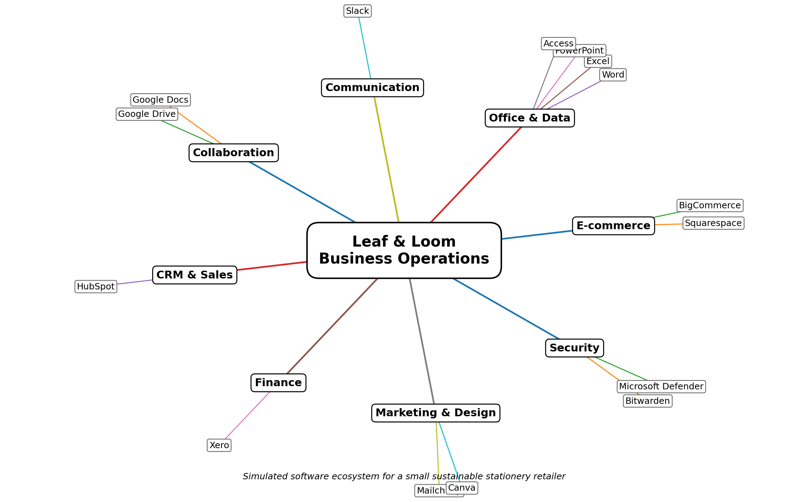
Figure 1. Mind map of contemporary applications supporting Leaf & Loom business operations
The map suggests a phased architecture. Phase one should focus on the commerce platform, Office applications, Slack and Google Docs because these directly support selling, analysis and coordination. CRM and more sophisticated finance or marketing integrations can be added after workflows and data ownership are stable. This reduces the risk of purchasing overlapping subscriptions before the business understands which application should hold each type of information.

4. Task 3: Office Applications for Creating, Storing, Presenting and Analysing Information

4.1 Microsoft Word
Microsoft Word is a document-production application for largely structured narrative information that includes reports, policies, letters, procedures (perhaps more titles when considering desktop publishing) and proposals. Styles and templates can also standardise headings, fonts and page layout; tables and images combine text with evidence; references support academic or professional sourcing, while review functions allow for controlled editing. Microsoft Track Changes records insertions, deletions and reviewer identities to make the switch between accepted and rejected changes rather than overwriting original language in silence [6].
Word for supplier onboarding policy, complaints policy, employee handbook or product quality report the primary advantage is the standardisation it brings: a controlled template can streamline the re-creation of document structure and facilitate clearer outputs. Tools such as review also provide visibility into responsibility when multiple people are involved. One limitation is that Word still is a very flexible platform. Users can override styles, introduce inconsistent formatting, create multiple versions or hidden comments and tracked changes left behind in a final file. The control response is procedural: using approved templates, naming files meaningfully, common storage, version history and a final document check. Word is great for formal written narrative content and should not be the authoritative source for transactional stock and order data.

4.2 Microsoft PowerPoint
Microsoft PowerPoint pulls highlighted data and transforms it into a narrative slide format. Key features include Themes, Slide Master, Charts, Tables, Diagrams, images, Audio or video and Speaker notes and Presenter View shows current slide, next slide and notes to the presenter while the audience sees the presentation itself. The rationale is based on a helpful communication principle: the slide can show the punch line, while support for that punch line can be deferred to notes or an underlying report [7].
Leaf & Loom might deploy PowerPoint for a monthly trade review, vendor pitch, personnel or product-launch briefing. The advantage is its focus: a carefully designed data presentation highlights the few findings that require decision-making. It also maintains a uniform visual identity as managed using Slide Master. That very ability to simplify is what makes it limited. Text-heavy slides can overwhelm the audience, whereas very polished graphs can conceal inflexible data or tentative opinions. Animations and larger media files may also add distraction or compatibility issues. PowerPoint is, for managerial use, verified analysis communicated from Excel (or elsewhere) and not the place where the analysis is performed.

4.3 Microsoft Excel
Microsoft Excel is a spreadsheet application that helps you organise structured data in tables, perform calculations using formulas, explore and analyse data visually. Supports Functions, Sorting and Filtering, Validation, Charts, PivotTables and What-If Analysis. Additional features tested further in this portfolio include lookup functions such as VLOOKUP, which searches the first column of a table for a lookup value and returns a value from the same row and allowing for both exact and approximate match options [8] and Goal Seek which reverses the logic chain from formula output to finding the input required to achieve that result [9].
Fast adaptability and transparency of model logic are what make Excel so attractive for small businesses. Leaf & Loom might find it helpful to calculate product prices, compare suppliers, analyse reorders and summarise budgets and sales. Yet spreadsheet flexibility creates control risk. Formulas can be overwritten, copied incorrectly or depend on unstated assumptions; source data and outputs can become muddled up; email versions can branch out. A 2024 literature review showed the significance of faults in spreadsheets, as such errors can call conclusions and decisions into question. Practical controls include separate areas for input and calculation, data validation, protected formula cells, clear units, documented assumptions and independent checking of calculations that matter (key profitability drivers). Excel can perform well for analysis but is not a replacement for using a relational database [10].

4.4 Microsoft Access
It is a relational database application with tables, relationships, queries, forms and reports (Microsoft Access). According to Microsoft, a well-designed database allows you to store each item of information once and then use relationships and other objects to retrieve or present the data. A relational design separates Products, Suppliers and Purchase Orders into distinct entities joined through keys. This avoids the need for repeated redundancy and enables validation rules to be enforced at the time of data entry [11].
Here is an Access prototype for Leaf & Loom: a Products table (ProductID, description and current supplier), a Suppliers table (SupplierID and contact details) and a PurchaseOrders table referencing the relevant IDs. Queries can identify all products belonging to a specific supplier, or orders that were still awaiting delivery, forms used for more streamlined data entry and reports for summarising the results for management. The caveat, of course, is that the quality of databases depends on writing good designs. Any absence of unique keys, duplicated fields or erroneous relationships can lead to bugs, which become increasingly difficult to fix once the records have increased in volume. Access is not automatically the right long-term platform for every scaling business. If you are constantly handling high transaction volumes, have a great deal of remote access, and need to have adequate uptime or large numbers of simultaneous users at the same time, migrating to a server or cloud-based business system may help. As such, the database shouldn't be used just because it is a Microsoft application but should fit to your requirements.

4.5 Integrated Office Workflow
Application | Primary information type | Best-fit business use | Key limitation / control
Word | Narrative and formal documents | Policies, reports, procedures | Formatting/version inconsistency; use templates and controlled storage.
PowerPoint | Visual and spoken communication | Briefings, pitches, management reviews | Oversimplification; keep source analysis outside slides.
Excel | Tabular data, models and calculations | Pricing, budgets, stock and analysis | Formula/data risk; validate inputs and review calculations.
Access | Relational records | Structured product/supplier/order prototype | Requires database design and governance; reassess scalability.

Table 2. Comparative business use of Microsoft Office applications
The strongest workflow assigns each application a distinct role. Access can hold structured records; Excel can analyse exported or linked data; Word can document the procedure and management rationale; and PowerPoint can communicate selected findings. The critical control is a defined source of truth. If the same supplier address is edited independently in Access, Excel and Word, integration has created inconsistency rather than efficiency. Leaf & Loom should define which system owns each data element, who can change it, how changes are approved and where authoritative files are stored.

4.6 Practical Test 1: Excel VLOOKUP
The first practical test demonstrates how an exact-match lookup can reduce repetitive manual searching. A simulated product table is created with ProductCode in the first column, followed by ProductName, UnitPrice and Supplier. The order area contains a product code typed by the user. The formula =VLOOKUP(G2,$A$2:$D$7,2,FALSE) returns the matching product name, while =VLOOKUP(G2,$A$2:$D$7,3,FALSE) returns the unit price. FALSE is important because Microsoft specifies it for an exact match [8]. Absolute references keep the table array fixed if the formula is copied.
ProductCode | ProductName | UnitPrice | Supplier
ST101 | Recycled Notebook | £4.50 | PaperSource
ST102 | Bamboo Pen Set | £6.80 | EcoWrite
ST103 | Cork Desk Organiser | £18.00 | Natural Office
ST104 | Weekly Planner | £9.50 | PlanBright
ST105 | Refillable Highlighter Pack | £7.20 | ColourLoop
ST106 | A4 Recycled Paper (500) | £6.40 | GreenPrint

Table 3. Simulated product master data for VLOOKUP testing
Using ST103 as the lookup value should return “Cork Desk Organiser” and £18.00. If quantity is 4 and the order total formula is =G4*G5, the expected total is £72.00. The business benefit is consistency: a user selects a code while the name and price are retrieved from the controlled table. The limitation is structural. VLOOKUP requires the lookup field to be in the first column of the table array and can return incorrect or missing results when codes contain errors or the wrong match mode is used. A modern Excel deployment might prefer XLOOKUP for greater flexibility, but VLOOKUP is tested here because it is one of the features explicitly required by the assessment brief. The screenshot evidence should show both the formula bar and the returned result so the marker can verify practical use rather than seeing only a finished table.

4.7 Practical Test 2: Excel Goal Seek
The second practical test uses Goal Seek to answer a managerial question: how many units must Leaf & Loom sell to achieve a monthly profit target? The model uses one adjustable input, Units Sold, and a profit formula. The starting values are: Units Sold = 100; Selling Price = £12.00; Variable Cost per Unit = £5.50; Fixed Monthly Costs = £1,200; and Profit = (Selling Price – Variable Cost) × Units Sold – Fixed Costs. The initial profit is therefore -£550.00. Goal Seek is appropriate because the desired result is known (£600 profit) and one input (units) is allowed to change [9].
Cell | Label | Starting value / formula
B2 | Units Sold | 100
B3 | Selling Price | £12.00
B4 | Variable Cost per Unit | £5.50
B5 | Fixed Monthly Costs | £1,200.00
B6 | Profit | = (B3-B4)*B2-B5

Table 4. Simulated Goal Seek model
In Excel, the user selects Data > What-If Analysis > Goal Seek, sets cell B6 to 600 and changes cell B2. The mathematical result is approximately 276.923 units. That output requires interpretation because physical products cannot be sold as a fraction. The operational target must therefore be rounded up to 277 units, which produces £600.50 profit. This is an important distinction between calculation and decision-making: Goal Seek provides a numerical input that satisfies the formula, but the manager remains responsible for applying real-world constraints. The model is also deliberately limited. It assumes constant price, variable cost and fixed cost, and ignores demand capacity, discounts, returns and tax. A real decision would test those assumptions before treating 277 units as a sales plan.

5. Task 4: Communication and Collaboration Applications

5.1 Communication Application: Slack
Slack is a workplace communication app that is organised into channels, direct messages and message threads. A Slack channel is a dedicated space for projects or teams, and threads keep more detailed discussion attached to the original message instead of adding noise to the main channel [12]. For example, in a channel like #launch-planning, messages on stock, packaging, website content and delivery readiness might all come together, whereas a thread might hold the fully formed response to one action point.
The primary advantage is contextual communication. Contrary to a chain of isolated emails, a channel can maintain an archive of posts and conversations that others on the team can find and return to at any time. Threads optimise structure, as a threaded archive keeps a sub-discussion linked to the message which initiated it. Thus, Slack can enable fast coordination at work, particularly for queries on confusion that do not require formal meetings. Place information relevant to projects in public channels instead of private conversations, so that team communication can be as transparent as possible [13].
Volume and immediacy are where it becomes limited. If the team treats chat as a permanent record of communication, then a constant stream of messages risks dividing focus, overwhelming them with notifications and making it difficult to find important decisions. Searchable history does not eliminate the need to document approved processes or final decisions in an appropriate document or system. Access also needs to be controlled: sharing sensitive information in wide channels simply because it is easy. Slack is for coordination and clarification move material decisions into the document, task or system of record for Leaf & Loom.

5.2 Online Collaboration Application: Google Docs
Google Docs is an online document collaboration application allowing multiple users to work on a shared document (instead of sending copies of files back and forth). On Google Drive sharing permissions identify Viewer, Commenter and Editor roles while on Google Docs the platform supports Suggested edits that can be examined before becoming document content [14]. Comments and version history (including Track Changes in Word, for example) have added traceability around the discussion and revision. And that's what makes Google Docs appropriate for collaborative documents that are still a work in progress, like a product-launch checklist, brief or questions to ask your supplier.
This allows team members to contribute without naming the versions something like final-v2-final, and comments help segregate discussion from approved text. If ownership is an issue, suggesting mode is helpful so that a proposed change can be either approved or rejected. This way you can see version history to find when the content was altered or even restore a previous state if necessary. It allows for asynchronous collaboration at Leaf & Loom so one person writes draft launch actions, another comments on supplier lead time and a manager later approves final wording [15].
These limitations relate to permissions, governance and document sprawl. Links that are shared too widely may receive more access than the owner expects. One risk is that if every little activity creates a new document, staff may not know what the source of truth file really is. The collaborative document can also become an informal database of duplicate product or customer data. For Leaf & Loom they should have named folders, least privilege permissions, good document owners and a convention for archiving anything that was superseded. A demonstration document that is to be used as evidence for the coursework must not contain personal or sensitive information.

5.3 Combined Use and Critical Analysis
Slack and Google Docs are useful in entirely different coordination problems. Slack-centred communication: Slack shines in a team that needs fast, contextual exchange. Google Docs is an artefact-centred tool: it works best when there is a piece of content that all users have to revise. Using one as though it is the other would create gaps. One decision made in Slack can get lost in the conversation history; a Google Doc without any discussion may never surface ambiguity quickly enough. Research on digital workplace teams also contends that technology influences communication and collaboration through how its affordances operate in practice rather than mere tool adoption alone [16].
Dimension | Slack | Google Docs | Management implication
Coordination mode | Fast channel/thread communication | Shared document collaboration | Choose tool according to the work object.
Persistent output | Conversation history | Controlled document content and revisions | Move final decisions into the authoritative document.
Best feature for this portfolio | Threaded response | Comment / Suggesting mode | Demonstrate different collaboration mechanisms.
Main risk | Noise, overload, lost decisions | Permission errors, document sprawl | Use naming, access and review rules.

Table 5. Critical comparison of Slack and Google Docs
A sensible Leaf & Loom workflow is to post a concise issue in #launch-planning, discuss the detail in a thread and place the agreed wording or action in the shared launch checklist. The document then becomes the persistent artefact, while Slack remains the communication layer. This workflow increases traceability without forcing every minor question into a formal document and without allowing informal chat to become the sole record of a decision.

5.4 Practical Testing and Screenshot Evidence
The practical proof should show there is one genuine feature in each application that is tested only with simulated data. The capability: Threaded reply inside a channel for Slack. In Google Docs, it is a controlled collaborative review with a comment and/or Suggested edit. Screenshots should reveal the action, not showcase the application home screen. Prior to submission, crop or hide any personal email addresses & real workspace data/notifications that have nothing to do with the simulation.

6. Overall Conclusion and Recommendations
From the portfolio software drives business results only when it is linked to a specification discipline and governed appropriately. As the e-commerce platform for the simulated retailer, Squarespace Commerce was chosen to begin due to a small product catalogueue and strong visual content and easy administration requirements of wanting everything in one place at this stage. BigCommerce continues to be a credible future alternative, where multichannel complexity or more sophisticated commerce needs may warrant further operational depth. As illustrated by the software-ecosystem mind map, platform selection needs to be seen as an ecosystem decision instead of individual disconnected subscriptions.
These four Office applications have roles that relate to each other: Word deals with structured narrative documents, PowerPoint delivers a curated scorecard of findings, Excel supports the analysis and modelling tasks, while Access structures relational records. The two tests in spreadsheets are an example of these capabilities VLOOKUP helps you retrieve controlled product information, and Goal Seek allows you to work backwards from a target outcome, but they also show why we still need data quality and managerial interpretation. Slack and Google docs pair likewise: Slack speeds up discussion, while Google docs provide a written collaborative artefact (with permissions and revision control).
Therefore, Leaf & Loom needs to embrace software on a stepwise basis (defining a source of truth for each key type of information), implement minimum necessary access, write down assumptions in analytical models and review all applications to see if they are reducing errors, delays and duplication. This is a more sustainable way of choosing tools compared to using the most popular options or the ones with the best features.

References

[1] | BigCommerce, "The ecommerce platform built for how you actually sell," BigCommerce, [Online]. Available: https://www.bigcommerce.com/product/. [Accessed 10 August 2026].
[2] | Squarespace, "Ecommerce Website Builder – Start an Online Store," Squarespace, [Online]. Available: https://www.squarespace.com/ecommerce-website. [Accessed 10 August 2026].
[3] | Miro, "AI mind map maker for connected thinking," Miro, [Online]. Available: https://miro.com/mind-map/. [Accessed 10 August 2026].
[4] | A. S. Sajadi, A. Babajani , S. S. Maroufi and N. Sarraf, "Using the mind map method in medical education, its advantages and challenges: A systematic review," Journal of Education and Health Promotion, vol. 13, 2024.
[5] | M. Fang, A. K. Abdallah and O. Vorfolmeyeva, "Collaborative AI-enhanced digital mind-mapping as a tool for stimulating creative thinking in inclusive education for students with neurodevelopmental disorders," BMC Psychology, vol. 12, 2024.
[6] | Microsoft, "Track changes in Word," Microsoft Support, [Online]. Available: https://support.microsoft.com/en-us/word/training/track-changes-in-word. [Accessed 10 August 2026].
[7] | Microsoft, "Use Presenter View in PowerPoint," Microsoft Support, [Online]. Available: https://support.microsoft.com/en-us/powerpoint/training/use-presenter-view-in-powerpoint. [Accessed 10 August 2026].
[8] | Microsoft, "VLOOKUP function," Microsoft Support, [Online]. Available: https://support.microsoft.com/en-us/excel/functions/vlookup-function. [Accessed 10 August 2026].
[9] | Microsoft, "Use Goal Seek to find the result you want by adjusting an input value," Microsoft Support, [Online]. Available: https://support.microsoft.com/en-us/excel/use-goal-seek-to-find-the-result-you-want-by-adjusting-an-input-value. [Accessed 10 August 2026].
[10] | P. L. Poon, M. F. Lau, Y. T. Yu and S. F. Tang, "Spreadsheet quality assurance: a literature review," Frontiers of Computer Science, vol. 18, no. 2, 2024.
[11] | Microsoft, "Learn the structure of an Access database," Microsoft Support, [Online]. Available: https://support.microsoft.com/en-us/access/learn-the-structure-of-an-access-database. [Accessed 10 August 2026].
[12] | Slack, "What is a channel?," Slack Help Center, [Online]. Available: https://slack.com/help/articles/360017938993-What-is-a-channel. [Accessed 10 August 2026].
[13] | Slack, "Use threads to organise discussions," Slack Help Center, [Online]. Available: https://slack.com/help/articles/115000769927-Use-threads-to-organize-discussions. [Accessed 10 August 2026].
[14] | Google, "Share files from Google Drive," Google Drive Help, [Online]. Available: https://support.google.com/drive/answer/2494822. [Accessed 10 August 2026].
[15] | Google, "Suggest edits in Google Docs," Google Docs Editors Help, [Online]. Available: https://support.google.com/docs/answer/6033474. [Accessed 10 August 2026].
[16] | J. N. Lane, P. M. Leonardi, N. S. Contractor and L. A. DeChurch, "Teams in the Digital Workplace: Technology’s Role for Communication, Collaboration, and Performance," Small Group Research, vol. 55, no. 1, pp. 139-183, 2024.
[17] | P. L. Poon, M. F. Lau, Y. T. Yu and S. F. Tang, "Spreadsheet quality assurance: a literature review," Frontiers of Computer Science, vol. 18, no. 2, 2024.
[18] | Microsoft, "Learn the structure of an Access database," Microsoft Support, [Online]. Available: https://support.microsoft.com/en-us/access/learn-the-structure-of-an-access-database. [Accessed 10 August 2026].
[19] | P. L. Poon, M. F. Lau, Y. T. Yu and S. F. Tang, "Spreadsheet quality assurance: a literature review," Frontiers of Computer Science, vol. 18, no. 2, 2024.

Appendices

Appendix A – Squarespace Commerce Exploration
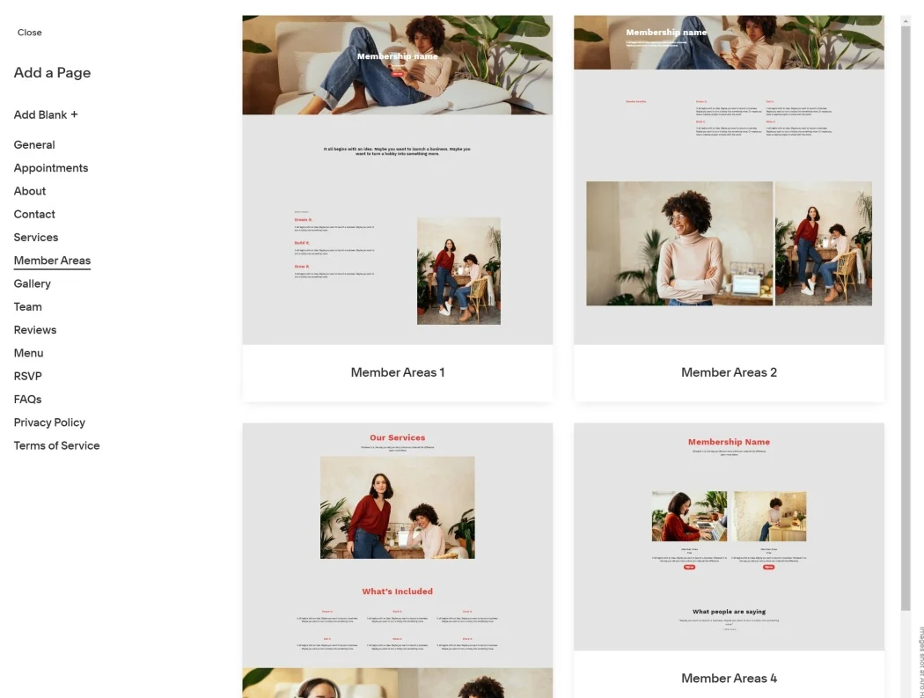
Figure A1. Squarespace Commerce interface explored using simulated information

Appendix B – BigCommerce Exploration
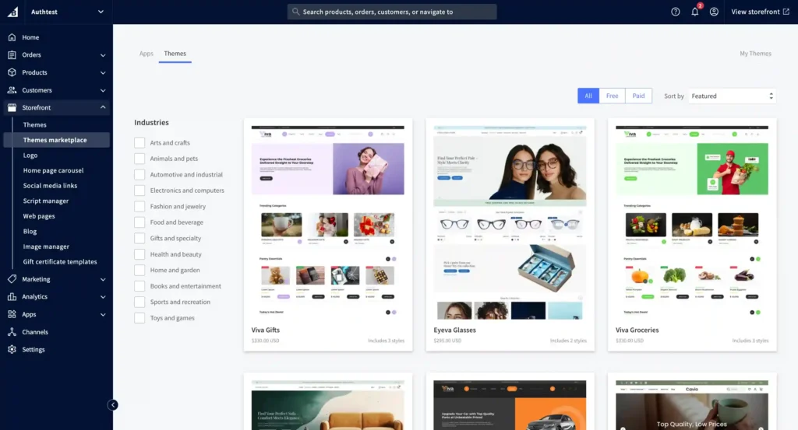
Figure B1. BigCommerce commerce-management interface explored for comparison

Appendix C – Miro Mind Map Practical Evidence
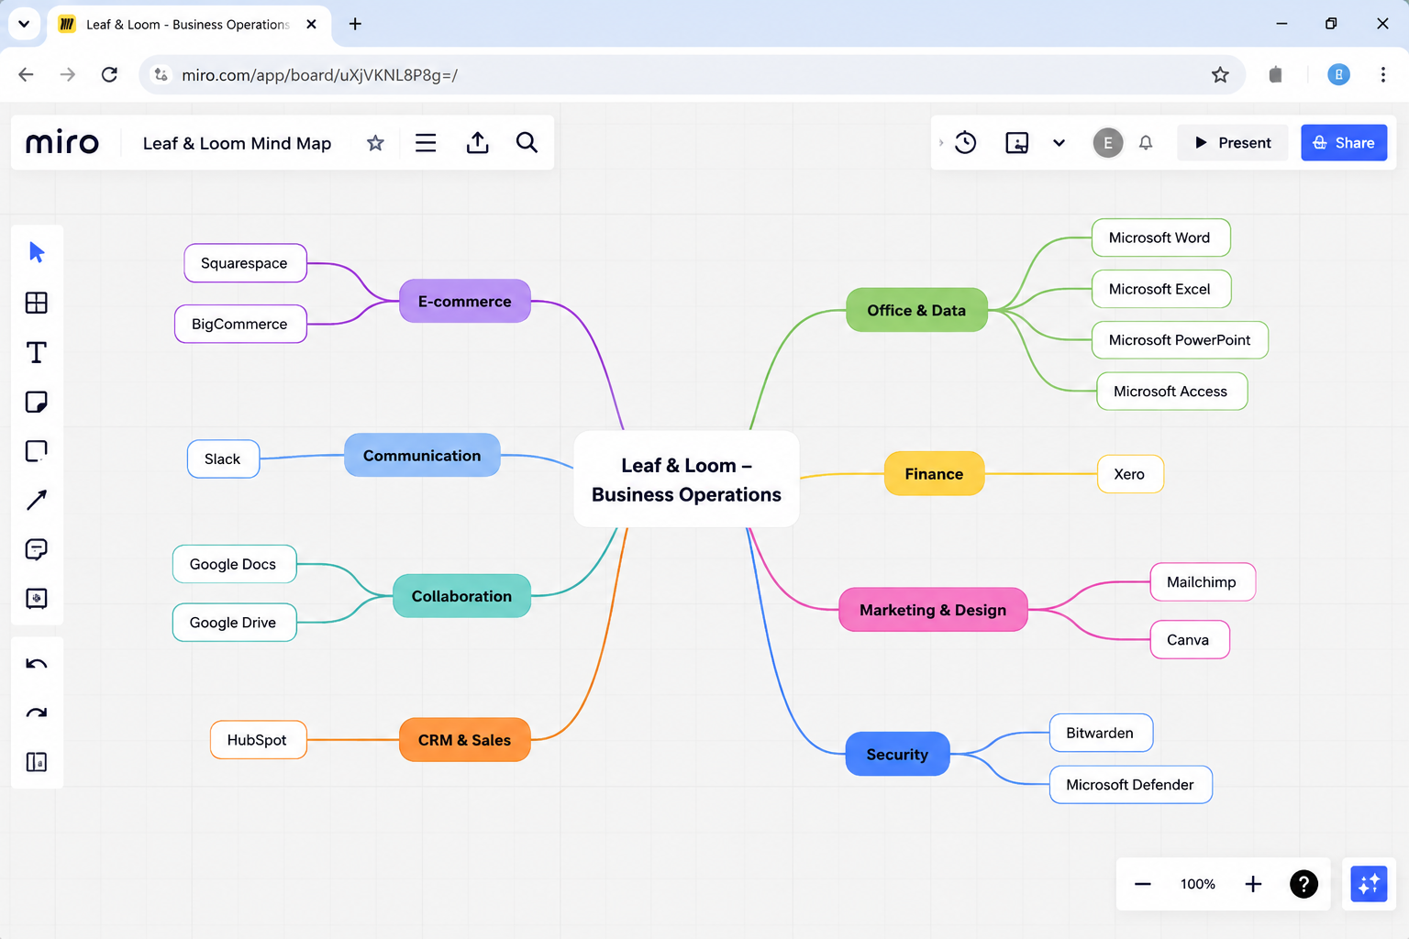
Figure C1. Miro mind map created to organise contemporary business software applications

Appendix D – Excel VLOOKUP Practical Evidence
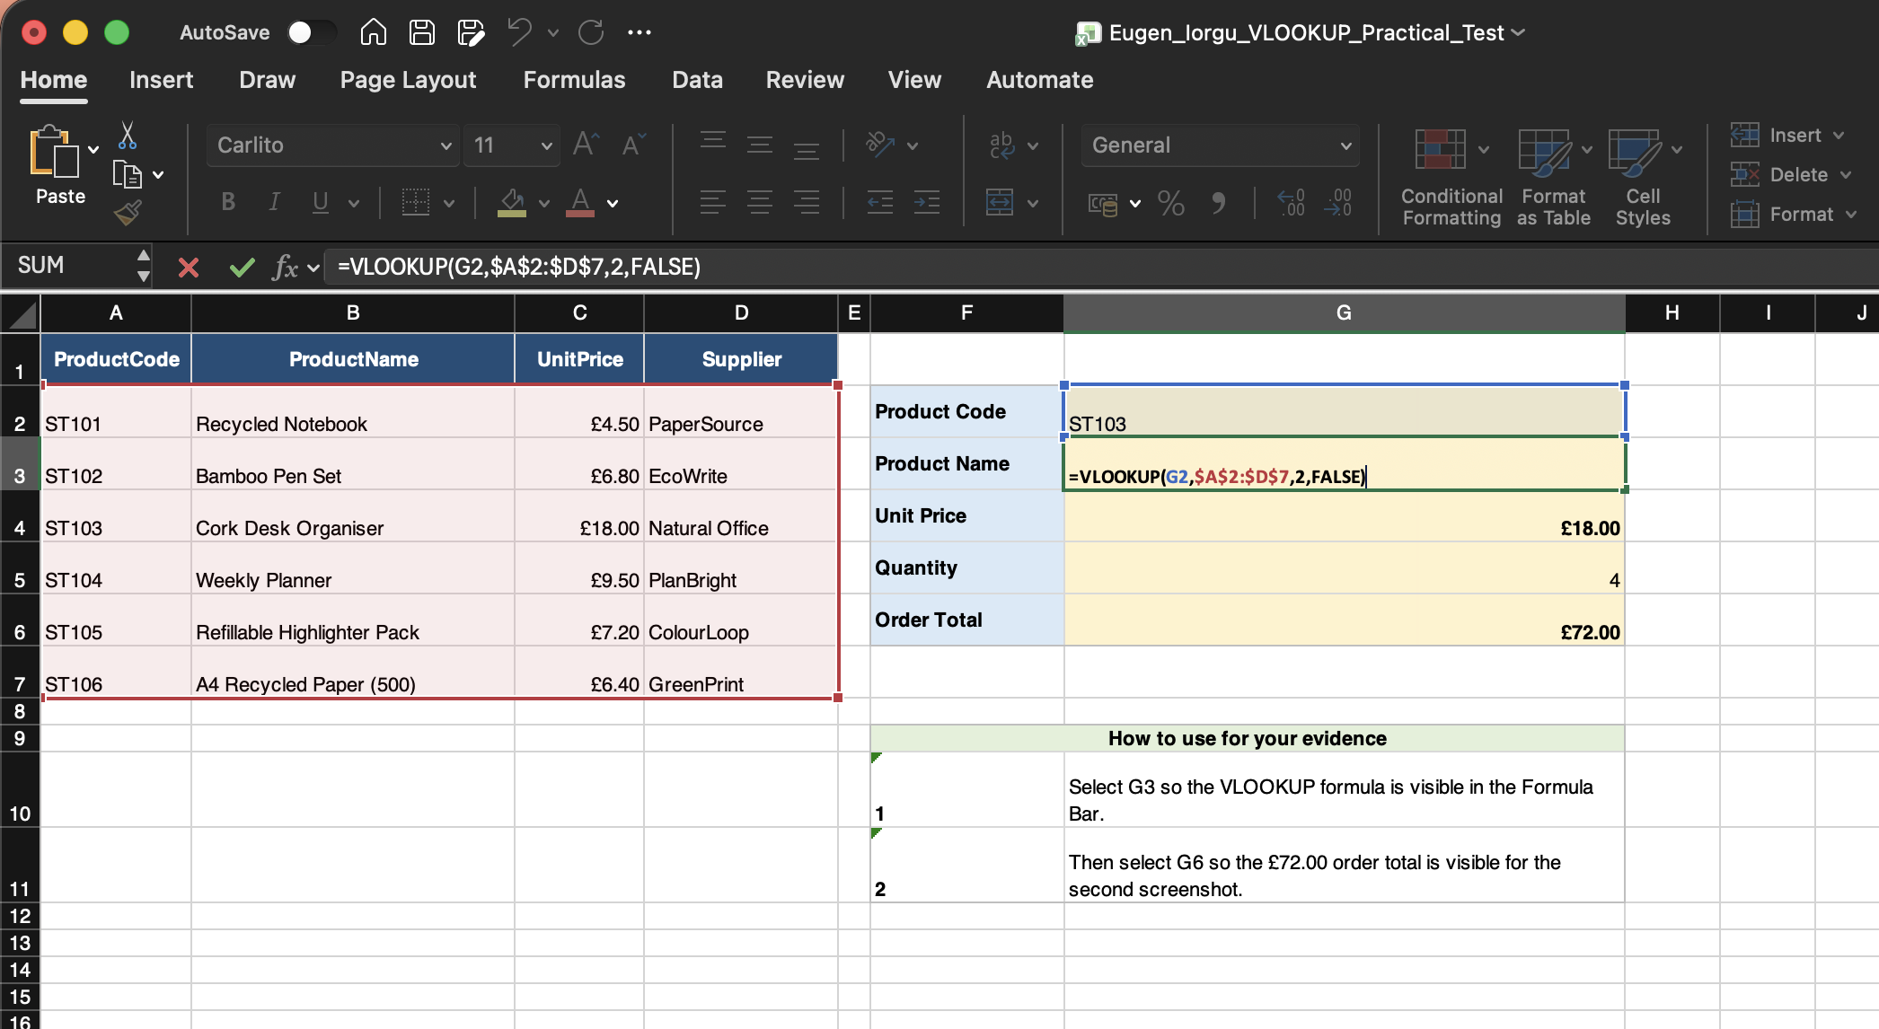
Figure D1. Excel VLOOKUP exact-match test using simulated product data
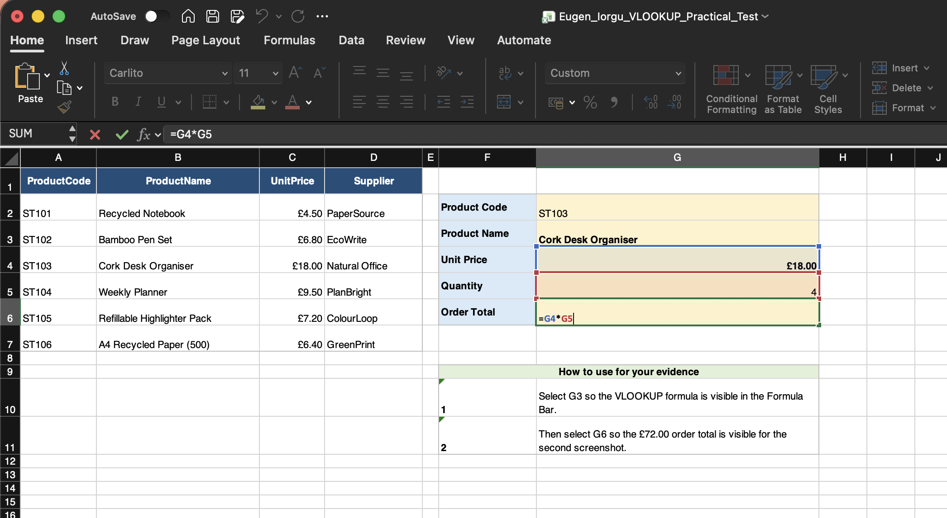
Figure D2. VLOOKUP output used in the simulated order calculation

Appendix E – Excel Goal Seek Practical Evidence
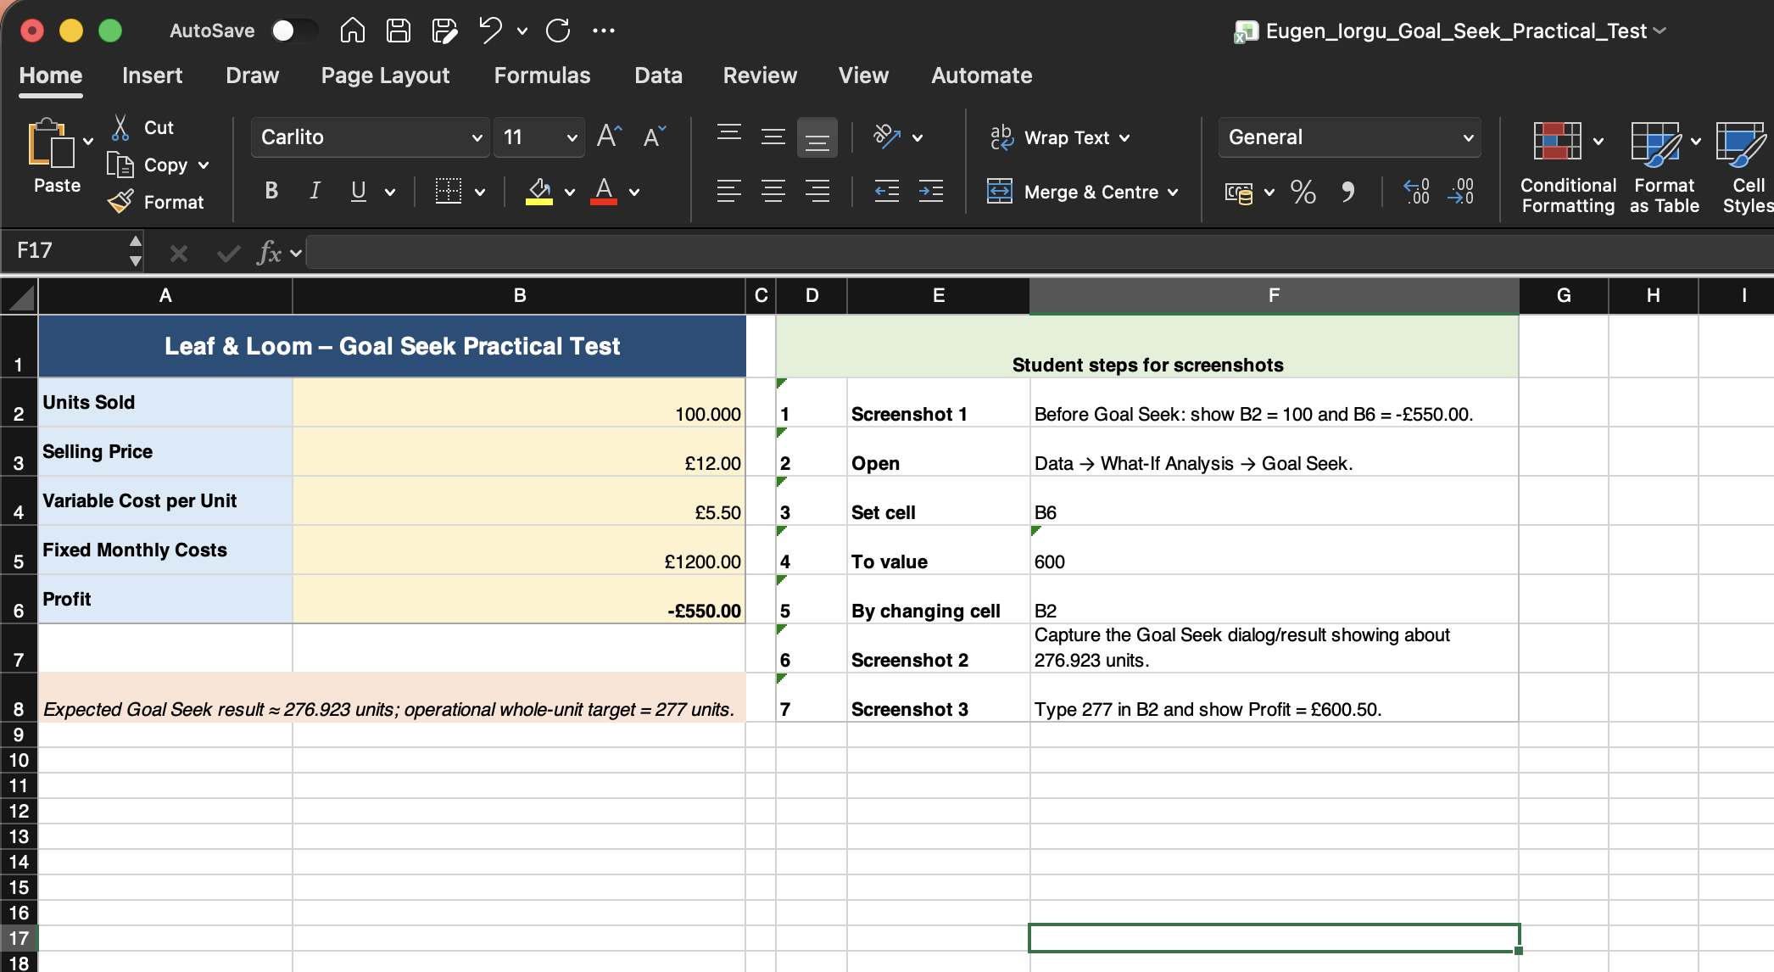
Figure E1. Excel Goal Seek model before the target calculation
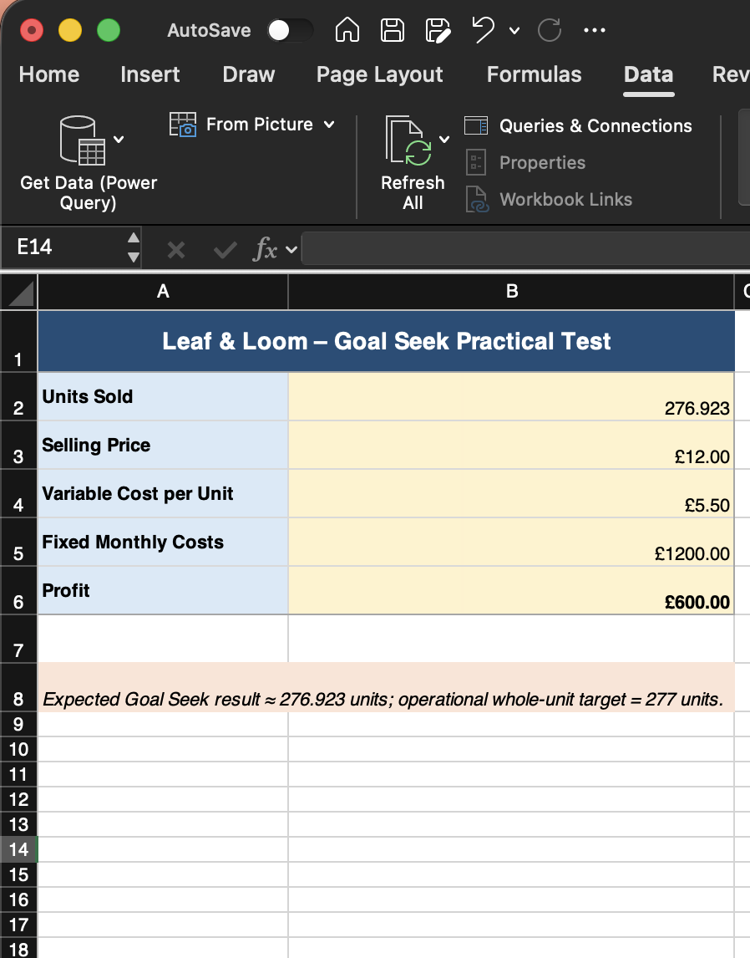
Figure E2. Goal Seek used to determine the units required for the target profit
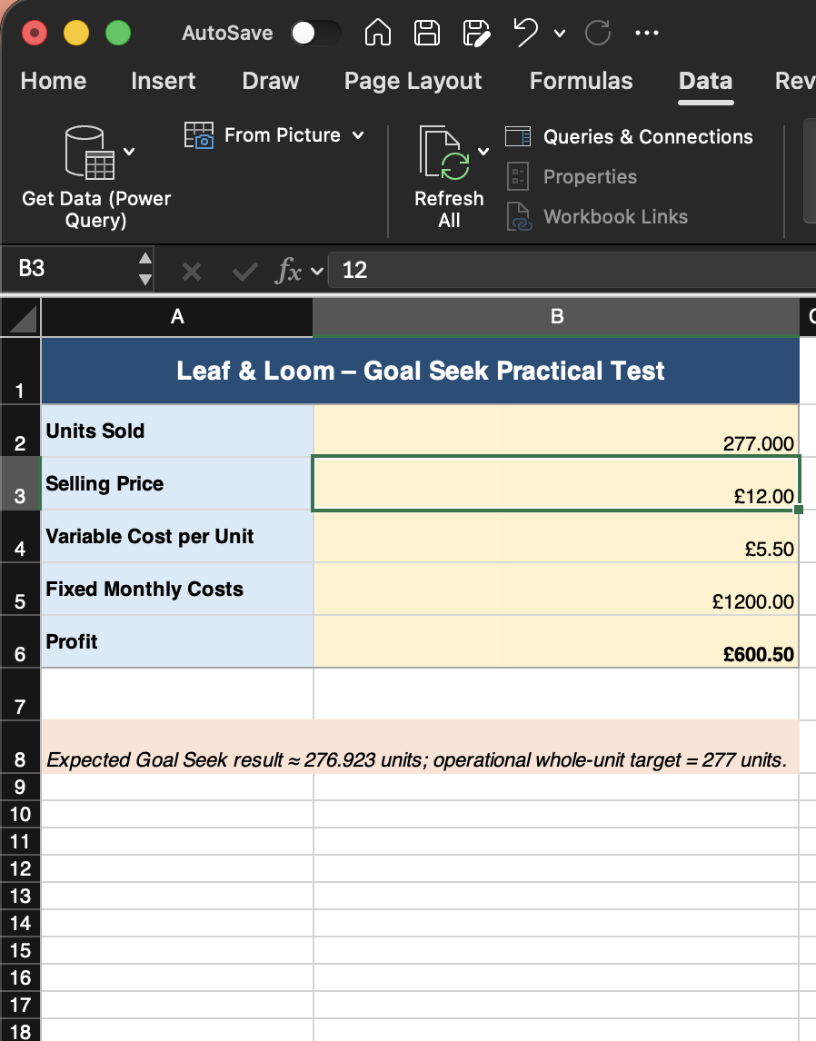
Figure E3. Goal Seek result translated into a whole-unit business target

Appendix F – Slack Communication Practical Evidence
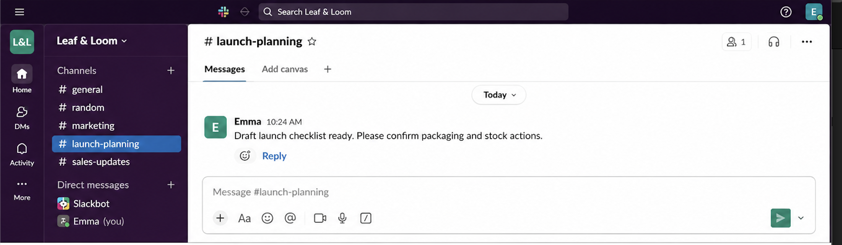
Figure F1. Slack channel used for simulated operational communication
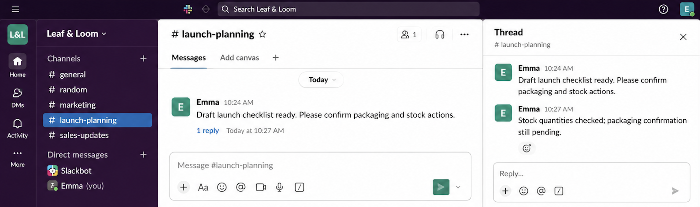
Figure F2. Slack thread used to keep a detailed response attached to the original message

Appendix G – Google Docs Collaboration Practical Evidence
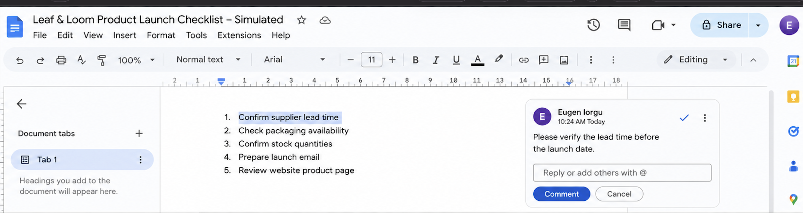
Figure G1. Google Docs comment used for asynchronous review
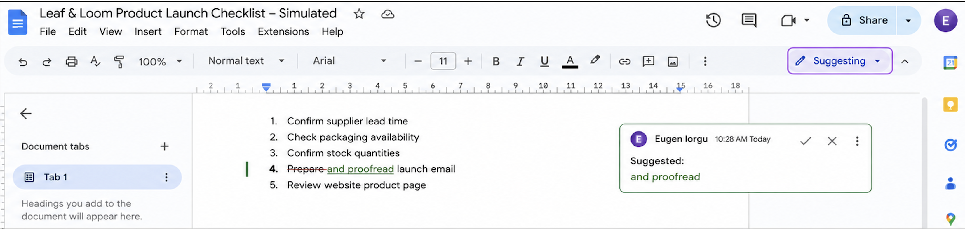
Figure G2. Google Docs Suggesting mode used for controlled collaborative editing

