

Cloud Computing: An Overview and Recommendations Based on Specified Case Study.
This report has been written as an assignment to Cloud Computing Technologies course, Lecturer Dr. Anupam Mazumdar, at T.S.D. University, London Campus

Projected for: London Bikes
Author: Biancamaria Di Napoli

10/05/2020

Table of Contents

Introduction 3
Cloud Computing 4
Characteristics 4
Technology 5
Service Models 5
Software-as-a-Service (SaaS) 6
Platform-as-a-Service (PaaS) 7
Infrastructure-as-a-Service (IaaS) 7
Deployment Models 8
Cloud Solution 9
Migration 12
Bibliography and Reference 14

Introduction

Cloud Computing is an increasingly popular option among companies that decide to invest in this new technology, but despite being increasingly widespread, it is always difficult to give a concrete definition of it. This report aims to make the Cloud Computing a more understandable and approachable reality. It will also provide: a clear definition of this technology, the different service models available and how it is possible to deploy them. In each model description will be highlighted the characteristics to understand the best use and the concrete benefits that derive from it. It will also be possible to deepen the concept of virtualization, which finds its maximum expression in the Cloud Computing. Familiarizing and making some topics more accessible will guide London Bikes in a path of optimization of its resources through a proposal for implementation in the cloud.
The most important message to convey is that cloud computing is not simply a new technology to make the company more productive, but rather a new way of approaching to the work dynamics. Precisely for this reason it is a path that, as we will see, must be carefully planned involving the various business sectors to make the transition as smooth as possible. The Cloud Computing is the technology that introduces into the future and being part of it is a challenge that must be accepted!

Cloud Computing

Cloud computing has established itself thanks to the increasingly massive use of the internet and the widespread diffusion of mobile devices as an opportunity to facilitate constant access to IT resources.
But before going into the topic, it is necessary to understand exactly what the term Cloud Computing is referring to.

Cloud Computing is a set of technologies and IT services methods of use of that promote the software use and supply, and the possibility of storing and processing large amount of data via internet. It therefore consists in a form of data storage, information and digital content in an intangible platform; a new way of saving and storing data arose with the development of new technologies. And these set of new technologies allow a service supply offered by a provider to a user, consisting of storing , archiving and / or processing data, because of the use of hardware end/or software resources that are allocated on the internet.

The National Institute of Standards and Technology (NIST) gives an exhaustive definition of Cloud Computing:
"Cloud computing is a model for enabling ubiquitous, convenient, on-demand network access to a shared pool of configurable computing resources (e.g., networks, servers, storage, applications, and services) that can be rapidly provisioned and released with minimal management effort or service provider interaction. This cloud model is composed of five essential characteristics, three service models, and four deployment models. (Mell & Grance, 2011) "

After this definition the concept of Cloud Computing is complete and in it five essential characteristics are identified: on-demand self-service, broad network access, resource pooling, rapid elasticity, measured service; which give shape to three service models: Software, Platform and Infrastructure; and deployed according to four models : private cloud, community cloud, public cloud, hybrid cloud.

Characteristics

To appreciate the real value ​​of the cloud, that it will be discuss later in this paper, it is necessary to understand the five cloud fundamental characteristics that, by definition, consist:
- On-demand self-service: the different services offered can be requested directly by the user in total autonomy, without having to interact with the service provider.
The services are also provided only when necessary, according to the consumer needs. This means that waste and inefficiencies are reduced to a minimum.
- Broad network access: the services can be used from any device, both fixed and mobile, and in any location through internet access.
- Resource pooling: the available resources are made accessible, and they can be used by several consumers at the same time (multi-tenant), and they are dynamically assigned and reassigned between different virtual servers. The customer does not know the exact resources location.
- Rapid elasticity: the resources increase or decrease is provided by an elastic mode, depending on the demand or need of the moment.
- Measure service: the resources are continuously optimized, using continuous performance measurement.

Technology

The term virtualization indicates a process that creates a virtual resource normally physically available. In Cloud Computing environment, virtualisation is a technology that replicates hardware machine functionality such as application servers, storage and networks, to create software-based IT services,.
Virtualization uses virtual machines (VMs) to simulate the physical machine functions and it does so using an operating system called hypervisor. An Hypervisor operates a separation of the machine application and operating system from the hardware below. Hypervisor plays a central role in virtualisation allowing the physical host machine to run several virtual machines simultaneously, maximising the computing resources as, for instance, CPU, network bandwidth, memory and so on. During these operations, the hypervisor manages the computing resources of each virtual machine as needed. This makes IT operations much more efficient and convenient. Virtualization is one of the most important technologies in Cloud Computing because it allows to allocate virtual resources to centralized groups that can be easily managed and distributed using a level of management software.

There are several types of virtualization:
- Server virtualization: it uses an hypervisor to partition physical servers by creating multiple virtual servers, each with its own operating system. This allows to harness the full power of physical servers to significantly reduce operating and hardware costs.
- Application Virtualization: users can run applications separately regardless of their operating system.
- Desktop Virtualization: it permits users to have access to a desktop remotely by a connected device.
- Network virtualization: it works by dividing the available bandwidth into independent channels, each it can be assigned to a server or device as needed.
- Storage virtualization: virtualization software is able to identify the available capacity offered by physical devices and to aggregate this capacity together in a virtual environment.
- Virtualization of data: it allows an application to access and use data without requiring details such as the physical location of the data or its formatting.

Service Models

In Cloud Computing there are three different service models based on the interaction and the control type that the user needs: Software-as-a-Service, Platform-as-a-Service and Infrastructure-as-a-Service. Before choosing which model is most suitable it is very important the evaluation of their requirements.

Software-as-a-Service (SaaS)

Saas is the acronyms of Software as a Service and make the Cloud immediately available to the users. In SaaS, in deed, a third-party provider hosts the applications and makes them available through the Internet. In the past a software was purchased and installed locally on the device, while in the SaaS method the software is hosted in the cloud and accessible via the Internet by subscription. All the typical software elements from the scripts, to the codes, remain unchanged and they are managed by the software supplier.
While traditional software was purchased via CD, or downloaded, and then installed on the computer, in SaaS, all the applications used are and updated online, and the files are saved on the cloud rather than on individual computers facilitating teamwork.
Infrastructure management and control are the responsibility of the Cloud provider.

The advantages of SaaS can be summarized in the following points:

- No hardware costs: all the computing power is provided by the cloud provider.
- No costs of initial installation: the applications are ready for use by subscription.
- Pay as you need: the real cost is calculated on what it has been used.
- Scalability: no software installation is required to have access to additional memory and services.
- Automatic updates: software vendor is in charge for free and automatics
- Compatibility with all devices: all applications can theoretically be used by any device through an Internet connection, such as laptop, smartphones and tablets.
- Accessibility : all the applications are accessible from anywhere with any device connected to the Internet.
- Customization: software can generally be modified to adapt to users' needs and brand.

Security is a very sensitive topic in Cloud Computing and the user has no control over it. In SaaS, data is shared with the service provider, in fact, the data is stored by the provider and transmitted through the internet, so one of the applied techniques is strong data encryption. This technique also ensures that the privacy and integrity of the data is protected, so a multifactor passwords is used and ensures that only authorized users can have access to and possibly modify the data. Customer information is further protected during transmission in the network by strong encoding techniques such as TLS and SSL.
The availability of data is another sensitive area because it can depend on several factors, the most important is the internet connection. All cloud services are administered through an internet connection, so if there is no internet there is not access to the cloud. The service provider, for its part, ensures 24/7 availability of data through continuous hardware and software maintenance. In addition, in order to ensure the availability of data following any attacks that may cause a temporary DoS, the service provider frequently produces backup copies of customer data and stores them on various servers whose location is secret. This is definitely an effective method for quick recovery from a disaster.

Platform-as-a-Service (PaaS)

PaaS is the acronyms of Platform as a Service and it is a connection link between Software as a Service (SaaS) and Infrastructure as a Service (IaaS).
PaaS is a cloud service the provider offers a development environment and a proper tools to design new applications. Developers and software companies are the main users of this service designed to whoever wants to quickly create and release new programs or applications without having to effort the necessary infrastructure.
PaaS offer a basic infrastructure such as servers, operating systems, storage space and middleware. Middleware is a bridge program connecting multiple applications together.
PaaS provides all the functionality to support the entire life cycle of web applications. It therefore ensures efficient management during the creation, testing and distribution phases, but also at the time of management and updating.

There are therefore several advantages to using PaaS to support the lifecycle of cloud-based applications:
- Rapidity: the application development process is full of numerous frequent and repetitive steps and activities that take time and can slow down the project. PaaS, by design, allows automation and in some cases, tedious maintenance activities, such as storage provisioning and configuration of domain name settings, can be fully automated. This automation can have a dramatic effect on development times, allowing a faster application delivery.
- Insure governance: Paas also allows to standardize the best governance practices, in order to obtain the peace of mind of being able to support and maintain applications more efficiently without infrastructure constraints.
-Simplify the development: smart and optimized PaaS tools are available and they simplify the coding process, improving both development times and quality. Frameworks and configuration tools can also ensure that best practices and standards are used.
-Reduce the cost: the total cost of ownership for applications is drastically reduced, because there is not hardware investment.

In Paas security issue is shared between the developer and the provider. The developer has to make sure that he takes the necessary security measures to protect his applications and the provider will have to ensure that he applies adequate security measures to protect the platform.

Infrastructure-as-a-Service (IaaS)

IaaS is the acronyms of Infrastructure as a Service and it is the lowest level of cloud computing abstraction. This form of cloud provides virtualized processing and computing resources on the Internet. An IaaS service corresponds to a virtual machine where the user can configure according to his needs. IaaS is a self-service model that can be used tor access, monitor and manage remote data center infrastructures. Companies, rather than buying hardware definitively, can opt for IaaS solutions that allow them to use, and therefore pay, only the resources actually necessary for their purposes. In IaaS users are responsible for managing applications, operating systems, and so on.

The advantages of using IaaS are the following:
- High-performance hardware: it can be used without having to use local resources. All devices, including mobile devices, can connect, via the web, to their virtualized infrastructure and also run applications that require important computing resources. Providers, in fact, host hardware, servers, storage devices and other components that are part of the entire cloud infrastructure on behalf of their customers.
- Reduced management costs: hardware devices are maintained by the service providers, and the consequence is save not only money and but also energy and time.
- Scalability: it can be adjusted on customer request. This is a very important feature for companies that often have to deal with temporary or changing workloads over time. Users have the option to upgrade or downgrade resources such as CPU, storage space, RAM and so on according to current needs. These operations are done through a simple control panel accessible from the web.
- Pay per-use: it means pay only and exclusively for the resources used, it allows companies to weight their budget according to the resources necessary for the development and design of the applications, without having to resort to excessive expenses for resources actually not used. IaaS services are suitable to be used for short periods.
- Complete platform management: offering networking services (switches, virtual routers, etc.), storage services, system maintenance services, backup schedules and so on.

Deployment Models

A cloud deployment model consists of a specific configuration of parameters that can vary according to who controls the infrastructure, storage size and accessibility. So we identify four deployment models:
- Public cloud: the cloud provider provides resources for the public or for a large group of companies. In this model an organization own the cloud infrastructure and it sells services to the public or to a group of businesses. For those who decide to use this model the benefits are given by the reduction of start-up costs and the delegation of risk management to the vendor infrastructure, however the concern of many is to have sufficient guarantees on data security and privacy , very important in a business scenario, lead companies towards other types of solutions.
- Private Cloud: the resources are used for the private use of a single company, or a group of companies and in this case a single organization own or lease the cloud infrastructure . This model definitely guarantees greater security and confidentiality.
- Hybrid Cloud: the infrastructure is formed by the merger of public and private clouds, united in a single entity. The goal of this model is to reduce the limits of the two previous models, obtaining a more flexible service. In this case a careful analysis of which services must belong to the public cloud and the private cloud needs to be run.
- Community Cloud: represents a cloud shared between different organizations that supports and shares, for example, the mission, safety requirements, policy and compliance considerations.

Furthermore, in a Cloud Computing environment it is possible identify three distinct actors:

- The service provider : provides services (storage, applications, computing capacity).
- Developer: choose and configure the services offered by the supplier. Implements a service that uses the resources made available by the service provider to offer them to the end user.
- End user: uses the services configured by the developer.

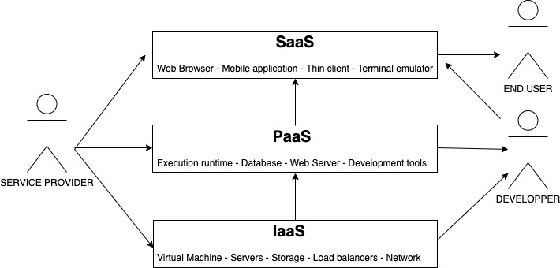
Figure 1. Actors in Cloud Computing environment. Source (Author)

To conclude this first part of the discussion highlighting some fundamental elements in the field of Cloud Computing:
- Network: it is without a doubt the most important part that allows access to the Cloud through the Internet.
- Front-end: it represents all those electronic devices that through applications allow the user to interact with the cloud.
- Backend: it is represented by all the infrastructures necessary to make the cloud a living entity

Cloud Solution

According to all the aspects considered, it is easy to understand why Cloud Computing is an increasingly widespread technology among companies. Certainly one of the most attractive features, besides the reduction of IT management costs, is the opportunity of being able to access the data wherever through the Internet. This paradigm has completely changed the way to work, optimizing it at the highest levels, just thinking that with the only use of a smartphone and access credentials, it is possible to access to shared resources in the cloud as happens in the office. With this in mind, the London Bikes business environment has been considered. After an initial meeting with the company executives , it was highlighted the interest and the desire to move some activities, managed internally, in the cloud. One of these is the website that they host internally and this means that London Bikes are using their hardware resources. This resources must be continuously implemented and updated in order to be competitive for an high performing site. In this case, Cloud Computing offers through the SaaS model the chance of hosting it in the cloud. This solution is undoubtedly a winner because through a package tailored to the company needs, it is possible to benefit of a series of advantages, such as scalability and higher performance, at a much lower cost than traditional management. The hosting packages in the cloud also offer a high storage capacity, and in some cases unlimited, so it is the ideal solution for the confidential information that the company would like to secure. With the migration of these activities to the Cloud, data backups are performed regularly.

The deployment solution of the SaaS cloud model is certainly hybrid cloud. This gives more flexibility and more data distribution options. This is a very valuable option for those companies that face the reality of cloud computing for the first time, in this way a part of the data is managed privately. In the specific case of London bikes, the most sensitive data, such as databases with customer and employees information, can be shared privately.

The proposal to move some business activities to the cloud will be a guided process through the use of tools that will allow to a careful evaluation with London Bikes trying to analyse if the company is truly ready for this step. The starting point of this evaluation will examine the TOE framework which will consider purely the IT aspect in the transition to the cloud. The TOE framework highlights how the corporate context and culture can influence the implementation of an innovation. The three aspects considered by the framework are: Technological, Organizational and Environmental (TOE).

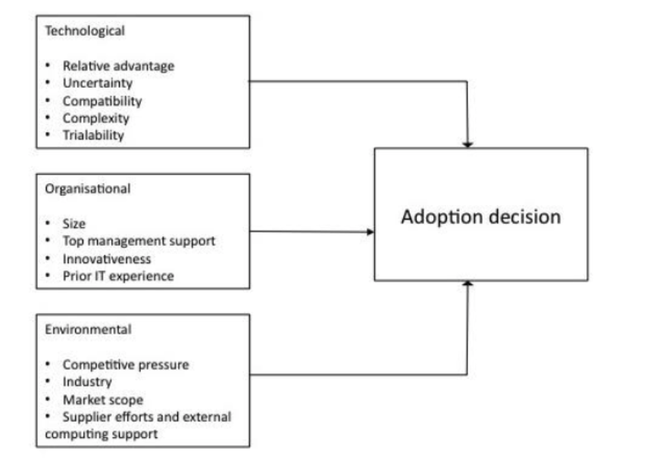
Figure 2. TOE framework. Source (DePietro, et al., 1990).

The figure clearly shows that a careful analysis of these three areas leads to a decision which, in order to be further validated, must take into account the sensitive issues related to the company's business environment. In this regard, the Cloud lifecycle is preferred alongside the TOE framework.
The Cloud lifecycle allows to break down the planning process into several phases, which must take place consecutively. The design of the phases has been studied in a way that at the end of each phase, it is possible to stop without losing the previous achievements and to do further more evaluations. The main four phases are: Architect, Engage, Operate and Refresh.

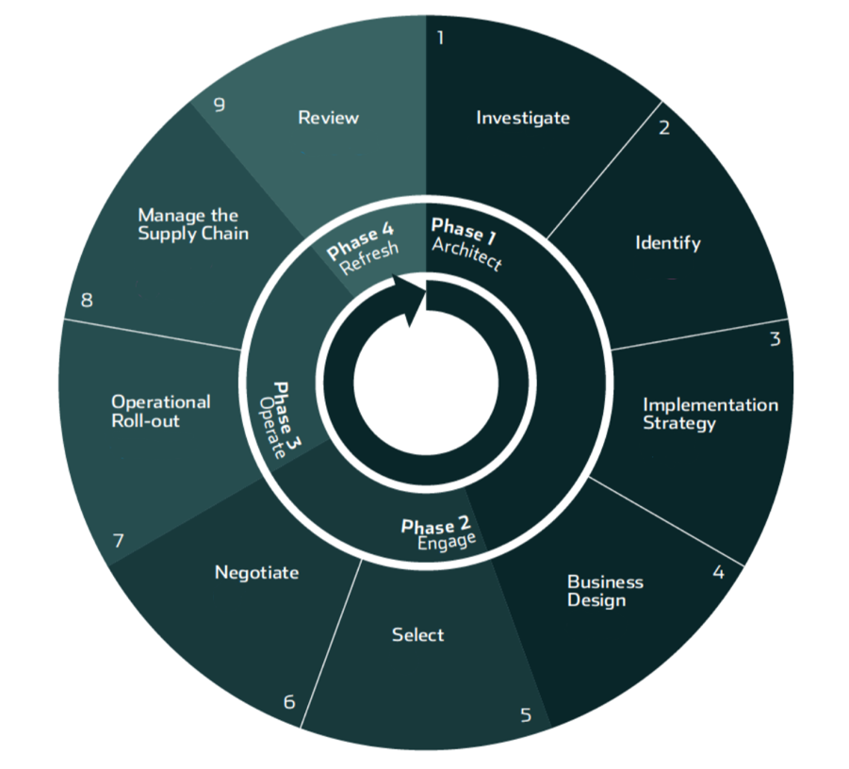
Figure 3. Cloud Lifecycle. Source (Conway & Curry, 2012)

The first phase is further divided into four steps:
- Investigate: an accurate analysis is made to underline the corporate objectives to be achieved and which areas of the company will be involved;
- Identify: identify which areas are outsourced in the cloud and what kind of impact this can have on the business;
- Implementation strategy: a strategy is studied takings into consideration the Business Planning and the Risk management;
- Business design: it establishes how the new service will be managed and presented it to stakeholders, maintaining the same image of reliability.
The second phase is divided into two steps:
- Select: the provider is selected based on various parameters;
- Negotiate: in this phase negotiating conditions are in place.
The third phase is divided into two steps:
- Operational Roll-out: daily planning of migration times;
- Manage the Supply Chain: internal and external communications are intensified for smooth transition.
The last phase is refreshing, where a review of the service requirements takes place and necessary improvements are evaluated.

Migration

Cloud migration is represented by the process of movement data, applications and other business elements to a Cloud environment and it is a very delicate stage.
There are several ways for a company to manage the process, whether it is to opt for Infrastructure as a Service (IaaS), Platform as a Service (PaaS) or Software as a Service (Saas ). The choice depends on the organization needs, the evaluation criteria of the various feasible options and the architectural principles of the company. There are the five possible paths of migration to evaluate:

- Rehosting or Lift-and-Shift (for IaaS)

In this case, the company opts to replicate applications on different hardware environments, without changing the infrastructural configurations. This kind of choice is suitable for companies that are involved in high expense of managing, updating and maintaining infrastructures on premise, and for this reason the speed of migration to the Cloud becomes the most important factor.

- Refactoring or rearchitecting (for PaaS)

The organization decides to run its applications on the Cloud provider's infrastructure. This choice allows the company to become familiar with the Cloud, ensuring, however, retroactive compatibility with the systems present in the on premise data center. Developers are therefore able to reuse application frameworks, programming languages ​​and technologies in which they have invested time and resources in the past.

- Revising (for IaaS or PaaS)

This option consists of a modification or extension of the development code that allows to modernize the legacy environments. The revising allows organizations to maximize the benefits and features of the infrastructure made available by the Cloud provider by opting for a preparatory choice for one of the two previous routes (refactoring or rehosting).

- Rebuilding (for PaaS)

This choice provides the possibility of rebuilding completely an application, rewriting its code. The application will be therefore subject to a complete architectural revision. The advantages are linked to the possibility of accessing all the innovative features made available by the Cloud provider and its developer community. The organization's IT team will have access to templates for the rapid creation of new features, reducing the time and complexity of development processes.

- Replacing (for SaaS)

In this case, the organization chooses to replace a licensed application and to opt for a Pay per Use model. The companies that choose this eventuality ensure greater flexibility in adapting the functionalities of the strategic software to their needs.

The main objective of a Cloud migration process is to be able to ensure that data and applications are hosted in the most efficient IT environment, based on the analysis of factors such as costs, performance and security of the various options.

The steps and processes that the organization follows in the process of migration to the Cloud are different and based on factors such as the specific resources that companies want to move, or the chosen migration path.

Bibliography and Reference

Butterfield, R. et al., 2016. Towards Modelling a Cloud Application's Life Cycle. Conference Paper.
Conway, G. & Curry, E., 2012. MANAGING CLOUD COMPUTING: A LIFE CYCLE APPROACH. Conference Paper.
De Pietro, R., Wiarda, E. & Fleischer, M., n.d. The context for change: organization, technology and environment, in Tornatzky, L.G. and Fleischer, M.. s.l.:s.n.
Mell, P. & Grance, T., 2011. The NIST Definition of Cloud Computing. National Institute of Standard and Technology.
Microsoft, 2019. Cloud rationalization. [Online]
Available at: https://docs.microsoft.com/en-us/azure/cloud-adoption-framework/digital-estate/5-rs-of-rationalization
[Accessed 05 05 2020].
Narayana, K. E., Kumar, S. & Dr.K.Jayashree, 2017. A Review on Different types of Deployment Models in Cloud Computing. International Journal of Innovative Research in Computer and Communication Engineering, 5(2), pp. 1475-1481.
Orban, S., 2016. 6 Strategies for Migrating Applications to the Cloud. [Online]
Available at: https://aws.amazon.com/it/blogs/enterprise-strategy/6-strategies-for-migrating-applications-to-the-cloud/
[Accessed 05 05 2020].
Rao, C. C., Leelarani, M. & Kumar, Y. R., 2013. Cloud: Computing Services And Deployment Models. International Journal Of Engineering And Computer Science , 2(12), pp. 3389-3392.
Ubaidullah Bokhari, M., Shallal, Q. M. & YahyaKordTamandani, 2016. Cloud Computing Serice Model: A Comparative Study. IEEE Network, pp. 890-895.

