BEng Electrical and Electronic Engineering

Electronics II

ACDA6001

Assignment 1
Parallel Multiplier

John Nigel James
1603327

Dr Gary Jones

Contents

Title Page 1
Contents 2
Task 1 3
Introduction to Multipliers 4
Design 6
Adders 6
Design Schematic 7
VHDL Code 9
- Line0 9
- LineX 10
- Port Mapping 11
Testing 12
Schematics 13
Results and Conclusions 14

Task 2 15
State Table 16
Device selection 16
State Reduction & Final logic Statement 17
Discrete Gate Solution 18
VHDL Code 19
Testbed & Summary and improvements 20
References 21

Task 1

The requirement is to design simulate and synthesise a 12 x 4-bit unsigned number multiplier based on a simple parallel Braun multiplier. An example of a 5 x 5-bit multiplier is shown in fig 1. Xilinx design software is to be used to achieve this.

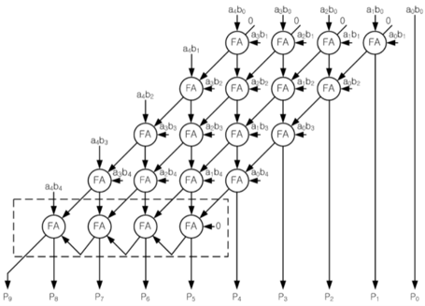

Fig 1 – 5 x 5 Multiplier

Introduction to Multipliers

Any system which requires the processing of digital signals will have a multiplier as its basic building block. Arithmetic operations such as digital communications, filtering and analysis all employ algorithms to perform the multiplication process. With the advancement in semiconductor technology, the demand for faster more efficient digital processing has led to an increase in chip density and speed (frequency) of operation and thus greater power consumption.

Several multiplier algorithms and methods have been designed to meet the demand, each having their own advantages and disadvantages wrt speed, power consumption and complexity. Some examples of these are discussed in the following paragraphs.

Serial vs Parallel

A SERIAL multiplier employs the simplest method of multiplication: to add a series of partial products. As both operands are entered serially then the simple structure leads to a smaller physical circuit, less hardware, and a smaller area on the chip. Due to the serial operation of the multiplier the sequential action takes more time and thus the propagation delay is greater.

Example of a Serial Multiplier – Bit-Serial Multiplier

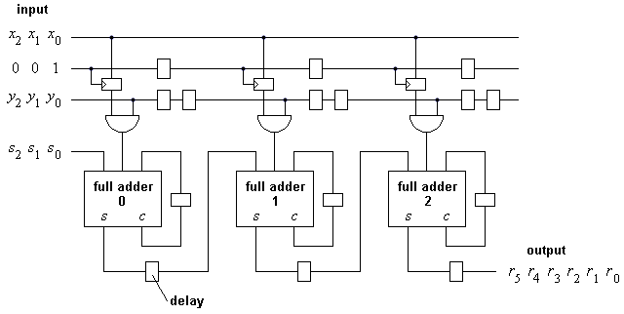

In comparison the PARALLEL multiplier operates by entering the operands in parallel. Although higher speed, the increase in circuit complexity and thus physical hardware occupying a greater area on the chip and consuming more power makes the parallel multiplier more expensive.

Example of a Parallel Multiplier - Braun Multiplier

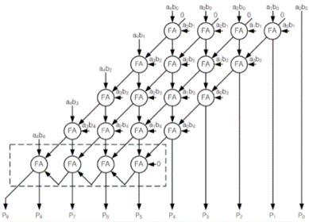

Comparison

Table 1 – Comparison of Series and Parallel Multiplier

Type | Speed | Circuit Complexity | Layout | Power Consumption | Area
Serial | Low | Simple | Regular | Low | Small
Parallel | Higher | More complex | Irregular | High | Large

It is not possible to conclude which is the better multiplier as it is dependent on the requirements of the system design e.g., number of bits to be multiplied, and the trade-offs are technology dependant. For a simple, inexpensive system where operating speed is not an issue then the serial multiplier would suffice. A parallel multiplier would be of higher speed but use more power and cost more to manufacture. A solution to satisfy most requirements would be a multiplier combining both methods i.e., a serial-parallel multiplier.

Design

Digital multiplication requires a binary number (multiplicand) to be added to itself several times as specified by another number (multiplier) to produce a result (product).

To achieve this a network of AND gates is used to construct an electronic device which will take n number of inputs and provide n outputs, dependent on the state of the inputs.

Hardware Description Language (VHDL) was used to write a code that describes a logic circuit. This was then synthesised and simulated to ensure each block was functional before proceeding to the next stage. The code was progressed by using each block to construct a network. Port mapping and the declaration of inputs and outputs was carried out, and the design synthesised and simulated. The final simulation, or testbench, was run to prove the system.

The basic building blocks used in the network design were the Half Adder and Full Adder.

Proteus design software was utilised to construct a schematic diagram for the system. The code was constructed, synthesised, and simulated in VHDL using Xilinx ISE.

Adders

Half and full adders carry out the function of simple binary addition using traditional arithmetical principles. The outputs are generated depending on the combination and number of inputs. These are the sum, carry or sum and carry.

VHDL code was written to describe the function of both the half and full adder. Both sections of code were synthesised and run on a test bed to debug. Any issued evident were resolved and the testing repeated until successful test beds were established. Regular synthesising and debugging were carried out throughout the process to assure correct functionality and prevent coding errors being carried forward, thus promoting high confidence at each stage of design.

Half Adder

A half adder has 2 inputs and 2 outputs. See truth table below:

A | B | Sum | Carry
0 | 0 | 0 | 0
0 | 1 | 1 | 0
1 | 0 | 1 | 0
1 | 1 | 0 | 1
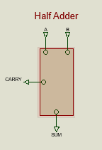

Full Adder

A full adder has 3 inputs and 2 outputs. See truth table below:

A | B | Cin | Sum | Carry
0 | 0 | 0 | 0 | 0
0 | 0 | 1 | 1 | 0
0 | 1 | 0 | 1 | 0
0 | 1 | 1 | 0 | 1
1 | 0 | 0 | 1 | 0
1 | 0 | 1 | 0 | 1
1 | 1 | 0 | 0 | 1
1 | 1 | 1 | 1 | 1
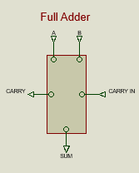

Design Schematic

A schematic diagram was produced to visualise the steps to be taken by the multiplier. A table was then drawn up showing the inputs to each line and the intermediate signal outputs were allocated codes accordingly. The schematic and table are shown below:

Schematic Diagram of 4 x 12 Multiplier

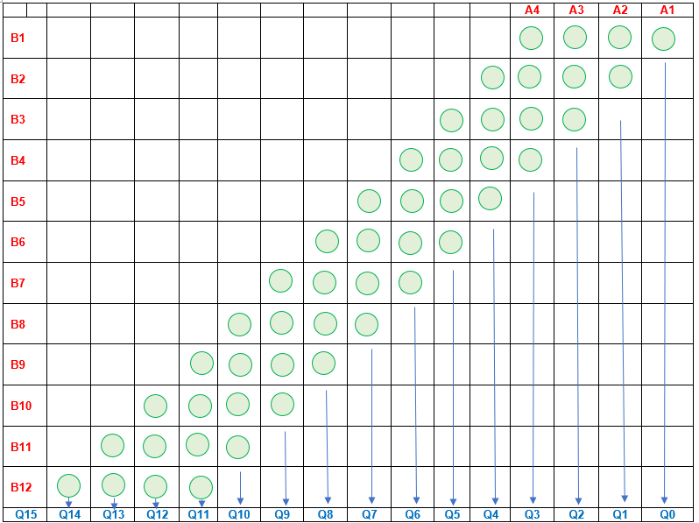

Table of Inputs and Outputs of 4 x 12 Multiplier

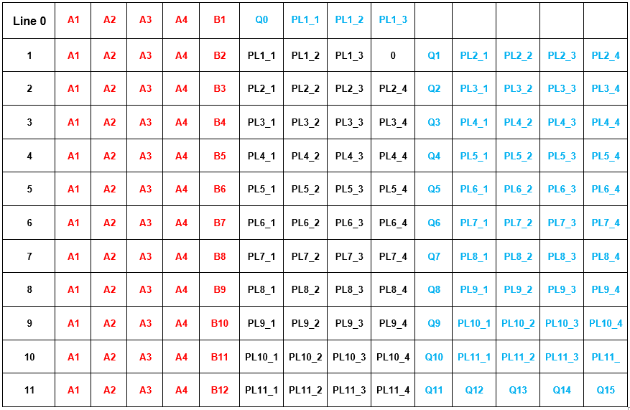

Note: Inputs of each stage are shown in Red, intermediate signals in Black and outputs in Blue.

The VHDL Code

Xilinx ISE Design Suite was used to set up a new project. A VHDL module was opened, and inputs and outputs declared. At this stage no intermediate signals existed so only the multiplicand and multipliers were declared.

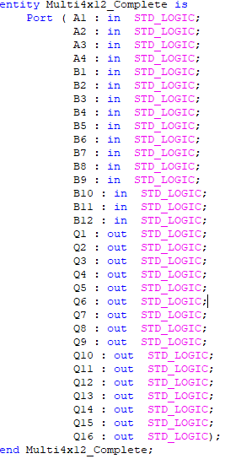

The behavioural architecture of line 0 and lineX was then written. This defined the inputs and outputs of the two base lines of the “arithmetic function”, the half adder and full adder and involved importing the code written earlier in the process.

Line0

The VHDL code for line0 incorporating the half adder. The code clearly shows the four inputs (multiplicands), the Multiplier and the four outputs.

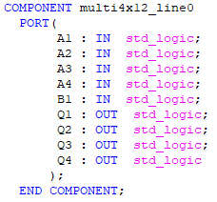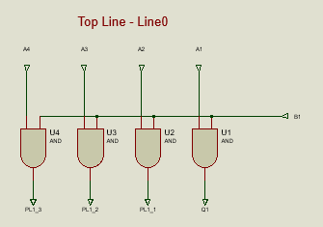

VHDL Code and Schematic of Line0

LineX

LineX, the full adder, incorporates the inputs and outputs as that of the half adder but additionally has the intermediate signals (P1 – P4) which are the carry outputs. At this stage they are defined generically.

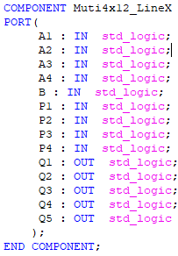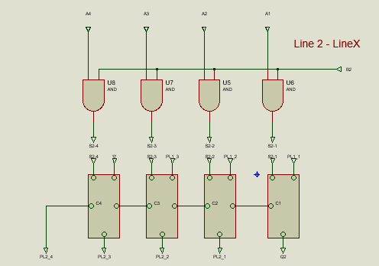

VHDL Code and Schematic of LineX

Intermediate Outputs

The intermediate (carry) signals were declared for lines 1 to 12 as these are now required in the construction of the stages of the multiplier. Note line1 (Line0) as has only 3 signal as this is a half adder.

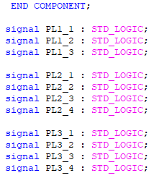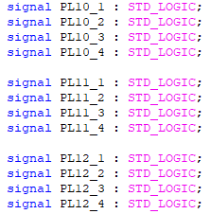

Note – Only lines 1 to 4 and 10 to 12 shown for brevity.

Port Mapping

The multiplier was then constructed line by line, defining each line by number, type (line0 or LineX) and input, intermediate and output signal ports.

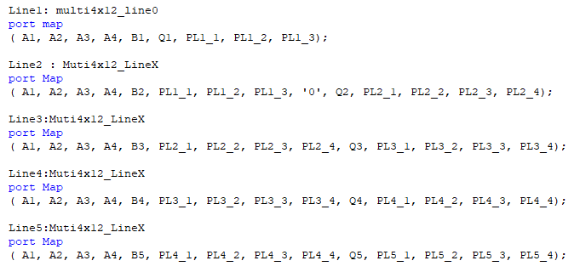

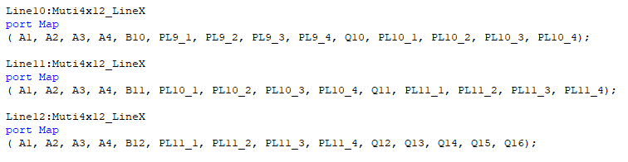

Note – Only lines 1 – 4 and 10 – 12 shown for brevity.

Testing

The code was synthesised one final time to ensure no errors existed. Once satisfactory synthesis was completed than a test bench was constructed. This involved declaring and assigning all inputs (A1 – A4), multipliers (B1 – B12) and outputs (Q1 – Q16), line by line, except for the intermediate signals.

Stimulus Processes were defined for the multiplicands and multipliers with the time periods assigned as multiples of 20ns. This ensured the periods of the signals would align allowing more accurate analysis of the simulation graph.

A behavioural check was carried out and on successful completion a behavioural simulation was run.

Once generated, the input and output signals were split into virtual buses and individually re-ordered to the Most Significant Bit at the top of their respective buses. The radix of each was changed to unsigned decimal to allow easy analysis.

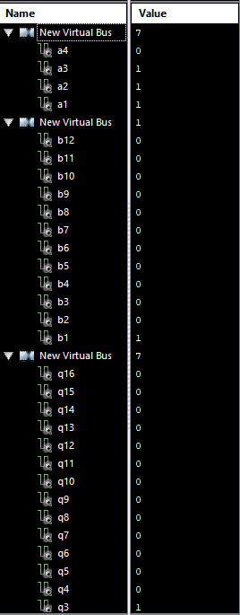

Overall Schematic Diagram

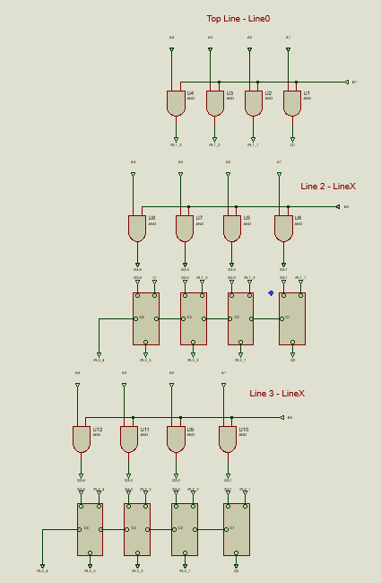

Note – Only lines 1 – 3 and 11 – 12 shown for brevity.

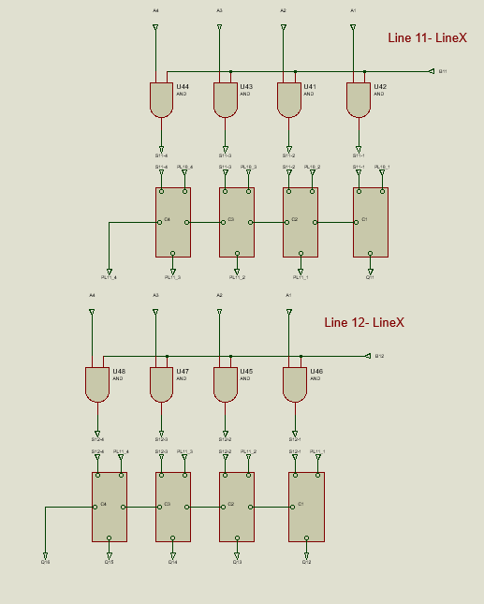

Summary and Conclusions

The following statements on the multiplier are true if:

B = 0 then all Q’s = 0

Q = S + P

S = A X B

Therefore Q = A X B + P

The highest multiplicand is 4 bit 1111 (15)

The highest multiplier is 12 bit (111111111111) (4096)

This was proved within the test bench as shown in the following:

On return to the testbed for final analysis and write-up the original results could not be reproduced. See screenshot below.

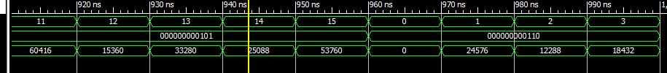

Further investigation and manipulation of the data ordering (MSB to LSB) in the generated graph enabled correct sequencing of the inputs A1 to A4.

Inputs B were only present up to and including 110

Thus the results were not established.

Having obtained correct results first time around it was decided that more time for further data manipulation, file corruption and fault analysis would be required.

Task 2

The aim of part 2 of this assignment is to design, simulate and synthesise the FSM described by the state diagram below as both VHDL and discrete gate solution.

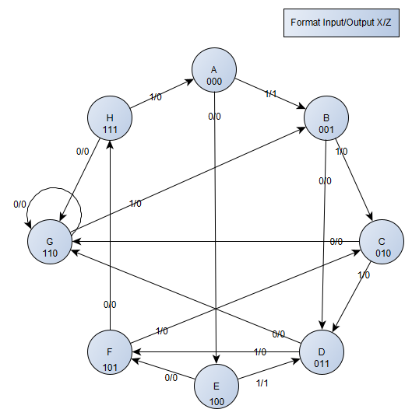

Process

To produce the VHDL and discrete gate solution for the FSM described, the following process was observed:

- Obtain state table from the state diagram.
- Choose the type and number of flip-flops required.
- Obtain the truth table of each device.
- Carry out state reduction.
- Derive the simplified flip-flop output equations.
- Design and the discrete state solution.
- Write VHDL Code

State Table

The state table was obtained form the state diagram given. The present states (A to H) were stepped through in order and the next state derived dependant on whether the input (X) was ‘X=0’ or ’X=1’.

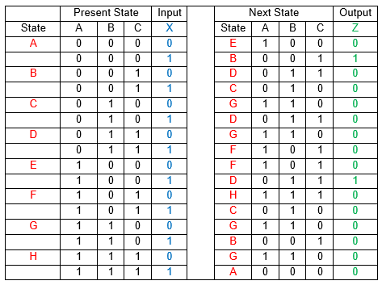

Device Selection

As the input is 8 bit (000 to 111) then 3 devices would be required. It was decided to use D type Flip-Flops. The D type has two inputs, clock (Clk) and data (D), and two outputs (Q) and (/Q) As long as the clock input is low (0) then changes at the D input will not change the output. If the clock input goes high (1) then the logic state at input D will appear at output Q. The output /Q is always the inverse of Q. See fig below:

D-Type Flip-Flop Truth Table

Inputs |  | Output
Clk | D | Q | /Q
0 | X | No Change
1 | 0 | 0 | 1
1 | 1 | 1 | 0

State Reduction

Using the state and truth table for the D-type, Karnaugh Mapping was employed to derive the logic tables for each of the devices, Da, Db and Dc. The logic was then reduced to minimum conditions using the looping method and final logic statements were derived for each device.

Logic table for device Da

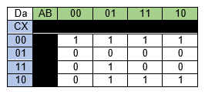
Da was reduced from 8 functions down to 3. The final logic statement for Da was:

/C./X+/A.B.C+A.C./X

Logic table for device Db

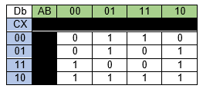
Db was reduced from 10 functions down to 5. The final logic statement for Da was:

B./C..X+C./X+/A.B./C+A./B.X+/A./B.C

Logic table for device Dc

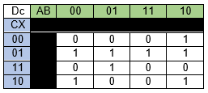

DC was reduced from 8 functions down to 4. The final logic statement for Da was:

/C.X+/B./C./X+/A.B.X+A./B./C

Final Logic Statement

The final logic statement describing the machine was:

/C./X+/A.B.C+A.C./X+ B./C..X+C./X+/A.B./C+A./B.X+/A./B.C+/C.X+/B./C./X+/A.B.X+A./B./C

Discrete Gate Solution

Proteus software was used to construct the discrete gate solution. The final circuit is shown below:

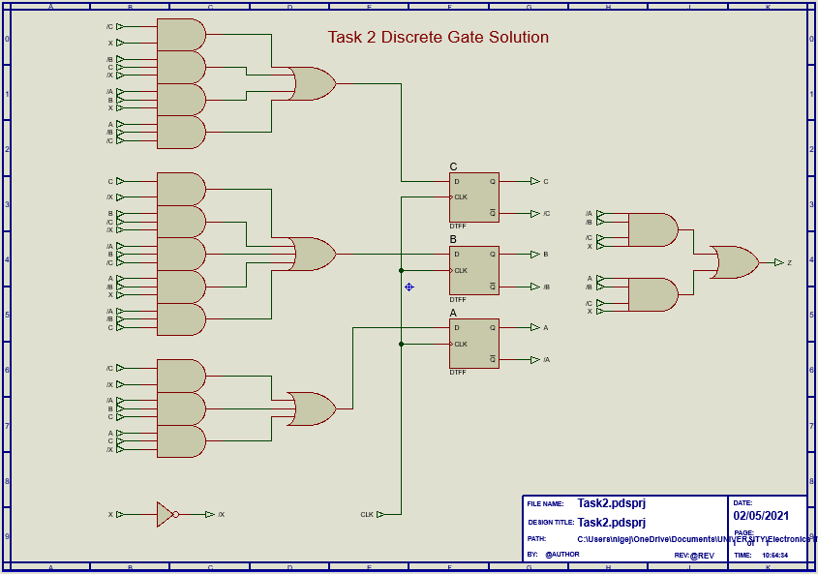

VHDL Code

ISE Design Suite software was used to construct code for the machine in VHDL.

The code is attached at Appendix A.

The code began by writing a behavioural and declaring the present and next states as described in the state diagram, with the next state dependant on whether the clock input (X) was high or low. As can be seen from the code below, the output z was defined as the current states with the transition states that produced a (1) logic hi output designated Z. This would allow for easier recognition of states when reading the Testbed graphs.

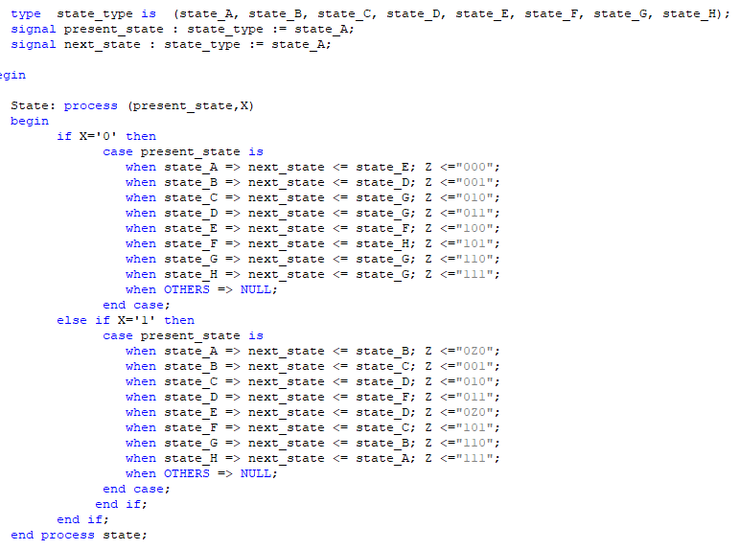

The next statement was the instruction on the action to be taken dependant on the state of the input X:

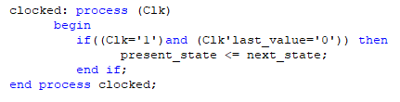

The code was synthesised to debug, no faults were apparent.

Testbed

The next stage was to wite a testbed and simulate the code.

The test bed was written to show a “route” that the machine would take around the state diagram taking in several states and directions but specifically those transitions that produced an output. i.e., from state A to B and E to D. This can be seen in the figures below:

The transitions producing an output Z can clearly be seen in blue.

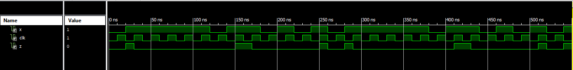

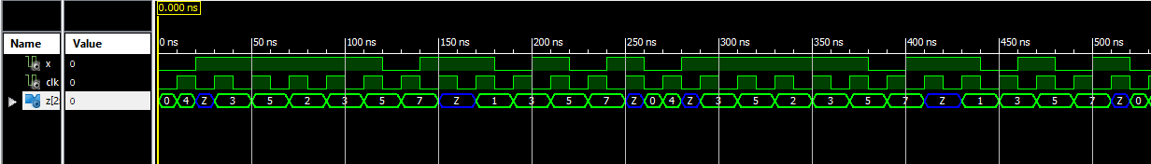

Summary & Improvements

- The Finite State Machine as described by the state diagram is of an A type machine. The System must take account of the input (X) matching up with the output at the transition from 000 to 001 and 100 to 011.
- The output Z is a function of an output decoder which is not part of the machine and is dependent of the output of the machine.
- Grouping of the functions to reduce the number of logic statements ultimately reduces the number of devices use. This reduces the overall cost of hardware in production.
- The process of writing the VHDL code for a programmable hardware device was significantly less time consuming than the discrete gate method. It ultimately reduces the number of gates and thus chips and devices used.
- The test bed was written to specifically test and show the transitions between the states that produced an output. A good test bed would test the transition from every state to every other state in both directions. This would highlight any issues such as hang states which could be resolved, thus proving the entire system.

References

Pramod V Rampur, Jagadish M and Yogeesha G, 2016. Design and Implementation of Advanced Array Multiplier for Binary Multiplication on FPGA. International Journal of Engineering Research and, [online] V5(08), pp.1 - 3. Available at: <http://www.ijert.org> [Accessed 19 March 2021].

Sharma, J. and Kumar, S., 2004. Speed Comparison of Various Multipliers. International Journal of Engineering and Management Research, Volume 4(Issue 3), pp 244 to 247.

Learnabout-electronics.org. 2021. D Type Flip-flops. [online] Available at: <https://learnabout-electronics.org/Digital/dig53.php> [Accessed 1 May 2021].

ACDA6001 Electronics II Course Notes

Lecture Videos

